Supplementary Materials of

Transfer Learning Across Material Properties Using Center-Environment Features: From Energetics to Mechanical Properties in Multi-Component Mo Alloys

Liqin Qinª, Yuchao Tangª, Limin Zhangª, Bin Xiaoª, Wenyi Huo^{c}, and Yi Liu*^{a,b}

ª Materials Genome Institute & State Key Laboratory of Materials for Advanced Nuclear Energy, Shanghai University, Shanghai 200444, China
^{b} Institute of Low-dimensional Carbons and Device Physics, Shanghai University, Shanghai 200444, China
^{c} NOMATEN Centre of Excellence, National Centre for Nuclear Research, Otwock 05-400, Poland
*Email: yiliu@shu.edu.cn (Y. L.)

Text S1 Computational parameters in the first-principles calculations
In this work, the target properties, single- and double-site substitution energy (E_{SS} and E_{DS}), are defined as follows:
$$E_{SS}=E_{\text{tota}l}+E_{Mo}−E_{pure}−E_{X}$$ | (1)
$$E_{DS}=E_{\text{tota}l}+2×E_{Mo}−E_{pure}−E_{X}−E_{Y}$$ | (2)
where $E_{total}$ represents the total energy of the system after atomic substitution in the Mo host lattice, $E_{Mo}$ denotes the energy per Mo atom in the pristine Mo unit cell, $E_{pure}$ signifies the total energy of the unsubstituted Mo host lattice, and $E_{X}$ or $E_{Y}$ corresponds to the average energy per atom of the 11 substitution elements in their conventional unit cells.
All computational simulations were conducted utilizing Density Functional Theory (DFT) as integrated within the Vienna Ab-initio Simulation Package (VASP) software^{1, 2}. We employed the Perdew-Burke-Ernzerhof (PBE) parametrization² for the generalized gradient approximation (GGA-PBE)^{3, 4} to calculate the exchange-correlation energy. The interactions between core and valence electrons were approximated using Projector-Augmented Wave (PAW) potentials^{5, 6}. The kinetic energy cutoff for the wave functions was established at 500 eV. For body-centered cubic molybdenum (BCC-Mo), a Gamma-centered k-mesh of 5 × 5 × 5 was applied to discretize the Brillouin zone (BZ). The total energy calculations were refined to a convergence threshold of 1 × 10⁻⁵ eV, while the forces were converged with an accuracy of less than 0.02 eV/Å. Spin-polarized calculations were performed to account for the magnetic properties of the system. Taking into account the dilute concentration of the alloying elements, lattice relaxation was initially carried out within the BCC-Mo systems. Subsequently, ionic relaxation was executed under the constraint of maintaining a constant cell volume and shape.
Elastic constant calculations were implemented through VASP's IBRION module. Enhanced computational parameters included an elevated cutoff energy of 600 eV and stricter convergence criteria (energy: 1×10⁻⁸ eV, forces: 0.001 eV/Å). Displacement response calculations followed cubic symmetry constraints, employing four displacement points along each atomic coordinate axis with controlled displacement amplitudes of 0.15 Å to ensure reliable elastic constant determination.
In order to balance the reliability of calculation results and effectively control resource and time consumption, this study selected systems covering all single-site substitution systems and 20 carefully screened First Nearest Neighbor double-site substitution systems for elastic constant calculations (32 systems in total). Two key principles were followed in the system selection process: first, ensuring that all the studied types of alloying elements were included; second, prioritizing systems with substitution energies as negative as possible, aiming to select thermodynamically more stable configurations and obtain more valuable calculation results.

Text S2 Calculation methods of elastic mechanical properties of Mo alloys

In this work, the elastic mechanical properties are calculated using the Voigt-Reuss-Hill method⁷⁻¹⁰ as follows.
Formula for Bulk modulus (B)：
$$B=B_{v} = B_{R} = \frac{C_{11}+2C_{12}}{3}$$ | (3)
Formula for Shear modulus(G)：
$$G_{v} = \frac{C_{11}−C_{12}+3C_{44}}{5}$$ | (4)
$$G_{R}=\frac{5(C_{11}−C_{12})C_{44}}{4C_{44}+3(C_{11}−C_{12})}$$ | (5)
$$G=\frac{G_{v}+G_{R}}{2}$$ | (6)
Young’s modulus (E)：
$$E = \frac{9BG}{3B+G}$$ | (7)
Poisson’s ratio ($v$)：
$$v = \frac{3B−2G}{2(3B+G)}$$ | (8)

Table S1. Elementary attributes (66) used in the Center-Environment feature construction in this work. The selected attributes (18) are presented in bold.
ID | Features | Abbreviate
ID | Features | Center | Environment
1 | Radii metal (Waber) | C_R | E_R
2 | Radii pseudo-potential (Zunger) | C_Rp | E_Rp
3 | Quantum number | C_Qn | E_Qn
4 | Radii covalent | C_Rc | E_Rc
5 | Volume of atom (Villars, Daams) | C_Va | E_Va
6 | V^{2/3} (Miedema) | C_V2/3 | E_V2/3
7 | Thermal neutron capture cross section | C_Tna | E_Tna
8 | Surface tension at Tm | C_StT | E_StT
9 | Spin nuclei | C_Sn | E_Sn
10 | Spectral lines n_{o} | C_Sln | E_Sln
11 | Periodic number start counting top right, right-left sequence | C_Pntrrl | E_Pntrrl
12 | Periodic number start counting left bottom, left-right sequence | C_Pnlblr | E_Pnlblr
13 | Periodic number start counting bottom right, right-left sequence | C_Pnbrrl | E_Pnbrrl
14 | Oxidation state first | C_Osf | E_Osf
15 | nW^{1/3} (Miedema) | C_nW1/3 | E_nW1/3
16 | Nuclear charge effective (Slater) | C_Nce | E_Nce
17 | Moment nuclear magnetic | C_Mnm | E_Mnm
18 | Molar heat capacity | C_Mhc | E_Mhc
19 | Mendeleev t-d start right | C_Mtdr | E_Mtdr
20 | Mendeleev t-d start left | C_Mtdl | E_Mtdl
21 | Mendeleev Pettifor regular | C_MPr | E_MPr
22 | Mendeleev Pettifor | C_MP | E_MP
23 | Mendeleev H t-d start right | C_MHtdr | E_MHtdr
24 | Mendeleev H t-d start left | C_MHtdl | E_MHtdl
25 | Mendeleev H d-t start right | C_MHdtr | E_MHdtr
26 | Mendeleev H d-t start left | C_MHdtl | E_MHdtl
27 | Mendeleev d-t start right | C_Mdtr | E_Mdtr
28 | Mendeleev d-t start left | C_Mdtl | E_Mdtl
29 | Mendeleev chemists sequence | C_Mcs | E_Mcs
30 | Melting temperature | C_Mt | E_Mt
31 | Mass attenuation coefficient for MoK^{α} | C_MacMo | E_MacMo
32 | Mass attenuation coefficient for CuK^{α} | C_MacCu | E_MacCu
33 | Mass attenuation coefficient FeK^{α} | C_MacFe | E_MacFe
34 | Mass attenuation coefficient CrK^{α} | C_MacCr | E_MacCr
35 | Magnetic resonance | C_Mr | E_Mr
36 | Magnetic frequency of nuclei | C_Mfn | E_Mfn
37 | Group number | C_Gn | E_Gn
38 | Entropy of solid | C_Es | E_Es
39 | Enthalpy of vaporization | C_Ev | E_Ev
ID | Features | Abbreviate
ID | Features | Center | Environment
40 | Enthalpy of vacancies (Miedema) | C_EvM | E_EvM
41 | Enthalpy of surface (Miedema) | C_EsM | E_EsM
42 | Enthalpy of melting | C_Em | E_Em
43 | Enthalpy of atomization | C_Eat | E_Eat
44 | Energy of ionization first | C_Eif | E_Eif
45 | Energy of ionization second | C_Eis | E_Eis
46 | Energy of ionization third | C_Eit | E_Eit
47 | Energy cohesive (Brewer) | C_Ec | E_Ec
48 | Electronegativity absolute | C_Eab | E_Eab
49 | Electronegativity (Martynov&Batsanov) | C_EMB | E_EMB
50 | Electronegativity (Alfred-Rochow) | C_EAR | E_EAR
51 | Electronegativity (Pauling) | C_EP | E_EP
52 | Electrochemical weight equivalent | C_Ewe | E_Ewe
53 | valence electron (Schubert) | C_veS | E_veS
54 | Distance from core electron (Schubert) | C_Dce | E_Dce
55 | Density | C_D | E_D
56 | Debye temperature | C_Dt | E_Dt
57 | Conductivity thermal | C_Ct | E_Ct
58 | Conductivity electrical | C_Ce | E_Ce
59 | Compression modulus | C_Cm | E_Cm
60 | Chemical potential (Miedema) | C_Cp | E_Cp
61 | Charge nuclear effective (Clementi) | C_Cne | E_Cne
62 | Boiling temperature | C_Bt | E_Bt
63 | Atomic weight | C_Aw | E_Aw
64 | Atomic concentration | C_Ac | E_Ac
65 | Atomic number start counting left top, left-right sequence | C_Anltlr | E_Anltlr
66 | Atomic electron scattering factor at 0.5 | C_Aesf | E_Aesf

Table S2 Ranges of hyper-parameters in the various ML models used in this work.
Regression algorithm | Parameter List | Range
BayesianRidge | Alpha_1 | 1e-2 -- 1e3
BayesianRidge | Alpha_1 | 1e-2 -- 1e3
BayesianRidge | Lambda_1 | 1e-2 -- 1e3
BayesianRidge | Lambda_2 | 1e-2 -- 1e3
KNN | N_neighbors | 2 -- 20
KNN | weights | Uniform, distance
KNN | p | 1, 2, 3
RandomForest | N_estimators | 50 -- 200
RandomForest | Max_depth | 3 -- 8
RandomForest | Min_samples_split | 2 -- 50
RandomForest | Min_samples_leaf | 1 -- 20
RandomForest | Random_state | 0 -- 200
SVR (rbf) | C | 1e-2 -- 1e5
SVR (rbf) | epsilon | 1e-3 -- 1
SVR (rbf) | gamma | 1e-3 -- 1e3
XGBoost | N_estimators | 50 -- 200
XGBoost | Max_depth | 3 -- 8
XGBoost | Learning_rate | 0.001-- 0.01
XGBoost | subsample | 0.6 -- 0.8
XGBoost | gamma | 0.01 -- 0.1
XGBoost | Colsample_bytree | 0.6 -- 0.8
XGBoost | Random_state | 0 -- 200

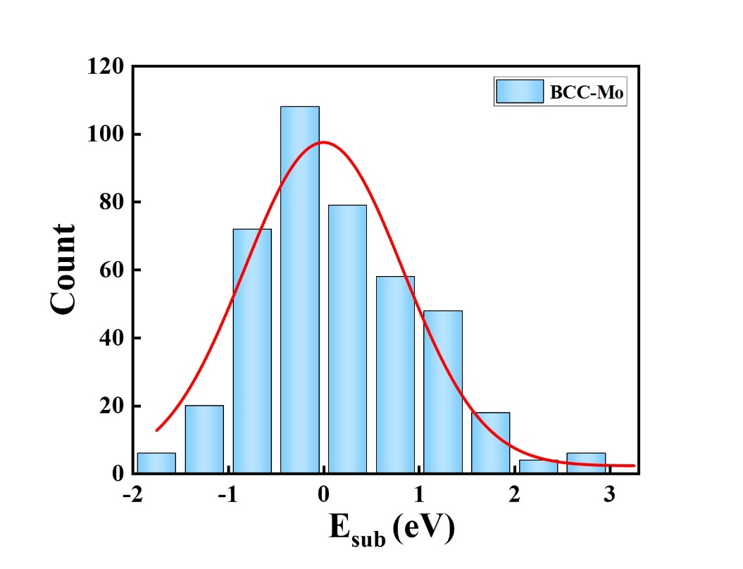
Fig. S1 Distribution of DFT substitution energies in BCC Mo alloys used as training and test datasets in this work.

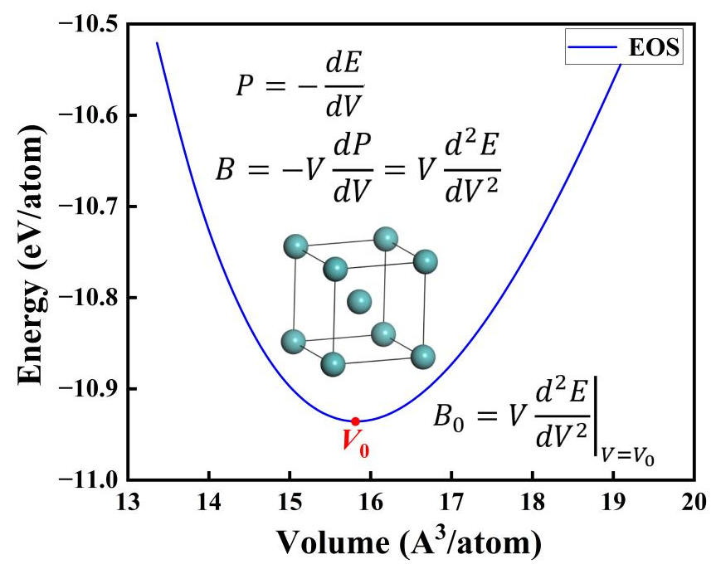
Fig. S2 Schematic plot of potential energy surface or equation of states of a crystal system as a function of volume where E represents the total energy of the system, V stands for the volume, F denotes the pressure, and B is the bulk modulus.

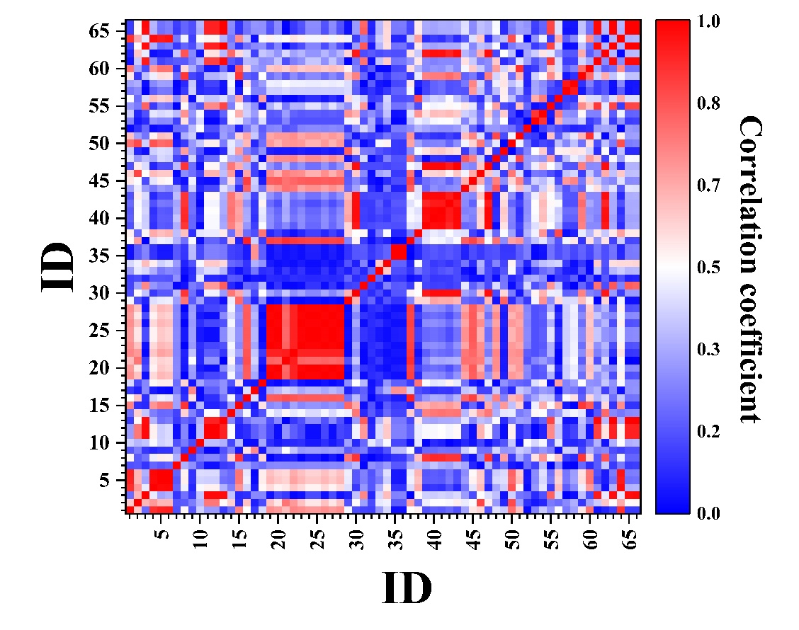
Fig. S3 Correlation heatmap of the initial features (66) before the hierarchical unsupervised feature selection. The feature ID are referred to Table S1.

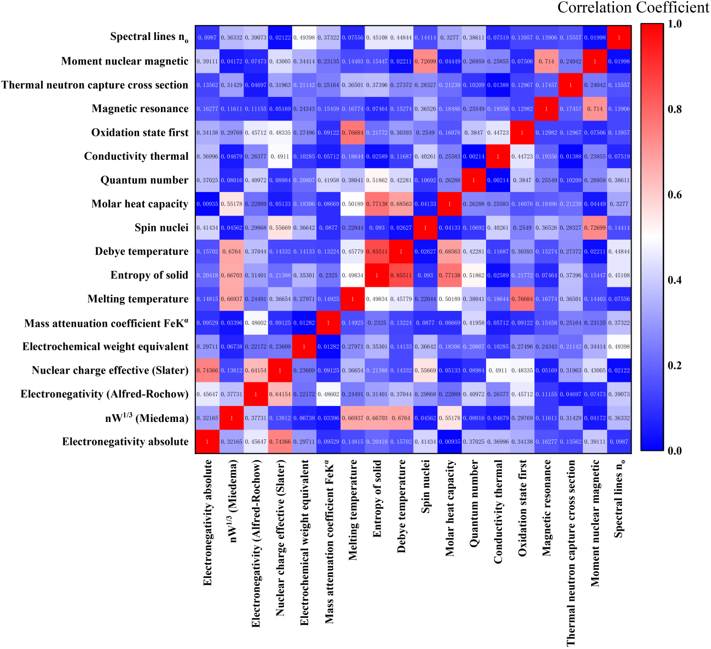
Fig. S4 Correlation heatmap of the features (18) after the hierarchical unsupervised feature selection. The feature labels are referred to Table S1.

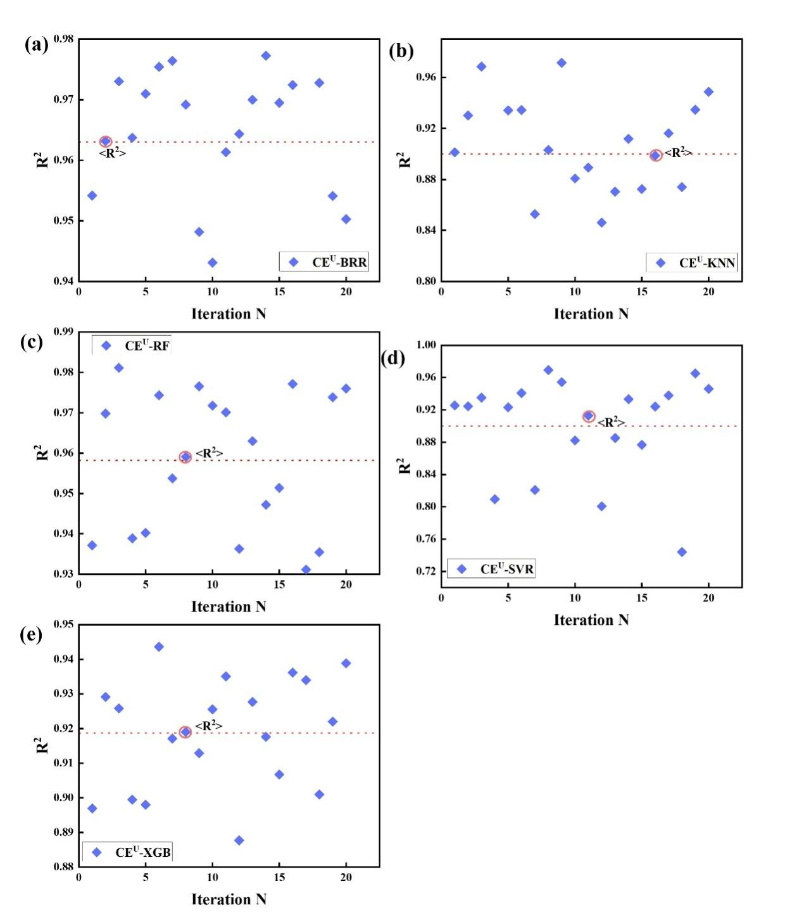
Fig. S5 R² values of each test dataset across 20 iterations for (a) CE^{U}-BRR, (b) CE^{U}-KNN, (c) CE^{U}-RF, (d) CE^{U}-SVR, and (e) CE^{U}-XGB models with the initial unselected CE features.

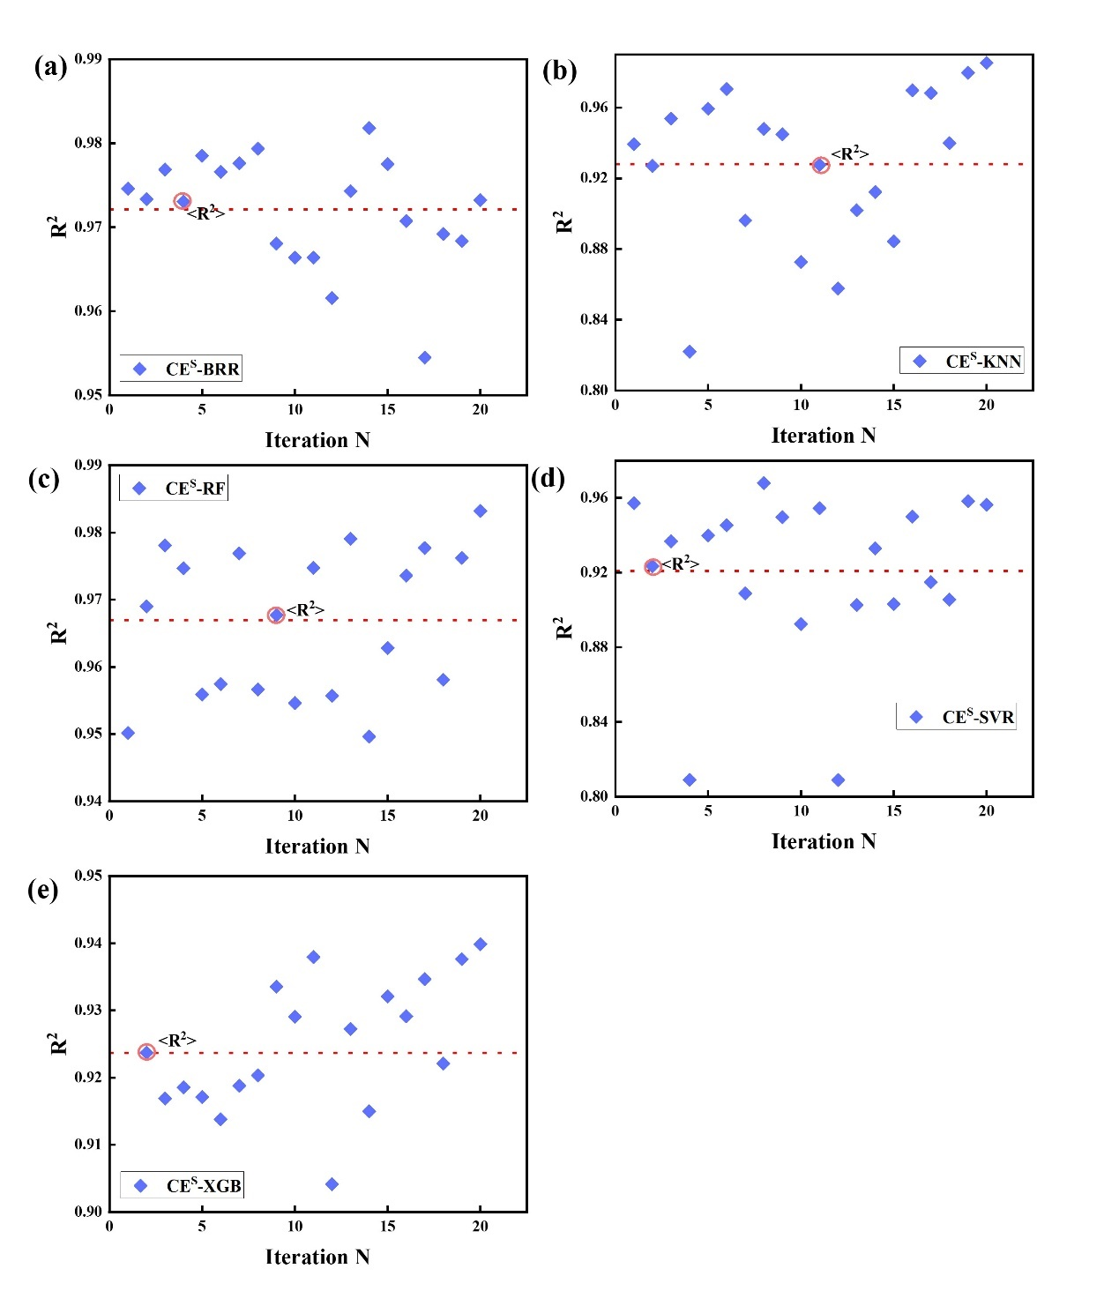
Fig. S6 R² values of each test dataset across 20 iterations for (a) CE^{S}-BRR, (b) CE^{S}-KNN, (c) CE^{S}-RF, (d) CE^{S}-SVR, and (e) CE^{S}-XGB models with the selected CE features.

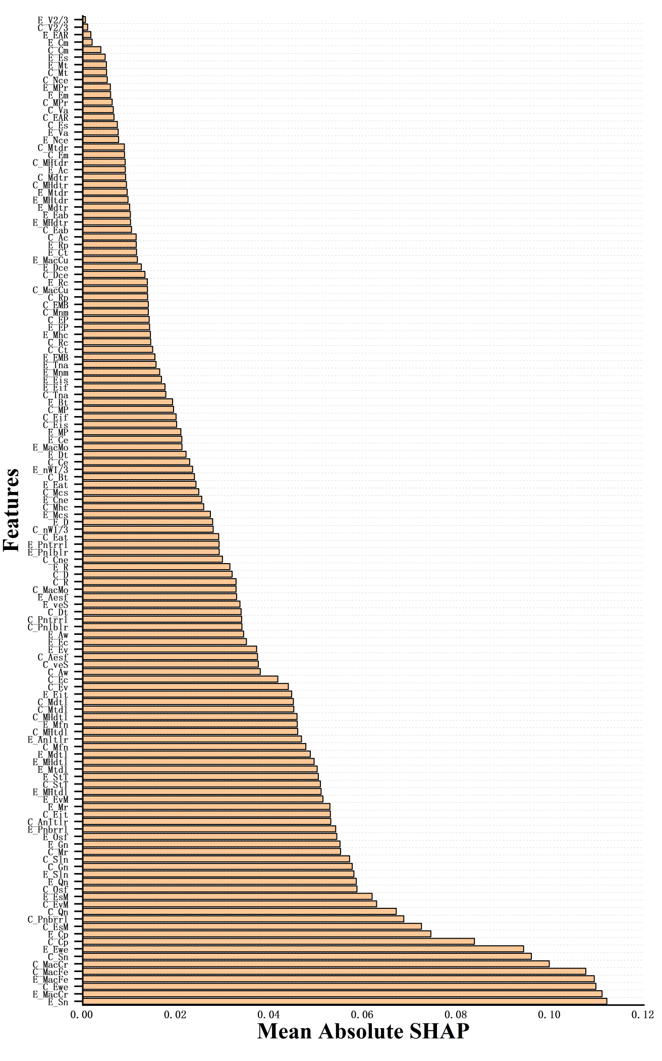
Fig. S7 Feature importance via SHAP analysis of the CE^{U}-BRR model.
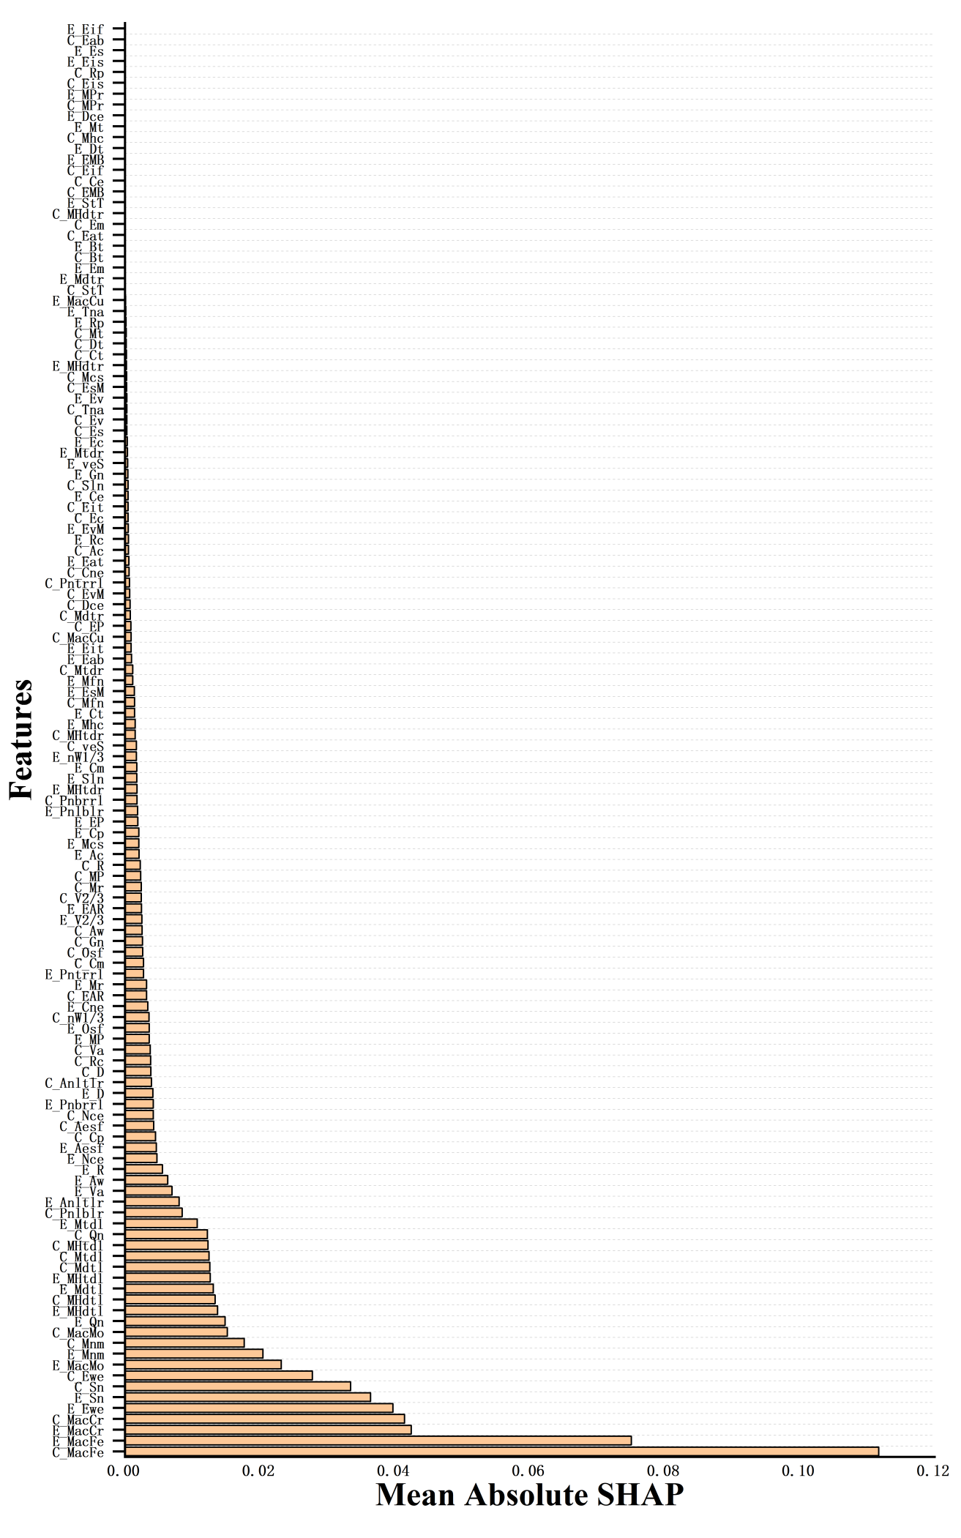
Fig. S8 Feature importance via SHAP analysis of the CE^{U}-KNN model.
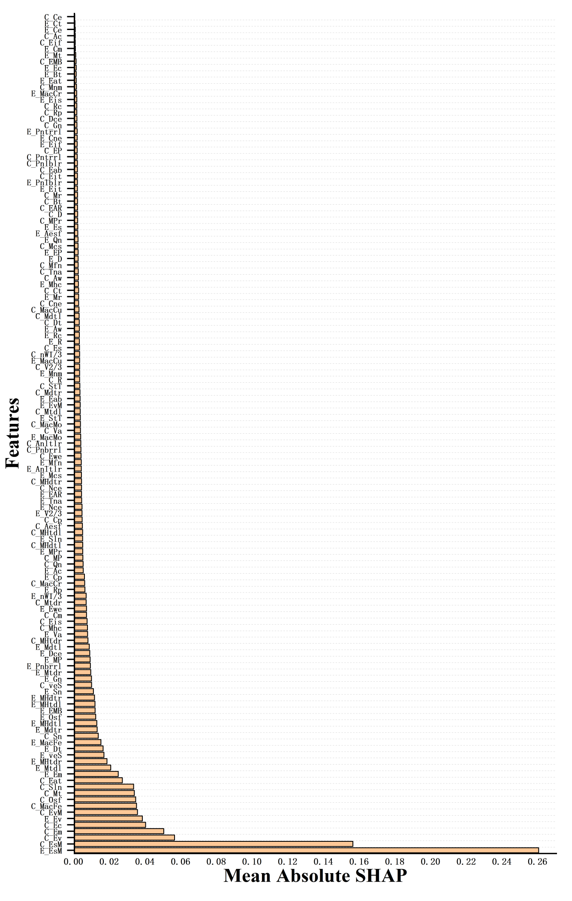
Fig. S9 Feature importance via SHAP analysis of the CE^{U}-RF model.
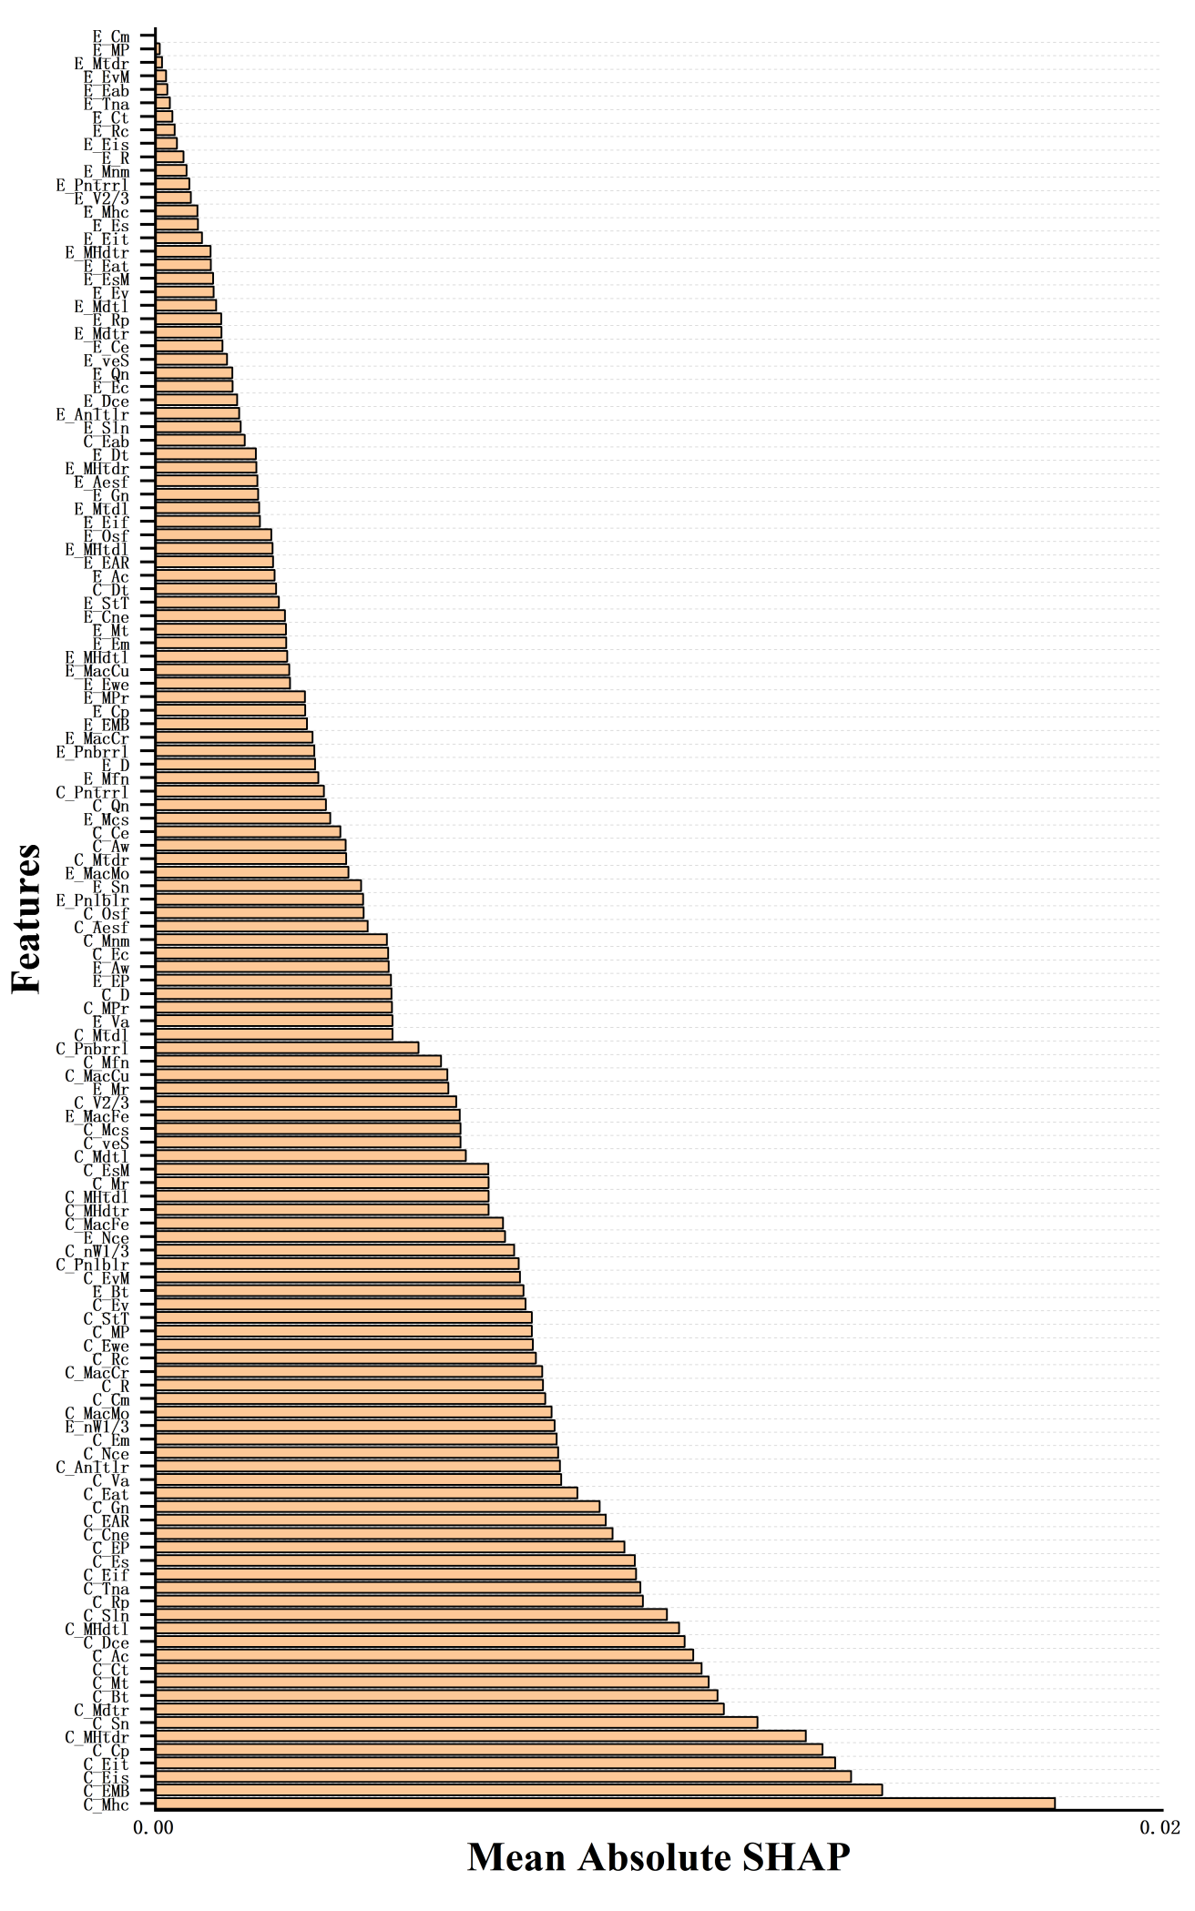
Fig. S10 Feature importance via SHAP analysis of the CE^{U}-SVR model.
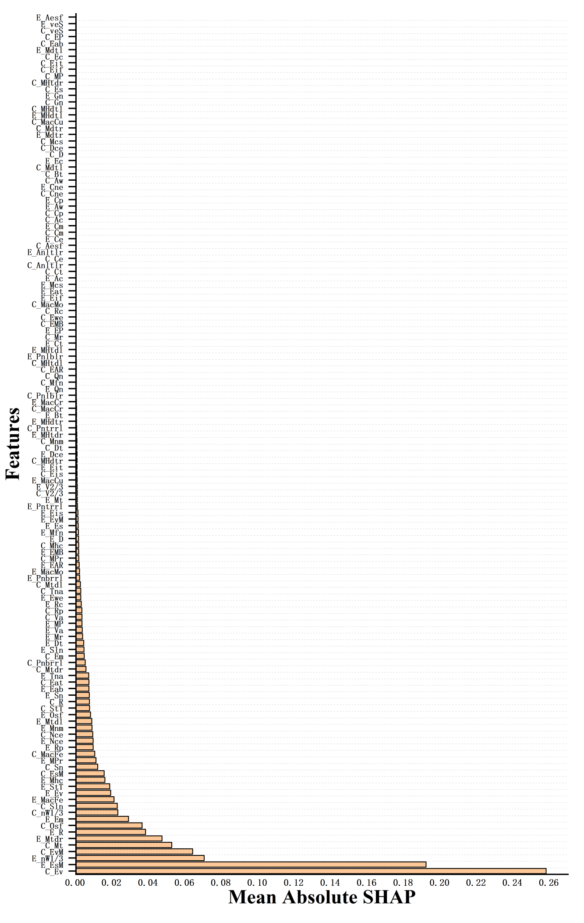
Fig. S11 Feature importance via SHAP analysis of the CE^{U}-XGB model.
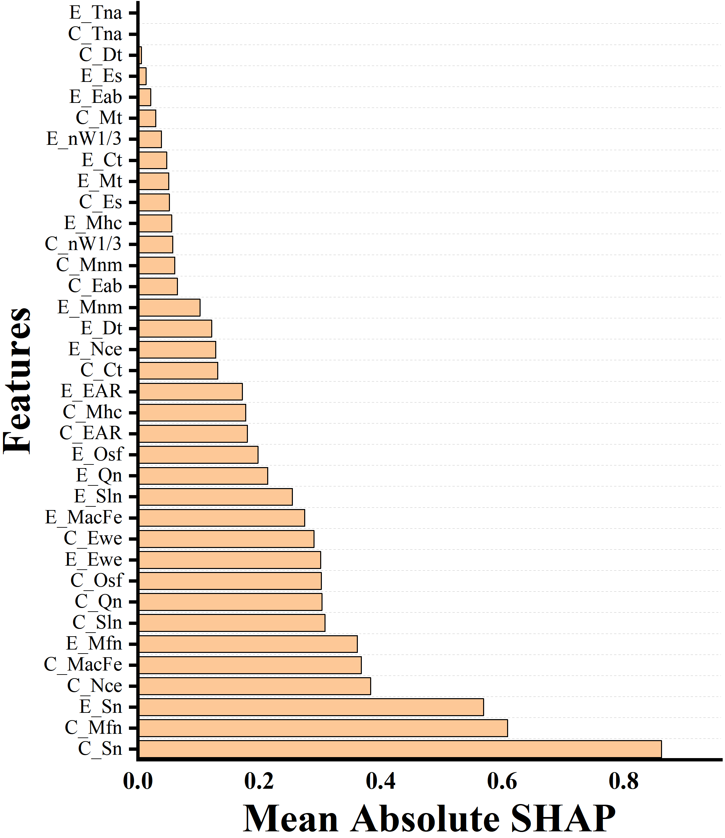
Fig. S12 Feature importance via SHAP analysis of the CE^{S}-BRR model.

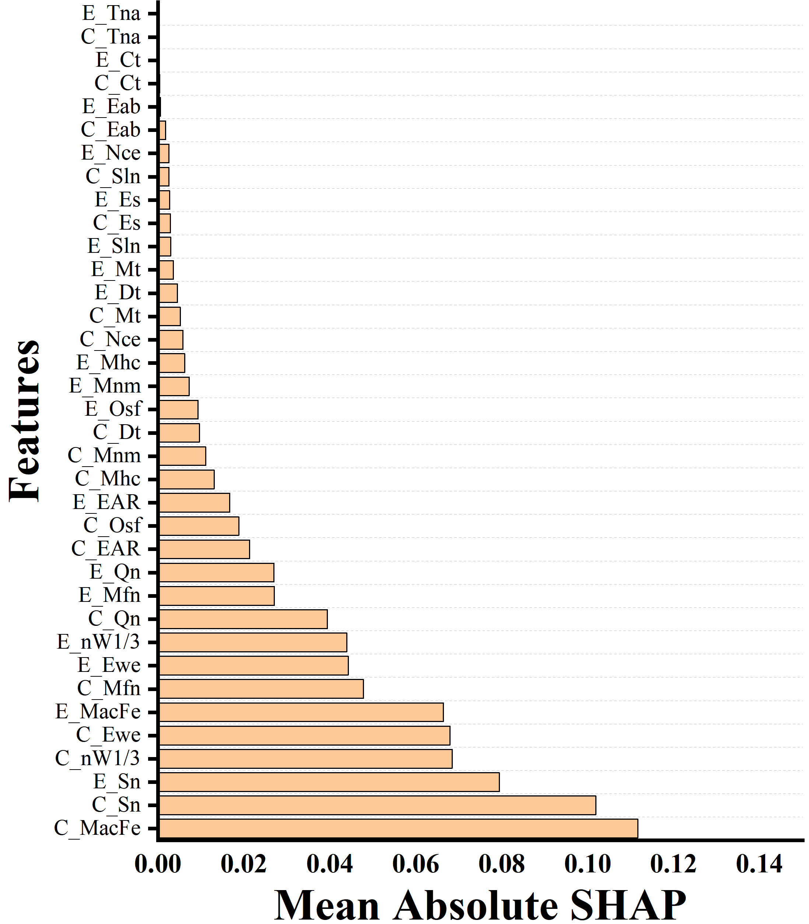
Fig. S13 Feature importance via SHAP analysis of the CE^{S}-KNN model.

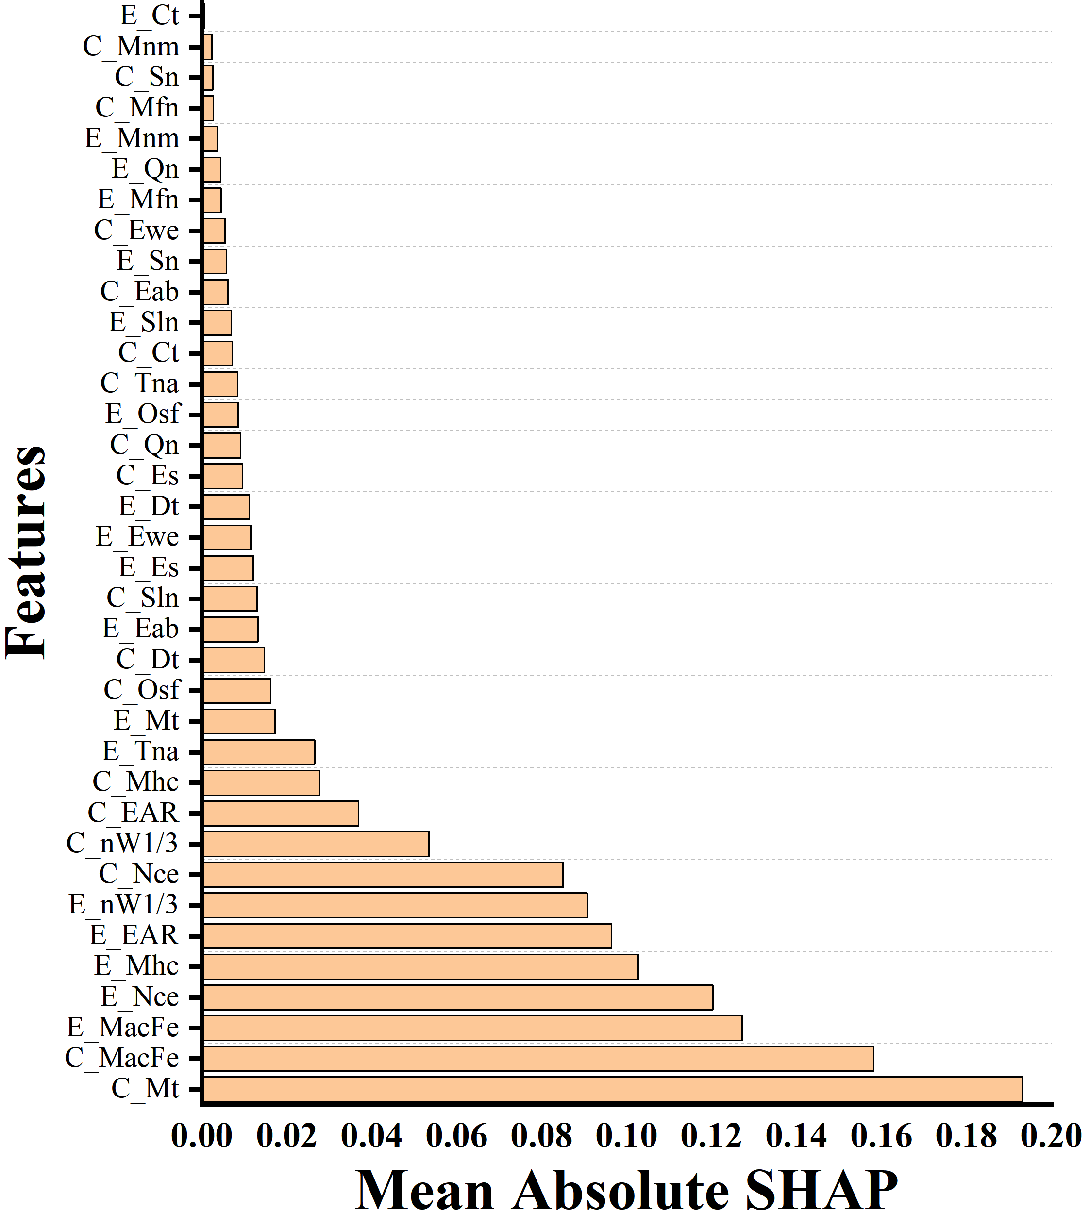
Fig. S14 Feature importance via SHAP analysis of the CE^{S}-RF model.

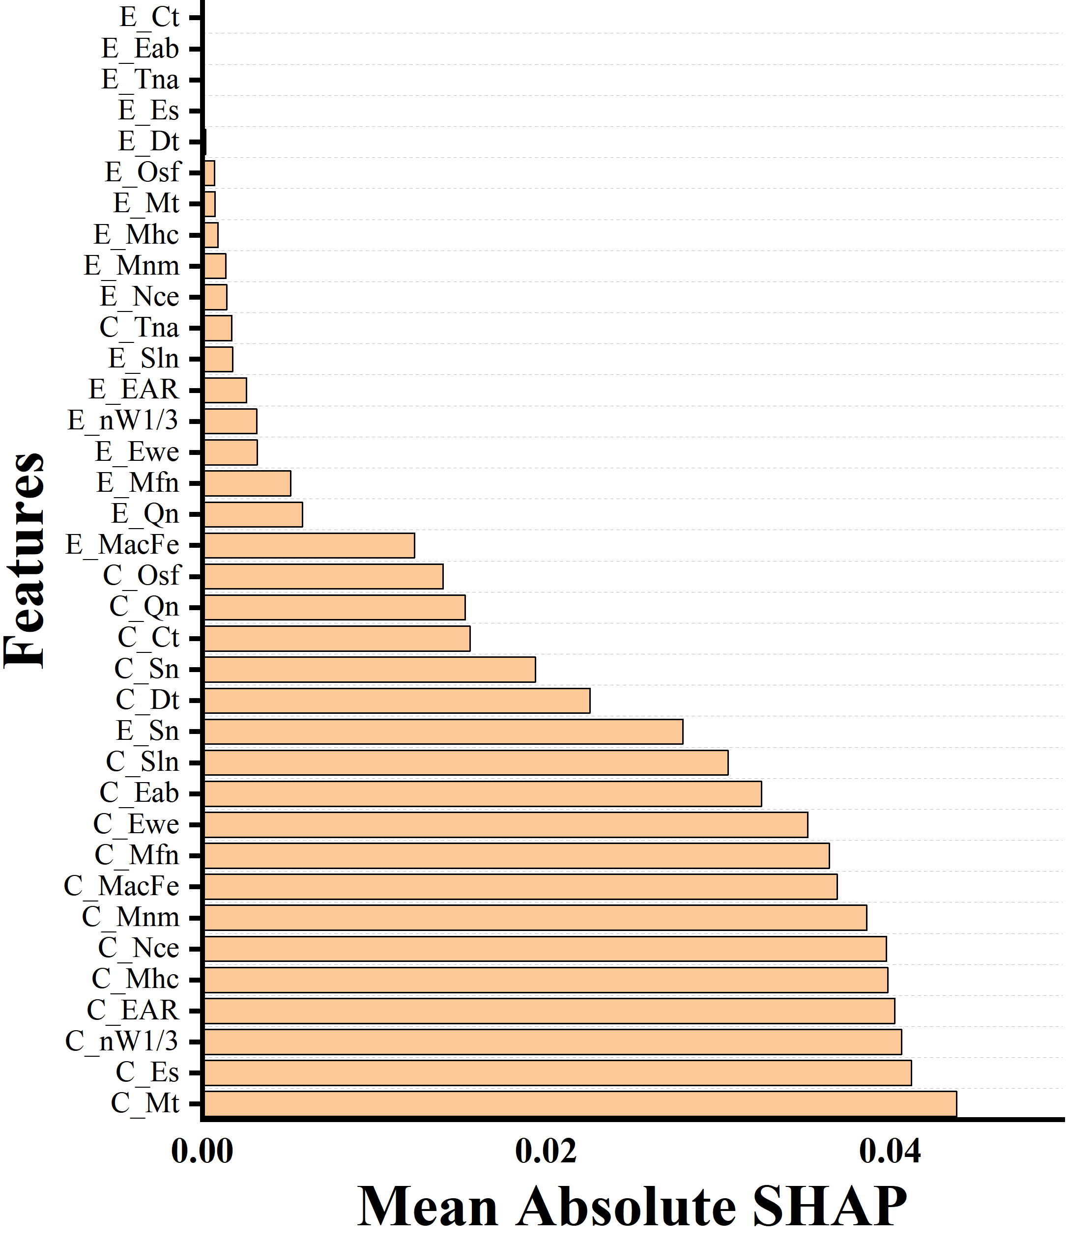
Fig. S15 Feature importance via SHAP analysis of the CE^{S}-SVR model.

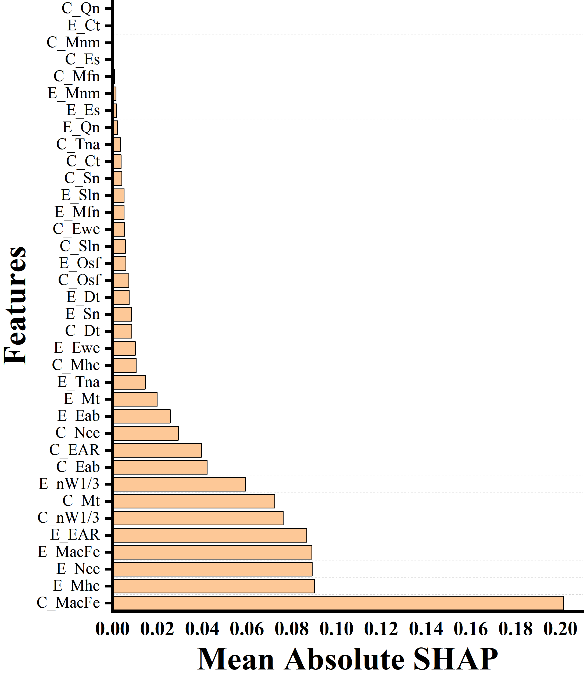
Fig. S16 Feature importance via SHAP analysis of the CE^{S}-XGB model.

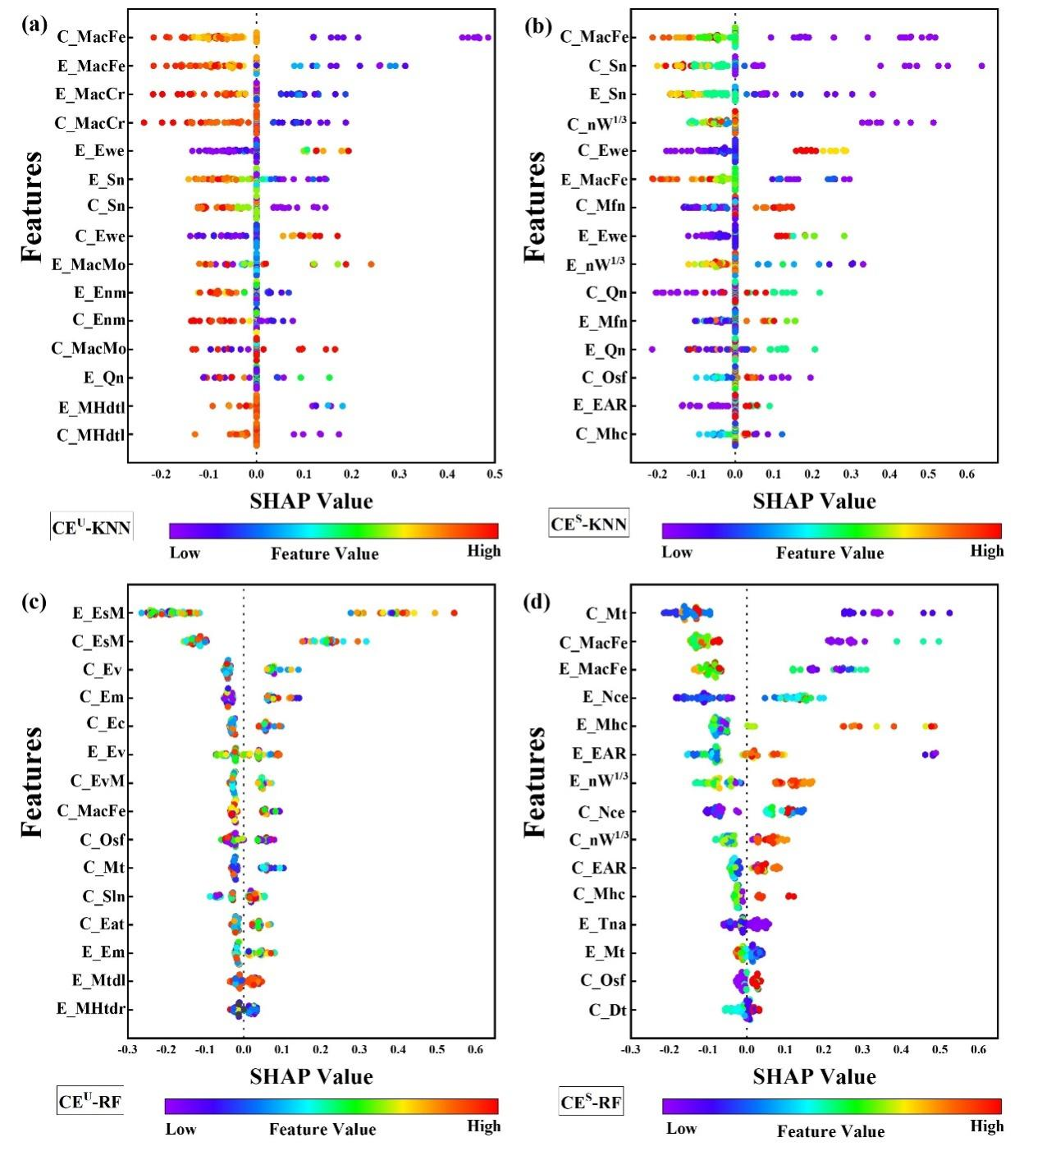
Fig. S17 SHAP analyses of the features of (a) CE^{U}-KNN, (b) CE^{S}-KNN, (c) CE^{U}-RF, and (d) CE^{S}-RF models.

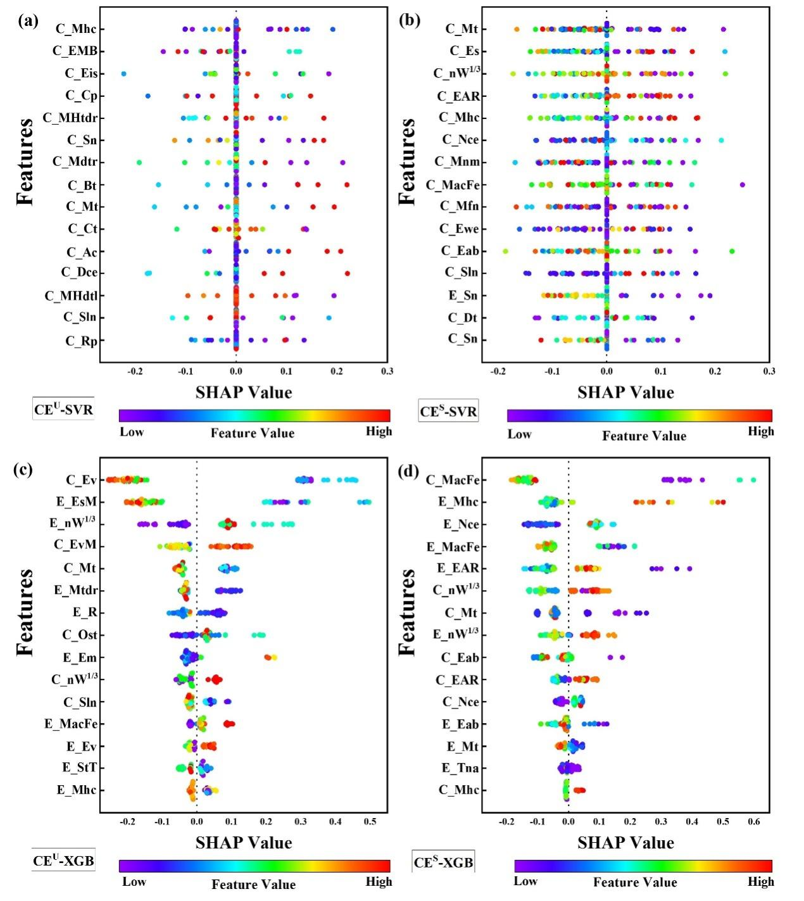
Fig. S18 SHAP analyses of the features of (a) CE^{U}-SVR, (b) CE^{S}-SVR, (c) CE^{U}-XGB, and (d) CE^{S}-XGB models.

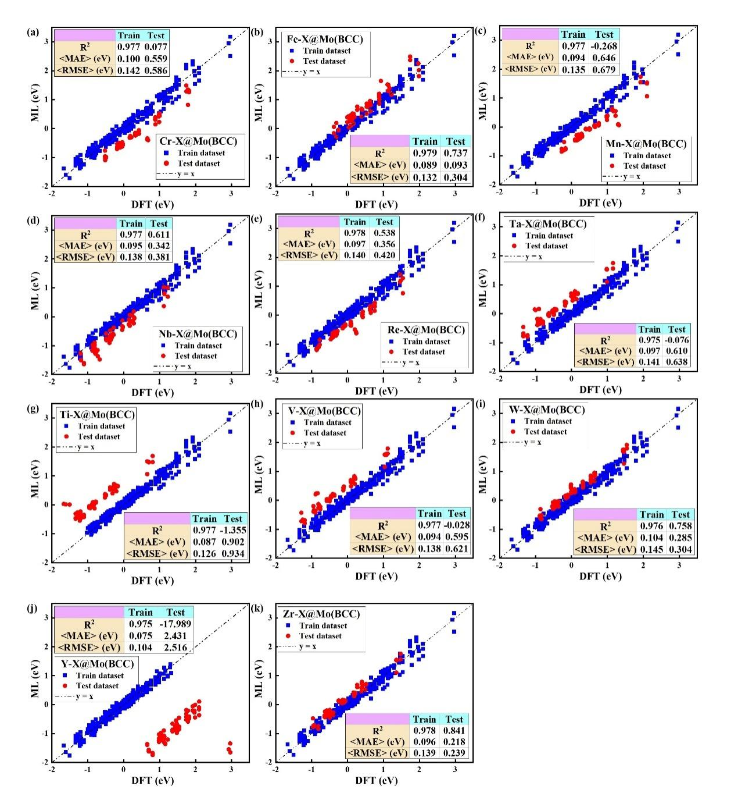
Fig. S19 Performance of the CE^{U}-BRR models for the leave-p-out prediction against DFT results on the unseen systems with new elements X= (a) Cr, (b) Fe, (c) Mn, (d) Nb, (e) Re, (f) Ta, (g) Ti, (h) V, (i) W, (j) Y, and (k) Zr, respectively.

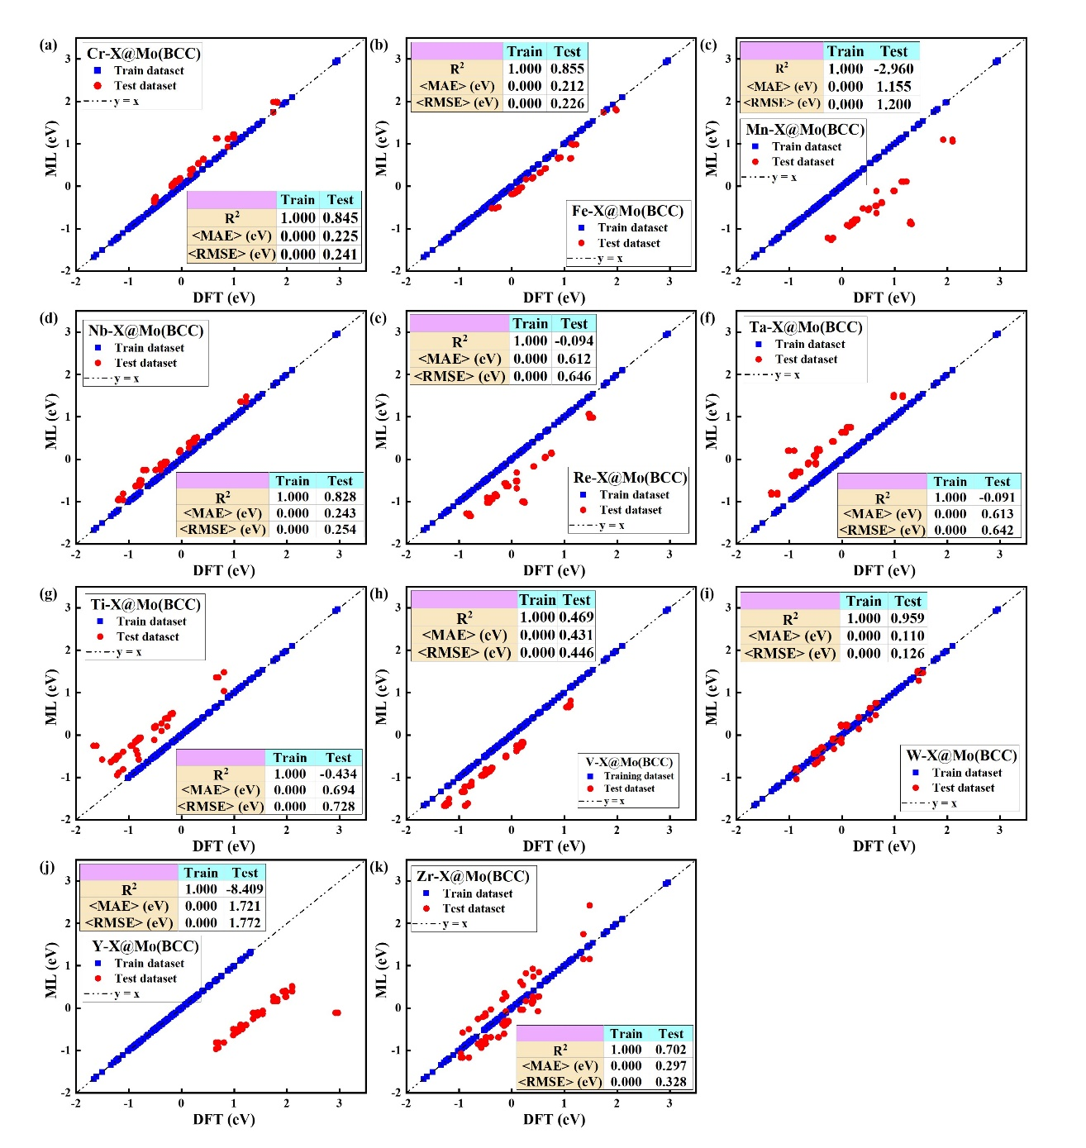
Fig. S20 Performance of the CE^{U}-KNN models for the leave-p-out prediction against DFT results on the unseen systems with new elements X= (a) Cr, (b) Fe, (c) Mn, (d) Nb, (e) Re, (f) Ta, (g) Ti, (h) V, (i) W, (j) Y, and (k) Zr, respectively.

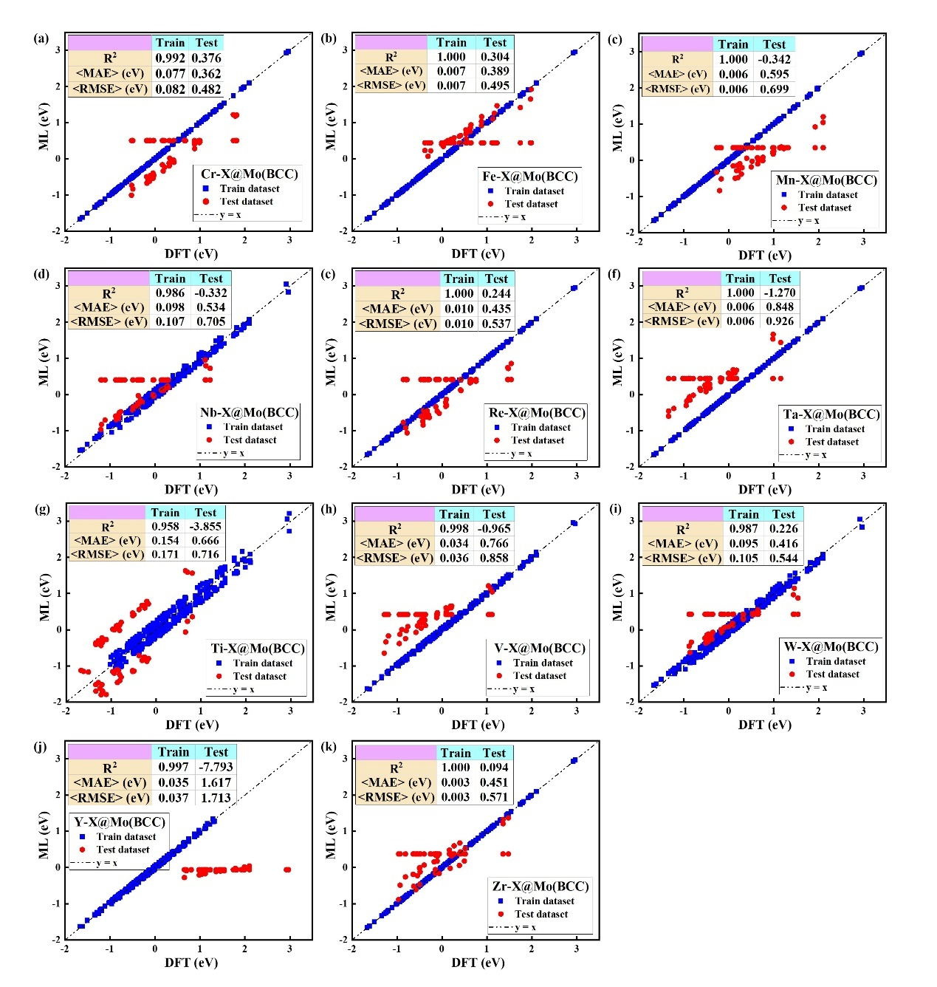
Fig. S21 Performance of the CE^{U}-SVR models for the leave-p-out prediction against DFT results on the unseen systems with new elements X= (a) Cr, (b) Fe, (c) Mn, (d) Nb, (e) Re, (f) Ta, (g) Ti, (h) V, (i) W, (j) Y, and (k) Zr, respectively.

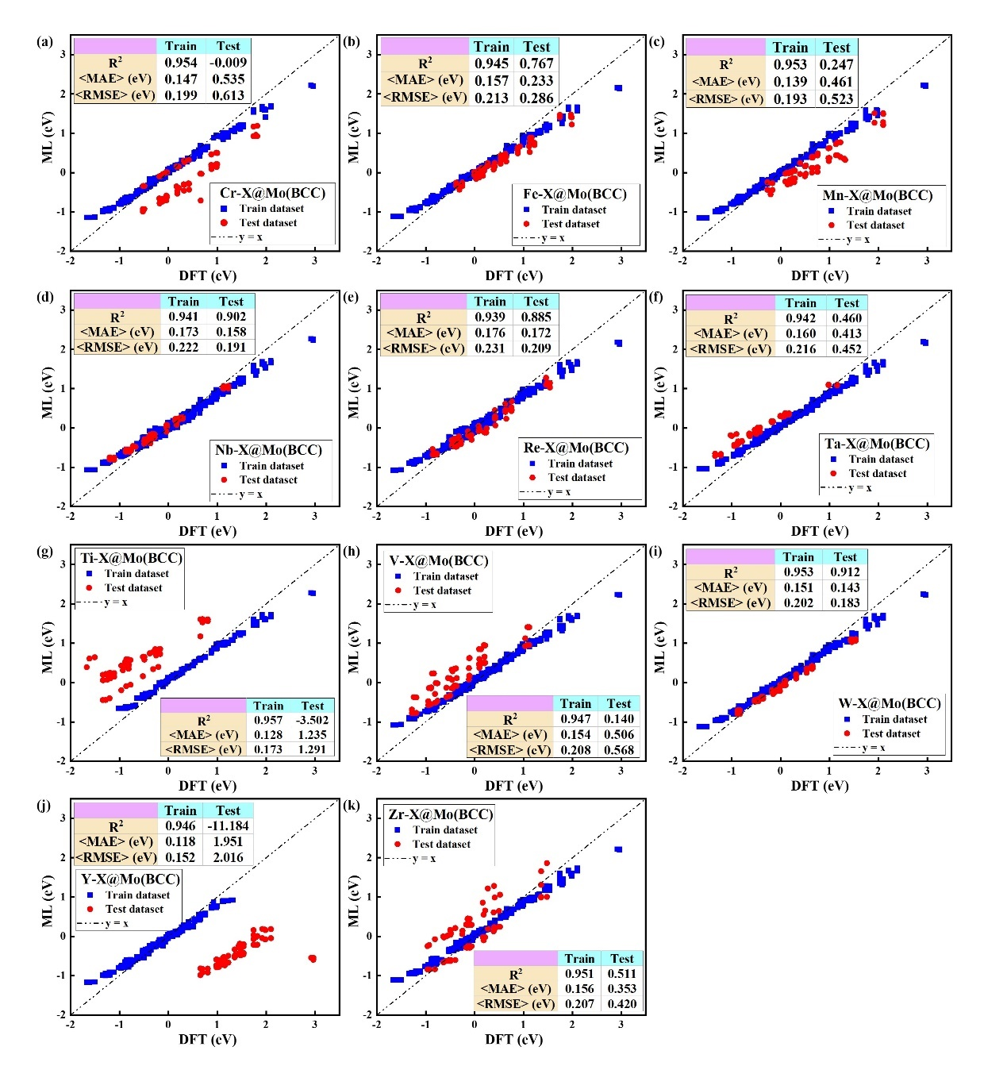
Fig. S22 Performance of the CE^{U}-XGB models for the leave-p-out prediction against DFT results on the unseen systems with new elements X= (a) Cr, (b) Fe, (c) Mn, (d) Nb, (e) Re, (f) Ta, (g) Ti, (h) V, (i) W, (j) Y, and (k) Zr, respectively.

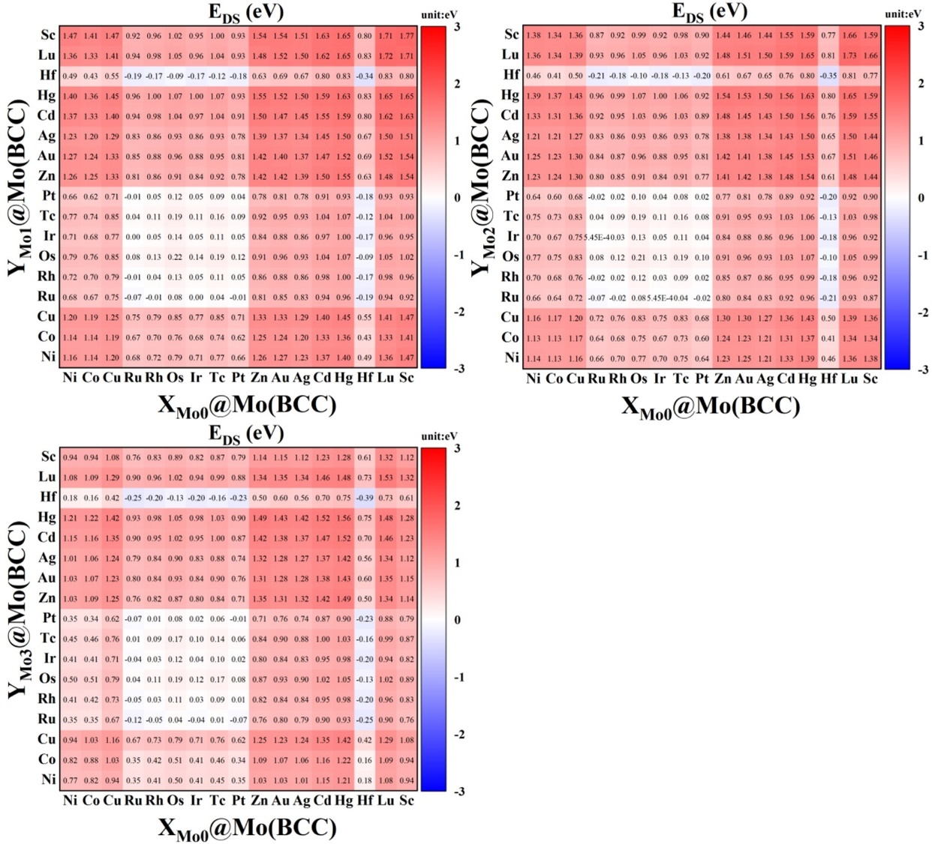
Fig. S23 Double-site substitution energies predicted by the CE^{U}-RF model for the unknown systems with new elements.

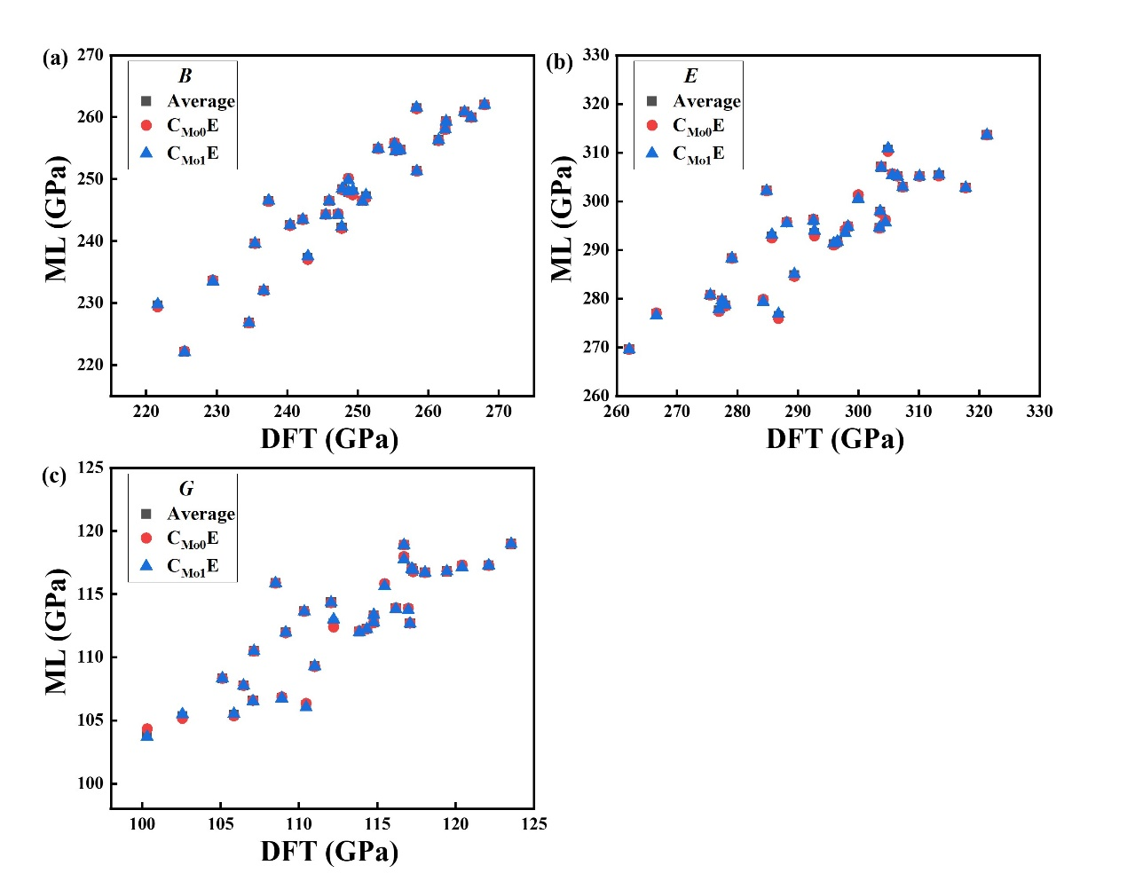
Fig. S24 Mechanical properties of (a) B, (b) E, and (c) G predicted by the dual-CE-feature and single-CE-feature models compared with the DFT results. C_{Mo0}E denotes the single-CE-feature model constructed with the Mo0 site as the center; C_{Mo1}E denotes the single-CE-feature model constructed with the Mo1 site as the center; Average denotes the dual-CE-feature model with averaged properties.

References
(1) Kresse, G.; Furthmüller, J. Efficient iterative schemes for ab initio total-energy calculations using a plane-wave basis set. Physical Review B 1996, 54 (16), 11169-11186. DOI: https://doi.org/10.1103/PhysRevB.54.11169.
(2) Kresse, G.; Furthmüller, J. Efficiency of ab-initio total energy calculations for metals and semiconductors using a plane-wave basis set. Computational Materials Science 1996, 6 (1), 15-50. DOI: https://doi.org/10.1016/0927-0256(96)00008-0.
(3) Perdew, J. P.; Burke, K.; Ernzerhof, M. Generalized Gradient Approximation Made Simple. Physical Review Letters 1996, 77 (18), 3865-3868. DOI: https://doi.org/10.1103/PhysRevLett.77.3865.
(4) Kresse, G.; Furthmüller, J.; Hafner, J. Theory of the crystal structures of selenium and tellurium: The effect of generalized-gradient corrections to the local-density approximation. Physical Review B 1994, 50 (18), 13181-13185. DOI: https://doi.org/10.1103/PhysRevB.50.13181.
(5) Blöchl, P. E. Projector augmented-wave method. Physical Review B 1994, 50 (24), 17953-17979. DOI: https://doi.org/10.1103/PhysRevB.50.17953.
(6) Kresse, G.; Joubert, D. From ultrasoft pseudopotentials to the projector augmented-wave method. Physical Review B 1999, 59 (3), 1758-1775. DOI: https://doi.org/10.1103/PhysRevB.59.1758.
(7) Born, M.; Huang, K. Dynamical Theory Of Crystal Lattices; Oxford University Press, 1996. DOI: https://doi.org/10.1093/oso/9780192670083.001.0001.
(8) Voigt, W. Lehrbuch der Kristallphysik; Teubner Verlag, Leipzig, 1928.
(9) Reuss, A. Calculation of the Flow Limits of Mixed Crystals on the Basis of the Plasticity of Monocrystals. Zeitschrift fur Angewandte Mathematik und Mechanik 1929, 9, 49-58. DOI: https://doi.org/10.1002/zamm.19290090104.
(10) Hill, R. The Elastic Behaviour of a Crystalline Aggregate. Proceedings of the Physical Society. Section A 1952, 65 (5), 349. DOI: https://doi.org/10.1088/0370-1298/65/5/307.

