Supplementary Figures
Targeting the Hepatic WISP1 and HMGB1 Pro-Inflammatory Axis Alleviates Sepsis-Induced Liver Injury
Wei Liu^{1, *}, Junli Lu¹, Ying Xiao¹ and Hui Zhang^{1, *}
¹Department of Critical Care Medicine, Fujian Medical University Union Hospital, Xinquan Road, Fuzhou 350001, Fujian, P.R. China

*Corresponding author: Hui Zhang, Wei Liu
Department of Critical Care Medicine, Fujian Medical University Union Hospital, Xinquan Road, Fuzhou 350001, Fujian, P.R. China
E-mail:
Hui Zhang: xhzh@fjmu.edu.cn
Wei Liu: sophielw4021@fjmu.edu.cn

Supplementary Figures and Figure legends

Supplementary Figure 1 Original uncropped Western blot images for Figure 2A
The panel displays the full-length polyvinylidene fluoride membranes probed for WISP1 and HMGB1 along with the internal loading control GAPDH. The six lanes from left to right correspond directly to the sham surgery group, the model group, the oe-Wisp1 group, the sh-Wisp1 group, the oe-Hmgb1 group, and the sh-Hmgb1 group. Molecular weight markers are clearly visible on the left margin of each membrane to confirm the correct target protein sizes. These uncropped images validate the specificity of the antibodies and support the quantitative densitometric analysis presented in the main text.

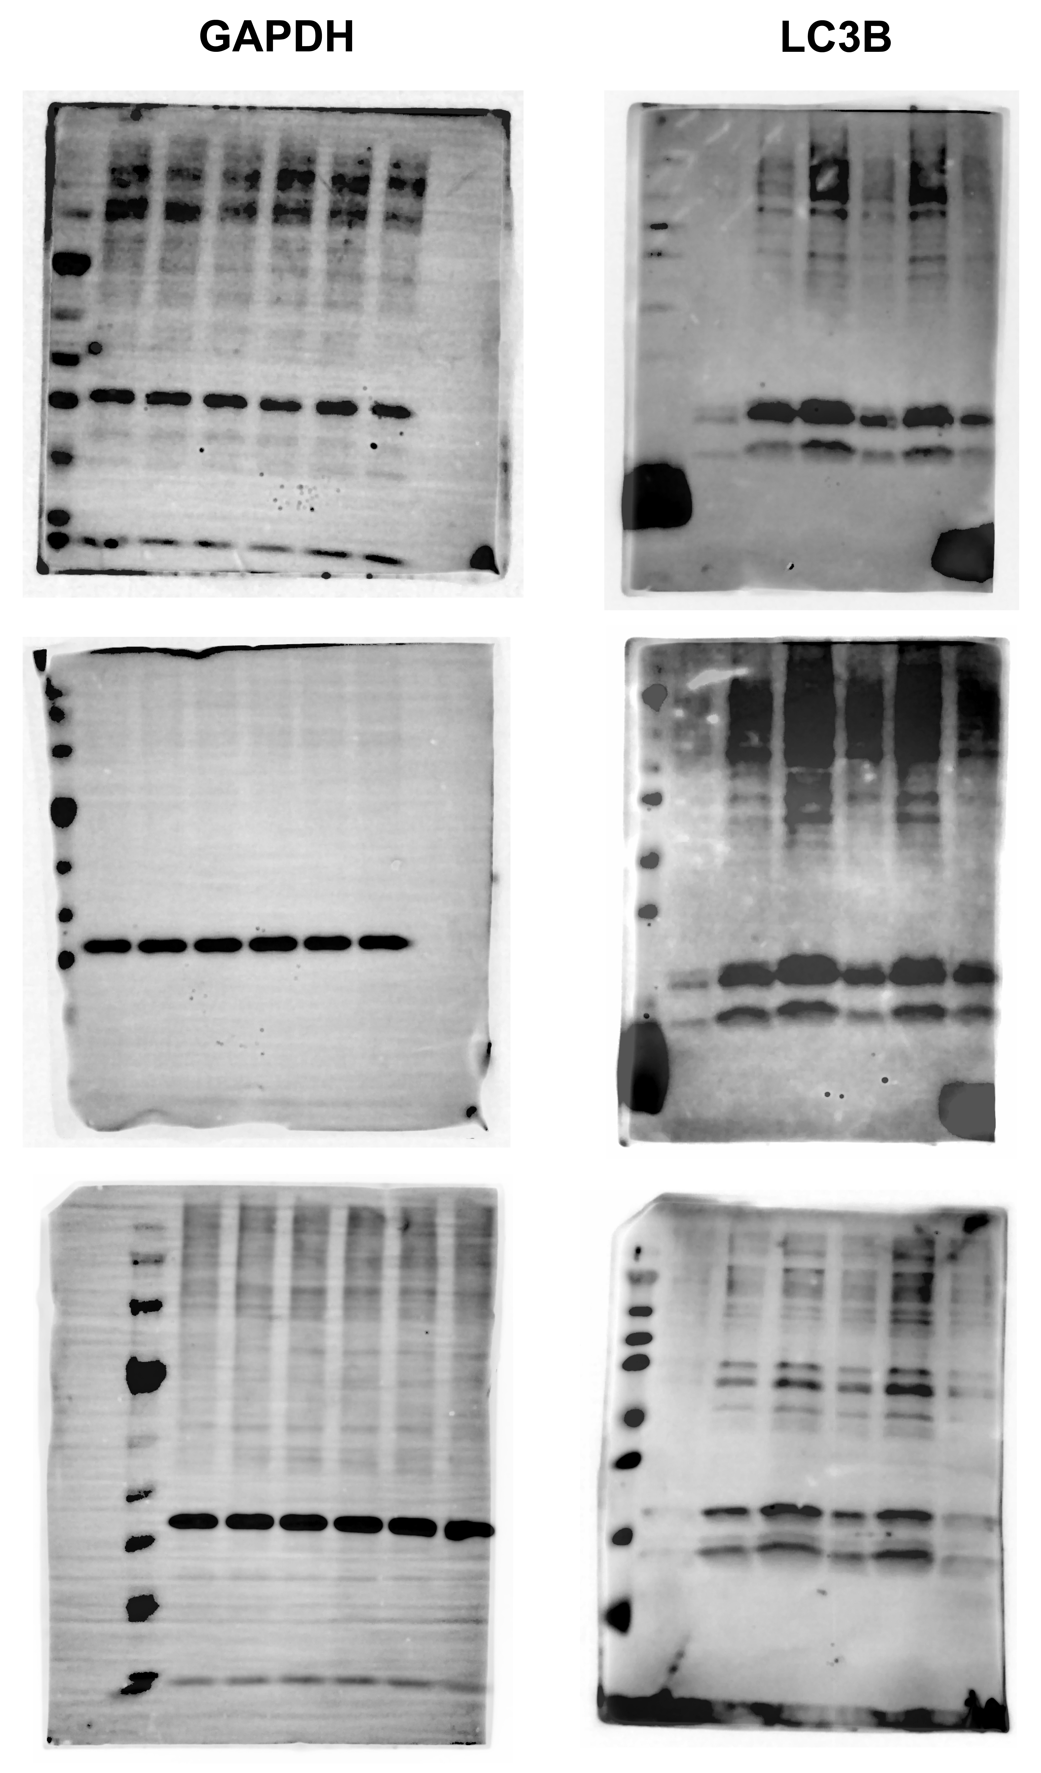

Supplementary Figure 2 Original uncropped Western blot images for Figure 3B
The panel presents the complete immunoblots utilized to evaluate macrophage autophagic processing. The membranes show the expression bands for LC3B-I and LC3B-II along with the corresponding GAPDH loading control. The sequence of the loaded experimental groups matches the exact order established in the primary methodology. Providing these full blots demonstrates the robust accumulation of LC3B-II during sepsis progression and confirms the absence of non-specific binding.

Supplementary Figure 3 Original uncropped Western blot images for Figure 5A
The panel exhibits the entire uncropped Western blot membranes for the targeted macrophage M2 polarization markers. The detected proteins include CCL22 and CD200R with GAPDH utilized as the consistent reference protein. The lane arrangement strictly follows the established experimental cohorts from the in vivo studies. These full-scale images verify the structural integrity of the protein bands utilized for assessing the phenotypic shift in hepatic macrophages.

