Supplementary material
Supplementary Table S1. Complete-case sample sizes and main sources of missingness
Model | Full cohort N | Complete-case N | Excluded N | Main variables contributing to missingness
Primary models | 852 | 743 | 109 | Albumin (82), UPCR (30), D-dimer (12)
PH exploratory model with ApoB | 852 | 619 | 233 | ApoB and primary model covariates
EP exploratory model with urine IgG/Cr | 852 | 682 | 170 | Urine IgG/Cr and primary model covariates
Some patients had more than one missing covariate; counts across variables therefore do not sum to the excluded N.
Supplementary Table S2. Exploratory multivariable models
Model | Exploratory variable | OR | 95% CI | p-value | N
PH + ApoB | ApoB | 2.11 | 1.00-4.49 | 0.0515 | 619
PH + ApoB + ISKDC | ApoB | 1.60 | 0.66-3.89 | 0.2956 | 619
EP + urine IgG/Cr | ln-urine IgG/Cr | 1.38 | 1.07-1.78 | 0.0142 | 682
EP + urine IgG/Cr + ISKDC | ln-urine IgG/Cr | 1.39 | 1.06-1.81 | 0.0161 | 682
Exploratory models are hypothesis-generating and were not used for primary inference.
Supplementary Table S3. Sensitivity analysis excluding biopsies with fewer than 10 glomeruli
Parameter | Full cohort | Excluding <10 glomeruli
PH prevalence | 633/852 (74.3%) | 612/820 (74.6%)
EP prevalence | 304/852 (35.7%) | 292/820 (35.6%)
PH Model 1 AUC | 0.687 | 0.682
PH Model 2 ISKDC OR | 21.90 | 22.70
EP Model 1 AUC | 0.707 | 0.705
EP Model 2 ISKDC OR | 2.43 | 2.63
All primary associations were preserved in direction and statistical significance.
Supplementary Table S4. Procalcitonin exploratory analysis
Item | Result
Available data | 200/852 (23.5%)
Missing data | 652/852 (76.5%)
EP+ vs EP- | 0.040 vs 0.030 ng/mL; p=0.006
PH+ vs PH- | p=0.34
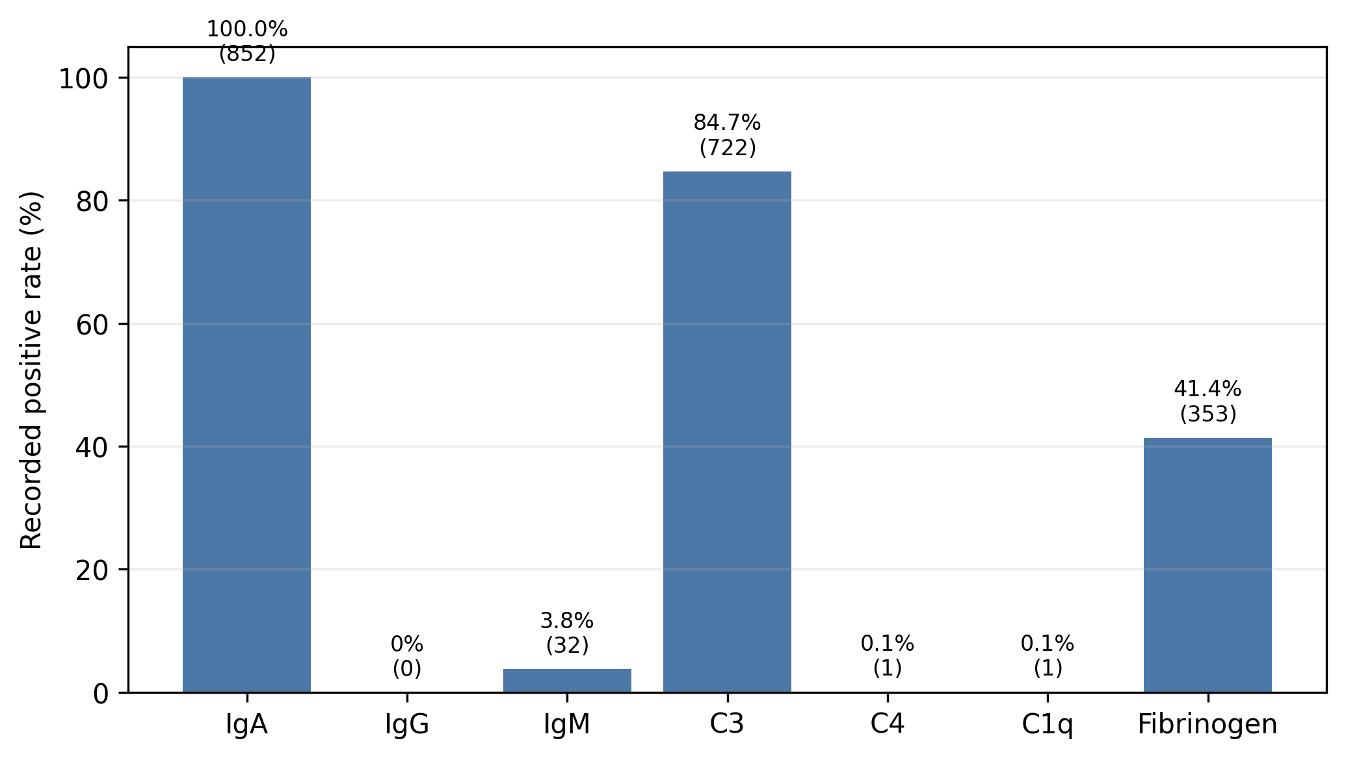
Supplementary Figure S1. Immunofluorescence markers recorded as positive in routine pathology reports. Rates are shown as percentages of the full cohort (N=852).
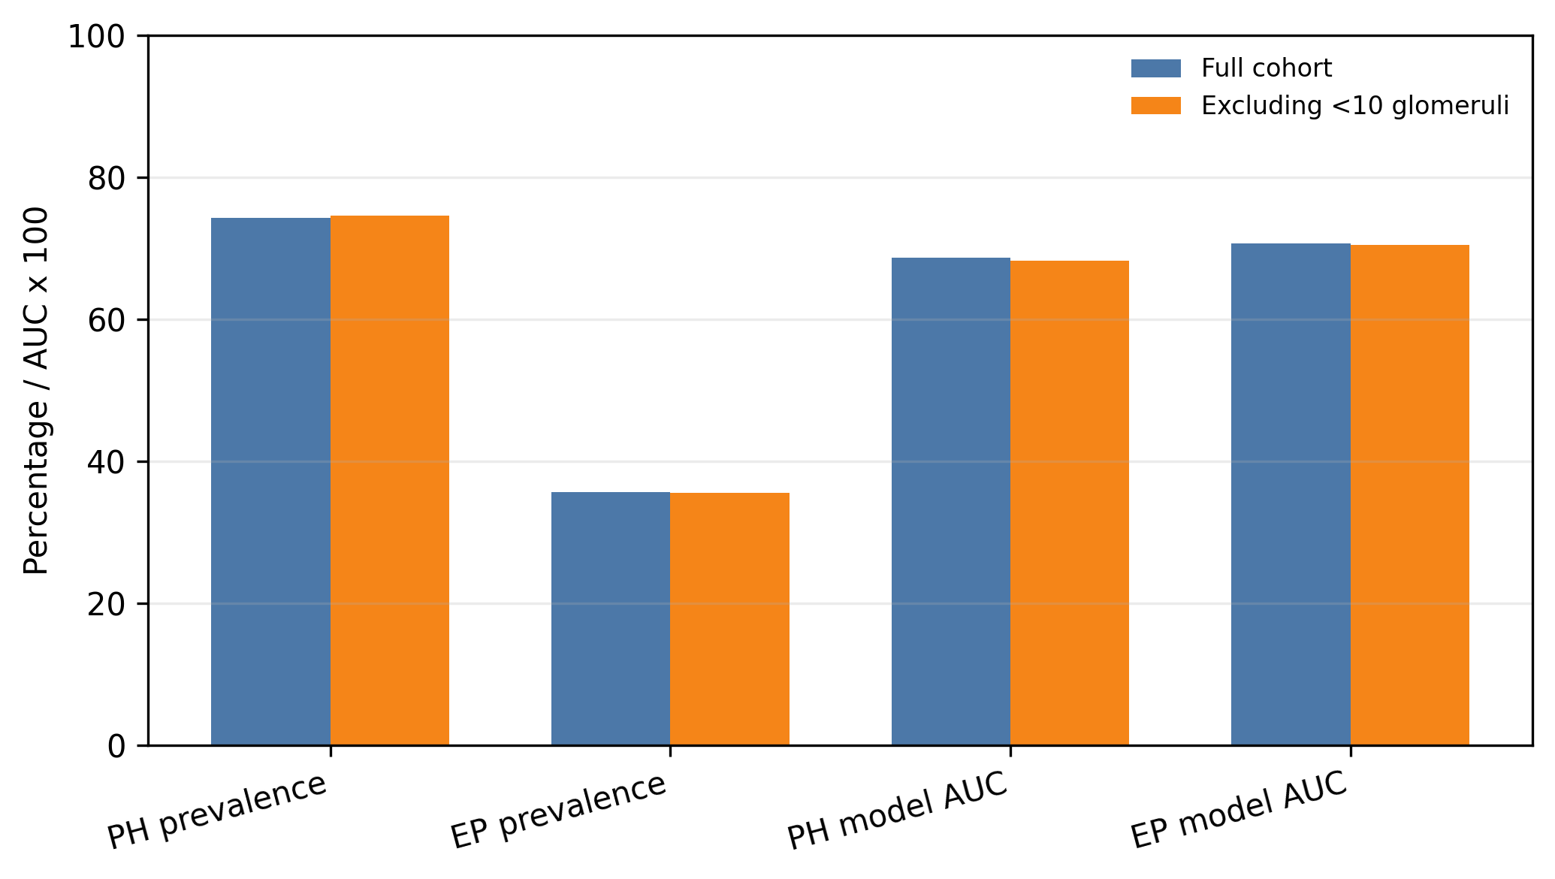
Supplementary Figure S2. Sensitivity analysis excluding biopsies with fewer than 10 glomeruli. Prevalence estimates and model discrimination were similar after excluding 32 biopsies with fewer than 10 glomeruli.

