Supplementary material 1: Search terms
The following search terms were used: “retinal,” “vessels,” hemorrhage,”, “retina change”, “retina characteristic” , “retina sign”, “retina vasculature”, “retina microvasculature”, “retinopathy”, “avn”, “arteriovenous nicking”, “central retinal vein equivalent”, “crae”, “crve”, “recurrence”, “recurr”, “relapse”, “remission”, “second”, “cerebral ischemia” ,”cerebral infarction”, “cerebrovascular disorder”, “cerebrovascular disease”, “cerebrovascular accident”, “cerebrovascular event”, “cva”, “cardioembolic”, “cryptogenic”, “ischemic encephalopathy”.

Supplementary table 1: Risk of bias assessment

Author / Year | Q1 | Q2 | Q3 | Q4 | Q5 | Q6 | Q7 | Q8 | % Yes | Overall risk of bias
De Silva et al (2011) | ✓ | ✓ | ✓ | ✓ | ✓ | ✓ | ✓ | ✓ | 100 | Low
Klycsz. P et al (2023) | ✓ | ✓ | ✓ | ✓ | ✓ | ✓ | ✓ | ✓ | 100 | Low
Yuan yuan, Z et al (2020) | ✓ | ✓ | ✓ | ✓ | ✓ | ✓ | ✓ | ✓ | 100 | Low
Zhuo Y et al (2017) | ✓ | ✓ | ✓ | ✓ | ✓ | ✓ | ✓ | ✓ | 100 | Low
Zhuo, Y et al (2023) | ✓ | ✓ | ✓ | ✓ | - | - | ✓ | ✓ | 75 | Moderate
Zhao, Y et al (2024) | ✓ | ✓ | ✓ | ✓ | ✓ | ✓ | ✓ | ✓ | 100 | Low
HjelmgrenI et al (2019) | ✓ | ✓ | ✓ | ✓ | ✓ | ✓ | ✓ | ✓ | 100 | Low
Q1: Were the criteria for inclusion in the sample clearly defined?
Q2: Were the study subjects and the setting described in detail?
Q3: Was the exposure measured in a valid and reliable way?
Q4: Were objective, standard criteria used for measurement of the condition?
Q5: Were confounding factors identified?
Q6: Were strategies to deal with confounding factors stated?
Q7: Were the outcomes measured in a valid and reliable way?
Q8: Was appropriate statistical analysis used?
✓: Yes; -: No

Supplementary Table 2: Detailed characteristics of studies

Study Authors | Study Design | Country | Follow up Duration | Participants (number of patients who experienced recurrent stroke events) | Interventions | Selection Criteria | Retinal Imaging Parameters | Main Outcomes
De Silva et al | Prospective Cohort Study | Singapore | 29 months | 652 (92) | Retinal photographs | 1. Within 7 days of stroke onset  2. Assessed to be stroke according to NIHSS and OCSP | AVN, FAN, Opacification of arteriolar wall, CRAE, CRVE, Retinopathy | AVN and FAN predicted recurrent cerebrovascular events. FAN also predicted subsequent composite vascular events, including cerebrovascular events, coronary events, and vascular death.
Klycsz. P et al | Prospective Cohort Study | Germany | 2 years | 722 (74) | Retinal photographs | 1. Stroke onset within 14 days before study inclusion 2. Assessed using the modified Rankin Scale (mRS) of 2 or below and had an ABCD2 score of 3 or above or an acute ischaemic or haemorrhagic stroke in cerebral imaging 3. Have one modifiable cardiovascular risk factor (ie, arterial hypertension, diabetes mellitus, atrial fibrillation or current tobacco smoking) | AVN, FAN, Retinopathy, Rarefaction of arterioles and venules | Retinal changes did not predict major subsequent vascular events in patients with recent TIA or minor stroke.
Yuan yuan, Z et al | Prospective Cohort Study | China | at least 1 year after the first stroke, or the earliest of the following events occur: cerebral infarction, cerebral hemorrhage, acute myocardial infarction, death, loss to follow-up | 332 (94) | Retinal image | 1. 30 - 80 years old 2. onset of ischemic stroke within 14 days 3. had adequate sitting balance to carry out the retinal photography | AVN, CRAE, CRVE, Asymmetry index of arterioles and venules, Retinopathy, Bifurcation angle of arteriole | Cerebral atherosclerosis, white matter lesions and a history of heart disease were independently associated with recurrent stroke
Zhuo Y et al | Retrospective Case Control Study | China | 1 year | 196 (59) | Retinal image analysis system | 1. age of 30-80 years 2. stroke onset over 1 year 3. had adequate sitting balance to carry out the retinal photography | CRAE, CRVE, Asymmetry index of arterioles and venules, Retinopathy, Bifurcation coefficient of arterioles and venules, bifurcation angle of arteriole and venule, MABA, MVBA | Retinal vessel characteristics interacted with each other as well as traditional clinical risk factors in affecting the risk of stroke recurrence
Zhuo, Y et al | Prospective Cohort Study | China | 2 years | 450 (90) | Retinal images | 1. Aged 18 years or older 2. stroke onset within 3 months 3. adequate sitting balance to perform retinal photography | CRAE, CRVE, Mean arterial-venous ratio, Asymmetry index of arteriole and venules, arterial occlusion, bifurcation coefficient of arterioles and venules, Fractal dimension of retinal arterioles and venules | Compared with the model  built with the ESRS alone, the model built by  combining ESRS with retinal characteristics can  more accurately predict the risk of recurrent stroke
Zhao, Y et al | Prospective Observational, Cross Sectional study | China | 3 years | 141 (35) | Digital retinal imaging | 1.Aged 18 years or older 2. Confirmation of cerebral infarction through computed tomography or magnetic resonance imaging 3. Diagnosis of atherothrombosis, small artery disease, or cardioembolism based on the modified version of the Trial of ORG 10172 in Acute Stroke Treatment (NEW-TOAST) classification criteria | Mean arterial-venous ratio, Mean arterial and venous tortuosity, mean arterial and venous branching angle, mean arterial and venous diameter | Incorporating measurements of retinal venular or arteriolar diameter into prognostic models based on traditional risk factors could enhance the accuracy of predicting recurrent cerebrovascular events in Asian patients with AIS
Hjelmgren et al | Retrospective Cohort Study | Sweden | 6 years | 445 (62) | Retinal photography | 1. 40 years old or older 2.Stroke onset within 6 months before the ultrasound examination 3. T2DM | Retinopathy | T2DM patients with their first ischemic stroke or TIA found no association between DR and recurrent stroke and no significant association between diabetes and recurrent stroke. We found an association between the presence of CAS and diabetes but no association between DR and the presence of CAS

Supplementary Table 3: Summary of other retinal biomarkers

Other retinal biomarkers | Findings from studies
Arteriovenous nicking (AVN) | AVN was shown to predict recurrent cerebrovascular events after adjustment for covariates like age, sex, hypertension, diabetes (HR 2.28, 95% CI 1.20–4.33) (De Silva et al. (n = 652)) but showed no significant difference in MD of AVN (no recurrence: 0.30±0.08, recurrence: 0.30±0.07, p = 0.83) when no adjustment was done for risk factors such as a prior MI (p = 0.03) or other heart diseases (p = 0.04) (Zhuo et al. 2023 (n = 612)).
Focal arteriolar narrowing (FAN) | FAN was shown to predict recurrent cerebrovascular events (HR 2.75, 95% CI 1.14–6.63) and composite vascular events (HR 2.77, 95% CI 1.31–5.86) after adjustment for covariates (De Silva et al. (n = 652)).
Asymmetry index | Asymmetry index of arterioles could predict recurrent stroke events (OR = 2.035, 95% CI 1.152 - 3.597, p = 0.014) ((Zhuo et al. 2017), although this could not be replicated in their 2023 study (no recurrence and recurrence: 0.83±0.01; p = 0.97). Asymmetry index of venules has been consistently found to be predictive of stroke recurrence in both their 2017 study (OR = 3.696, 95% CI 1.582-8.633, p = 0.003) and 2023 study (no recurrence: 0.77±0.02, recurrence: 0.76±0.2, p = 0.01).
Bifurcation angle of arterioles and venules | Decrease in bifurcation angle of arterioles (OR 0.810, 95%CI 0.711-0.923, p value 0.004) and venules (OR 0.847, 95%CI 0.767-0.936, p value 0.001) is associated with stroke recurrence (Zhuo et al. 2017). However, Zhuo et al. 2023 did not adjust for clinical risk factors and found that there was no significant relationship between bifurcation angle of arterioles (p=0.74) or venules (p=0.28) and stroke recurrence.
Mean arteriolar diameter, mean venous diameters | Wider mean arteriolar diameter (MAD>74.14μm, OR 2.80, 95% CI:1.24-6.30, p value = 0.013) is related to an increase in stroke recurrence. Additionally, mean venous diameters of larger than 83.91μm was found to be related to an increase in stroke recurrence (OR 2.41, 95%CI 1.09-5.33, p value = 0.031) (Zhao et al.).
Mean arterial-venous ratio | No significant difference found in both Zhuo et al. 2017 ​​(n = 196, p = 0.96​​) and Zhao et al. (n=141, OR = 1.26, 95% CI 0.58-2.71, p = 0.559).
Mean venous tortuosity (MVT), mean arterial tortuosity (MAT) | Zhao et al. found no significant relationship between mean venous tortuosity (MVT) (p=0.411) and mean arterial tortuosity with stroke recurrence (p = 0.335) with MVT <1.026 as the comparison group.
Fractal dimensions (FD) | No significant difference between fractal dimensions (FD) of the retinal arterioles (p=0.12) and venules (p=0.31) in patients with or without stroke recurrence (Zhuo et al. 2023).

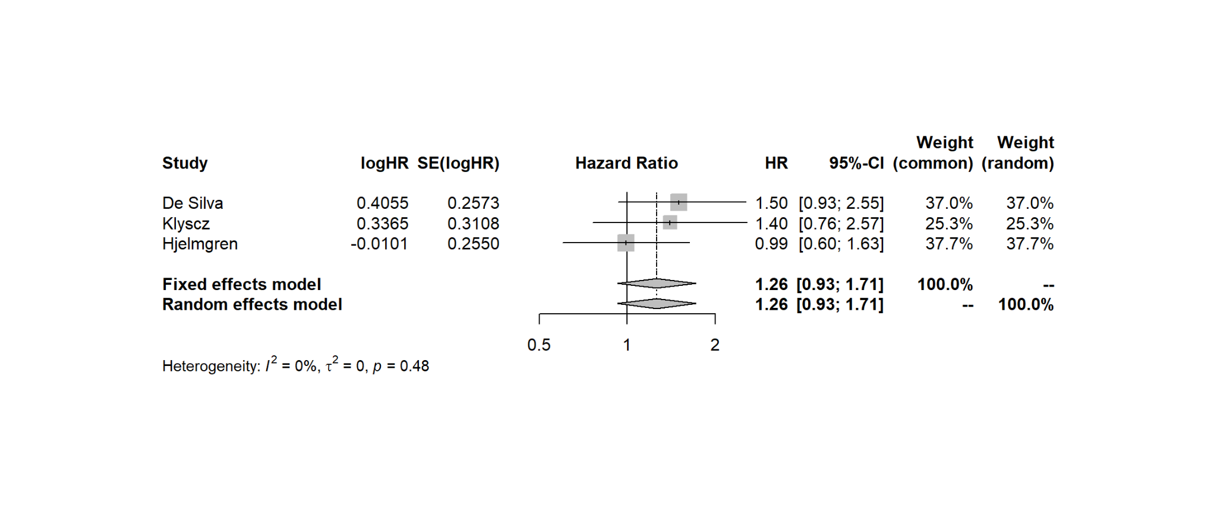
Supplementary Figure 1: Retinopathy HR

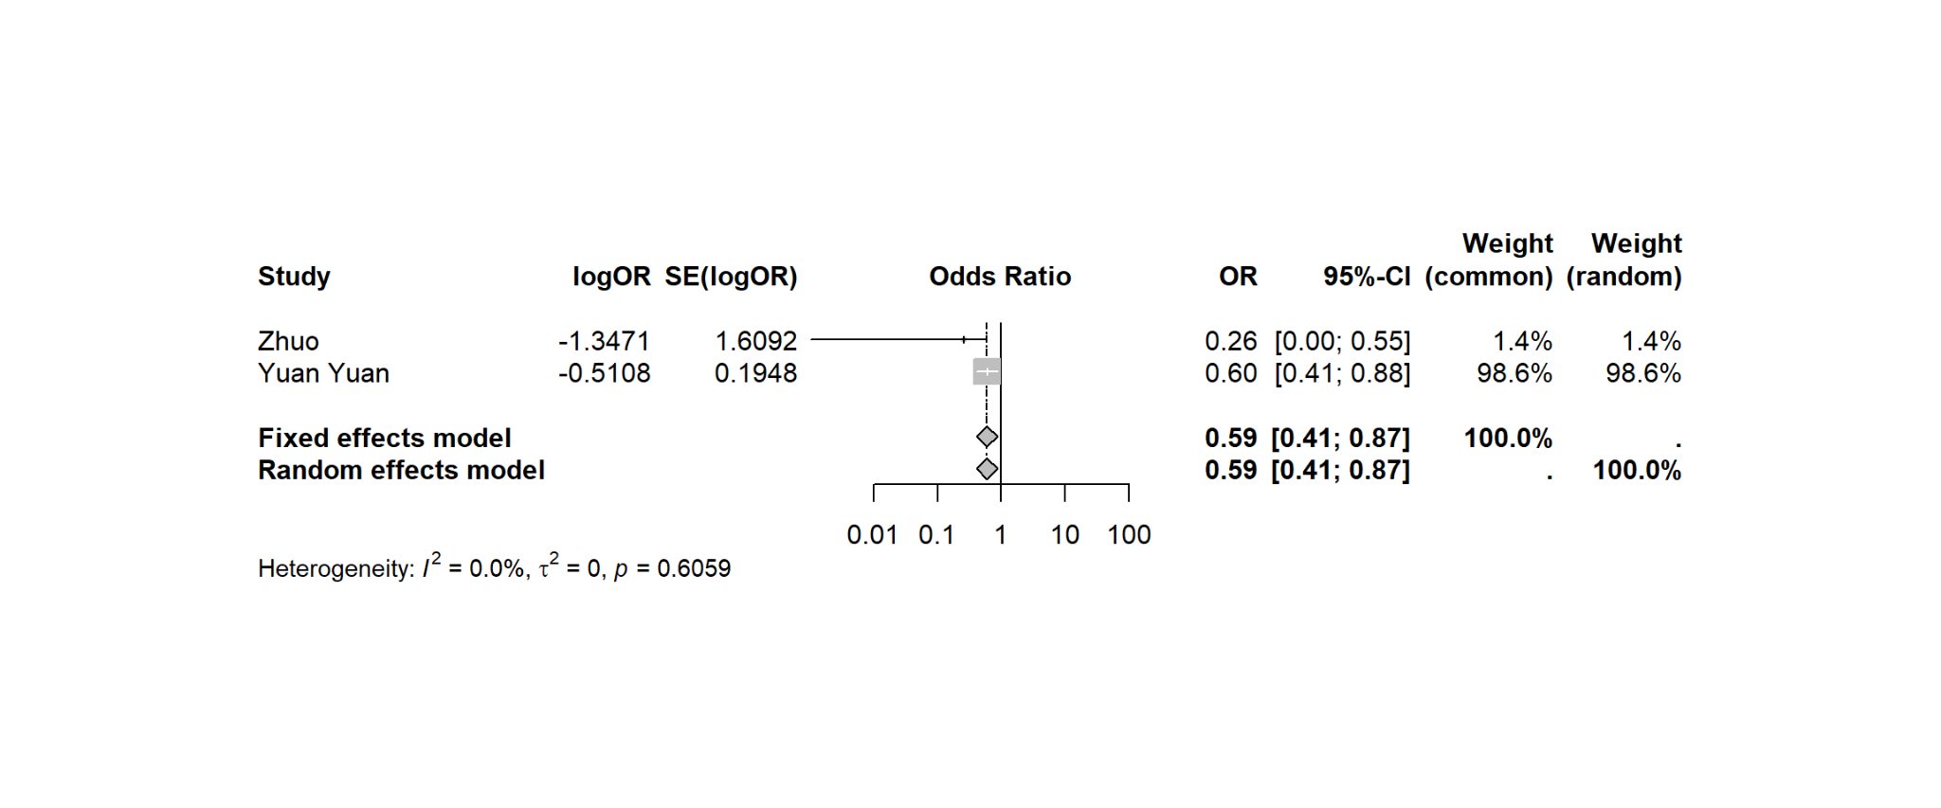
Supplementary Figure 2: Retinopathy OR

Retinal vessel calibre

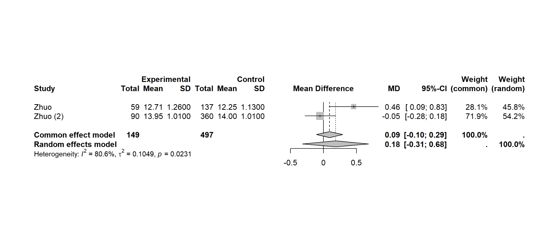
Supplementary Figure 3: Central retinal arteriolar equivalent mean difference

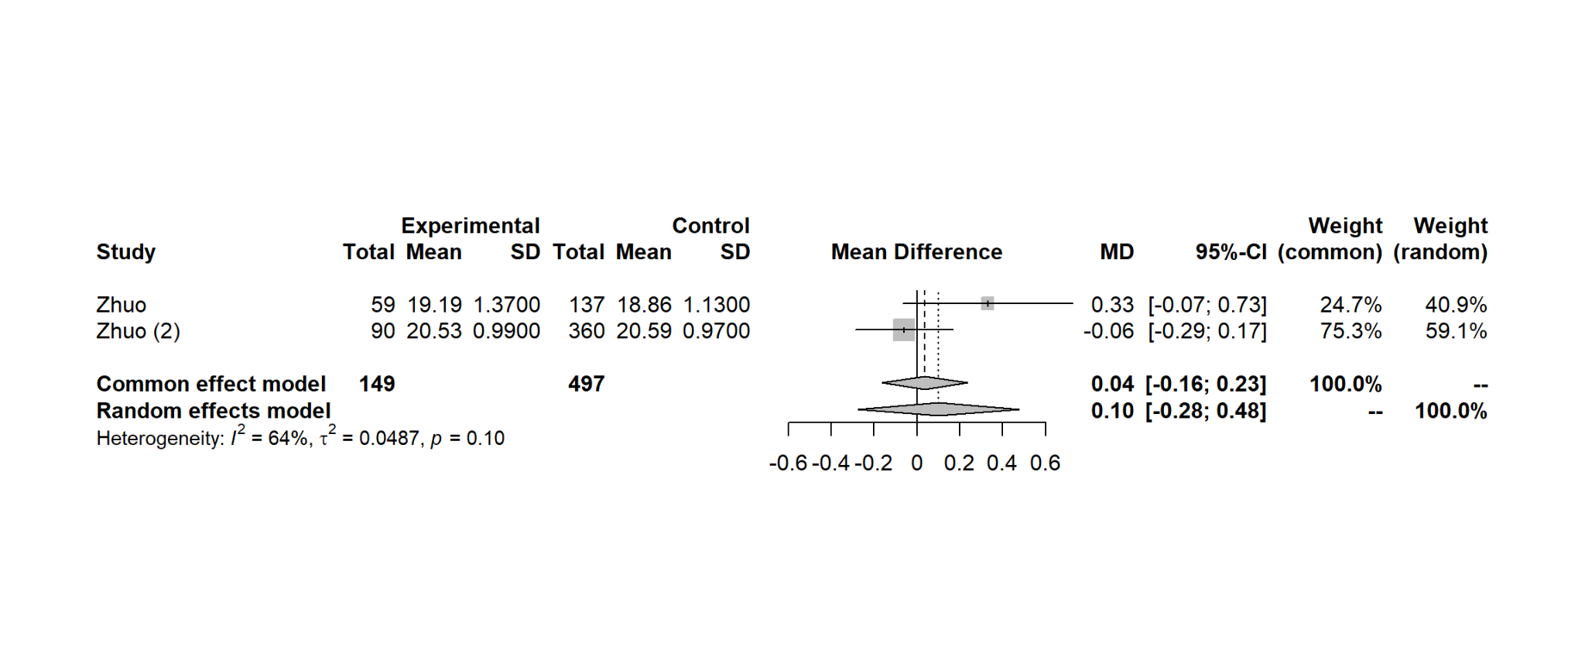
Supplementary Figure 4: Central retinal venule equivalent mean difference

Bifurcation coefficient of vessels
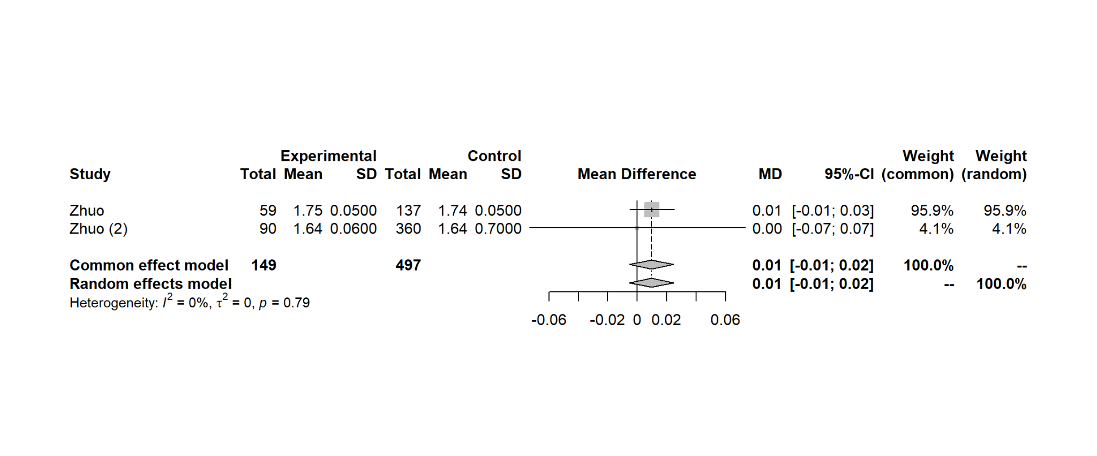
Supplementary Figure 5: Bifurcation coefficient of arterioles mean difference

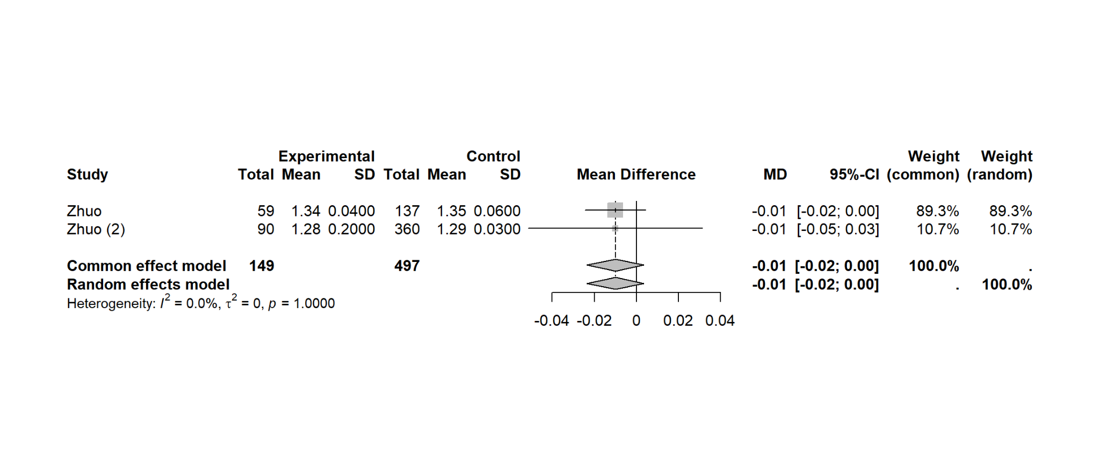 Supplementary Figure 6: Bifurcation Coefficient of Venules (Mean difference)

Branching angle
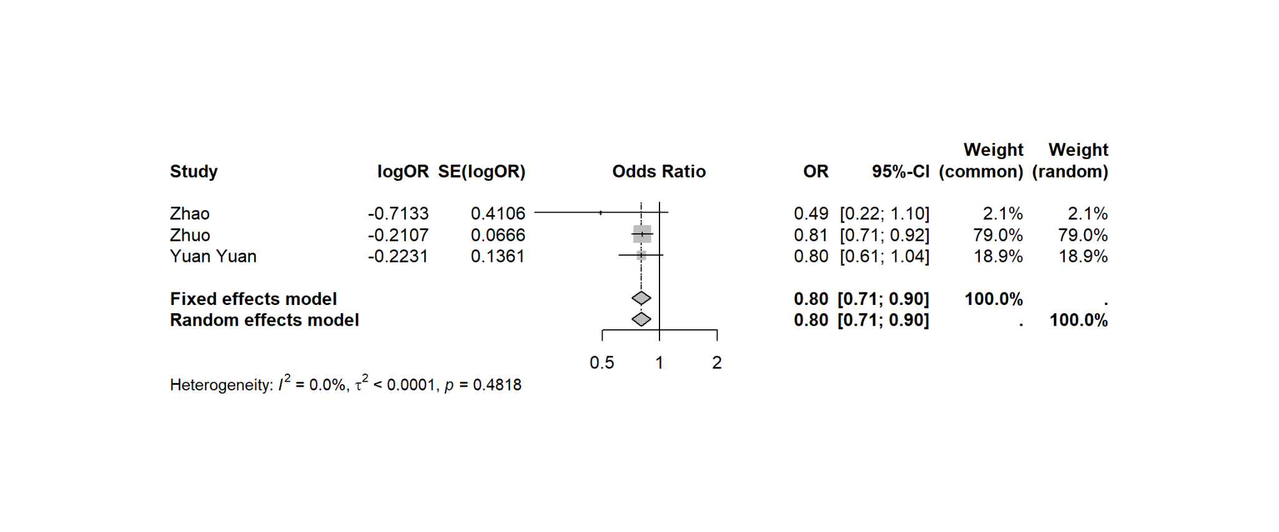
Supplementary Figure 7: Mean Arterial Branch Angle (OR)

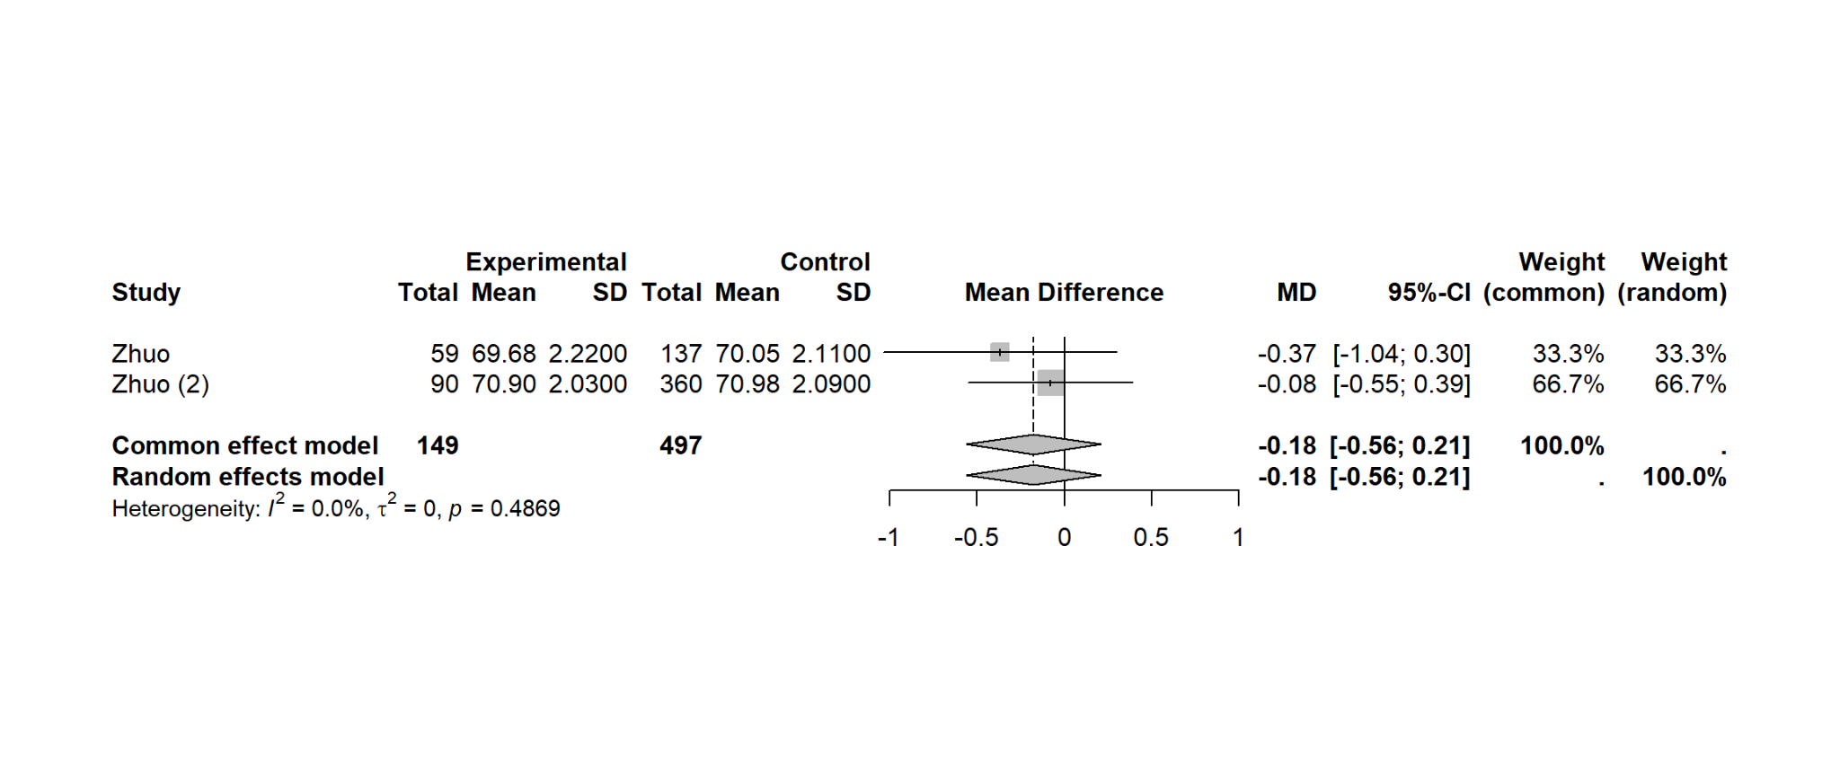
Supplementary Figure 8: Mean Arterial Branch Angle (Mean difference)

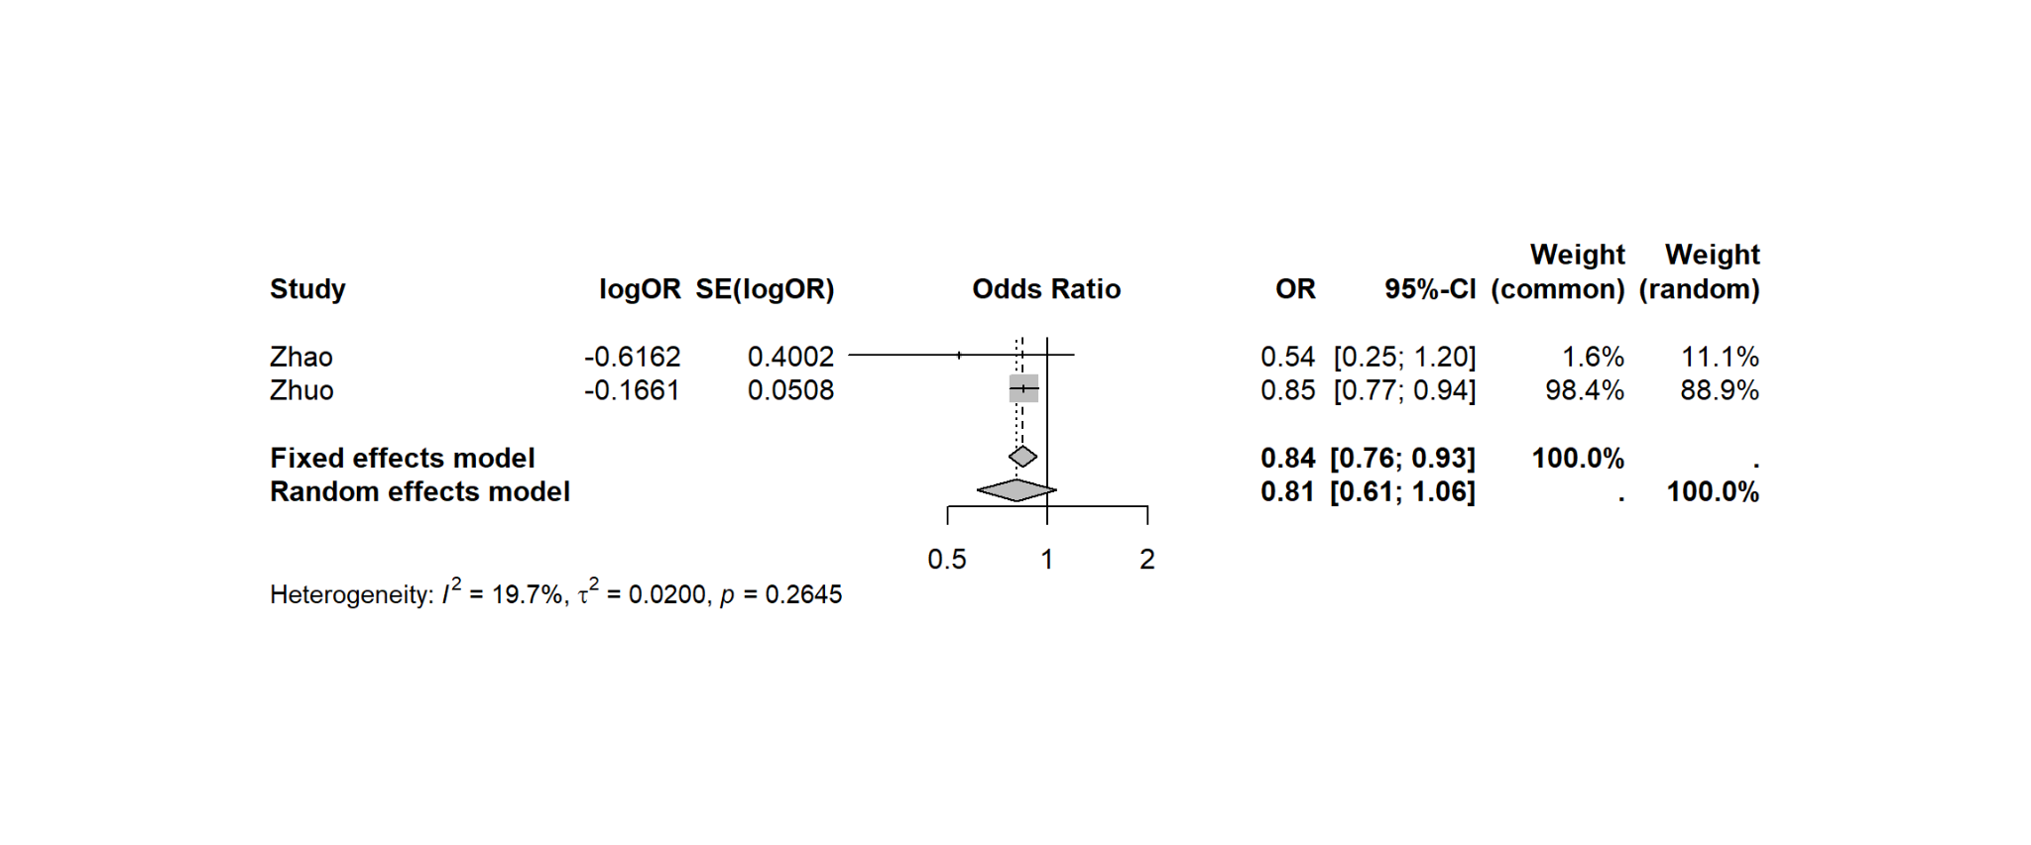
Supplementary Figure 9: Mean Venous Branching Angle (OR)

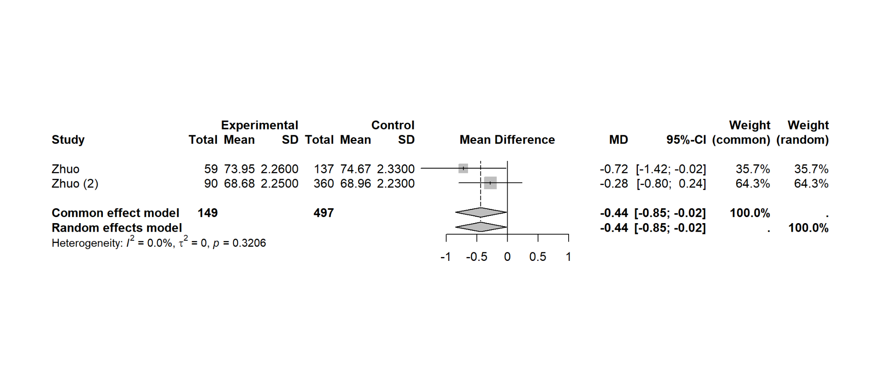
Supplementary Figure 10: Mean Venous Branching Angle (mean difference)

