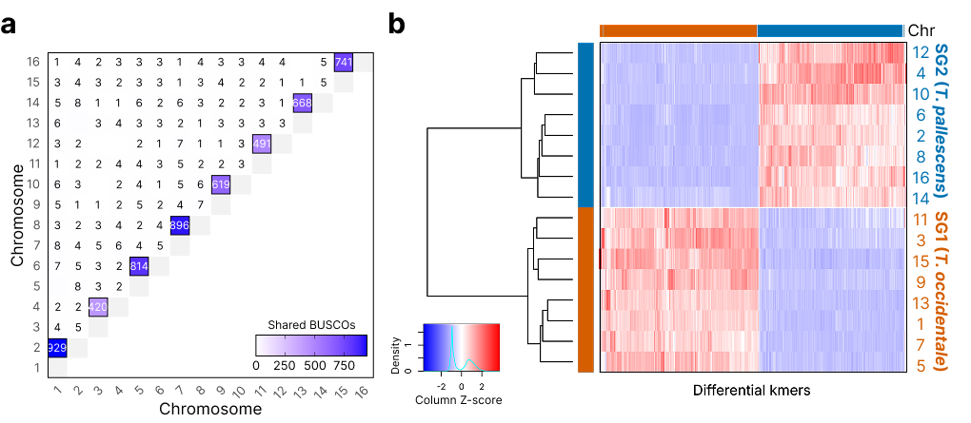
Figure S1. Subgenome partitioning of the allotetraploid T. repens. (a) Shared presence of BUSCO genes between chromosomes, indicating chromosomal homology. (b) SubPhaser hierarchical clustering of differential k-mer profiles across chromosomes, separating homologous chromosome sets into 2 subgenome groups (orange = SG1; blue = SG2).
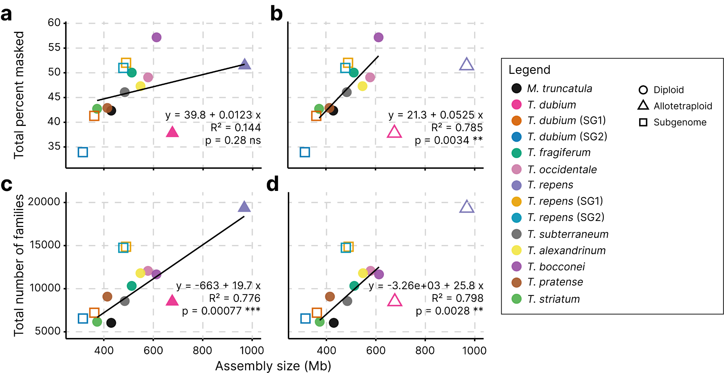
Figure S2. Relationship between genome size and TE content across Trifolium. (a-b) Total repeat fraction, as the percentage of masked bases, against assembly size, using (a) all whole-genome assemblies or (b) diploid assemblies only. (c-d) TE family diversity, as the number of distinct TE families, against assembly size, using (c) all whole-genome assemblies or (d) diploid assemblies only. Hollow points were included for context, including points for subgenome values, but were excluded from the corresponding linear regression.The coefficient of determination (R²)

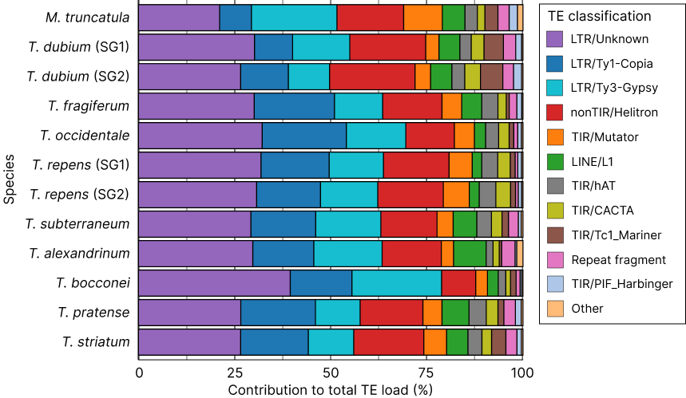
Figure S3. Relative contribution of TE classes to total TE load across Trifolium species.
Values expressed as percentages of the total TE content per genome, showing the proportional contribution of each class to the total repetitive fraction.

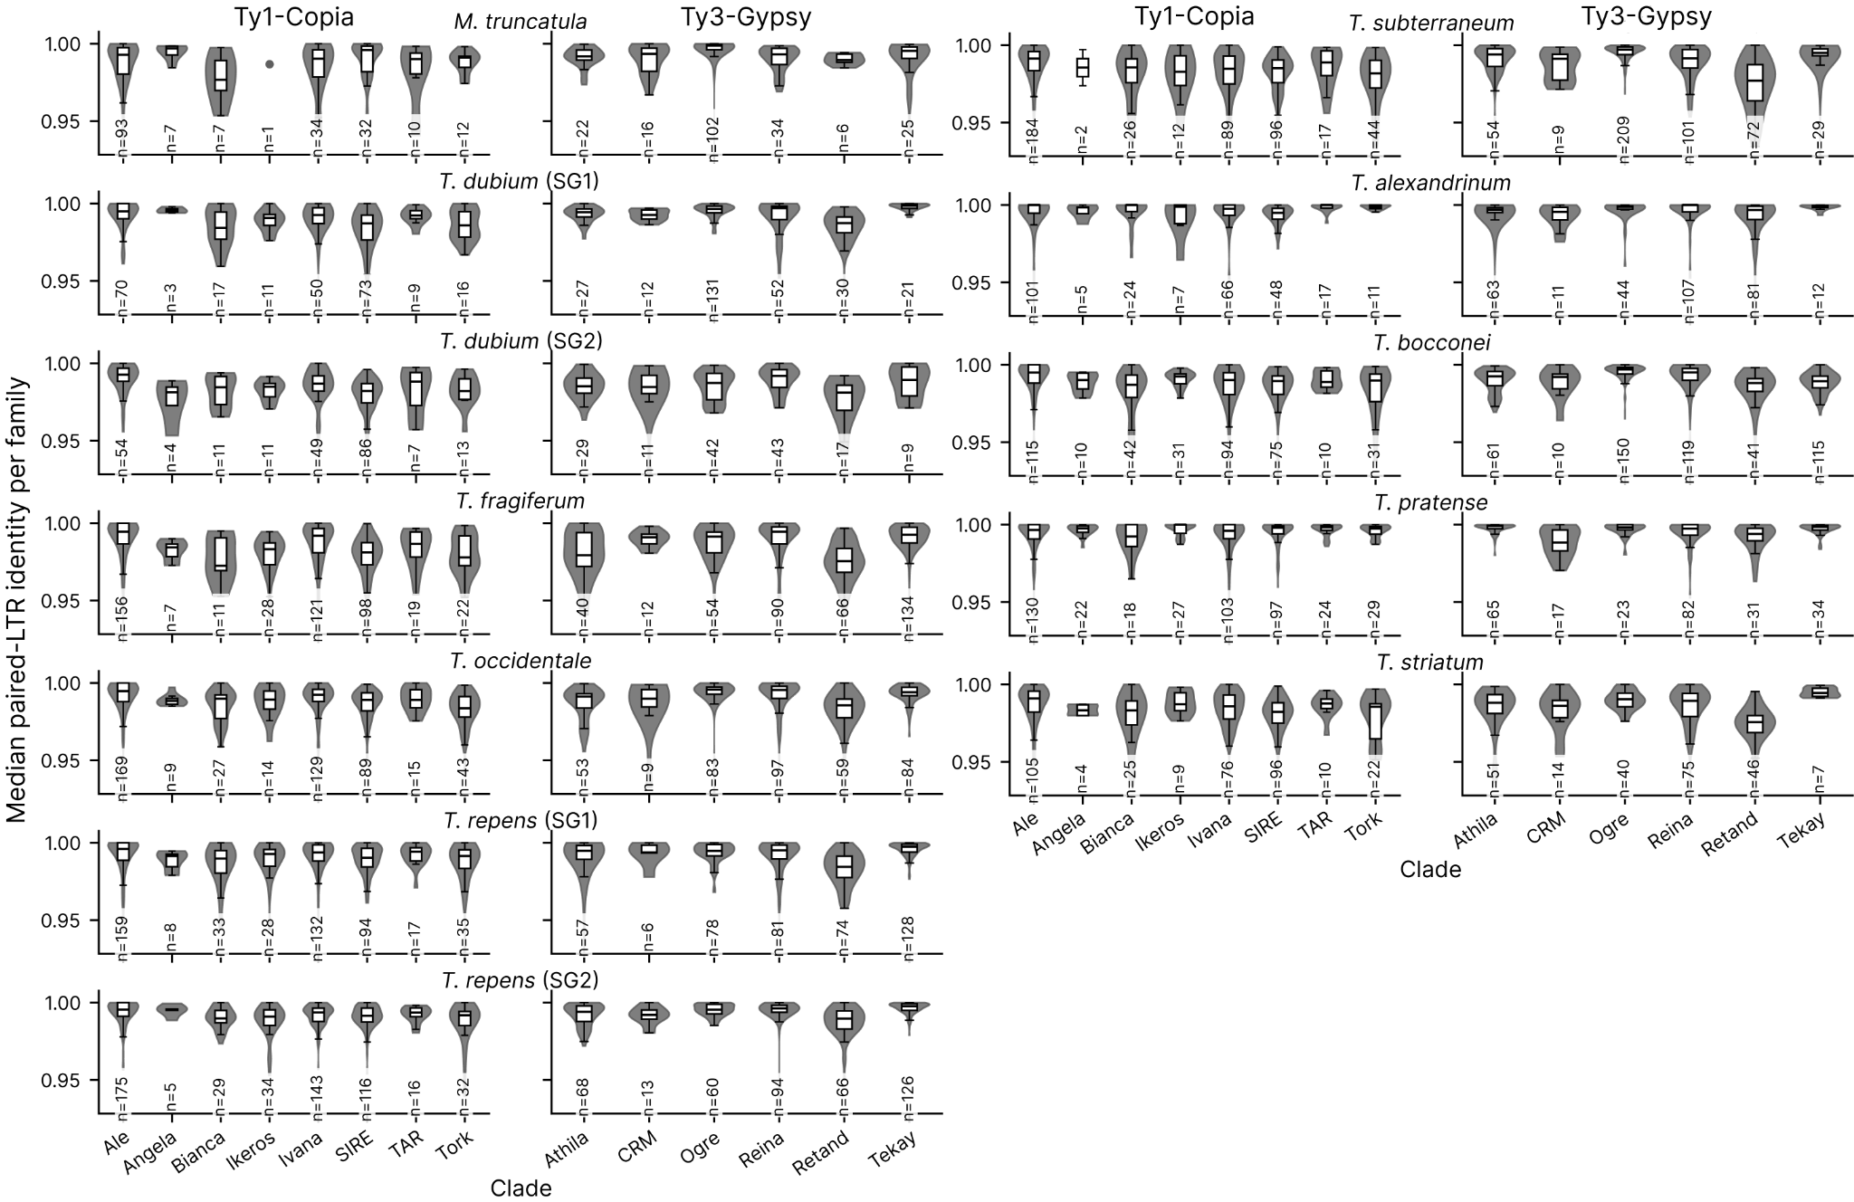
Figure S4. Clade-level paired-LTR identity across Trifolium. Violin plots show family-level median paired-LTR identity for Ty1-Copia and Ty3-Gypsy clades in each diploid species.

