Supporting Information for

Self-organized circular polarization asymmetry in nonchiral random fiber lasers
Wenyu Du¹, Federico Tommasi², Stefano Cavalieri², Diederik Sybolt Wiersma^{3,2,4}, Francesco Riboli^{1,3,}*

¹Istituto Nazionale di Ottica (INO), CNR, 50019 Sesto Fiorentino, Italy
²Dipartimento di Fisica e Astronomia, Università di Firenze, 50019 Sesto Fiorentino, Italy
³European Laboratory for Nonlinear Spectroscopy (LENS), 50019 Sesto Fiorentino, Italy
⁴Istituto Nazionale di Ricerca Metrologica (INRiM), 10135 Torino, Italy
* Corresponding author E-mail: riboli@lens.unifi.it

Contents
Supplementary Information Ⅰ:
Reliability benchmark
Supplementary Information Ⅱ:
Experimental setup
Supplementary Information Ⅲ:
Absence of circular polarization in pure dye emission
Supplementary Information Ⅳ:
Threshold associated emergence of circular polarization in the random fiber laser regime
Supplementary Information Ⅴ:
Spatial channel and pixel level correlation

Reliability benchmark
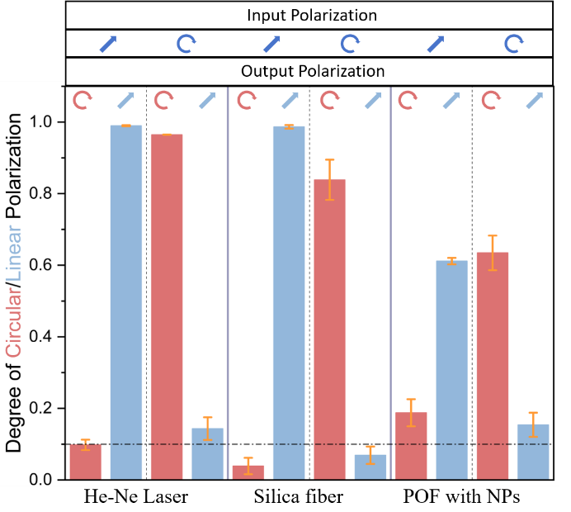
Fig. S1. Reliability benchmark for circular polarization retrieval. Comparison of the degree of linear polarization (D_{LP}, blue) and the circular polarization component (S₃/S₀, orange) measured from a He-Ne laser reference, a silica fiber reference, and a nanoparticle doped polymer optical fiber sample. Measurements are performed under linearly polarized pumping and circularly polarized pumping. Error bars represent the standard deviation over five repeated measurements.

In these reference measurements, as shown in Fig.S1, the normalized circular Stokes component S₃ remained confined close to zero, and the corresponding D_{CP} values were typically below 0.1. Based on these reference results, values of D_{CP} exceeding 0.1 are considered reliably above the instrumental noise level. This criterion is applied uniformly across all datasets.
For pure PM597 dye emission without scattering nanoparticles, the measured S₃ values remain within approximately ±0.05 across the emission spectrum. This range is therefore taken as an empirical estimate of the noise limited background for circular polarization in the absence of coherent optical feedback.
For the polymer optical fiber, the degree of circular polarization typically falls in the range of approximately 0.12 to 0.25, depending on the pumping condition, indicating that the measured circular polarization is well above the experimental noise floor. At the same time, the degree of linear polarization decreases from values close to unity in the reference systems to values around 0.6-0.7 in the polymer optical fiber sample, reflecting strong polarization mixing induced by multiple scattering.
Figure S1 also shows that D_{OP}, defined as D_{LP}²+D_{CP}², is close to 1 for the He-Ne laser as expected, and slightly below 1 for the silica fiber. On the other hand, in the case of fiber with nanoparticles, the D_{OP} is around 0.4. This reduction is primarily due to the detection process. In the experiment, the detector effectively averages emissions from multiple spatial channels. Since different channels may exhibit different polarization states, their incoherent superposition leads to a decrease in the measured degree of polarization. Therefore, the detected D_{OP} represents a spatially averaged quantity, and its value is necessarily lower than the degree of polarization of a single local emission mode.

Experiment setup
Figure S2 shows the experimental setup used to study the emission characteristics of different dye nanoparticle composite systems excited by a 532 nm laser. The output laser beam first passed through a Glan prism to produce a linearly polarized beam, which was then focused onto the sample by a lens. The emission from the sample was collected through an optical filter to remove residual pump light. A quarter wave plate and a linear polarizer were placed in the detection path to analyze the polarization state of the emitted light. The collected light was divided by a beam splitter. One part was imaged by a CMOS camera to record the spatial emission pattern, while the other part was coupled into a fiber spectrometer (QE65 Pro, Ocean Optics) for spectral measurement.
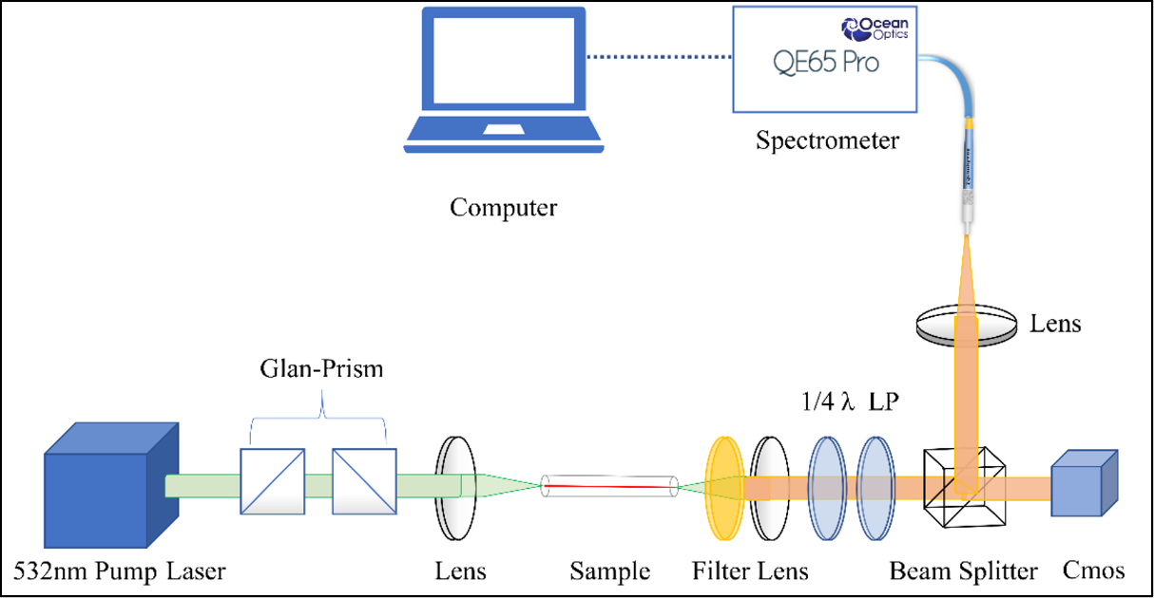
Fig. S2 Experimental arrangement and polarization acquisition.

Absence of circular polarization in pure dye emission
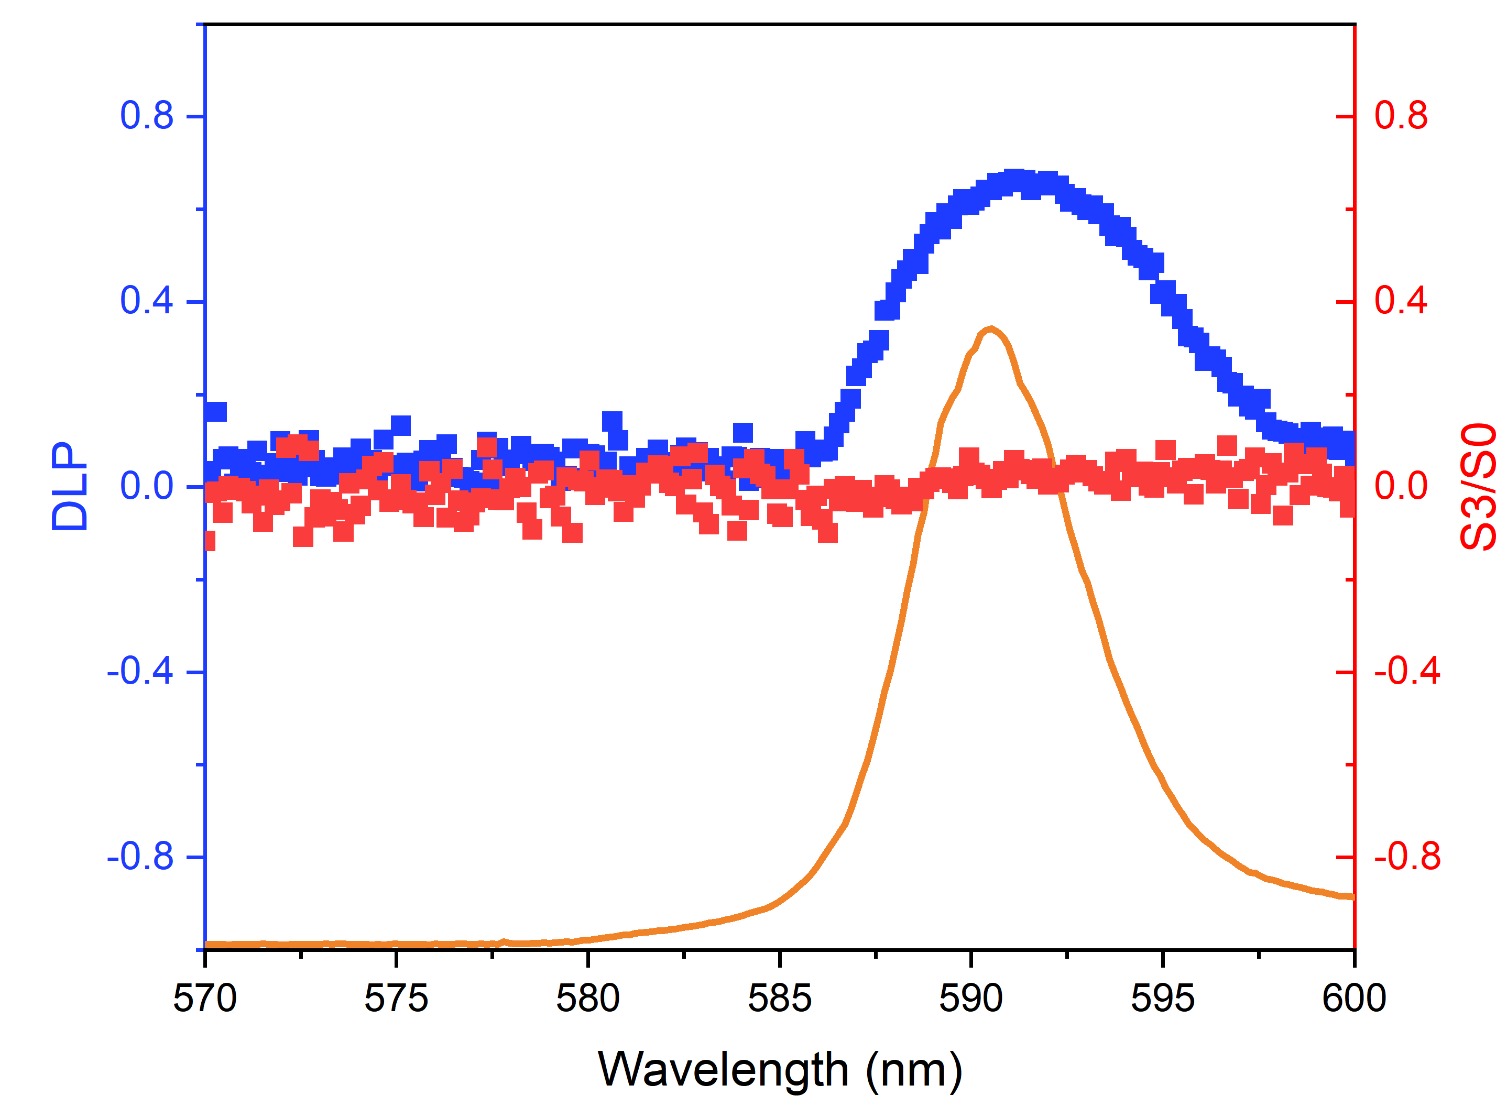
Fig. S3. Polarization properties of pure dye emission. Fluorescence emission measured from the dye solution without nanoparticles(orange line). Blue and red dots represent the degree of linear polarization (D_{LP}, left axis) and the circular polarization component S₃/S₀ (right axis), respectively, showing weak and spectrally smooth polarization features in the absence of random lasing.

S₃ remains close to zero across the entire emission spectrum and spatial profile. Quantitatively, S₃ for pure dye samples remains confined within approximately ±0.05 across the entire emission spectrum, overlapping with the experimental noise level and showing no systematic dependence on wavelength or pump polarization.

Threshold associated emergence of circular polarization in the random fiber laser regime
When scattering nanoparticles are introduced into the core of a fiber with laser dye, the system undergoes a transition from amplified spontaneous emission to random lasing as the pump energy exceeds the threshold. This transition is accompanied by the appearance of sharp spectral peaks and strong spatial localization of emission channels. Consistent with the effective channel selection picture in Fig.1(g), the onset of lasing is identified by a clear threshold. From the emission intensity versus pump power curve in Fig. S4, the random laser threshold can be identified near the pump power at which the slope of the intensity curve increases abruptly. Below this point, emission intensity increases gradually, and no clear spectral structure is present.
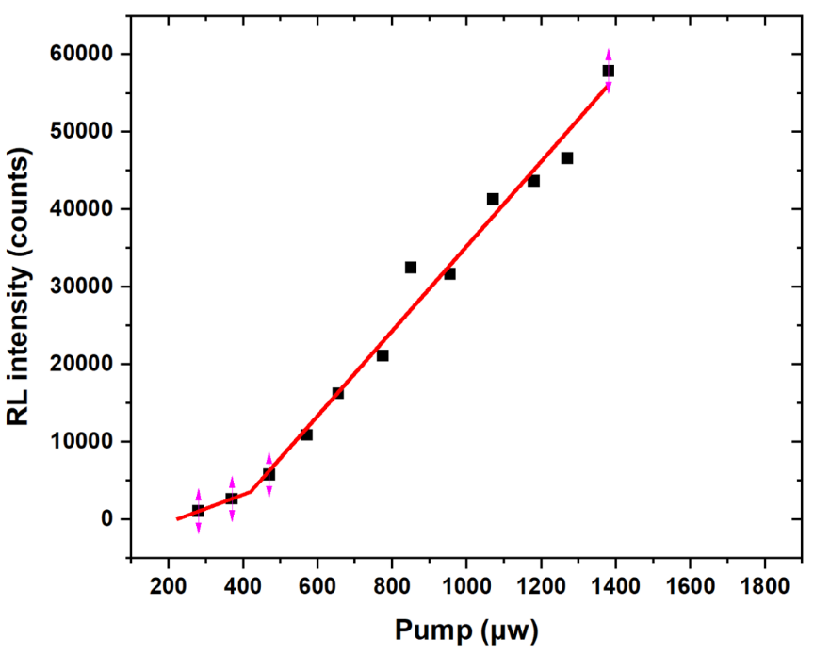
Fig. S4. Threshold behavior. The variation of random laser emission intensity with pump energy in a polymer optical fiber. The inflection point corresponds to the threshold.

Spatial channel and pixel level correlation
Fig. S5(a-e) show spatial emission images used to reconstruct the full Stokes parameters of the polymer optical fiber random laser. The five subpanels correspond, from left to right and from top to bottom, to the emission recorded without a polarization analyzer and under the four analyzer configurations required for Stokes parameter extraction. The unfiltered image reveals a strongly structured emission pattern consisting of multiple radially distributed filamentary channels emanating from a localized region near the fiber core. When polarization analyzers are inserted, the overall spatial morphology remains largely unchanged, while the relative intensity distribution within individual filaments varies between different analyzer settings. This observation indicates that the spatial emission channels persist across different polarization bases. The polarization information is therefore encoded mainly in the relative intensity modulation of these channels rather than in the appearance or disappearance of specific channels. These images provide the experimental basis for pixel level Stokes parameter reconstruction and subsequent polarization state analysis.
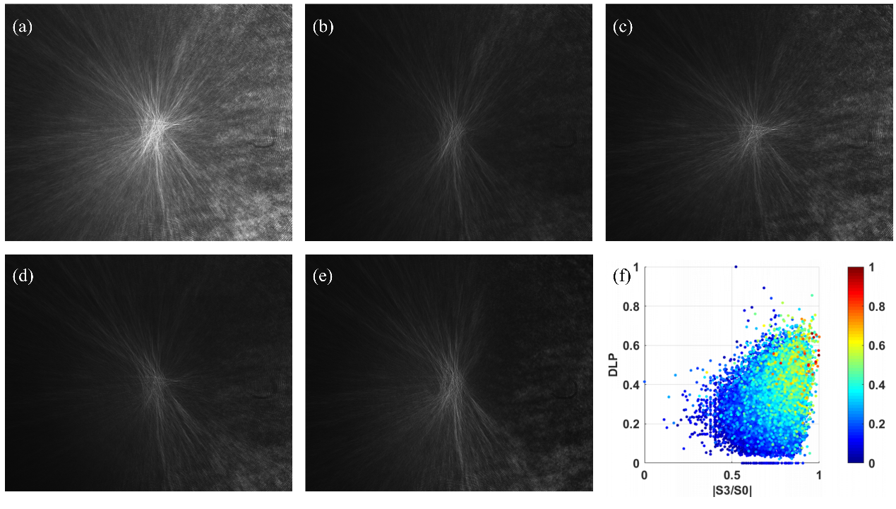
Fig. S5. Polarization analyzed images used for Stokes reconstruction. Images are recorded without analyzer (a) and under the analyzer settings required for Stokes retrieval (b-e). Spatial channels persist across analyzer settings, while relative filament intensities change, enabling pixel wise polarization reconstruction. (f)Scatter plots of D_{LP} or S₃/S₀ versus intensity for all pixels and for the highest intensity subset, showing broad distributions and weak correlation.

Fig. S5(f) shows a scatter plot of all pixels, where the horizontal axis represents the circular polarization component S₃/S₀, the vertical axis denotes D_{LP}, and the color of each point corresponds to the normalized emission intensity. The data points form a broad, dispersed distribution across the (S₃/S₀, D_{LP}) parameter space. In particular, no clear linear dependence is observed between S₃/S₀ and D_{LP}. Pixels with similar circular polarization values can exhibit widely different linear polarization degrees, and vice versa.

