A Global and National Safe and Just Operating Space for Humanity

Supplementary Information B

- Details of the methodology
This study combines Environmentally Extended Multiregional Input-Output (EEMRIO) analysis with location-specific biophysical accounting to assess national consumption footprints against national ecological carrying capacity (NECC) for six environmental pressures. We use the Eora26 EEMRIO database (v199.82 basic price) (Lenzen et al., 2012, 2013) for 2017 (most recent year for which there is non-paid available data) covering 189 countries, integrated with environmental extensions for land use (cropland, pasture, forest), blue water consumption, and nutrient flows (nitrogen (N) and phosphorus (P)). We then develop a normative consumption scenario to evaluate redistribution potential within global boundaries.
Here we provide a detailed methodology for pasture land use, since the calculations for this environmental pressure consist of extra steps compared to the other types of land use.
  - Pasture
The pasture land environmental extension was developed using a bottom-up approach based on livestock feed requirements rather than reported pasture area statistics. This methodology provides a more accurate representation of productive pasture use linked to livestock production. The calculation follows the Global Footprint Network (GFN) methodology for pasture land footprint estimation (Borucke et al., 2013; Lin et al., 2019), adapted to integrate with Eora sector-level data.
Livestock Stocks
Livestock population data were obtained from FAOSTAT (Food and Agriculture Organization Corporate Statistical Database) (FAOSTAT, 2026) for the year 2017. The dataset includes stocks (number of heads) for all major livestock categories: cattle, sheep, goats, pigs, poultry (chickens, ducks, geese, turkeys), horses, mules, asses, camels, and buffalo.
Feed Intake Parameters
Feed intake rates (kg dry matter per head per day) were obtained from the GFN's Excel file "World 2014" (Global Footprint Network, 2018). These rates are differentiated by livestock type and UN geographic region to account for climate-dependent variations in animal metabolism and feed requirements.
From the number of head per animal and the feed intake, the feed demand can be estimated. The feed demand is filled by crops, crops’ residues, and cropped grasses.
In addition, livestock feed requirements are divided into two categories based on animal diet composition: 1) Grass-only feed demand: For animals that consume 100% grass; 2) Crop feed requirements: For all other animals, crop and crop residues feed are calculated as the difference between total feed demand and grass-only feed demand.
Crop Feed Supply
Market-based crop feed data were obtained from FAOSTAT for 2017 (production and imports). The dataset was filtered to include only the "Feed" element category. Feed crops were converted from fresh weight to dry matter using crop-specific water content values from the GFN Excel file.
Crop Residue Feed Supply
Crop production data were obtained from FAOSTAT and merged with crop residue feed conversion ratios from the GFN Excel file. First, the production of crops is multiplied by the nutrition index, which is a measurement of nutritional value by weight compared to products in the same aggregate groups. The nutrition index is used to weight different products in the same group when summing their production to calculate an average yield. This index is only available for cereals. For other crops it is assumed as 1. Then, this is multiplied by three factors: harvest factor, crop recovery rate, and share of recovered crop residues used as feed (Haberl et al., 2007). These ratios represent the fraction of crop residues that become livestock feed (rather than being burned, composted, or left in fields) and vary by crop type and UN region.
FAOSTAT crop categories were matched with GFN residue categories. However, some crops had to be assigned to broader categories:
- Pulses: bambara beans, beans, broad and horse beans, chickpeas, cowpeas, lentils, lupins, peas, pigeon peas, pulses n.e.s., vetches, other pulses n.e.c.
- Oil crops: castor oil seeds, coconuts, hempseed, karite nuts (sheanuts), linseed, melonseed, mustard seed, olives, poppy seed, rapeseed, safflower seed, seed cotton, sesame seed, sunflower seed, tung nuts, jojoba seeds, groundnuts, rape or colza seed, tallowtree seeds, groundnuts, excluding shelled oilseeds n.e.s., other oil seeds, n.e.c.
- Roots and tubers: potatoes, sweet potatoes, taro, yams, yautia, chicory roots, ginger, carrots and turnips, roots and tubers n.e.s., edible roots and tubers with high starch or inulin content, n.e.c.
- Cereals: barley, canary seed, oats, rye, triticale, fonio, buckwheat, quinoa, cereals n.e.s.
- Maize: green corn, maize.
Grass supply
The grass feed demand corresponds to the amount of grass for animal feed exclusively by grass. It is estimated from the feed requirements multiplied by the % grass feed, only when the latter is 100%.
Then the pasture feed demand is estimated as the feed requirement minus the crop and crop residue feed, plus the grass feed demand.
This value is multiplied by the yield, equivalence, and temporal factors to be converted to global hectares. The yield factor is multiplied by the above-ground NPP (%) and the edible % of aboveground NPP (70 and 30% respectively) (Global Footprint Network, 2018).

- Additional results
  - Additional figures
Figures A1 to A5 show per capita consumption footprints by income group and national ecological carrying capacity (NECC) tercile. Countries are sorted by income group (LI = low income, LMI = lower-middle income, UMI = upper-middle income, HI = high income) and divided into three terciles based on the ratio of total consumption to NECC. The top panel shows countries with the highest spare capacity, the middle panel shows countries consuming near their NECC (no spare capacity), and the bottom panel shows countries in overshoot. Stacked bars represent domestic production (green) and imported resources (yellow). Red circles indicate total per capita NECC for each country. The horizontal dashed line represents the global boundary distributed equally per capita.
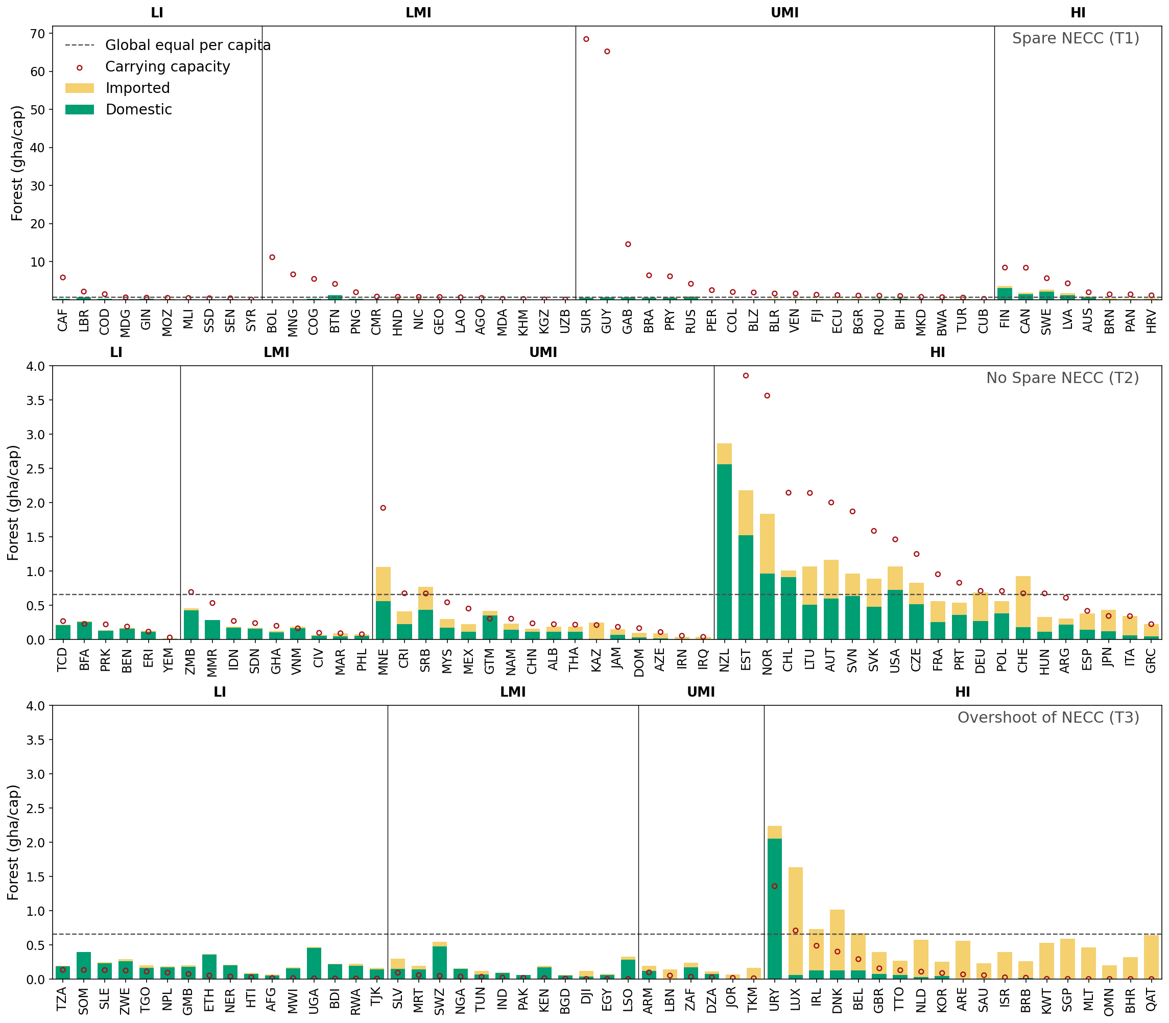
Figure A1. Per capita forest consumption footprints by income group and national ecological carrying capacity (NECC) tercile.
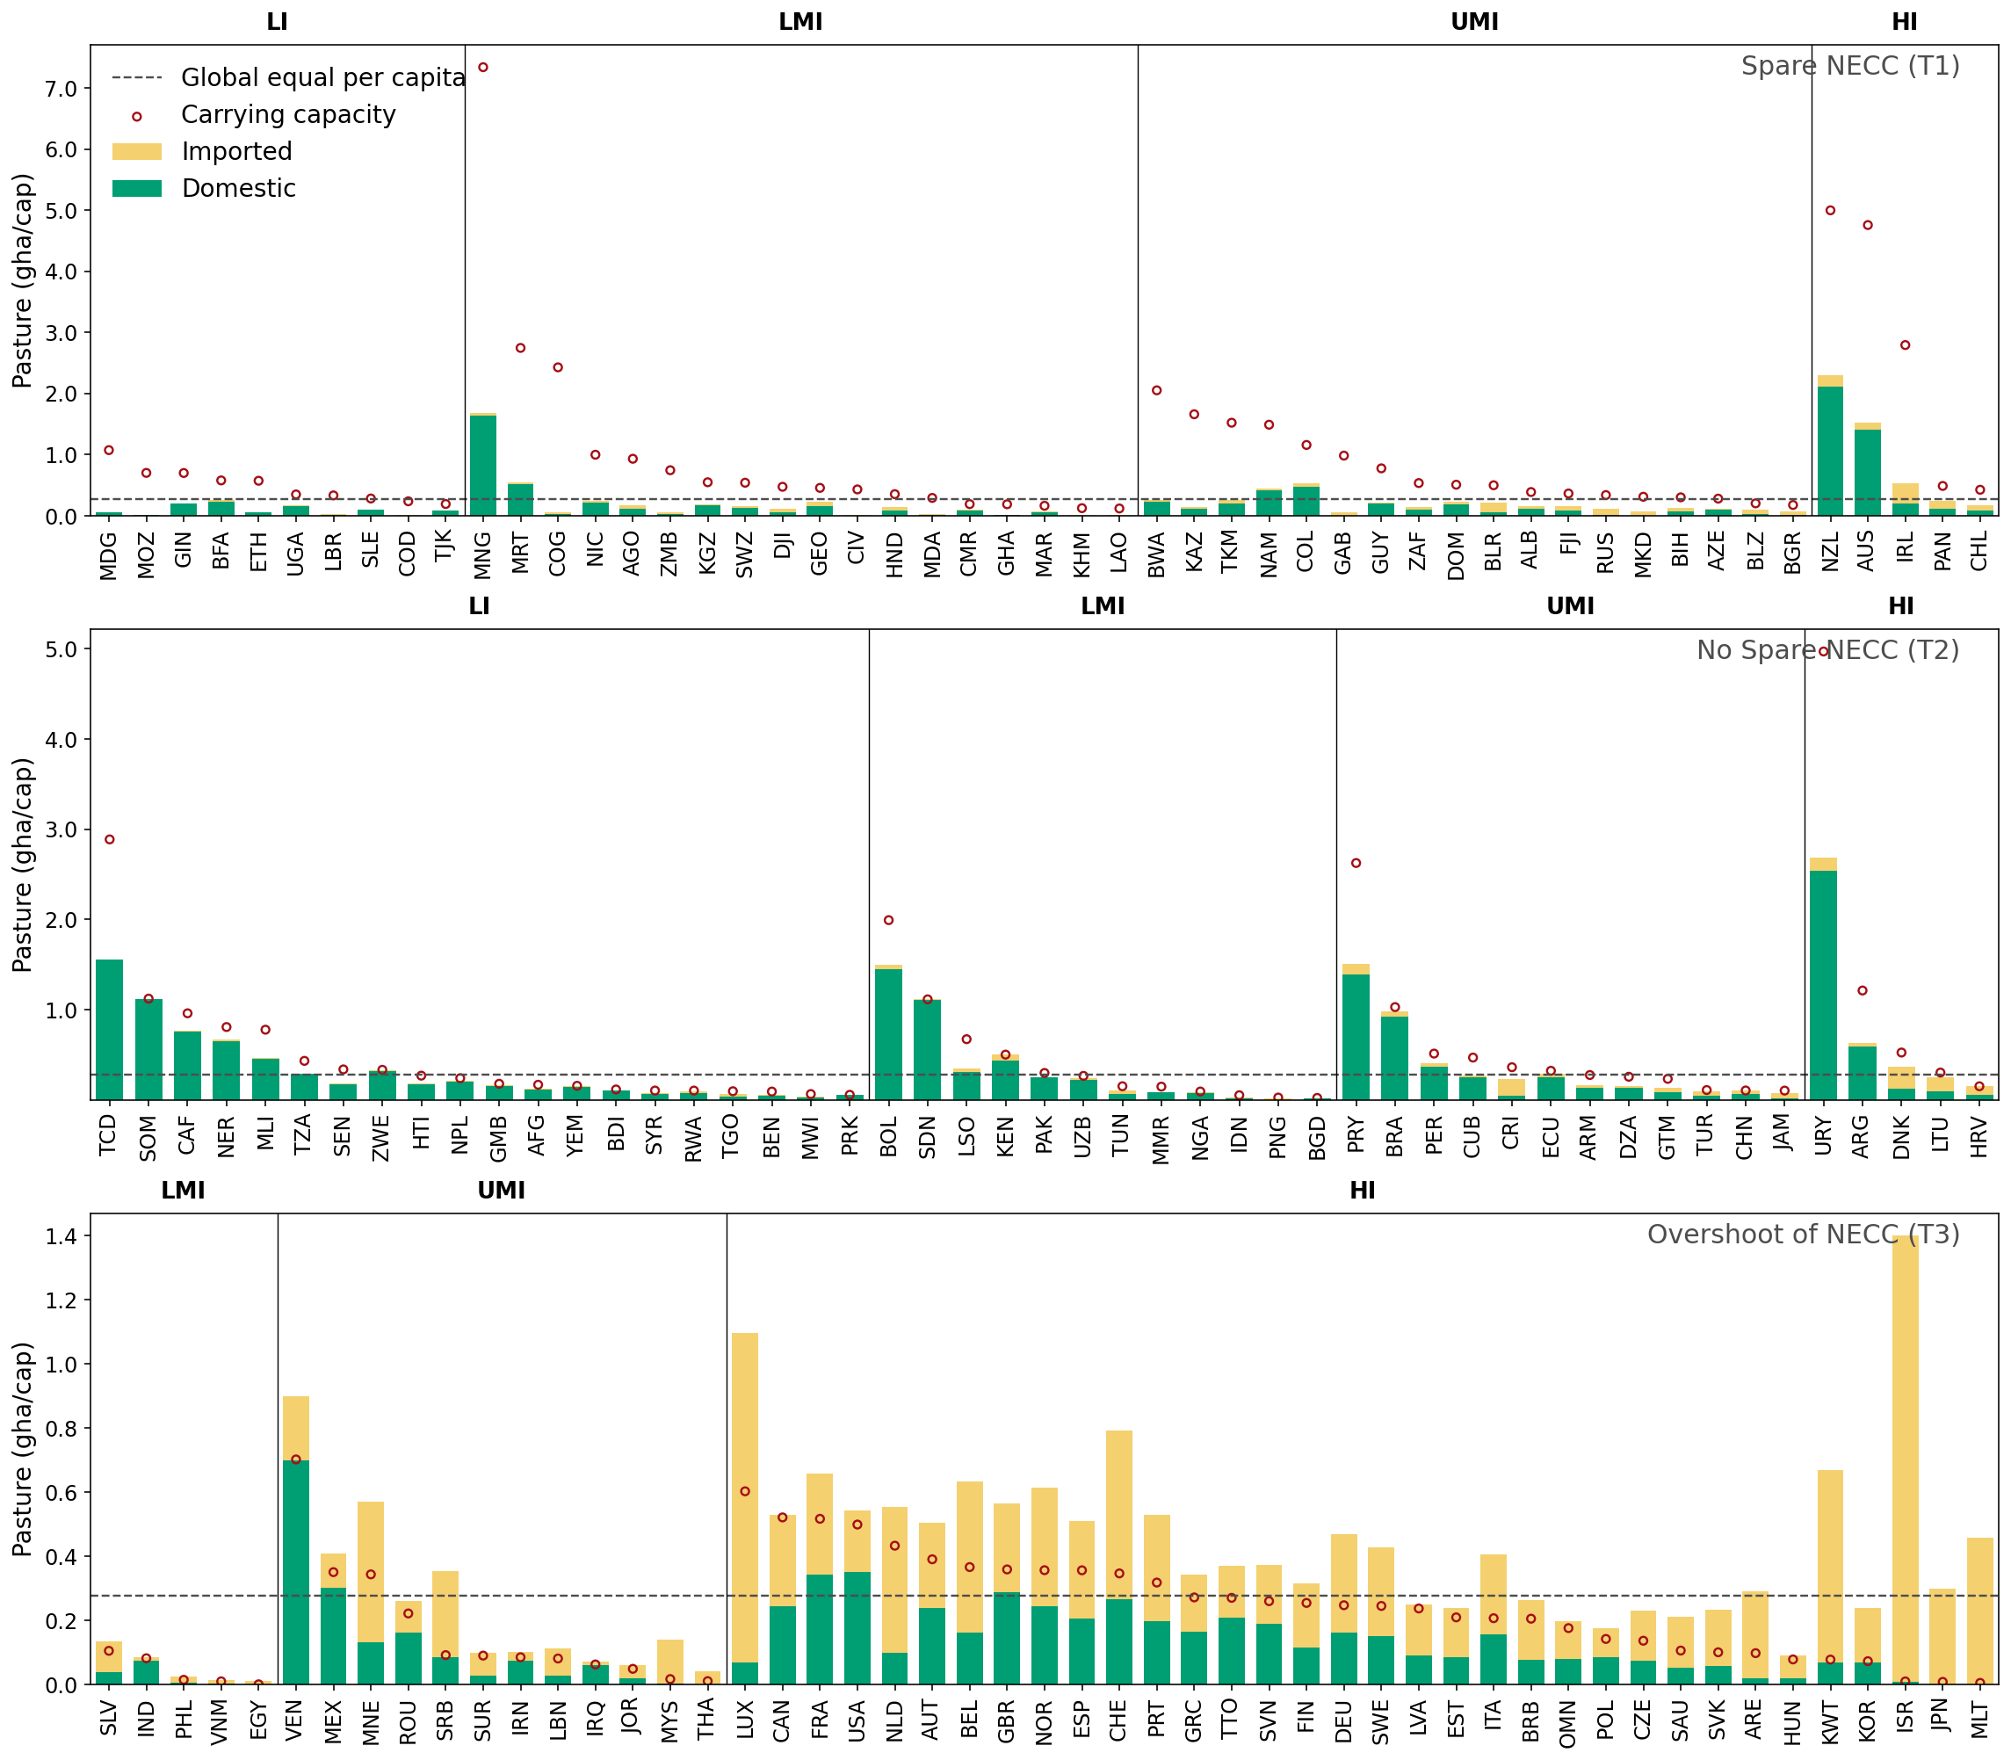
Figure A2. Per capita pasture consumption footprints by income group and national ecological carrying capacity (NECC) tercile.
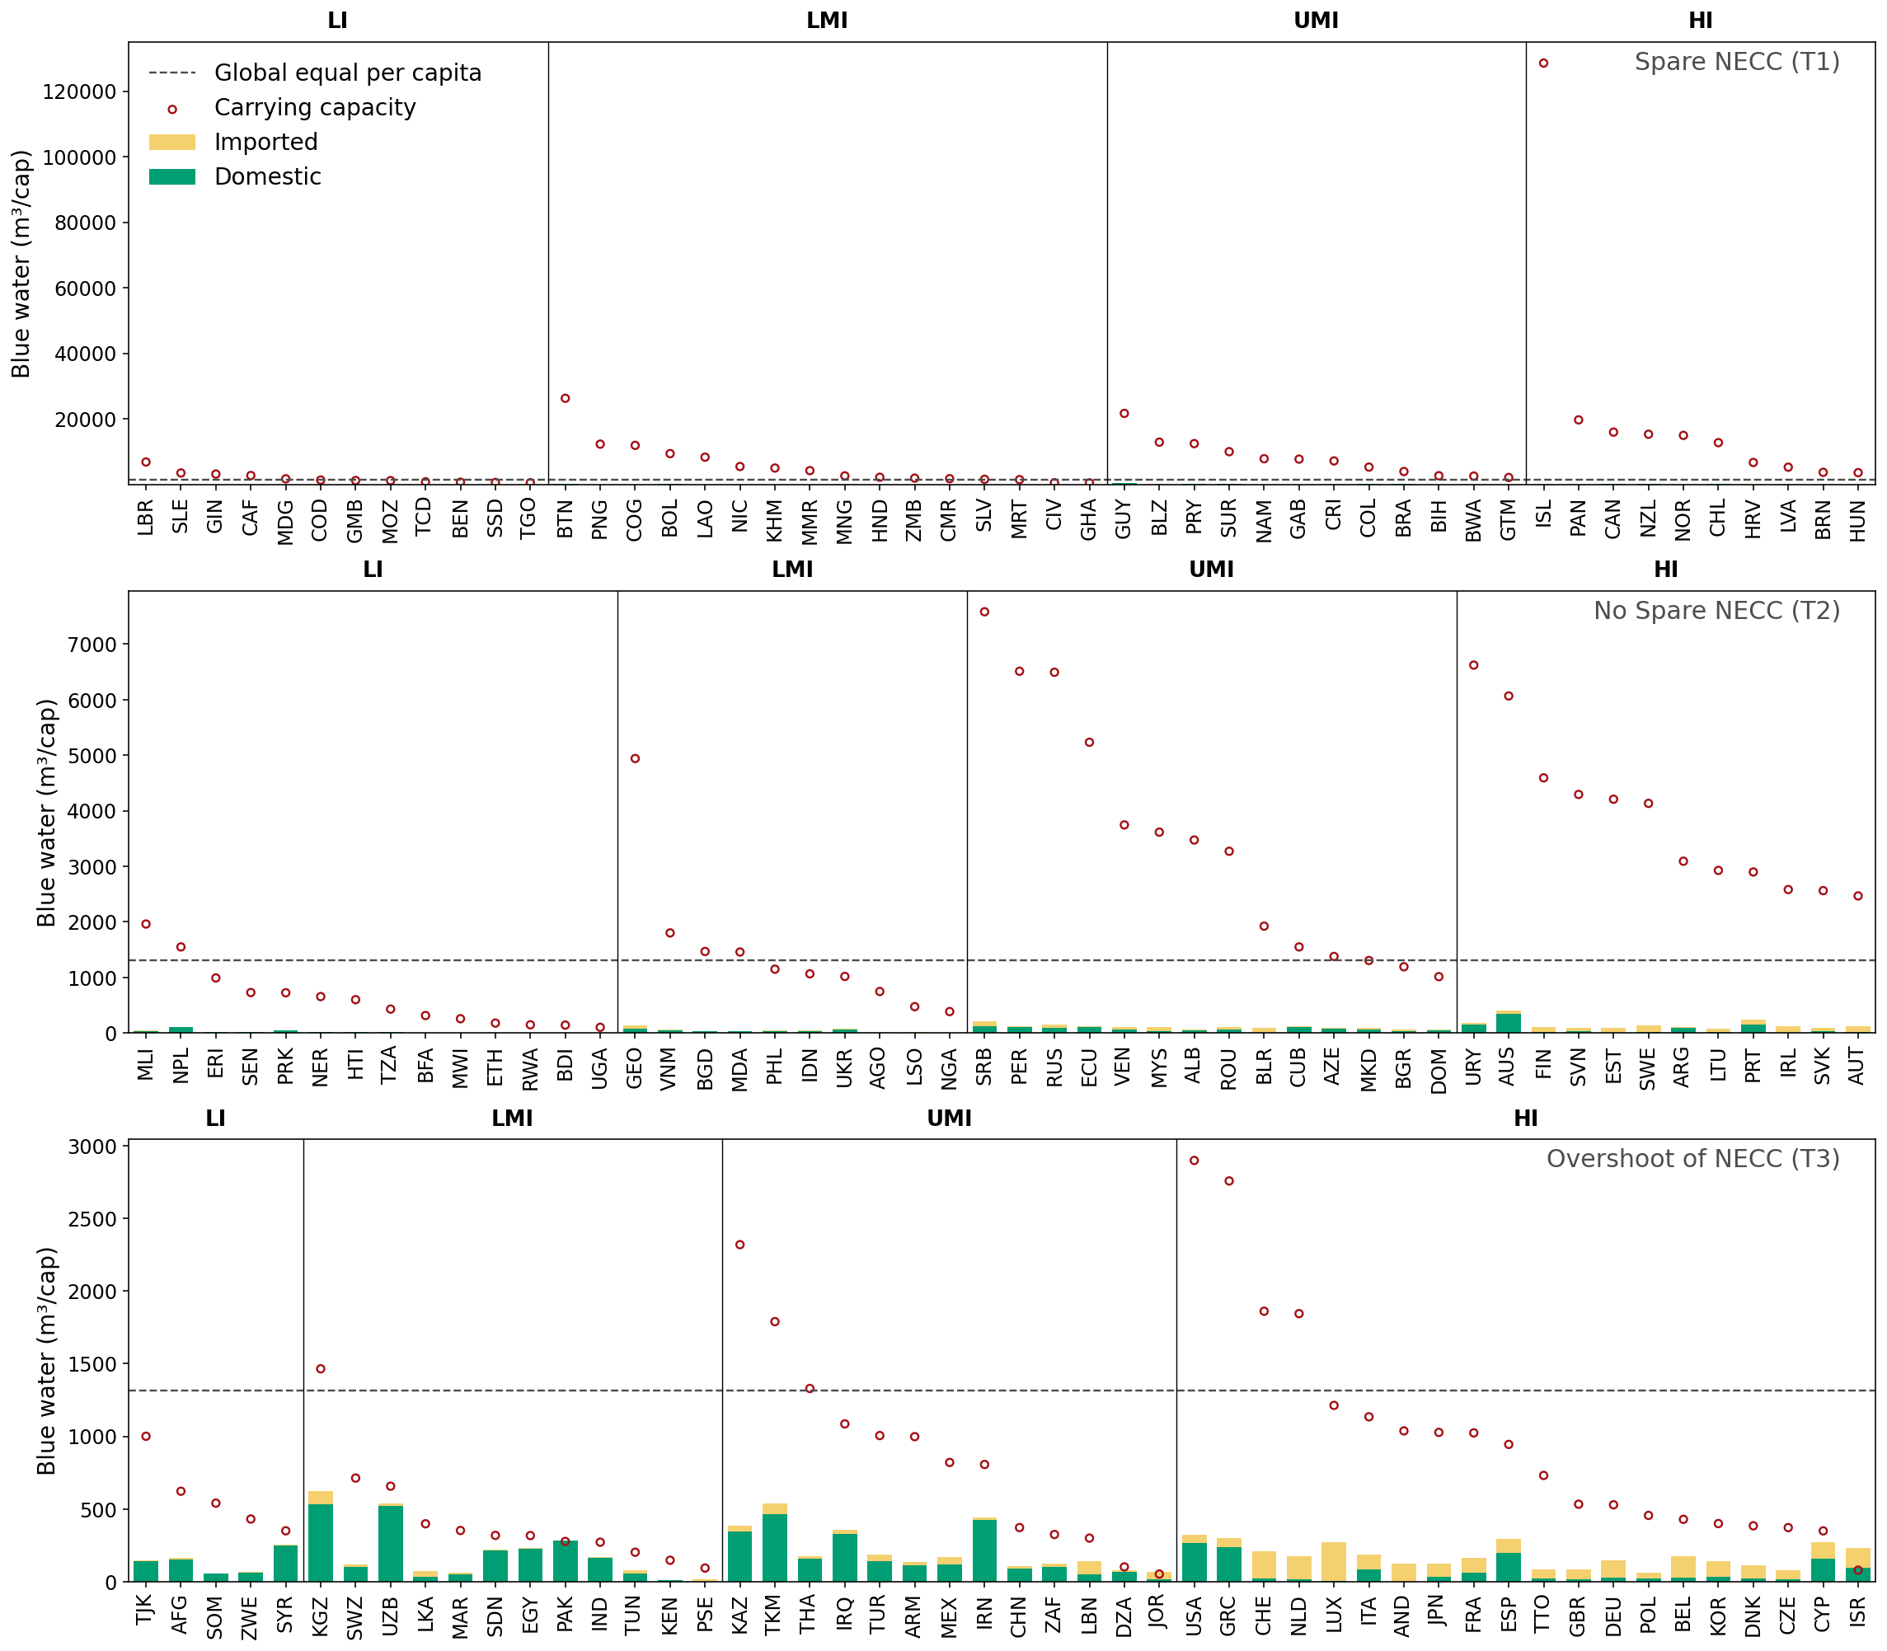
Figure A3. Per capita blue water consumption footprints by income group and national ecological carrying capacity (NECC) tercile.
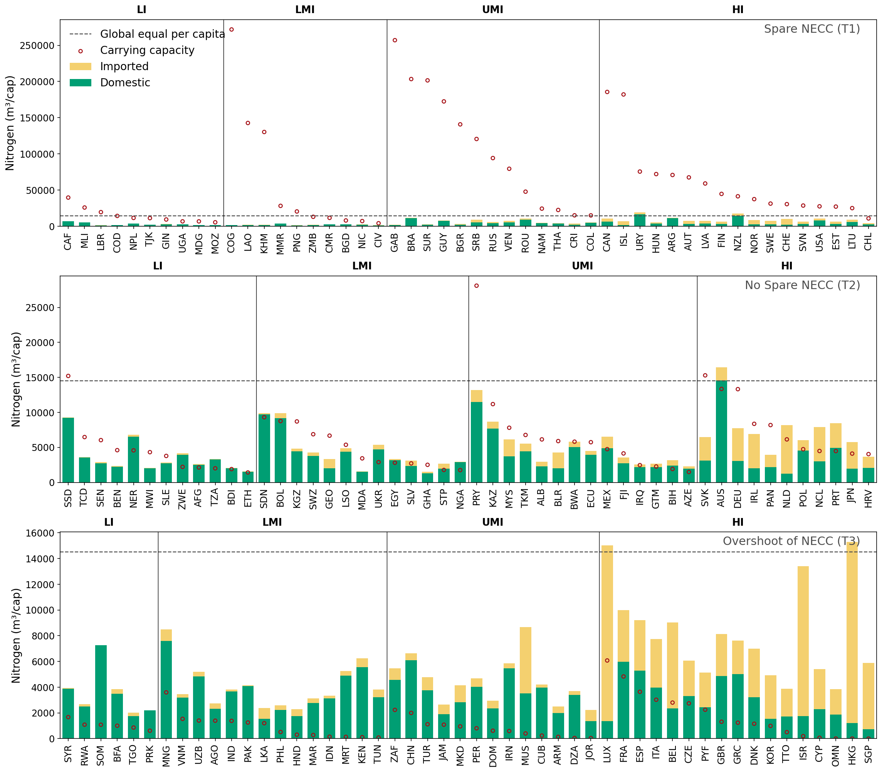
Figure A4. Per capita nitrogen consumption footprints by income group and national ecological carrying capacity (NECC) tercile.
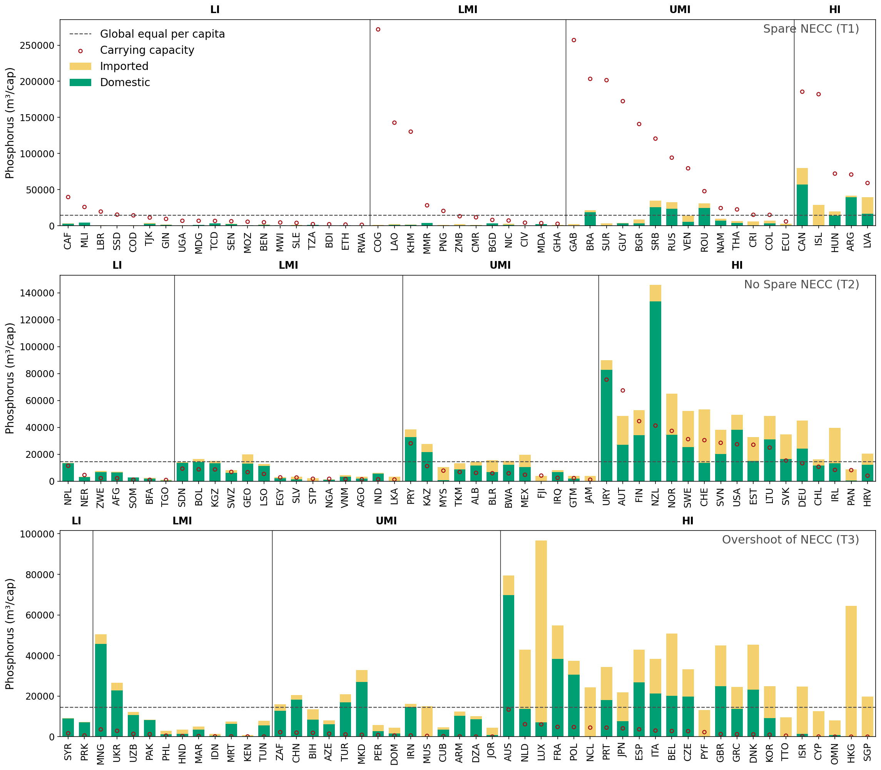
Figure A5. Per capita phosphorus consumption footprints by income group and national ecological carrying capacity (NECC) tercile.
  - Outliers Figure 5
Cropland – removed as outliers (ratio > 5): ['ARE', 'BHR', 'BRB', 'BRN', 'CHE', 'DJI', 'ISR', 'JPN', 'KOR', 'KWT', 'LUX', 'MLT', 'MNE', 'QAT', 'SGP', 'TTO']
Forest – removed as outliers (ratio > 5): ['ARE', 'BDI', 'BGD', 'BHR', 'BRB', 'DJI', 'ETH', 'FIN', 'ISR', 'KEN', 'KWT', 'MLT', 'MWI', 'NER', 'NLD', 'OMN', 'RWA', 'SGP', 'SWZ', 'TJK', 'TKM', 'UGA', 'ZAF']
Nitrogen – removed as outliers (ratio > 5): ['ARM', 'CUB', 'CYP', 'DNK', 'DZA', 'GBR', 'GRC', 'HKG', 'HND', 'IDN', 'IRN', 'ISR', 'JOR', 'KEN', 'MAR', 'MRT', 'MUS', 'OMN', 'PER', 'PHL', 'SGP', 'SOM', 'TTO', 'TUN']
Pasture – removed as outliers (ratio > 5): ['AUS', 'BOL', 'ISR', 'JPN', 'KWT', 'MLT', 'MNG', 'MYS', 'NZL', 'PRY', 'TCD', 'URY']
Phosphorus – removed as outliers (ratio > 5): ['ARM', 'AUS', 'AZE', 'BEL', 'BIH', 'CAN', 'CHN', 'CUB', 'CYP', 'CZE', 'DNK', 'DOM', 'DZA', 'ESP', 'FRA', 'GBR', 'GRC', 'HKG', 'HND', 'HRV', 'IDN', 'IRN', 'ISR', 'ITA', 'JOR', 'JPN', 'KEN', 'KOR', 'LUX', 'MAR', 'MKD', 'MNG', 'MRT', 'MUS', 'NCL', 'NLD', 'NZL', 'OMN', 'PAK', 'PER', 'PHL', 'POL', 'PRK', 'PRT', 'PYF', 'SGP', 'SYR', 'TTO', 'TUN', 'TUR', 'UKR', 'URY', 'UZB', 'ZAF']
- Additional discussion
  - Comparison to other national and global thresholds
Land Use
When comparing our land-use results with those from the GFN (York University Ecological Footprint Initiative & Global Footprint Network, 2023), we observe some country-level differences, though global totals remain relatively consistent. Our global consumption estimates are 12% higher for cropland and only 1% higher for forest compared to GFN values.
A more substantial difference appears for pasture, where our global value is approximately 50% higher than GFN's estimate. This discrepancy stems from a methodological choice regarding countries where production footprint exceeds biocapacity. GFN assumes that the footprint equals the biocapacity (i.e., capping footprint at the biocapacity level), whereas we assume that biocapacity equals the footprint (i.e., adjusting biocapacity upward to match the observed footprint). We adopted this approach to avoid underestimating actual pasture exploitation.
Nutrients
For nitrogen (N), we compare our results with Mekonnen & Hoekstra (2015), and for phosphorus (P), with Mekonnen & Hoekstra (2018). Our global grey water footprint (GWF) for N is substantially higher—approximately three times their estimate—while our P estimate is around 20% lower than Mekonnen's.
These differences likely arise from several factors: (1) temporal scope—Mekonnen and Hoekstra analysed 2002–2010 data, whereas we use 2017 data; (2) spatial resolution—they worked at the river basin scale while we used national averages; and (3) methodological differences in estimating N emissions to water sources. For P, our calculation relies on an average conversion factor derived from Mekonnen and Hoekstra's work rather than a detailed bottom-up assessment. Despite these numerical differences, the geographical distributions of water pollution levels (WPL) show relatively similar patterns across both studies.
Blue water
Our freshwater availability threshold aligns well with established estimates in the literature. Seckler et al. (1998) estimated utilisable blue water resources at 14,000 km³/year. de Fraiture et al. (2001) subsequently defined physical water scarcity as occurring when withdrawals exceed 60% of the utilisable resource, equivalent to a threshold of 8,400 km³/year. Our threshold of approximately 10,000 km³/year falls within a similar range.
Comparison with the Planetary Boundaries framework is more complex. The 2023 assessment (Richardson et al., 2023) uses different control variables for all pressures we examined, precluding direct comparison. The 2015 assessment (Steffen et al., 2015) provides more comparable freshwater data, showing similar geographical patterns of blue water use to our results. However, their proposed threshold of 4,000–6,000 km³/year (with current use at 2,600 km³/year) differs substantially from our threshold of ~10,000 km³/year (with current consumption of 1,025 km³/year). These numerical differences likely reflect different methodologies to account for blue water use and divergent approaches to threshold-setting. For nutrients and land use, the different control variables in the Planetary Boundaries framework prevent meaningful quantitative comparison.
While absolute threshold values differ across studies due to methodological choices, temporal scope, and spatial resolution, the geographical patterns of resource overshoot show notable consistency. This suggests that our assessment captures similar structural patterns of environmental pressure distribution, even when specific numerical values diverge from other frameworks.
  - Other limitations
Some limitations constrain our analysis and point toward future research directions. First, our assessment excludes green water, which constitutes the majority of agricultural water use globally (Hoekstra & Mekonnen, 2012). Including green water would alter the self-sufficiency assessment, particularly for water-scarce regions where rainfed agriculture dominates. Second, our land assessment methodology, based on the GFN approach, measures human appropriation of biophysical capacity but does not account for historical land conversion or the initial natural state of ecosystems. For example, cropland capacity is calculated based on current agricultural productivity, without considering that this land may have been converted from forests, grasslands, or wetlands, a conversion that itself represents an environmental impact and biodiversity loss.
- References
Borucke, M., Moore, D., Cranston, G., Gracey, K., Iha, K., Larson, J., Lazarus, E., Morales, J. C., Wackernagel, M., & Galli, A. (2013). Accounting for demand and supply of the biosphere’s regenerative capacity: The National Footprint Accounts’ underlying methodology and framework. Ecological Indicators, 24, 518–533. https://doi.org/10.1016/j.ecolind.2012.08.005
de Fraiture, C., Molden, D., Amarasinghe, U., & Makin, I. (2001). PODIUM: Projecting water supply and demand for food production in 2025. Physics and Chemistry of the Earth, Part B: Hydrology, Oceans and Atmosphere, 26(11), 869–876. https://doi.org/10.1016/S1464-1909(01)00099-5
FAOSTAT. (2026). FAOSTAT Database. https://www.fao.org/faostat/en/#data/QCL
Global Footprint Network. (2018). National Footprint Accounts—World 2014 [Excel file].
Haberl, H., Erb, K. H., Krausmann, F., Gaube, V., Bondeau, A., Plutzar, C., Gingrich, S., Lucht, W., & Fischer-Kowalski, M. (2007). Quantifying and mapping the human appropriation of net primary production in earth’s terrestrial ecosystems. Proceedings of the National Academy of Sciences, 104(31), 12942–12947. https://doi.org/10.1073/pnas.0704243104
Hoekstra, A. Y., & Mekonnen, M. M. (2012). The water footprint of humanity. Proceedings of the National Academy of Sciences, 109(9), 3232–3237. https://doi.org/10.1073/pnas.1109936109
Lenzen, M., Kanemoto, K., Moran, D., & Geschke, A. (2012). Mapping the Structure of the World Economy. Environmental Science & Technology, 46(15), 8374–8381. https://doi.org/10.1021/es300171x
Lenzen, M., Moran, D., Kanemoto, K., & Geschke, A. (2013). Building Eora: A Global Multi-Region Input–Output Database at High Country and Sector Resolution. Economic Systems Research, 25(1), 20–49. https://doi.org/10.1080/09535314.2013.769938
Lin, D., Martindill, J., Borucke, M., Cohen, L., Galli, A., Lazarus, E., Zokai, G., Iha, K., Eaton, D., & Wackernagel, M. (2019). Working Guidebook to the National Footprint and Biocapacity Account. Global Footprint Network.
Mekonnen, M. M., & Hoekstra, A. Y. (2015). Global Gray Water Footprint and Water Pollution Levels Related to Anthropogenic Nitrogen Loads to Fresh Water. Environmental Science & Technology, 49(21), 12860–12868. https://doi.org/10.1021/acs.est.5b03191
Mekonnen, M. M., & Hoekstra, A. Y. (2018). Global Anthropogenic Phosphorus Loads to Freshwater and Associated Grey Water Footprints and Water Pollution Levels: A High-Resolution Global Study. Water Resources Research, 54(1), 345–358. https://doi.org/10.1002/2017WR020448
Richardson, K., Steffen, W., Lucht, W., Bendtsen, J., Cornell, S. E., Donges, J. F., Drüke, M., Fetzer, I., Bala, G., von Bloh, W., Feulner, G., Fiedler, S., Gerten, D., Gleeson, T., Hofmann, M., Huiskamp, W., Kummu, M., Mohan, C., Nogués-Bravo, D., … Rockström, J. (2023). Earth beyond six of nine planetary boundaries. Science Advances, 9(37), eadh2458. https://doi.org/10.1126/sciadv.adh2458
Seckler, D., Amarasinghe, U. A., Molden, D. J., de Silva, R., & Barker, R. (1998). World water demand and supply, 1990 to 2025: Scenarios and issues (IWMI Research Report). https://doi.org/10.22004/ag.econ.61108
Steffen, W., Richardson, K., Rockström, J., Cornell, S. E., Fetzer, I., Bennett, E. M., Biggs, R., Carpenter, S. R., de Vries, W., de Wit, C. A., Folke, C., Gerten, D., Heinke, J., Mace, G. M., Persson, L. M., Ramanathan, V., Reyers, B., & Sörlin, S. (2015). Planetary boundaries: Guiding human development on a changing planet. Science, 347(6223), 1259855. https://doi.org/10.1126/science.1259855
York University Ecological Footprint Initiative & Global Footprint Network. (2023). Public Data Package of the National Footprint and Biocapacity Accounts, 2023 edition [Excel file]. https://data.footprintnetwork.org

