Supplementary Material

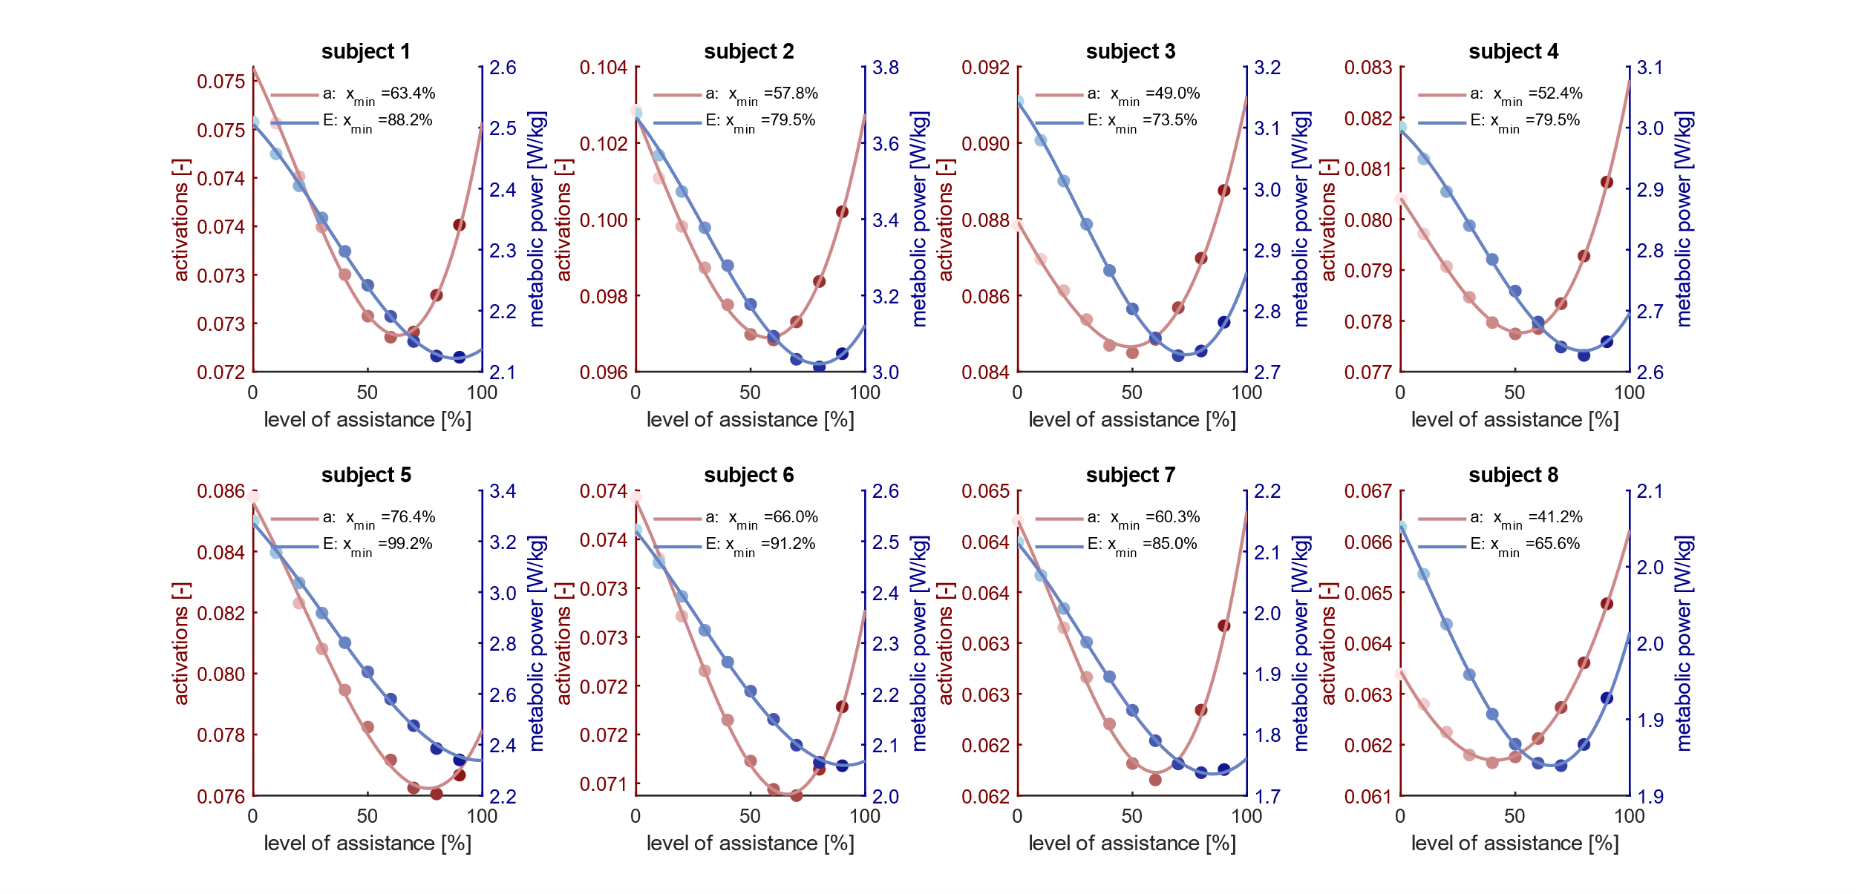
Supplementary Figure 1: Mean muscle activations and metabolic power across levels of assistance for each subject.

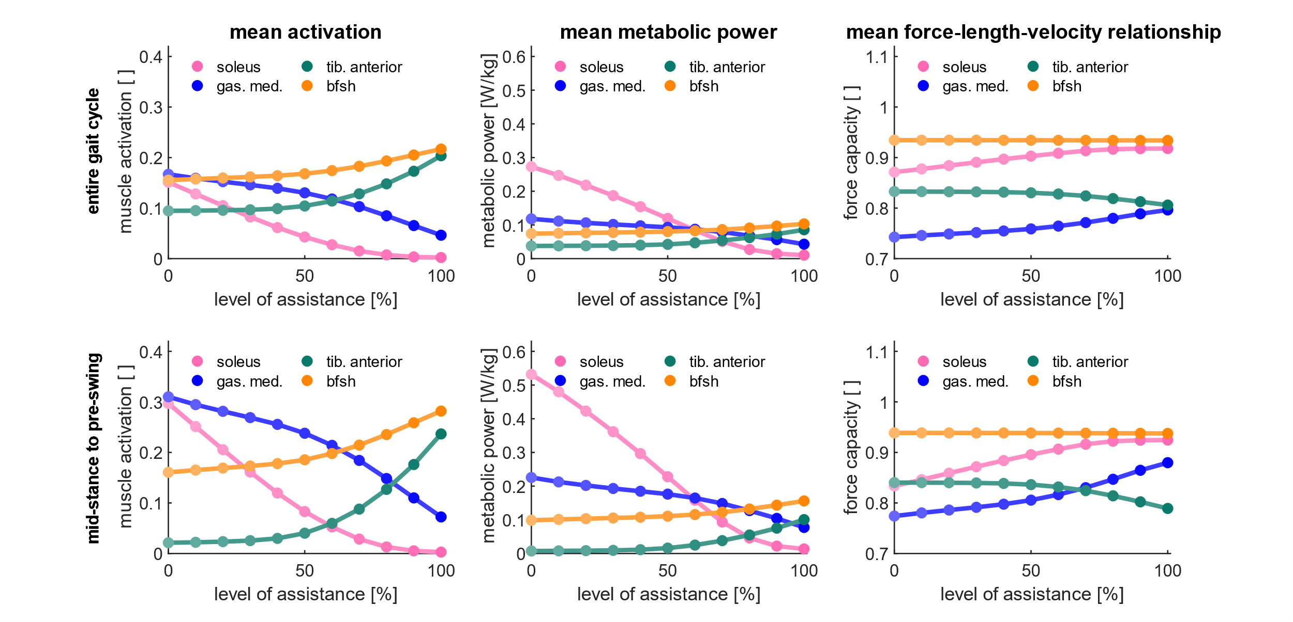
Supplementary Figure 2: Mean muscle activations, metabolic rates, and force-length-velocity relationship of soleus, gastrocnemius medialis, tibialis anterior, and biceps femoris short head (bfsh) muscles across levels of assistance. Mean values were computed with respect to the entire gait cycle (upper row) and mid-stance to pre-swing phase, 12 to 62% of the gait cycle. The force-length-velocity relationship represents the active force generation capacity of the muscle, computed as the product of the force-length and force-velocity relationship. Average values were computed among all subjects.

