Supplementary materials for ‘Assessment of Chilling Requirements of a Comprehensive Diversity of Olive Cultivars: A PhenoFlex and Forcing Test Approach to Inform Sustainable Cultivation Under Climate Change’

Omar Abou-Saaid^{1,2,3}, Adnane El Yaacoubi⁴, Cherkaoui El Modafar³, Hayat Zaher², Bouchaib Khadari^{1,5, *}
¹AGAP Institut, Université de Montpellier, CIRAD, INRAE, Institut Agro, 34398 Montpellier, France
²INRA, UR Amélioration des Plantes, Marrakech 40005, Morocco
³Centre d’Agrobiotechnologie et Bioingénierie, URL-CNRST 05, Université Cadi Ayyad, Marrakech 40010, Morocco
﻿⁴Ecole Supérieur de Technologie, Université Sultan Moulay Slimane, Khenifra 54006, Morocco
⁵Conservatoire Botanique National Méditerranéen, Agropolis International, 34090 Montpellier, France
*Corresponding author: b.khadari@cbnmed.fr
Introduction
Accurate assessment of chill is a prerequisite in the process of selecting resilient cultivars in future conditions and in different areas. In this study, we used the PhenoFlex model previously calibrated for olive Olea europaea L. along with endodormancy dates derived from a forcing test to estimate the amount of y_{c} (chill requirement) and z_{c} (heat requirement) for the flowering of nine cultivars representative of the phenotypic variability of cultivated olive in the Mediterranean Basin. The season onset for the start date of accumulation of chill for each cultivar was derived from the PLS analysis in a formal study (Abou-Saaid et al., 2022). Further, we demonstrated earlier in Abou-Saaid and Khadari (2025) that the start of chill calibrated with PhenoFlex was similar to a PLS analysis conducted in (Abou-Saaid et al., 2022). In this supplementary material we provide details about the calibration workflow of the amount of chill and heat for the nine olive cultivars and the additional figures and tables as mentioned in the main text.
Work flow of the calibration process using the calibrated PhenoFlex for Picholine Marocaine
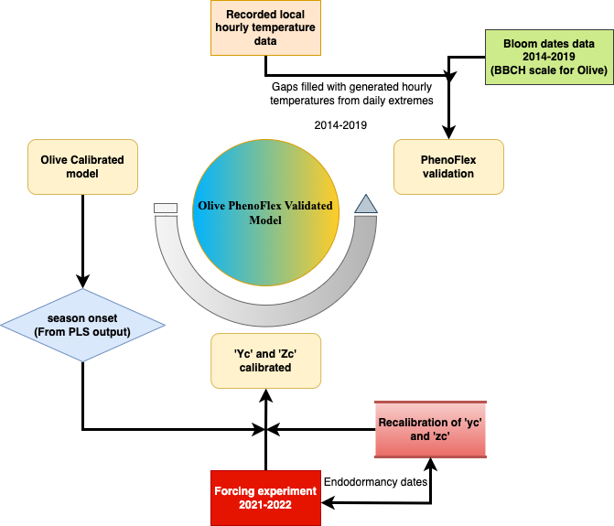
Figure S1. Overview of the modelling workflow process used in this study. The calibrated model for cultivated olive (PM), was used with its original parameters except for the two parameters for y_{c} and z_{c} calibrated using endodormancy dates derived from two years experiments (2021 and 2022) and FFD dates for height years between 2014 and 2022. The season onset used for each cultivar is from a PLS analysis. Hourly temperatures recorded directly from the study site were used for this purpose.
Table S1. Endodormancy dates derived from the forcing tests for the two years 2021 and 2022
Cultivar | Endodormancy dates
Cultivar | 2021 | 2022
Sabatera | February 20th | February 01st
Dressi | January 20th | February 8th
Beladi | January 20th | February 8th
Grappolo | February 11st | February 22nd
Arbequina | February 20th | February 22nd
Sevillenca | February 1st | February 8th
Frantoio | February 20th | March 1st
Koroneiki | February 25th | February 22nd
Leccino | February 25th | March 8th
Table S2. Global climate models from climate wizard database that are used to generate future temperature data for Tassaout, where the worldwide Olive Germplasm bank is maintained. (adapted and modified from Fernandez et al. (2020))
Name | Abbreviation | Climate category | Reference and/or link
Beijing Climate Center – Climate System Model 1.1 | bcc-csm1−1 | Moderate | Wu (2012) http://forecast.bcccsm.ncc-cma.net/web/channel-43.htm
Geophysical Fluid Dynamics Laboratory – Earth System Models | GFDL-ESM2G  GFDL-ESM2M | Cool  Cool | Delworth et al. (2006) https://www.gfdl.noaa.gov/earth-system-model/
 | GFDL-CM3 | Warm | Donner et al. (2011)
Institute of Numerical Mathematics Climate Model version 4 | inmcm4 | Cool | Volodin et al. (2010)
Institute Pierre –Simon Laplace – Climate Model 5A | IPSL-CM5A-LR  IPSL-CM5A-MR | Moderate  Moderate | https://cmc.ipsl.fr/ipsl-climate-models/ipsl-cm5/
Community Climate System Model 4 | CCSM4 | Moderate | http://www.cesm.ucar.edu/models/ccsm4.0/
Community Earth System Model version 1 – BioGeoChemical model enabled | CESM1-BGC | Moderate | Lindsay et al. (2014)
Beijing Normal University –Earth System Model | BNU-ESM | Warm | Ji et al. (2014)
Canadian Earth System Model 2 | CanESM2 | Warm | Chylek et al. (2011)
Model for Interdisciplinary Research On Climate –Earth System Model | MIROC-ESM | Warm | Watanabe et al. (2011)
Centre National de Recherches Météorologiques – Climate Model 5 | CNRM-CM5 | Warm | http://www.umr-cnrm.fr/spip.php?article126&lang=en
Australian Community Climate and Earth-System Simulator 1.0 | ACCESS1−0 | Moderate | Bi et al. (2013)
Commonwealth Scientiﬁc and Industrial Research Organization – Mark3.6.0 | CSIRO-Mk3−6-0 | Warm | Rotstayn et al. (2010)

Table S3. Chilling phases of the studied cultivars with the representative cultivar for each group and its chill requirements delineated with PhenoFlex.
Chilling group | Representative cultivar | Chilling Phase¹ | Chill requirements (CP)
High chill cultivars | Leccino | November 21st -February 24th | 104
Mid chill cultivars | PM | December 27th -February 21st | 58
Low chill cultivars | Sabatera | January 01st - January 25th | 38
Abou-Saaid et al. (2022)¹

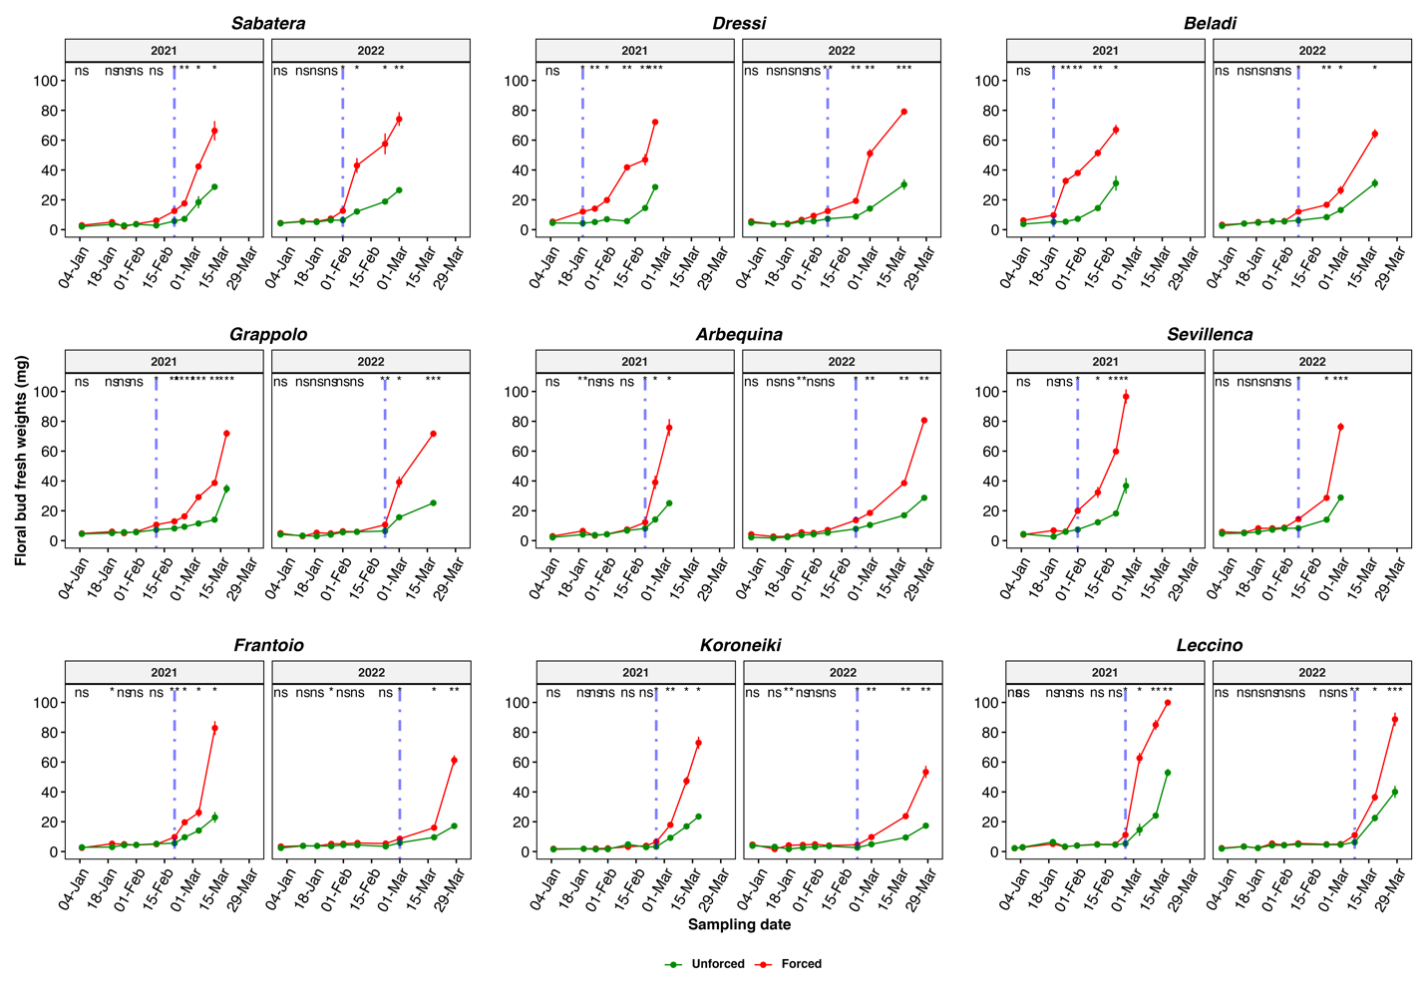
Figure S2. Dynamics of floral bud weights subjected to two treatments over two consecutive years (2021 and 2022), starting from January each year. The blue line depicts the progression of floral bud weights under natural conditions (unforced floral buds), while the orange line represents the floral bud weights dynamics under forced conditions in growing room. The term “endodormancy” is used to denote the point at which a t-test comparison of mean bud weights between the two treatments becomes significant and maintains this significance in subsequent sampling dates.

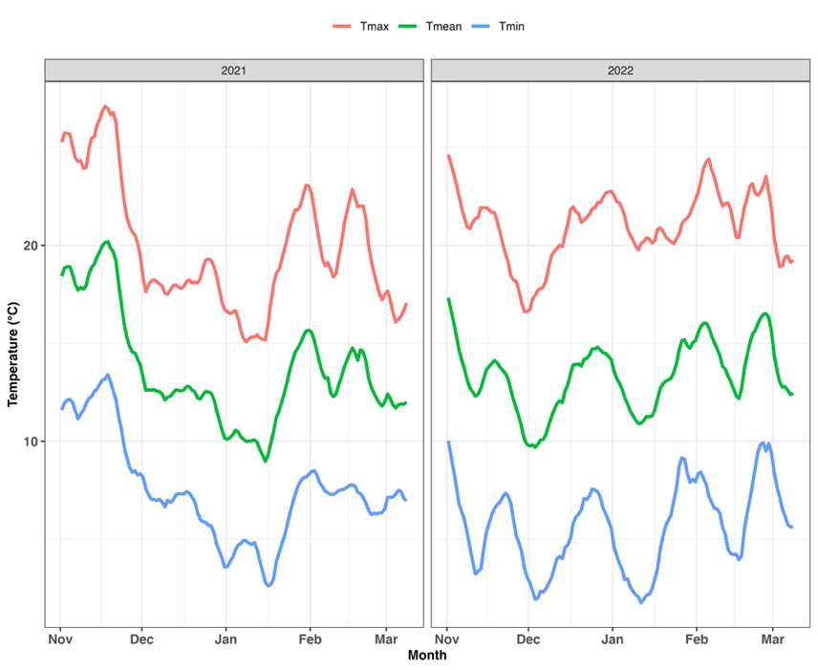
Figure S3. Variation in the daily minimum, maximum, and mean temperatures registered during the two seasons of experiments, 2020-2021 and 2021-2022, spanning from November to March. Temperatures are plotted with a running mean of 11 days.

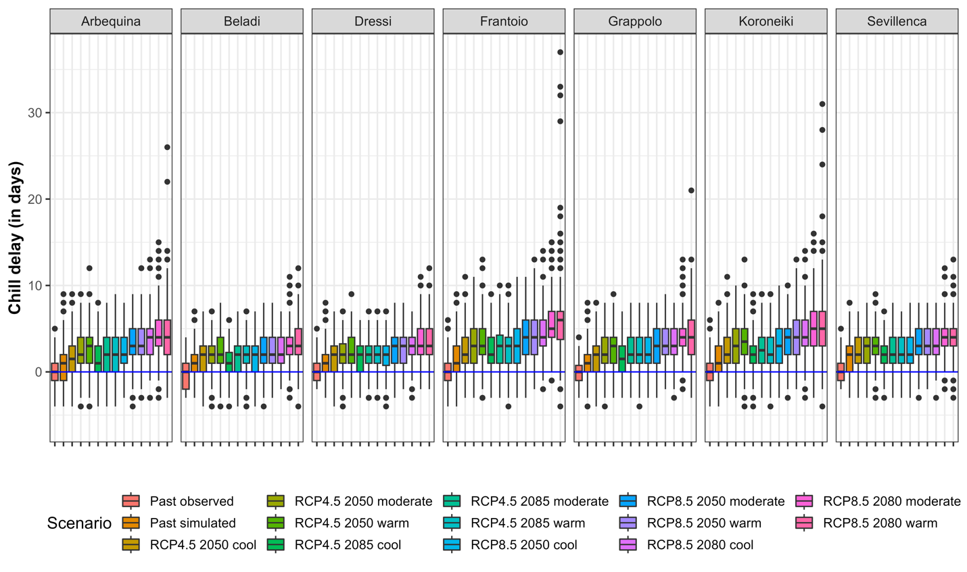
Figure S4. Chill delay as projected using PhenoFlex model for each cultivar with its chill requirements calculated by PhenoFlex (see Table 1) using chill start date delineated with PLS. The delay is expressed as the difference in days between a median value of the date of the end of chill estimated with PhenoFlex for observed temperatures (Past observed) and the date projected using temperatures generated for each scenario.

References

Abou-Saaid, O. et al., 2022. Statistical Approach to Assess Chill and Heat Requirements of Olive Tree Based on Flowering Date and Temperatures Data: Towards Selection of Adapted Cultivars to Global Warming. Agronomy, 12(12): 2975. doi:10.3390/agronomy12122975.
Abou-Saaid, O. and Khadari, B., 2025. Forcing experiment and model integration to validate an olive tree phenological model. Agricultural and Forest Meteorology, 373: 110752. doi:https://doi.org/10.1016/j.agrformet.2025.110752.
Fernandez, E., Whitney, C. and Luedeling, E., 2020. The importance of chill model selection — a multi-site analysis. European Journal of Agronomy, 119. doi:https://doi.org/10.1016/j.eja.2020.126103.

