Fig.1: NPW water sample at various dilutions tested for the manganese tolerating bacterial presence recognised as developed colonies.

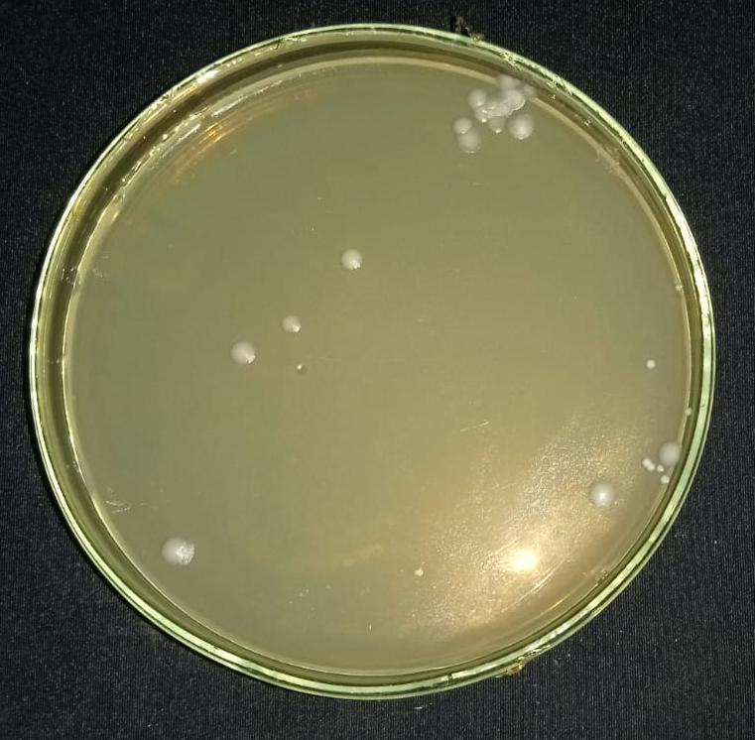 | 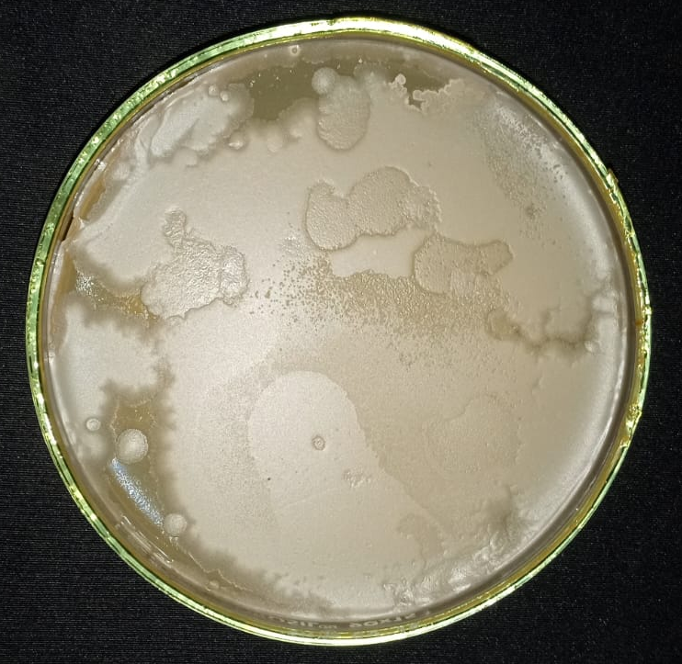
0.05 mM – NPW Dil. 10⁻² | 0.05 mM – NPW Dil. 10⁻⁴
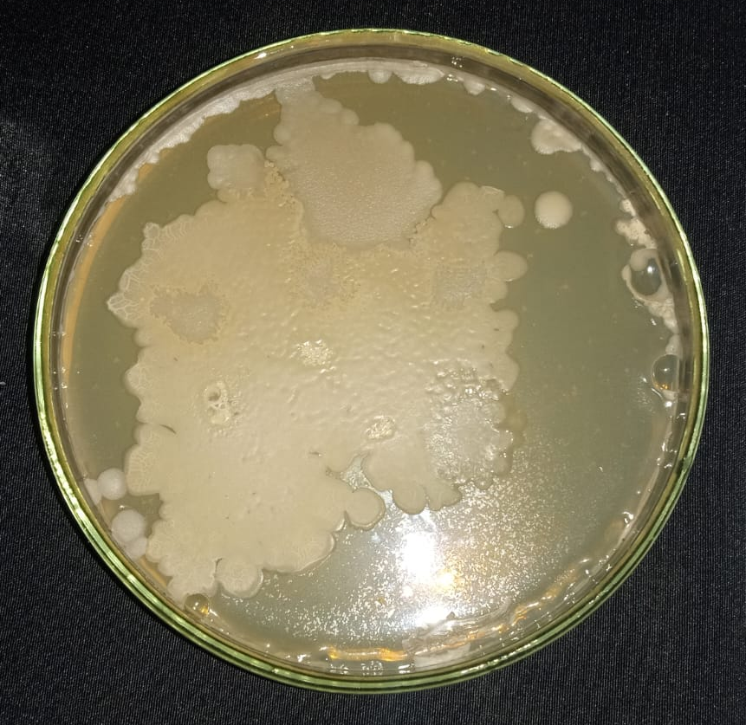 | 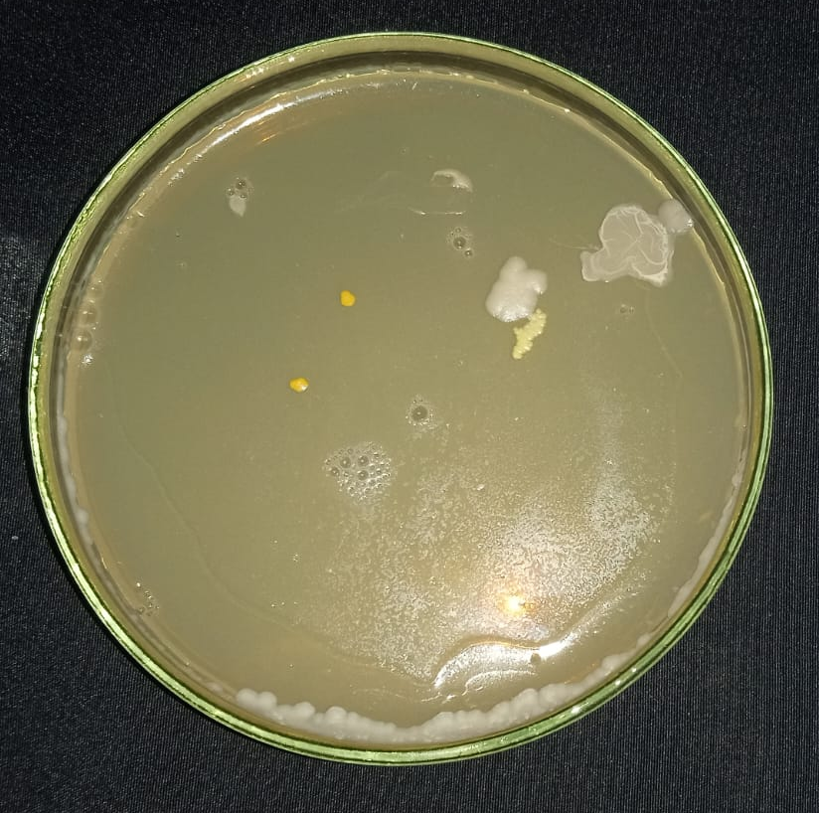
1 mM – NPW Dil. 10⁻² | 1 mM – NPW Dil. 10⁻⁴
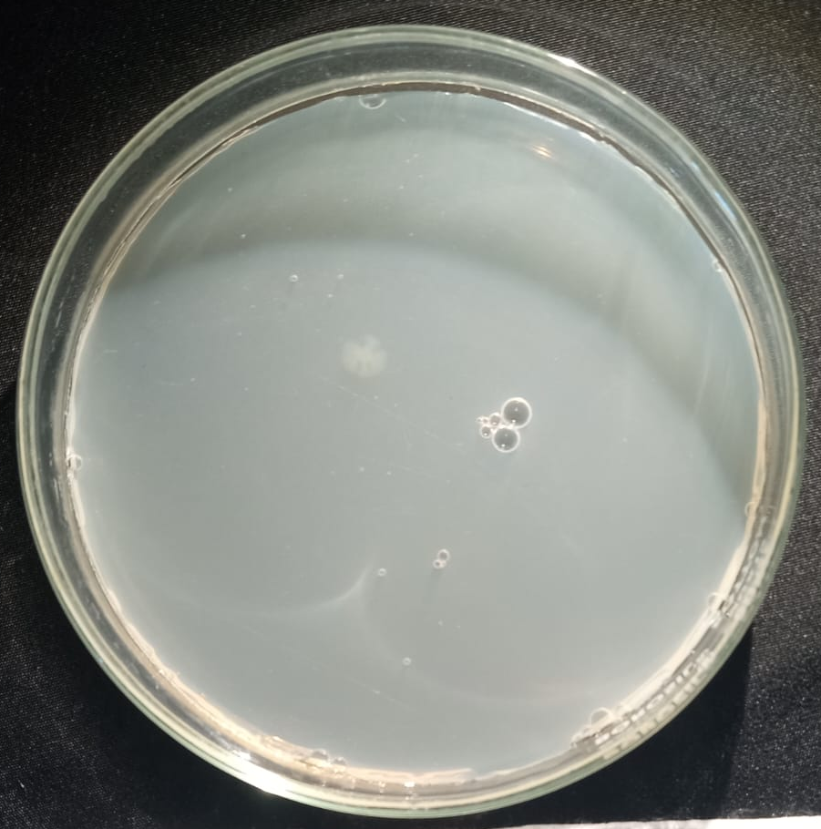 | 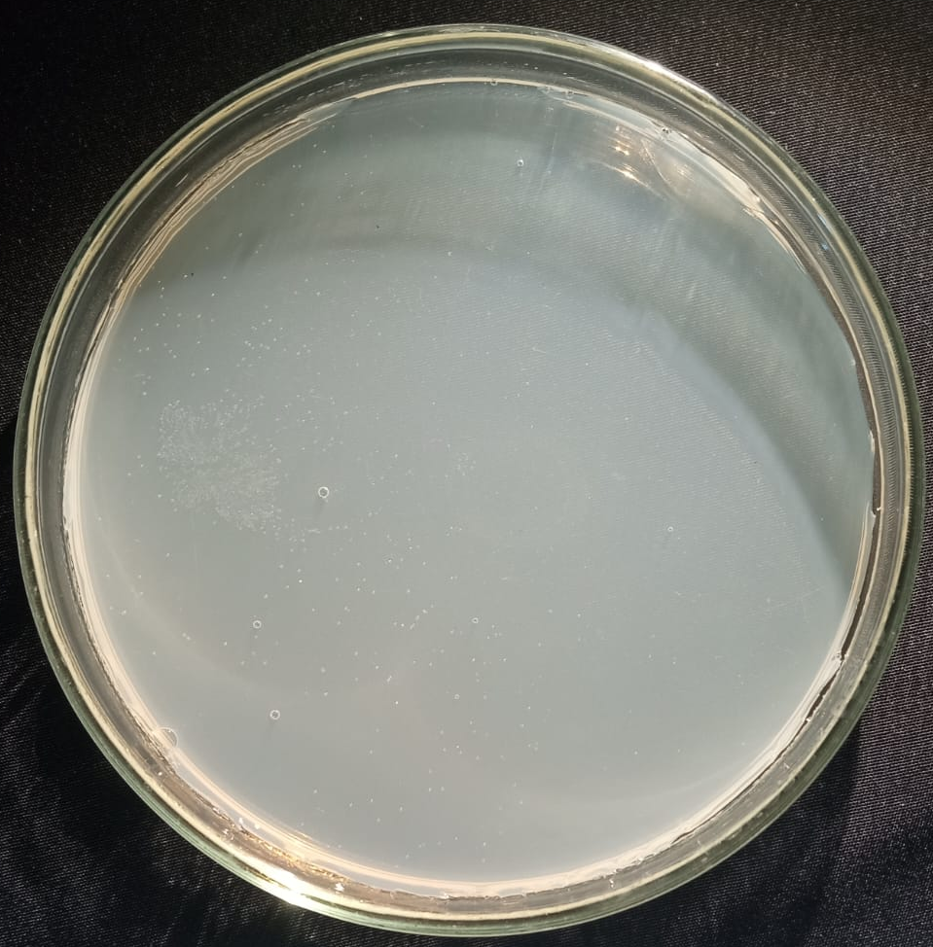
0.1 mM – NPW Dil. 10⁻² | 0.1 mM – NPW Dil. 10⁻⁴
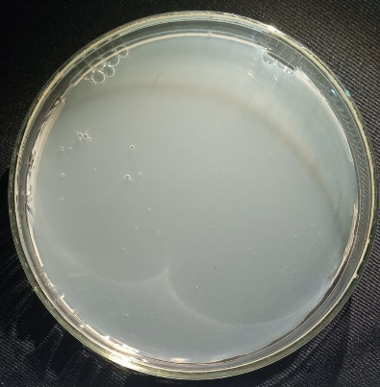 | 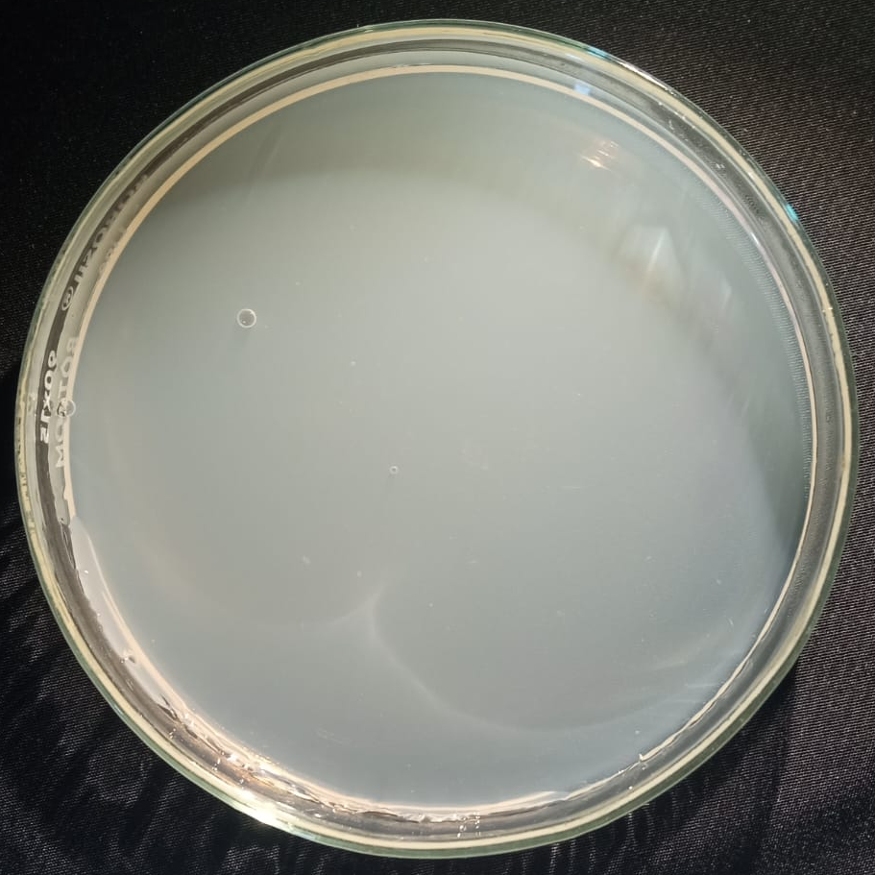
0.5 mM – NPW Dil. 10⁻² | 0.5 mM – NPW Dil. 10⁻⁴

Fig.2: DCW water sample at various dilutions tested for the manganese tolerating bacterial presence recognised as developed colonies.

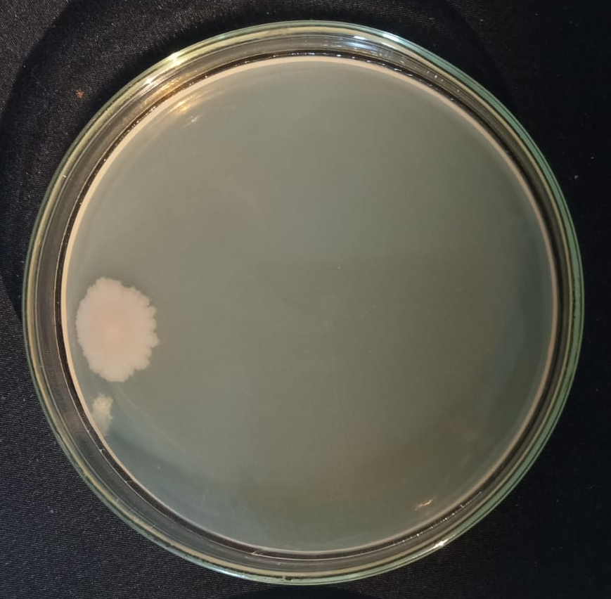 | 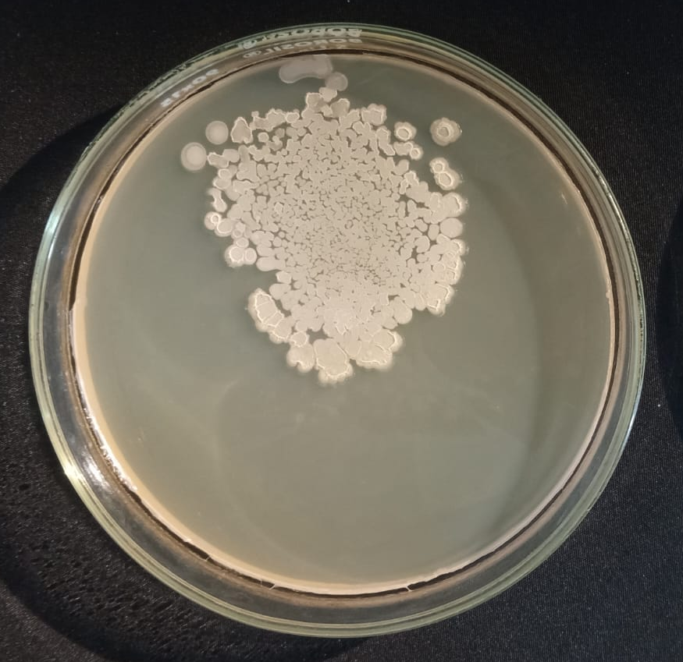
0.05 mM -DCW Dil. 10⁻² | 0.05 mM -DCW Dil. 10⁻⁴
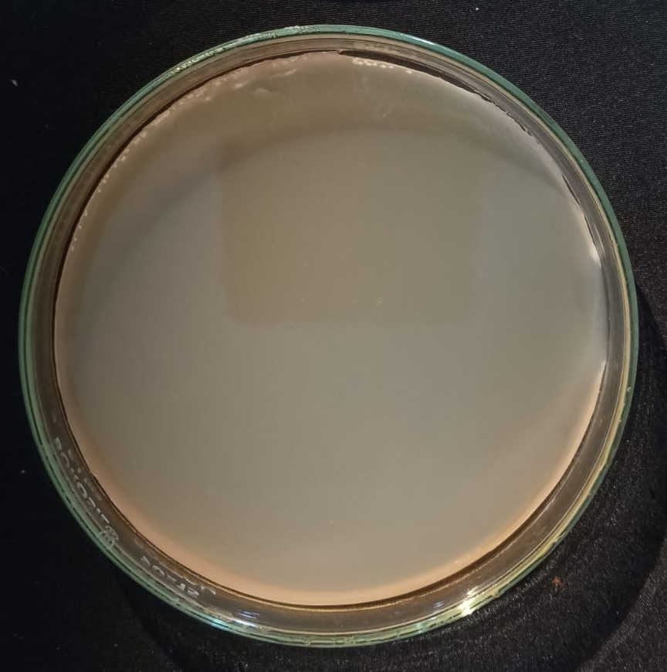 | 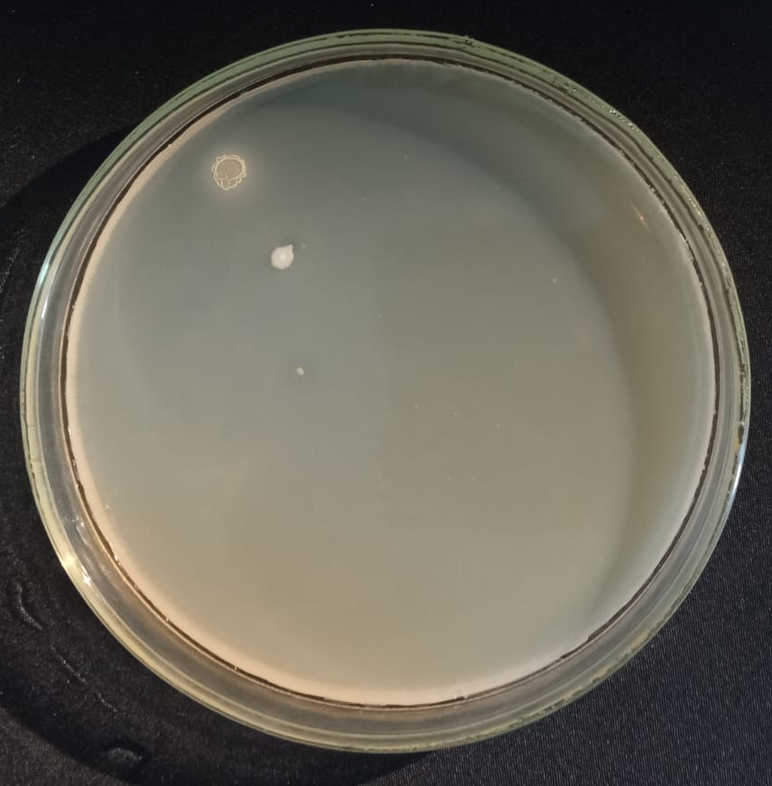
1 mM -DCW Dil. 10⁻² | 1 mM -DCW Dil. 10⁻⁴
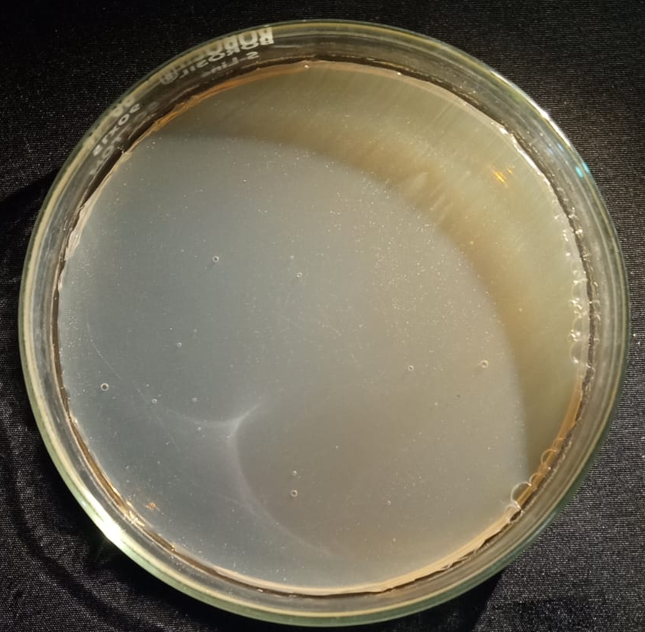 | 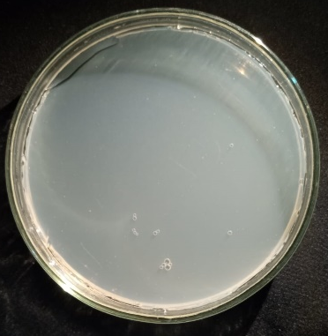
0.1 mM -DCW Dil. 10⁻² | 0.1 mM -DCW Dil. 10⁻⁴

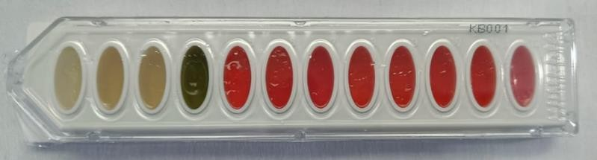
Uninoculated HiIMViC test kit
Mn/1/DCW | Mn/1/NPW
Fig : IMViC and sugar fermentation output recorded for Manganese heavy metal tolerant bacteria

Image: MIC (Minimum Inhibitory Concentration) of MnSO4. H2O (Manganese sulphate monohydrate for selected isolates
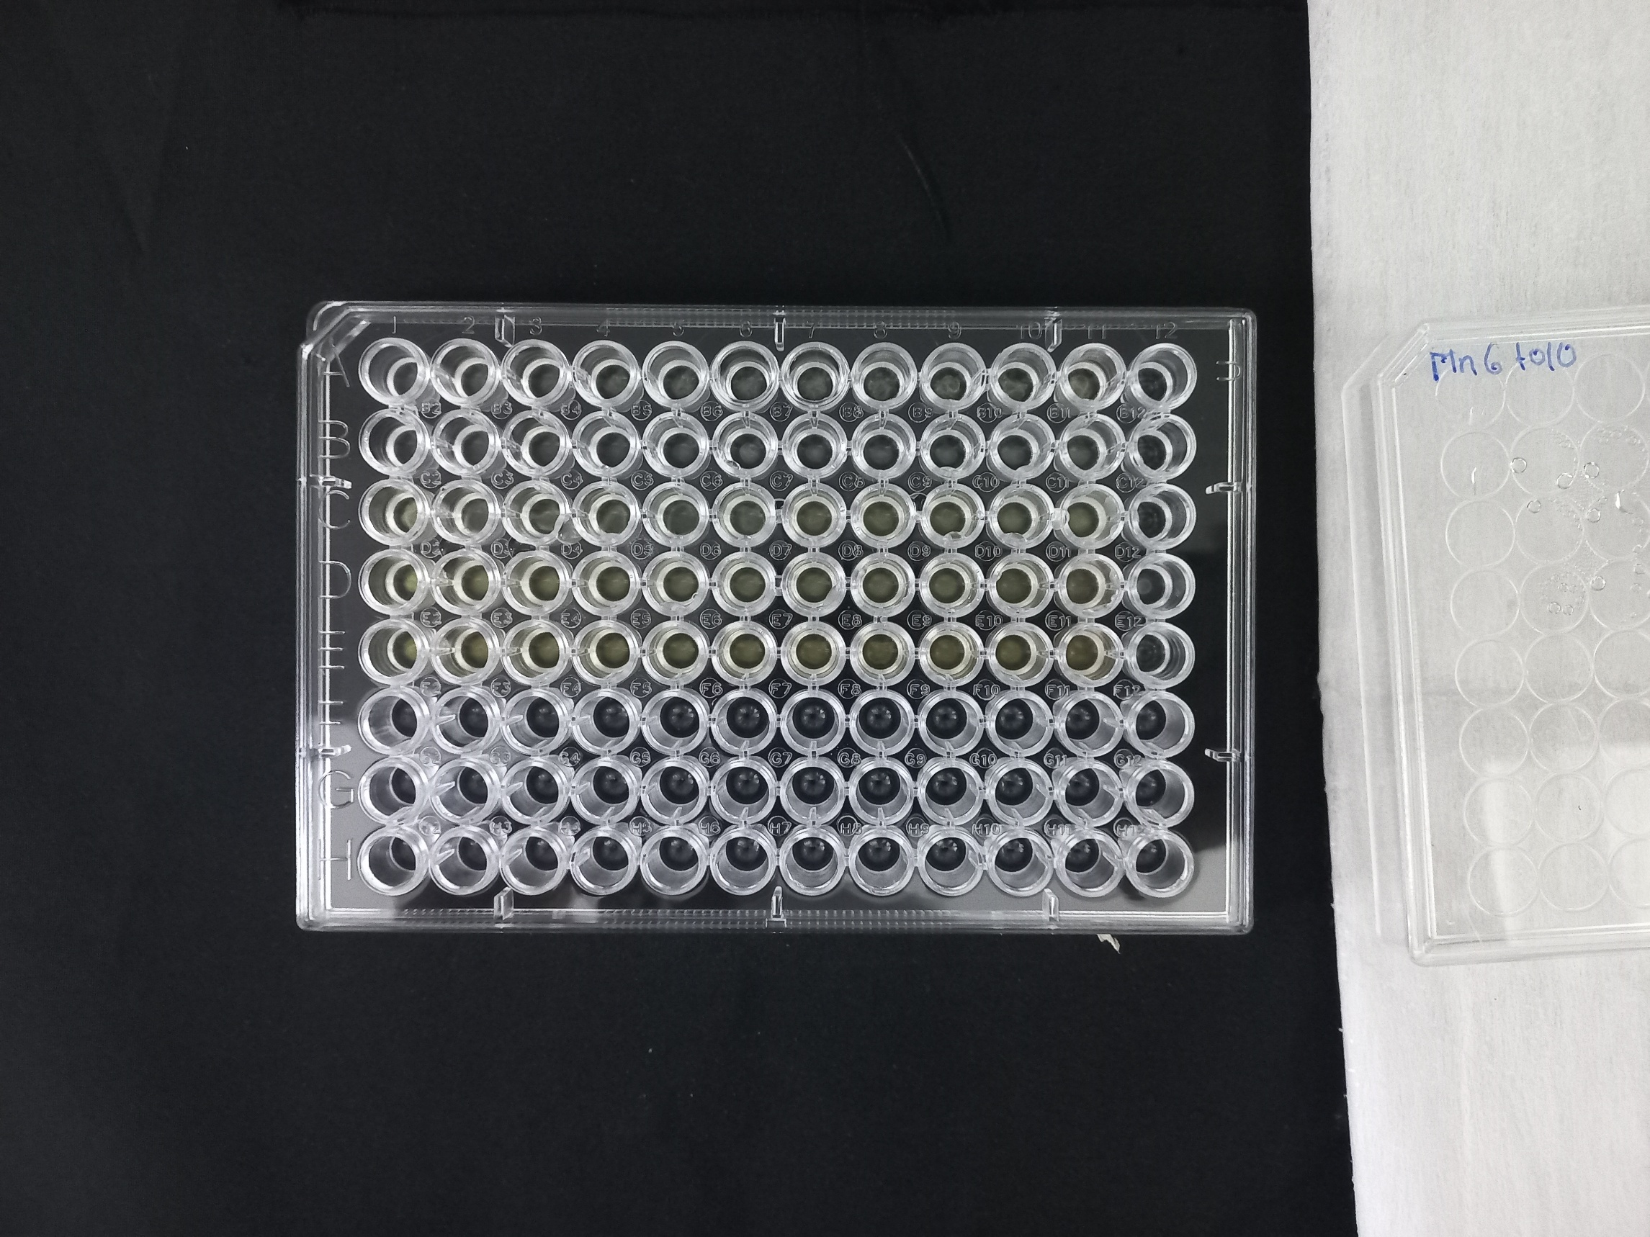

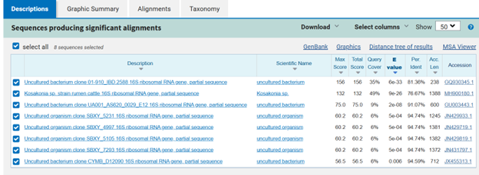

Fig : The Sample Mn/1/DCW showed best score homology with Kosakonia sp.

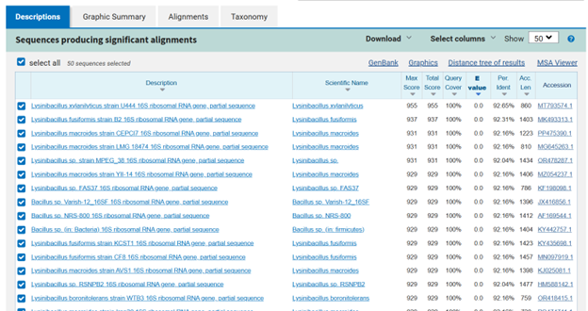

Fig : The Sample Mn/1/NPW showed best score homology with Lysinibacillus xylanilyticus.

