Supporting Information

Appendix S1. Additional Methodology 1
Neurocognitive measures 1
MRI Sleep Protocol 3
MRI Data pre-processing and quality assessments 3
Appendix S2. Supplementary Results 3
Variable selection for clustering 4
Variable imputation 5
Between-subgroup comparisons on in-model neurocognitive variables 5
Supplementary Tables 6
Table S1 MRI Acqusition Parameters across sites. 6
Table S2 Between-group comparisons on the reward learning task while covarying for age and IQ. 6
Table S3 The differences on key clinical and in-model variables between autistic and non-autistic children within Subgroup 1. 7
Table S4 The details of the cluster-corrected differences in surface area and cortical thickness between all subgroups. 8
Table S5 The demographic information across subgroups at the second timepoint 9
Table S6. The results of the linear mixed-effects models (B=estimate derived from the model, p= p-value, R²= marginal variance explained attributed to the fixed effect). 10
Supplementary Figures 11
Figure S1 The overview of the pre-processing pipeline for structural images. 12
Figure S2. The uncorrected t-maps for the vertex-wise comparisons on surface area between all subgroups. 13
Figure S3. The neuroanatomical differences in cortical thickness. Cluster corrected t-maps (p<0.05) for A) Cluster 1-Cluster 2 B) Cluster1-Cluster 3 C) Cluster 3 – Cluster 4 D) Cluster 3 – Cluster 2 E) Cluster 2 – Cluster 4 F) Cluster 1- Cluster 4. 14
Figure S4. The neuroanatomical differences in surface area between subgroups while covarying for autism as a categorical effect. Cluster corrected t-maps (p<0.05) for A) Cluster 1-Cluster 2 B) Cluster1-Cluster 3 C) Cluster 3 – Cluster 4 D) Cluster 3 – Cluster 2 E)Cluster 2 – Cluster 4 F) Cluster 1- Cluster 4 15
Figure S5. The neuroanatomical differences in surface area between subgroups not covarying for IQ as a categorical effect. Cluster corrected t-maps (p<0.05) for A) Cluster 1-Cluster 2 B) Cluster1-Cluster 3 C) Cluster 3 – Cluster 4 D) Cluster 3 – Cluster 2 E)Cluster 2 – Cluster 4 F) Cluster 1- Cluster 4 16

Appendix S1. Additional Methodology

Neurocognitive measures
Specific tasks were augmented by additional pre-tests and parent demonstrations to make them more accessible for children with complex needs or intellectual disability. For example, we included animations where characters in the task demonstrate a difference between two stimuli as this simple categorisation is a prerequisite to understand the task rules. We then administer a pre-test where children must differentiate between these two stationary visual stimuli. Only after passing this pre-test, children can proceed to the task where these stimuli are moving. This allows us to ascertain whether children have the cognitive ability to engage with the task and understand the rules of the task.

Go-NoGo task design
Demonstration, pretest and practice stages are included before the main block of trials. The task consists of 40 test stimuli (NoGo trials), with 1 in 5 NoGo trials. Stimuli are presented in a pseudo-randomised order, with the constraint that NoGo stimuli must not appear consecutively, i.e., it needs to be separated by at least one Go trial. The interval between trials is set at 500ms and the speed of stimuli is set by the Bayesian Optimisation algorithm. Two different auditory feedback tones (dog barking or cat hissing) are given when participants respond to the go and no-go stimulus respectively.

Go-NoGo quality control procedure
48 children out of 213 children who attempted the task did not complete all 40 trials and needed to be excluded from analyses. A further 13 autistic and 6 neurotypical children were excluded because of very low d’ values (<0). 3 participants were excluded because qualitative feedback stated that they chose the No-Go stimulus on purpose.

Sustained attention task design
Demonstration, pretest and practice stages are included before the main block of trials. The minimum number of foils between targets is 3 and such that no more than one target appears on the screen at one time. Stimuli are set to be moving across the screen with a velocity that has been optimised for each child and the distance between stimulus was set to 6 metrics. The interval between trials is set at 500 ms. Auditory feedback tones, mainly car hound sounds, are given when participants respond to the target stimulus. The task discontinues after 5 consecutive missed trials, or a total time of 5 minutes.
Sustained attention quality control procedure
17 participants were excluded from the analyses because they completed less than 50 trials and had a low hit rate <5. A further three participants were excluded because of low d’ values (<0). 3 participants were excluded because of very poor quality as assessed by the qualitative information.
Reward learning task design
The position where the correct stimulus is presented (i.e., left or right on the screen), is randomised. Throughout the task, two magic boxes are rewarded on a 100% reinforcement schedule and two boxes are unrewarded on a 100% reinforcement schedule. The interval between trials is set at 500ms.

Reward learning quality control procedure
7 children were excluded from analyses as they preferred tapping one side of the screen on 80% or more trials which rendered their stimulus choice random. Two further participants were excluded because qualitative feedback suggested that they enjoyed tapping the incorrect stimulus.

Bayesian Optimisation
Young children, especially those with a neurodevelopmental condition, may struggle with their control of motor response. For that reason, we developed an algorithm which optimises the speed of moving stimuli to the individual ability of each child in the Go-NoGo and the Sustained Attention tasks. The Bayesian Optimisation algorithm uses the data gathered from a simple Reaction Time task, where children are asked to pop the bubbles that are moving across screen. By using the information about accuracy of the child at a given speed, it aims to estimate the speed at which child can most optimally complete the task i.e., touch at least 80% of the moving stimuli.

MRI Sleep Protocol
MRI was acquired during natural sleep. Children could visit a mock scanner before the MRI visit to ascertain whether they are comfortable in the MR environment. To prepare children for the experience, parents were also provided with an MRI preparation pack, which included earplugs and MRI sound recording. On the night of the scan, we used an MRI space tent, which is a structure that goes over the scanner and makes the environment more child friendly. Furthermore, parents could bring their child’s metal-free comfort items (e.g., soft toys, books) so that they could follow the child’s bedtime routine as closely as possible and to make the experience more comfortable for the child. Earplugs were inserted before the child fell asleep or during natural sleep, and further ear protection was added before the start of the scan.

MRI Data pre-processing and quality assessments
All MRI images that were acquired underwent preprocessing with Freesurfer v6.0.0. Subsequently the cortical reconstructions were visually inspected by trained raters. Depending on the accuracy of the cortical reconstruction, the decision was either to 0) exclude the scan 1) include it as is 2) perform manual edits or 3) process with SynthSR. All scans which have been rated as “3 = preprocces with synthSR” and “0 = exclude” were processed using synthSR and run with Freesurfer again. They were subsequently rated again to 0) exclude 1) include as is or 2) perform manual edits. After manual edits were performed, the scans were rated for the final time and given rating of 0) original scan better 1) edited scan better or 2) exclude scan. The details of how many scans were excluded at each step are presented in Figure S1.

Appendix S2. Supplementary Results

Participants on the diagnostic pathway for autism (suspected autism) and autistic children

There were 83 autistic children with a confirmed clinical diagnosis and 15 children who were on a diagnostic pathway for autism. The two groups did not differ significantly in age (t = 0.99, df = 19.82, p = .34) or gender (χ² = 0.46, df = 1, p = .50). At the follow-up wave, 12 children from the suspected autism group re-enrolled. Of these, 4 (33%) had received a confirmed autism diagnosis, while 8 (67%) remained on a diagnostic pathway 12–15 months after the initial assessment.

The effect of diagnostic group was significant while comparing children on the reward learning criterion, reward learning rate and mean response time (RT) on the reward learning task. The significant difference between the autism and suspected autism cases did not survive the correction for multiple comparisons (learning criterion: P=.75, learning rate: P =.53, mean RT: P=.61) and therefore, these groups were combined to form an autism group for the between-group analyses in neurocognitive measures.

Variable selection for clustering

The variable selection included both theoretical and data-driven procedures. We considered the multicollinearity bias when performing variable selection and weighting in clustering. This issue refers to an instance when variables are collinear, and some variables get assigned a higher weight than others. As a result, any highly correlated variables will be interpreted as the same construct and, due to higher weightings, can result in the final clustering solution to be skewed in the direction of that construct. We aimed to avoid this bias by identifying variables that are highly correlated but represent the same construct. We performed within-task correlations between all variables derived from the task and excluded highly correlated variables. Our main performance dependent variable d’ correlated highly with accuracy (r= 0.81), misses (r=-0.68), false alarms(r=-0.65), and correct rejections (r =0.74). We also noted a weak correlation of d’ with the mean response time (RT) to hit stimuli (r=-0.17) and a moderate correlation of d’ and response time variability (r=-0.39). As mean RT and RTV were highly correlated (r=0.70), we chose to include RTV as the main variable derived from RTs. Therefore, our main dependent variables on the Go/noGo task were d’ and RTV.
In the sustained attention task, the performance dependent variable d’ was highly correlated with accuracy (r=0.68), hitrate (r=0.82), correct rejections(r=0.73) and moderately correlated with false alarms (r=-0.48). However, it showed a weak correlation with misses (r=-0.07), as well as mean RT (r=0.22). Therefore, we chose to include d’ and mean RT in the clustering analyses.
For the non-social Reward Learning Task, we computed three main dependent variables: learning criterion, learning rate and accuracy, as well as mean RT. In the non-social paradigm, learning criterion correlated highly with accuracy (r=-0.73) and learning rate (r=-0.90). Therefore, our main selected DVs were learning criterion and mean RT.

Variable imputation

We aimed for the inclusion of children for whom all tasks were attempted but not all trials completed. For children who completed a subset of trials which precluded the evaluation of valid indices of performance, we imputed poor performance (n=17 for Go/noGo task, n=3 for the reward learning task, n=35 for the sustained attention task). The imputed value was derived from the bottom 5th percentile of that specific DV. This would allow the clustering algorithm to group children who struggled to complete a given task.

Between-subgroup comparisons on in-model neurocognitive variables

Subgroup 1 showed low scores across all three neurocognitive tasks, but also difficulties in task completion on the sustained attention measure. Over 62% of children in that subgroup show scores in the bottom 25th percentile on the inhibitory control performance variable (d’) and 59% of children in the subgroup were in the bottom 25th percentile in terms of the sustained attention index (d’). In terms of reward processing, 77% of children in that subgroup were in the bottom 25th percentile which signified slow learning from rewards.
Subgroup 3 showed comparably low scores to Subgroup 1 across all three measures but struggled to complete both the inhibitory control and the sustained attention measure. 65% of children in Subgroup 3 were unable to complete the inhibitory control task and 45% of children unable to complete the sustained attention task.

Supplementary Tables

Table S1 MRI Acqusition Parameters across sites.

Site | Manufacturer | Model | Software version | Coverage | Slice thickness [mm] | TR [ms] | TE | FA | FOV
Ghent | Siemens | PrismaFit 3T | XA30 | 256*256 | 1.0 | 2300 | 2.98 | 9 | 256
London | GE Medical  Systems | Discovery MR750 | DV25.0_R02_1549.b | 256*256 | 1.0 | 7.36 | 3.05 | 11 | 256
Nijmegen | Siemens | PRISMA-FIT | syngo MR E11 | 256*256 | 1.0 | 2300 | 2.96 | 9 | 93.75
Paris | Phillips | Ingenia | 5.7.1  \5.7.1.2 | 256*256 | 1.0 | 6.566 | 3.05 | 9 | 256
Stockholm | Siemens | Prisma 3T | VE11C | 256*256 | 1.0 | 2300 | 2.96 | 9 | 256

Table S2 Between-group comparisons on the reward learning task while covarying for age and IQ.
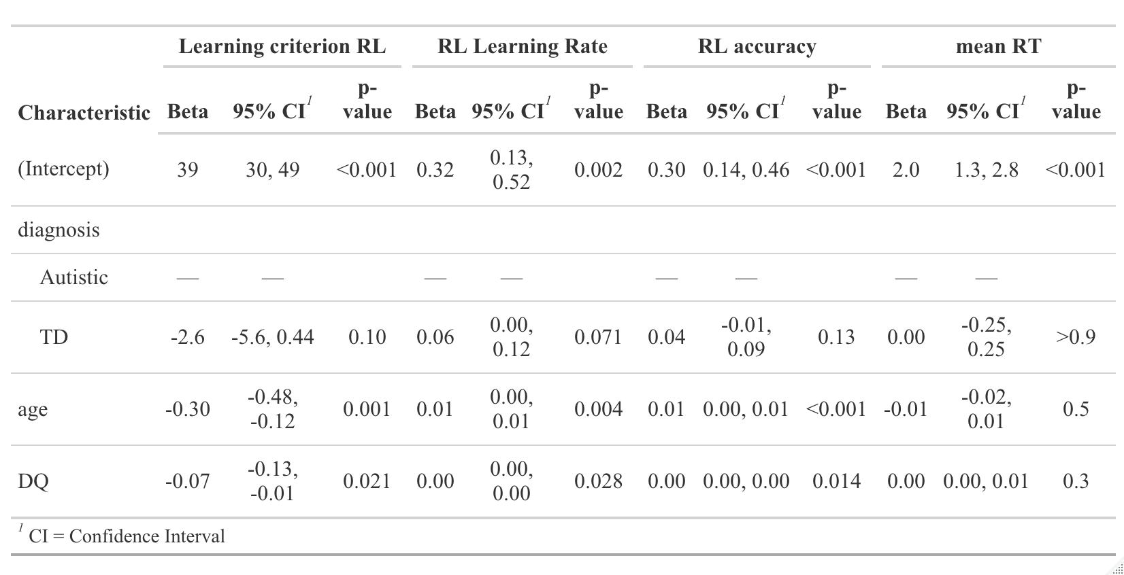

Table S3 The differences on key clinical and in-model variables between autistic and non-autistic children within Subgroup 1.

Cluster 1 | N | Autism N = 13¹ | TD N = 9¹ | p-value² | η2
gender | 22 |  |  | 0.7
Female |  | 4 (22%) | 3 (33%)
Male |  | 9 (71%) | 6 (67%)
Age (months) | 22 | 42.03 (±5.14) | 37.08 (±6.57) | 0.059 | 0.105
ADHD Rating Scale Total Score | 22 | 27.00 (±10.79) | 18.71 (±7.57) | 0.042* | 0.131
Inattention Score | 22 | 13.53 (±5.20) | 8.29 (±2.50) | 0.012* | 0.220
Hyperactivity-Impulsivity Score | 22 | 13.47 (±5.95) | 10.43 (±5.50) | 0.2 | 0.022
Total SRS score | 22 | 89.82 (±30.87) | 44.71 (±5.22) | <0.001*** | 0.532
Sensory Experiences Questionnaire Total Score | 22 | 84.00 (±16.68) | 64.57 (±8.85) | 0.020* | 0.231
Response Time Variability on the Go/No-Go task | 22 | 0.35 (±0.13) | 0.35 (±0.16) | 0.9 | -0.038
d' on the Go/No-Go task | 22 | 0.00 (±0.98) | 0.39 (±0.85) | 0.3 | 0.011
mean RT on the Sustained Attention task | 22 | 1.20 (±0.40) | 1.21 (±0.49) | >0.9 | -0.040
d' on the Sustained Attention task | 22 | 0.23 (±1.45) | 0.29 (±1.29) | >0.9 | -0.040
mean RT on the Reward Learning task | 22 | 2.68 (±3.02) | 3.89 (±6.26) | 0.9 | -0.038
Learning Criterion on the Reward Learning task | 22 | 29.00 (±1.94) | 29.56 (±1.33) | 0.3 | 0.012
¹n (%); Mean (±SD)
²*p<0.05; **p<0.01; ***p<0.001

Table S4 The details of the cluster-corrected differences in surface area and cortical thickness between all subgroups.
 | H | Region | BA | Vertices | Talairach | t_{max} | p_{cluster}
Surface Area
Subgroup 1 < Subgroup 2 | R | superior frontal gyrus, precentral gyrus, caudal middle frontal gyrus | 9, 4, 46 | 3354 | 22, 30, 30 | -1.668157 | 5.667346e-05
Subgroup 1 > Subgroup 2 | L | inferior parietal cortex, superior parietal cortex, lateral occipital cortex | 40, 5, 19 | 4786 | -31 -64 41 | 4.366879 | 2.048988e-05
 | L | precuneus cortex | 7 | 1815 | 7 -43 47 | 3.730647 | 4.471305e-03
Subgroup 1 < Subgroup 3 | R | precentral gyrus, superior frontal gyrus | 4,9 | 1439 | 21 10 52 | -1.668092 | 4.031344e-02
 | R | precentral gyrus | 4 | 1303 | 54, 0, 37 | -1.668176 | 4.365185e-02
Subgroup 1 > Subgroup 3 | R | precuneus cortex, isthmus-cingulate cortex, | 7, | 3349 | 15 -43 34 | 4.408204 | 2.442504e-05
 | L | precuneus cortex, isthmus-cingulate cortex | 7, | 2962 | -9 -36 32 | 3.822710 | 2.909032e-05
 | R | lateral occipital cortex | 19 | 2551 | 45 -64 -6 | 2.918478 | 1.267347e-03
 | L | lingual gyrus | 18 | 1525 | -16 -59 -1 | 4.166037 | 3.742301e-03
Subgroup 3 < Subgroup 2 | R | pars triangularis, lateral orbital frontal cortex, pars orbitalis | 45,11,  44 | 1732 | 46 35 -12 | -1.668516 | 1.024421e-03
 | L | pars triangularis, pars opercularis | 45,44 | 1530 | -50 18 18 | -1.669034 | 2.358125e-02
Subgroup 3 > Subgroup 2 | L | postcentral gyrus | 1 | 1235 | -57 -9 26 | 3.791780 | 3.974144e-02
Subgroup 3 < Subgroup 4 | R | pars triangularis, lateral orbital frontal cortex, pars orbitalis | 45,11,  44 | 1457 | 40 29 -8 | -1.668648 | 3.274240e-03
 | R | lingual gyrus | 18 | 1709 | 21 -62 4 | -1.668253 | 9.477666e-03
Subgroup 3 > Subgroup 4 | L | superior temporal gyrus | 22 | 987 | -54 -13 -5 | 3.500064 | 4.391680e-02
Subgroup 2 < Subgroup 4 | R | medial orbital frontal cortex, rostral anterior cingulate cortex | 11, 24/32 | 1186 | 7 28 -14 | -1.669629 | 9.876743e-05
 | R | postcentral gyrus, supramarginal gyrus, superior parietal cortex | 1,40,5 | 2652 | 43 -26 51 | -1.668102 | 4.159111e-04
 | L | superior frontal gyrus, rostral middle frontal gyrus | 9, 46 | 1042 | -13 61 -6 | -1.671409 | 3.362967e-03
 | L | lateral orbital frontal cortex, insula | 19, 13/16 | 1411 | -36 -2 -6 | -1.668407 | 6.196878e-03
Cortical thickness
Subgroup 3 > Subgroup 2 | R | lateral orbital frontal cortex, medial orbital frontal cortex, pars triangularis, rostral anterior cingulate cortex | 19, 11, 45, 24/32 | 3851 | 17 32 -19 | 3.731665 | 2.666936e-04
 | R | fusiform gyrus, inferior temporal gyrus | 37, 44/45 | 3900 | 40 -48 -12 | 3.091618 | 5.345980e-03
Subgroup 3 > Subgroup 4 | R | fusiform gyrus, inferior temporal gyrus | 37, 44/45 | 4835 | 40 -47 -13 | 3.253842 | 7.645096e-04
 | R | medial orbital frontal cortex, lateral orbital frontal cortex | 11,19 | 1945 | 15 34 -21 | 4.033410 | 5.718784e-03
 | L | rostral anterior cingulate cortex, medial orbital frontal cortex | 24/32, 11 | 943 | -7 33 -8 | 2.926005 | 1.387978e-02

Table S5 The demographic information across subgroups at the second timepoint
Subgroup | N | 1 N = 18¹ | 2 N = 59¹ | 3 N = 11¹ | 4 N = 20¹ | p-value²
Age (months) | 108 | 53 (51, 56) | 61 (53, 63) | 61 (51, 65) | 52 (46, 64) | 0.13
Gender | 108 |  |  |  |  | 0.2
F |  | 4 (22%) | 24 (41%) | 1 (9.1%) | 6 (30%)
M |  | 14 (78%) | 35 (59%) | 10 (91%) | 14 (70%)
Diagnosis | 108 |  |  |  |  | 0.003**
Autism |  | 11 (61%) | 15 (25%) | 8 (73%) | 6 (30%)
TD |  | 7 (39%) | 44 (75%) | 3 (27%) | 14 (70%)
ADHD Rating Scale Total Score | 108 | 27 (18, 37) | 14 (9, 23) | 17 (7, 22) | 16 (7, 25) | 0.005**
Inattention Score | 108 | 14 (9, 17) | 6 (2, 10) | 6 (3, 10) | 5 (2, 12) | 0.002**
Hyperactivity-Impulsivity Score | 108 | 15 (10, 20) | 9 (5, 13) | 12 (4, 12) | 10 (5, 13) | 0.027*
Score above a cut-off indicative of ADHD combined subtype | 108 |  |  |  |  | 0.009**
0 |  | 9 (50%) | 50 (85%) | 10 (91%) | 18 (90%)
1 |  | 9 (50%) | 9 (15%) | 1 (9.1%) | 2 (10%)
Score above a cut-off indicative of ADHD inattentive subtype | 108 |  |  |  |  | 0.015*
0 |  | 9 (50%) | 50 (85%) | 10 (91%) | 17 (85%)
1 |  | 9 (50%) | 9 (15%) | 1 (9.1%) | 3 (15%)
Score above a cut-off indicative of ADHD hyperactive-impulsive subtype | 108 |  |  |  |  | 0.2
0 |  | 12 (67%) | 49 (83%) | 9 (82%) | 19 (95%)
1 |  | 6 (33%) | 10 (17%) | 2 (18%) | 1 (5.0%)
¹Median (Q1, Q3); n (%)
²*p<0.05; **p<0.01; ***p<0.001

Table S6. The results of the linear mixed-effects models (B=estimate derived from the model, p= p-value, R²= marginal variance explained attributed to the fixed effect).

 |  |  | ADHD Total Score |  |  | Inattentive Score |  |  | Hyperactivity-Impulsivity Score
 |  |  | B | p | R² | B | p | R² | B | p | R²
Model 1 |  | Timepoint | 0.878 | 0.208 |  | 0.084 | 0.832 |  | 0.794 | 0.484
 |  | Gender | 1.554 | 0.478 |  | 1.647 | 0.139 |  | -0.093 | 0.045*
 |  | Baseline age | 0.262 | 0.064 |  | 0.114 | 0.112 |  | 0.148 | 0.938
 |  | Time Interval | -0.072 | 0.863 |  | -0.024 | 0.910 |  | -0.049 | 0.833
Model 2 |  | Subgroup | -2.739 | 0.008** | 0.056 | -1.570 | 0.003** | 0.069 | 0.363 | 0.039* | 0.033
 |  | Timepoint | 0.879 | 0.208 |  | 0.084 | 0.832 |  | -1.170 | 0.045*
 |  | Gender | 1.692 | 0.426 |  | 1.726 | 0.108 |  | 0.794 | 0.977
 |  | Baseline age | 0.267 | 0.053 |  | 0.116 | 0.092 |  | 0.009 | 0.049*
 |  | Time elapsed | -0.179 | 0.664 |  | -0.085 | 0.682 |  | -0.276 | 0.680
Model 3 |  | Subgroup  *Timepoint | -0.415 | 0.568 | <0.001 | -0.322 | 0.439 | <0.001 | -0.09 | 0.821 | <0.001
 |  | Subgroup | -2.117 | 0.155 |  | -1.087 | 0.177 |  | -1.30 | 0.217
 |  | Timepoint | 1.836 | 0.313 |  | 0.826 | 0.426 |  | 1.001 | 0.327
 |  | Gender | 1.692 | 0.426 |  | 1.726 | 0.108 |  | -0.034 | 0.977
 |  | Baseline age | 0.267 | 0.053 |  | 0.116 | 0.092 |  | 0.150 | 0.049*
 |  | Time elapsed | -0.179 | 0.664 |  | -0.085 | 0.682 |  | -0.094 | 0.821

Supplementary Figures

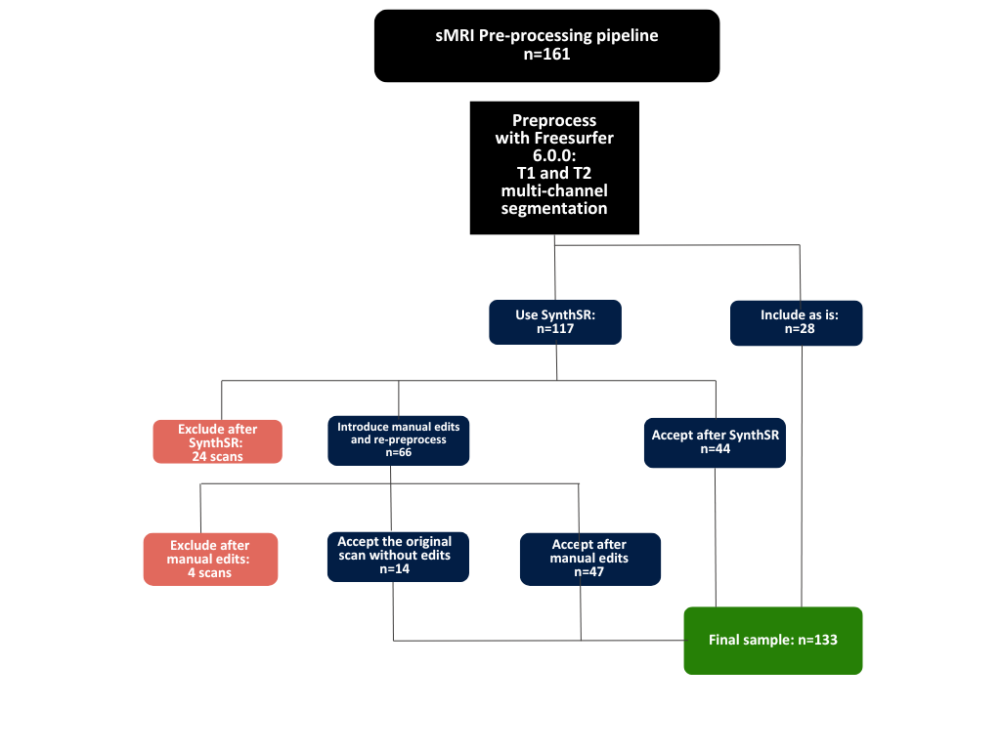

Figure S1 The overview of the pre-processing pipeline for structural images.

Surface Area (uncorrected)

Figure S2. The uncorrected t-maps for the vertex-wise comparisons on surface area between all subgroups.

Cortical thickness

Figure S3. The neuroanatomical differences in cortical thickness. Cluster corrected t-maps (p<0.05) for A) Cluster 1-Cluster 2 B) Cluster1-Cluster 3 C) Cluster 3 – Cluster 4 D) Cluster 3 – Cluster 2 E) Cluster 2 – Cluster 4 F) Cluster 1- Cluster 4.

Covariation for Autism

Figure S4. The neuroanatomical differences in surface area between subgroups while covarying for autism as a categorical effect. Cluster corrected t-maps (p<0.05) for A) Cluster 1-Cluster 2 B) Cluster1-Cluster 3 C) Cluster 3 – Cluster 4 D) Cluster 3 – Cluster 2 E)Cluster 2 – Cluster 4 F) Cluster 1- Cluster 4

No co-variation for IQ

Figure S5. The neuroanatomical differences in surface area between subgroups not covarying for IQ as a categorical effect. Cluster corrected t-maps (p<0.05) for A) Cluster 1-Cluster 2 B) Cluster1-Cluster 3 C) Cluster 3 – Cluster 4 D) Cluster 3 – Cluster 2 E)Cluster 2 – Cluster 4 F) Cluster 1- Cluster 4

