Supplementary Figure 1


Supplementary Figure 1: FAO questionnaire format for AMU estimation in sheep

Supplementary Figure 2

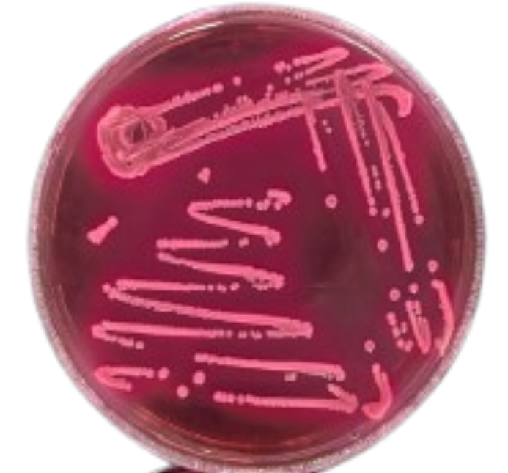

Supplementary Figure 2: Representative image of MacConkey agar showing pink colonies

Supplementary Figure 3

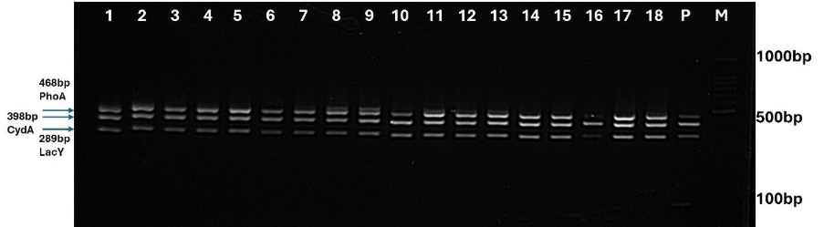
Supplementary Figure 3: Representative gel image showing the amplicons of E coli genes confirmed by multiplex PCR

Supplementary Figure 4

A) B)
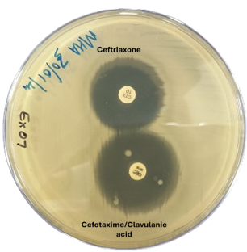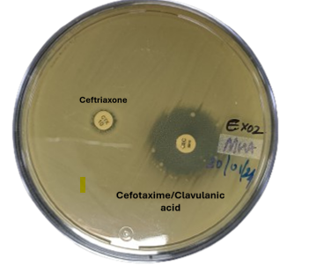

Supplementary Figure 4: Representative petri dish images for (A) Standard disc diffusion assay and (B) Combined Disc diffusion test for confirmation of ESBL producing in E. coli.

Supplementary Figure 5

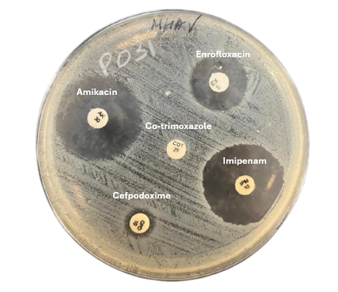
Supplementary Figure 5: Representative petri dish images for antimicrobial susceptibility test (AST) by disk diffusion method.

Supplementary Figure 6
A)
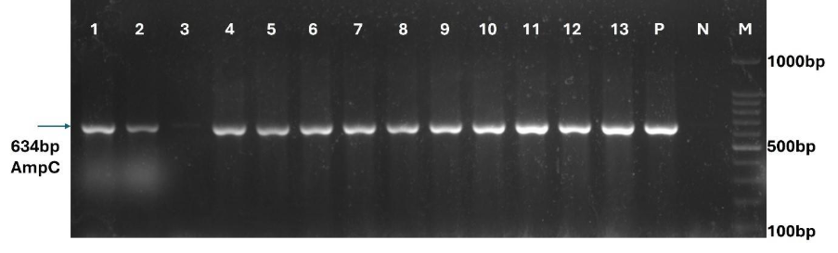

B)
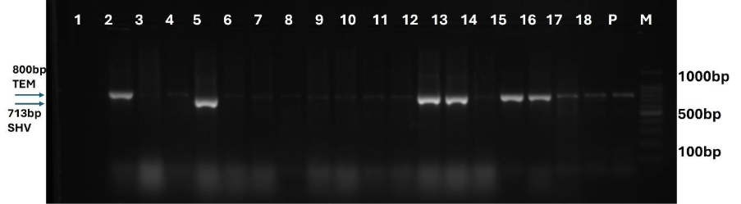
Supplementary figure 6: Representative gel image showing the amplicons of (A) AmpC gene (634bp) detected in ESBL E.coli (B) TEM (800bp) and SHV (713bp) genes detected by multiplex PCR in ESBL E.coli

Supplementary Figure 7
(a) (b)
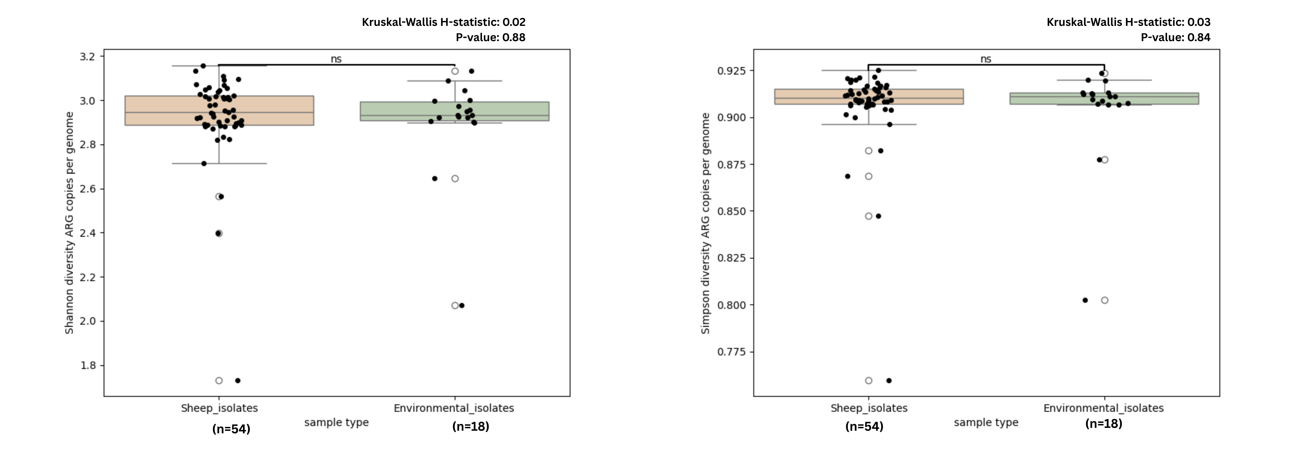
Supplementary Figure 7: Boxplots representing the alpha diversity calculated for the ARG copies number per genome in sheep (orange colour) and the environmental (green colour) isolates using the (a) Shannon and (b) Simpson indices. The difference in ARG copies number per genome alpha diversity between the two sources was not statistically significant.

Supplementary Figure 8 (a)
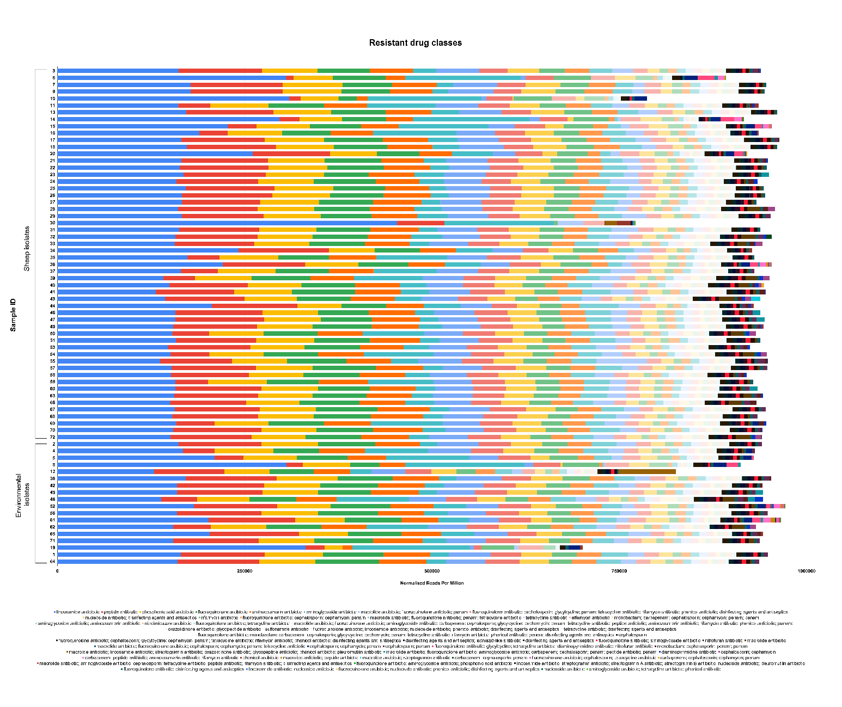

(b) (c)
Kruskal-Wallis H-statistic: 1.02 Kruskal-Wallis H-statistic: 2.55 P-value: 0.31 P- value: 0.11
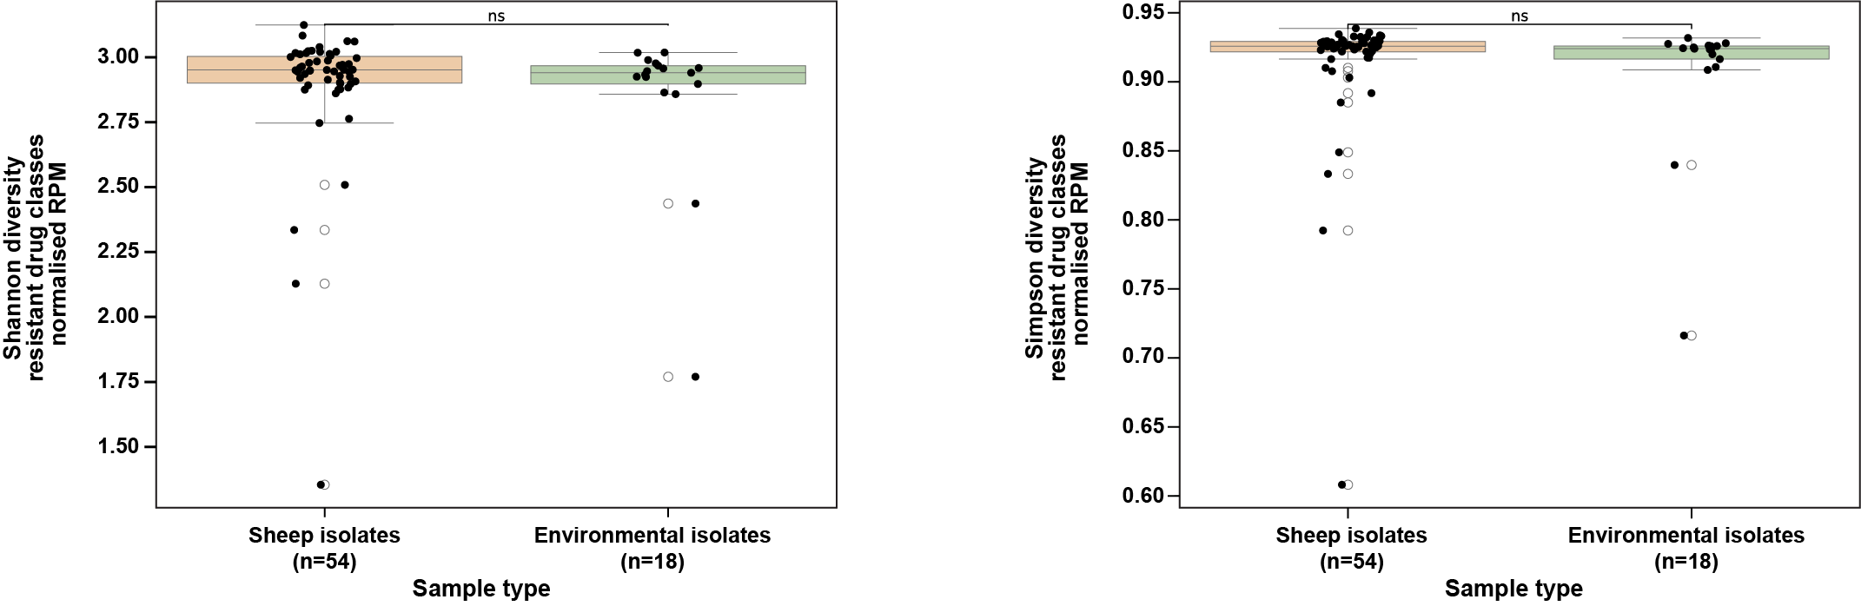
Supplementary figure 8: (a) Bar plot showing antibiotic resistant drug classes based on normalised RPM in ESBL-E coli isolates from sheep and environment.
Boxplots representing the alpha diversity calculated for the RPM of antibiotic-resistant drug classes in sheep (orange colour) and the environmental (green colour) isolates using the (b) Shannon and (c) Simpson indices. The difference in the RPM of antibiotic-resistant drug classes alpha diversity between the two sources was not statistically significant.

Supplementary Figure 9

Supplementary Figure 9: Bar plot showing resistance mechanisms based on normalised RPM in ESBL-E coli isolates from sheep and environment

Supplementary Figure 10
(a) (b)
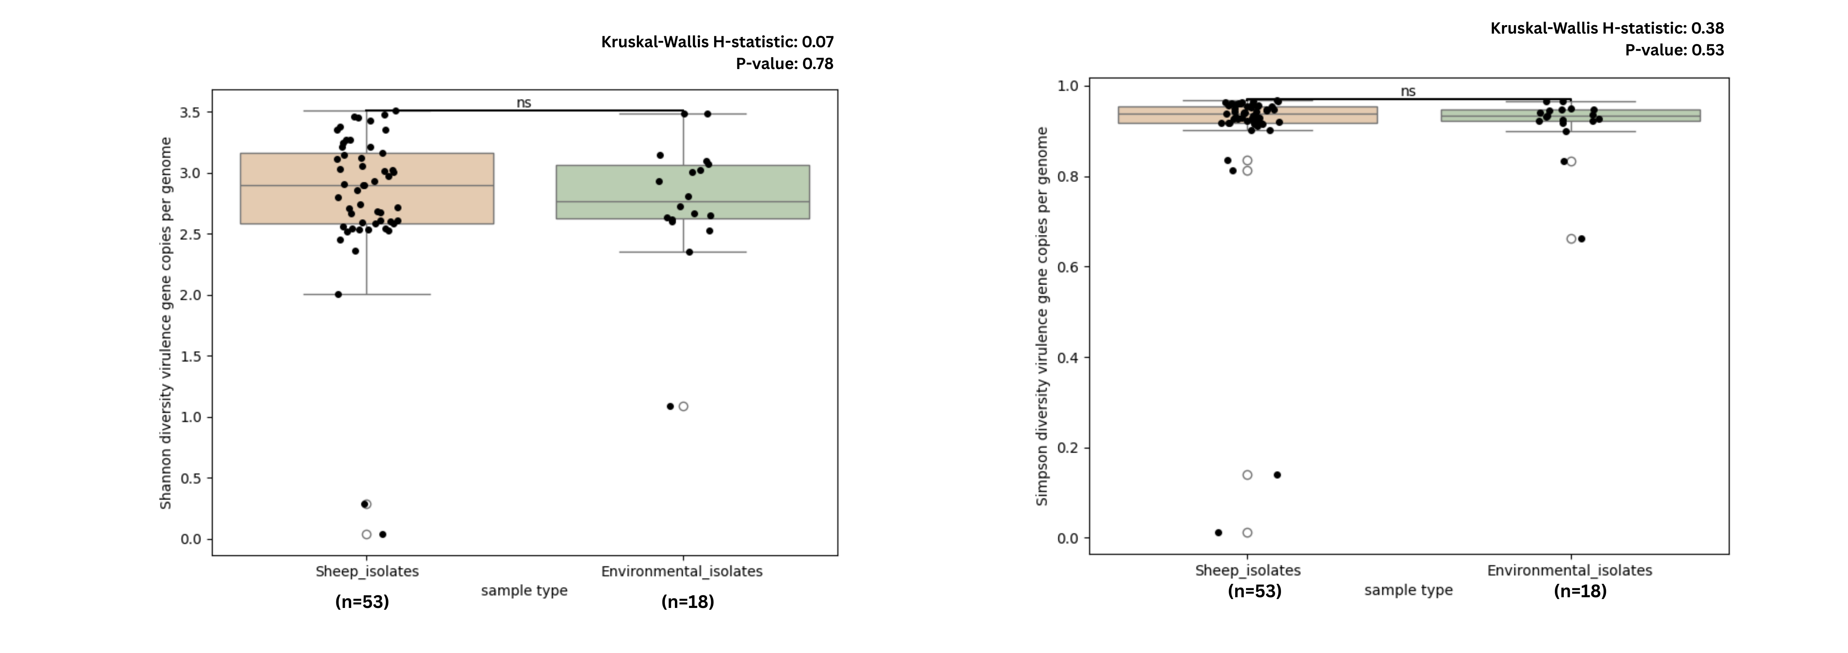
Supplementary Figure 10: Boxplots representing the alpha diversity calculated for the virulence gene copies number per genome in sheep (orange colour) and the environmental (green colour) isolates using the (a) Shannon and (b) Simpson indices. The difference in the virulence gene copies number per genome of virulence genes alpha diversity between the two sources was not statistically significant.

Supplementary Figure 11

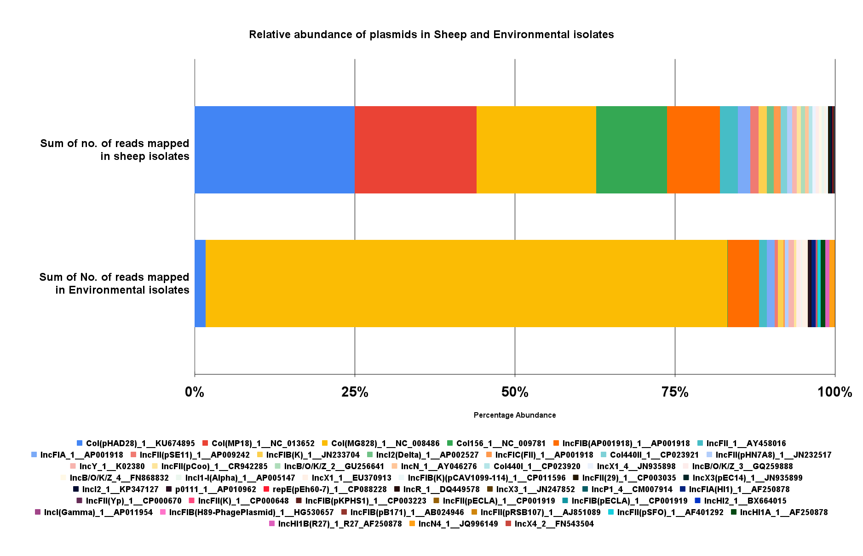
Supplementary Figure 11: Bar plot showing mean percent prevalence of plasmids based on normalised RPM in ESBL-E coli isolates from sheep and environment

Supplementary Figure 12
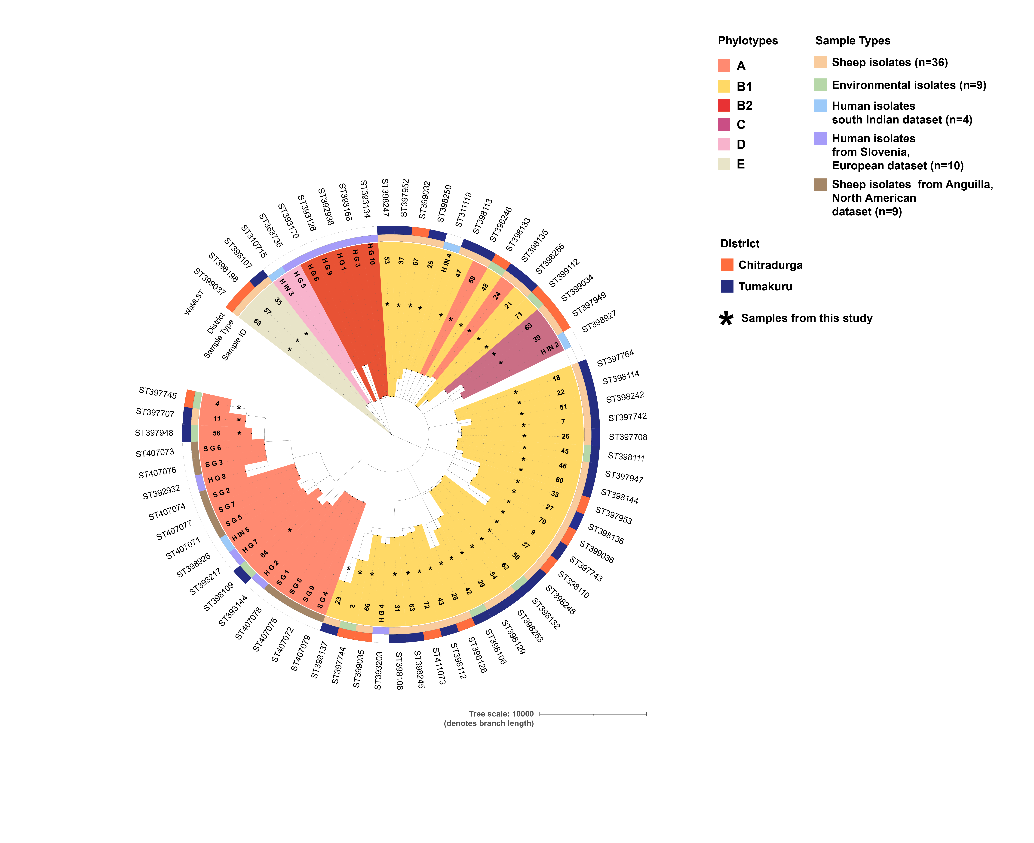
Supplementary Figure 12: Nested pie chart showing wgMLST and Phylotypes in 36 sheep isolates, 9 environmental, 4 human isolates from South Indian dataset, 10 human isolates from Slovenia, European dataset and 9 sheep isolates from Anguilla, North American dataset

Supplementary Figure 13

Supplementary Figure 13: Bar plot showing resistance pattern observed for WHOA authorized antibiotics based on normalised RPM (n= 54 sheep samples and n=18 environmental samples)

