Supplementary Materials
Supplement to: Pucher G., Kopp, K., Deep, A., et al. (2026): Development and Clinical Validation of a Multimodal AI Framework to Predict Persistent Fever During Antibiotic Therapy in Hospitalized Patients with Cancer

Table of contents
Supplemental Table 1. Data preprocessing steps 3
Supplemental Table 2. Engineered Features derived from clinical covariates. 3
Supplemental Table 3. Hyperparameter search spaces for the Logistic Regression baseline model. 7
Supplemental Table 4. Performance metric per model during 5-fold nested CV over 20 trials on the UME dataset. 7
Supplemental Table 5. Performance metric per model during validation on the holdout UME dataset. 8
Supplemental Table 6. Performance metric per model during validation on the pooled St. Josef/Ruhrlandklinik cohort. 8
Supplemental Table 7. Performance metric per model during validation on the MIMIC-IV ICU cohort. 9
Supplemental Table 8. Top 10 features with highest Permutation Feature Importance values for the multimodal TabPFN model and per dataset. 10
Supplemental Table 9. Distributional shift of fever prevalence in the datasets and additional time lagged features after changing the operational definition of the antibiotic reassessment time window 10

Supplementary Figure 1. Screenshot of the webapplication used in the clinician validation study 12

Supplementary File 1. Tripod+AI Checklist. 13

Supplemental Table 1. Data preprocessing steps
Processing step | Description
Measurement errors | Body temperature: Remove data points where $x<23 °C$ or $x>47 °C$
Measurement errors | Heart rate: Remove data points where $x<20 bpm$ or $x>300 bpm$
Measurement errors | Mean arterial pressure: Remove data points where $x<20 mmHg$ or $x>200 mmHg$
Measurement errors | Hemoglobin: Remove data points where $x≤0 g/dl$ or $x>40 g/dl$
Measurement errors | Serum Creatinine: Remove data points where $x≤0 mg/dl$ or $x>80 mg/dl$
Measurement errors | Pulse Oximetry SpO₂: Remove data points where $x≤50 \%$ or $x>100 \%$
Measurement errors | Bilirubin: Remove data points where $x≤0 mg/dl$ or $x>60 mg/dl$
Measurement errors | Leukocytes: Remove data points where $x≤0 nl$ or $x>400 nl$
Measurement errors | C-reactive Protein: Remove data points where $x≤0 mg/dl$ or $x>50 mg/dl$
Duplicates | Remove redundant records where patient identifier, recorded time and recorded value are identical
Missing values (LR model) | Forward-filling of the last observed values within the context window ($ω_{c}$​); remove time series if no values are included in the prediction window ($ω_{p}$​)
Scaling | Standard scaling of numerical covariates
Categorical values | One-hot encoding of categorical covariates

Supplemental Table 2. Engineered Features derived from clinical covariates.
Feature | Description | Datatype
cond_hemat | One-hot encoded ICD-10 code for admission diagnosis of other hematological malignancies | boolean
cond_leuk | One-hot encoded ICD-10 code for admission diagnosis of leukemia | boolean
cond_solid | One-hot encoded ICD-10 code for admission diagnosis of solid tumors | boolean
age | Age of patient at admission | integer
elixhauser_score | Elixhauser comorbidity score based on ICD-10 codes prior to admission | float
sex_male | One-hot encoded if sex of patient is male | boolean
length_stay | Length of days from start of hospital stay to first administered antibiotic dosage | float
time_lag_1_bt_max | Highest recorded body temperature (°C) 24-48 hours after first administered antibiotic dosage | float
time_lag_2_bt_max | Highest recorded body temperature (°C) 0-24 hours after first administered antibiotic dosage | float
time_lag_1_bt_mean | Mean recorded body temperature (°C) 24-48 hours after first administered antibiotic dosage | float
time_lag_2_bt_mean | Mean recorded body temperature (°C) 0-24 hours after first administered antibiotic dosage | float
time_lag_1_krea_max | Highest recorded serum creatinine (mg/dl) 24-48 hours after first administered antibiotic dosage | float
time_lag_2_krea_max | Highest recorded serum creatinine (mg/dl) 0-24 hours after first administered antibiotic dosage | float
time_lag_1_bili_max | Highest recorded bilirubin (mg/dl) 24-48 hours after first administered antibiotic dosage | float
time_lag_2_bili_max | Highest recorded bilirubin (mg/dl) 0-24 hours after first administered antibiotic dosage | float
time_lag_1_leua_max | Highest recorded leucocytes (nl) 24-48 hours after first administered antibiotic dosage | float
time_lag_2_leua_max | Highest recorded leucocytes (nl) 0-24 hours after first administered antibiotic dosage | float
time_lag_1_hb_max  v | Highest recorded hemoglobin (g/dl) 24-48 hours after first administered antibiotic dosage | float
time_lag_2_hb_max | Highest recorded hemoglobin (g/dl) 0-24 hours after first administered antibiotic dosage | float
time_lag_1_crp_max | Highest recorded CRP (mg/dl) 24-48 hours after first administered antibiotic dosage | float
time_lag_2_crp_max | Highest recorded CRP (mg/dl) 0-24 hours after first administered antibiotic dosage | float
time_lag_1_hr_max | Highest recorded heart rate (bpm) 24-48 hours after first administered antibiotic dosage | float
time_lag_2_hr_max | Highest recorded heart rate (bpm) 0-24 hours after first administered antibiotic dosage | float
time_lag_1_map_max | Highest recorded mean arterial pressure (mmHg) 24-48 hours after first administered antibiotic dosage | float
time_lag_2_map_max | Highest recorded mean arterial pressure (mmHg) 0-24 hours after first administered antibiotic dosage | float
time_lag_1_so2_max | Highest recorded SO2 (%) 24-48 hours after first administered antibiotic dosage | float
time_lag_2_so2_max | Highest recorded SO2 (%) 0-24 hours after first administered antibiotic dosage | float
fever_variability_lag_1 | Body temperature variability 24-48 hours after first administered antibiotic dosage | float
fever_variability_lag_2 | Body temperature variability 0-24 hours after first administered antibiotic dosage | float
last_bt_fever_lag_1 | Last body temperature measurement before prediction window | float
fever_diff_lag_1 | Difference in body temperature from first to last measured value 24-48 hours after first administered antibiotic dosage | float
fever_diff_lag_2 | Difference in body temperature from first to last measured value 0-24 hours after first administered antibiotic dosage | float
fever_percent_lag_1 | Percentage of measured body temperatures over fever threshold 24-48 hours after first administered antibiotic dosage | float
fever_percent_lag_2 | Percentage of measured body temperatures over fever threshold 0-24 hours after first administered antibiotic dosage | float
fever_lag_1_evening | Highest recorded body temperature (°C) during evening hours 24-48 hours after first administered antibiotic dosage | float
fever_lag_1_afternoon | Highest recorded body temperature (°C) during afternoon hours 24-48 hours after first administered antibiotic dosage | float
fever_lag_1_morning | Highest recorded body temperature (°C) during morning hours 24-48 hours after first administered antibiotic dosage | float
fever_lag_2_night | Highest recorded body temperature (°C) during night hours 24-48 hours after first administered antibiotic dosage | float
fever_lag_2_evening | Highest recorded body temperature (°C) during evening hours 0-24 hours after first administered antibiotic dosage | float
fever_lag_2_afternoon | Highest recorded body temperature (°C) during afternoon hours 0-24 hours after first administered antibiotic dosage | float
fever_lag_2_morning | Highest recorded body temperature (°C) during morning hours 0-24 hours after first administered antibiotic dosage | float
fever_lag_2_night | Highest recorded body temperature (°C) during night hours 0-24 hours after first administered antibiotic dosage | float
fever_points_lag_1 | Number of body temperature recordings 24-48 hours after first administered antibiotic dosage | integer
fever_points_lag_2 | Number of body temperature recordings 0-24 hours after first administered antibiotic dosage | integer
fever_change_lag_1 | Change rate of measured body temperatures 24-48 hours after first administered antibiotic dosage | float
fever_change_lag_all | Change rate of measured body temperatures 0-48 hours after first administered antibiotic dosage | float
fever_range_lag_1 | Range of measured body temperatures 24-48 hours after first administered antibiotic dosage | float
fever_range_lag_2 | Range of measured body temperatures 0-24 hours after first administered antibiotic dosage | float
trend | Trend of measured body temperatures 0-48 hours after first administered antibiotic dosage | float
skewness_lag_all | Skewness of measured body temperatures 0-48 hours after first administered antibiotic dosage | float
fourier_max_magnitude | Maximum fourier transform magnitude of body temperatures 0-48 hours after first administered antibiotic dosage | float
predictions_max | Chronos-2 based forecasted highest body temperature 48-72 hours after first administered antibiotic dosage | float
documented_infection | true = a bacterial/fungal/viral infection is documented or strongly clinically diagnosed/suspected in the notes.  false = notes explicitly suggest no infection / no evidence of infection. | boolean
documented_resistence | true = microbiology or clinical documentation mentions antimicrobial resistance / reduced susceptibility (e.g., MRSA, ESBL, VRE, resistant organism).  false = no resistance documented. | boolean
clinical_impression | Global clinical status during the relevant period (0-48h after antibiotic start, if inferable).  1 = fairly okay / clinically stable / not severely ill.  2 = bad / clinically ill / concerning deterioration or severe condition. | integer
probability_of_persisting_fever | Note-based estimate of whether fever will still persist >48h after antibiotic start.  1 = low likelihood  2 = high likelihood | integer
probability_icu | note-based estimate of likelihood of ICU transfer/escalation.  1 = low likelihood  2 = high likelihood | integer
ab_change | Any documented change in antibiotic regimen during the encounter/relevant period, including start, stop, switch, escalation, de-escalation, or replacement.  true = any such change documented  false = no antibiotic change documented | boolean
pathogen_identified | true = a specific pathogen organism is documented from culture/PCR/etc. (not just "infection")  false = no pathogen identified/documented | boolean
abx_escalation_due_to_failure | true = antibiotics were escalated/switched specifically due to persistent fever, clinical worsening, treatment failure, or microbiology results  false = no such failure-driven escalation documented | boolean
neutropenia | true = neutropenia documented/suspected (including febrile neutropenia context)  false = neutropenia not documented | boolean
profound_immunosuppression | true = strong immunosuppression documented (e.g., intensive chemotherapy, high-dose steroids, transplant, severe immune suppression)  false = no strong immunosuppression documented | boolean
noninfectious_fever_suspected | true = notes favor/consider noninfectious fever cause (e.g., tumor fever, drug fever, thromboembolism, inflammatory cause)  false = no noninfectious cause suspected/documented | boolean
diagnostic_uncertainty_high | true = clinicians document unclear source/etiology, broad differential, ongoing search, uncertain diagnosis  false = diagnosis/source appears reasonably clear in notes | boolean
empiric_abx_adequate | Clinical judgment from notes whether empiric antibiotics likely covered the suspected pathogen/source.  true = notes suggest coverage appropriate/effective  false = notes suggest mismatch, insufficient coverage, or ineffective regimen | boolean
source_control_needed | true = notes suggest infection source likely requires procedural/surgical control (e.g., drainage, debridement, line removal, biliary intervention)  false = no such source control need documented | boolean
clinical_trajectory_0_48h_improving | true = symptoms/signs/labs/overall status improving  false = symptoms/signs/labs/overall status not improving | boolean
infection_focus_intraabdominal | Main documented/suspected infection source.  true = intra-abdominal source (abscess, biliary, GI etc.)  false = no intra-abdominal source (abscess, biliary, GI etc.) | boolean
infection_focus_pneumonia | Main documented/suspected infection source.  true = pulmonary infection/pneumonia  false = no pulmonary infection/pneumonia | boolean
infection_focus_unknown | Main documented/suspected infection source.  true = no clear focus  false = focus exists and known | boolean
sepsis_or_shock_sepsis | Main documented/suspected infection source.  true = sepsis documented/suspected without shock  false = no sepsis documented/suspected without shock | boolean
focal_consolidation | true = focal airspace consolidation is present  false = no focal consolidation visible | boolean
ground_glass_opacities | true = ground-glass opacities are present  false = no ground-glass opacities visible | boolean
pulmonary_nodules | true = one or more pulmonary nodules are visible  false = no pulmonary nodules visible | boolean
halo_or_reversed_halo_sign | true = halo sign OR reversed-halo sign is present  false = neither sign visible | boolean
pleural_effusion | true = pleural effusion is present  false = no pleural effusion visible | boolean

Supplemental Table 3. Hyperparameter search spaces for the Logistic Regression baseline model.
Model | Hyperparameter | Range
Logistic Regression | C | {10-4, ..., 10} (log scale)
 | penalty | [l1, l2, elasticnet] (categorical)
 | l1_ratio | {0, ..., 1} (uniform)

Supplemental Table 4. Performance metric per model during 5-fold nested CV over 20 trials on the UME dataset. UME = University Medicine Essen; LR = Regularized logistic regression; Qwen zero = Qwen-3-Next-80B in zero-shot setting; Qwen few = Qwen-3-Next-80B in few-shot setting; TPFN tab = TabPFN with tabular data only, TPFN multi = TabPFN with multimodal data.
Metric | Naive | LR | TPFN tab | TPFN multi | Qwen zero | Qwen few
Discrimination
AUROC (95% CI) | 0.67 (0.64-0.70) | 0.74 (0.71-0.77) | 0.78 (0.76-0.81) | 0.84 (0.81-0.86) | - | -
AUPRC (95% CI) | 0.71 (0.67-0.75) | 0.77 (0.73-0.81) | 0.81 (0.77-0.85) | 0.85 (0.82-0.89) | - | -
Calibration
Calibration intercept (95% CI) | 0.23 (0.10-0.35) | 0.01 (-0.11-0.14) | 0.02 (-0.13–0.16) | -0.01 (- 0.17-0.15) | - | -
Calibration slope (95% CI) | 1.12 (0.89-1.37 | 1.23 (1.01-1.48) | 0.90 (0.78–1.03) | 0.98 (0.87-1.11) | - | -
Brier score (95% CI) | 0.23 (0.22-0.24) | 0.21 (0.20-0.22) | 0.19 (0.18–0.20) | 0.16 (0.15-0.18) | -
Threshold-based metrics
Sensitivity (95% CI) | 0.59 (0.55-0.63) | 0.73 (0.69-0.76) | 0.77 (CI 0.74-0.80) | 0.80 (0.77-0.84) | 0.47 (0.42-0. 50) | 0.47 (0.43-0.51)
Specificity (95% CI) | 0.66 (0.62-0.70) | 0.62 (0.57-0.66) | 0.63 (CI 0.59-0.68) | 0.71 (0.66-75) | 0.74 (0.70- 77) | 0.74 (0.70-0.77)
PPV (95% CI) | 0.68 (0.64-0.72) | 0.71 (0.67-0.74) | 0.72 (CI 0.69-0.76) | 0.77 (0.74-0.78) | 0.69 (0.65-0.74) | 0.70 (0.66-0.74)
NPV (95% CI) | 0.56 (0.52-0.60) | 0.64 (0.60-0.69) | 0.69 (CI 0.64-0.73) | 0.74 (0.70-78) | 0.53 (0.49-0.57) | 0.53 (0.50-0.57)
F1 score (95% CI) | 0.63 (0.60-0.66) | 0.72 (0.69-0.74) | 0.75 (CI 0.72-0.77) | 0.79 (0.76-0.81) | 0.56 (0.52-0.60) | 0.56 (0.53-0.60)
Accuracy (95% CI) | 0.62 (0.59-65) | 0.68 (0.65-0.71) | 0.71 (CI 0.68-0.74) | 0.76 (0.73-0.79) | 0.59 (0.56-0.62) | 0.60 (0.56-0.63)

Supplemental Table 5. Performance metric per model during validation on the holdout UME dataset. UME = University Medicine Essen; LR = Regularized logistic regression; Qwen zero = Qwen-3-Next-80B in zero-shot setting; Qwen few = Qwen-3-Next-80B in few-shot setting; TPFN tab = TabPFN with tabular data only, TPFN multi = TabPFN with multimodal data.
Metric | Naive | LR | TPFN tab | TPFN multi | Qwen zero | Qwen few
Discrimination
AUROC (95% CI) | 0.65 (0.59-0.71) | 0.76 (0.71-0.82) | 0.77 (0.72-0.82) | 0.82 (0.77-0.87) | - | -
AUPRC (95% CI) | 0.65 (0.57-0.73) | 0.75 (0.67-0.82) | 0.76 (0.68-0.83) | 0.81 (0.73-0.88) | - | -
Calibration
Calibration intercept (95% CI) | -0.04 (-0.27-0.19) | -0.25 (-0.53-0.00) | -0.28 (-0.57--0.01) | -0.38 (-0.68--0.09) | - | -
Calibration slope (95% CI) | 0.35 (0.03-0.87) | 0.70 (0.50-0.92) | 0.76 (0.56-0.97) | 1.00 (0.76-1.30) | - | -
Brier score (95% CI) | 0.24 (0.22-0.26) | 0.20 (0.18-0.23) | 0.20 (0.17-0.23) | 0.18 (0.15-0.20) | - | -
Threshold-based metrics
Sensitivity (95% CI) | 0.62 (0.54-0.70) | 0.76 (0.70-0.83) | 0.77 (0.70-0.84) | 0.81 (0.74-0.87) | 0.43 (0.37-0.50) | 0.43 (0.36-0.50)
Specificity (95% CI) | 0.58 (0.50-0.66) | 0.66 (0.58-0.73) | 0.69 (0.61-0.77) | 0.76 (0.69-0.83) | 0.78 (0.70-0.85) | 0.79 (0.72-0.86)
PPV (95% CI) | 0.60 (0.52-0.68) | 0.69 (0.62-0.76) | 0.71 (0.64–0.79) | 0.76 (0.69-0.83) | 0.66 (0.56-0.76) | 0.68 (0.57–0.78)
NPV (95% CI) | 0.60 (0.52-0.68) | 0.74 (0.66-0.81) | 0.75 (0.67–0.82) | 0.79 (0.72-0.85) | 0.58 (0.52-0.65) | 0.58 (0.52–0.66)
F1 score (95% CI) | 0.61 (0.54-0.67) | 0.73 (0.67-0.78) | 0.74 (0.67–0.81) | 0.78 (0.73-0.83) | 0.52 (0.45-0.60) | 0.53 (0.45-0.61)
Accuracy (95% CI) | 0.60 (0.54-0.65) | 0.71 (0.66-0.76) | 0.73 (0.66–0.81) | 0.79 (0.0.74-0.84) | 0.61 (0.54-0.68) | 0.61 (0.55-0.68)

Supplemental Table 6. Performance metric per model during validation on the pooled St. Josef/Ruhrlandklinik cohort. LR = Regularized logistic regression; Qwen zero = Qwen-3-Next-80B in zero-shot setting; Qwen few = Qwen-3-Next-80B in few-shot setting; TPFN tab = TabPFN with tabular data only, TPFN multi = TabPFN with multimodal data.
Metric | Naive | LR | TPFN tab | TPFN multi | Qwen zero | Qwen few
Discrimination
AUROC (95% CI) | 0.59 (0.52-0.66) | 0.69 (0.62-0.75) | 0.72 (0.65-0.78) | 0.75 (0.69-0.81) | - | -
AUPRC (95% CI) | 0.55 (0.45-0.64) | 0.64 (0.55-0.73) | 0.70 (0.60-0.77) | 0.73 (0.64-0.80) | - | -
Calibration
Calibration intercept (95% CI) | -0.26 (-0.51--0.02) | -0.47 (-0.76–-0.20) | -0.44 (-0.74–-0.17) | -0.21 (-0.48-0.06) | - | -
Calibration slope (95% CI) | 0.16 (-0.04-0.54) | 0.42 (0.25–0.59) | 0.62 (0.38–0.87) | 0.69 (0.47–0.93) | - | -
Brier score (95% CI) | 0.25 (0.23-0.28) | 0.25 (0.22–0.29) | 0.23 (0.20–0.26) | 0.20 (0.18–0.23) | - | -
Threshold-based metrics
Sensitivity (95% CI) | 0.50 (0.41-0.60) | 0.70 (0.61-0.78) | 0.76 (0.68- 0.83) | 0.73 (0.64-0.81) | 0.54 (0.45-0.63) | 0.54 (0.44-0.63)
Specificity (95% CI) | 0.58 (0.51-0.66) | 0.58 (0.50-0.66) | 0.62 (0.54- 0.70) | 0.71 (0.64-0.79) | 0.69 (0.61-0.76) | 0.68 (0.60-0.75)
PPV (95% CI) | 0.48 (0.39-0.57) | 0.56 (0.48-0.64) | 0.61 (0.52-0.67) | 0.66 (0.57-0.74) | 0.57 (0.47-0.66) | 0.56 (0.47-0.66)
NPV (95% CI) | 0.60 (0.52-0.68) | 0.71 (0.63-0.79) | 0.77 (0.69-84) | 0.77 (0.69-84) | 0.66 (0.59-0.74) | 0.66 (0.59-0.73)
F1 score (95% CI) | 0.49 (0.41-0.57) | 0.62 (0.55-0.69) | 0.67 (0.58-0.75) | 0.69 (0.61-0.77) | 0.55 (0.47-0.63) | 0.55 (0.46-0.62)
Accuracy (95% CI) | 0.55 (0.49-0.61) | 0.63 (0.57-0.69) | 0.68 (0.60-0.76) | 0.72 (0.64-0.80) | 0.62 (0.56-0.68) | 0.62 (0.56-0.68)

Supplemental Table 7. Performance metric per model during validation on the MIMIC-IV ICU cohort. LR = Regularized logistic regression; Qwen zero = Qwen-3-Next-80B in zero-shot setting; Qwen few = Qwen-3-Next-80B in few-shot setting; TPFN tab = TabPFN with tabular data only, TPFN multi = TabPFN with multimodal data.
Metric | Naive | LR | TPFN tab | TPFN multi | Qwen zero | Qwen few
Discrimination
AUROC (95% CI) | 0.70 (0.66-0.74) | 0.71 (0.67-0.75) | 0.75 (0.72-0.79) | 0.79 (0.76-0.83) | - | -
AUPRC (95% CI) | 0.68 (0.63-0.73) | 0.65 (0.61-0.69) | 0.72 (0.68-0.77) | 0.72 (0.67-0.77) | - | -
Calibration
Calibration intercept (95% CI) | -0.05 (-0.19-0.09) | -0.06 (-0.59-0.47) | -0.57 (-0.75--0.41) | -0.08 (-0.23-0.08 | - | -
Calibration slope (95% CI) | 1.14 (0.86-1.45) | 0.97 (0.44-1.55) | 0.84 (0.71-0.97) | 0.73 (0.61-0.85) | - | -
Brier score (95% CI) | 0.22 (0.21-0.23) | 0.22 (0.21-0.23) | 0.22 (0.20-0.23) | 0.19 (0.18-0.21) | - | -
Threshold-based metrics
Sensitivity (95% CI) | 0.60 (0.55-0.65) | 0.83 (0.79-0.87) | 0.68 (0.63-0.73) | 0.70 (0.65-0.74) | 0.71 (0.66-0.75) | 0.80 (0.76-0.82)
Specificity (95% CI) | 0.72 (0.68-0.77) | 0.50 (0.46-0.55) | 0.73 (0.68-0.77) | 0.75 (0.71-0.79) | 0.40 (0.36-0.45) | 0.43(0.38-0.47)
PPV (95% CI) | 0.65 (0.60-0.70) | 0.59 (0.56-0.62) | 0.68 (CI 0.63-0.73) | 0.71 (0.66-0.75) | 0.50 (0.46-0.55) | 0.54 (0.51-0.57)
NPV (95% CI) | 0.68 (0.64-0.72) | 0.78 (0.73-0.83) | 0.73 (0.69-0.77) | 0.74 (0.70-0.78) | 0.62 (0.56-0.67) | 0.72 (0.67-0.76)
F1 score (95% CI) | 0.62 (0.58-0.66) | 0.69 (0.66-0.73) | 0.68 (0.64-0.71) | 0.70 (0.66-0.74) | 0.59 (0.55-0.63) | 0.64 (0.61-0.67)
Accuracy (95% CI) | 0.66 (0.63-0.70) | 0.65 (0.61-0.69) | 0.70 (CI 0.67-0.73) | 0.73 (0.70-0.76) | 0.54 (0.51-0.58) | 0.60 (0.56-0.63)

Supplemental Table 8. Top 10 features with highest Permutation Feature Importance values for the multimodal TabPFN model and per dataset. For feature descriptions, see Supplemental Table 2. UME = University Medicine Essen.
Model | UME Top 10 Permutation Feature Importance, AUC (95% CI) |  | UME holdout 10 Permutation Feature Importance, AUC (95% CI)
TabPFN multi-modal | predictions_max | 0.062 (0.028-0.092) | predictions_max | 0.048 (0.003-0.091)
TabPFN multi-modal | last_bt_fever_lag_1 | 0.022 (0.004-0.045) | time_lag_1_leua_max | 0.033 (0.002-0.061)
TabPFN multi-modal | time_lag_1_bt_max | 0.012 (-0.013-0.035) | time_lag_2_leua_max | 0.013 (0.000-0.030)
TabPFN multi-modal | time_lag_1_leua_max | 0.009 (-0.006-0.039) | time_lag_1_bt_max | 0.011 (-0.002-0.025)
TabPFN multi-modal | fever_points_lag_1 | 0.008 (-0.006-0.026) | last_bt_fever_lag_1 | 0.011 (-0.004-0.022)
TabPFN multi-modal | time_lag_2_leua_max | 0.007 (-0.010-0.025) | fever_percent_lag_1 | 0.002 (-0.005-0.020)
TabPFN multi-modal | time_lag_1_bt_mean | 0.004 (-0.009-0.022) | fever_points_lag_1 | 0.001 (-0.001-0.004)
TabPFN multi-modal | fever_percent_lag_1 | 0.002 (-0.017-0.015) | fever_variability_lag_1 | 0.001 (-0.002-0.006)
TabPFN multi-modal | time_lag_2_bili_max | 0.002 (-0.008-0.014) | pathogen_identified | 0.001 (-0.001-0.001)
TabPFN multi-modal | fever_variability_lag_1 | 0.001 (-0.003-0.006) | profound_immunosuppression | 0.001 (0.000-0.001)
 | St. Josef/Ruhrlandklinik Top 10 Permutation Feature Importance, AUC (95% CI) |  | MIMIC-IV ICU Top 10 Permutation Feature Importance, AUC (95% CI)
TabPFN multi-modal | predictions_max | 0.055 (0.002-0.111) | predictions_max | 0.080 (0.057-0.106)
TabPFN multi-modal | time_lag_1_bt_max | 0.028 (0.016-0.042) | time_lag_2_leua_max | 0.014 (0.001-0.029)
TabPFN multi-modal | time_lag_2_leua_max | 0.013 (0.000-0.031) | last_bt_fever_lag_1 | 0.014 (0.009-0.020)
TabPFN multi-modal | time_lag_2_bt_max | 0.004 (0.000-0.008) | fever_percent_lag_1 | 0.011 (0.005-0.017)
TabPFN multi-modal | time_lag_1_leua_max | 0.002 (-0.010-0.014) | time_lag_1_bt_max | 0.010 (0.005-0.017)
TabPFN multi-modal | fever_range_lag_2 | 0.002 (0.000-0.003) | time_lag_1_leua_max | 0.004 (0.000-0.009)
TabPFN multi-modal | fever_variability_lag_2 | 0.001 (0.000-0.002) | time_lag_2_bili_max | 0.002 (0.000-0.004)
TabPFN multi-modal | fever_lag_2_evening | 0.001 (0.000-0.002) | fever_change_lag_1 | 0.001 (0.000-0.002)
TabPFN multi-modal | time_lag_1_crp_max | 0.001 (0.000-0.002) | fever_diff_lag_1 | 0.001 (0.000-0.002)
TabPFN multi-modal | noninfectious_fever_suspected | 0.001 (0.000-0.002) | time_lag_1_bt_mean | 0.001 (-0.003-0.005)

Supplemental Table 9. Distributional shift of fever prevalence in the datasets and additional time lagged features after changing the operational definition of the antibiotic reassessment time window from 48-72 hours to 72-96 hours after start of antibiotics
Cohort | Fever prevalence, 72-96 hours after start of antibiotics, n (%)
UME, training | 441 (43.53)
UME, holdout | 116 (40.99)
Ruhrlandklinik/St. Josef, pooled | 86 (35.01)
MIMIC-IV ICU | 254 (37.78)
Additional time lagged features | Description
time_lag_3_bt_max | Highest recorded body temperature (°C) 48-72 hours after first administered antibiotic dosage
time_lag_3_bt_mean | Mean recorded body temperature (°C) 48-72 hours after first administered antibiotic dosage
time_lag_3_krea_max | Highest recorded serum creatinine (mg/dl) 48-72 hours after first administered antibiotic dosage
time_lag_3_bili_max | Highest recorded bilirubin (mg/dl) 48-72 hours after first administered antibiotic dosage
time_lag_3_leua_max | Highest recorded leucocytes (nl) 48-72 hours after first administered antibiotic dosage
time_lag_3_hb_max  v | Highest recorded hemoglobin (g/dl) 48-72 hours after first administered antibiotic dosage
time_lag_3_crp_max | Highest recorded CRP (mg/dl) 48-72 hours after first administered antibiotic dosage
fever_variability_lag_3 | Body temperature variability 48-72 hours after first administered antibiotic dosage
fever_diff_lag_3 | Difference in body temperature from first to last measured value 48-72 hours after first administered antibiotic dosage
fever_percent_lag_3 | Percentage of measured body temperatures over fever threshold 48-72 hours after first administered antibiotic dosage
fever_lag_3_evening | Highest recorded body temperature (°C) during evening hours 48-72 hours after first administered antibiotic dosage
fever_lag_3_afternoon | Highest recorded body temperature (°C) during afternoon hours 48-72 hours after first administered antibiotic dosage
fever_lag_3_morning | Highest recorded body temperature (°C) during morning hours 48-72 hours after first administered antibiotic dosage
fever_lag_3_night | Highest recorded body temperature (°C) during night hours 48-72 hours after first administered antibiotic dosage
fever_points_lag_3 | Number of body temperature recordings 48-72 hours after first administered antibiotic dosage
fever_change_lag_3 | Change rate of measured body temperatures 48-72 hours after first administered antibiotic dosage
fever_change_lag_all | Change rate of measured body temperatures 0-72 hours after first administered antibiotic dosage
fever_range_lag_3 | Range of measured body temperatures 48-72 hours after first administered antibiotic dosage
trend | Trend of measured body temperatures 0-72 hours after first administered antibiotic dosage
skewness_lag_all | Skewness of measured body temperatures 0-72 hours after first administered antibiotic dosage
fourier_max_magnitude | Maximum fourier transform magnitude of body temperatures 0-72 hours after first administered antibiotic dosage
predictions_max | Chronos-2 based forecasted highest body temperature 72-96 hours after first administered antibiotic dosage

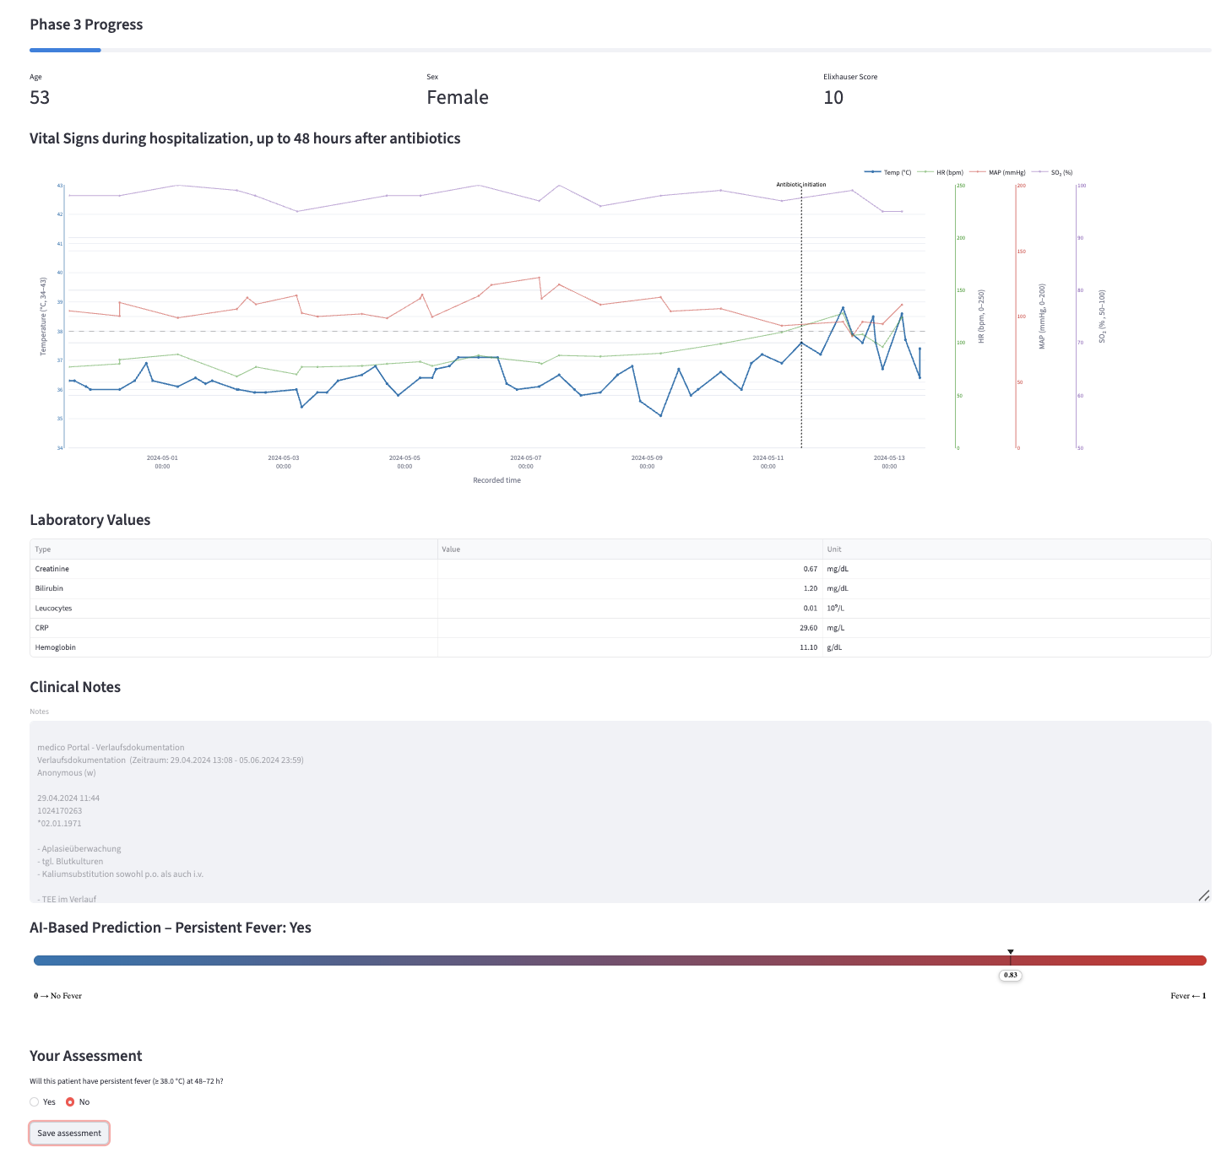
Supplemental Figure 1. Screenshot of the web application used in the clinician validation study.

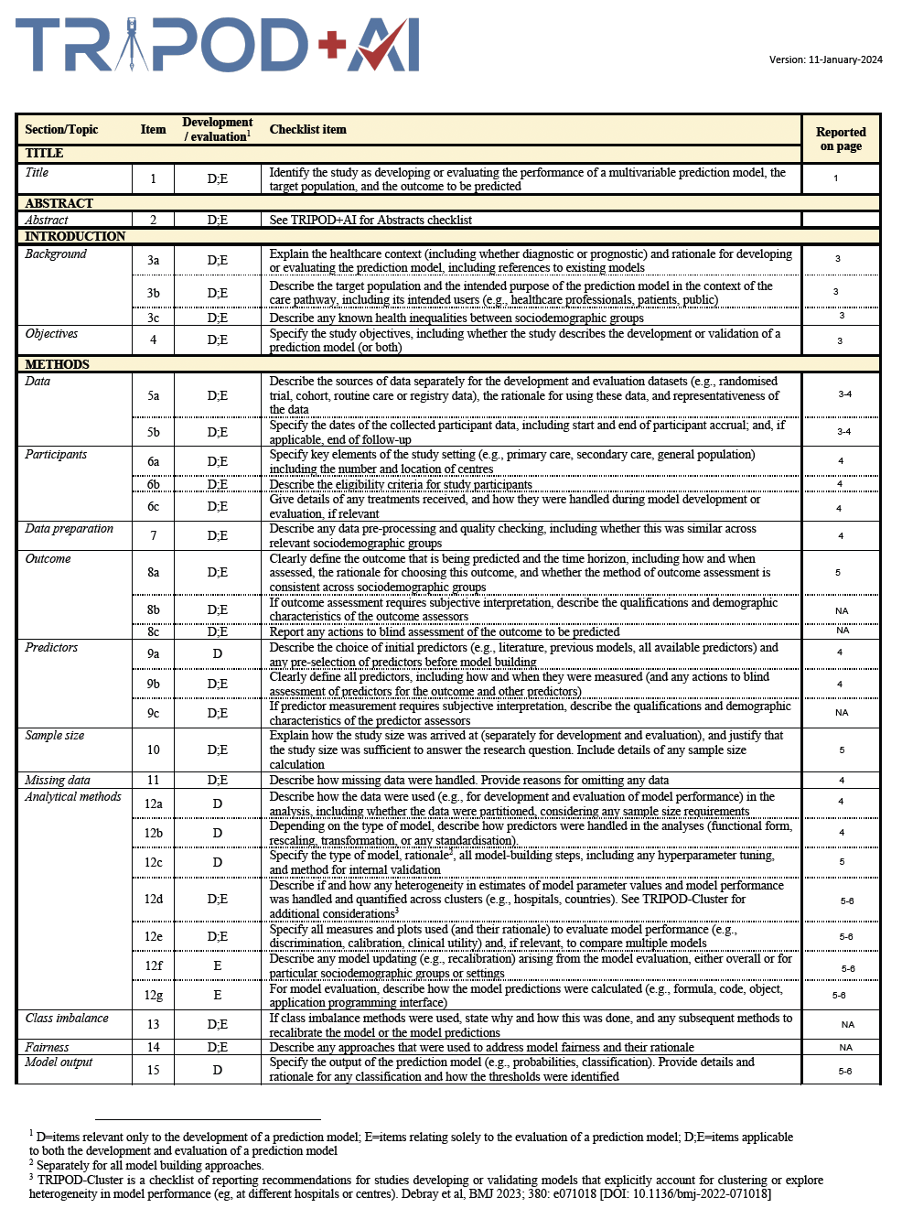
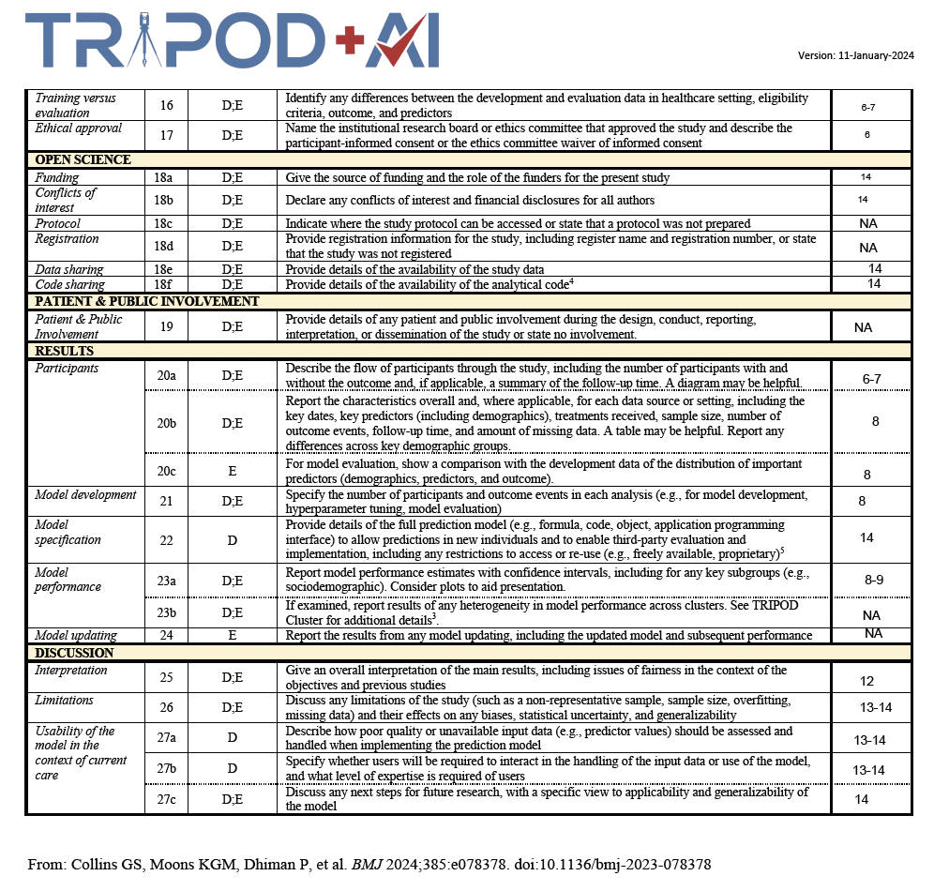
Supplemental File 1. Tripod+AI Checklist.

