Comprehensive Spatiotemporal Water Quality Assessment in Industrially Polluted Digaru River of Assam, India: Multivariate Statistics, Water Quality Indexing, and Human Health Risks

K Zamminsion^{1*}, Jasraj Kumawat², Siddhant Dash³, Ajay Kalamdhad^{1,4}
¹Centre for the Environment, Indian Institute of Technology Guwahati, Guwahati-781039, Assam, India
²Centre for Sustainable Technologies, Indian Institute of Science, Bengaluru-560012, Karnataka, India
³Department of Civil Engineering, SRM University, Guntur-522502, Andhra Pradesh, India
⁴Department of Civil Engineering, Indian Institute of Technology Guwahati, Guwahati-781039, Assam, India
*Corresponding Author: k.zamminsion@iitg.ac.in

Supplementary:
Station Name | Longitude | Latitude | Description of Station
L1 | 91.827024 | 26.014107 | Control point
L2 | 91.851504 | 26.026856 | Uppermost point of BIC
L3 | 91.87683126 | 26.04167083 | Nearby Byrnihat bridge (BIC)
L4 | 91.874092 | 26.041318 | Tributary of Digaru from the southeast
L5 | 91.888459 | 26.057785 | Lowermost industrial point (BIC)
L6 | 91.89771898 | 26.0616254 | 500m downstream from BIC
L7 | 91.935877 | 26.076989 | 6.3Km from L6 | Agricultural fields
L8 | 91.97826352 | 26.12132518 | Sonapur market | Sewage inflow
L9 | 91.993726 | 26.158884 | Agricultural fields | villages
L10 | 91.992803 | 26.187566 | Besides several brick kilns
L11 | 91.960334 | 26.225013 | Converge point with the Kopili River
L12 | 91.95786366 | 26.24425056 | Converge point with Brahmaputra
Table S1: Geocoordinates and description details of the sampling stations

Table S2: Descriptive statistics of all physicochemical parameters within the study area
Parameters  (µg/L) | Max | Min | Average | Stdev | Skewness | Kurtosis | Permissible limits (BIS, 2012) /WHO, 2011
DO | 8.95 | 5.40 | 7.42 | 0.78 | -0.55 | -0.55 | -
pH | 7.46 | 4.82 | 6.55 | 0.38 | -0.52 | 2.46 | 6.5-8.5
EC | 156.25 | 41.69 | 71.69 | 19.51 | 1.11 | 1.90 | 1500
Turbidity | 502.00 | 2.70 | 76.56 | 104.45 | 2.43 | 6.03 | 5
TA | 56.89 | 20.56 | 35.55 | 8.88 | 0.27 | -1.11 | 200
TH | 77.45 | 11.19 | 44.74 | 16.68 | -0.21 | -0.70 | 200
BOD₅ | 47.00 | 5.10 | 19.90 | 8.83 | 0.62 | 0.21 | 0
TDS | 95.30 | 13.61 | 40.09 | 19.79 | 0.86 | -0.20 | 500
F⁻ | 1.00 | 0.03 | 0.37 | 0.26 | 0.44 | -1.16 | 1
Cl⁻ | 11.42 | 0.61 | 4.08 | 1.79 | 0.96 | 2.75 | 250
NO₃²⁻ | 55.91 | 0.31 | 11.07 | 10.71 | 1.79 | 3.20 | 45
PO₄³⁻ | 0.41 | 0.01 | 0.16 | 0.10 | 0.39 | -0.60 | 0.1
SO₄²⁻ | 27.30 | 0.35 | 5.69 | 4.87 | 2.10 | 5.38 | 200
COD | 290.00 | 11.99 | 111.84 | 85.02 | 0.63 | -0.97 | 25

Table S3: Descriptive statistics of all metals within the study area
Metals  (µg/L) | Max | Min | Average | Stdev | Skewness | Kurtosis | Permissible limits (BIS, 2012)
Na | 8377.32 | 632.89 | 4221.22 | 2529.47 | -0.04 | -1.37 | -
Mg | 2842.07 | 524.1 | 1381.92 | 509.68 | 0.83 | 1.21 | 30,000
Al | 2497.92 | 18.12 | 523.33 | 483.74 | 2.17 | 5.71 | 200
K | 5923.44 | 1895.01 | 3078.53 | 936.48 | 1.56 | 2.53 | -
Ca | 3819.64 | 751.58 | 1748.71 | 677.63 | 0.92 | 0.63 | 200,000
Cr | 8.92 | 0.03 | 2.54 | 1.81 | 1.25 | 2.10 | 50
Mn | 321.82 | 5.44 | 87.11 | 62.06 | 2.13 | 5.06 | 300
Fe | 3938.7 | 80.36 | 1262.05 | 636.17 | 2.29 | 7.65 | 300
Co | 7.8 | 0.003 | 0.7 | 1.20 | 4.79 | 27.08 | -
Ni | 9.21 | 0.12 | 2.93 | 2.27 | 1.04 | 0.63 | 20
Cu | 116.44 | 0.03 | 27.14 | 28.17 | 1.63 | 2.11 | 1500
Zn | 369.98 | 12.62 | 104.0 | 62.33 | 1.81 | 5.90 | 5000
Sr | 40.31 | 12.37 | 23.11 | 5.63 | 0.96 | 1.14 | -
Ba | 58.59 | 0.01 | 24.12 | 14.79 | 0.39 | -0.41 | 700
Pb | 68.43 | 0.9 | 23.74 | 15.54 | 1.02 | 0.55 | 10

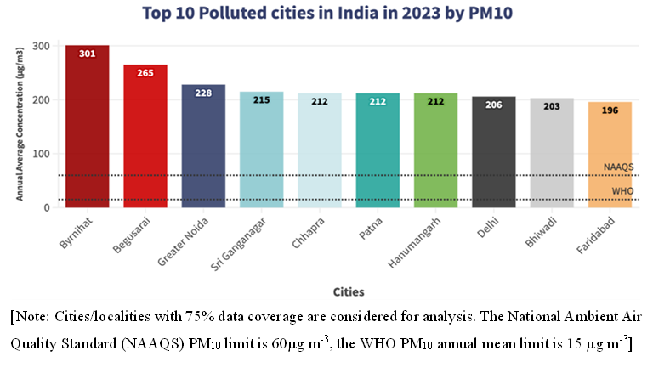
Fig S1: Top 10 Polluted cities in India 2023 by PM10 according to the CPCB’s National Ambient Air Quality Standard (NAAQS) report 2024 (CREA, 2024)

Table S4: Health risk assessment factors including reference values for HHRA
Table S4.1 denotes the general indices used for estimation of CDI for adults and children via oral and dermal exposure routes:
Indices Notations | Adults | Children | Unit | References
Daily Ingestion rate (IR) | 2 | 0.64 | L/day | USEPA, (2004); (Nur et al., 2025); (Siddique et al., 2021)
Exposure frequency (EF) | 350 | 350 | days/year | USEPA, (2004); (Nur et al., 2025); (Siddique et al., 2021)
Exposed skin area (SA) | 18000 | 6600 | cm² | USEPA, (2004); (Nur et al., 2025); (Siddique et al., 2021)
Exposure time per day (ET) | 0.58 | 1 | h/day | USEPA, (2004); (Nur et al., 2025); (Siddique et al., 2021)
Exposure duration (ED) | 70 | 6 | years | USEPA, (2004); (Nur et al., 2025); (Siddique et al., 2021)
Body weight (BW) | 70 | 15 | kg | USEPA, (2004); (Nur et al., 2025); (Siddique et al., 2021)
Average time for non-carcinogens (AT) | 25550 | 2190 | days | USEPA, (2004); (Nur et al., 2025); (Siddique et al., 2021)

Table S4.2 denotes the oral (gastrointestinal) absorption factors and dermal permeability coefficient for all the potentially toxic metals found within the study area:
Potentially Toxic Elements | Gastrointestinal absorption factor (Abs_{g} in %) | Dermal permeability coefficient (K_{p} in cm/h) | References
Mn | 6 | 1.00×10⁻³ | (USEPA, 2004); (Nur et al., 2025); (Siddique et al., 2021)
Cr | 3.8 | 3.00×10⁻³ | (USEPA, 2004); (Nur et al., 2025); (Siddique et al., 2021)
Pb | 11.7 | 1.00×10⁻³ | (USEPA, 2004); (Nur et al., 2025); (Siddique et al., 2021)
Fe | 1.4 | 1.00×10⁻³ | (USEPA, 2004); (Nur et al., 2025); (Siddique et al., 2021)
Co | 20 | 4.00×10⁻³ | (USEPA, 2004); (Nur et al., 2025); (Siddique et al., 2021)
Ni | 4 | 4.00×10⁻³ | (USEPA, 2004); (Nur et al., 2025); (Siddique et al., 2021)
Cu | 57 | 1.00×10⁻³ | (USEPA, 2004); (Nur et al., 2025); (Siddique et al., 2021)
Zn | 20 | 6.00×10⁻⁴ | (USEPA, 2004); (Nur et al., 2025); (Siddique et al., 2021)

Table S4.3 denotes the reference doses of each potentially toxic metals considered for each exposure routes, for estimation of the Hazard Quotient (HQ):
Potentially Toxic Elements | R_{f}Doral | R_{f}D_{dermal} | Oral cancer slope factor (SF) (µg/kg/day)⁻¹ |  | References
 | (µg kg⁻¹ day⁻¹) | (µg kg⁻¹ day⁻¹) | Ingestion | Dermal
Cr | 3 | 0.075 | 0.0005 | NA | (USEPA, 2011); (Siddique et al., 2021); (Nur et al., 2025)
Mn | 24 | 0.96 | NA | NA | (USEPA, 2011); (Siddique et al., 2021); (Nur et al., 2025)
Fe | 700 | 140 | NA | NA | (USEPA, 2011); (Siddique et al., 2021); (Nur et al., 2025)
Co | 0.3 | 0.06 | NA | NA | (USEPA, 2011); (Siddique et al., 2021); (Nur et al., 2025)
Ni | 20 | 0.8 | 0.00091 | NA | (USEPA, 2011); (Siddique et al., 2021); (Nur et al., 2025)
Cu | 40 | 12 | NA | NA | (USEPA, 2011); (Siddique et al., 2021); (Nur et al., 2025)
Zn | 300 | 60 | NA | NA | (USEPA, 2011); (Siddique et al., 2021); (Nur et al., 2025)
Pb | 1.4 | 0.42 | 0.0085 | NA | (USEPA, 2011); (Siddique et al., 2021); (Nur et al., 2025)

Fig S2: Eight-point Calibration details of all the metals considered within the study.
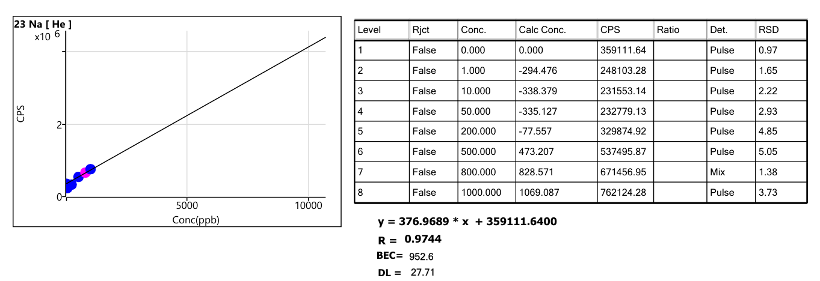
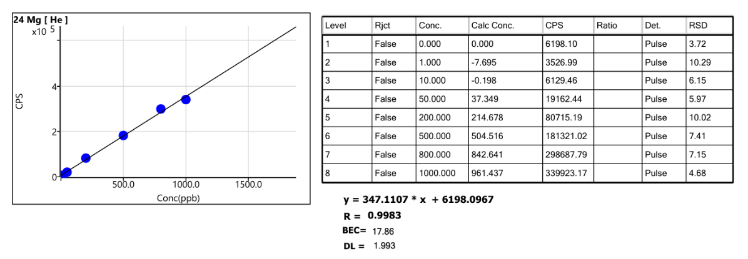
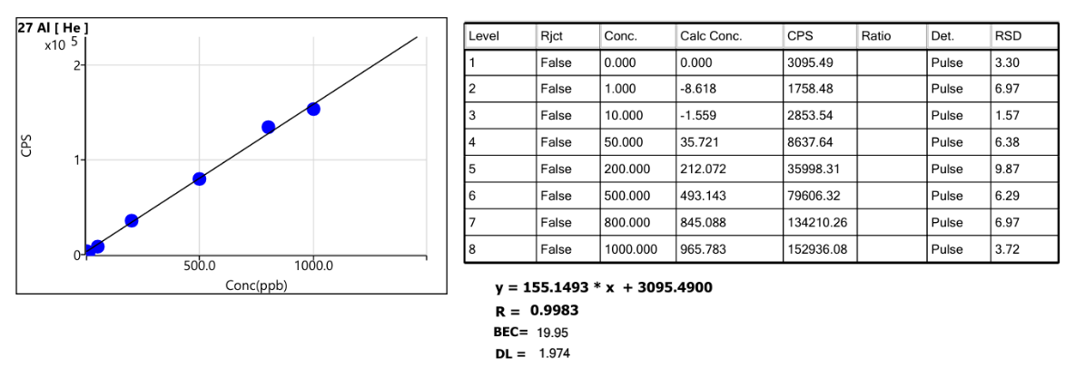
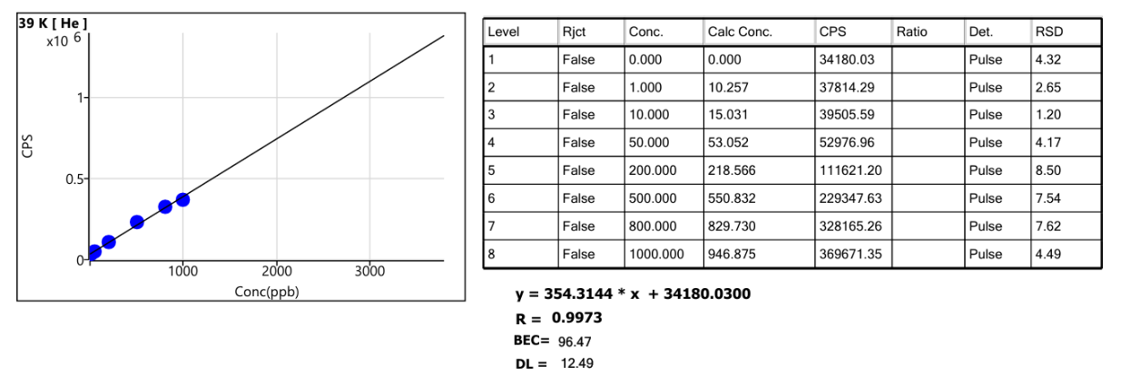
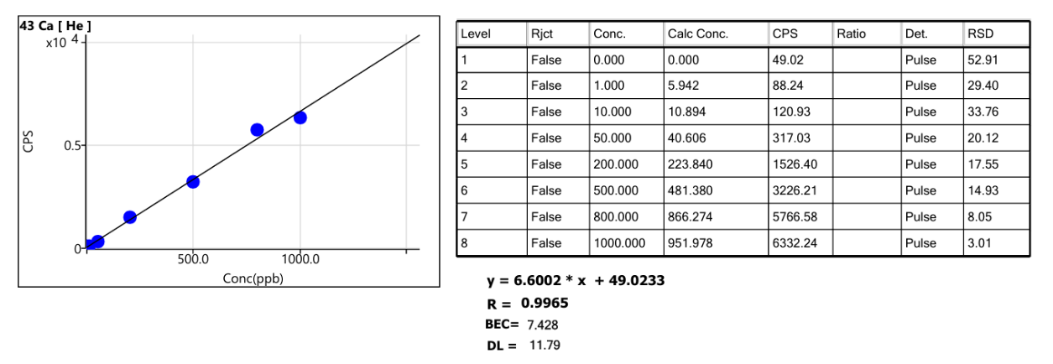
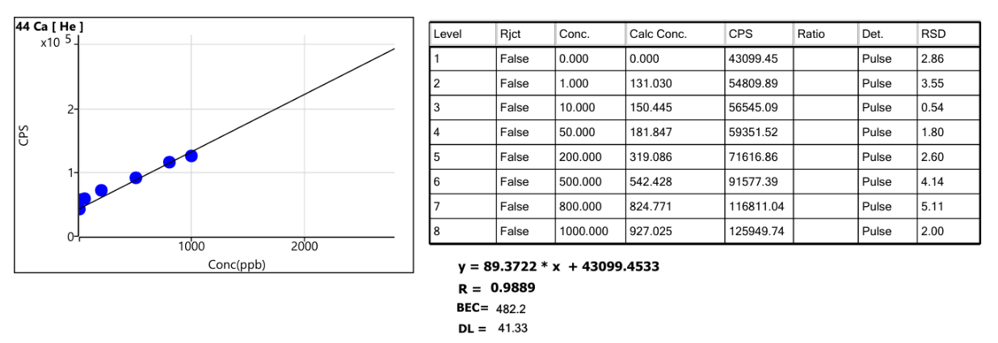
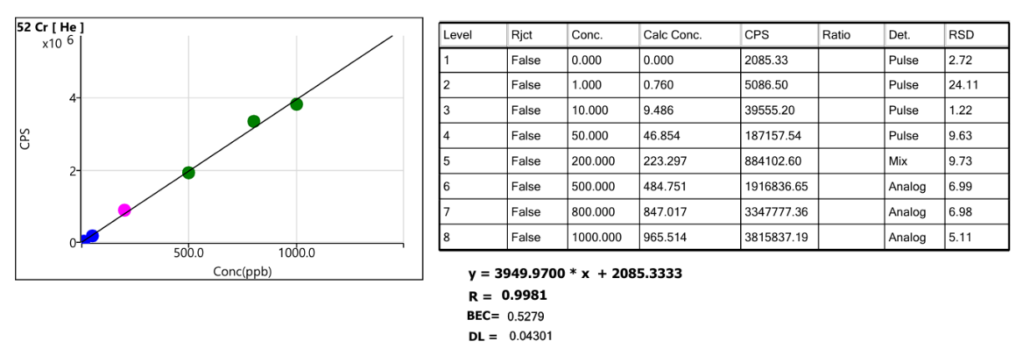
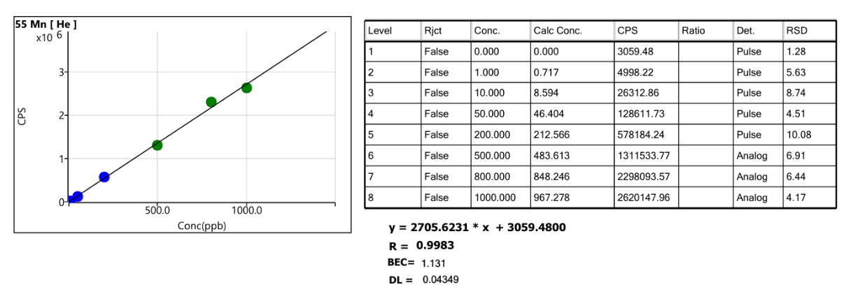
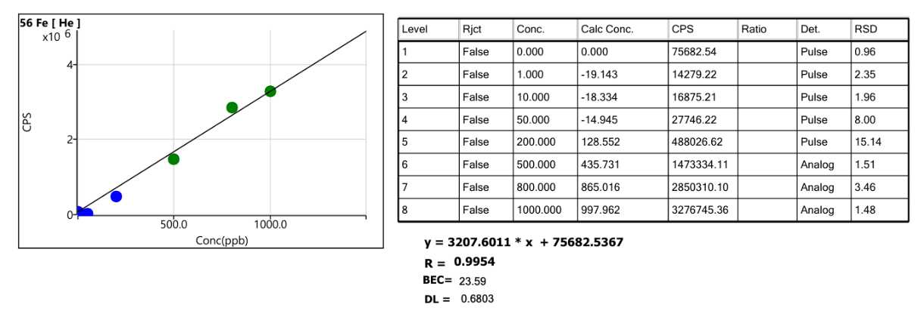
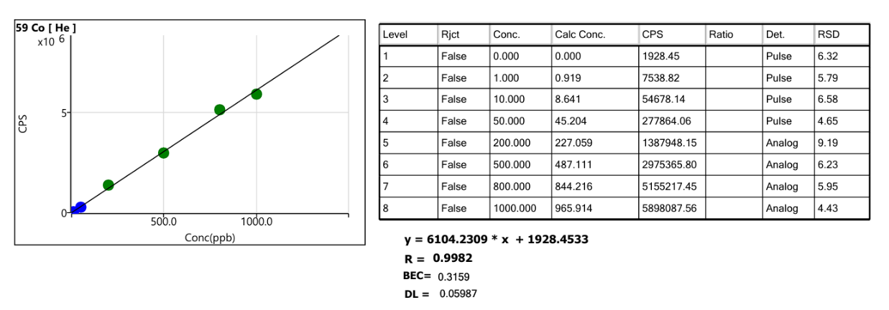
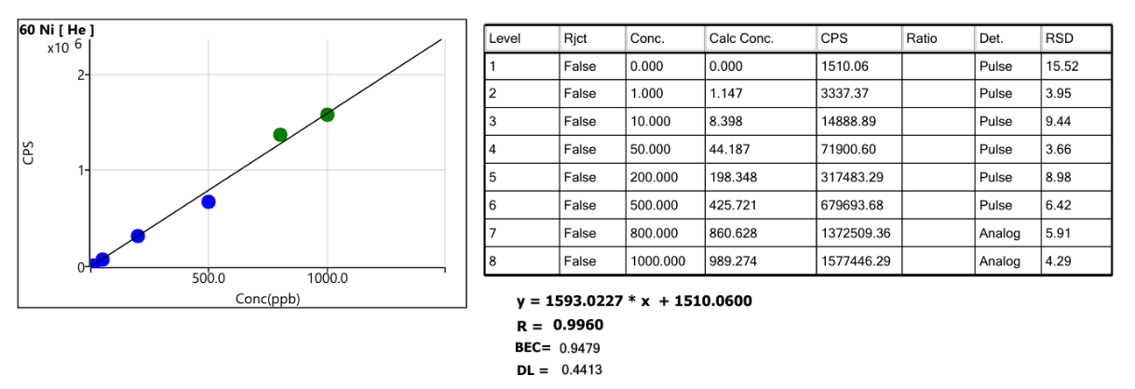
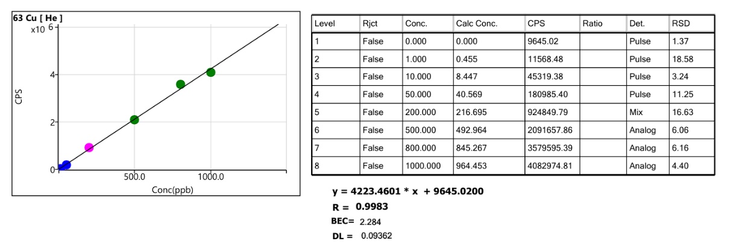
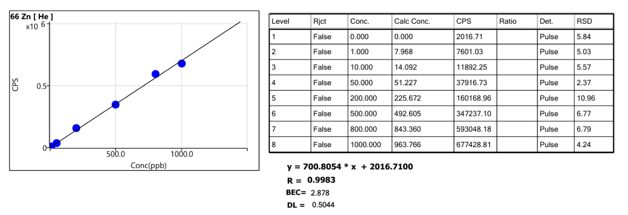
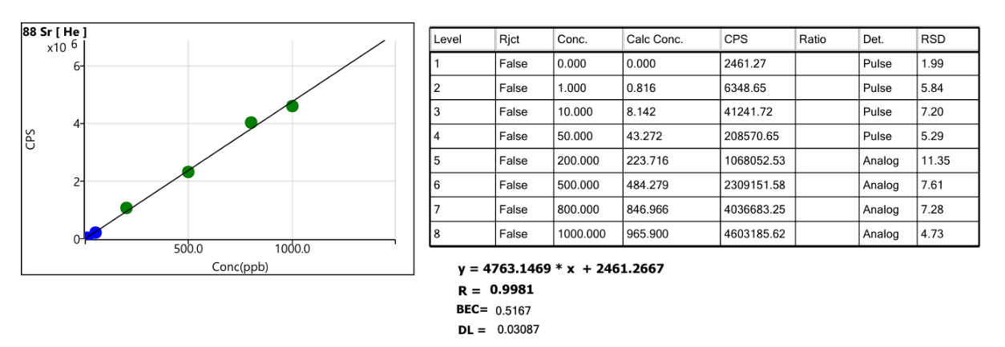
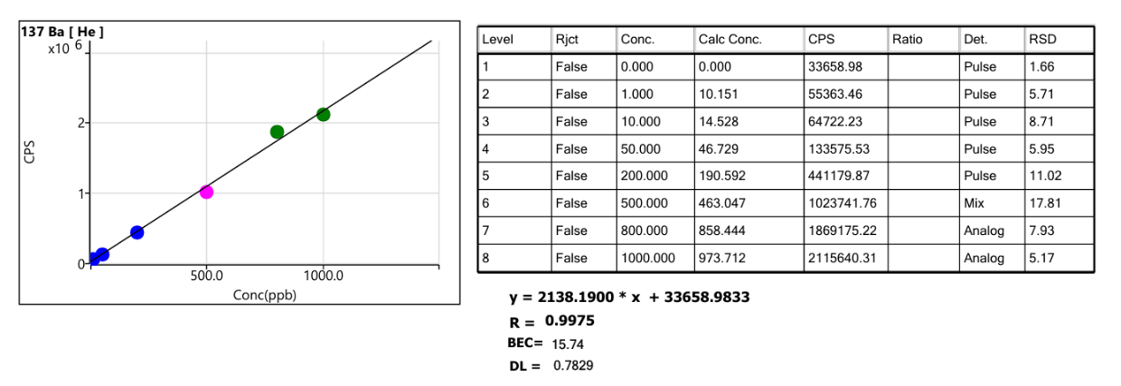
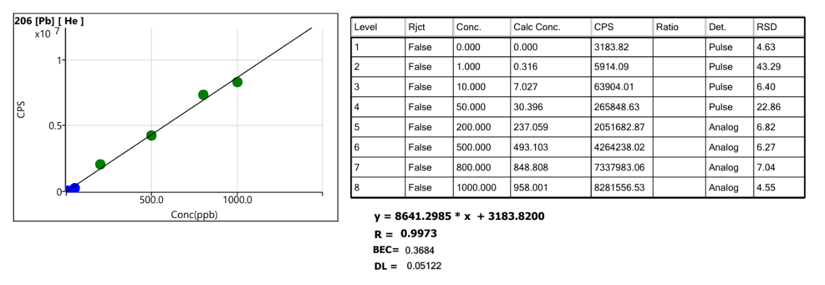
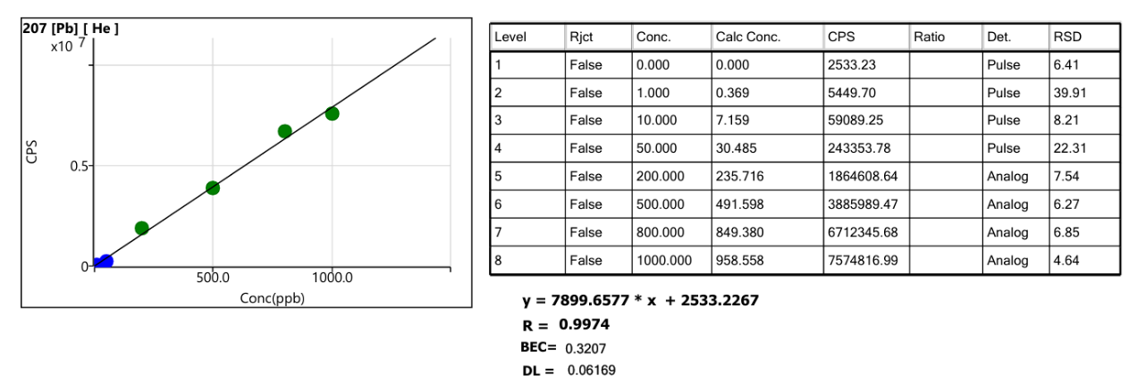
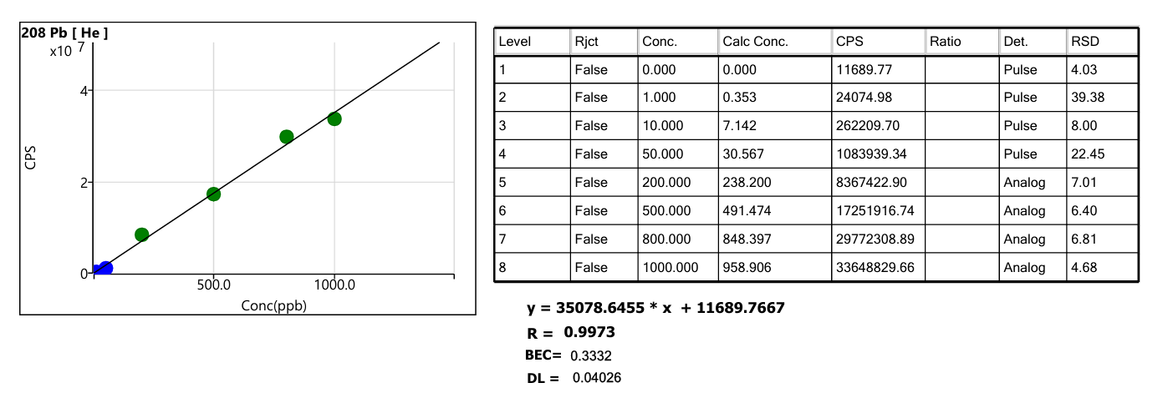

Abbreviation
APHA American Public Health Association
BIC Byrnihat Industrial Clusters
BOD5 5-day Biochemical Oxygen Demand
CDI Chronic Daily Intake
COD Chemical Oxygen Demand
DO Dissolved Oxygen
EC Electrical Conductivity
HDPE High-Density Polyethylene
HCA Hierarchical Cluster Analysis
HQ Hazard Quotient
IC Ion Chromatography
MEWQI Modified Entropy-weight Water Quality Index
MPN Most Probable Number
PCBA Pollution Control Board of Assam
PCA Principal Component Analysis
TA Total Alkalinity
TH Total Hardness
WHO World Health Organisation
WQI Water Quality Index

References:
CREA. (2024). 37 NCAP cities meet annual pollution targets but 118 new cities record hazardous pollution levels in 2023 (Issue January). www.energyandcleanair.org
Nur, T., Begum, S., Alam, N. E., Shahidur, M., Khan, R., Ferdous, F., & Kabir, A. (2025). Comprehensive analysis and human health risk assessment of tap water quality in Dhaka City , Bangladesh : Integrating source identification , index-based evaluation , and heavy metal assessment. Journal of Hazardous Materials, 485(December 2024), 136837. https://doi.org/10.1016/j.jhazmat.2024.136837

Siddiquee, M.S.H., Ahamed, R., 2020. Exploring water consumption in Dhaka
City using instrumental variables regression approaches. Environ Process 7 (4), 1255–1275. https://doi.org/10.1007/s40710-020-00462-3.
City using instrumental variables regression approaches. Environ Process 7 (4), 1255–1275. https://doi.org/10.1007/s40710-020-00462-3.
WHO (2011) Guidelines for drinking-water quality, 4th edn. WHO, Geneva
Zakir, H. M., Sharmin, S., Akter, A., & Rahman, S. (2020). Assessment of health risk of heavy metals and water quality indices for irrigation and drinking suitability of waters : a case study of Jamalpur Sadar area , Bangladesh. Environmental Advances, 2(September), 100005. https://doi.org/10.1016/j.envadv.2020.100005

