Supplementary figures
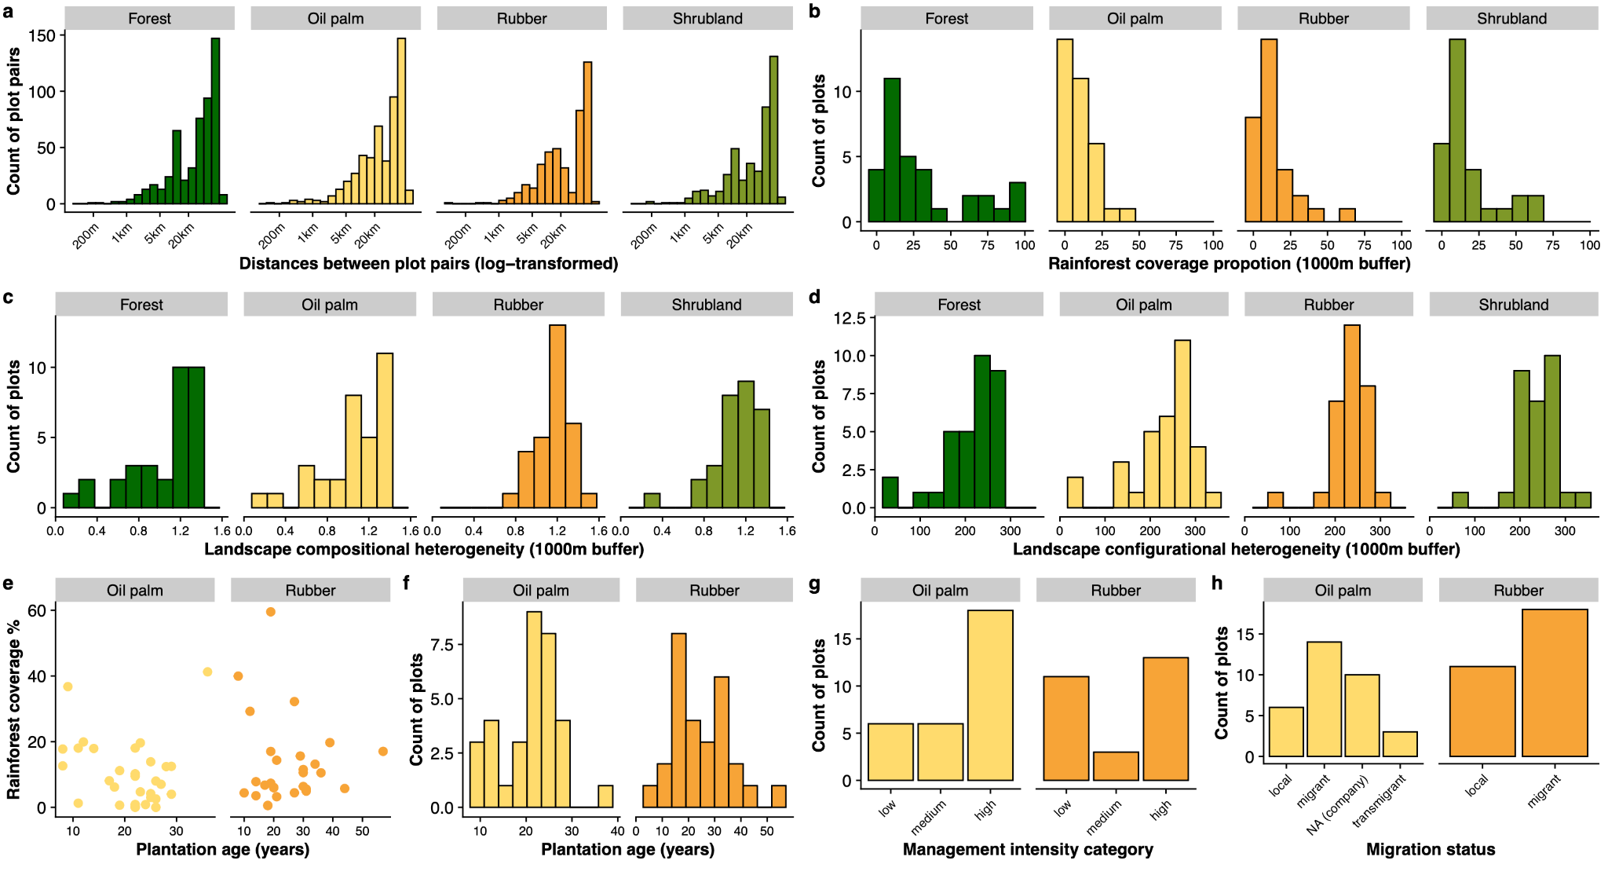
Figure S1. Distribution of study plots across land-use types. Panels show the distributions of (a) distances between plot pairs (log-transformed), (b) surrounding rainforest cover within a 1000 m buffer, (c) landscape compositional heterogeneity, and (d) landscape configurational heterogeneity (both within a 1000 m buffer). Panels (e) and (f) show the relationship between plantation age and rainforest cover, and the distribution of plantation age in oil palm and rubber plantations. Panels (g) and (h) show management intensity categories and migration status of soil animal communities in plantation systems. Colors denote land-use types (forest, shrubland, rubber and oil palm).

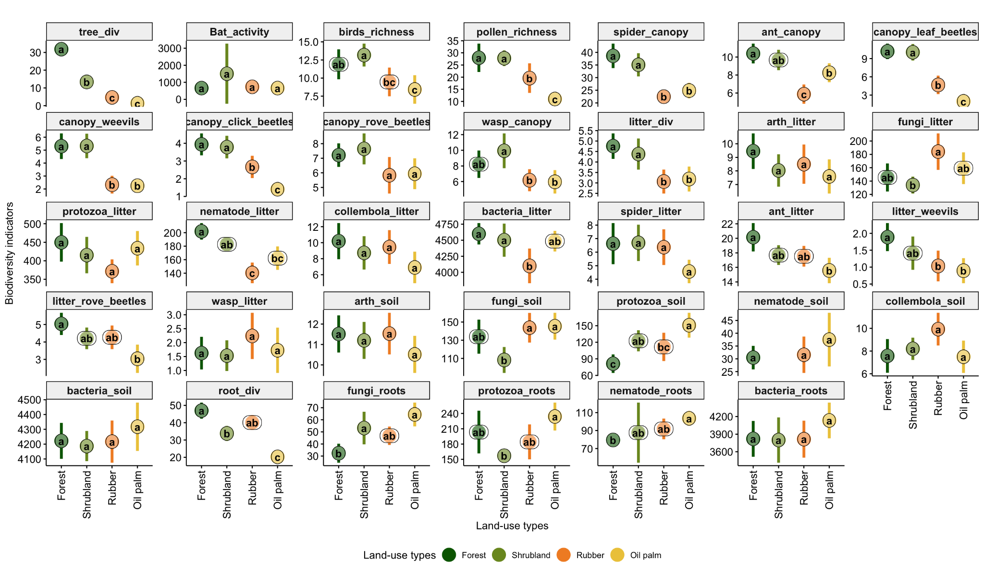
Figure S2. Effects of land-use types on 34 biodiversity indicators across taxonomic and functional groups from canopy, litter, soil or root compartments. Mean values ± 95% confidence intervals are shown for forests, shrublands, rubber and oil palm plantations. Different letters above points indicate significant differences among land-use types (post-hoc test, p < 0.05).

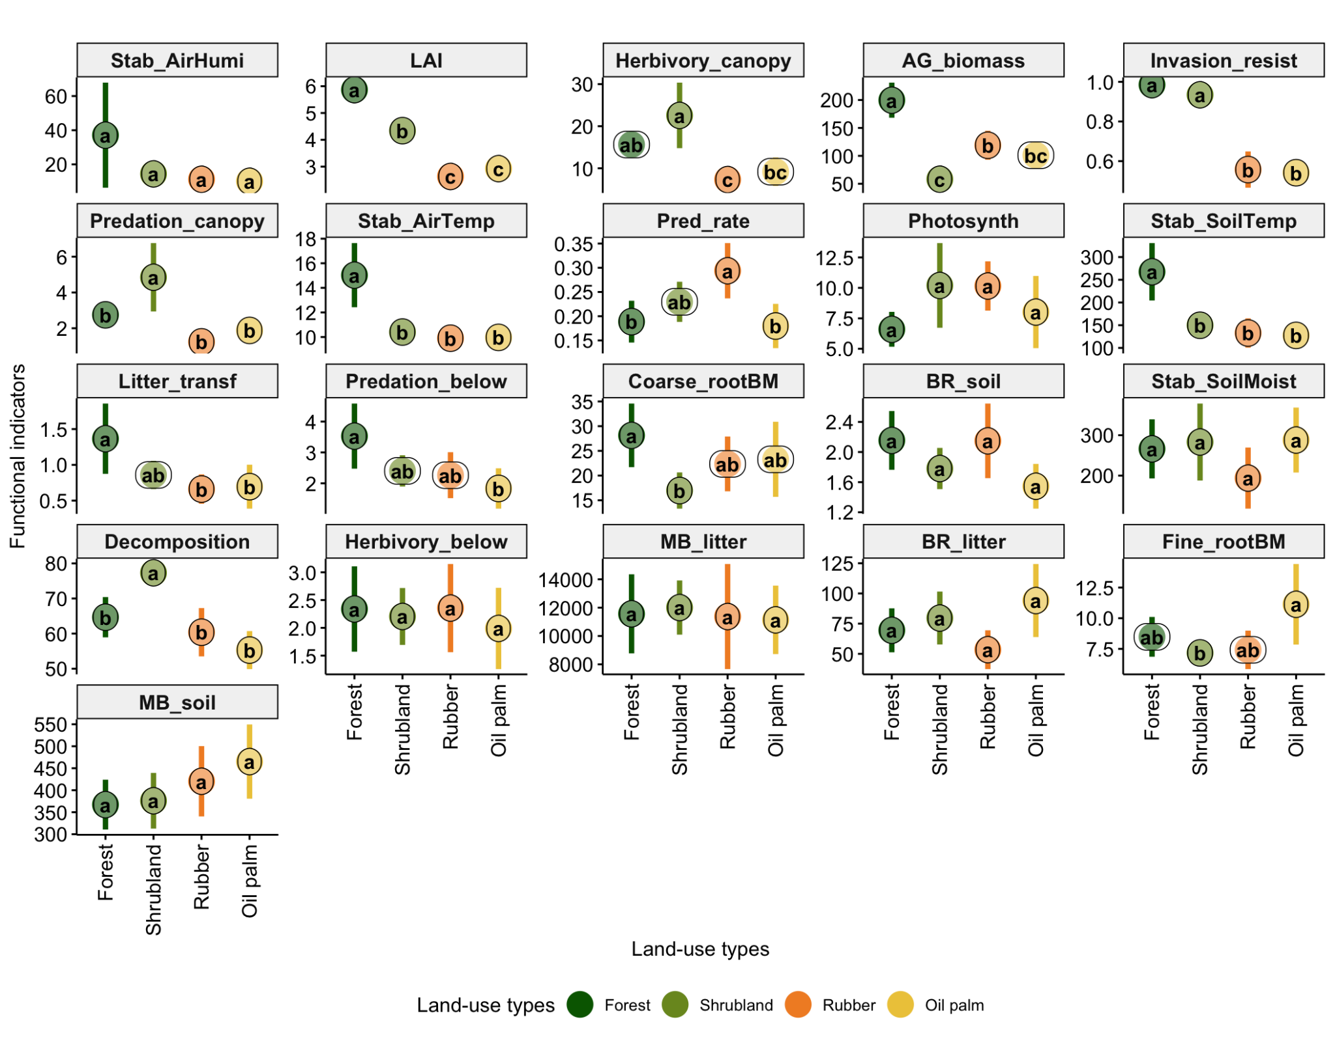Figure S3. Effects of land-use types on 20 functional indicators. Mean values ± 95% confidence intervals are shown for forests, shrublands, rubber and oil palm plantations. Different letters above points indicate significant differences among land-use types (post-hoc test, p < 0.05). For abbreviations of ecosystem functioning indicators, see the caption of Figure 1.
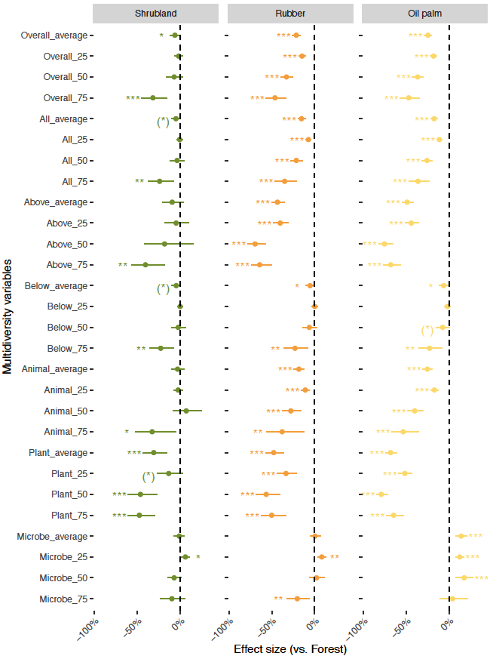
Figure S4. Effects of land-use types on multidiversity across different variables. Effect sizes (mean ± 95% confidence intervals) are shown relative to forests (dashed line at 0). Multidiversity was calculated separately for aboveground, belowground, animal, plant, and microbial indicators, and further combined into an overall index. The term ‘All’ refers to direct aggregation of all indicators, while ‘Overall’ refers to the mean of aboveground and belowground multidiversity values; both approaches yielded similar results. For each group, multidiversity was quantified using two approaches: (i) the averaging method (average) and (ii) the threshold method at 25%, 50%, and 75% cut-offs (25, 50, 75). Asterisks indicate significant effects, with (*) p < 0.1, *p < 0.05, **p < 0.01 and ***p < 0.001.
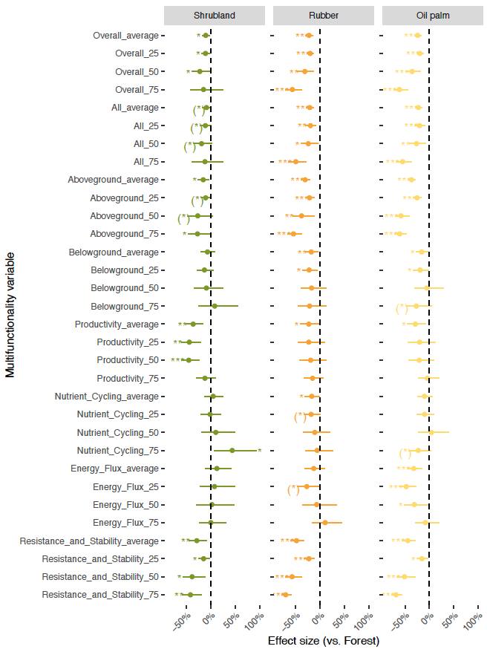
Figure S5. Effects of land-use types on multifunctionality across different variables. Effect sizes (mean ± 95% confidence intervals) are shown relative to forests (dashed line at 0). Multifunctionality was calculated separately for aboveground, belowground and different functional indicators, and further combined into an overall index. The term ‘All’ refers to direct aggregation of all indicators, while ‘Overall’ refers to the mean of aboveground and belowground multidiversity values; both approaches yielded similar results. For each group, multifunctionality was quantified using two approaches: (i) the averaging method (average) and (ii) the threshold method at 25%, 50%, and 75% cut-offs (25, 50, 75). Asterisks indicate significant effects, with (*) p < 0.1, *p < 0.05, **p < 0.01 and ***p < 0.001.
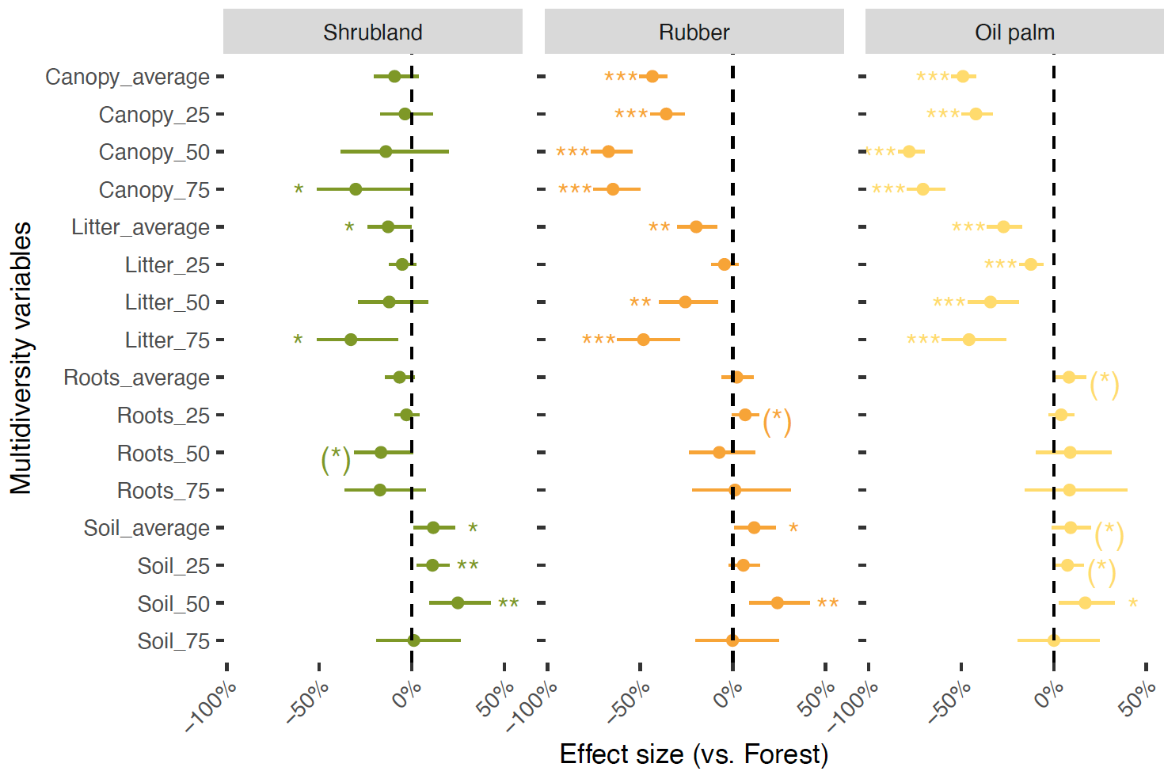
Figure S6. Effects of land-use types on multidiversity across vertical microhabitats. Effect sizes (mean ± 95% confidence intervals) are shown relative to forests (dashed line at 0). Multidiversity was calculated separately for canopy, litter, rhizosphere and soil. For each group, multidiversity was quantified using two approaches: (i) the averaging method (average) and (ii) the threshold method at 25%, 50%, and 75% cut-offs (25, 50, 75). Asterisks indicate significant effects, with (*) p < 0.1, *p < 0.05, **p < 0.01 and ***p < 0.001.

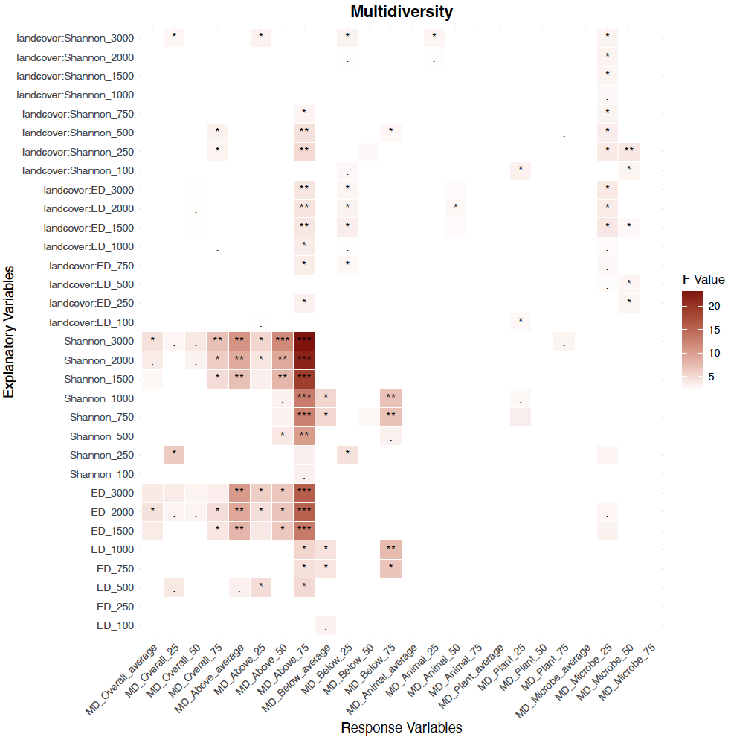
Figure S7. Heatmap of two-way ANOVA results for the effects of local land use and landscape heterogeneity at different spatial scales on multidiversity. The effects of landscape heterogeneity indices (ED and Shannon) and their interactions with land-use types on various multidiversity (MD) indicators. The color intensity of the heatmap represents the magnitude of the F-value from the two-way ANOVA, with darker colors indicating a more significant effect. Asterisks indicate significant effects, with . p < 0.1, *p < 0.05, **p < 0.01 and ***p < 0.001. Unlabeled areas denote non-significant effects. For each group, multidiversity was quantified using two approaches: (i) the averaging method (average) and (ii) the threshold method at 25%, 50%, and 75% cut-offs (25, 50, 75). Explanatory variables include ED and Shannon indices at different spatial scales (100 m, 250 m, 500 m, 750 m, 1000 m, 1500 m, 2000 m and 3000 m). Significance was determined using the Benjamini-Hochberg (FDR) method to correct for multiple comparisons across all p-values for each response variable.

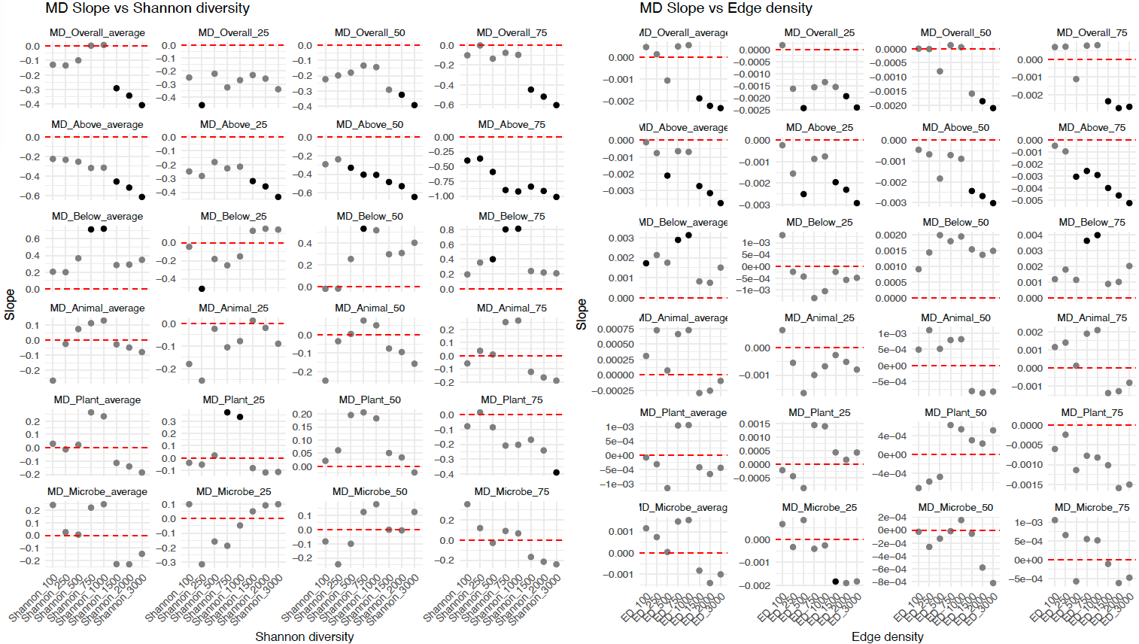Figure S8. Regression slopes of the effects of landscape heterogeneity on multidiversity. Linear regression slopes of different landscape complexity indices (Shannon and ED) on various multidiversity (MD) indicators. The left panel (MD Slope vs Shannon diversity) displays the regression slopes for the Shannon index at different spatial scales, while the right panel (MD Slope vs Edge density) shows the slopes for the ED index. For each group, multidiversity was quantified using two approaches: (i) the averaging method (average) and (ii) the threshold method at 25%, 50%, and 75% cut-offs (25, 50, 75). Explanatory variables include ED and Shannon indices at different spatial scales (100m, 250m, 500m, 750m, 1000m, 1500m, 2000m and 3000m). Each point within the subplots represents the slope between a specific response variable and an explanatory variable. The magnitude and sign of the slope reflect the strength and direction of the relationship between landscape complexity and multidiversity. The dashed red line at zero indicates a zero slope. Points above the line represent a positive relationship, and points below the line show a negative relationship. Black points signify that the regression slope is statistically significant at the p<0.1 level, while gray points are not significant. Significance was determined using the Benjamini-Hochberg (FDR) method to correct for multiple comparisons across all p-values for each response variable.
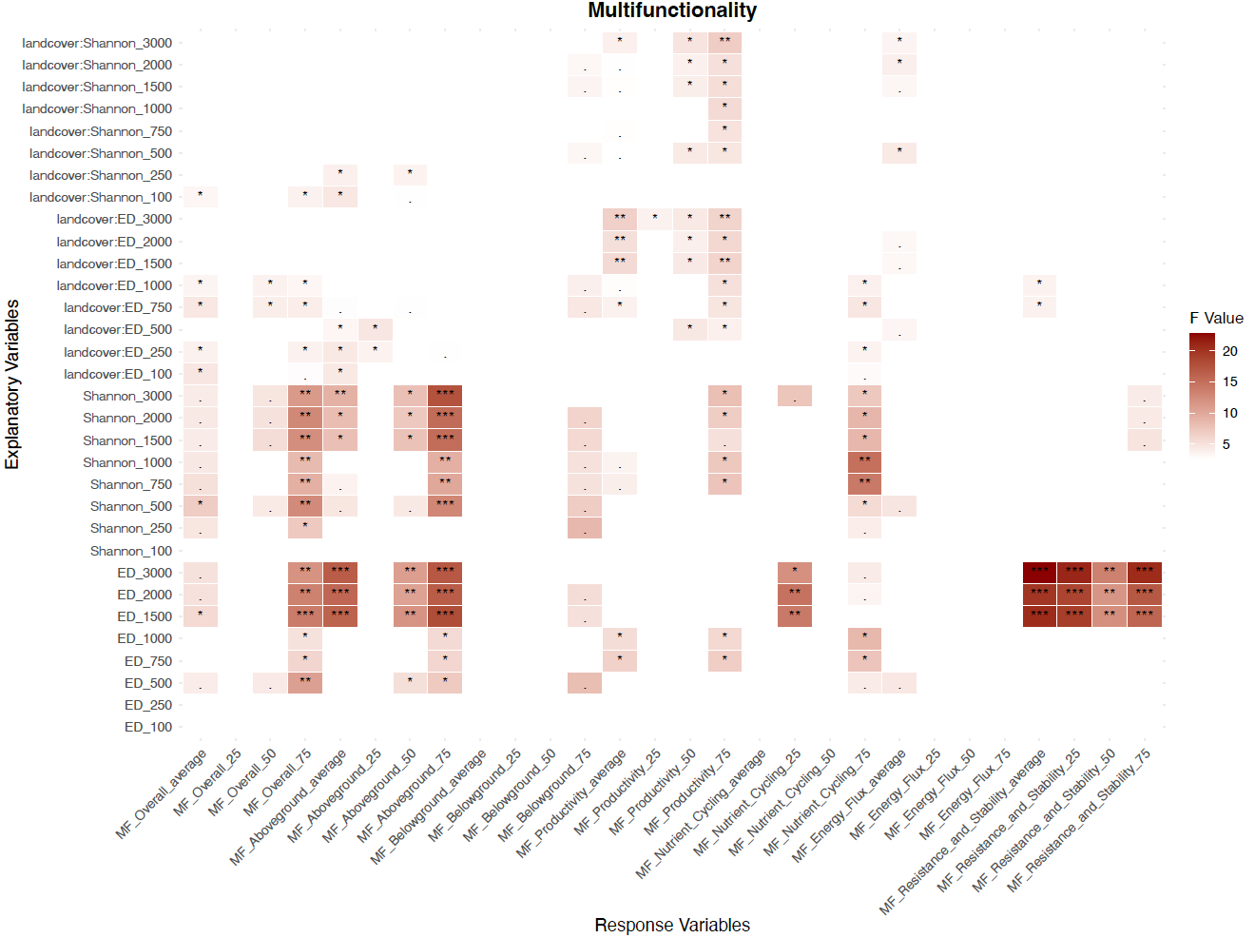 Figure S9. Heatmap of ANOVA results for the effects of local land use and landscape heterogeneity at different spatial scales on multifunctionality. The effects of landscape heterogeneity indices (ED and Shannon) and their interactions with land-use types on various multifunctionality (MF) indicators. The color intensity of the heatmap represents the magnitude of the F-value from the two-way ANOVA, with darker colors indicating a more significant effect. Asterisks indicate significant effects, with . p < 0.1, *p < 0.05, **p < 0.01 and ***p < 0.001. Unlabeled areas denote non-significant effects. For each group, multidiversity was quantified using two approaches: (i) the averaging method (average) and (ii) the threshold method at 25%, 50%, and 75% cut-offs (25, 50, 75). Explanatory variables include ED and Shannon indices at different spatial scales (100m, 250m, 500m, 750m, 1000m, 1500m, 2000m and 3000m). Significance was determined using the Benjamini-Hochberg (FDR) method to correct for multiple comparisons across all p-values for each response variable.

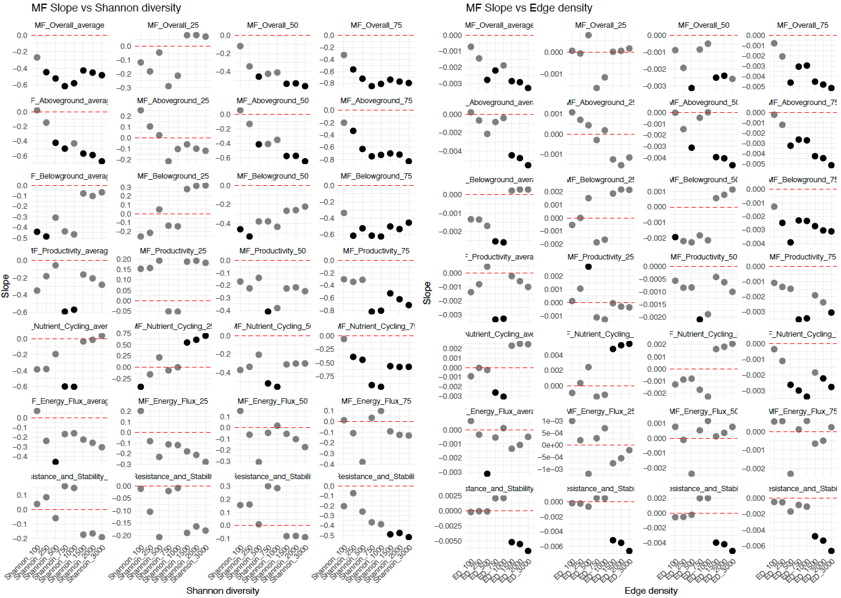
Figure S10. Regression slopes of the effects of landscape complexity on multifunctionality. Linear regression slopes of different landscape complexity indices (Shannon and ED) on various multifunctionality (MF) indicators. The left panel (MF Slope vs Shannon diversity) displays the regression slopes for the Shannon index at different spatial scales, while the right panel (MF Slope vs Edge density) shows the slopes for the ED index. For each group, multidiversity was quantified using two approaches: (i) the averaging method (average) and (ii) the threshold method at 25%, 50%, and 75% cut-offs (25, 50, 75). Explanatory variables include ED and Shannon indices at different spatial scales (100 m, 250 m, 500 m, 750 m, 1000 m, 1500 m, 2000 m and 3000 m). Each point within the subplots represents the slope between a specific response variable and an explanatory variable. The magnitude and sign of the slope reflect the strength and direction of the relationship between landscape complexity and multifunctionality. The dashed red line at zero indicates a zero slope. Points above the line represent a positive relationship, and points below the line show a negative relationship. Black points signify that the regression slope is statistically significant at the p<0.1 level, while gray points are not significant. Significance was determined using the Benjamini-Hochberg (FDR) method to correct for multiple comparisons across all p-values for each response variable.

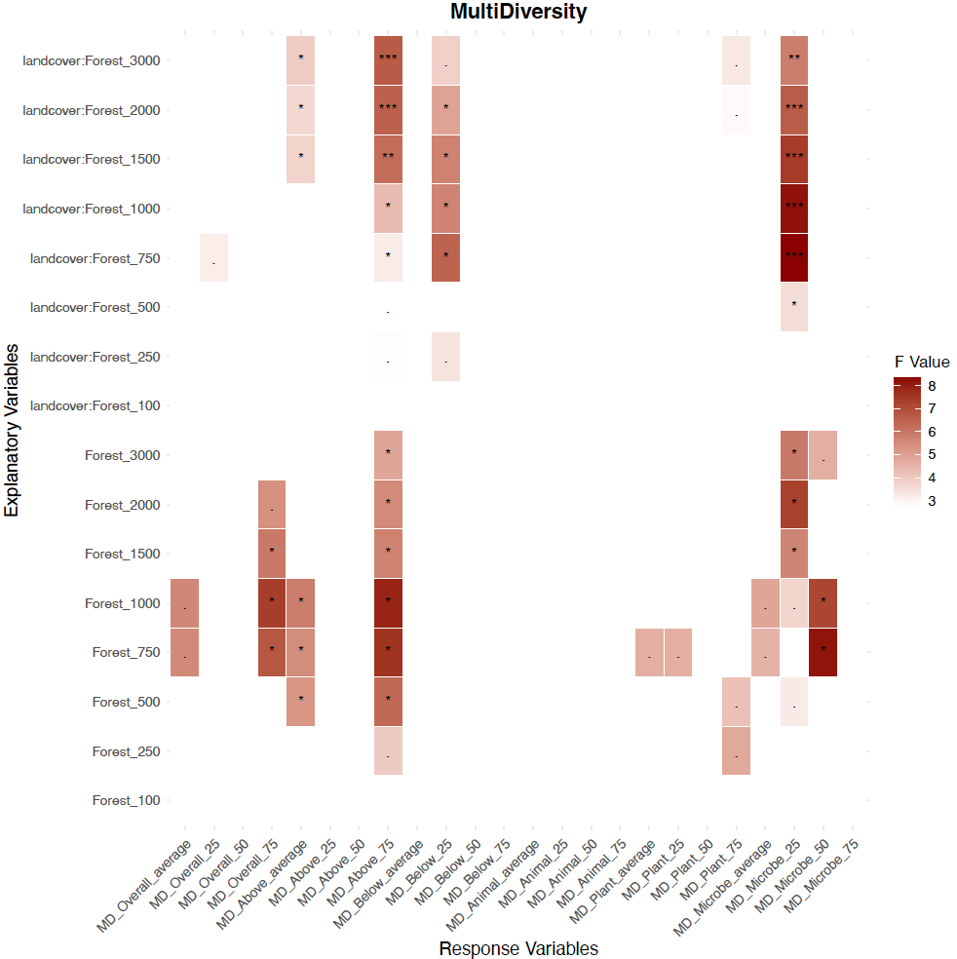
Figure S11. Heatmap of ANOVA results for the effects of local land use and forest coverage at different spatial scales (%forest) on multifunctionality. The effects of %forest and their interactions on various multifunctionality (MF) indicators. The color intensity of the heatmap represents the magnitude of the F-value from the two-way ANOVA, with darker colors indicating a more significant effect. Asterisks indicate significant effects, with . p < 0.1, *p < 0.05, **p < 0.01 and ***p < 0.001. Unlabeled areas denote non-significant effects. For each group, multidiversity was quantified using two approaches: (i) the averaging method (average) and (ii) the threshold method at 25%, 50%, and 75% cut-offs (25, 50, 75). Explanatory variables include %forest at different spatial scales (100m, 250m, 500m, 750m, 1000m, 1500m, 2000m and 3000m). Significance was determined using the Benjamini-Hochberg (FDR) method to correct for multiple comparisons across all p-values for each response variable.

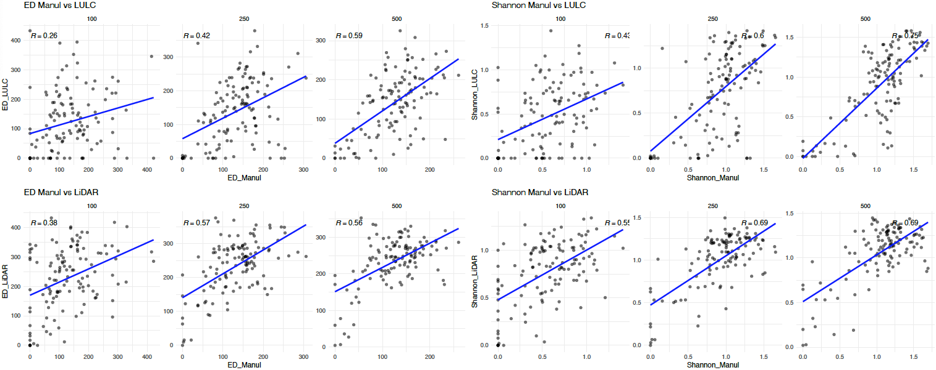
Figure S12. Correlations of landscape heterogeneity indicators (edge density and Shannon diversity) among land-use maps derived from three different data sources or mapping approaches (manually interpreted orthophotos, Sentinel-based maps, and airborne LiDAR-based maps) at buffer scales of 100, 250, and 500 m. Correlations are shown using the manually interpreted maps as the reference.

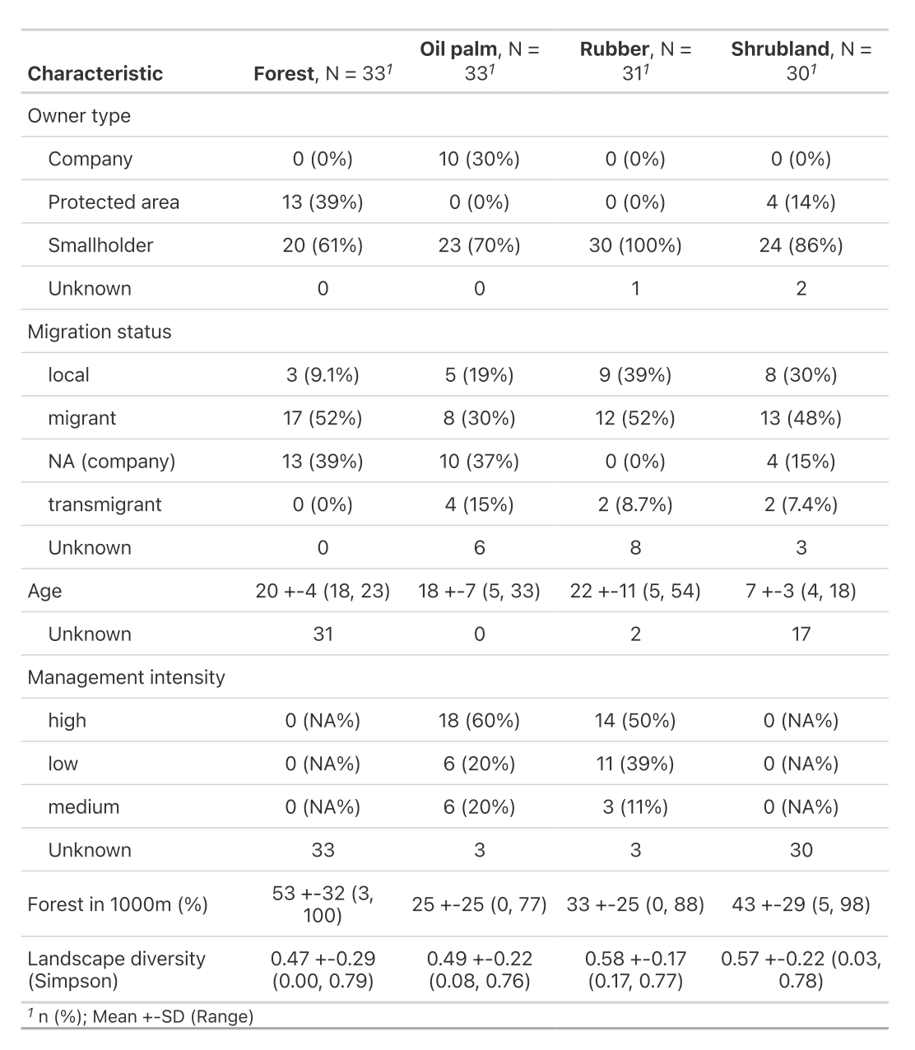

Table S1 Summary of site characteristics across land-use types (forest, oil palm, rubber, and shrubland). Values are given as counts (percentages) or mean ± SD (range).

