Materials & Methods
In vitro cell culture
Human OC cells, A2780 and SKOV3, were obtained from the American Type Culture Collection (ATCT). Prior to use, the cell lines were authenticated and the cell identity was confirmed (STR loci amplification PowerPlex® 16 HS System, Promega; fragment analysis was done on an ABI3730xl, Life Technologies; data were analyzed with GeneMarker HID
Software, Softgenetics). A2780 cells were maintained in RPMI-1640 culture medium (Biosera – cat. no. LM-R1639/500) supplemented with 10% FBS (Gibco - cat. no. A1048501), 1% L-glutamine (Biosera - cat. no. XC-T1715/100), and 1% penicillin-streptomycin (Biosera - cat. no. XC-A4122/100). SKOV3 cells were maintained in Dulbecco’s Modified Eagle Medium High Glucose (DMEM; Biosera - cat. no. LM-D1111/500) supplemented with 10% FBS and 1% penicillin-streptomycin at 37 °C in a humidified atmosphere with 5% CO₂.
Murine OC cells ID8-VEGF were derived from the parental ID8 cell line, which originates from the C57BL/6JOlaHsd mouse strain, and genetically engineered to overexpress vascular endothelial growth factor (VEGF). This cell line was kindly provided by the Tumor Immunology Laboratory of Dr. Denarda Dangaj at the Ludwig Institute for Cancer Research (Lausanne, Switzerland) [1]. ID8-VEGF cells were maintained in RPMI-1640 culture medium supplemented with 4% FBS, 1.5% penicillin-streptomycin and 1% insulin-transferrin-selenium (Gibco – cat. no. 41-400-045) at 37 °C in a humidified atmosphere with 5% CO₂.
Peripheral blood mononuclear cells (PBMCs) were isolated from a healthy donor's buffy coat (Transfusion and Tissue Department, University Hospital Brno) using Histopaque-1077 (Merck - cat. no. 10771) according to the manufacturer’s instructions. Isolated PBMCs were resuspended in complete OpTmizer medium (Gibco - cat. no. A1048501) supplemented with 10% FBS, 1% L-glutamine, 1% penicillin-streptomycin, and 2 ng/mL IL-2 (Merck - cat. no. SRP3085-50UG) at a concentration of 5 × 10⁶ cells/mL at 37 °C in a humidified atmosphere with 5% CO₂.
Co-culture experiments
For co-culture experiments, human OC cells SKOV3 and A2780 cells were seeded and cultured for 24 h until they were fully adhered. Activated PBMCs (4 µg/mL phytohemagglutinin (Merck - cat. no. L2646); for 24 h) were added to cancer cell cultures in a ratio of 2:1 (PBMC:cancer cells). Cell co-cultures were treated with ERS modulators: tauroursodeoxycholic acid (TUDCA; 1 mM working concentration; Merck - cat. no. 580549-5GM), tunicamycin (Tun; 0.5 µM working concentration; Merck – cat. no. T7765), or their combination (T+T). Treatments were maintained in co-cultures for 24 h (RT-qPCR), 48 h (SDS-PAGE and WB, flow cytometry, IF staining, SEM, and TEM), or 72 h (3D spheroids).
Viability assay (MTT)
Cell metabolic activity was assessed using the MTT assay. Cancer cells were seeded at 1500 cells/well in technical triplicates in 96-well plates and cultured for 24 h until fully adhered to the plates. Subsequently, activated PBMC were added to a final volume of 200 µL. Cell co-cultures were treated as described in the Co-culture experiments. Viability/metabolic activity assessment was performed using MTT Reagent 3-(4,5-Dimethylthiazol-2-yl)-2,5-Diphenyltetrazolium Bromide (Merck - cat. no. M2128-1G) at a concentration of 0.5 mg/mL for 3 h. The formazan was then solubilized using DMSO (Serva - cat. no. 2038502) and its concentration was determined by absorbance measurement at 595 nm using a microplate reader Infinite M1000 PRO (Tecan – cat. no. 30064852).
RT-qPCR
Total RNA was isolated using phenol-chloroform isolation (RNA blue, TopBio - cat. no. R013; 1-Bromo-3-Chloropropane, Merck - cat. no. B9673; Isopropanol, 75 % Ethanol, PCR H₂O). RNA samples were transcribed into cDNA using the High Capacity cDNA Reverse transcription Kit (Thermo Fisher Scientific - cat. no. 4368814). Amplification reactions were carried out in a final volume of 10 µL in a reaction mixture containing Luna Universal qPCR Master Mix (New England Biolabs - cat. no. M3003X), primers, H₂O, and cDNA. All reactions were performed in technical triplicates, and gene expression was calculated using the comparative threshold cycle 2^{−ΔΔCT} method with ACTB as a housekeeping gene. Amplification was performed using a LightCycler Instrument QuantStudio 5 (Applied Biosystems, USA). All primers were synthesized by Generi Biotech (Czechia).
SDS-PAGE and Western blot
For western blot analysis, cell lysates were harvested in 100 µL of NET buffer (150M NaCl, 1% NP-40, 50 mM Tris pH 8.0, 50 mM NaF, 5 mM EDTA pH 8.0, in 100 mL H₂O). Protein quantification was performed using the Bradford Assay (Bio-Rad - cat. no. 5000006), lysates were stabilized in CSB medium (glycerol, 1 M Tris pH 6.8, bromphenol blue, 1 M Tris pH 6.8, SDS, β-merkaptoethanol) and incubated at 95 °C for 10 min. Ten micrograms of protein was loaded onto a 10% polyacrylamide gel and resolved by SDS-PAGE, followed by electrotransfer onto a PVDF membrane Immobilon-P (Merck - cat. no. IPVH00010). Membranes were blocked with 5% BSA (Serva – cat. no. 11930.04) and incubated with primary antibodies overnight (Suppl. Table 1). Protein-containing membranes were washed with 0.1% Tween-20 solution and incubated with HRP-conjugated secondary antibodies (Suppl. Table 1), washed, and ECL reagent was applied to enhance signal visualization. The signal was detected using G:BOX (Syngene). β-Actin was used as a loading control (Suppl. Table 1).
Scratch wound healing assay
Cell migration was assessed using a scratch wound assay. Cancer cells were seeded in an IncuCyte Imagelock 96-Well Microplate (Sartorius - cat. no. BA-04857) (SKOV3: 50,000 cells/well; A2780: 80,000 cells/well) in technical quadruplicates and allowed to grow to 90% confluence. PBMCs were stained with CellTracker Deep Red Dye (ThermoFisher Scientific - cat. no. C34565) according to the manufacturer’s instructions prior to adding them to the cancer cell culture.
A scratch was performed using the IncuCyte 96-Well Woundmaker Tool (Sartorius - cat. no. BA-04858). After scratching, the wells were washed with PBS, and the cells were treated as listed in the Co-culture experiments, and pre-stained PBMCs were added. Cell co-cultures were placed in a live-cell imaging system IncuCyte (Sartorius, Germany) and captured at 4 × magnification once an hour for 24 h. Images were analyzed by automated mask-based measurement of the wound area over time, and the percent closure was calculated for each condition and normalized to the control condition.
Immunofluorescence staining of in vitro co-cultures
For immunofluorescence staining, cells were seeded in an 8 Well Chamber removable (ibidi - cat. no. 80841) and treated as listed in the Co-culture experiments. Following the experiment, the cells were fixed with 4% paraformaldehyde (PFA; Roth – cat. no. R67334). Triton 0.1% solution was used to permeabilize cells, and 3 % BSA solution for saturating excess protein-binding sites. Cells were stained with primary and secondary antibodies (Suppl. Table 1). Cell nuclei were counterstained with DAPI (4′,6-Diamidino-2-phenylindole dihydrochloride; Merck- cat. no. MBD0015). The stained cells were mounted using Roti-Mount FluorCare (Carl Roth - cat. no. R.HP19.1). Images were acquired using an Eclipse Ti-E microscope (Nikon) at 20× magnification. Images containing separate channels for individual signals were exported as 16-bit. jpeg files and processed for image analyses.
Flow cytometry Analysis of in vitro co-cultures
Cells (see Co-culture experiments) were harvested, fixed in 4 % PFA, washed in 1% BSA, permeabilized in 0.1% saponin (Merck - cat. no. 47036-50G-F), and stained with conjugated antibodies for 30 min at 4 ̊ C (Suppl. Table 1). Data were recorded using a BD FACSymphony A1 cytometer (BD Bioscience, Heidelberg, Germany) and the results were analyzed using FlowJo V10 software. For representative dot plots see Suppl. Figure 2 F – K.
Cytokine detection (ELISA)
The concentration of interferon-γ (IFN-γ) in the cell culture supernatant was determined using a commercially available ELISA kit (Mabtech – cat. no. 3420-1HP-DP-1) according to the manufacturer. The concentration of released IFN-γ in pg/mL was determined by absorbance measurement at 450 nm using a microplate reader (Infinite M1000 PRO).
Scanning electron microscopy (SEM)
Cells (see Co-culture experiments) were harvested and fixed in 3% glutaraldehyde (Sigma – cat. no. 108790) with 1% tannin (Sigma – cat. no. W304204) in 0.1 M cacodylate buffer (Sigma – cat. no 97068). After washing with 0.1 M cacodylate buffer, the samples were dehydrated by increasing ethanol concentrations (30%, 50%, 70%, 80%, 90%, 96%, and absolute ethanol) . The samples were dried in a Critical Point Dryer (Bal-Tec CPD 030, LEICA, Wetzlar, Germany). After that, samples were fixed on aluminum pin stubs (Micro to Namo) and sputtered with gold in SCD 040 sputter coater (BALZERS UNION).
The samples were examined using SEM (Vega, Tescan Orsay Holding, Brno). SEM micrographs were obtained using a secondary electron detector at a voltage of 15 kV using 5000 × magnification.
Transmission electron microscopy (TEM)
Cells were harvested and fixed in 3% glutaraldehyde with 1% tannin in 0.1 M cacodylate buffer and post-fixed in 1% OsO₄ (Sigma – cat. no. 201030) in 0.1 M cacodylate buffer. Cell suspensions were dehydrated in increasing concentrations of ethanol (50%, 70%, 96%, and 100%), treated with 100% acetone, and embedded in Durcupan (Sigma – cat. no. 44610) resin. Ultrathin sections were prepared using a Leica EM UC6 ultramicrotome, stained with uranyl acetate and Reynold’s lead citrate (Penta Chemicals), and examined using a Morgagni 268D TEM (ThermoFisher Scientific). Images were captured using a Veleta CCD Camera (Olympus, Prague, Czech Republic). One hundred cells from each experimental group were examined in two independent experiments.
Immune-cancer 3D spheroids
Spheroid formation was induced by single-cell suspension culture in the Nunclon™ Sphera™ 96-Well, Nunclon Sphera-Treated, U-Shaped-Bottom Microplate (Thermo Scientific – cat. no. 174925) using 10 000 cells/well. Spheroid formation was allowed for 48 h before adding PBMCs and treatments (see Co-culture experiments). Spheroids were collected by gentle centrifugation, washed with PBS, and fixed using 4% PFA. Tissue clearing was performed using CUBIC before immunofluorescence staining to reduce light scattering and improve optical transparency.
For IF staining, spheroids were washed with 3% BSA and 0.1% Triton X-100 and incubated overnight at 4 °C with primary antibodies (Suppl. Table 1). IF signals were obtained by staining with conjugated secondary antibodies (Suppl. Table 1). Spheroid images were acquired using a ZEISS Lightsheet 7 (Carl Zeiss AG, Germany) at 10× magnification. Data processing was performed using ZEN Blue and IMARIS software.
Dendritic cell vaccine development
Female C57BL/6JOlaHsd mice (see section Animals) were euthanized, and the femur, fibula, and pelvis were excised. Intact de-muscled bones were sterilized with 70% ethanol and immediately pulp dried. One of the epiphyses was cut, and the bones were inserted with the cut portion facing downwards into 0.5 mL Eppendorf tubes (a hole was pierced at the bottom of the tubes with a sterile needle). The tubes prepared with the inserted bones were placed in 1.5 mL tubes containing 100 µL of 0.2 M EDTA in PBS and briefly spun. The isolated cell suspension in 0.2 M EDTA was homogenized and diluted with 1 mL of 0.2 M EDTA in PBS. The cell suspension was filtered through a 70 µm cell strainer (Corning – cat. no. 352350) into 50 mL centrifuge tubes. Cells were centrifuged at 300 × g for 10 min and then resuspended in 1 mL of Fixative-Free Lysing Solution (Invitrogen – cat. no. HYL250) for 2 min at 37 °C. Cells were centrifuged at 300 × g for 10 min and then resuspended in RPMI 1640 culture medium supplemented with 10% FBS, 1% L-glutamine, 1% penicillin/streptomycin, 50 µM 2-mercaptoethanol, and 20 ng/mL GM-CSF (Invitrogen – cat. no. RP-8620), transferred to a ⌀6 cm Petri dish, and placed at 37 °C in a humidified atmosphere with 5% CO₂ (Suppl. Figure 1). Every other day, the bone marrow cells were replaced with ½ volume of medium supplemented with GM-CSF at a final concentration of 20 ng/mL. The cells were cultured for 10 days under this regimen. On day 11, murine recombinant IL-4 (Invitrogen - cat. no. RP-8666) was added at 500 ng/mL to the culture medium. On day 12, the supernatant of the lysed ID8-VEGF cells was added to the medium for 24 h. On day 13, the medium was replaced with fresh medium supplemented with lipopolysaccharide (LPS) from E. coli O111:B4 (Merck – cat. no. L2630) at a concentration of 250 ng/mL and murine recombinant IFN-γ (Gibco – cat. no. 315-05-100UG) at a concentration of 100 ng/mL for 24 h, respectively. Cells were centrifuged at 1000 rpm for 5 min and resuspended in DMSO (Sigma – cat. no. D2650-100ML) with 10% FBS. The dendritic cell suspension was subsequently frozen in aliquots at - 80 °C where stored until further use.
Immediately before intraperitoneal (i.p.) administration (see chapter In vivo combination therapy), frozen Dendritic Cell Vaccine (DCV) stocks were processed as follows: vials were rapidly thawed in a 37°C water bath, and their contents were resuspended in PBS and transferred to a 15 mL Falcon tube. To obtain the required total of 15–16 × 10⁶ cells for the experiment, multiple vials were pooled. PBS was added to reach a final volume of 15 mL, and the suspension was centrifuged at 450 × g for 5 min. Cells were resuspended in PBS to a final concentration of 1 × 10⁶ DC cells/mouse/dose.
Animals
All in vivo experiments were performed using C57BL/6JOlaHsd strain, obtained from Charles River Laboratories (Wilmington, MA, USA). Mice were treated and handled in accordance with the national and EU animal welfare legislation, and all procedures were approved by the institutional (Masaryk University, Brno, Czech Republic) and national ethics committees (Identification number of project MSMT-41524/2020-3).
In vivo combination therapy
For the therapeutic intervention experiment, a syngeneic mouse model of ID8-VEGF was used. C57BL/6JOlaHsd mice were subcutaneously injected with 15 × 10⁶ ID8-VEGF cells into the left flank [1]. During the optimization phase, the initial number of ID8-VEGF cells required to establish a measurable tumor burden within a reasonable timeframe (~26 days) was determined. The need for a higher cell count per injection was attributed to the model’s inherent immunogenicity.
Subcutaneous tumors were initiated in ♀ C57BL/6JOlaHsd mice (8-12 weeks old, with comparable body weight) by microinjection of a cell suspension of 15 × 10⁶ ID8-VEGF cells/100 µL of PBS into the left flank (day 0). Two days after tumor initiation (day 2), mice were randomly assigned to four treatment groups (n = 12 mice per group): A) control (PBS); B) TUDCA; C) DCV; and D) combination therapy (TUDCA + DCV). Therapeutic interventions were administered i.p. in three doses, spaced five days apart, beginning when tumors were palpable. At each treatment point, mice received the following: A) 100 µL of PBS; B) 150 µL of TUDCA in PBS (100 mg/mL), corresponding to ~75 mg TUDCA/kg body weight; C) DCV – 1 × 10⁶ cells/mouse; and D) combination therapy – TUDCA (75 mg/kg) administered first, followed by DCV (1 × 10⁶ cells/mouse) i.p. on the following day. Body weight and subcutaneous tumor growth were monitored regularly using digital calipers (FST, Vancouver, Canada). The mice were sacrificed by cervical dislocation on day 26, four days after the final treatment. Tumors were excised, weighed, and measured to assess the tumor burden. Approximate tumor volume was calculated using the formula: Vol (mm³) = L × W × H / 2, where L is the length (mm), W the width (mm), and H the height (mm). Tumors and spleens were processed as follows: i) immediately fixed with 4% PFA and then embedded in paraffin for immunofluorescence (IF) staining and analysis; ii) tissue frozen at -80 °C for RNA isolation and gene expression analysis.
Histological tissue slide preparation, tumor tissue Immunofluorescence staining and microscopy
Formalin-Fixed Paraffin-Embedded (FFPE) murine tumor and spleen tissue samples were processed into 5-μm-thick transverse sections. The sections were placed at 56 °C overnight, followed by deparaffinization and rehydration using xylene and ethanol. Antigen retrieval was performed using Dako Tris/EDTA pH9 buffer (Agilent Technologies – cat.no. S2367) at 98 °C for 30 min. The sections were then incubated with 10 % BSA. The primary antibodies were diluted in 0.05% Tween-20 in PBS and used to incubate the sections overnight at 4 °C. After thorough washing with PBS, the sections were incubated with secondary antibodies diluted in 0.05 % Tween-20 solution for 2 h in the dark, followed by DAPI counterstaining for 5 min in the dark. Tumor and spleen tissue sections were mounted using Roti-Mount FluorCare mounting medium. Staining was imaged using an AxioImager.Z2 (Zeiss), at 40× magnification. For quantitative fluorescence intensity analysis, all images were captured in a single uninterrupted run, and uniform microscope settings were maintained. The images were exported as 16-bit. tiff files and processed for image analysis.
Image Analysis
For each sample, images were acquired in one or more fluorescence channels, always including DAPI for the cell nuclei, converted to grayscale, and normalized. Cell segmentation was performed using the DAPI channel as the nuclear marker. To remove background noise and improve contrast, the images were smoothed by convolution with a circular brush filter, followed by background correction through subtraction of the filtered image. A global threshold was derived from the mean intensity and standard deviation, and binary masks were refined using morphological operations (opening and hull filling). Unusual objects with small areas were removed to exclude artifacts. For the other channels, analogous preprocessing was applied only with a different threshold factor and exclusion of artifacts. Masks from all fluorescence channels were combined to estimate the overall tissue area, followed by segmentation using the propagate function to delineate the individual cells within the tissue mask. Each cell was characterized by the occurrence and intensity of the signal in the evaluated channels. Subsequently, the images were characterized by two attributes: (1) Occurrence, defined as the proportion of cells with the detected signal relative to all cells within the frame, and (2) Relative signal intensity, defined as the ratio of the average intensity of the evaluated signal to the average intensity of the reference signal (cell nuclei).
Statistical Analysis
The experimental data were statistically processed using R statistical software version 4.3.1 (R Core Team, 2023) (https://www.r-project.org). Significance threshold was set as follow: (*p<0.05, **p<0.01, ***p<0.001). P-values are reported both with () and without () FDR correction due to the exploratory nature of the study, the limited sample size, and to allow balanced interpretation of statistical and biological relevance. All experiments were conducted in at least three biological replicates.
Cell viability assay, scratch wound healing assay, and RT-qPCR: Prior to statistical analyses, outliers were detected using a robust z-score method (threshold |z| > 3.5) and excluded from further comparisons. Pairwise comparisons between groups were performed using Dunn’s test. Raw p-values were subsequently adjusted for multiple comparisons using the false discovery rate (FDR) method (Benjamini–Hochberg).
Immunofluorescence analysis: Group differences were assessed using the Kruskal–Wallis test, followed by Dunn’s post-hoc test with Holm’s correction for multiple comparisons. Functions from the EBImage library were used for image data analysis and the calculation of derived attributes.

Supplementary Tables and Figures
Supplementary Table 1: List of antibodies.

Antibody | Host animal | Manufacturer, cat. no. | Dilution
Anti-mouse IgG, HRP-linked Antibody | Horse | CST, #7076S | 1:2000^{b}
Anti-Mouse Secondary Antibody, AF568 | Goat | Invitrogen, A11004 | 1:2000^{IF}
Anti-rabbit IgG, HRP-linked Antibody | Goat | CST, #7074S | 1:2000^{b}
Anti-Rabbit Secondary Antibody, AF488 | Goat | Invitrogen, A11034 | 1:2000^{IF}
Anti-Rat Secondary Antibody, AF647 | Donkey | Invitrogen, A48272 | 1:2000^{IF}
β-Actin | Mouse | CST, #3700S | 1:10000ª
BAD | Rabbit | CST, #9239S | 1:500^{IF}
BCL2 | Rabbit | Abcam, ab32124 | 1:500^{IF}
BiP | Rabbit | CST, #3177S | 1:1000ª; 1:500^{IF}
BiP-AF488 | Mouse | Sony, 53-9768-82 | 1:100^{F}
CD3 | Rat | Biorad, MCA1477 | 1:500^{IF}
CD3ε | Rabbit | CST, #85061S | 1:1000ª
CD3-BV510 | Mouse | Sony, 2102240 | 1:100^{F}
CD4 | Rabbit | Zeta, Z2420RL | 1:1000ª
CD4-SB436 | Mouse | Sony, 62-0049-42 | 1:50^{F}
CD8α | Rabbit | CST, #85336S | 1:1000ª
CD8-PE-Cy7 | Mouse | Sony, 2323560 | 1:100^{F}
CD28 | Rabbit | Abcam, ab243228 | 1:200ª
CHOP | Mouse | CST, #2895S | 1.500ª
CHOP | Mouse | Sony, 5343510 | 1:200^{IF}
DAPI | - | Merck, MBD0015 | 1:1000^{IF}
FOXP3 | Rabbit | CST, #12632S | 1:1000ª
IRE1α | Rabbit | CST, #3294S | 1:1000ª
IRE1a-AF555 | Rabbit | BS-4308R-A555 | 1:100^{F}
PD-1 | Rabbit | CST, #86163S | 1:500ª; 1:250^{IF}
PD-L1 | Rabbit | CST, #13684S | 1:500ª
PERK | Rabbit | CST, #3192S | 1:1000ª
Phalloidin | - | Abcam, ab176761 | 1:2000^{IF}
XBP1s | Rabbit | CST, #40435S | 1:500ª
XBP1-AF647 | Rabbit | ab252103-100µl | 1:100^{F}
Antibodies for Western Blot (WB); ª primary antibodies diluted in 5 % BSA/PBS+0.1% Tween-20; ^{b}secondary antibodies diluted in 5% milk/PBS+0.1% Tween-20. Antibodies for Immunofluorescence staining (IF) diluted in 3% BSA/PBS. Antibodies for Flowcytometry (F) diluted in 1% BSA/PBS.
Abbreviations: AF – Alexa Fluor; BAD – BCL2-associated Agonist of cell Death; BCL2 – B-cell lymphoma 2; BiP – Binding Immunoglobulin Protein; BSA – Bovine Serum Albumin; BV – Brilliant Violet; CD3 – Cluster of Differentiation 3; CD4 – Cluster of Differentiation 4; CD8 – Cluster of Differentiation ; CD28 – Cluster of Differentiation 28; CHOP – C/EBP Homologous Protein; CST – Cell Signaling Technology; Cy7 – Cyanine 7; DAPI – 4′,6-Diamidino-2-phenylindole dihydrochloride; F – Flowcytometry; FoxP3 – Forkhead Box P3; HRP – Horseradish Peroxidase; IF – Immunofluorescence; IgG – Immunoglobulin G; IRE1α – Inositol-Requiring Enzyme 1 α; PD-1 – Programmed Death 1; PD-L1 – Programmed Death-Ligand 1; PE – Propidium Iodade; PERK – Protein Kinase R-like ER Kinase; SB – SuperBright; XBP1s – X-box Binding Protein 1 Spliced; WB – Western Blot.

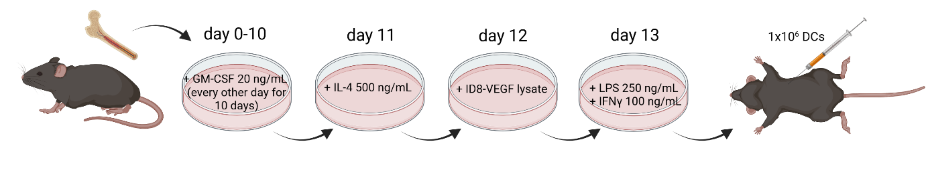
Supplementary Figure 1: Preparation of Dendritic Cell Vaccines (DCV).
The femur, fibula, and pelvis were isolated from ♀ C57BL/6JOlaHsd mice. The bones were sterilized and immediately pulp dried. The cell suspension was immediately homogenized in 0.2 M EDTA and filtered through a 70 µm Corning® cell strainer. Cells were resuspended in Fixative-Free Lysing Solution, centrifuged at 300 × g, resuspended in RPMI 1640 culture medium supplemented with 10% FBS, 1% L-glutamine, 1% penicillin/streptomycin, 50 µM 2-mercaptoethanol, and 20 ng/mL GM-CSF, and placed at 37 °C in a humidified atmosphere with 5% CO₂. Every other day, the cells were replaced with ½ volume of medium supplemented with 20 ng/mL GM-CSF for 10 days. On day 11, IL-4 was added to the culture medium at a concentration of 500 ng/mL. On day 12, the supernatant of the lysed ID8-VEGF cells was added to the medium for 24 h. On day 13, the medium was replaced with fresh medium supplemented with lipopolysaccharide from E. coli at a concentration of 250 ng/mL and IFN-γ at a concentration of 100 ng/mL for 24 h. Cells were resuspended in DMSO supplemented with 10% FBS and frozen in aliquots at - 80 °C where stored until further use. DCV stocks were resuspended in PBS to a final concentration of 1 × 10⁶ cells/mouse/dose.
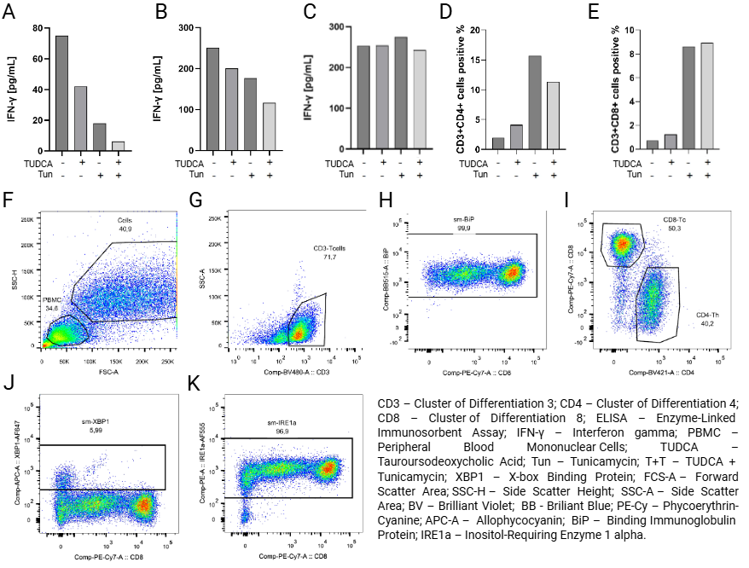
Supplementary Figure 2: Cytokine detection and flow cytometry analysis of in vitro co-cultures.
(A-C) IFN-γ production in co-cultures upon ERS modulation. (A) When co-cultured with SKOV3 cells, PBMCs released approximately 75 pg/mL IFN-γ into the culture medium. Treatment with TUDCA and/or Tun reduced IFN-γ production.
(B) In co-culture with A2780 cells, PBMCs released 250 pg/mL of IFN-γ under control conditions, and treatments with TUDCA, Tun, or their combination led to reduced IFN-γ production.
(C) In the PBMC monoculture, IFN-γ production remained unchanged under all experimental conditions. PBMCs released 250 pg/mL IFN-γ.
(D) XBP1s expression was low in CD3⁺CD4⁺ cells (2.5% cells positive) under control conditions. Upon Tun treatment, proportion of XBP1 positive cells increased in the CD3⁺CD4⁺ population (17% cells positive). Proportion of XBP1 positive cells was elevated in the T+T group in the CD3⁺CD4⁺ population (12% cells positive).
(E) XBP1s expression was low in CD3⁺CD8⁺ cells (1.5% cells positive) under control conditions. Upon Tun treatment, XBP1 positive cells increased in the CD3⁺CD8⁺ population (9% of cells positive). Number of XBP1 positive cells was elevated in the T+T treated group in the CD3⁺CD8⁺ population (9% of cells positive).
(F-K) Representative flow cytometry dot plots illustrating the sequential gating strategy and subsequent analysis of UPR markers in TL subsets.
(F) Initial identification of PBMCs based on forward scatter area (FSC-A) and side scatter height (SSC-H) parameters to exclude debris from the analysis. The PBMC gate comprised 34.6% of the total events, and the subsequent “Cells” gate included 40.9% of events after exclusion of doublets and non-viable events.
(G) Identification of CD3⁺ TLs within the gated cell population using anti-CD3 (Comp-BV480-A) antibody. CD3⁺ cells represented 71.7% of the parent cell population.
(H) Subclassification of CD3⁺ TLs according to CD4 (Comp-BV421-A) and CD8 (Comp-PE-Cy7-A) staining. CD8⁺ cytotoxic TLs (CD8-Tc) accounted for 50.3%, while CD4⁺ helper TLs (CD4-Th) comprised 40.2% of CD3⁺ TLs.
(I) Intracellular expression of BiP (Comp-BB515-A) in CD8⁺ TLs. The proportion of BiP⁺ (sm-BiP) cells within the CD8⁺ TLs subset was 96.1%.
(J) Intracellular expression of XBP1 (sm-XBP1; Comp-APC-A) in CD8⁺ TLs. The frequency of sm-XBP1⁺ cells was 5.99% of the CD8⁺ population.
(K) Intracellular expression of IRE1α (sm-IRE1α; Comp-PE-A) in CD8⁺ TLs. The percentage of sm-IRE1α⁺ cells within CD8⁺ TLs was 96.9%.

Gates were established based on fluorescence-minus-one (FMO) controls. The percentages indicate the proportion of cells within the respective parent gates. The data shown are representative of independent experiments.
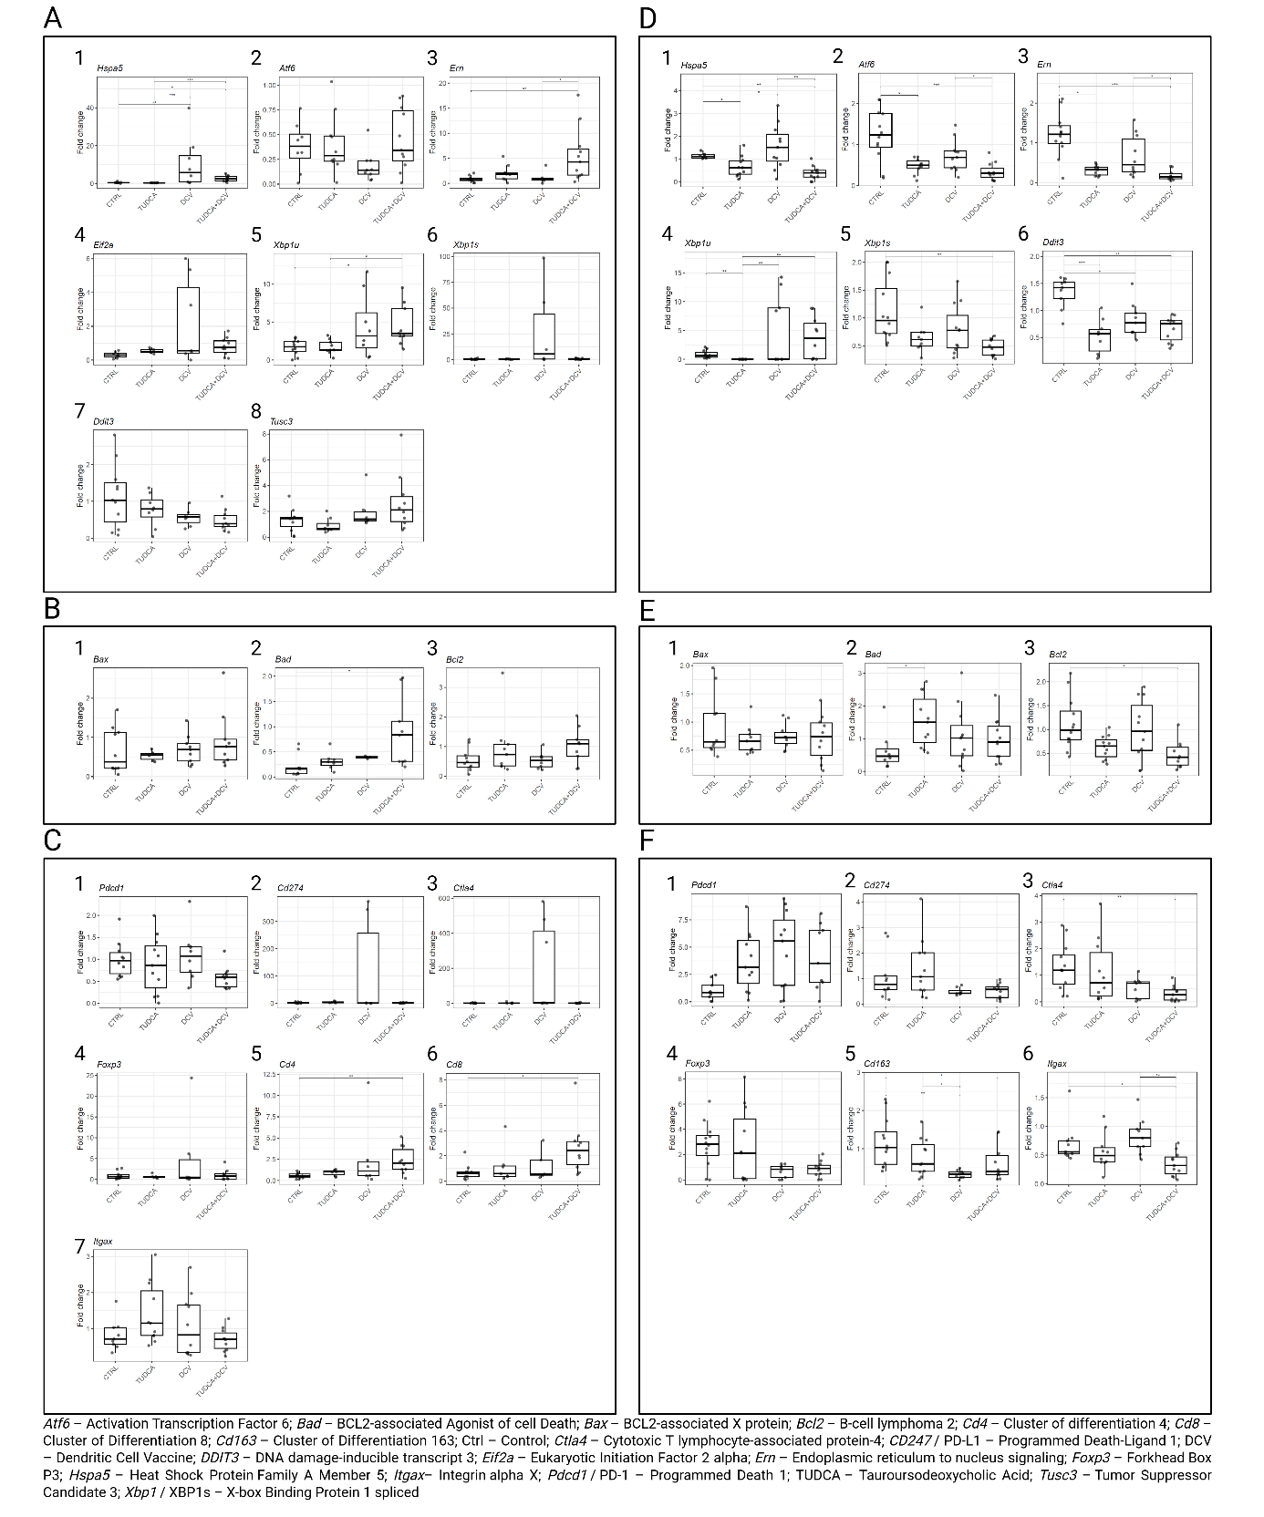
Supplementary Figure 3: Gene expression analysis of murine tumor and splenic tissue (Experiment 1).
(A) Significant differences were observed in the expression of Hspa5, where both DCV- and TUDCA+DCV-treated animals showed an increase in Hspa5 expression in the tumor tissue compared to the control animals (DCV: p<0.01; TUDCA+DCV: p<0.05). Ern expression was significantly upregulated in the TUDCA+DCV group compared to the control (p<0.01) and DCV-treated groups (p<0.05). An increase in Xbp1u expression was observed in the DCV (ns) and TUDCA+DCV groups (p<0.05).
(B) A significant increase was observed in Bad expression in TUDCA+DCV animals compared to the control (p<0.05).
(C) DCV increased the expression of Foxp3, Ctla4, and Cd247. Importantly, Foxp3, Ctla4, and Cd247 expression was downregulated in the TUDCA+DCV group. Moreover, a slight decrease in the expression of Pdcd1 was observed in the TUDCA+DCV group compared to that in the control group.
(D) Gene expression analysis of murine splenic tissue showed elevated expression of Hspa5 in DCV-treated animals compared to the TUDCA group (p<0.05), and importantly, compared to TUDCA+DCV-treated animals (p<0.01). The expression of Ddit3 was highest in the control animals among all the therapeutic groups. Significant decrease was observed in TUDCA- (p<0.001), DCV- (p<0.05), and TUDCA+DCV-treated animals (p<0.01). Atf6 expression was highest in the control animals. A significant decrease was observed in TUDCA- (p<0.05) and TUDCA+DCV-treated animals (p<0.001). Importantly, a decrease in Atf6 expression was observed in TUDCA+DCV-treated animals compared to that in DCV monotherapy (p<0.05). Ern expression was significantly decreased in TUDCA- (p<0.05) and TUDCA+DCV- treated animals (p<0.001). Importantly, Ern expression was significantly decreased in TUDCA+DCV-treated animals compared to that in DCV monotherapy (p<0.05). An increase in Xbp1u expression was observed in DCV (p<0.01), TUDCA+DCV (p<0.01), and control animals (p<0.01) compared to TUDCA group. The spliced variant of Xbp1 mRNA was decreased in the TUDCA+DCV group (p<0.01).
(E) A significant increase in Bad expression was observed in TUDCA-treated animals (p<0.05). TUDCA+DCV-treated animals showed decreased expression of Bcl2 (p<0.05).
(F) A decrease in Ctla4 expression in spleen tissue was observed in the TUDCA+DCV group (p<0.01). A statistically significant decrease in Cd163 expression was observed in DCV- (p<0.01) and TUDCA+DCV-treated animals (p<0.05). Cd163 expression was highest in the control group. The expression of Itgax was significantly decreased in the TUDCA+DCV-treated group compared to the control (p<0.05) and DCV groups (p<0.01).
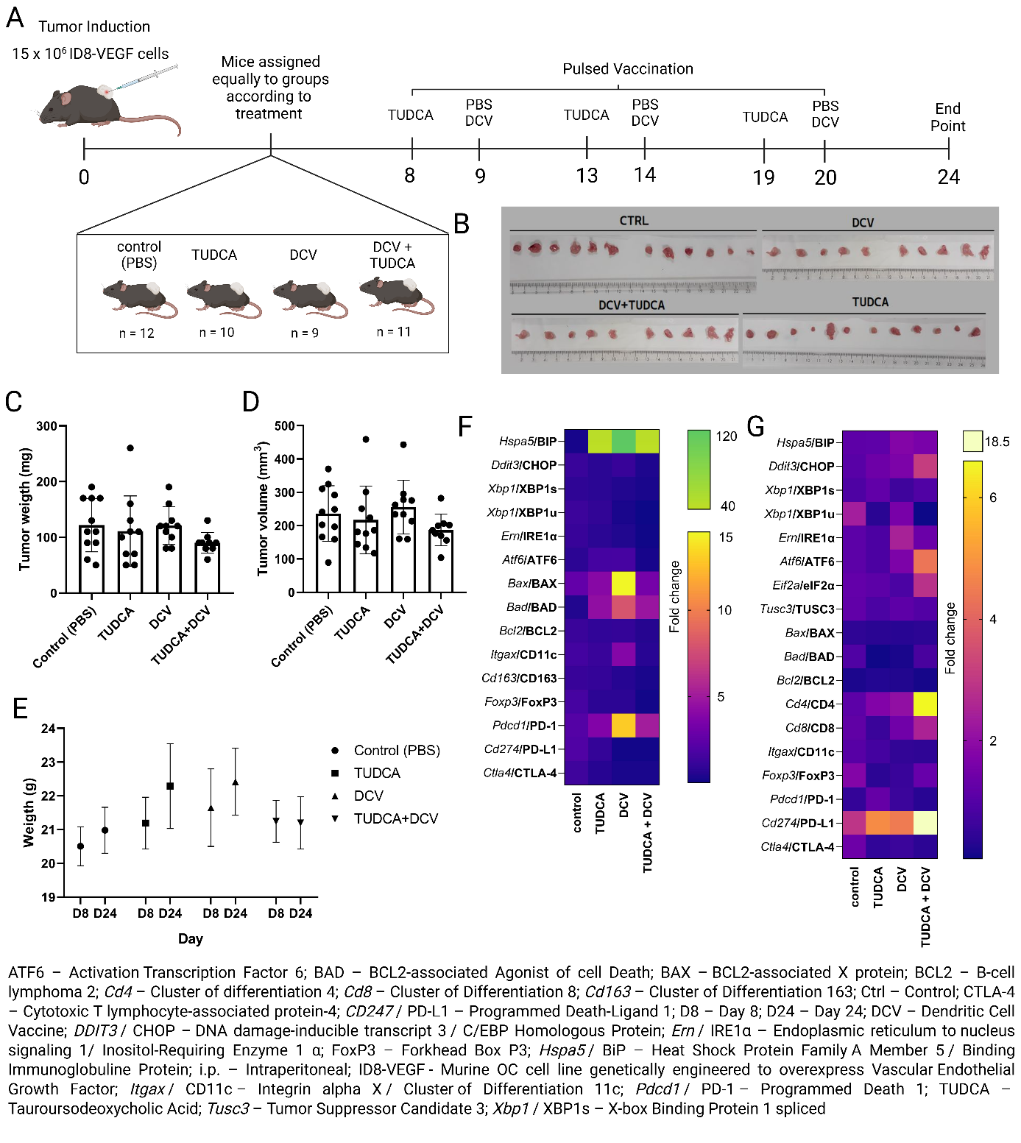
Supplementary Figure 4: In vivo evaluation of ERS modulation in a murine ovarian cancer model (Experiment 2).
(A) Tumors were initiated in C57BL/6JOlaHsd female mice by injecting 15 × 10⁶ ID8-VEGF cells into the left flank (day 0). Mice were randomly assigned to four treatment groups: A) control (PBS); B) TUDCA; C) DCV (dendritic cell vaccine); D) combination therapy (TUDCA+DCV). Therapeutic interventions were administered intraperitoneally (i.p.) in three doses, beginning when the tumor became palpable in all the mice. At each treatment point, the mice received the following: control group – 100 µL of PBS i.p.; TUDCA group – 150 µL of TUDCA in PBS (100 mg/mL) i.p.; DCV group – 1 × 10⁶ DC cells/mouse i.p.; combination therapy group – 150 µL of TUDCA in PBS (100 mg/mL) administered first, followed by DCV (1 × 10⁶ DC cells/mouse) i.p. on the following day. The mice were sacrificed by cervical dislocation on day 24.
(B) Rows of excised tumors from individual mice in each treatment group at the end of the experiment on day 24. A ruler is included for scale (cm).
(C-D) Tumor burden (day 24) relative to day 8: controls reached 122 ± 48 mg and 236 ± 84 mm³. TUDCA monotherapy reduced the weight to 111 ± 63 mg (–8.9%) and volume to 217 ± 101 mm³ (–8.1%). DCV alone reduced the weight to 114 ± 83 mg (–18.1%) but slightly increased the volume to 256 ± 81 mm³ (+8.1%). Combination therapy was the most effective, decreasing the weight and volume to 90 ± 19 mg (–26.1%) and 187 ± 48 mm³ (–20.9%), respectively.
(E) All groups started treatment with comparable body weights (day 8) and showed only small changes by day 24. The control mice (PBS) lost 0.82% of their intial weight, TUDCA-treated mice lost 0.55%, DCV-treated mice lost 2.74%, and combination therapy mice lost 2.60%. No significant differences were observed between the groups, indicating that the treatments did not induce systemic toxicity.
(F-G) Heat maps showing the expression of selected UPR, apoptotic, EMT, and immune markers in tumor (F) and spleen tissues (G), highlighting treatment-associated molecular changes.
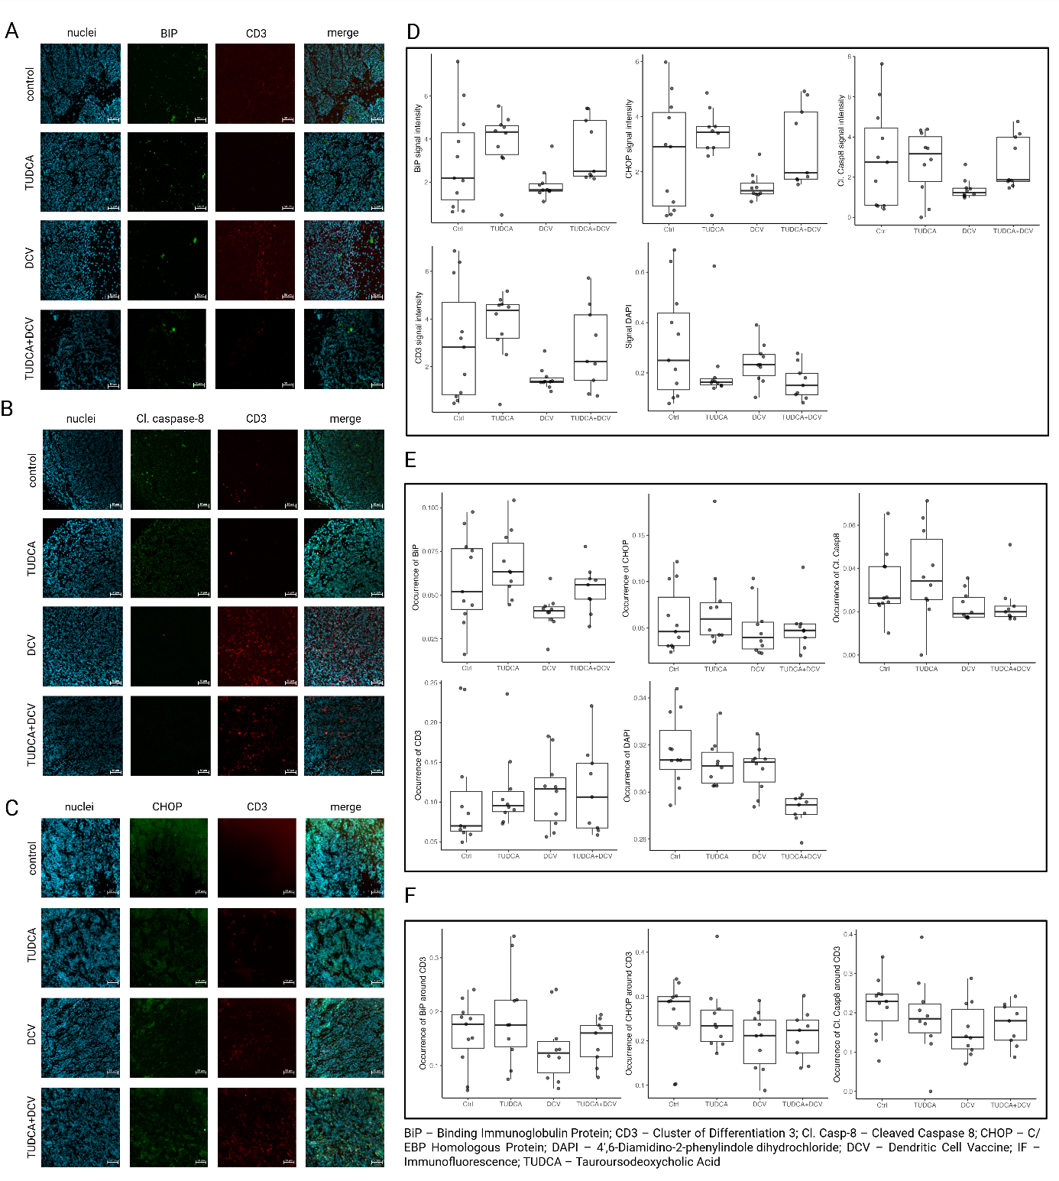
Supplementary Figure 5: Immunofluorescence analysis of murine tumor tissue (Experiment 2).
(A-C) Representative images of mouse-derived tumor tissue immunofluorescence (IF) staining. Tissues were counterstained for (A) BiP, CD3, and cell nuclei (DAPI), (B) cleaved caspase-8, CD3, and cell nuclei (DAPI), and (C) CHOP, CD3, and cell nuclei (DAPI). Scale bar 50 µm.
(D) Relative signal intensity box plots of the tumor tissue staining. Tumor tissue analysis showed a statistically significant decrease in the relative signal intensity of BiP in DCV-treated animals (p=0.035).
(E) Relative occurrence box plots of tumor tissue staining. Tumor tissue analysis showed a statistically significant decrease in relative BiP occurrence in DCV group compared to the TUDCA group (p=0.007).
(F) Relative signal occurrence around CD3 box plots of tumor tissue staining. The relative occurrence of cleaved caspase-8 in the tumor tissue and around CD3 showed no significant difference between the tested groups.
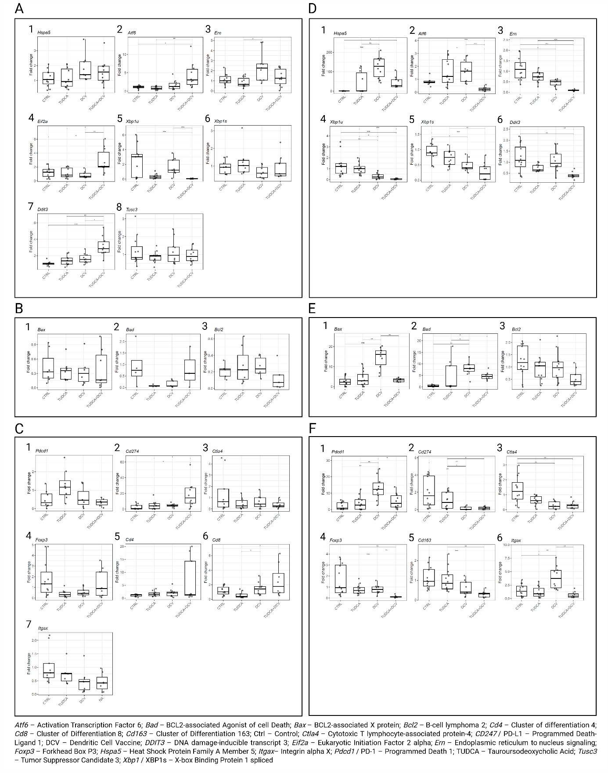Supplementary Figure 6: Gene expression analysis of murine tumor and splenic tissue (Experiment 2).
(A) Tumor tissue of TUDCA+DCV-treated animals showed a significant increase in the expression of Atf6 (p<0.05), Eif2a (p<0.05), and Ddit3 (p<0.001). Conversely, Xbp1u expression was decreased in the tissues of TUDCA+DCV-treated animals (p<0.001). Ern expression was elevated in DCV-treated animals compared to that in the TUDCA group (p<0.05).
(B) Bad expression was lowest in the tumor tissue of TUDCA-treated animals, although no statistical significance was observed. Bcl2 expression was slightly decreased in the tumor tissue of TUDCA+DCV-treated animals (ns).
(C) Cd274 expression was elevated in the tumor tissue of TUDCA+DCV-treated mice compared to that in the control (p<0.05) and TUDCA treatment alone (p<0.05). Tumor tissues of DCV- and TUDCA+DCV-treated mice showed elevated expression of Cd8 compared to those of TUDCA-treated mice (p<0.05).
(D) Gene expression analysis of murine splenic tissue showed elevated expression of Hspa5 in DCV-treated (p<0.001) and TUDCA+DCV-treated animals (p<0.05). Atf6 expression was significantly decreased in the spleen tissue of mice treated with TUDCA+DCV therapy compared to those treated with DCV monotherapy (p<0.001), TUDCA monotherapy (p<0.001), and the control group (p<0.05). Spleen tissue of TUDCA+DCV-treated animals showed the lowest expression of Ern compared to TUDCA monotherapy (p<0.001) and control animals (p<0.05). Both the DCV and TUDCA+DCV groups had significantly lower splenic Xbp1 expression than the TUDCA monotherapy group (DCV p<0.05; TUDCA+DCV p<0.001) and the control animals (DCV p<0.01; TUDCA+DCV p<0.001). Similarly, splicing of Xbp1 was reduced in the spleen tissue of DCV- (p<0.05) and TUDCA+DCV-treated mice (p<0.001). Importantly, Ddit3 expression was significantly reduced in TUDCA+DCV-treated mice compared to that in DCV monotherapy (p<0.01) and control animals (p<0.01).
(E) Spleen tissue of DCV-treated animals showed elevated expression of Bax (p<0.001) and Bad (p<0.01). However, when comparing DCV monotherapy to animals treated with combination therapy of TUDCA+DCV, a significant reduction in Bax expression was observed in the spleen tissue of mice treated with TUDCA+DCV (p<0.01), while Bad expression remained elevated (p<0.05).
(F) Pdcd1 expression was significantly elevated in the tissues of DCV-treated animals (p<0.01), but not in the tissues of TUDCA+DCV-treated mice. A significant decrease in Cd274 and Ctla4 expression was observed in the tissues of DCV- (p<0.01) and TUDCA+DCV-treated mice (p<0.01). The expression of Foxp3 was lowest in the spleen tissue of TUDCA+DCV-treated mice compared to those treated with TUDCA and DCV monotherapies (p<0.01) and to the control (p<0.001). Decreased expression of Cd163 was observed in the tissues of TUDCA+DCV-treated mice compared to those treated with TUDCA monotherapy (p<0.01) and control animals (p<0.001). Itgax expression was elevated in DCV-treated mice (p<0.05).

1. Zhang, L., et al., Generation of a syngeneic mouse model to study the effects of vascular endothelial growth factor in ovarian carcinoma. Am J Pathol, 2002. 161(6): p. 2295-309.

