Gut-derived extracellular vesicle enriched miR-125a-5p mediates cadmium-induced intestinal injury through NF-κB pathway activation
Mengzhen Song, Lina Ping, Yulin Wang, Wenjun Zhou, Jinping Fan, Shiyu Tao, Yaoqin Shen*

Authors and Affiliations:
College of Animal Science & Technology and College of Veterinary Medicine, Huazhong Agricultural University, Wuhan 430070, China

*Corresponding author: Yaoqin Shen, College of Animal Science & Technology and College of Veterinary Medicine, Huazhong Agricultural University, Wuhan, China 430070 (e-mail:yshen@mail.hzau.edu.cn).

Table S1: Differentially expressed miRNAs in C-EVs vs.Cd-EVs
miRNAs | C-EVs (Mean) | Cd-EVs (Mean) | Log2FC (Cd-EVs/C-EVs) | P value | P adjust | Regulate
1_1129 | 536.87 | 33.03 | -3.711 | 0.038 | 0.201 | down
1_1767 | 2624.44 | 320.21 | -3.030 | 0.000 | 0.003 | down
1_1768 | 2624.44 | 320.21 | -3.030 | 0.000 | 0.003 | down
1_2164 | 439.81 | 0.00 | -4.379 | 0.041 | 0.201 | down
1_492 | 1272.79 | 4235.65 | 1.818 | 0.000 | 0.004 | up
10_2411 | 0.00 | 444.50 | 4.231 | 0.021 | 0.128 | up
10_2412 | 0.00 | 444.50 | 4.231 | 0.021 | 0.128 | up
10_3543 | 362.99 | 0.00 | -4.088 | 0.043 | 1.000 | down
11_3801 | 2006.97 | 13412.10 | 2.813 | 0.000 | 0.000 | up
11_4517 | 928.58 | 121.76 | -2.947 | 0.024 | 0.138 | down
12_5841 | 0.00 | 456.27 | 4.280 | 0.021 | 0.128 | up
13_7434 | 87.96 | 7655.32 | 6.481 | 0.000 | 0.000 | up
14_8832 | 503.43 | 0.00 | -4.545 | 0.012 | 0.099 | down
15_10108 | 0.00 | 432.47 | 4.197 | 0.024 | 0.138 | up
15_9547 | 0.00 | 1116.30 | 5.559 | 0.000 | 0.004 | up
15_9978 | 1235.53 | 3318.94 | 1.521 | 0.003 | 0.039 | up
16_10586 | 0.00 | 1077.94 | 5.504 | 0.000 | 0.008 | up
16_11364 | 0.00 | 9429.79 | 8.641 | 0.000 | 0.000 | up
18_13215 | 91.77 | 1001.52 | 3.550 | 0.008 | 0.066 | up
18_13726 | 0.00 | 391.60 | 4.056 | 0.035 | 0.186 | up
3_17548 | 0.00 | 489.56 | 4.367 | 0.015 | 0.114 | up
4_18980 | 0.00 | 27767.71 | 10.200 | 0.000 | 0.000 | up
5_21252 | 1808.17 | 6017.72 | 1.826 | 0.000 | 0.004 | up
5_21358 | 87.96 | 656.12 | 2.946 | 0.040 | 0.201 | up
5_22212 | 0.00 | 550.04 | 4.541 | 0.014 | 0.106 | up
6_23425 | 9069.68 | 3493.60 | -1.306 | 0.000 | 0.004 | down
7_25459 | 584.06 | 0.00 | -4.764 | 0.006 | 0.063 | down
8_26159 | 0.00 | 855.71 | 5.184 | 0.001 | 0.014 | up
9_28069 | 3088.88 | 833.31 | -1.804 | 0.002 | 0.026 | down
X_30769 | 0.00 | 587.26 | 4.635 | 0.007 | 0.063 | up
mmu-miR-125a-5p | 318.13 | 1244.78 | 2.051 | 0.020 | 0.128 | up
mmu-miR-1a-3p | 177.97 | 1051.91 | 2.643 | 0.019 | 0.128 | up
mmu-miR-2137 | 991.91 | 2854.83 | 1.597 | 0.004 | 0.045 | up
mmu-miR-30b-5p | 1675.63 | 426.03 | -1.862 | 0.017 | 0.117 | down
mmu-miR-30c-5p | 3916.25 | 1397.05 | -1.381 | 0.004 | 0.045 | down
mmu-miR-335-5p | 43.10 | 1471.31 | 5.009 | 0.001 | 0.014 | up
mmu-miR-5106 | 3690.54 | 1722.31 | -1.017 | 0.026 | 0.142 | down
mmu-miR-5108 | 778.45 | 2172.14 | 1.573 | 0.012 | 0.099 | up
mmu-miR-5110 | 89.73 | 727.49 | 3.061 | 0.041 | 0.201 | up
mmu-miR-6239 | 956.70 | 2199.57 | 1.293 | 0.044 | 0.210 | up

Table S2: List of antibodies used for western blot analysis
Antibodies | Source | Product number | Dilution
p-NF-κB p65 | CST | 3033 | 1: 1000
NF-κB p65 | CST | 8242 | 1: 1000
ZO-1 | Abcam | ab96587 | 1: 1000
Occludin | Abcam | ab167161 | 1: 1000
Claudin-1 | Abcam | ab307692 | 1: 1000
β-actin | CST | 4967 | 1: 1000
Goat anti-rabbit | Santa Cruz | sc-2004 | 1: 10000

Figure S1
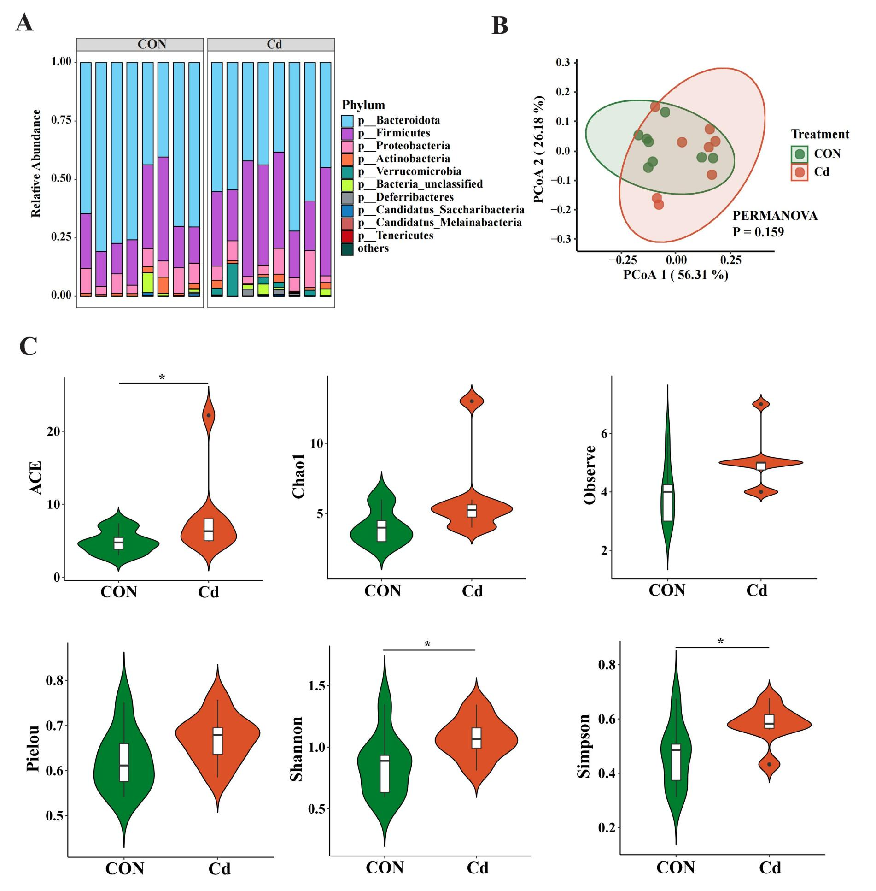
Figure S1. Phylum‑level disruption of gut microbiota induced by cadmium.(A) Phylum‑level taxonomic composition bar plot. (B) Principal coordinates analysis (PCOA) at the phylum level. (C) Phylum‑level α‑diversity indices. n = 8. *P < 0.05.

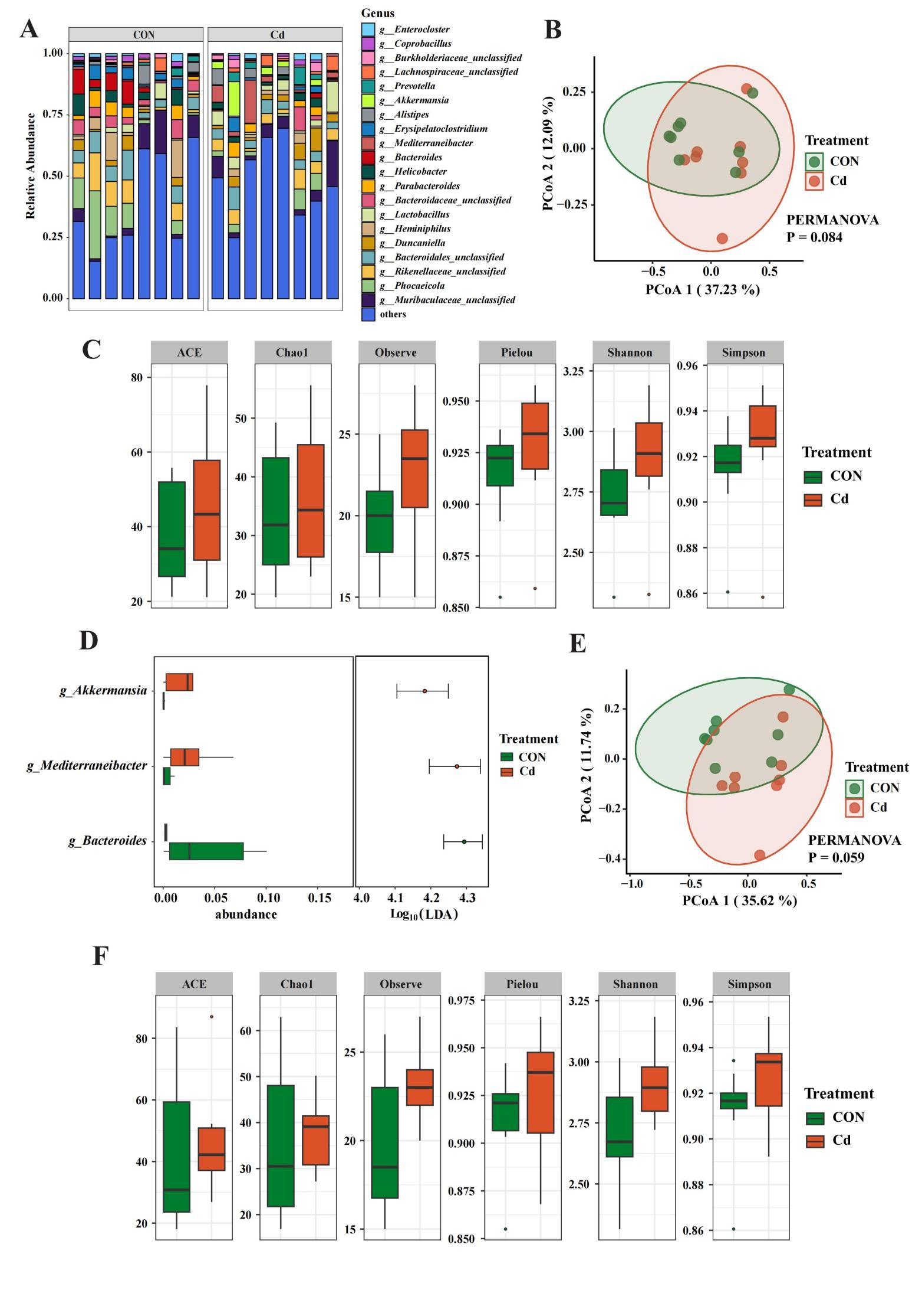
Figure S2
Figure S2. Genus‑ and species‑level disruption of gut microbiota induced by cadmium. (A) Genus‑level taxonomic composition bar plot. (B) Principal coordinates analysis (PCOA) at the genus level. (C) Genus‑level α‑diversity indices. (D) Differentially abundant taxa at the genus level. (E) Principal coordinates analysis (PCOA) at the species level. (F) Species‑level α‑diversity indices. N = 8.
Figure S3
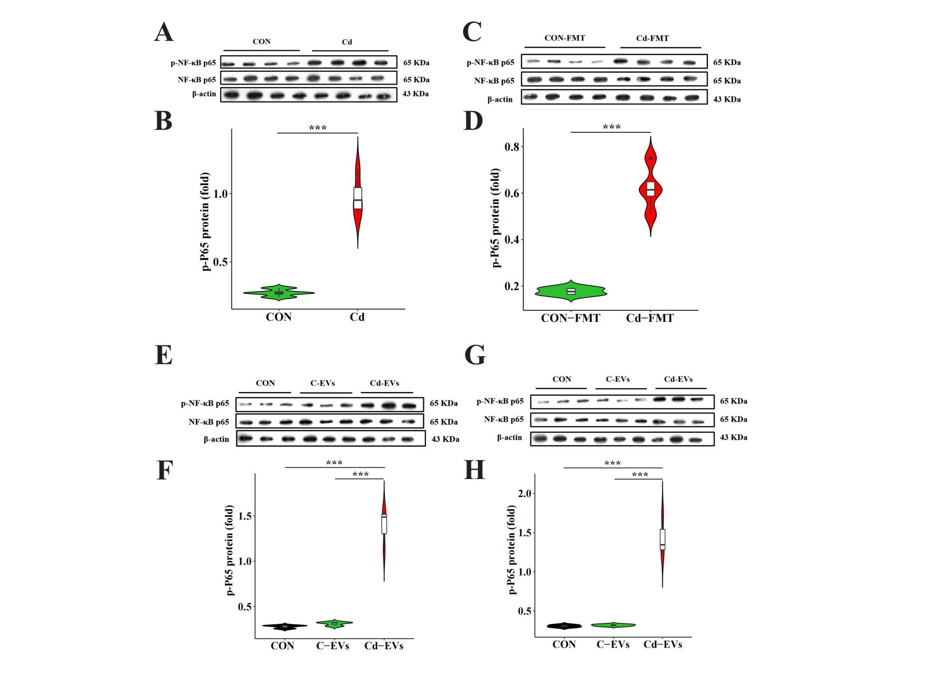
Figure S3. Expression of p‑NF‑κB‑p65 in vivo and in vitro. (A) Expression of p‑NF‑κB‑p65 in the jejunum of mice upon cadmium treatment. (B) Expression of p‑NF‑κB‑p65 in the jejunum of mice following fecal microbiota transplantation (FMT). (C) Expression of p‑NF‑κB‑p65 in the jejunum of mice after EVs intervention. (D) Expression of p‑NF‑κB‑p65 in MODE‑K cells following EVs intervention. Statistical differences were evaluated by one‑way ANOVA with Tukey’s post‑hoc test. Data are presented as mean ± SEM. N=3. Significance thresholds: ***P < 0.001.

