Appendix

Table App1. English translation of the list of occupational labels used in the experiment

 | Occupation
1 | Managers
2 | Lawyers
3 | Psychologists
4 | Judges
5 | Aircraft Pilots
6 | Programmers
7 | Engineers
8 | Criminal Investigators
9 | Dentists
10 | Doctors
11 | Physicists
12 | Veterinarians
13 | Kindergarten Teachers
14 | Teachers
15 | Journalists
16 | Fine artists
17 | Bookkeeper
18 | Meter Readers
19 | Survey Researchers
20 | Fishers
21 | Telephone Operators
22 | Highway Maintenance Workers
23 | Farmworkers
24 | Food Preparation Workers
25 | Receptionists
26 | Customer Service Representatives
27 | Postal Service Workers
28 | Waiters
29 | Cleaning Workers
30 | Barbers
31 | Bartenders
32 | Massage Therapists
33 | Plumbers
34 | Cooks
35 | Car Mechanics
36 | Embalmers
37 | Explosives Workers
38 | Athletes
39 | Firefighters
40 | Cashiers
41 | Bus Drivers
42 | Office Clerks
43 | Clergy
44 | Insurance Sales Agents
45 | Police Officers
46 | Musicians
47 | Painters
48 | Tailors
49 | Secretaries
50 | Sailors
51 | Nurses
52 | Parking Lot Attendants
53 | Chief Executives
54 | Mob member
55 | Usurers
56 | Thieves
57 | Drug Traffickers
58 | Fences
59 | Bank Robbers
60 | Peculators

Figure App1. Dendogram of the hierarchical cluster analysis which was run on the coordinates of the labels arranged freely in the semantic space

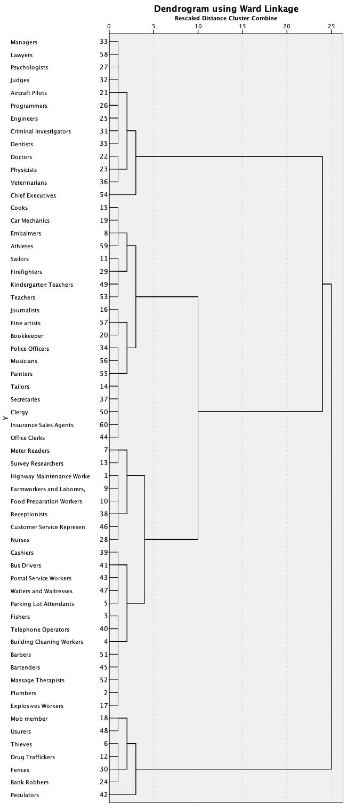

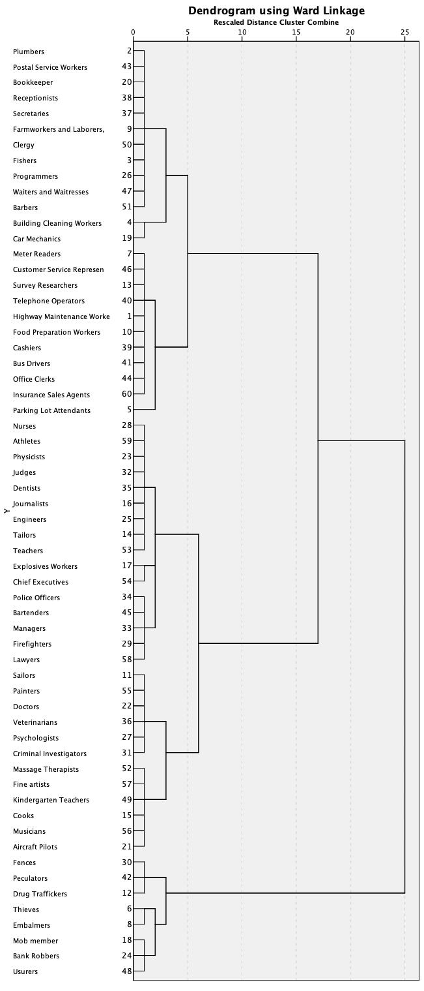
Figure App2. Dendogram of the hierarchical cluster analysis which was run on the coordinates of the labels arranged according to valence and arousal in the affective space

