Table 4: The variability in function of panels in 16 MLVA (VNTR) assay
Panel 1 groups eight minisatellites (MLVA 8) Panel 2A group 3 & Panel 2B group 5 microsatellites

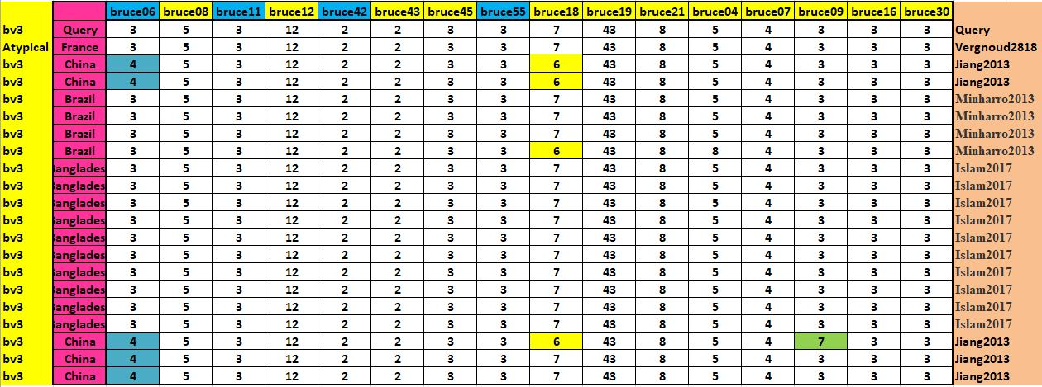

Table.5: MLVA-16 profiles of B. abortus biovar 3 isolates from Bangladesh compared with international strains.

