Supplementary Information
S.1 Exosome quantification by NanoSight
The exosome concentration was shown in Table S.1 and size distribution of exosome samples from various cultured cell lines. The size distribution for all exosome samples is around 100 – 200 nm.
Table S.1 Particle concentration and statistical values of exosome samples.
 | Particle concentration  (particles/mL) | Mean (nm) | Mode (nm)
Sample 1 – HEK293 | 4.26 ± 1.05 x 10⁸ | 182.6 ± 8.0 | 161.7 ± 6.1
Sample 2 – Met5a | 1.83 ± 1.30 x 10⁸ | 206.5 ± 45.5 | 97.4 ± 0.4
Sample 3 – OVCAR3 | 4.93 ± 0.16 x 10⁸ | 148.7 ± 1.0 | 100.9 ± 4.0
Sample 4 – SKOV3 | 3.63 ± 0.13 x 10⁸ | 203.5 ± 2.6 | 127.5 ± 10.5
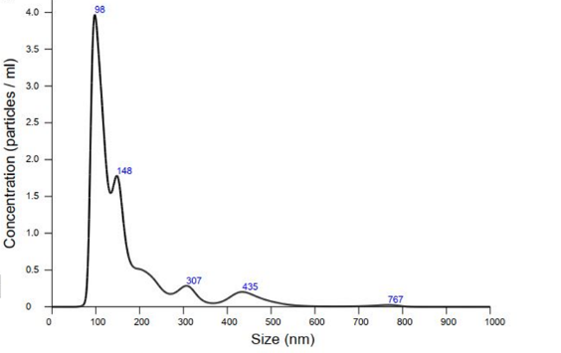
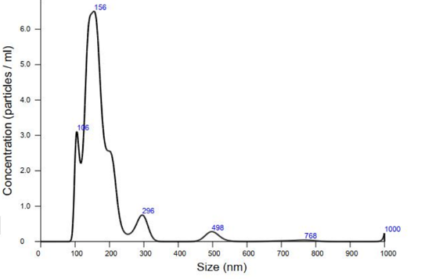

Sample 1 Sample 2
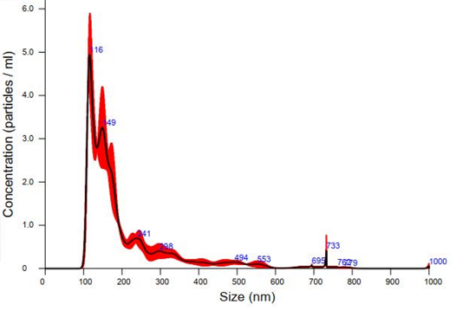
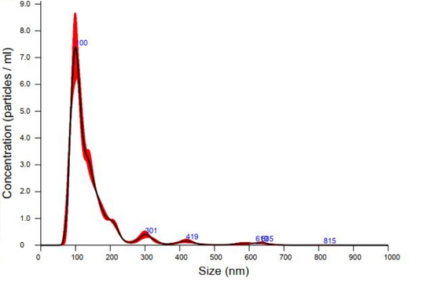

Sample 3 Sample 4
Figure S.1 Size distribution of exosome samples quantified by NanoSight.
S.2 Stability of low concentration of enzymatic solution
We observed that the result of HRP/TMB reaction may be inconsistent when we used the same HRP-conjugated antibody solution especially when low concentration (< 1 µg/mL). The earlier we used the solution, the more colour it can be produced. Thus, this experiment was designed to clarify whether preparation time of low concentration of HRP-conjugated antibody solution affects the colour change or not. HRP-conjugated antibody solution was prepared at 0.5 µg/mL and kept in ice box (approximately 4ºC). Then, we added 3 µL of HRP-conjugated solution with 47 µL of commercial TMB in 96-well plate after 0 min, 30 min, 60 min of mixing. After that, the 96-well plate was measured with absorbance at wavelength 652 nm at 30 sec, 1 min, 2 min, 3 min, 4 min and 5 min. The result indicated that the absorbance was decreased when the preparation time was increased which means the enzymatic activity seems to be reduced when its solution was kept for a longer time before use. Thus, in all experiments involved with HRP-conjugated antibody solution, the solution was prepared fresh before use every time.
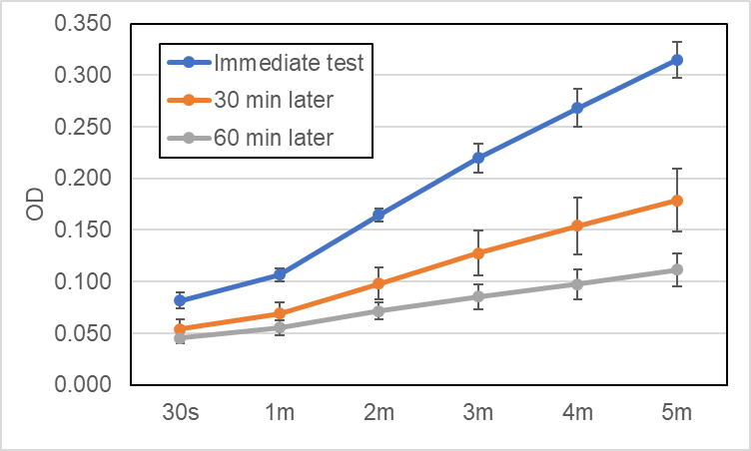

Figure S.2 The absorbance of HRP/TMB reaction from different preparation times of 0.5 µg/mL of HRP-conjugated antibody solution over time.

