Optimizing redox capability and basic site distribution in Co-modified Cu/ZSM-5 catalysts for efficient methanol oxidation
Sihan Yinª, Zhitao Han^{a*}, Jiyue Wangª, Junhao Jingª, Liangzheng Linª, Yang Cheª, Yangbo Dengª
a. Marine Engineering College, Dalian Maritime University, Dalian 116026, China;
Correspondence information: Dr. Zhitao Han, Dalian Maritime University, No.1, Linghai Road, Dalian 116026, China, hanzt@dlmu.edu.cn, ORCID: 0000-0001-5501-6067, Tel: +86 138 9869 2035.

Materials
CH₃OH, CO₂ (99.999 %) and N₂ (99.999 %) pure gases were obtained from Dalian Special Gases Co., Ltd. Cu (NO₃)₂‧3H₂O, Co (NO₃)₃6H₂O were obtained from China National Pharmaceutical Group Co., Ltd. ZSM-5 zeolite was obtained from Qingdao Yuan Ke Catalyst Co., Ltd.

Catalyst Characterization
The X-ray diffraction (XRD) tests were conducted using an X-ray diffractometer (Empyrean, PANalytical) with Cu Ka (λ = 0.154 nm) as the radiation source. The XRD diffractograms of the catalyst samples were recorded in the 2θ range of 5-90 ° with a scanning speed of 2 °/min and a scanning interval of 0.02 °.
The structural properties of the samples were investigated by N₂ physisorption (ASAP 2020 PLUS, Micromeritics). The samples were required to be degassed under vacuum at 350 °C for 4 h before each test, N₂ adsorption-desorption data were recorded at the temperature of liquid nitrogen (-196 °C). Specific surface areas and pore volumes were calculated using the Brunauer-Emmett-Teller (BET) equation and the Barrett-Joyner-Halenda (BJH) method, respectively.
Transmission electron microscopy (TEM) images of catalysts were measured on a JEM-2100F electron microscope (JEOL，Japan). The acceleration voltage was 200 kV, and the surface chemical analysis was conducted by using energy dispersive X-ray spectrometer (EDS).
The X-ray photoelectron spectra (XPS) of the catalysts were measured with a photoelectron spectrometer (AXIS-ULTRA DLD-600W, Shimadzu) using Al Kα as the radiation source. The binding energies of the different elements were calibrated by the C 1s peak at 284.6 eV.
The H₂-temperature programmed reduction (H₂-TPR) experiments were performed on the samples using a chemisorption analyzer (Autochem II 2920, Micromeritics). Firstly, the samples were dried and pretreated in a He flow (50 mL/min) at 350 °C for 1 h, and then cooled to 50 °C. Subsequently, the samples were heated up to 900 °C with an H₂ (10 %)/Ar (50 mL/min) mixture as the reducing gas at a heating rate of 10 °C /min, while signal changes were recorded with a thermal conductivity detector (TCD).
The O₂-temperature-programmed desorption (O₂-TPD) experiments were performed on the samples using a chemisorption analyzer (Autochem II 2920, Micromeritics). Firstly, the samples were dried and pretreated in a He flow (50 mL/min) at 350 °C for 1 h, then cooled to 50 °C. Subsequently, the samples were exposed to O₂ (5 %)/He (50 mL/min) mixture for 1 h to saturate the adsorption and then switched to He gas flow (50 mL/min) for 1 h to remove O₂ physically adsorbed on the surface. Finally, the sample was heated up to 900 °C under He (50 mL/min) gas flow at a heating rate of 10 °C/min, while signal changes were recorded with TCD.
Temperature-programmed desorption of CO₂ (CO₂-TPD) was performed using a chemisorber (Autochem II 2920, Micromeritics). The catalyst was pretreated at 350 °C for 1 hour in pure helium gas (50 mL/min), then cooled to 50 °C, and chemically adsorbed on CO₂ at 50 °C for 30 min to reach the adsorption equilibrium. Finally, the sample was heated from 50 °C to 700 °C at a rate of 10 °C/min for CO₂ desorption.
In-situ diffuse reflectance infrared Fourier transform spectroscopy (DRIFTS) was recorded using an FTIR spectrometer (Nicolet iS50, ThermoFisher Scientific) equipped with MCT/A detector and cooled by liquid nitrogen. Samples were pretreated in flowing N₂ at 300 °C for 30 min before each experiment. Then background spectrum was recorded in N₂ flow and would be automatically subtracted from the corresponding spectra. All spectra were measured by accumulating 64 scans with a resolution of 4 cm⁻¹.

Catalytic performance
Fig S1. CH₃OH conversion, CO₂ selectivity, CO selectivity, HCHO selectivity of (a) Co_{0.1}Cu/ZSM-5, (b) Co_{0.3}Cu/ZSM-5, (c) Co_{0.7}Cu/ZSM-5 catalysts
TEM and EDS
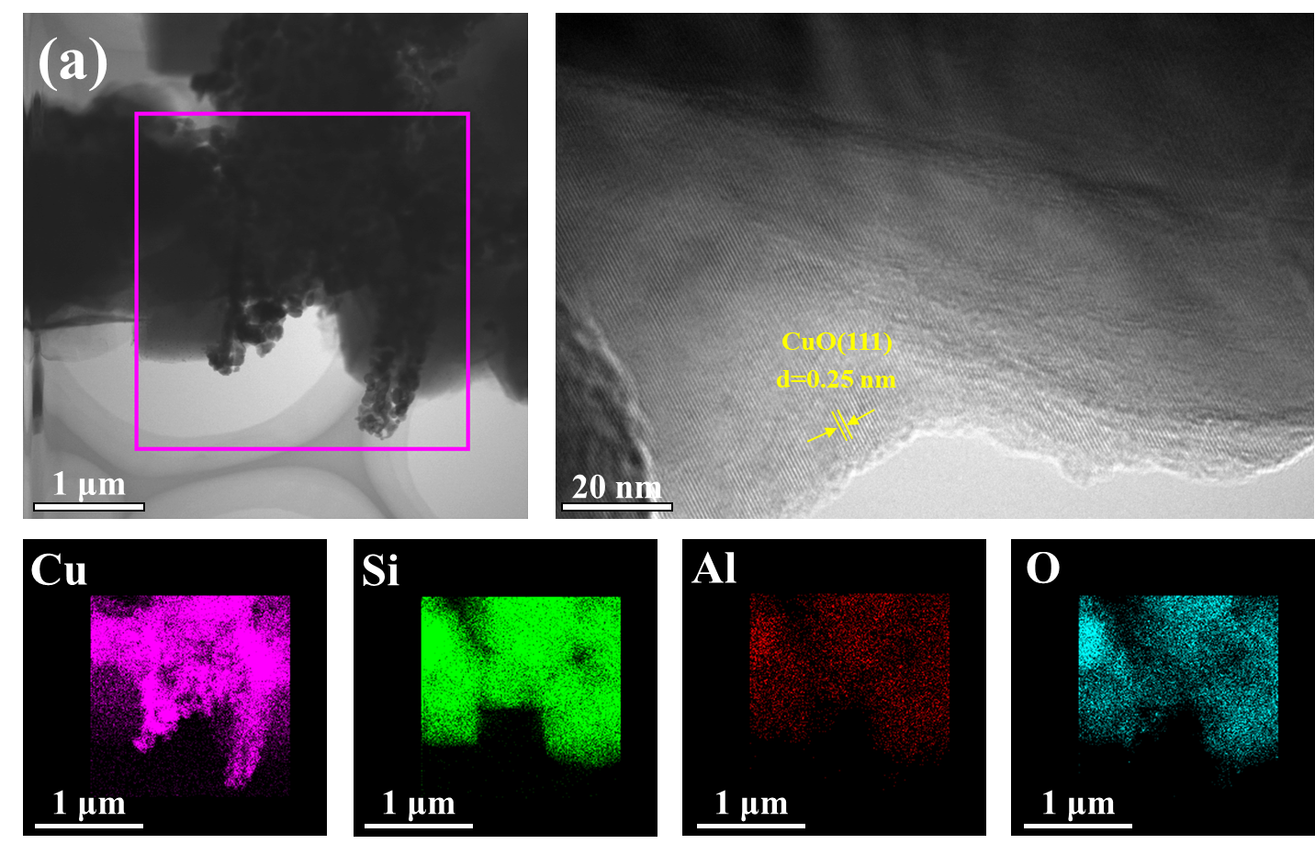
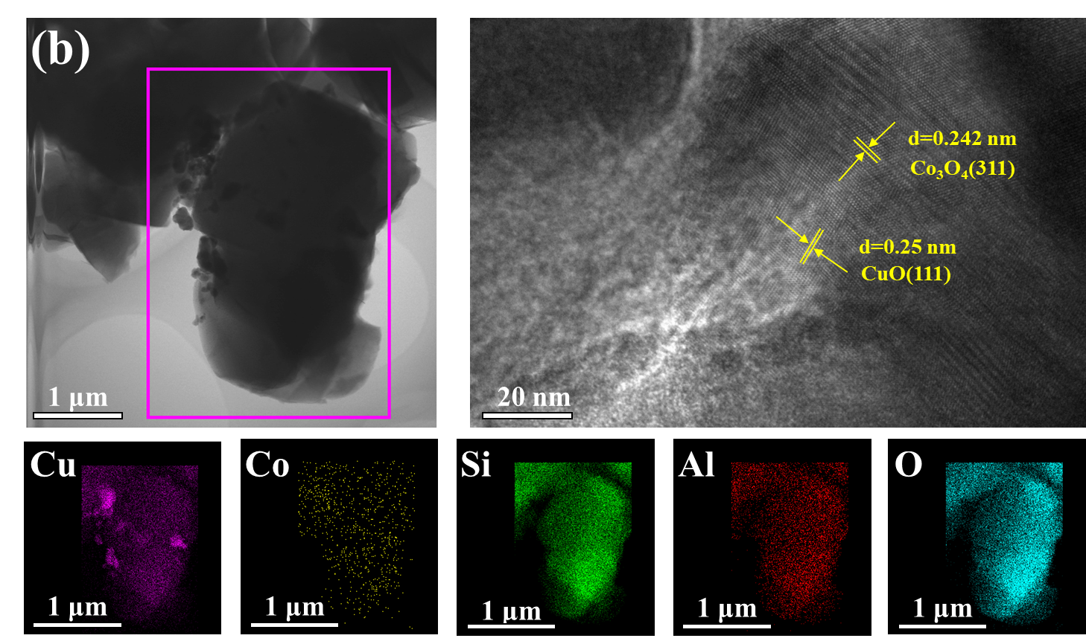
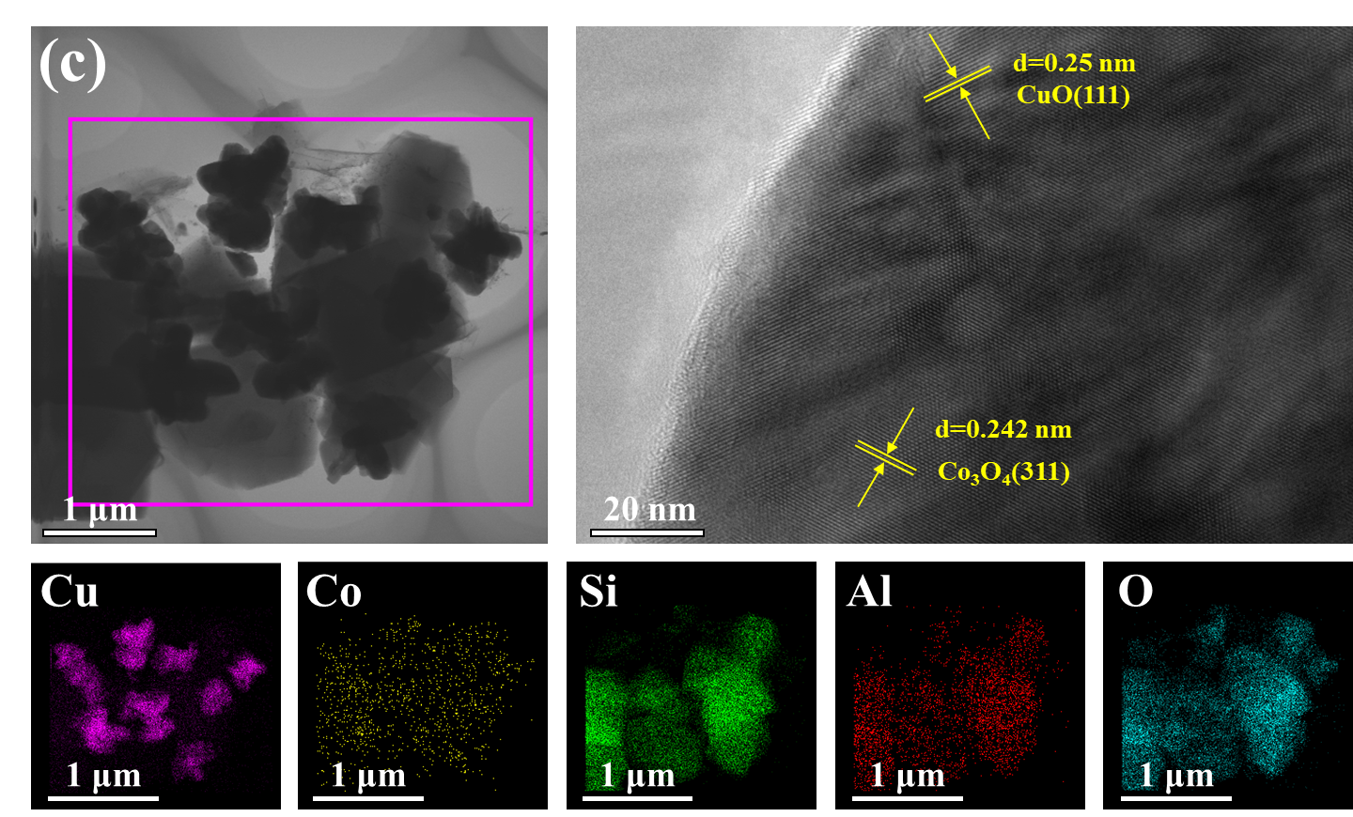
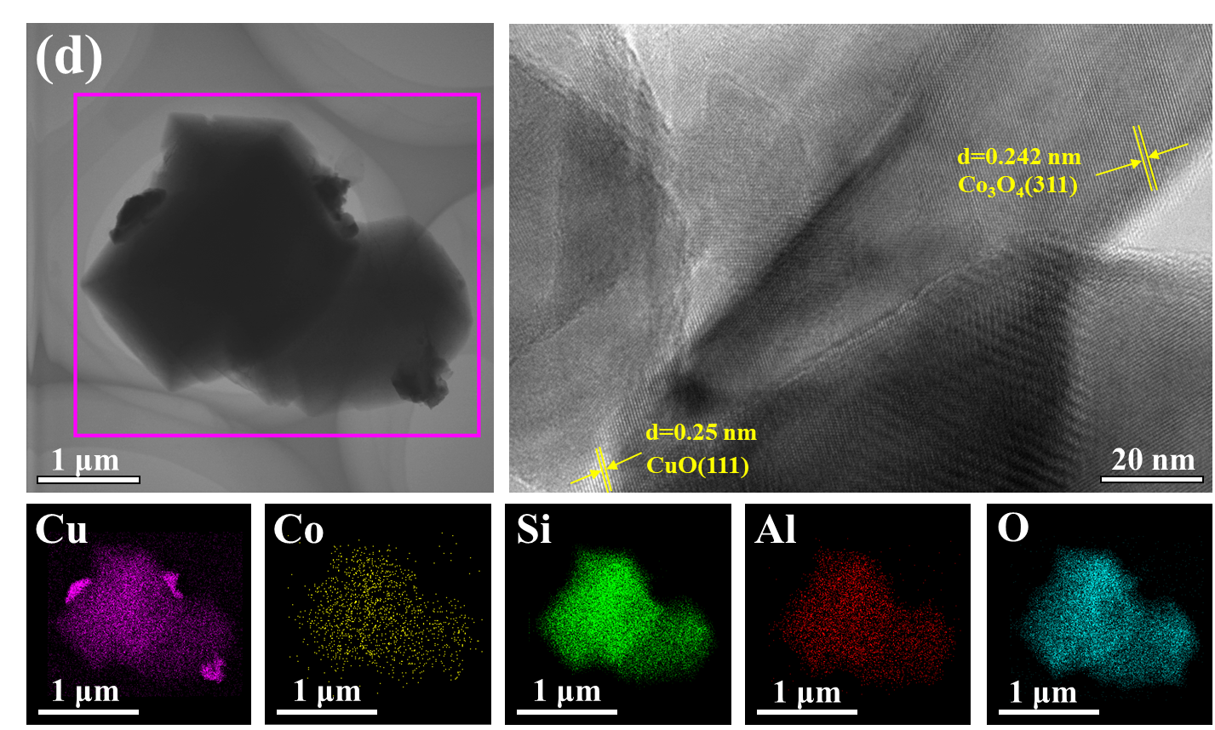
Fig S2. TEM and EDS mappings of (a) Cu/ZSM-5, (b) Co_{0.1}Cu/ZSM-5, (c) Co_{0.3}Cu/ZSM-5, (d) Co_{0.7}Cu/ZSM-5 catalysts

H₂ consumption
Table S1 H₂ consumption date of the Co_{x}Cu/ZSM-5 catalysts
Catalysts | H₂ consumption(mmol/g)
Cu/ZSM-5 | 22.4
Co_{0.1}Cu/ZSM-5 | 17.76
Co_{0.3}Cu/ZSM-5 | 20.62
Co_{0.5}Cu/ZSM-5 | 27.2
Co_{0.7}Cu/ZSM-5 | 24.12

O₂-TPD
Table S2 O₂-TPD date of the Co_{x}Cu/ZSM-5 catalysts
Catalysts | O₂ amount (mmol/g) |  |  | Total amount  (mmol/g)
Catalysts | O_{α} | O_{β} | O_{γ} | Total amount  (mmol/g)
Cu/ZSM-5 | 0.13 | 0.73 | 0.73 | 1.59
Co_{0.1}Cu/ZSM-5 | 0.10 | 1.05 | 0.76 | 1.91
Co_{0.3}Cu/ZSM-5 | 0.16 | 1.34 | 0.87 | 2.37
Co_{0.5}Cu/ZSM-5 | 0.19 | 1.40 | 0.82 | 2.41
Co_{0.7}Cu/ZSM-5 | 0.15 | 1.22 | 0.85 | 2.22

CO₂-TPD
Table S3 CO₂-TPD date of the Co_{x}Cu/ZSM-5 catalysts
Catalysts | CO₂ amount (mmol/g) |  |  | Total amount  (mmol/g)
Catalysts | weak basic sites | medium basic sites | strong basic sites | Total amount  (mmol/g)
Cu/ZSM-5 | 0.60 | 0.38 | 0.26 | 1.24
Co_{0.1}Cu/ZSM-5 | 0.34 | 0.32 | 0.13 | 0.79
Co_{0.3}Cu/ZSM-5 | 0.38 | 0.23 | 0.29 | 0.90
Co_{0.5}Cu/ZSM-5 | 0.60 | 0.30 | 0.29 | 1.19
Co_{0.7}Cu/ZSM-5 | 0.47 | 0.29 | 0.26 | 1.02

Table. S4 The temperature of CH₃OH conversion reached 90% (T₉₀) and the temperature of CO₂ selectivity reached 100% (S₁₀₀) of methanol oxidation over various catalysts
Catalysts | T₉₀ (°C) | S₁₀₀(°C) | Reference
Co_{0.5}Cu/ZSM-5 | 160 | 180 | This work
Cu/ZSM-5 | 189 | 240 | [1]
20CuCoO_{x}@Y-A | 270 | - | [2]
Pd/Al₂O₃ | 200 | - | [3]
CeO₂-NS | 312 | - | [4]
1 % Pd/NaY | 205 | - | [5]
1 % Pd/HY | 192 | - | [5]
Cu/Li₂O/Al₂O₃ | - | - | [6]
TiO₂-CeO₂-CuO | 210 | 265 | [7]

References
[1]. Yin S, Han Z, Jing J, Zhang S, Sheng S, Lin L, Liu T, Gao C, Tian Y (2025) ChemistrySelect 10.
[2]. Zhang X, Liu D, Zhang M, Sun L, Toyao T, He C, Chen D, Liu W, Matsuoka M, Sun H, Wang X, Chen H (2024) Chemical Engineering Journal 487.
[3]. Zhang x, Chen X, Liu Y, Guo M (2020) Water, Air, & Soil Pollution 231.
[4]. Ru X, Li W, Wang X, Shi Z, Wen X, Mo S, zhang Q, Mo D (2023) Chemical Engineering Science 281.
[5]. Zhao W, Zhang H, Zhang L, Gong J, Chen T, Ren L, Ji Y, Meng F (2022) Catalysis Letters 153:1786-1796.
[6]. Shi Z, Li W, Wen X, Wang X, Ren E, Mo D (2022) Catalysis Letters 153:2482-2492.
[7]. Matejova L, Troppova I, Pitkaaho S, Pacultova K, Fridrichova D, Kania O, Keiski R (2023) Nanomaterials (Basel) 13.

