Pan-cancer analysis identified Tripartite Motif Containing 54 as a potential prognostic and diagnostic biomarker in human cancers
Yijun Liang^{1,#}, Ruijia Liu^{2,#}, Longhua Wang², Xudong Yu², Fuwen Zhang², Jing Li², Xiaobin Zao^{2*}, Yufei Yang^{1*}
1 Department of Oncology, Xiyuan Hospital of China Academy of Chinese Medical Sciences, No. 1 Caochang Street, Haidian District, Beijing, 100091, China;
2 Dongzhimen Hospital, Beijing University of Chinese Medicine, Beijing, China;
# These authors have contributed equally to this work;
*Correspondence should be addressed to Yufei Yang (yyf93@vip.sina.com) and Xiaobin Zao (A3417@bucm.edu.cn).

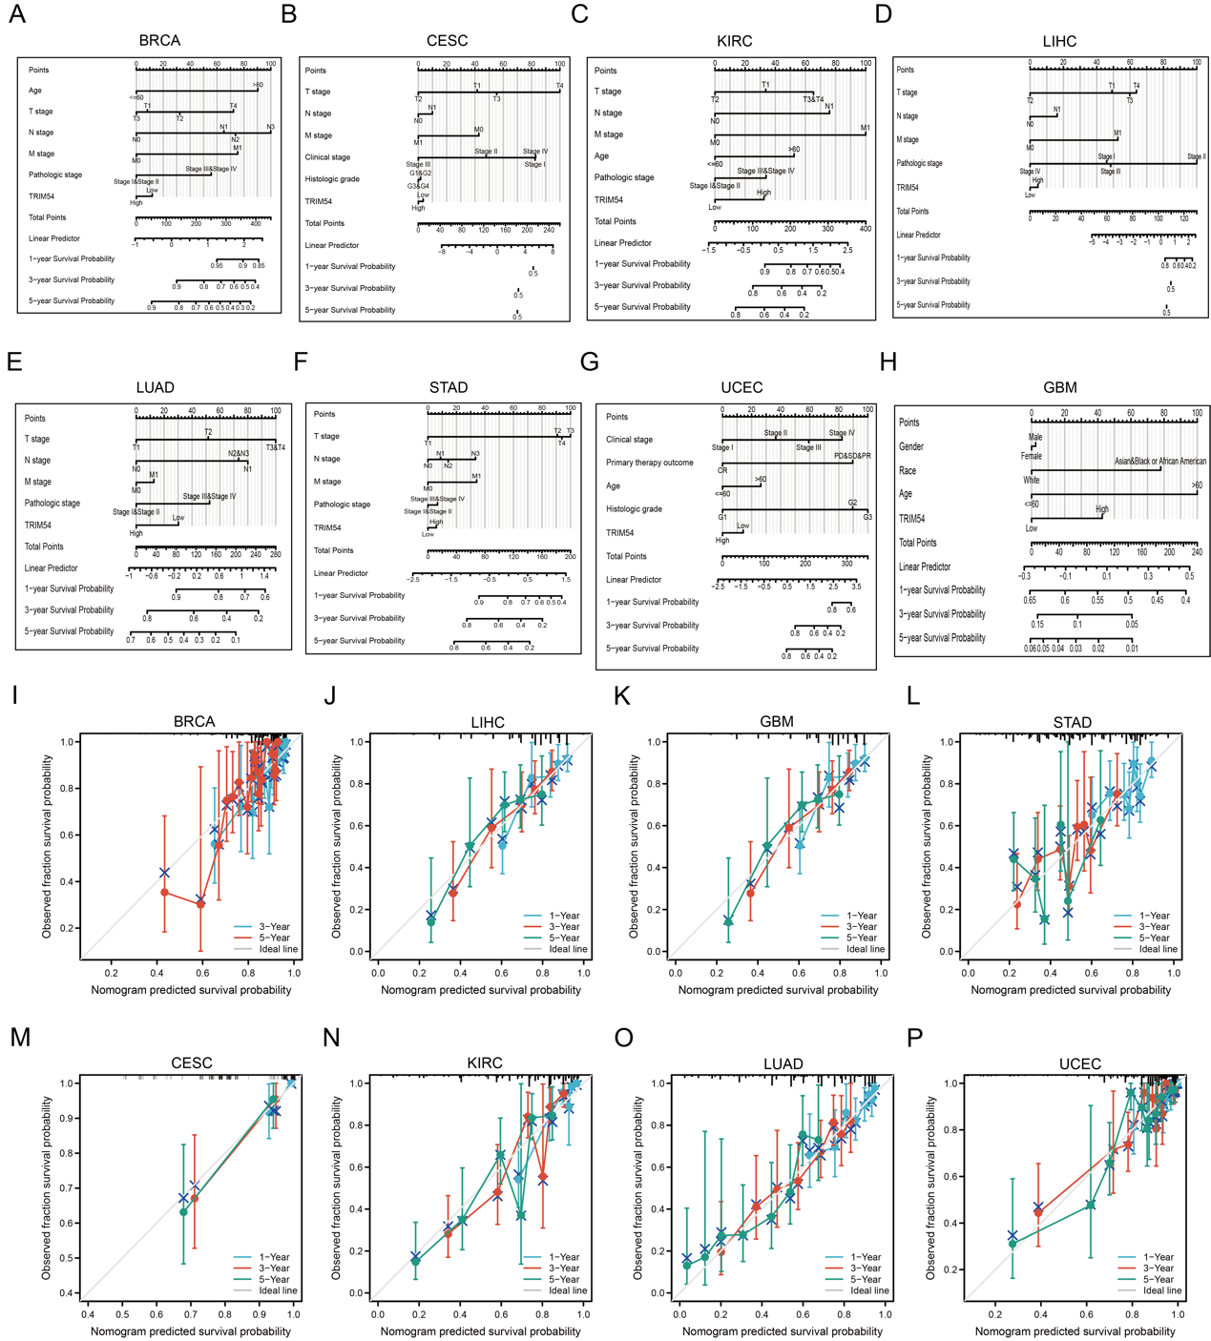
Figure S1. Prognostic value of TRIM54 in pan-cancer. (A-H) The nomogram that combines TRIM54 and other prognostic factors in BRCA (A), CESC (B), KIRC (C), LIHC (D), LUAD (E), STAD (F), UCEC (G), or GBM (H). (I-P) The calibration curve of the associated nomogram.

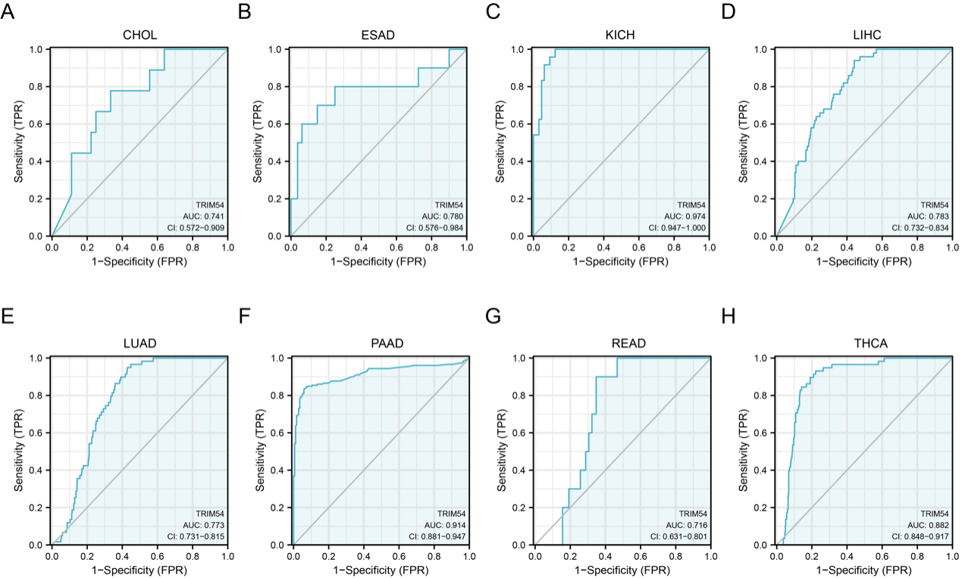
Figure S2. Diagnostic Value of TRIM54 in Pan-cancer. (A-H) The receiver operating characteristic curve of TRIM54 expression in CHOL (A), ESAD (B), KICH (C), LIHC (D), LUAD (E), PAAD (F), READ (G), or THCA (H).

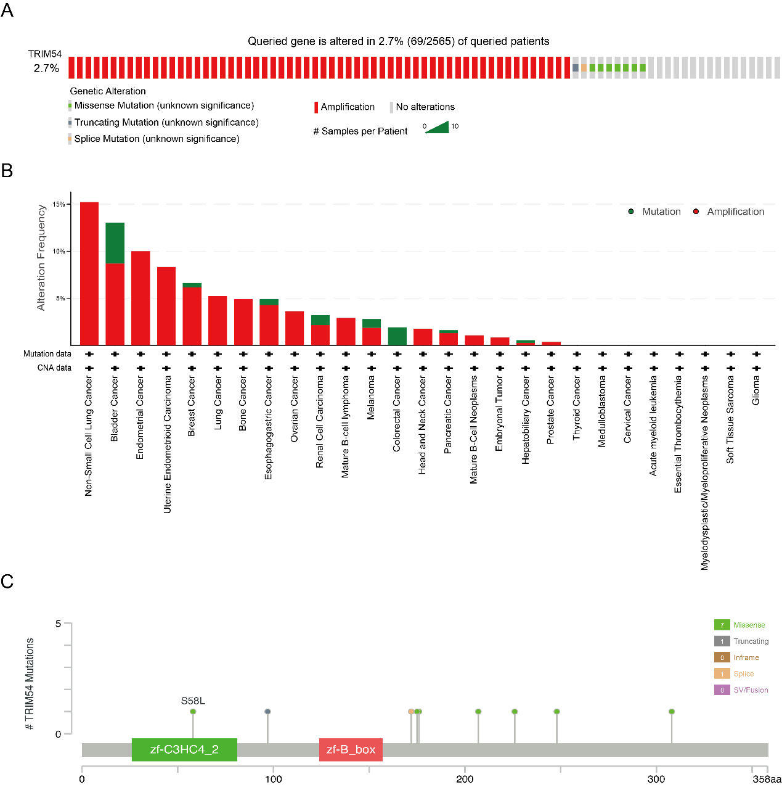
Figure S3. Genetic alterations of TRIM54 in pan-cancer. (A) Evaluation of TRIM54 total mutations using the genome-wide pan-cancer analysis. (B) Frequency of TRIM54 gene alterations by mutation type. (C) Mutation diagram of TRIM54 in various cancer types across protein domains.

Figure S4. Correlations between TRIM54 and immune-related scores and immune cell infiltration. *P < 0.05, **P < 0.01, ***P < 0.001.

