Supplementary Information
The Effect of TSH-suppressive Dose of Levothyroxine on Skeletal Muscle in Ovariectomized Rats

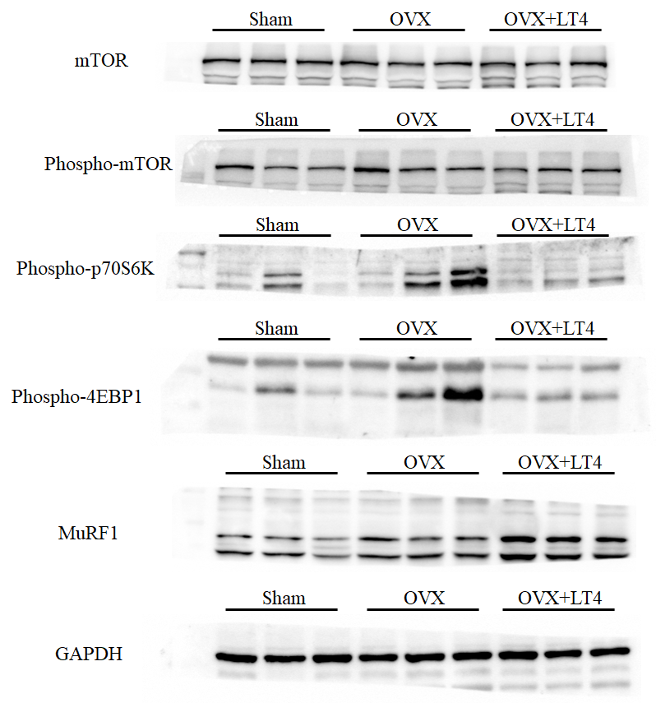
Supplementary Fig. 1. Original blots of Figure 2.
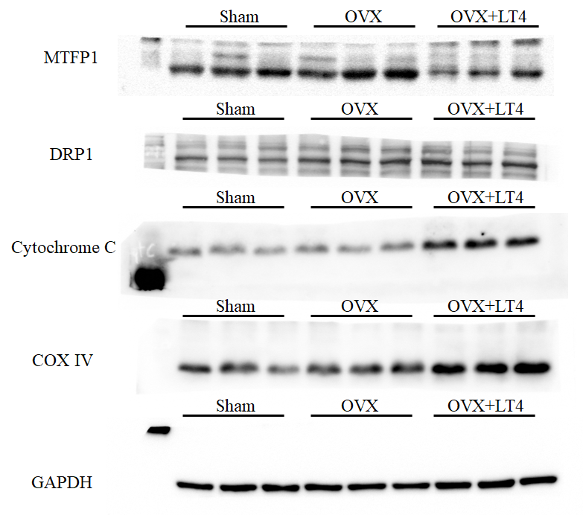

Supplementary Fig. 2. Original blots of Figure 6.

