Supplementary Figure 1: Molecular Docking of phyto-compounds against tick BSAP1 and RmAChE1
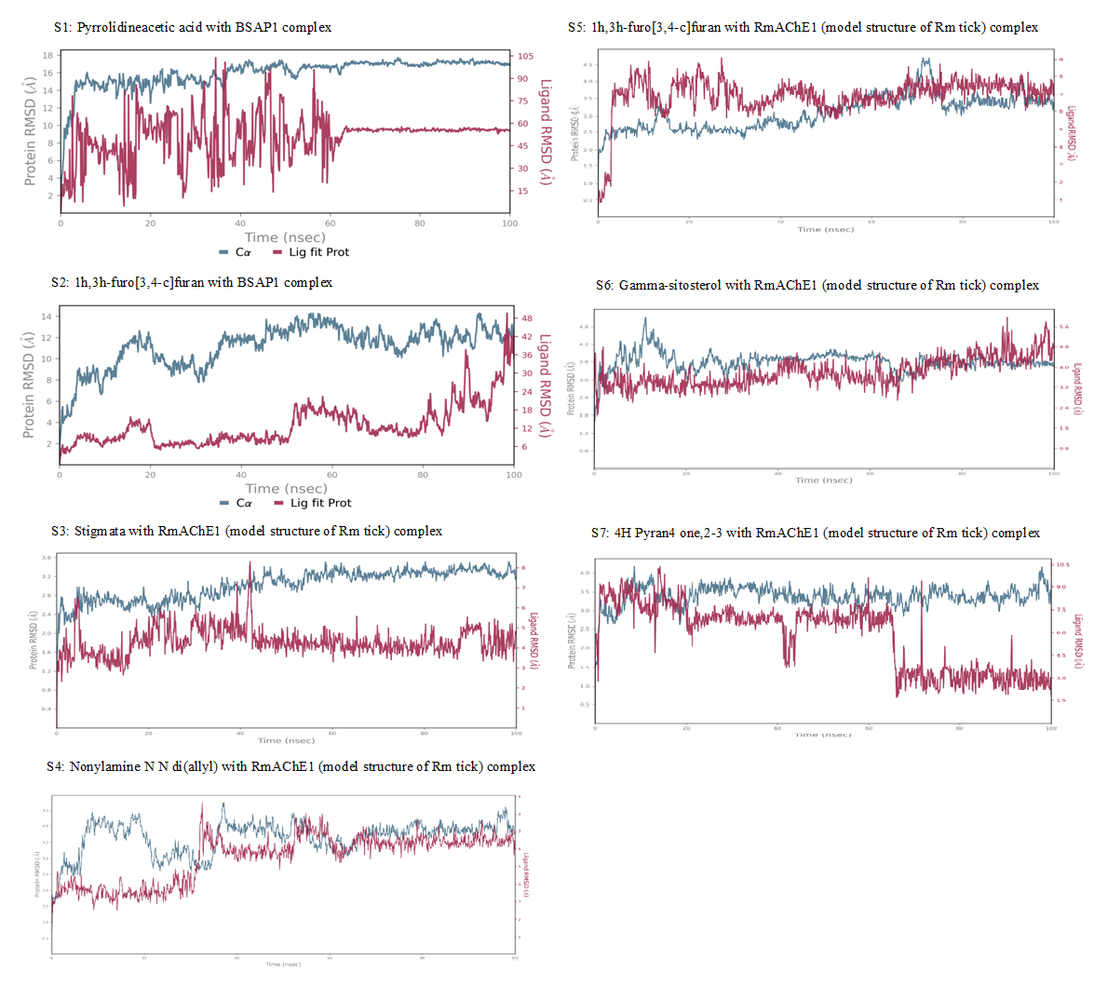

Supplementary Figure 2: protein–ligand interaction of phyto-compounds against tick BSAP1 and RmAChE1
