Additional file 1
Format: DOCX (Microsoft Word)
Title: Supplementary material for: Dietary staple protein quality and meningitis mortality across 54 African countries: an ecological cross-sectional study
Description: Supplementary tables and figures including study variable definitions and data sources (Table S1a), circularity assessment (Table S1b), correlation analyses (Tables S2a–S2d), sensitivity analysis results (Tables S3a–S3c), belt country descriptive analysis (Table S4), covariate selection flowchart (Figure S3), and forest plots of beta regression results (Figures S4a and S4b).

Supplementary Material
Dietary staple protein quality and meningitis mortality across 54 African countries: an ecological cross-sectional study
Table of Contents
Supplementary Tables
Table S1a. Study variables, definitions and data sources
Table S1b. Circularity assessment — study variables in relation to GBD 2023 cause of death modelling frameworks
Table S2a. Spearman rank correlations between all candidate predictor variables and meningitis cause fraction
Table S2b. Key inter-variable Spearman correlations — multicollinearity assessment
Table S2c. Variance Inflation Factor (VIF) results for all candidate covariates
Table S2d. Candidate covariates — selection criteria for beta regression models
Table S3a. Sensitivity 1 — HAP model (N=54 African countries)
Table S3b. Sensitivity 2 — Sanitation model (N=54 African countries)
Table S3c. Sensitivity 3 — No malaria model (N=54 African countries)
Table S4. Meningitis mortality, MACV coverage and dietary protein availability across 24 of 26 WHO meningitis belt countries
Supplementary Figures
Figure S1. Millet protein supply across African countries
Figure S2. Sorghum protein supply across African countries
Figure S3. Covariate selection flowchart for beta regression models
Figure S4a. Forest plot of beta regression coefficients — animal protein (primary and sensitivity models)
Figure S4b. Forest plot of beta regression coefficients — staple proteins (primary and sensitivity models)
Figure S5. Animal protein availability and meningitis mortality across 24 belt countries with available MACV coverage data
Supplementary Box
Box S1. Meningococcal A conjugate vaccine (MACV) vaccination coverage and its implications for the dietary analysis

The table below lists the study variables, including the dependent variable and covariates, and their data sources. Estimates from the Global Burden of Disease (GBD) Results tool represent modelled estimates generated by the Institute for Health Metrics and Evaluation using standardized statistical methods incorporating multiple data sources, including vital registration systems, surveys, and surveillance data.
Dietary variables were obtained from FAOSTAT Food Balance Sheets and represent national per-capita food supply estimates rather than individual-level consumption.

TableS1a. Study variables and data sources
Variable | Definition | Source
Outcome variable
Meningitis deaths | Proportion of all cause deaths attributable to meningitis for both sexes and all ages. | GBD Results Tool¹
Disease variables
Diarrhoeal diseases | Percentage of total deaths attributable to diarrhoeal diseases for both sexes and all ages. Diarrhoea is defined as ≥3 loose stools within a 24-hour period. | GBD Results Tool¹
HIV/AIDS | Percentage of total deaths attributable to HIV infection and AIDS-related conditions for both sexes and all ages. | GBD Results Tool¹
Malaria | Percentage of total deaths attributable to malaria caused by Plasmodium species (ICD-10 codes B50–B54). | GBD Results Tool¹
Care variables
Pneumococcal vaccine coverage (PCV3) | Estimated coverage of three doses of pneumococcal conjugate vaccine among children. | GBD vaccination estimates²
Haemophilus influenzae type b vaccine coverage (Hib3) | Estimated coverage of three doses of Haemophilus influenzae type b vaccine among children. | GBD vaccination estimates²
Household air pollution from solid fuels (REI) | Risk exposure indicator representing population exposure to household air pollution from the use of solid fuels for cooking. | GBD risk factor study³
Dietary variables
Animal protein intake | National per-capita supply of animal protein averaged for 2019–2023. | FAOSTAT Food Balance Sheets⁴
Non-cereal plant protein | National per-capita supply of protein from non-cereal plant sources averaged for 2019–2023. | FAOSTAT Food Balance Sheets⁴
Dietary energy supply | Aggregate of National average dietary energy supply from 2021-23 & 2022-24. | FAOSTAT Suite of Food Security Indicators⁵
Staple protein intake | National per-capita protein supply from staple foods including wheat, rice, maize, millet, sorghum, and cassava averaged for 2019–2023. | FAOSTAT Food Balance Sheets⁴

Notes
- Deaths for meningitis, diarrhoeal diseases, HIV/AIDS, and malaria were extracted from the Global Burden of Disease (GBD) Results Tool and expressed as the percentage of total deaths for both sexes and all ages.
GBD = Global Burden of Disease; REI = risk exposure indicator; PCV3 = three doses of pneumococcal conjugate vaccine; Hib3 = three doses of Haemophilus influenzae type b vaccine.
- Institute for Health Metrics and Evaluation (IHME). Global Burden of Disease Study 2023 (GBD 2023) Routine Childhood Vaccination Coverage Estimates and Forecasts 1980–2030. Seattle, USA: IHME; 2025. DOI: https://doi.org/10.6069/JCH3-FT68.
- GBD 2023 Disease and Injury and Risk Factor Collaborators. Burden of 375 diseases and injuries, risk-attributable burden of 88 risk factors, and healthy life expectancy in 204 countries and territories, 1990–2023: a systematic analysis for the Global Burden of Disease Study 2023. Lancet. 2025;406:1873–1922.
- Dietary indicators were obtained from FAOSTAT Food Balance Sheets and represent national per-capita food supply estimates.
- Dietary energy supply was obtained from the FAOSTAT Suite of Food Security Indicators, specifically “Dietary energy supply used in the estimation of the prevalence of undernourishment”.
- FAOSTAT Food Balance Sheet indicators represent national per-capita food supply rather than individual dietary intake, and are used as proxy measures of population-level dietary availability in ecological analyses.
Protein supply variables are expressed as g/capita/day, and dietary energy supply as kcal/capita/day.

The table below(Table S1b) represents circularity assessment of the study covariates in view their modelling imperatives.
Table S1b. Circularity assessment — study variables in relation to GBD 2023 cause of death modelling frameworks
Circularity arises when a variable used as a covariate in our regression was itself used as an input covariate in the GBD modelling that generated our outcome variable (meningitis cause fraction) or our predictor variables (diarrhoea and malaria cause fractions). Colour coding: green = no or minimal circularity; amber = indirect or partial circularity; red = direct circularity or high VIF — excluded. Decision column reflects the final analytical choice across all model specifications.
Variable | Domain | GBD meningitis model input? | GBD diarrhoea model input? | GBD malaria model input? | Circularity risk | Decision | Rationale
Study outcome
Meningitis cause fraction 2023 | Outcome | Output (modelled) | No | No | N/A | Outcome variable | GBD 2023 cause fraction — the modelled output, not an input to any other cause model.
Disease burden covariates
Diarrhoea cause fraction 2023 | Disease | No (direct) | Independent output | No | Indirect (shared inputs) | INCLUDED | Diarrhoea is an independently modelled GBD output — not a direct input to the meningitis model. However, both diarrhoea and meningitis share upstream GBD modelling inputs (sanitation, SDI, income), which may induce partial correlation attributable to shared modelling structure rather than purely biological co-occurrence. Retained as it captures genuine co-infectious disease burden and WASH-mediated environmental risk biologically relevant to meningitis. Indirect overlap acknowledged as a potential source of upward bias in the diarrhoea coefficient.
Malaria cause fraction 2023 | Disease | No (direct) | No | Independent output | Minimal (different inputs) | INCLUDED | Malaria is an independently modelled GBD output — not a direct input to meningitis or diarrhoea models. GBD malaria modelling uses Pf incidence and effective antimalarial treatment as primary inputs — distinct from the sanitation and socioeconomic covariates used in meningitis modelling. Shared upstream inputs are minimal. Malaria cause fraction captures concurrent infectious disease burden and immune competition independently of WASH pathways.
HIV cause fraction 2023 | Disease | No | No | No | None | EXCLUDED | No circularity concern but excluded on statistical grounds — near-zero bivariate association with meningitis (r=−0·01, p=0·944) indicating no meaningful predictive value.
Dietary covariates
Animal protein (g/capita/day) | Diet | No | No | No | None | INCLUDED | Absent from all GBD cause of death modelling frameworks. Entirely free of circularity. Primary dietary exposure of interest — mechanistically linked to immunoglobulin synthesis and mucosal immune competence.
Staple protein — wheat, rice, maize, millet, sorghum, cassava (g/capita/day) | Exposure | No | No | No | None | INCLUDED | Absent from all GBD cause of death modelling frameworks. No circularity. Primary staple-specific exposure variables — each entered separately in individual model specifications.
Total Kcal/day | Diet | No | No | No | None | EXCLUDED | No circularity concern. Excluded on statistical grounds — moderate collinearity with animal protein (r=0·38) without adding mechanistic specificity. Animal protein retained as the more biologically relevant dietary quality proxy.
Care and infrastructure covariates
Unsafe sanitation SEV (age-standardised) | Care | Yes — Level 3 | Yes — Level 1 | No | Moderate (double pathway) | SENSITIVITY only | Sanitation is a Level 3 input to GBD meningitis modelling and a Level 1 input to GBD diarrhoea modelling. Including sanitation in regression on GBD-derived cause fractions introduces circularity through both the outcome (meningitis) and one predictor (diarrhoea). Retained in sensitivity model only, with explicit acknowledgement of this limitation.
HiB3 vaccination coverage | Care | Yes — Level 1 | No | No | High (direct input) | EXCLUDED | HiB3 is a Level 1 covariate in GBD meningitis mortality modelling — a direct input to the model that generated our outcome variable. Regressing GBD meningitis deaths on HiB3 is formally circular. Confirmed by Delta AIC — models with and without HiB3 are statistically equivalent (ΔAIC<2), indicating HiB3 adds no genuine independent predictive value once this circularity is removed.
PCV3 vaccination coverage | Care | Yes — Level 1 | No | No | High (direct input) | EXCLUDED | Same circularity concern as HiB3 — PCV3 is a Level 1 covariate in GBD meningitis modelling. Additionally collinear with HiB3 (r=0·77), precluding simultaneous inclusion. Excluded on both circularity and collinearity grounds.
Socio-demographic Index (SDI) | Care | Yes — Level 3 | Yes — Level 3 | No | Moderate + high VIF | EXCLUDED | SDI is a Level 3 input to both GBD meningitis and diarrhoea models — introducing circularity through two pathways. Additionally has VIF=7·21 (exceeds threshold of 5) due to high collinearity with sanitation (r=−0·85) and household air pollution (r=−0·87). Excluded on both circularity and multicollinearity grounds.
Household air pollution from solid fuels | Care | No | No | No | None + high VIF | EXCLUDED | No circularity concern from GBD modelling. Excluded on statistical grounds — VIF=7·72 (exceeds threshold of 5) due to extreme collinearity with sanitation (r=+0·85) and SDI (r=−0·87). The three variables measure the same underlying poverty-infrastructure construct. Sanitation retained over air pollution as the more mechanistically direct predictor.
GBD = Global Burden of Disease 2023. Level 1/2/3 refers to the covariate hierarchy within the CODEm (Cause of Death Ensemble model) framework — Level 1 covariates are entered directly into cause-specific models, Level 3 covariates are background distal predictors. SEV = Summary Exposure Value. VIF = Variance Inflation Factor. Sources: GBD 2023 Causes of Death Collaborators Supplementary Appendix 1 (Shackelford et al., 2025), Table S10 and cause-specific covariate tables for meningitis, diarrhoeal diseases and malaria.

The figures below represent the millet protein supply(Fig S1) and the sorghum protein supply(Fig S2) in grams per capita per day for African countries.

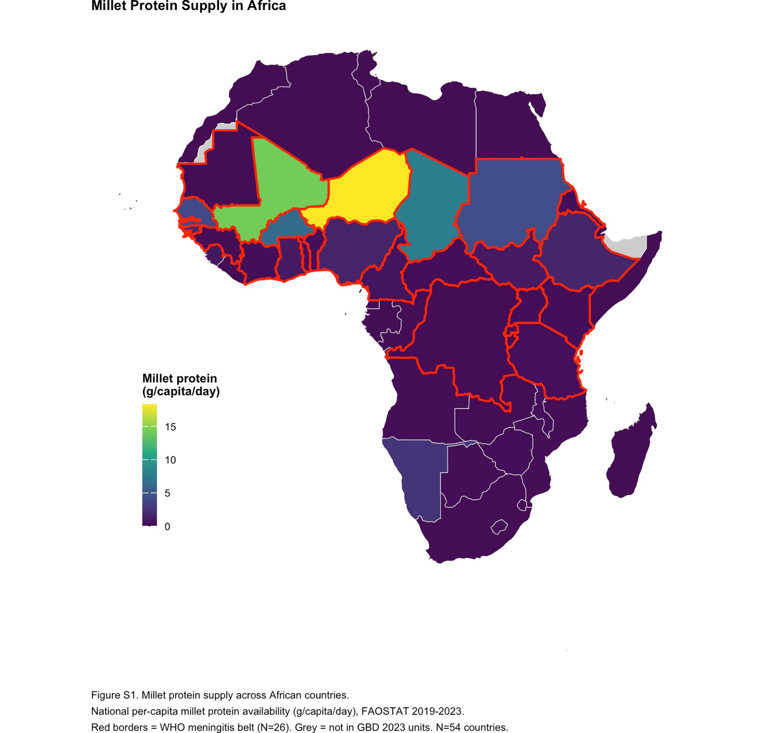

Figure S1. Millet protein supply across African countries. Choropleth map showing national per-capita millet protein availability (g/capita/day) from FAOSTAT food balance sheets averaged 2019–2023. Red borders indicate WHO extended meningitis belt countries (N=26). Grey areas = Somaliland and Western Sahara (not included in GBD 2023 analytical units). N=54 countries.

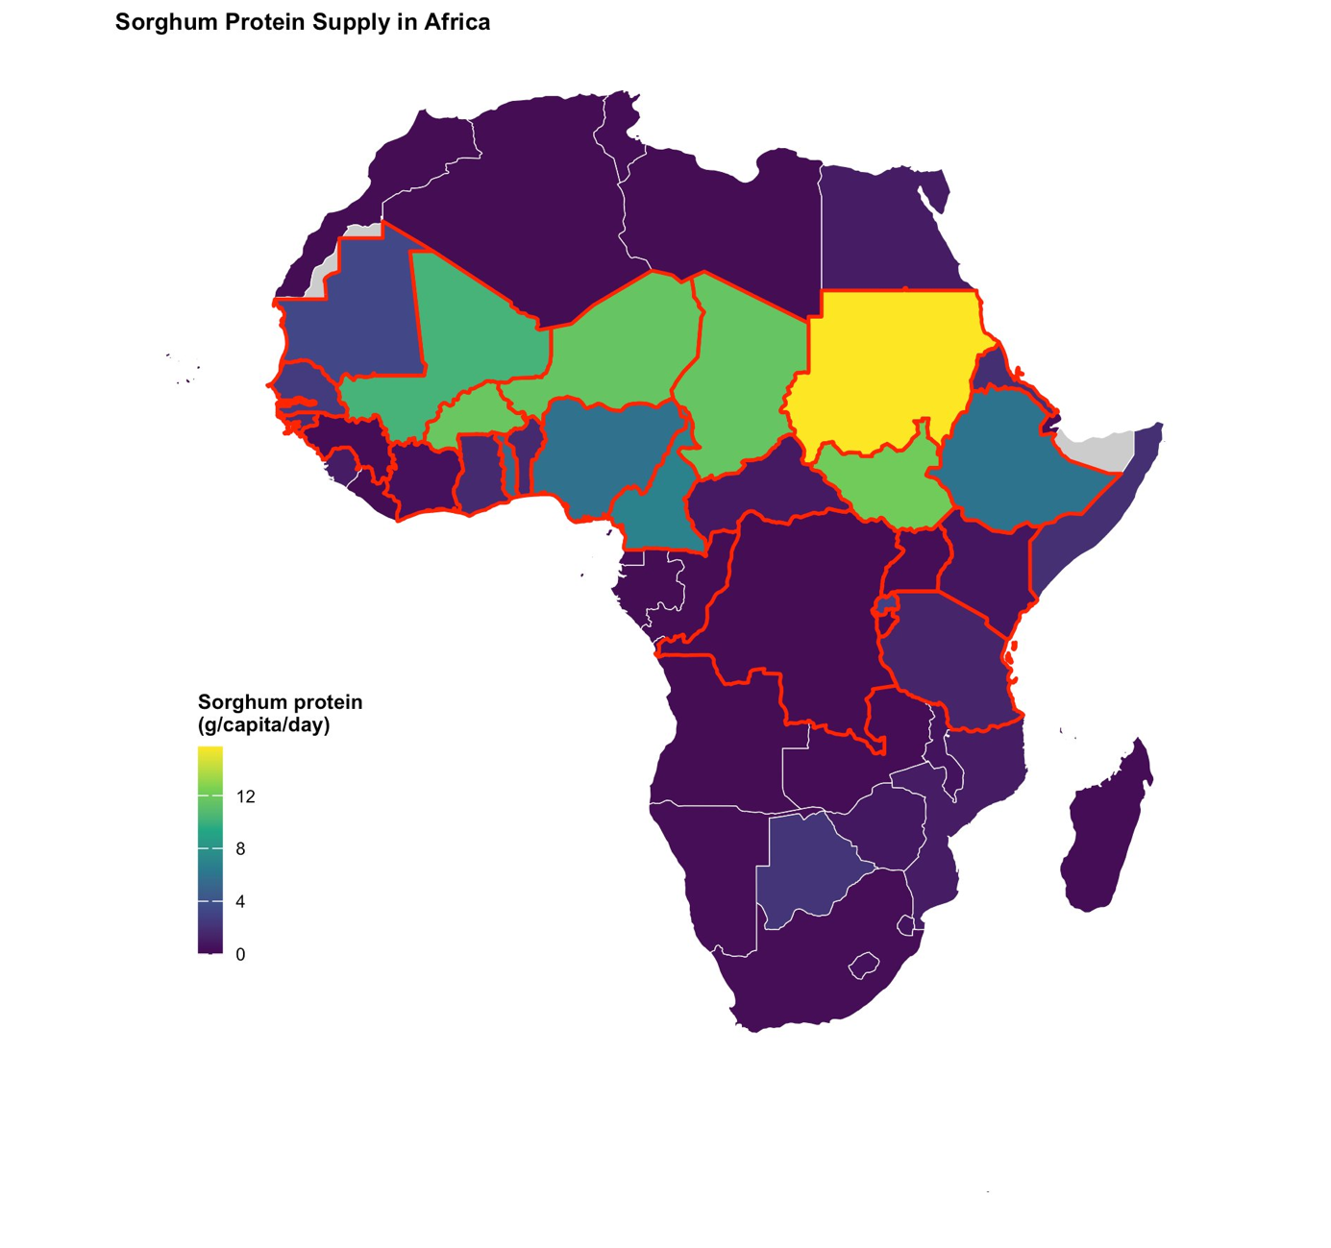
Figure S2. Sorghum protein supply across African countries. Choropleth map showing national per-capita sorghum protein availability (g/capita/day) from FAOSTAT food balance sheets averaged 2019–2023. Red borders indicate WHO extended meningitis belt countries (N=26). Grey areas = Somaliland and Western Sahara (not included in GBD 2023 analytical units). N=54 countries.

Correlation and multicollinearity assessment
Additional analyses were conducted to support and extend the primary findings reported in the main manuscript. These included detailed correlation analyses(Table S2a),key inter-variable correlations(Table S2b), assessment of multicollinearity among predictors(Table S2c).
Fig S3 is the flowchart indicating covariate selection done in view of need to generate a parsimonious beta regression analysis. Selection criteria for choosing candidate covariates are detailed in Table S2d. A forest plot incorporating results from primary modelling and all 3 sensitivity analysis is there in Figures S4a and S4b.

Table S2a. Spearman rank correlations between all candidate predictor variables and meningitis cause fraction across 54 African countries, with variable role in final model
r = Spearman rank correlation coefficient with meningitis cause fraction 2023 (N=54 countries). Row shading: green = retained in primary model; blue = retained in sensitivity model only; amber = excluded on circularity grounds; white = excluded on statistical grounds (no association or collinearity). r values shown in red if >+0·50 (strong positive); dark blue if <−0·50 (strong negative).
Variable | r | p value | Sig | Role in model / note
1. Disease burden variables
Diarrhoea cause fraction 2023 | +0·797 | <0·001 | *** | Retained — primary model. Strongest bivariate predictor. Independent of malaria (inter-variable r=−0·13). Indirect GBD circularity acknowledged (shared upstream modelling inputs with meningitis) — see Table S[X].
Malaria cause fraction 2023 | +0·605 | <0·001 | *** | Retained — primary model. Independent positive association; low VIF (1·73). GBD malaria modelling uses Pf incidence and antimalarial coverage as inputs — minimal shared upstream inputs with meningitis. Significant in 5 of 6 staple models in primary specification.
HIV cause fraction 2023 | −0·010 | 0·944 | ns | Excluded. Near-zero bivariate association (p=0·944) — no meaningful relationship with meningitis mortality at country level. No GBD circularity concern. Exclusion based solely on absence of predictive value.
2. Care, environment and healthcare variables
Household air pollution from solid fuels | +0·789 | <0·001 | *** | Excluded from primary model — VIF=7·72 (high; driven by collinearity with sanitation r=+0·82 and SDI r=−0·87 in full candidate set). No GBD circularity. Reconsidered after circularity assessment: VIF drops to 4·14 when sanitation excluded. Retained in Sensitivity 1 (HAP model) — best AIC across all 6 staples. Animal protein attenuated in that model due to collinearity suppression.
Unsafe sanitation (SEV, age-standardised) | +0·669 | <0·001 | *** | Excluded from primary model — dual GBD circularity: Level 1 input to GBD diarrhoea model AND Level 3 input to GBD meningitis model. VIF=6·29 in full candidate set (borderline). Retained in Sensitivity 2 to assess robustness with infrastructure covariate included despite partial circularity.
Socio-demographic Index (SDI) | −0·820 | <0·001 | *** | Excluded. VIF=8·12 (high; near-perfect collinearity with HAP r=−0·90 and sanitation r=−0·85). Level 3 GBD input to both meningitis and diarrhoea models — dual circularity. Composite upstream determinant subsuming proximal pathways already captured by diarrhoea and disease burden variables.
HiB3 vaccination coverage | −0·462 | <0·001 | *** | Excluded — GBD circularity: Level 1 direct input to GBD meningitis mortality model. Regressing GBD meningitis cause fraction on HiB3 is formally circular. Confirmed by Delta AIC: models with and without HiB3 statistically equivalent (ΔAIC<2 all staples).
PCV3 vaccination coverage | −0·293 | 0·031 | * | Excluded — same GBD circularity as HiB3 (Level 1 input to GBD meningitis model). Additionally collinear with HiB3 (r=+0·77), precluding simultaneous inclusion.
3. Dietary variables
Animal protein (g/capita/day) | −0·563 | <0·001 | *** | Retained — primary model. Strongest dietary predictor. Zero GBD circularity — absent from all GBD cause of death modelling frameworks. Significant in all 6 staple models across primary, Sensitivity 2 and Sensitivity 3 specifications. Attenuated (non-significant) in Sensitivity 1 HAP model due to collinearity suppression (HAP vs animal protein r=−0·66).
Non-cereal plant protein (g/capita/day) | +0·167 | 0·226 | ns | Excluded. Non-significant bivariate association (p=0·226). High collinearity with animal protein (r=+0·67). Positive direction of association reflects ecological confounding — high plant protein countries are predominantly low-income Sahel countries with high meningitis burden. No GBD circularity concern.
Total Kcal/day | −0·500 | <0·001 | *** | Excluded. Moderate collinearity with animal protein (r=+0·38). Captures overall dietary energy sufficiency rather than protein quality — the mechanistically relevant dimension for immune competence. Animal protein retained as more specific proxy. No GBD circularity concern.
4. Staple cereal protein variables (each tested separately in adjusted models)
Wheat protein (g/capita/day) | −0·635 | <0·001 | *** | Retained (tested separately). Only staple to reach independent statistical significance in primary model (β=−0·024, p=0·010), robust across Sensitivity 2 and 3 specifications. Reflects predominant consumption in North Africa where meningitis burden is lowest. Zero GBD circularity.
Millet protein (g/capita/day) | +0·541 | <0·001 | *** | Retained (tested separately). Primary hypothesis-generating staple — geographically concentrated in meningitis belt. Did not reach independent statistical significance in any adjusted model specification after controlling for covariates. Geographic co-distribution reflects shared poverty rather than direct dietary protein pathway.
Sorghum protein (g/capita/day) | +0·444 | <0·001 | *** | Retained (tested separately). Within-belt analysis (N=18 reliable data countries) with MACV controlled: borderline significant (β=−0·082, p=0·0003). Hypothesis-generating — five of six highest sorghum-consuming belt countries had imputed FAOSTAT data; protein complementarity from co-consumed legumes (e.g. Sudan peanuts) cannot be excluded.
Rice protein (g/capita/day) | +0·277 | 0·043 | * | Retained (tested separately). No significant independent association in any adjusted model. Weak positive bivariate association reflects geographic patterning — rice dominant in West African coastal countries where meningitis burden is moderate.
Maize protein (g/capita/day) | −0·067 | 0·631 | ns | Retained (tested separately). No bivariate or adjusted association. Widespread consumption across both high and low meningitis burden countries — no geographic concentration pattern.
Cassava protein (g/capita/day) | +0·448 | <0·001 | *** | Retained (tested separately). No significant independent association in any adjusted model. Predominant in Central and West Africa where meningitis burden is elevated — association reflects geographic patterning rather than direct dietary protein effect. Lowest protein content per gram of all tested staples.
Millet + Sorghum combined (g/capita/day) | +0·501 | <0·001 | *** | Not entered in primary analysis. Tested descriptively — combining millet and sorghum dilutes the individual signals, particularly given the high inter-staple collinearity (r=+0·75). Each staple tested separately to preserve resolution. Combined variable shown in supplementary belt subgroup analysis only.

*** p<0·001 ** p<0·01 * p<0·05 † p<0·1 ns = not significant. GBD = Global Burden of Disease 2023. SEV = Summary Exposure Value. Full VIF results in Table S2a (VIF). Inter-variable correlations in Table S2b. Circularity assessment in Supplementary Table S1b.

Table S2b. Key inter-variable Spearman correlations among candidate predictor variables — multicollinearity assessment
Only pairs with |r| > 0·38 or specific collinearity implications are shown. All correlations computed using Spearman’s rank method (N=54 African countries). Row shading: red = collinearity led to exclusion of one variable; amber = informative for HAP suppression effect; green = confirms independence of retained variables; blue = staple-specific collinearity.
Variable A | Variable B | r | Sig | Implication for model specification
Pairs leading to variable exclusion — collinearity or redundancy
SDI | Household air pollution | −0·900 | *** | Near-perfect collinearity. SDI and household air pollution are effectively measuring the same underlying poverty–infrastructure construct. Primary reason SDI excluded from all models.
Household air pollution | Unsafe sanitation | +0·822 | *** | High collinearity. Both proxy poverty and infrastructure deficit. Cannot be included simultaneously (VIF >5 in full candidate set). Household air pollution retained in Sensitivity 1 after circularity assessment; sanitation retained in Sensitivity 2.
SDI | Unsafe sanitation | −0·850 | *** | Very high collinearity confirming SDI, sanitation and household air pollution form a near-collinear cluster. Reinforces exclusion of SDI.
HiB3 vaccination | PCV3 vaccination | +0·771 | *** | High collinearity between the two vaccination variables. Both also excluded on GBD circularity grounds. Reported here for completeness.
Other noteworthy pairs — informing model interpretation
Millet protein | Sorghum protein | +0·747 | *** | High collinearity between the two primary Sahel staples. Reason each staple was entered separately into individual model specifications rather than simultaneously.
SDI | HiB3 vaccination | +0·431 | ** | Moderate collinearity. SDI partially proxies vaccination system strength. Contributes to instability if both included simultaneously.
Animal protein | Total Kcal/day | +0·382 | ** | Moderate collinearity. Total Kcal excluded as redundant with animal protein — both capture dietary adequacy but animal protein is the mechanistically specific variable for immune competence.
Household air pollution | Animal protein | −0·658 | *** | Strong negative correlation reflecting shared poverty ecology — countries with high solid fuel use tend to have low animal protein availability. Key reason animal protein is attenuated in the HAP sensitivity model (collinearity-driven suppression rather than true absence of association).
Household air pollution | Malaria | +0·636 | *** | Strong positive correlation. Both variables concentrate in sub-Saharan Africa. Contributes to collinearity suppression of malaria in the HAP sensitivity model.
Diarrhoea | Malaria | −0·13 | NS | Near-zero correlation confirming diarrhoea and malaria capture independent disease burden dimensions. Justifies inclusion of both in the primary model without multicollinearity concerns.
Diarrhoea | Animal protein | −0·521 | *** | Moderate-strong negative correlation reflecting shared poverty-WASH ecology. Diarrhoea and animal protein are partially collinear but VIF values confirm both can be included simultaneously (VIF 2·97 and 3·06 respectively).

*** p<0·001 ** p<0·01 * p<0·05 NS = not significant. Negative r values shown in red; positive in blue. Full VIF results in Supplementary Table S2a. Circularity assessment in Supplementary Table S1b.

Table S 2c. Variance Inflation Factor (VIF) results for all candidate covariates
VIF computed from an auxiliary ordinary least squares (OLS) regression including all candidate covariates simultaneously (N=54). Threshold: VIF ≥ 5 indicates unacceptable multicollinearity. Row shading: green = retained in primary model; amber = VIF ≥ 5; white = excluded on other grounds.
Variable | Domain | VIF | Threshold | Decision
DISEASE
Malaria cause fraction 2023 | Disease | 1·96 | < 5 ✓ | Retained
HIV cause fraction 2023 | Disease | 1·64 | < 5 ✓ | Excluded (r=NS)
Diarrhoea cause fraction 2023 | Disease | 2·97 | < 5 ✓ | Retained
CARE
Household air pollution (solid fuels) | Care | 7·72 | > 5 ⚠ | Excluded (primary) Retained (Sens 1)
Unsafe sanitation (SEV) | Care | 6·29 | > 5 ⚠ | Excluded (primary) Retained (Sens 2)
Socio-demographic Index (SDI) | Care | 8·12 | > 5 ⚠ | Excluded
HiB3 vaccination coverage | Care | 2·15 | < 5 ✓ | Excluded (circularity)
PCV3 vaccination coverage | Care | 1·93 | < 5 ✓ | Excluded (circularity)
DIET
Animal protein (g/capita/day) | Diet | 3·06 | < 5 ✓ | Retained
Non-cereal plant protein (g/capita/day) | Diet | 1·41 | < 5 ✓ | Excluded (r=NS)
Total Kcal/day | Diet | 2·50 | < 5 ✓ | Excluded (collinear with AP)

VIF = Variance Inflation Factor. NS = not significant in bivariate association. AP = Animal Protein. SEV = Summary Exposure Value. Circularity = variable is an input to GBD cause of death modelling framework generating the outcome or predictor variables (see Supplementary Table S1b).
Note: VIF values for household air pollution (7·72) and unsafe sanitation (6·29) reflect computation in the full candidate variable set. When each is tested in isolation without the other, VIF drops to acceptable levels: HAP VIF = 4·14 (Sensitivity 1 model), Sanitation VIF = 5·59 (Sensitivity 2 model). These two variables are nearly interchangeable proxies for poverty and infrastructure deficit (r = +0·82) and cannot be included simultaneously.

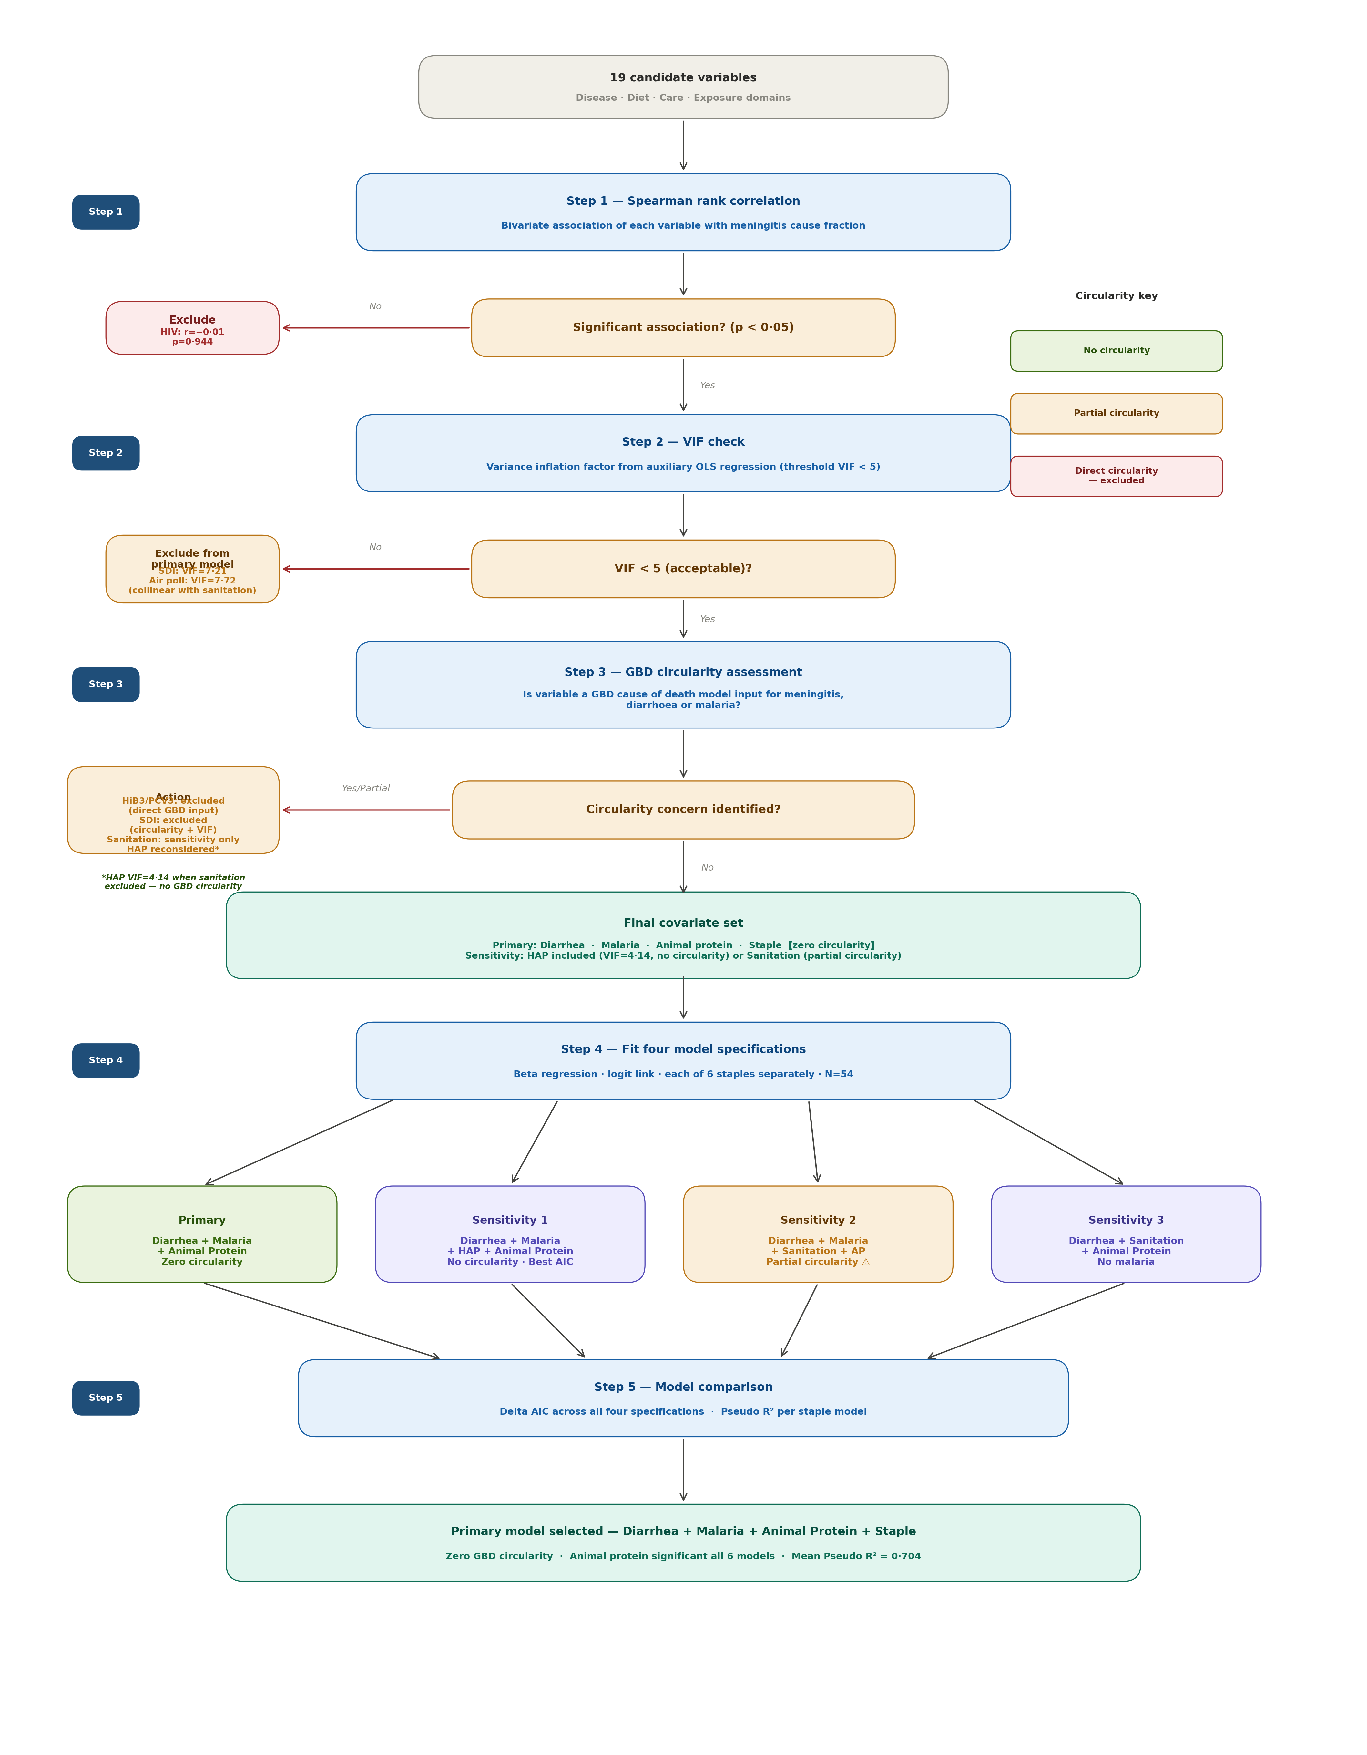

Figure S3. Covariate selection flowchart for beta regression models. Variables were assessed for inclusion based on three criteria: bivariate association with meningitis cause fraction (Spearman r, p<0·05), assessment of GBD modelling circularity (Table S1b), and absence of multicollinearity (VIF <5, Table S2c). The primary model retained variables with acceptable statistical properties and no direct GBD circularity. Diarrhoea cause fraction was retained despite indirect circularity concerns arising from shared upstream GBD modelling inputs with meningitis — this limitation is acknowledged in Table S1b and the manuscript limitations section. Variables with direct GBD circularity (HiB3, PCV3) or high VIF (SDI, HAP, sanitation) were excluded from the primary model. HAP and sanitation were reconsidered in pre-specified sensitivity models after circularity reassessment. N=54 African countries.

Table S2d. Candidate Covariates — Selection Criteria for Beta Regression Models
Outcome: Meningitis cause fraction 2023 (proportion bounded 0–1) | N = 54 African countries | Method: Beta regression, logit link, maximum likelihood estimation
Variable | Group | Source | Spearman r (with Meningitis) | VIF | Decision | Rationale
DISEASE
Diarrhoea Deaths 2023 | DISEASE | GBD 2023 | r = +0·797 (p<0·001) | 2·93 (OK) | INCLUDED | Diarrhoea deaths showed the strongest bivariate association with meningitis mortality across all 54 countries. Both conditions share upstream determinants — inadequate water, sanitation and hygiene infrastructure — making diarrhoea burden a theoretically coherent proxy for environmental conditions facilitating meningococcal transmission. Its low VIF (2·93) confirmed no multicollinearity with other selected covariates. Note: diarrhoea and meningitis share upstream GBD modelling inputs (sanitation, SDI, income), which may induce partial correlation attributable to shared modelling structure — an unavoidable limitation of ecological analyses using GBD-derived estimates acknowledged as a potential source of upward bias in the diarrhoea coefficient.
Malaria Deaths 2023 | DISEASE | GBD 2023 | r = +0·605 (p<0·001) | 1·73 (OK) | INCLUDED | Malaria demonstrated a significant independent positive association with meningitis mortality and a very low VIF (1·73), confirming it was not collinear with diarrhoea (inter-variable r=−0·13). GBD malaria modelling uses Pf incidence and effective antimalarial treatment as primary inputs — distinct from the sanitation and socioeconomic covariates used in meningitis modelling — meaning shared GBD upstream inputs are minimal. Malaria captures concurrent infectious disease burden and immune competition independently of WASH pathways. It remained significant in 5 of 6 staple models in the primary specification.
HIV Deaths 2023 | DISEASE | GBD 2023 | r = −0·010 (p=0·944) | 1·63 (OK) | EXCLUDED | Despite acceptable VIF (1·63), HIV deaths showed a near-zero and entirely non-significant bivariate association with meningitis mortality (p=0·944), indicating no meaningful relationship at the country level. The geographic distribution of HIV burden — concentrated in Southern and Eastern Africa — does not overlap substantially with the meningitis belt. No GBD circularity concern. Excluded on statistical grounds — including a non-predictive variable would needlessly consume a degree of freedom in a sample-size-constrained analysis (N=54).
DIET
Animal Protein (g/capita/day) | DIET | FAOSTAT 2021–2024 | r = −0·563 (p<0·001) | 2·86 (OK) | INCLUDED | Animal protein was selected as the sole dietary covariate on both statistical and theoretical grounds, and is entirely absent from all GBD cause of death modelling frameworks — making it the variable least susceptible to any form of analytical circularity. It showed the strongest biologically plausible association with meningitis mortality within the diet group. Mechanistically, adequate animal protein supports immunoglobulin synthesis, mucosal barrier integrity and innate immune function. Its VIF (2·86) was well within acceptable limits. The association remained significant across three of four beta regression model specifications; attenuation in the household air pollution sensitivity model was attributable to collinearity-driven suppression rather than a true absence of association.
Total Kcal/day | DIET | FAOSTAT 2019–2024 | r = −0·500 (p<0·001) | 2·37 (OK) | EXCLUDED | Total caloric availability showed a significant bivariate association and acceptable VIF (2·37). However, it was moderately correlated with animal protein (r=0·38), introducing partial redundancy without clear mechanistic advantage. Total Kcal captures overall dietary energy sufficiency rather than protein quality — the biologically relevant dimension for immune competence. Given the sample size constraint (N=54), parsimony favoured retaining only the more mechanistically specific variable. No GBD circularity concern.
Non-cereal Plant Protein (g/capita/day) | DIET | FAOSTAT 2021–2024 | r = +0·167 (p=0·226) | 1·39 (OK) | EXCLUDED | Non-cereal plant protein failed to reach statistical significance in bivariate analysis (p=0·226), suggesting no meaningful independent relationship with meningitis mortality. It was also highly correlated with animal protein (r=0·67), creating collinearity risk if both were included. The positive direction of the association — higher plant protein correlating with higher meningitis deaths — likely reflects ecological confounding, where high plant protein countries are predominantly low-income Sahel countries with high meningitis burden. No GBD circularity concern.
CARE
Household Air Pollution from Solid Fuels | CARE | GBD 2023 | r = +0·789 (p<0·001) | 7·72 (High) 4·14 in sensitivity* | EXCLUDED from primary; INCLUDED in Sensitivity 1 | Household air pollution (HAP) showed a strong bivariate association and no GBD circularity — absent from GBD meningitis, diarrhoea and malaria modelling frameworks. Its VIF of 7·72 in the full candidate variable set was driven by collinearity with sanitation (r=+0·82) and SDI (r=−0·87), precluding inclusion in the primary model. Following the circularity assessment, HAP was reconsidered as a sensitivity specification: when sanitation was excluded, HAP VIF dropped to 4·14 (acceptable) and it demonstrated the best model fit by AIC across all six staple models. HAP is included in Sensitivity 1 as the infrastructure proxy with zero GBD circularity and best statistical fit. Animal protein was attenuated in this model due to collinearity suppression (HAP, poverty and animal protein are highly intercorrelated at country level — r ranging +0·636 to −0·658).
Unsafe Sanitation (SEV, age-standardised 2023) | CARE | GBD 2023 | r = +0·669 (p<0·001) | 5·59 (Borderline) | SENSITIVITY 2 only | Unsafe sanitation showed a strong significant association with meningitis mortality. However, sanitation is a Level 1 covariate in GBD diarrhoeal disease modelling and a Level 3 covariate in GBD meningitis mortality modelling — creating dual circularity pathways through both the outcome variable and the diarrhoea predictor. This precludes its inclusion in the primary model. It is retained in Sensitivity 2 to allow comparison with prior ecological analyses and to assess robustness of animal protein when an infrastructure variable with partial circularity is included. Its borderline VIF (5·59) was considered acceptable in that sensitivity specification.
SDI (Socio-demographic Index) | CARE | GBD 2023 | r = −0·820 (p<0·001) | 7·21 (High) | EXCLUDED | SDI had the strongest bivariate correlation with meningitis mortality of all candidate variables (r=−0·820). However, it is a Level 3 covariate in both GBD meningitis and diarrhoea models — introducing circularity through two pathways simultaneously. Its VIF of 7·21 substantially exceeded the threshold of 5, driven by collinearity with sanitation (r=−0·85) and household air pollution (r=−0·87). Excluded on both circularity and multicollinearity grounds.
HiB3 Vaccination 2023 | CARE | GBD 2023 | r = −0·462 (p<0·001) | 2·10 (OK) | EXCLUDED | HiB3 is a Level 1 covariate in GBD meningitis mortality modelling — a direct input to the model that generated our outcome variable. Regressing GBD meningitis deaths on HiB3 is formally circular. Confirmed by Delta AIC: models with and without HiB3 were statistically equivalent (ΔAIC<2 across all staple specifications), indicating HiB3 adds no genuine independent explanatory value once circularity is removed.
PCV3 Vaccination 2023 | CARE | GBD 2023 | r = −0·293 (p=0·031) | 1·85 (OK) | EXCLUDED | Same circularity concern as HiB3 — PCV3 is a Level 1 covariate in GBD meningitis modelling. Additionally collinear with HiB3 (r=0·77), precluding simultaneous inclusion. Excluded on both circularity and collinearity grounds.
EXPOSURE (PRIMARY)
Wheat Protein (g/capita/day) | EXPOSURE | FAOSTAT 2021–2024 | r = −0·635 (p<0·001) | Tested separately | INCLUDED (separately) | Wheat protein had the strongest bivariate association of all staples (r=−0·635), reflecting its predominant consumption in North Africa where meningitis burden is lowest. It was the only staple to reach independent statistical significance in the primary model (β=−0·024, p=0·010), robust across sensitivity specifications. Each staple was modelled separately to avoid inter-staple multicollinearity and respect N=54 sample size constraints. No GBD circularity concern.
Millet Protein (g/capita/day) | EXPOSURE | FAOSTAT 2021–2024 | r = +0·541 (p<0·001) | Tested separately | INCLUDED (separately) | Primary hypothesis-generating staple — geographically concentrated in the meningitis belt. Despite the striking ecological overlap, millet protein did not reach independent statistical significance in any model after controlling for covariates. Geographic co-distribution reflects shared poverty and environmental determinants rather than a direct dietary protein pathway. No GBD circularity concern.
Sorghum Protein (g/capita/day) | EXPOSURE | FAOSTAT 2021–2024 | r = +0·444 (p<0·001) | Tested separately | INCLUDED (separately) | Co-distributed with millet across the Sahel. In the within-belt analysis restricted to reliable FAOSTAT data (N=18) controlling for mean MACV coverage, sorghum emerged as a significant independent predictor (β=−0·082, p=0·0003). However, five of the six highest sorghum-consuming belt countries had imputed dietary data under FAOSTAT revision, and protein complementarity from co-consumed legumes cannot be excluded. Hypothesis-generating only. No GBD circularity concern.
Rice Protein (g/capita/day) | EXPOSURE | FAOSTAT 2021–2024 | r = +0·277 (p=0·043) | Tested separately | INCLUDED (separately) | Included to provide systematic comparability across all major African dietary staples. Weak positive bivariate association reflects geographic patterning — rice dominant in West African coastal countries where meningitis burden is moderate. Did not achieve independent significance in any model specification. No GBD circularity concern.
Maize Protein (g/capita/day) | EXPOSURE | FAOSTAT 2021–2024 | r = −0·067 (p=0·631) | Tested separately | INCLUDED (separately) | Weakest bivariate association of all staples — reflecting widespread consumption across both high and low meningitis burden countries without clear geographic concentration. Included for systematic comparability. Consistent non-significance across all model specifications reinforces that the staple effect is geographically specific rather than a universal cereal protein phenomenon. No GBD circularity concern.
Cassava Protein (g/capita/day) | EXPOSURE | FAOSTAT 2021–2024 | r = +0·448 (p<0·001) | Tested separately | INCLUDED (separately) | Moderate positive bivariate association reflecting predominance in Central and West Africa where meningitis burden is elevated. Association likely reflects geographic and socioeconomic patterning rather than a direct dietary protein effect — cassava has the lowest protein content per gram of all tested staples. Did not achieve independent significance in any model specification. No GBD circularity concern.
Abbreviations: GBD = Global Burden of Disease 2023; FAOSTAT = Food and Agriculture Organization Statistical Database; SDI = Socio-demographic Index; SEV = Summary Exposure Value; VIF = Variance Inflation Factor; MACV = Meningococcal A Conjugate Vaccine; HAP = Household Air Pollution from Solid Fuels; WASH = Water, Sanitation and Hygiene. Spearman correlation coefficients computed against raw meningitis cause fraction 2023. VIF computed from OLS auxiliary regression including all candidate covariates simultaneously. *HAP VIF recalculated in sensitivity model excluding sanitation and SDI.
Primary model specification: Meningitis ∼ Diarrhea + Malaria + Animal Protein + Staple (each of 6 staple crops entered separately; zero GBD circularity). Sensitivity 1: + Household Air Pollution (HAP, best AIC, zero circularity). Sensitivity 2: + Sanitation (partial circularity acknowledged). Sensitivity 3: Diarrhea + Sanitation + Animal Protein + Staple (no malaria). Full circularity assessment in Supplementary Table S1b.

Sensitivity analysis Tables:
After the covariate selection process the primary modelling and sensitivity analysis was done. Sensitivity 1 included diarrhoea, Malaria, household air pollution(HAP) and animal protein and is depicted in Table S3a.Sensitivity 2 included diarrhoea, malaria, sanitation and animal protein and is available in Table S3b. Sensitivity 3 included diarrhoea, sanitation and animal protein and is available in Table S3c.
Table S3a. Sensitivity 1 — HAP model (N=54 African countries)
Meningitis ∼ Diarrhea + Malaria + HAP + Animal Protein + Staple. Best AIC in all 6 staples. No GBD circularity. HAP = household air pollution from solid fuels.
Staple | Variable | Estimate | 95% CI | p value | Sig
Millet model | Pseudo R² = 0.766 | ΔAIC = 0 (best)
 | Diarrhea | 5·0223 | [1·6574, 8·3872] | 0·0034 | **
 | Malaria | 1·2966 | [-1·4419, 4·0351] | 0·3534
 | HAP | 1·0643 | [0·4651, 1·6635] | <0·001 | ***
 | Animal Protein | -0·0134 | [-0·0301, 0·0033] | 0·1127
 | Staple | 0·0141 | [-0·0104, 0·0386] | 0·2581
Sorghum model | Pseudo R² = 0.766 | ΔAIC = 0 (best)
 | Diarrhea | 5·2674 | [1·6093, 8·9255] | 0·0048 | **
 | Malaria | 1·6058 | [-1·1251, 4·3367] | 0·2491
 | HAP | 1·0394 | [0·4343, 1·6445] | <0·001 | ***
 | Animal Protein | -0·0136 | [-0·0303, 0·0031] | 0·1106
 | Staple | 0·0048 | [-0·0226, 0·0322] | 0·7345
Rice model | Pseudo R² = 0.777 | ΔAIC = 0 (best)
 | Diarrhea | 5·9016 | [2·5522, 9·2510] | <0·001 | ***
 | Malaria | 1·5618 | [-1·0581, 4·1817] | 0·2426
 | HAP | 0·9660 | [0·3582, 1·5738] | 0·0018 | **
 | Animal Protein | -0·0136 | [-0·0301, 0·0029] | 0·1064
 | Staple | 0·0087 | [-0·0054, 0·0228] | 0·2290
Wheat model | Pseudo R² = 0.805 | ΔAIC = 0 (best)
 | Diarrhea | 5·3764 | [2·1095, 8·6433] | 0·0013 | **
 | Malaria | 1·2320 | [-1·4806, 3·9446] | 0·3734
 | HAP | 0·7318 | [0·0627, 1·4009] | 0·0321 | *
 | Animal Protein | -0·0136 | [-0·0299, 0·0027] | 0·1028
 | Staple | -0·0146 | [-0·0344, 0·0052] | 0·1478
Maize model | Pseudo R² = 0.766 | ΔAIC = 0 (best)
 | Diarrhea | 5·1703 | [1·7766, 8·5640] | 0·0028 | **
 | Malaria | 1·4222 | [-1·2712, 4·1156] | 0·3007
 | HAP | 1·0848 | [0·4762, 1·6934] | <0·001 | ***
 | Animal Protein | -0·0132 | [-0·0299, 0·0035] | 0·1185
 | Staple | -0·0075 | [-0·0261, 0·0111] | 0·4281
Cassava model | Pseudo R² = 0.764 | ΔAIC = 0 (best)
 | Diarrhea | 5·5016 | [2·2047, 8·7985] | 0·0011 | **
 | Malaria | 2·1543 | [-0·6742, 4·9828] | 0·1355
 | HAP | 1·0014 | [0·4022, 1·6006] | 0·0011 | **
 | Animal Protein | -0·0154 | [-0·0325, 0·0017] | 0·0747 | †
 | Staple | -0·0214 | [-0·0763, 0·0335] | 0·4459
*** p<0·001 ** p<0·01 * p<0·05 † p<0·1. Estimates are log-odds coefficients from beta regression with logit link, N=54 African countries. 95% CI = 95% confidence interval. ΔAIC = difference in Akaike Information Criterion relative to best-fitting model per staple (Sensitivity 1, HAP model). Pseudo R² shown per staple model.

Table S3b. Sensitivity 2 — Sanitation model (N=54 African countries)
Meningitis ∼ Diarrhea + Malaria + Sanitation + Animal Protein + Staple. Partial GBD circularity acknowledged (sanitation is GBD Level 1 input to diarrhoea model and Level 3 input to meningitis model).
Staple | Variable | Estimate | 95% CI | p value | Sig
Millet model | Pseudo R² = 0.768 | ΔAIC = +4.31
 | Diarrhoea | 6·4442 | [2·9209, 9·9675] | <0·001 | ***
 | Malaria | 2·8043 | [0·1205, 5·4881] | 0·0406 | *
 | Sanitation | 0·0101 | [0·0011, 0·0191] | 0·0277 | *
 | Animal Protein | -0·0211 | [-0·0372, -0·0050] | 0·0100 | *
 | Staple | 0·0073 | [-0·0182, 0·0328] | 0·5746
Sorghum model | Pseudo R² = 0.774 | ΔAIC = +3.46
 | Diarrhoea | 6·7514 | [3·0835, 10·4193] | <0·001 | ***
 | Malaria | 3·0143 | [0·3605, 5·6681] | 0·0260 | *
 | Sanitation | 0·0104 | [0·0014, 0·0194] | 0·0235 | *
 | Animal Protein | -0·0202 | [-0·0365, -0·0039] | 0·0144 | *
 | Staple | -0·0044 | [-0·0324, 0·0236] | 0·7608
Rice model | Pseudo R² = 0.785 | ΔAIC = +2.35
 | Diarrhoea | 6·7392 | [3·2923, 10·1861] | <0·001 | ***
 | Malaria | 2·7032 | [0·1662, 5·2402] | 0·0368 | *
 | Sanitation | 0·0104 | [0·0016, 0·0192] | 0·0227 | *
 | Animal Protein | -0·0190 | [-0·0347, -0·0033] | 0·0177 | *
 | Staple | 0·0119 | [-0·0024, 0·0262] | 0·1041
Wheat model | Pseudo R² = 0.805 | ΔAIC = +2.57
 | Diarrhoea | 6·4078 | [2·9958, 9·8198] | <0·001 | ***
 | Malaria | 1·9799 | [-0·7774, 4·7372] | 0·1593
 | Sanitation | 0·0053 | [-0·0045, 0·0151] | 0·2850
 | Animal Protein | -0·0199 | [-0·0356, -0·0042] | 0·0125 | *
 | Staple | -0·0181 | [-0·0379, 0·0017] | 0·0725 | †
Maize model | Pseudo R² = 0.768 | ΔAIC = +3.83
 | Diarrhoea | 6·3795 | [2·7823, 9·9767] | <0·001 | ***
 | Malaria | 2·8304 | [0·2001, 5·4607] | 0·0349 | *
 | Sanitation | 0·0107 | [0·0017, 0·0197] | 0·0212 | *
 | Animal Protein | -0·0206 | [-0·0365, -0·0047] | 0·0113 | *
 | Staple | -0·0052 | [-0·0248, 0·0144] | 0·6040
Cassava model | Pseudo R² = 0.765 | ΔAIC = +3.74
 | Diarrhoea | 6·6194 | [3·1443, 10·0945] | <0·001 | ***
 | Malaria | 3·3000 | [0·5105, 6·0895] | 0·0204 | *
 | Sanitation | 0·0099 | [0·0009, 0·0189] | 0·0323 | *
 | Animal Protein | -0·0221 | [-0·0386, -0·0056] | 0·0086 | **
 | Staple | -0·0157 | [-0·0725, 0·0411] | 0·5877
*** p<0·001 ** p<0·01 * p<0·05 † p<0·1. Estimates are log-odds coefficients from beta regression with logit link, N=54 African countries. 95% CI = 95% confidence interval. ΔAIC = difference in Akaike Information Criterion relative to best-fitting model per staple (Sensitivity 1, HAP model). Pseudo R² shown per staple model.

Table S3c. Sensitivity 3 — No malaria model (N=54 African countries)
Meningitis ∼ Diarrhea + Sanitation + Animal Protein + Staple. Tests robustness of findings in absence of malaria covariate.
Staple | Variable | Estimate | 95% CI | p value | Sig
Millet model | Pseudo R² = 0.741 | ΔAIC = +6.28
 | Diarrhea | 6·6058 | [2·9888, 10·2228] | <0·001 | ***
 | Sanitation | 0·0104 | [0·0012, 0·0196] | 0·0282 | *
 | Animal Protein | -0·0266 | [-0·0425, -0·0107] | 0·0010 | **
 | Staple | 0·0138 | [-0·0117, 0·0393] | 0·2888
Sorghum model | Pseudo R² = 0.743 | ΔAIC = +6.24
 | Diarrhea | 7·0176 | [3·2344, 10·8008] | <0·001 | ***
 | Sanitation | 0·0108 | [0·0014, 0·0202] | 0·0248 | *
 | Animal Protein | -0·0262 | [-0·0421, -0·0103] | 0·0013 | **
 | Staple | -0·0017 | [-0·0305, 0·0271] | 0·9090
Rice model | Pseudo R² = 0.765 | ΔAIC = +4.52
 | Diarrhea | 6·9820 | [3·4403, 10·5237] | <0·001 | ***
 | Sanitation | 0·0110 | [0·0018, 0·0202] | 0·0200 | *
 | Animal Protein | -0·0234 | [-0·0391, -0·0077] | 0·0035 | **
 | Staple | 0·0133 | [-0·0014, 0·0280] | 0·0764 | †
Wheat model | Pseudo R² = 0.798 | ΔAIC = +2.45
 | Diarrhea | 6·5577 | [3·1038, 10·0116] | <0·001 | ***
 | Sanitation | 0·0041 | [-0·0057, 0·0139] | 0·4154
 | Animal Protein | -0·0231 | [-0·0384, -0·0078] | 0·0031 | **
 | Staple | -0·0235 | [-0·0421, -0·0049] | 0·0133 | *
Maize model | Pseudo R² = 0.743 | ΔAIC = +6.02
 | Diarrhea | 6·5128 | [2·7992, 10·2264] | <0·001 | ***
 | Sanitation | 0·0115 | [0·0021, 0·0209] | 0·0170 | *
 | Animal Protein | -0·0257 | [-0·0416, -0·0098] | 0·0014 | **
 | Staple | -0·0087 | [-0·0285, 0·0111] | 0·3901
Cassava model | Pseudo R² = 0.748 | ΔAIC = +6.46
 | Diarrhea | 6·9303 | [3·3392, 10·5214] | <0·001 | ***
 | Sanitation | 0·0110 | [0·0016, 0·0204] | 0·0220 | *
 | Animal Protein | -0·0246 | [-0·0415, -0·0077] | 0·0041 | **
 | Staple | 0·0135 | [-0·0400, 0·0670] | 0·6200
*** p<0·001 ** p<0·01 * p<0·05 † p<0·1. Estimates are log-odds coefficients from beta regression with logit link, N=54 African countries. 95% CI = 95% confidence interval. ΔAIC = difference in Akaike Information Criterion relative to best-fitting model per staple (Sensitivity 1, HAP model). Pseudo R² shown per staple model.

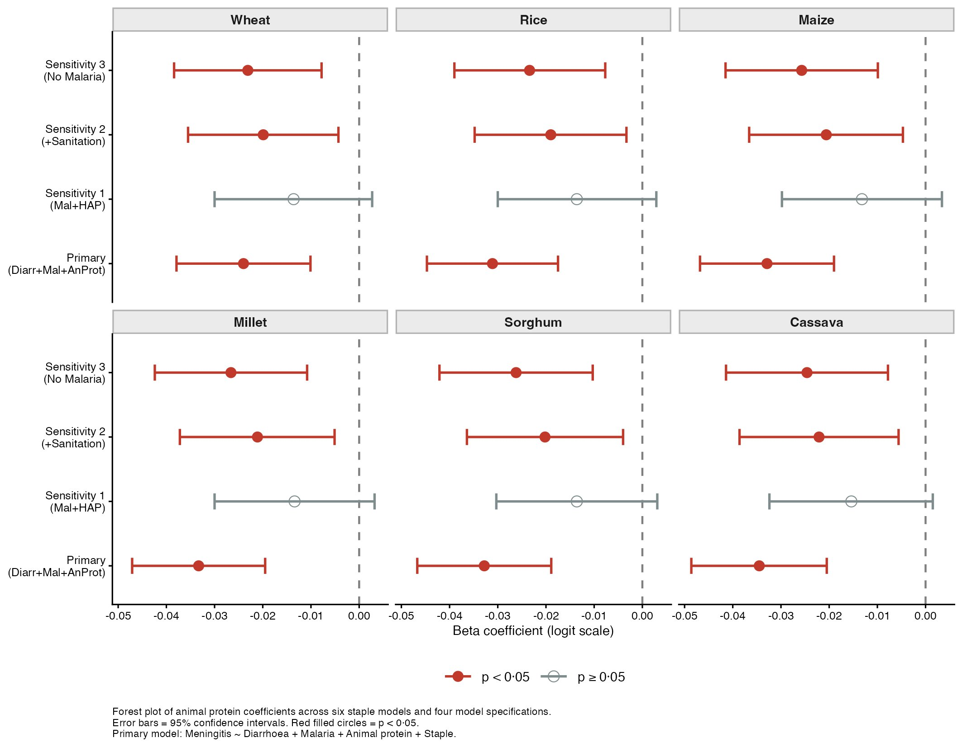
Figure S4a. Forest plot of beta regression coefficients for animal protein across six staple models and four model specifications. Red filled circles = p<0·05; open circles = p≥0·05. Error bars = 95% confidence intervals. N=54 African countries.
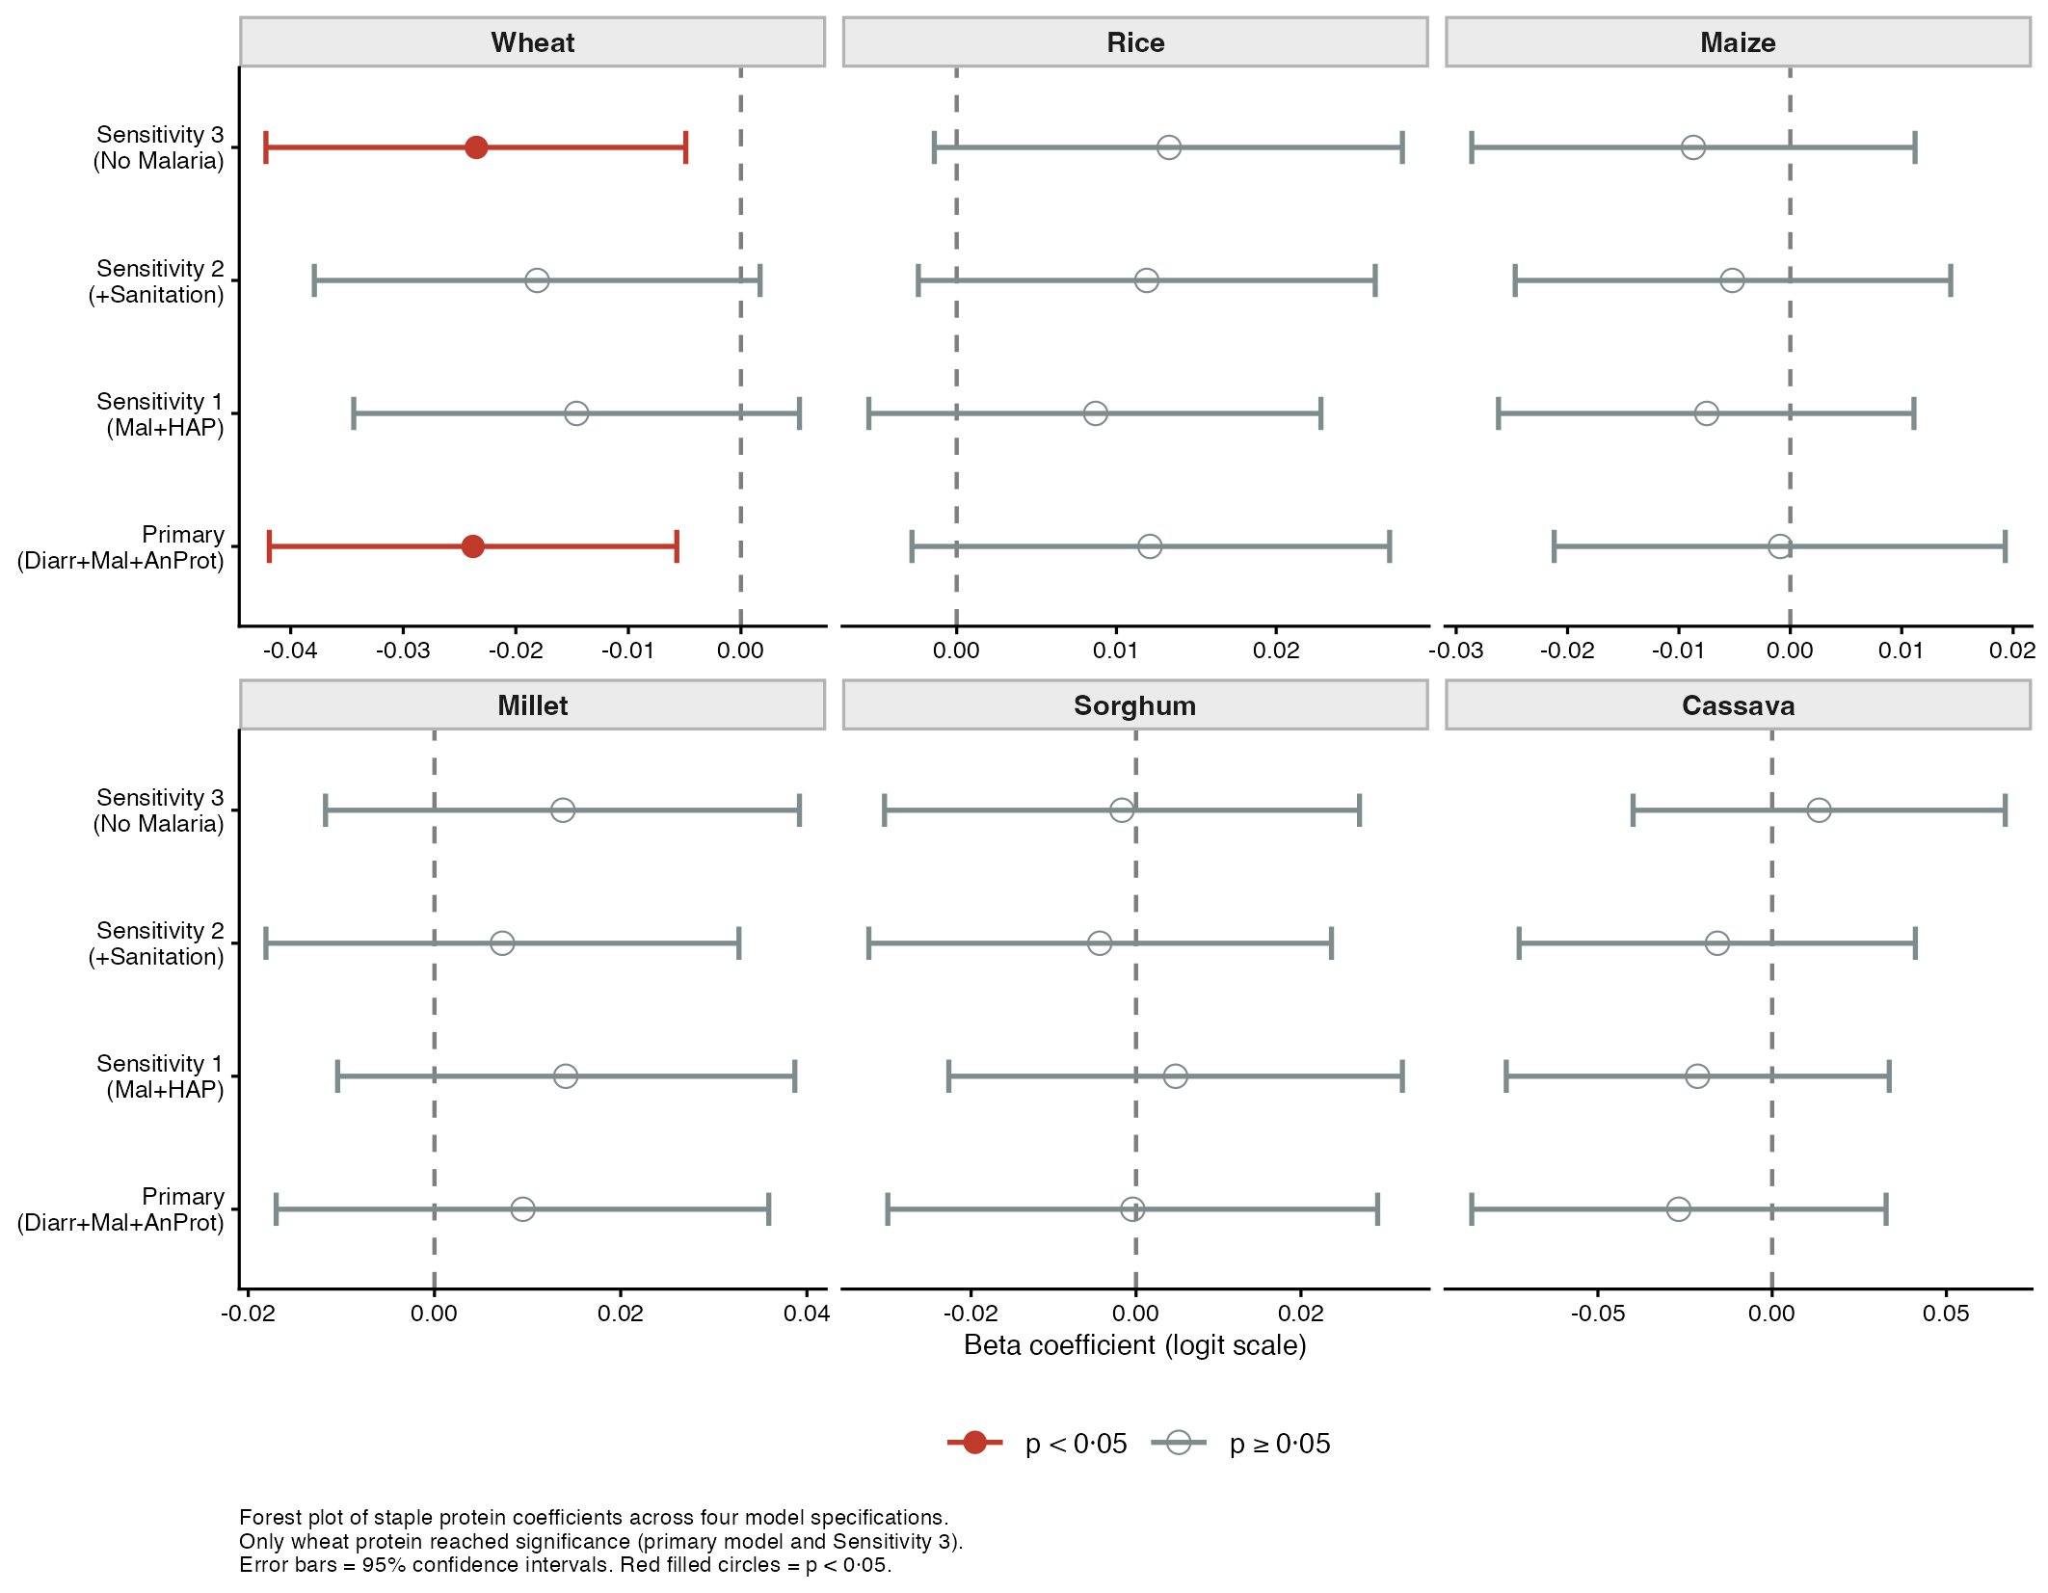
Figure S4b. Forest plot of beta regression coefficients for staple protein variables across primary and three sensitivity model specifications. Each panel represents one staple model. Red filled circles = p<0·05; open circles = p≥0·05. Error bars = 95% confidence intervals. Primary model: Meningitis ~ Diarrhoea + Malaria + Animal protein + Staple. Sensitivity 1: HAP replaces malaria. Sensitivity 2: Sanitation added. Sensitivity 3: Malaria excluded. N=54 African countries.

Box S1. Meningococcal A conjugate vaccine (MACV) vaccination coverage and its implications for the dietary analysis
Background. The meningitis belt extends from Senegal in the West to Ethiopia in the East of Africa and consists of 26 countries.¹From 2010, the Meningitis Vaccine Project introduced Meningococcal A conjugate vaccine (MACV), a monovalent serogroup A meningococcal conjugate vaccine, across 26 meningitis belt countries through mass campaigns targeting persons aged 1–29 years. Country-level coverage estimates for 2010–2021 were obtained from Bender et al, who modelled campaign and routine immunisation coverage using WHO surveillance data and post-campaign surveys.²
The coverage paradox. MACV coverage correlates positively with 2023 meningitis mortality across 54 African countries (Spearman r = +0·56, p < 0·001), reflecting deliberate campaign targeting of high-burden belt countries.
Direction of bias. MACV campaigns reduced overall suspected meningitis incidence by 57% (95% CI 55–59%) and confirmed serogroup A disease by >99% in vaccinated populations.³ High-millet Sahelian countries received the most intensive vaccination, reducing their 2023 meningitis rates below the natural disease burden. The millet association reported here is therefore a conservative lower-bound estimate of the true dietary relationship.
Dietary patterns and persistent heterogeneity. The Table S4 below illustrates the dietary protein landscape across belt countries alongside vaccination coverage and meningitis mortality. The countries are arranged in descending order of meningitis mortality. Two distinct patterns emerge. Sahelian countries (Niger, Mali, Burkina Faso, Chad) show high millet and sorghum dependence with high meningitis prevalence and varying levels of animal protein intake. Northern Nigeria too has a similar staple protein dependence on millet and sorghum with Northern areas having high meningitis mortality in contrast to Southern areas. The ecological nature of our data is brought out by the lower figures of millet and sorghum vis-à-vis Niger and Chad. Burkina Faso has relatively lower meningitis mortality figures in spite of high dependence on millet and sorghum with high vaccination coverage. Central African countries (Congo DRC, Burundi) show cassava dominance with equally low animal protein intakes. In contrast, Mauritania and Sudan have substantially higher animal protein intake and lower meningitis burden. The animal protein (Spearman r = −0·563, p = 0·000) correlate negatively with meningitis mortality across all 54 African countries. A scatter plot for animal protein intake and meningitis mortality is depicted in Fig S5.
Table S4. Meningitis mortality, MACV coverage and dietary protein availability across 24 of 26 WHO meningitis belt countries with available campaign coverage data, sorted by meningitis mortality (descending). All protein values g/capita/day from FAOSTAT food balance sheets.
Country# | Meningitis 2023 | Mean MACV• | Millet+ Sorghum•• | Cassava gm/cap/d | Animal gm/cap/d | Note
Nigeria | 0·0415 | 59·6% | 7·5 | 1·9 | 6·9 | Highest burden; 17 N. states only have higher burden and high dependence on Sorghum & millet.
Niger | 0·0293 | 78·7% | 29·9 | 0·4 | 10·1 | Highest millet
Chad† | 0·0280 | 85·8% | 19·4 | 0·3 | 27·5 | High M+S and animal protein†
Guinea | 0·0269 | 35·2% | 0·3 | 3·7 | 13·1 | Lower coverage
South Sudan† | 0·0269 | 63·3% | 13·1 | 2·5 | 24·3 | Conflict-affected†
Mali† | 0·0252 | 84·5% | 24·5 | 0·1 | 11·9 | High millet. Low animal protein†
Guinea-Bissau | 0·0227 | 72·0% | 3·9 | 0·6 | 9·3 | Campaign 2016
Kenya | 0·0225 | 6·5% | 1·0 | 0·5 | 14·6 | 5 districts only
Gambia | 0·0212 | 86·5% | 3·2 | 0·1 | 19·7 | High coverage; low M+S
Eritrea | 0·0211 | 78·9% | 2·3 | 1·8 | 13·9 | Late start 2019
Senegal | 0·0196 | 38·8% | 6·7 | 0·8 | 16·1 | 8 northern regions with high millet and sorghum dependence.
Burundi† | 0·0190 | 81·0% | 0·1 | 4·9 | 3·4 | Cassava-dependent; very low animal protein†
Central African Republic† | 0·0185 | 77·4% | 1·3 | 2·6 | 21·0 | Campaign 2017†
Benin† | 0·0183 | 26·7% | 2·0 | 2·9 | 13·6 | 5 N. regions with high †
Burkina Faso | 0·0177 | 89·3% | 18·1 | 0·0 | 18·2 | First vaccinated 2010
Ethiopia | 0·0164 | 77·7% | 7·7 | 0·0 | 7·0 | Low animal protein
Uganda | 0·0155 | 17·8% | 0·5 | 1·3 | 14·7 | 39 N. districts; 2017
Cameroon | 0·0152 | 34·4% | 7·7 | 3·0 | 13·7 | 4 N. regions
Côte d’Ivoire | 0·0147 | 28·2% | 0·8 | 4·5 | 16·1 | 25 N. districts; cassava-dependent
Togo† | 0·0142 | 52·1% | 6·0 | 2·8 | 9·0 | Campaign 2014†
Ghana | 0·0142 | 21·8% | 2·8 | 6·2 | 17·8 | 3 N. regions; cassava-dependent
Congo DRC | 0·0133 | 27·5% | 0·1 | 10·7 | 3·6 | Highest cassava; very low animal
Mauritania | 0·0117 | 50·5% | 3·4 | 0·0 | 32·0 | Highest animal; lower burden
Sudan† | 0·0025 | 88·2% | 20·0 | 0·0 | 20·5 | Lowest burden; 3× Niger animal:plant†

# Belt countries defined according to WHO extended meningitis belt definition of 26 countries. Of these, 24 had available MenAfriVac coverage estimates from Bender et al.;¹ Rwanda and Tanzania excluded due to absence of campaign coverage data in that dataset.
• Mean MACV coverage = mean annual modelled coverage ages 1–29 across post-campaign years to 2021 (Bender et al.¹). Values >80% shown in dark blue.
•• Total of millet and sorghum protein values from our dataset.
† Dietary data from earlier FAOSTAT time series (2018–2022) as current series values remain under revision. For Eritrea and Equatorial Guinea, values imputed from respective GBD sub-regions.
Colour coding — MACV: dark blue values >80%. Cassava: amber values ≥4 g/cap/day. Row shading: red = Nigeria (highest burden); amber = cassava-dominant countries (Congo DRC, Burundi, Côte d’Ivoire, Ghana — cassava ≥4 g/cap/day); green = Sudan (lowest burden among high-coverage countries).

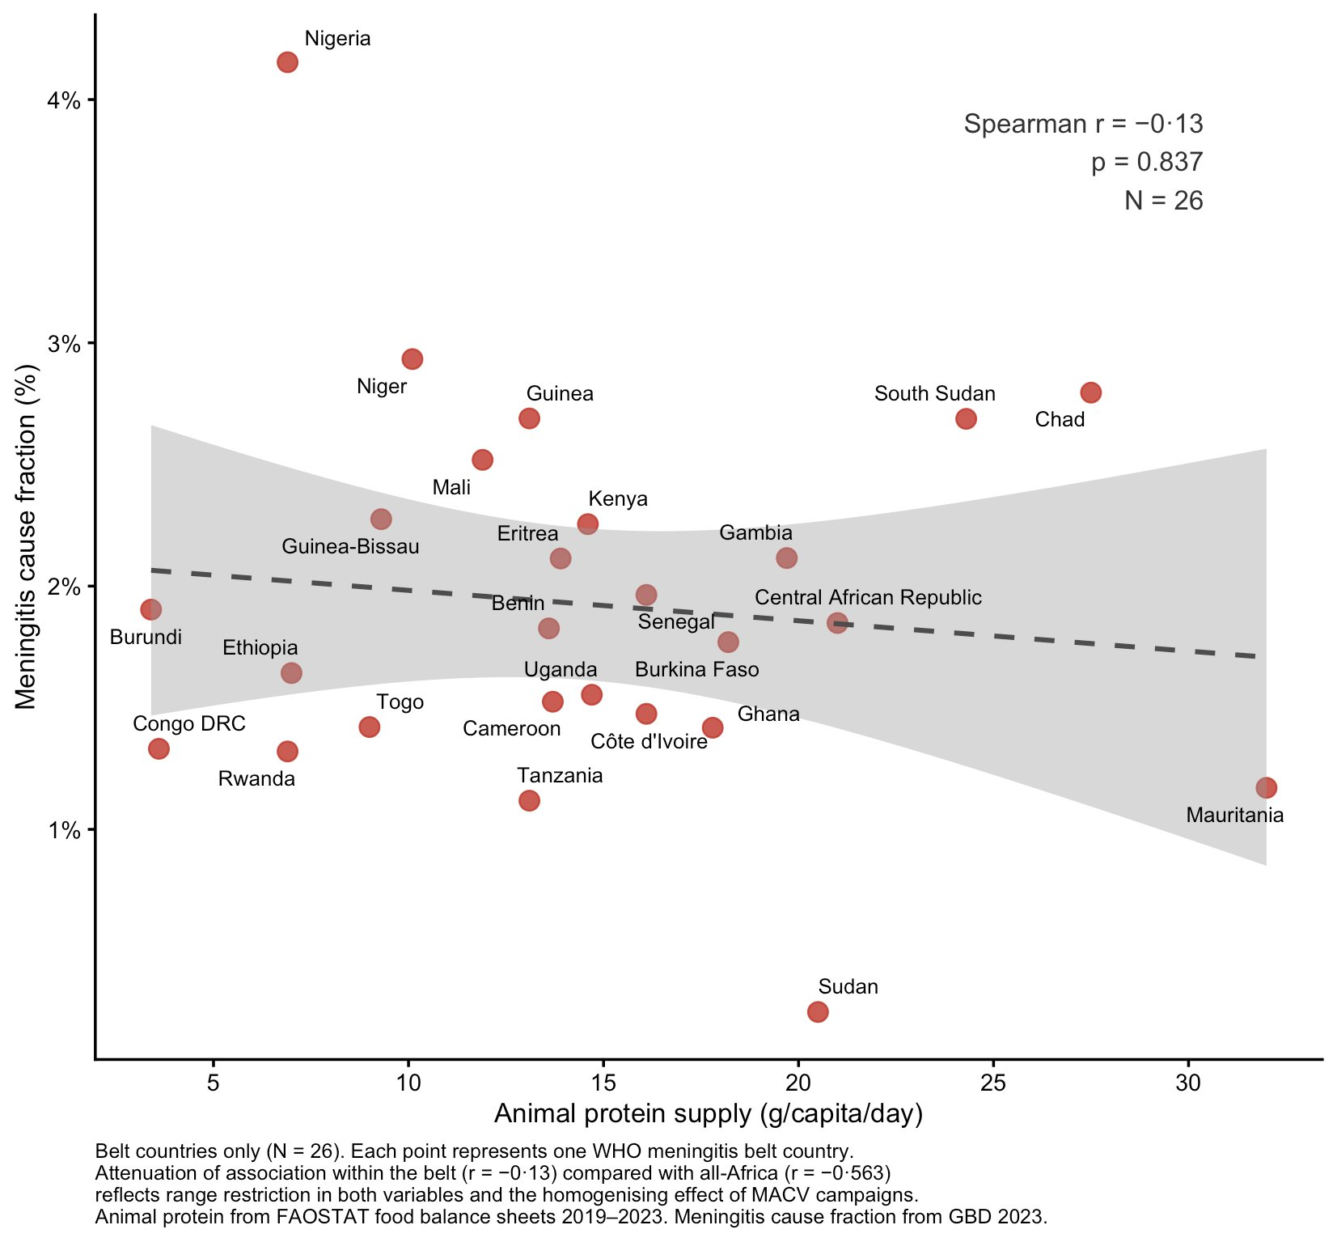
Figure S5:Animal protein availability and meningitis mortality across 24 belt countries with available MACV campaign coverage data.
Point size represents mean meningococcal A conjugate vaccine (MACV) coverage across post-campaign years 2010–2021.² Colour indicates millet and sorghum protein intake tertile. Triangles denote countries where dietary data were sourced from an earlier FAOSTAT time series under current revision or regionally imputed; circles denote countries with direct current series FAOSTAT data. The dashed line represents the linear regression trend (Spearman r = −0·13, p = 0·837). Nigeria's national millet and sorghum value underestimates true belt exposure due to averaging across all 36 states; meningitis burden is concentrated in the 17 northern states. Sudan's dietary data are under FAOSTAT revision. MACV = meningococcal A conjugate vaccine; FAOSTAT = Food and Agriculture Organization Statistical Database.

Bibliography:

1. Bwaka A, Bita A, Lingani C, Fernandez K, Durupt A, Mwenda JM, et al. Status of the Rollout of the Meningococcal Serogroup A Conjugate Vaccine in African Meningitis Belt Countries in 2018. J Infect Dis. 2019 Oct 31;220(220 Suppl 4):S140–7. doi:10.1093/infdis/jiz336 PubMed PMID: 31671448; PubMed Central PMCID: PMC6822965.
2. Bender RG, Shen J, Aravkin A, Bita Fouda AA, Bwaka AM, Galles NC, et al. Meningococcal A conjugate vaccine coverage in the meningitis belt of Africa from 2010 to 2021: a modelling study. EClinicalMedicine. 2023 Feb;56:101797. doi:10.1016/j.eclinm.2022.101797 PubMed PMID: 36880052; PubMed Central PMCID: PMC9985031.
3. Trotter CL, Lingani C, Fernandez K, Cooper LV, Bita A, Tevi-Benissan C, et al. Impact of MenAfriVac in nine countries of the African meningitis belt, 2010-15: an analysis of surveillance data. Lancet Infect Dis. 2017 Aug;17(8):867–72. doi:10.1016/S1473-3099(17)30301-8 PubMed PMID: 28545721.

