Supplementary Figures
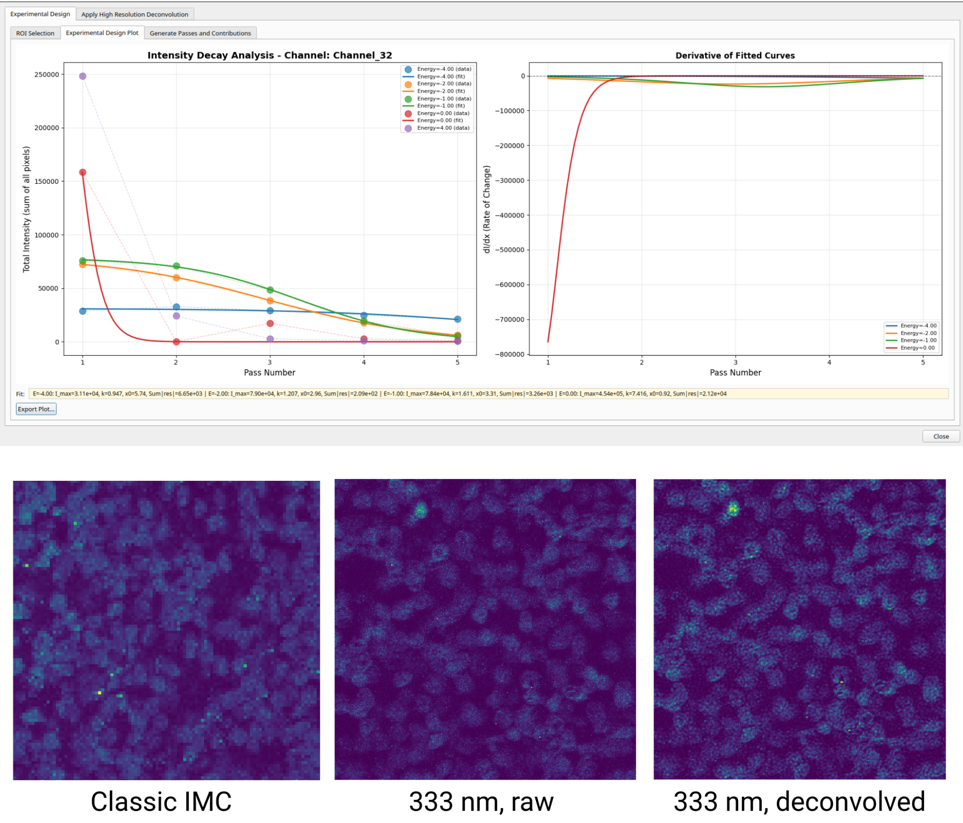
Supplementary Figure S1. High-resolution IMC laser optimization in OpenIMC. Screenshot of the OpenIMC interface during laser power optimization for high-resolution Imaging Mass Cytometry (IMC). Signal intensity from the DNA1 channel (Channel 32) was assessed across five successive passes over a single region of interest (ROI) at relative energy levels of -4 dB, -2 dB, -1 dB, 0 dB, and 4 dB. Left: raw signal intensity per pass. Right: first derivative of a sigmoidal fit to the intensity data. The parameter X0​, representing the pass number at which the derivative reaches a minimum (inflection point, which is computed for each line independently), serves as a critical input for Richardson-Lucy deconvolution. We additionally present an example of a Classic IMC acquisition (1 micron resolution), a 333 nm HR-IMC acquisition prior to deconvolution (raw), and the same 333 nm HR-IMC acquisition deconvolved within OpenIMC. Data obtained from DOI: 10.5281/zenodo.17077711.

Supplementary Table 1. Reproducibility and Benchmarking Statistics.
CLI Segmentation Reproducibility
Method | Metric |  | N | Median [IQR] | Mean ± SD | Range
Cellpose | Dice |  | 42 | 1.0 [0.0] | 1.0 ± 0.0 | 1.0-1.0
 | AJI |  | 42 | 1.0 [0.0] | 1.0 ± 0.0 | 1.0-1.0
 | Count Diff |  | 42 | 0.0 [0.0] | 0.0 ± 0.0 | 0.0-0.0
 | Mean Area Diff (px²) |  | 42 | 0.0 [0.0] | 0.0 ± 0.0 | 0.0-0.0
 | Boundary displacement (px) |  | 42 | 0.0 [0.0] | 0.0 ± 0.0 | 0.0-0.0
 | Hausdorff (px) |  | 42 | 0.0 [0.0] | 0.0 ± 0.0 | 0.0-0.0
CellSAM | Dice |  | 42 | 1.0 [0.0] | 1.0 ± 0.0 | 1.0-1.0
 | AJI |  | 42 | 1.0 [0.0] | 1.0 ± 0.0 | 1.0-1.0
 | Count Diff |  | 42 | 0.0 [0.0] | 0.0 ± 0.0 | 0.0-0.0
 | Mean Area Diff (px²) |  | 42 | 0.0 [0.0] | 0.0 ± 0.0 | 0.0-0.0
 | Boundary displacement (px) |  | 42 | 0.0 [0.0] | 0.0 ± 0.0 | 0.0-0.0
 | Hausdorff (px) |  | 42 | 0.0 [0.0] | 0.0 ± 0.0 | 0.0-0.0
GUI vs CLI Segmentation Parity
Method | Metric | N |  | Median [IQR] | Mean ± SD | Range
CellSAM | Dice | 42 |  | 1.0 [0.0] | 1.0 ± 0.0 | 1.0-1.0
 | AJI | 42 |  | 1.0 [0.0] | 1.0 ± 0.0001 | 0.9998-1.0
 | Count diff. | 42 |  | 0.0 [0.0] | 0.0 ± 0.0 | 0.0-0.0
GUI vs CLI Feature Parity
Method | Metric | N |  | Median [IQR] | Mean ± SD | Range
Cellpose | Morphology r | 10 |  | 1.0 [0.0] | 1.0 ± 0.0 | 1.0-1.0
Cellpose | Intensity r | 371 |  | 1.0 [0.0] | 1.0 ± 0.0 | 1.0-1.0
CellSAM | Morphology r | 10 |  | 1.0 [0.0] | 1.0 ± 0.0 | 1.0-1.0
CellSAM | Intensity r | 371 |  | 1.0 [0.0] | 1.0 ± 0.0 | 1.0-1.0
Rows report median [IQR], mean +/- standard deviation (SD), and range. Dice = Dice coefficient, AJI = Aggregated Jaccard Index, GUI = graphical user interface, CLI = command-line interface, IQR = interquartile range. 4 patient samples, derived from the IMMUcan study, were used for this analysis (DOI: https://doi.org/10.5281/zenodo.7575859) with 3 replicates each. N=42 represents the total number of acquistions * replicates. N=10 represents 10 morphology features. N=371 represents 371 intensity features.
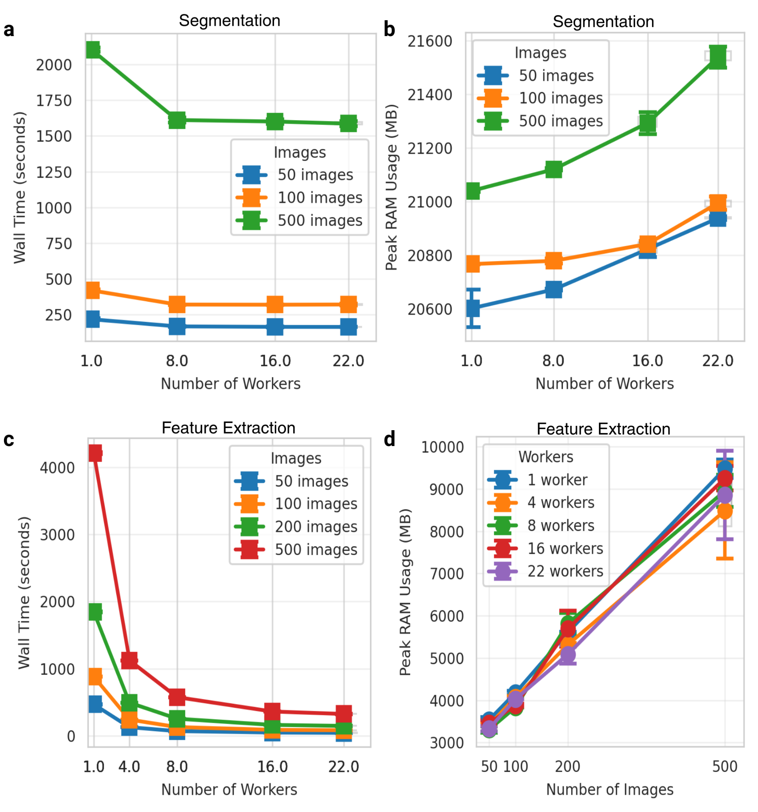
Supplementary Figure S2. Performance metrics of OpenIMC in datasets of different sizes with different amounts of allocated compute. We assess the scalability of segmentation and feature extraction within OpenIMC. Segmentation is performed using Cellpose Cyto 3 on the two DNA channels only, with image subsets derived from the Jackson et al. dataset (DOI: https://doi.org/10.5281/zenodo.3518284). A. Wall time for segmentation as a function of the number of workers across different size datasets. Wall time can be reduced for segmentation by 25% by increasing worker count for CPU bound processes, but GPU bound processes remain limited. Wall time primarily scales with the number of images in the dataset. B. Segmentation RAM usage as a function of the number of CPU workers. RAM usage remains stable and grows slightly (1 GB) as a function of increased worker count and number of total images. C. Feature extraction wall time as a function of the number of workers. We can see exponential decrease in wall time for all numbers of images with increased CPU count, with over 10-fold decrease in total wall time moving from 1 CPU worker to 22 CPU workers. D. Feature extraction RAM usage scales linearly with dataset size (number of images) and is not impacted by the number of CPU workers.

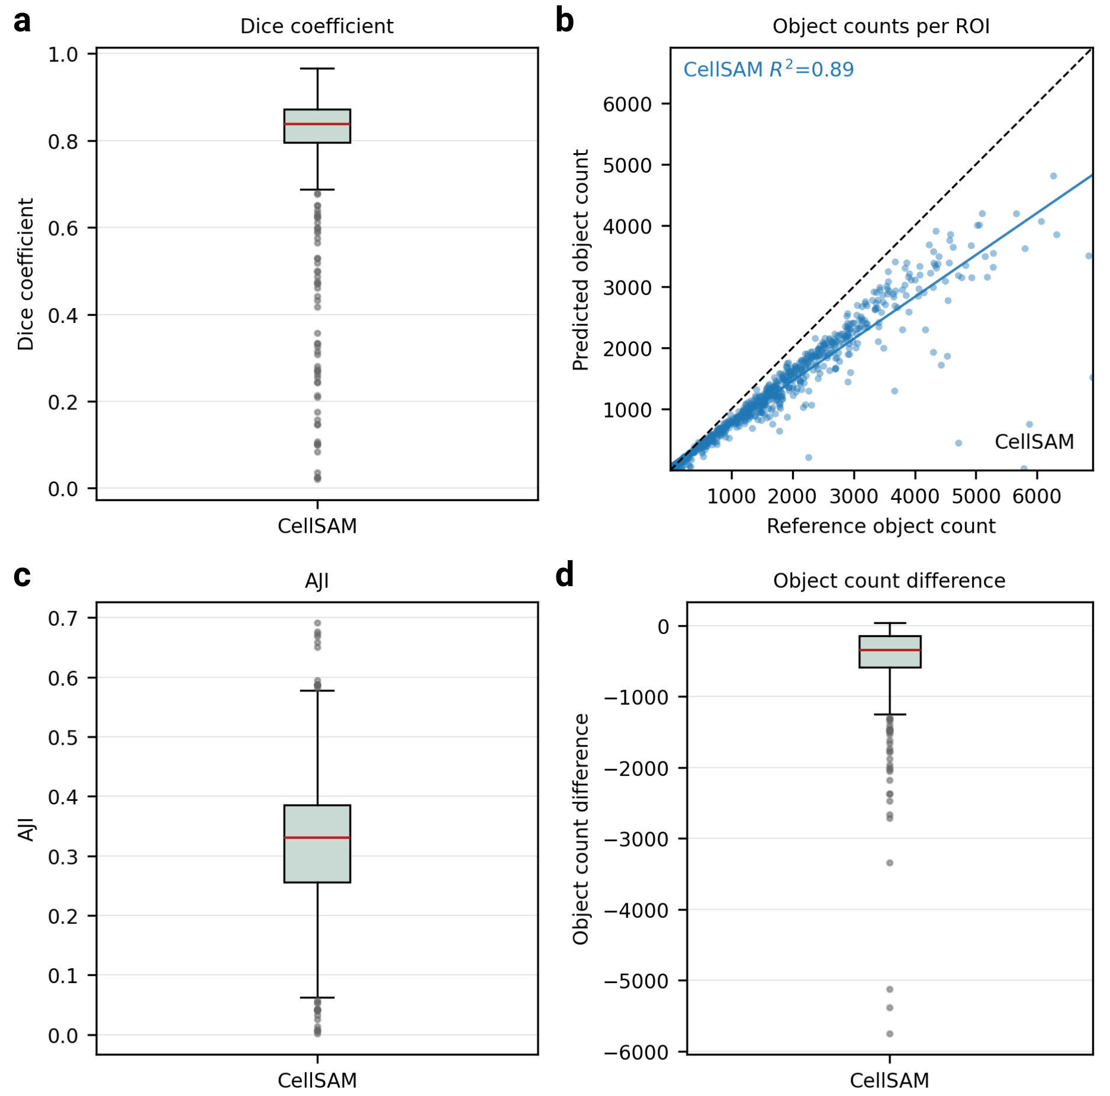

Supplementary Figure S3. Quantitative evaluation of CellSAM segmentation performance on Imaging Mass Cytometry data. Segmentation masks were generated with OpenIMC’s integration of CellSAM for the entire Jackson et al. dataset (DOI: https://doi.org/10.5281/zenodo.3518284). Mask channels were the same as were used in the initial publication and as follows: DNA1, DNA2, and Histone H3 (In113) as the nuclear channels and Cytokeratin 5, Fibronectin, Cytokeratin 19, Cytokeratin 8/18, CD68, Keratin 14, SMA, Vimentin, HER2, CD3, Progesterone Receptor, CD44, CD45, CD20, b-Catenin, Ki-67, Cytokeratin 7, and pan-Cytokeratin as the cytoplasmic/membranous channels. Masks in the original Jackson et al. publication (reference) were generated using Ilastik. A. Distribution of Dice coefficients comparing CellSAM-generated masks to reference annotations from the Jackson et al. dataset. The box plot indicates a median Dice coefficient of 0.84 (red line), with the interquartile range (IQR) spanning 0.80 to 0.87. Individual outliers are represented as gray points. B. Correlation between predicted object counts by CellSAM and reference object counts across regions of interest (ROIs). The solid blue line represents the linear regression (R2=0.89), while the dashed black line indicates the 1:1 identity line. C. Distribution of the Aggregated Jaccard Index (AJI) for CellSAM segmentations, reflecting pixel-level and instance-level accuracy. D. Box plot of the absolute object count difference per ROI. Box plot elements: center line, median; box limits, upper and lower quartiles; whiskers, 1.5x IQR; points, outliers. Differences between CellSAM and Ilastik can be attributed to one of the following: using a generalist segmentation model, rather than one trained exclusively for this dataset, incorrect parameters for CellSAM (here, defaults were used), and/or that the reference is not a ‘ground truth’ and both contain regions of strong segmentation and weak segmentation.
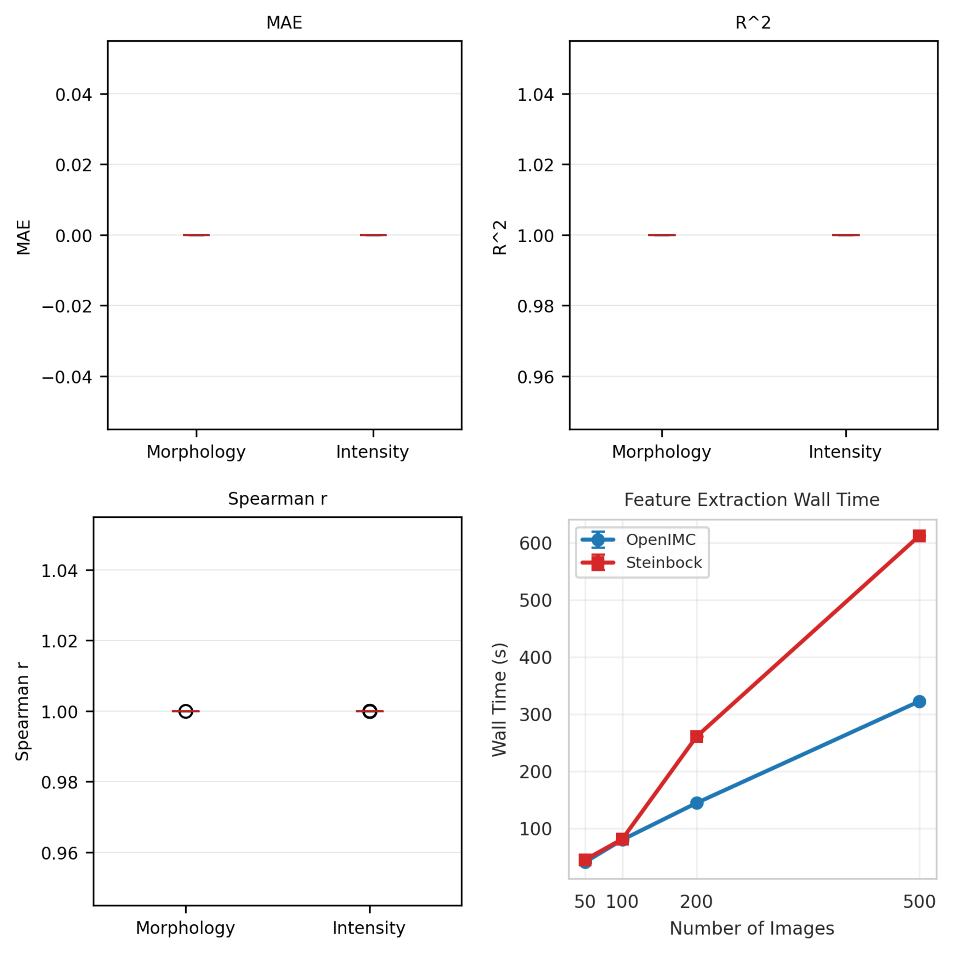
Supplementary Figure S4. Validation and benchmarking of OpenIMC feature extraction performance relative to Steinbock. A–C, Concordance analysis between OpenIMC and Steinbock for morphology and intensity features. Mean Absolute Error (MAE) (A), Coefficient of Determination (R^2) (B), and Spearman correlation coefficients (r) (C) demonstrate perfect agreement (MAE = 0.0, R^2 = 1.0, r = 1.0) between the two pipelines (Steinbock and OpenIMC) for overlapping feature sets. Box plots represent distributions across all extracted features; red lines indicate medians. D. Computational efficiency benchmarking. Feature extraction wall time (seconds) is plotted against the number of processed images (n = 50, 100, 200, and 500). OpenIMC (blue) demonstrates superior scalability compared to Steinbock (red) by leveraging multiprocessing (22 cores). While maintaining numerical identity for shared features, OpenIMC additionally extracts an expanded suite of metrics, including intensity variance and higher-order morphological descriptors, not currently supported by Steinbock. Error bars represent standard deviation across three independent runs. 4 patient samples, derived from the IMMUcan study, were used for this analysis (DOI: https://doi.org/10.5281/zenodo.7575859) with 3 replicates each.
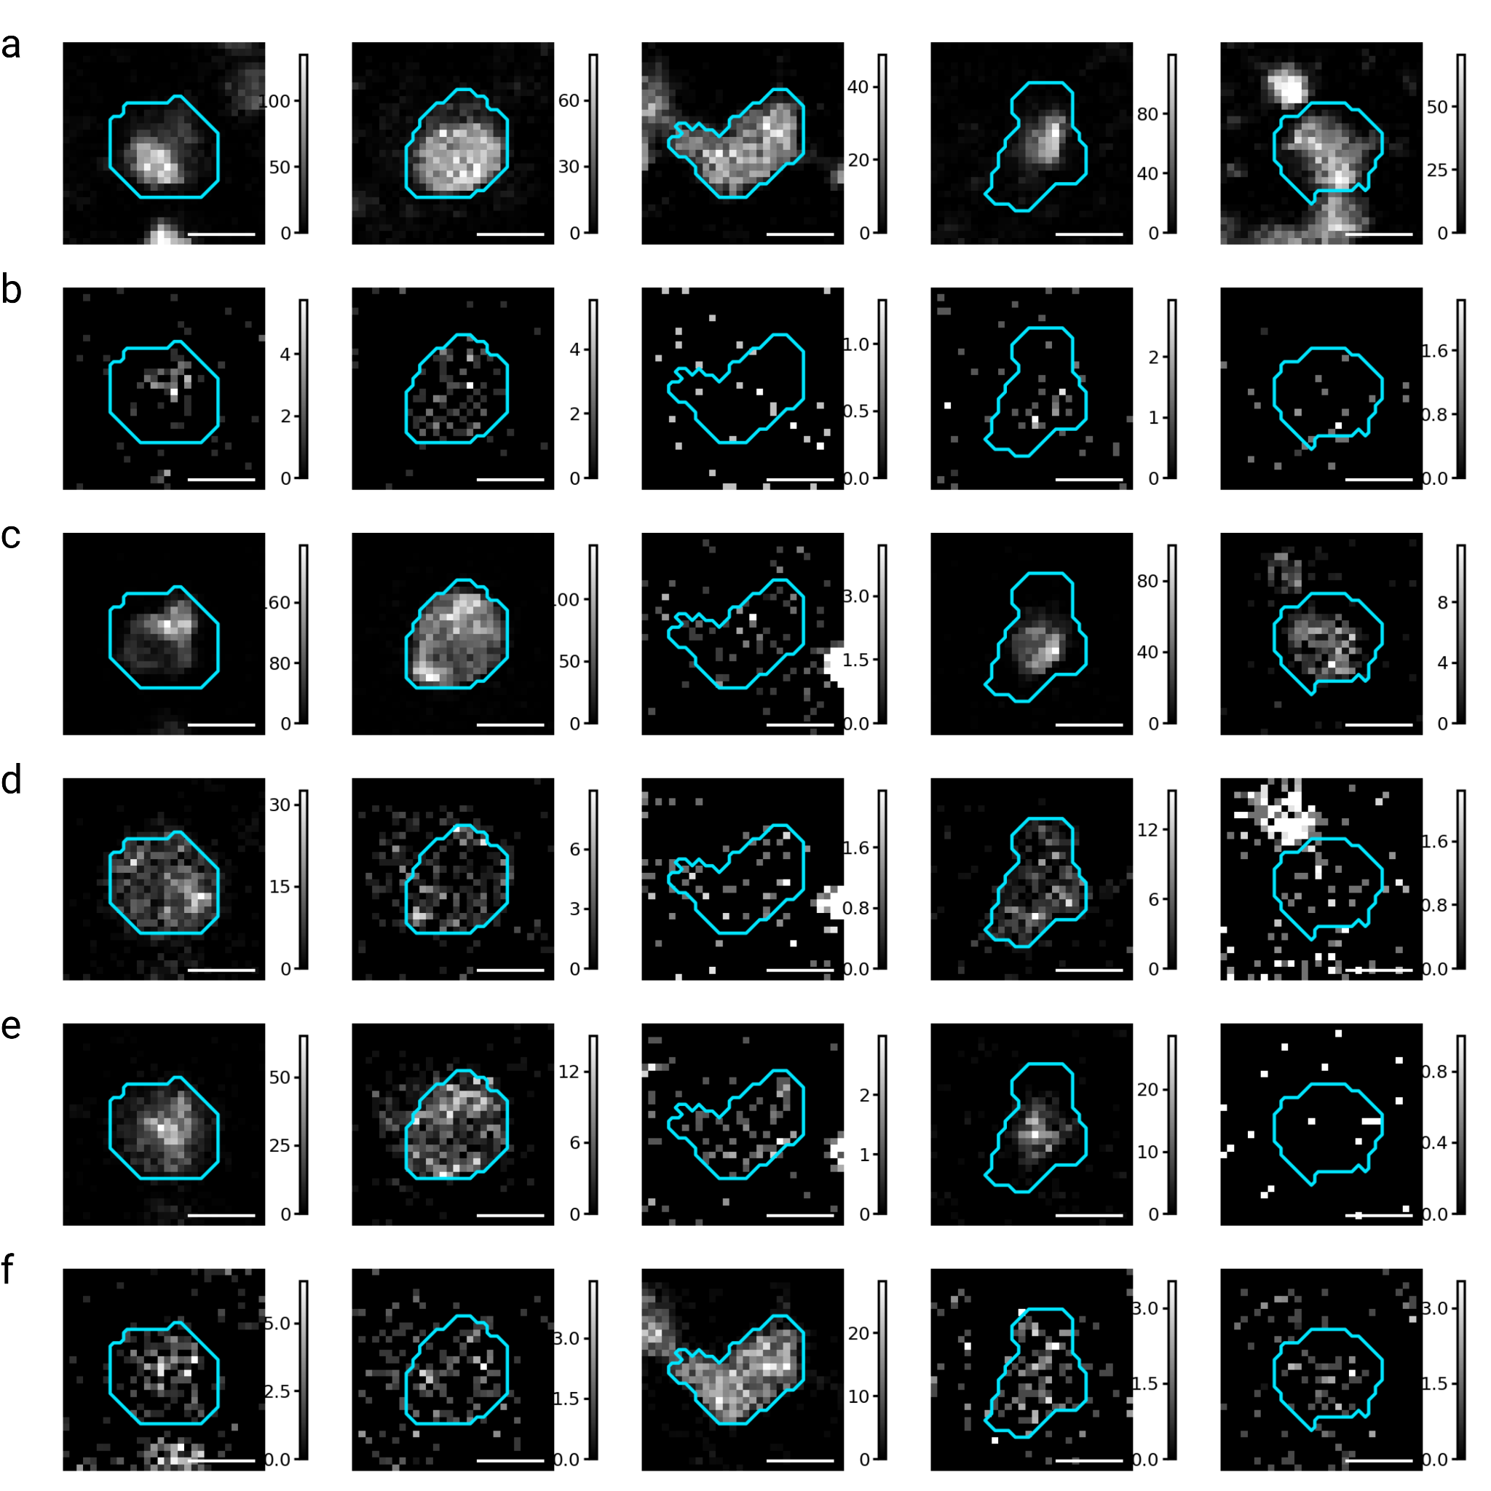
Supplementary Figure S5. IMC Crops of Markers Expressed by Atypical Circulating Cells. Crops of 5 cells, with segmentation outline in blue, from the heterogenous Atypical Circulating Cell (ACC) cluster showing DNA (A), Fibronectin (B), Vimentin (C), CD44 (D), CD68 (E), CD14 (F). Markers are shown without additional scaling. Scale bar of 10 microns. All crops were generated directly within OpenIMC’s Cluster Explorer tool.
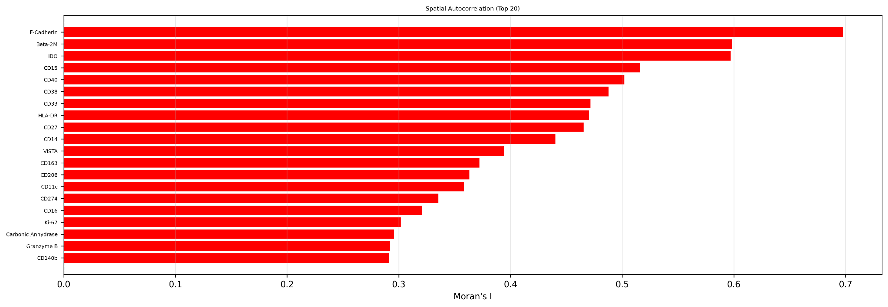
Supplementary Figure S6. Moran’s I for the 20 largest effect markers in the spatial dataset. Red bars indicate adjusted p-values less than 0.05. Moran’s I represents the spatial auto-correlation of a given marker, ranging from -1 (dispersion) to +1 (clustering). Values above 0.3 generally represent strong hot-spot regions. E-Cadherin (epithelial cells) represents the strongest autocorrelation, with a value of ~0.7. Plot generated within OpenIMC’s Advanced Spatial Analysis Module. Data was derived from the IMMUcan study for this analysis (DOI: https://doi.org/10.5281/zenodo.7575859).

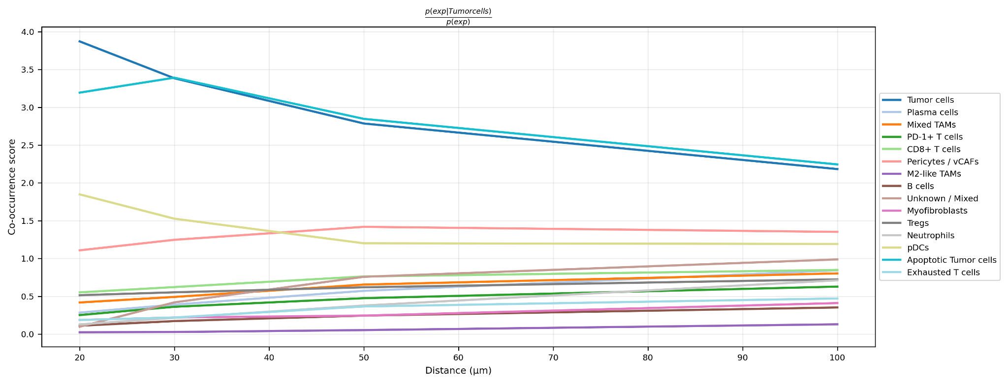
Supplementary Figure S7. Co-occurrence likelihood curves from the nearest tumor cell. Co-occurrence curves representing the likelihood of finding target phenotypes as a function of distance (20 to 100 μm) from its nearest Tumor cell. The sharp decay in the tumor-tumor curve indicates the characteristic spatial scale of malignant nests and the quantitative exclusion of immune populations from the malignant niche. Plot generated within OpenIMC’s Advanced Spatial Analysis Module. Data was derived from the IMMUcan study for this analysis (DOI: https://doi.org/10.5281/zenodo.7575859).

Supplementary Table S2. Antibody Panel for Circulating Rare Cells in Breast Cancer.
Metal Tag | Target | Antibody Clone
89 Y | CD45 | Mouse_IgG1k_H130
141 Pr | EpCAM | Mouse_IgG2b_9C4
142 Nd | CD20 | Rabbit_IgG_SP32
144 Nd | SMA | Mouse_IgG2a, kappa_1A4
145 Nd | PR | Rabbit_IgG_YR85
146 Nd | CD8a | Mouse_IgG1k_RPA-T8
147 Sm | FAP | Sheep_IgG_Polyclonal
148 Nd | HER2 | Rabbit_IgG_29D8 (Helios)
149 Sm | CD56 | Mouse_IgG2b k_NCAM16.2
152 Sm | Fibronectin | Rabbit_IgG_EPR19241-46
153 Eu | N-cadherin | Rabbit_IgG_SP90
154 Sm | Vimentin | Rabbit_IgG_EPR3776
156 Gd | CD14 | Rabbit_IgG_EPR3653
158 Gd | E-Cadherin | Rabbit_IgG_24E10
159 Tb | CD68 | Rabbit_IgG_EPR20545
161 Dy | Ki-67 | Rabbit_IgG_EPR3610
164 Dy | ER | Rabbit_IgG_D6R2W
166 Er | CD45-RA | Mouse_IgG2bk_HI100
168 Er | CD31 | Rabbit_IgG_EPR3094
169 Tm | CD66b | Rabbit_IgG_EPR20721
170 Er | CD3 | Rabbit_IgG_Polyclonal
171 Yb | CD44 | Rat_IgG2b_IM7 (Helios)
173 Yb | CD45-RO | Mouse_IgG2a_UCHL1
174 Yb | HER2 (c-erbB2) | Mouse_IgG2b_42
175 Lu | CK8 | Rabbit_IgG_EP1628Y
175 Lu | CK18 | Rabbit_IgG_EPR1626
176 Yb | CD4 | Rabbit_IgG_EPR6855
195 Pt | ICSK1 | Standard Bio Membrane Kit
196 Pt | ICSK2 | Standard Bio Membrane Kit
198 Pt | ICSK3 | Standard Bio Membrane Kit

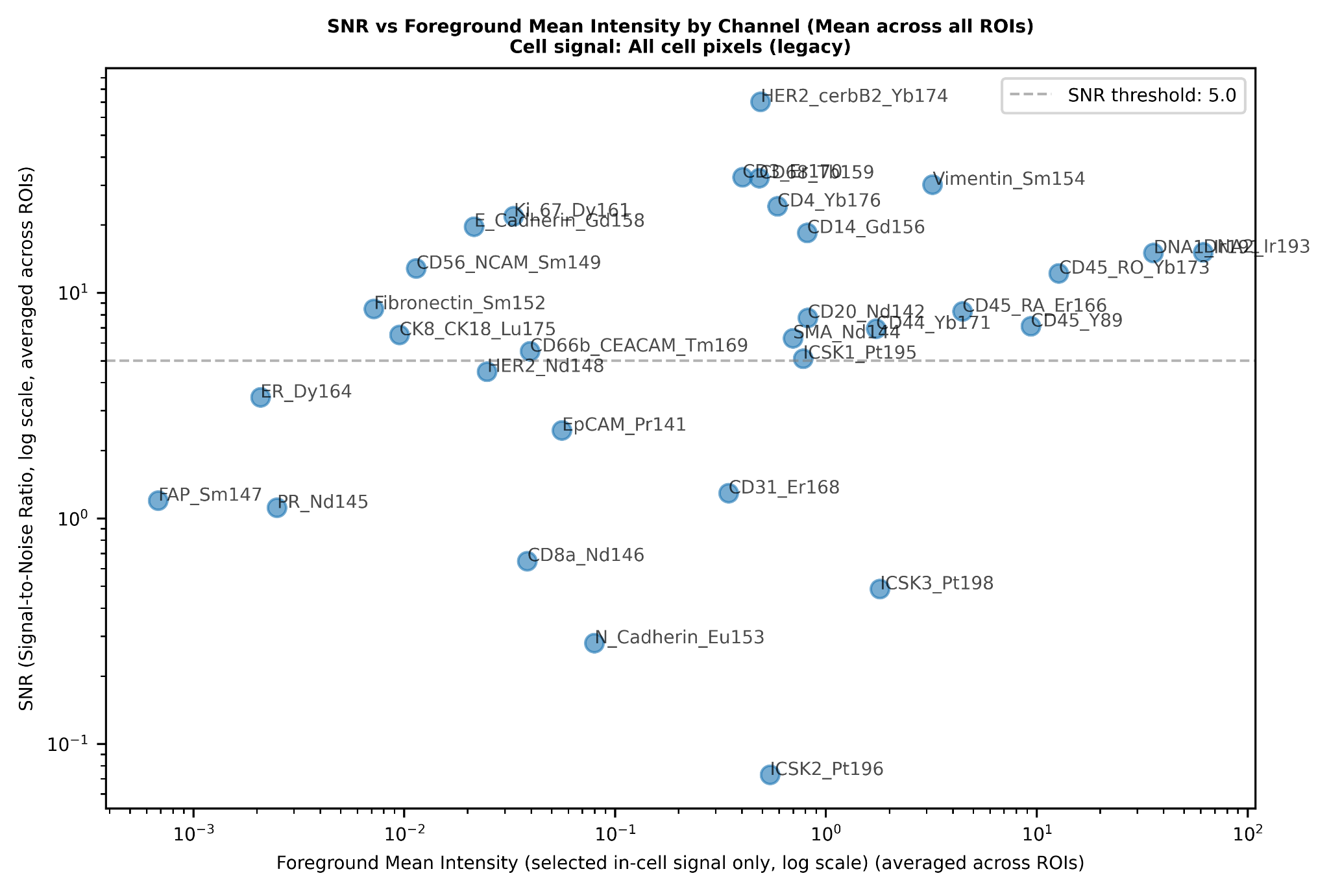
Supplementary Figure S8. Signal to Noise Ratio vs Mean Intensity quality control in OpenIMC for Circulating Rare Cell Analysis. Signal is computed from all segmented cell regions, with a mean taken across ROIs. Noise is signal from all non-segmented regions. Mean intensity is the total mean intensity, including both foreground and background. A dashed line is shown at SNR = 1.0, where signal equals noise. Markers with SNR below 5.0 were excluded from downstream analysis.
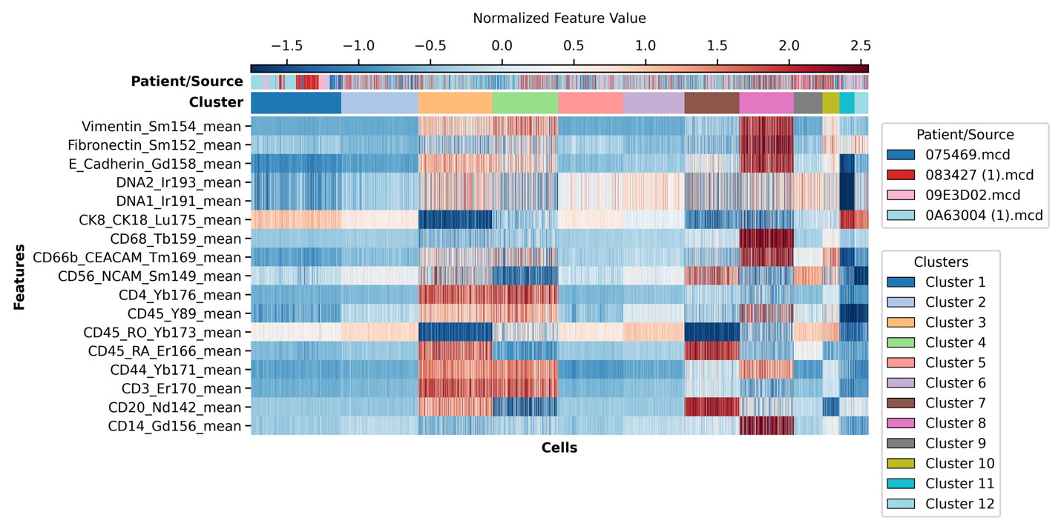
Supplementary Figure S9. Clustering of single circulating cells prior to merging clusters together manually. Clustering was computed with Leiden.

