Supplementary Information Appendix
Extended Results

Supporting Figures and Tables
The additional Figures and Tables provided in the SI are intended to support the results described in the main text. These include:
- Comparisons between modelled population estimates with census counts at ward-level, stratified by province (Figure S1)
- Model evaluation statistics (R (Pearson), RMSE, MAE, MAPE, MedAE, bias, imprecision) with stratification by province (Table S1)
- Summaries of the proportion of administrative units for which the census counts were within the 95% CIs of the modelled estimates (Table S2 – districts, Table S3 – wards), with stratification by province

The conservative and expanded grid cell subsets are defined based on the location of census residential household locations. Additional Figures are provided in the SI to support the definition of these subsets:
- Figure S2 shows the (1) number of grid cells and (2) modelled estimates of population, for (i) all grid cells, (ii) the expanded subset, and (iii) the conservative subset.
- Figure S4 shows how the location of grid cells with modelled population estimates (lower axis) maps to locations of residential census households (upper axis) nationally, with summaries per province provided in Figure S5.

A limitation of the analyses to compare modelled estimates (all grid cells and grid cell subsets) and census counts, concerns the presence of grid cells with residential households at the time of the census, but without modelled population estimates due to an absence of building footprints. As discussed in the main text, the gridded population estimates nationally include 2,273,498 grid cells with estimated population, corresponding to a national population estimate of 21,657,131 (95% CI: 20,912,731 - 22,474,310). In comparison, the 2022 census population was 19,693,423 (3), and there were 1,525,866 grid cells with residential households recorded in the census.
As shown in Figure S4, of the 1,525,866 grid cells nationally with residential census households, 1,145,112 of these also have population predicted in the modelled estimates, which we termed the “conservative” subset (green flow). The remaining 380,754 grid cells with residential census households do not have modelled population estimates (purple flow). When we relax the definition of grid cells with residential census households to also consider the eight surrounding grid cells (identified through the application of a 3x3 spatial filter), an additional 4,807,710 grid cells are identified as potentially having residential households. Of these 4,807,710 grid cells, approximately 12.5% (n=602,584) are grid cells with modelled population estimates (yellow flow), whilst the remaining grid cells do not have building footprints (red flow, n=4,205,126). The green and yellow flows together represent the “expanded” subset (1,747,697 grid cells). The blue flow represents the 525,721 grid cells that have modelled population estimates but are not included in either the conservative or expanded subset, due to an absence of residential census households. Grid cells in the blue flow are likely to: (1) have only non-residential or uninhabited buildings, (2) have building footprints that are false positives, or (3) have residential buildings but these are missing from the census residential household definition. Figure S5 builds on Figure S4 to show how the classification of grid cells in the modelled population estimates dataset and the census residential households dataset compare on a province-by-province basis. Relatively consistent patterns are seen between provinces.
The situation of grid cells with residential households in the census, but without modelled population estimates, can largely be attributed to the temporal differences between the 2022 census and the year of the satellite imagery from which the building footprints were extracted. Nationally, 92% of grid cells with building footprints were extracted from satellite imagery dating from 2017 (22.9%), 2018 (42.5%) or 2019 (26.8%), with the remaining building footprints extracted from satellite imagery from preceding years, with the earliest imagery dating from 2010. Thus, there is a minimum of 3 years elapsed between the most recent satellite imagery used in the building footprint extraction, and the census. Figure S3 shows the year of the satellite imagery from which the building footprints used in the population modelling were extracted, summarized in terms of the count of grid cells for each year (2010-2019), with stratification by province.

As described in the main text, we conducted an additional analysis to identify those grid cells with residential households at the time of the census, but for which no modelled population estimates were predicted (n=380,754 nationally). Table S8 provides a summary of the count of grid cells with modelled population estimates (building footprints), residential census households, and residential census households but no modelled population estimates, summarised both nationally and per province. We estimated the portion of the census population count that is potentially resident in those grid cells without building footprints. For each ward, the count of census households in the subset of grid cells was multiplied by the mean household size (estimated based on the census count of population divided by the count of census households), to estimate the census population associated with those grid cells. Across the 380,754 grid cells nationally with residential census households but no modelled population estimates, we estimated the census population resident in those grid cells to be 2,311,349, which when subtracted from the national census population total, gives an adjusted national census population of 17,382,074 (Table S8).

Additional analyses comparing the subsets of modelled estimates with the adjusted census comparator are described in the main text. The following SI Figures and Tables support this additional analysis:
- Figure S6 shows the modelled population estimates for expanded and conservative subsets, compared against adjusted census counts for province, district and wards.
- Figure S7 provides scatterplots for modelled ward estimates based on the conservative subset, plotted against adjusted census counts, with stratification by province.
- Table S4 provides model evaluation statistics (R (Pearson), RMSE, MAE, MAPE, MedAE, bias, imprecision) comparing the modelled population estimates based on the expanded and conservative subsets, and the adjusted census totals, for all districts and wards nationally. Table S5 provides the same model evaluation statistics with stratification by province.
- Summaries of the proportion of administrative units for which the adjusted census totals were within the 95% CIs of the modelled estimates subsets are provided for districts and wards in Table S6. Additional summaries for the conservative subset of estimates are provided in Table S7, which quantify the percentage of spatial units in which the lower 95% CI exceeds the adjusted census count, and the upper 95% CI is less than the adjusted census count. Summaries are provided for districts and wards nationally, as well as with stratification by province.

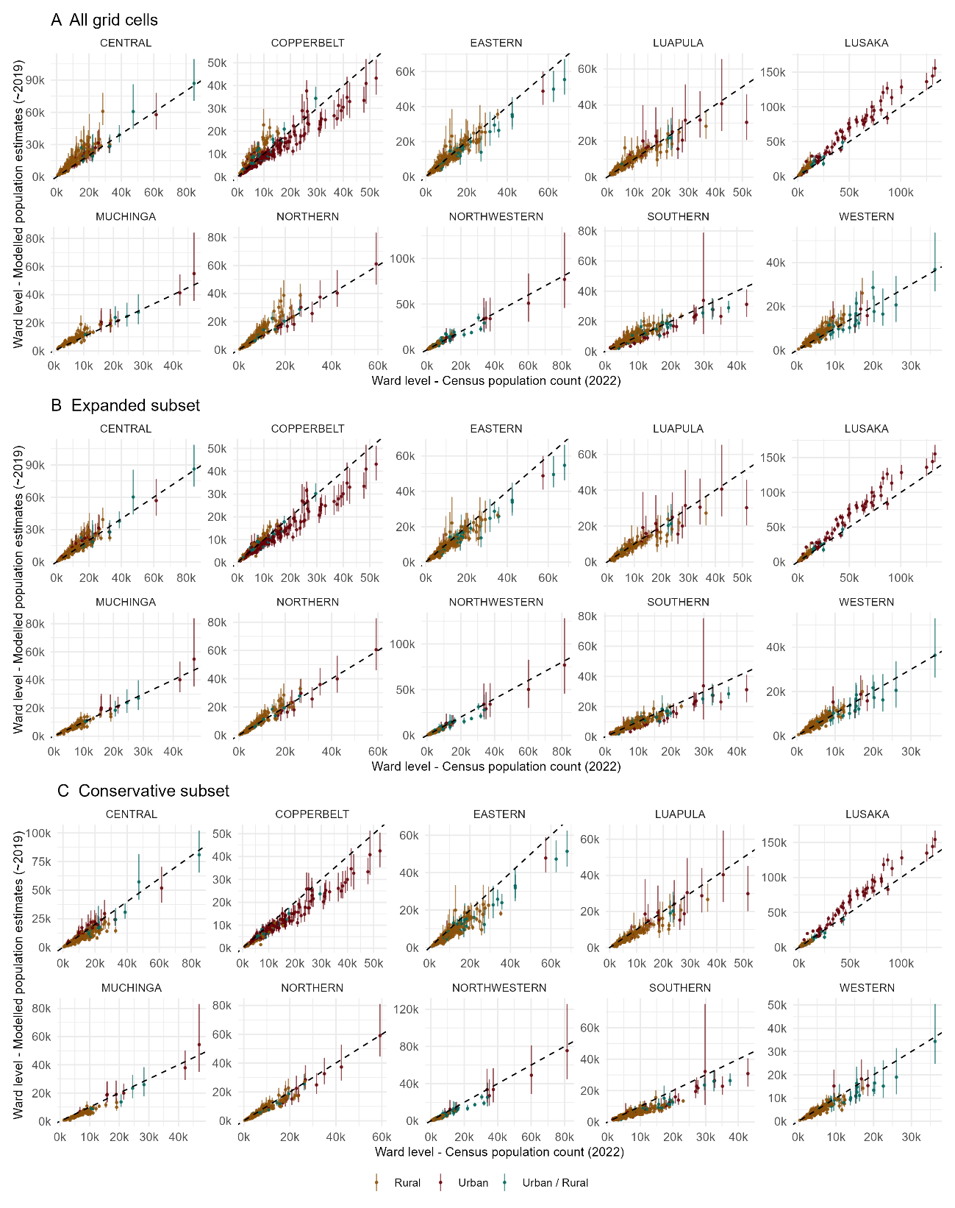
Figures

Fig. S1. Modelled population estimates with 95% credible intervals (CIs) plotted against census counts for each ward, stratified by province. Parts A-C show modelled estimates based on (A) all grid cells, (B) the expanded subset, and (C) the conservative subset. The diagonal black line (y=x) shows a one-to-one relationship between the modelled and census-enumerated counts. The axis limits vary between plots to accommodate the wide range of values in ward population. The rural/urban designation of each ward, as used in the census, is also shown.

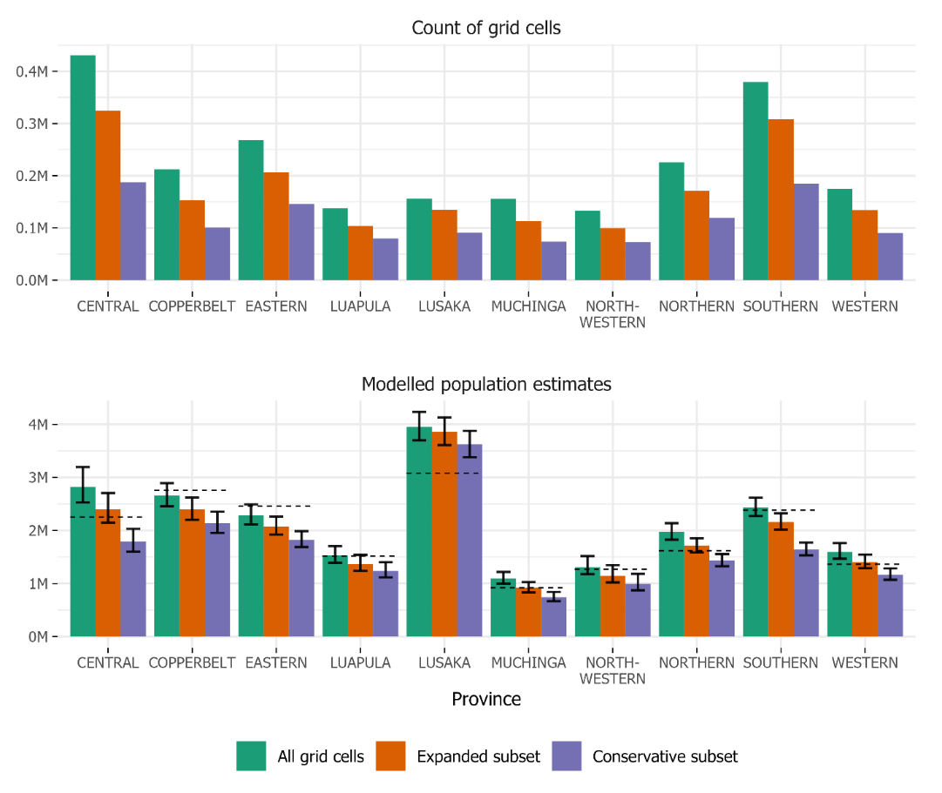
Fig. S2. For each province, the count of grid cells with modelled population estimates (upper) and the modelled estimates of population (lower) are shown, for all grid cells (green), the expanded subset of grid cells (orange) and the conservative subset of grid cells (purple). In the lower plot, the green/orange/purple bars show the mean value of the modelled population estimates, with the 95% CIs shown by the error bars, and the 2022 enumerated census count shown by the dotted line.

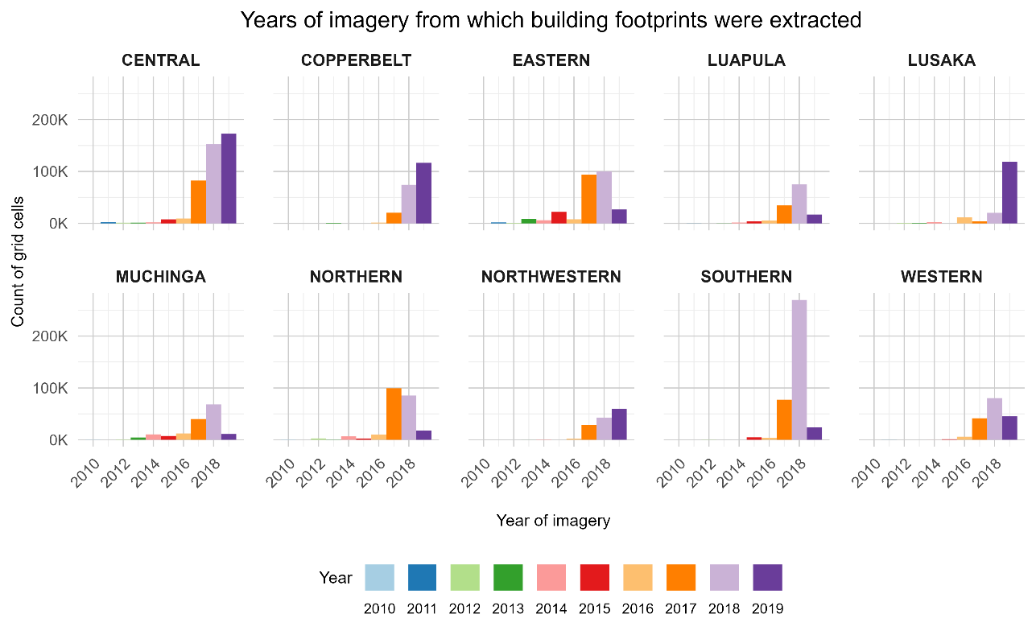
Fig. S3. The year of the satellite imagery, from which Ecopia building footprints were extracted, quantified in terms of the count of grid cells with building footprints, stratified by province.

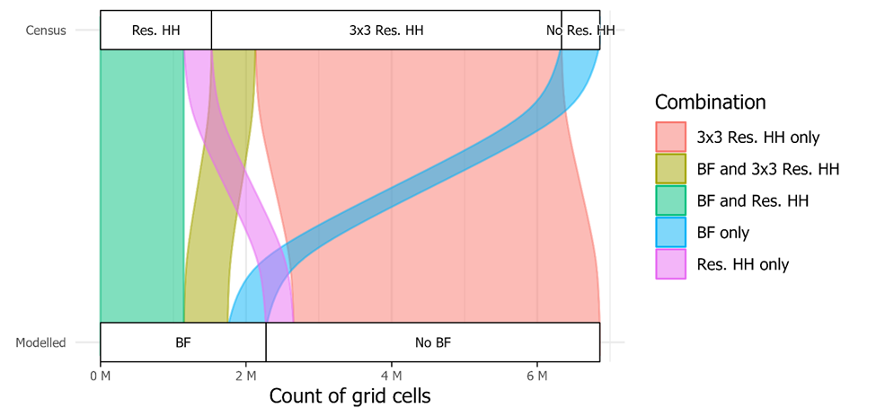

Fig. S4. The count of grid cells with building footprints (BFs), and thus modelled population estimates (lower axis), and the count of grid cells with residential census households (HHs; upper axis). The spatial agreement between these classifications are shown by the flows between the upper and lower axes. The conservative subset of grid cells is represented by the green flow, the expanded subset is represented by the combination of the green and yellow flows. The purple flow represents grid cells with residential census households but with no building footprints and therefore no modelled population estimates. The blue flow represents grid cells with building footprints but no residential census households.

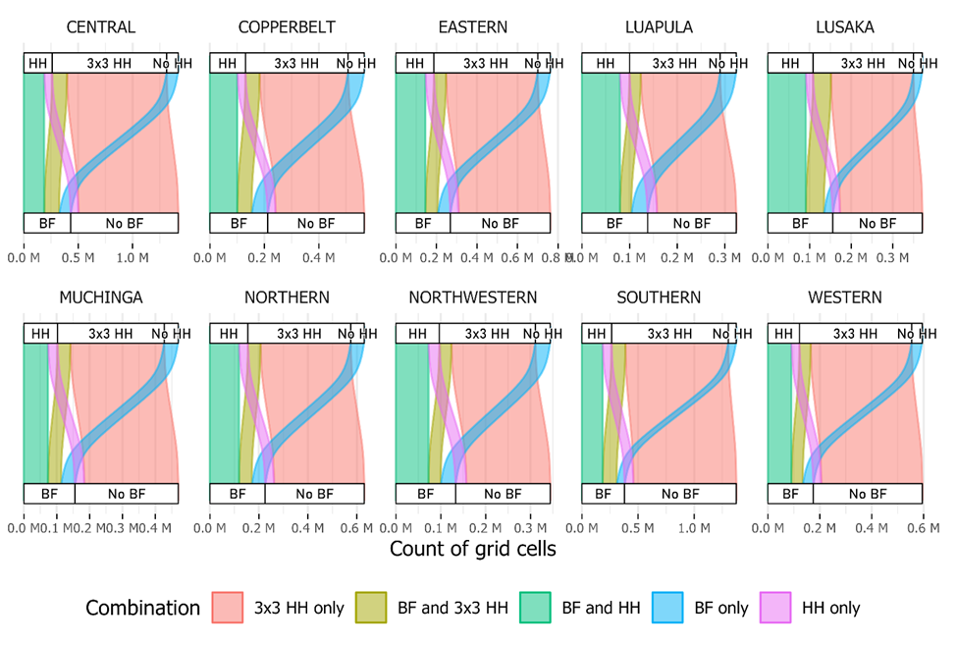

Fig. S5. For each province, the count of grid cells with building footprints (BFs), and thus modelled population estimates (lower axis), and the count of grid cells with residential census households (HHs; upper axis). The spatial agreement between these classifications are shown by the flows between the upper and lower axes. The conservative subset of grid cells is represented by the green flow, the expanded subset is represented by the combination of the green and yellow flows. The purple flow represents grid cells with residential census households but with no building footprints and therefore no modelled population estimates. The blue flow represents grid cells with building footprints but no residential census households.

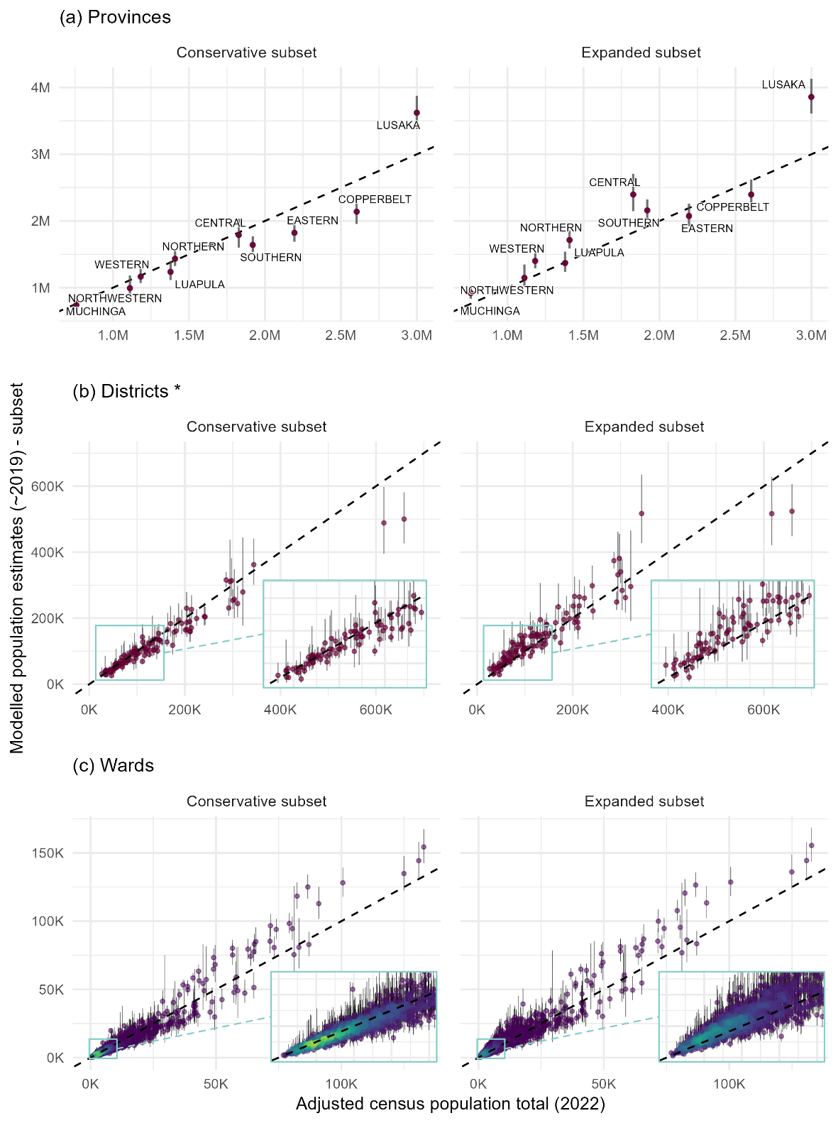
Fig. S6. Modelled population estimates with 95% credible intervals (CIs) for expanded and conservative subsets, plotted against adjusted census counts for each (a) province (n=10), (b) district (n=116) and (c) ward (n=1,858) nationally. The district of Lusaka is omitted from the district plots in (b) due to being the only district with population exceeding 1 million (see Figure 2 of main text). The diagonal dashed line (y=x) on each plot shows a one-to-one relationship between the modelled estimates and adjusted census totals. The points on the ward plot are coloured based on the density of points, with brighter colours (yellow/green) showing the greatest density of points. See Fig. S7 for ward plots stratified by province.

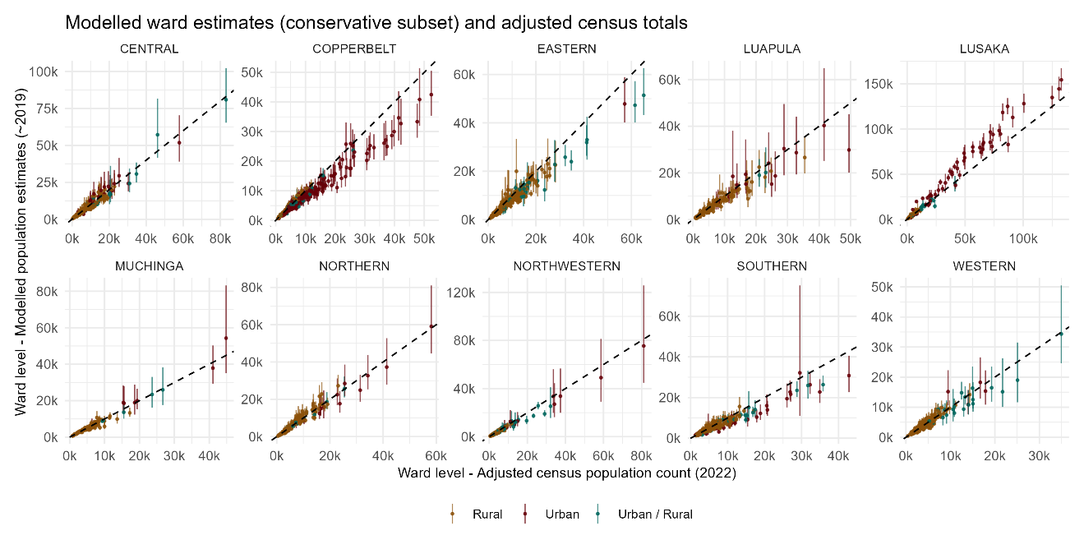

Fig. S7. Modelled population estimates (conservative subset) with 95% credible intervals (CIs) plotted against adjusted census counts for each ward, stratified by province. The diagonal black line (y=x) shows a one-to-one relationship between the modelled and census-enumerated counts. The axis limits vary between plots to accommodate the wide range of values in ward population. The rural/urban designation of each ward, as used in the census, is also shown.

Tables

Table S1. Model evaluation statistics, comparing modelled estimates against census enumeration at ward-level, with stratification by province.

Metric | Ward population
Metric | Central | Copper-belt | Eastern | Luapula | Lusaka | Muchinga | Northern | North-western | Southern | Western
n wards | 180 | 253 | 206 | 169 | 118 | 104 | 180 | 167 | 254 | 227
All grid cells
R (Pearson) | 0.925 | 0.919 | 0.961 | 0.935 | 0.986 | 0.968 | 0.935 | 0.981 | 0.918 | 0.919
RMSE | 5,383.4 | 3,753.8 | 2,986.1 | 2,865.4 | 11,548.5 | 2,492.1 | 3,774.1 | 1,932.6 | 2,582.5 | 2,101.1
MAE | 3,508.0 | 2,676.4 | 1,943.8 | 1,626.2 | 7,633.1 | 1,874.6 | 2,443.4 | 1,185.6 | 1,796.3 | 1,485.2
MAPE [%] | 34.4 | 28.3 | 17.4 | 20.6 | 37.5 | 26.6 | 28.7 | 18.2 | 21.1 | 26.2
MedAE | 2,028.3 | 1,743.7 | 1,259.0 | 1,003.1 | 4,271.0 | 1,376.2 | 1,282.0 | 689.7 | 1,111.7 | 1,084.5
Bias | 3,122.2 | -434.4 | -868.7 | 49.0 | 7,293.4 | 1,660.3 | 1,951.5 | 192.8 | 180.1 | 968.2
Imprecision | 4,397.7 | 3,735.9 | 2,863.9 | 2,873.5 | 8,992.1 | 1,867.5 | 3,239.4 | 1,928.8 | 2,581.3 | 1,868.9
Expanded subset of grid cells
R (Pearson) | 0.954 | 0.966 | 0.965 | 0.944 | 0.987 | 0.973 | 0.968 | 0.987 | 0.944 | 0.947
RMSE | 3,270.2 | 3,221.7 | 3,422.3 | 2,890.6 | 11,212.7 | 1,696.1 | 2,087.6 | 1,926.0 | 2,436.8 | 1,435.6
MAE | 2,184.3 | 2,073.9 | 2,348.3 | 1,584.1 | 6,899.7 | 1,118.5 | 1,391.9 | 1,094.7 | 1,681.6 | 1,008.3
MAPE [%] | 18.6 | 17.6 | 20.0 | 16.8 | 27.9 | 13.2 | 16.0 | 15.4 | 17.6 | 17.8
MedAE | 1,314.7 | 1,206.3 | 1,614.6 | 903.7 | 2,359.2 | 648.3 | 899.5 | 622.3 | 1,055.4 | 670.3
Bias | 749.2 | -1,473.3 | -1,883.3 | -897.2 | 6,487.4 | -34.3 | 501.5 | -783.8 | -904.0 | 111.1
Imprecision | 3,192.1 | 2,870.7 | 2,864.5 | 2,756.0 | 9,184.3 | 1,703.9 | 2,032.1 | 1,764.6 | 2,267.3 | 1,434.5
Conservative subset of grid cells
R (Pearson) | 0.941 | 0.982 | 0.956 | 0.948 | 0.987 | 0.966 | 0.976 | 0.986 | 0.944 | 0.949
RMSE | 4,295.6 | 3,569.1 | 4,525.0 | 3,228.5 | 10,148.7 | 2,531.6 | 1,998.2 | 2,615.6 | 3,858.9 | 1,738.5
MAE | 3,087.3 | 2,529.7 | 3,264.7 | 1,879.5 | 6,253.3 | 2,027.0 | 1,446.9 | 1,740.9 | 3,019.2 | 1,153.1
MAPE [%] | 25.8 | 22.8 | 27.9 | 20.3 | 24.8 | 26.2 | 17.9 | 25.1 | 31.0 | 18.5
MedAE | 2,126.9 | 1,748.5 | 2,413.2 | 1,026.5 | 2,341.0 | 1,689.8 | 1,083.0 | 1,216.9 | 2,354.9 | 741.1
Bias | -2,621.4 | -2,486.6 | -3,107.1 | -1,675.2 | 4,480.4 | -1,738.5 | -1,056.8 | -1,708.5 | -2,941.8 | -928.3
Imprecision | 3,412.5 | 2,565.5 | 3,297.6 | 2,768.1 | 9,145.0 | 1,849.3 | 1,700.6 | 1,986.4 | 2,502.2 | 1,473.2

Table S2. The percentage of districts for which the census enumerated population counts are within the 95% CIs of the modelled population estimates, calculated from (i) all grid cells, (ii) the expanded subset, and (iii) the conservative subset. For those districts in which the lower 95% CI exceeds the census count, and the upper 95% CI is less than the census count also shown. Values are shown for all spatial units nationally, as well as with stratification by province.

 |  | All grid cells |  |  | Expanded subset |  |  | Conservative subset
 |  | within 95% CIs | L95% CI > census | U95% CI < census | within 95% CIs | L95%  CI > census | U95% CI < census | within 95% CIs | L95%  CI > census | U95% CI < census
National (n=116) |  | 63.8 | 29.3 | 6.9 | 75.0 | 5.2 | 19.8 | 44.0 | 0.9 | 55.2
Province | Central (n=11) | 72.7 | 27.3 | 0.0 | 90.9 | 9.1 | 0.0 | 72.7 | 0.0 | 27.3
Province | Copperbelt (n=10) | 50.0 | 30.0 | 20.0 | 60.0 | 0.0 | 40.0 | 10.0 | 0.0 | 90.0
Province | Eastern (n=15) | 66.7 | 6.7 | 26.7 | 60.0 | 0.0 | 40.0 | 33.3 | 0.0 | 66.7
Province | Luapula (n=12) | 75.0 | 16.7 | 8.3 | 83.3 | 0.0 | 16.7 | 66.7 | 0.0 | 33.3
Province | Lusaka (n=6) | 33.3 | 66.7 | 0.0 | 66.7 | 33.3 | 0.0 | 83.3 | 16.7 | 0.0
Province | Muchinga (n=8) | 50.0 | 50.0 | 0.0 | 87.5 | 0.0 | 12.5 | 25.0 | 0.0 | 75.0
Province | Northern (n=12) | 58.3 | 41.7 | 0.0 | 91.7 | 8.3 | 0.0 | 50.0 | 0.0 | 50.0
Province | Northwestern (n=11) | 81.8 | 18.2 | 0.0 | 63.6 | 0.0 | 36.4 | 45.5 | 0.0 | 54.5
Province | Southern (n=15) | 80.0 | 13.3 | 6.7 | 60.0 | 0.0 | 40.0 | 13.3 | 0.0 | 86.7
Province | Western (n=16) | 50.0 | 50.0 | 0.0 | 87.5 | 12.5 | 0.0 | 62.5 | 0.0 | 37.5

Table S3. The percentage of wards for which the census enumerated population counts are within the 95% CIs of the modelled population estimates, calculated from (i) all grid cells, (ii) the expanded subset, and (iii) the conservative subset. For those wards in which the census enumerated counts are outside the 95% CIs, the percentage of wards in which the lower 95% CI exceeds the census count, and the upper 95% CI is less than the census count also shown. Values are shown for all spatial units nationally, as well as with stratification by province.

 |  | All grid cells |  |  | Expanded subset |  |  | Conservative subset
 |  | within 95% CIs | L95%  CI > census | U95% CI < census | within 95% CIs | L95%  CI > census | U95% CI < census | within 95% CIs | L95%  CI > census | U95% CI < census
National (n=1,858) |  | 53.9 | 35.4 | 10.7 | 65.8 | 12.5 | 21.7 | 44.4 | 2.5 | 53.1
Province | Central (n=180) | 60.0 | 39.4 | 0.6 | 80.6 | 11.1 | 8.3 | 58.9 | 1.1 | 40.0
Province | Copperbelt (n=253) | 44.3 | 28.1 | 27.7 | 58.1 | 7.5 | 34.4 | 35.6 | 0.0 | 64.4
Province | Eastern (n=206) | 68.9 | 10.2 | 20.9 | 63.1 | 2.4 | 34.5 | 42.7 | 0.0 | 57.3
Province | Luapula (n=169) | 65.1 | 27.2 | 7.7 | 71.6 | 7.1 | 21.3 | 62.7 | 0.6 | 36.7
Province | Lusaka (n=118) | 33.1 | 63.6 | 3.4 | 51.7 | 43.2 | 5.1 | 54.2 | 28.8 | 16.9
Province | Muchinga (n=104) | 43.3 | 54.8 | 1.9 | 74.0 | 11.5 | 14.4 | 26.0 | 0.0 | 74.0
Province | Northern (n=180) | 47.2 | 45.0 | 7.8 | 70.0 | 17.8 | 12.2 | 57.2 | 0.0 | 42.8
Province | Northwestern (n=167) | 67.1 | 26.3 | 6.6 | 62.3 | 5.4 | 32.3 | 33.5 | 0.0 | 66.5
Province | Southern (n=254) | 59.4 | 28.0 | 12.6 | 66.5 | 7.5 | 26.0 | 24.4 | 0.0 | 75.6
Province | Western (n=227) | 43.2 | 52.9 | 4.0 | 63.0 | 23.3 | 13.7 | 54.2 | 4.0 | 41.9

Table S4. Model evaluation statistics, comparing the mean value of the modelled estimates from the expanded and conservative grid cell subsets, against adjusted census totals for districts and wards.
Statistic | District-level |  | Ward-level
Statistic | Expanded subset | Conservative subset | Expanded subset | Conservative subset
R (Pearson) | 0.984 | 0.985 | 0.960 | 0.967
RMSE | 67,257.0 | 58,013.7 | 4,039.5 | 3,439.7
MAE | 30,287.4 | 22,105.5 | 2,284.8 | 1,678.6
MAPE [%] | 21.4 | 12.3 | 28.7 | 16.2
MedAE | 19,360.1 | 8,803.4 | 1,327.1 | 722.8
Bias | 17,679.2 | -6,882.9 | 1,103.8 | -429.7
Imprecision | 65,173.3 | 57,853.9 | 3,886.8 | 3,413.7

Table S5. Model evaluation statistics, comparing the mean value of the modelled estimates based on the conservative and expanded subsets, against adjusted census population totals at ward-level, with stratification by province.

Metric | Ward population
Metric | Central | Copper-belt | Eastern | Luapula | Lusaka | Muchinga | Northern | North-western | Southern | Western
Expanded subset of grid cells
R (Pearson) | 0.946 | 0.949 | 0.971 | 0.950 | 0.987 | 0.973 | 0.953 | 0.987 | 0.907 | 0.926
RMSE | 4687.1 | 3400.9 | 2535.1 | 2451.5 | 11528.4 | 2294.1 | 3006.3 | 1675.8 | 2776.0 | 1893.6
MAE | 3326.8 | 2388.3 | 1560.9 | 1348.8 | 7600.8 | 1778.1 | 2072.9 | 1047.2 | 2131.5 | 1416.0
MAPE [%] | 43.2 | 27.7 | 16.3 | 18.6 | 41.3 | 33.4 | 29.2 | 19.6 | 32.6 | 29.9
MedAE | 2513.8 | 1650.0 | 872.8 | 773.5 | 3851.5 | 1512.8 | 1291.0 | 662.1 | 1645.6 | 1081.7
Bias | 3160.7 | -821.6 | -578.8 | -63.9 | 7290.7 | 1538.0 | 1698.4 | 216.8 | 941.0 | 962.9
Imprecision | 3470.8 | 3306.7 | 2474.2 | 2458.0 | 8968.3 | 1710.4 | 2487.5 | 1666.7 | 2616.8 | 1634.1
Conservative subset of grid cells
R (Pearson) | 0.973 | 0.980 | 0.973 | 0.958 | 0.988 | 0.979 | 0.977 | 0.990 | 0.961 | 0.958
RMSE | 2209.7 | 3249.8 | 3201.8 | 2500.4 | 10232.8 | 1497.3 | 1560.4 | 1794.0 | 2327.6 | 1194.1
MAE | 1503.4 | 2034.6 | 2134.5 | 1293.5 | 6010.0 | 826.6 | 1013.2 | 910.1 | 1482.7 | 744.3
MAPE [%] | 15.3 | 17.1 | 19.7 | 14.5 | 23.1 | 10.7 | 13.4 | 13.6 | 17.9 | 14.9
MedAE | 845.9 | 1088.2 | 1438.0 | 608.7 | 1360.3 | 482.6 | 580.3 | 436.8 | 870.0 | 471.3
Bias | -209.9 | -1834.9 | -1802.7 | -841.9 | 5283.7 | -166.2 | 140.1 | -707.9 | -1096.9 | -76.5
Imprecision | 2205.9 | 2687.5 | 2652.5 | 2361.4 | 8800.5 | 1495.3 | 1558.4 | 1653.4 | 2057.0 | 1194.2

Table S6. The percentage of spatial units (districts and wards) for which the adjusted census population totals are within the 95% CIs of the modelled population estimates, calculated from the expanded and conservative subsets. Values are shown for all spatial units nationally, as well as with stratification by province.

 |  | District-level |  | Ward-level
 |  | Expanded subset | Conservative subset | Expanded subset | Conservative subset
National |  | 53.4% | 75.0% | 46.6% | 69.5%
Province | Central | 45.5% | 90.9% | 42.8% | 80.0%
Province | Copperbelt | 40.0% | 40.0% | 41.1% | 59.7%
Province | Eastern | 73.3% | 60.0% | 71.8% | 66.5%
Province | Luapula | 75.0% | 83.3% | 71.6% | 78.1%
Province | Lusaka | 16.7% | 66.7% | 28.8% | 60.2%
Province | Muchinga | 50.0% | 100.0% | 31.7% | 85.6%
Province | Northern | 50.0% | 91.7% | 42.8% | 82.8%
Province | Northwestern | 81.8% | 72.7% | 62.3% | 68.3%
Province | Southern | 33.3% | 66.7% | 33.5% | 57.9%
Province | Western | 50.0% | 81.2% | 36.1% | 69.6%

Table S7. The percentage of spatial units (districts and wards) for which the adjusted census population counts are within the 95% CIs of the modelled population estimates, calculated from the conservative subset. For those spatial units in which the adjusted census counts are outside the 95% CIs of the modelled estimates, the percentage of spatial units in which the lower 95% CI exceeds the adjusted census count, and the upper 95% CI is less than the adjusted census count is also shown. Values are shown for all spatial units nationally, as well as with stratification by province.

 |  | Conservative subset - Districts |  |  | Conservative subset - Wards
 |  | within 95% CIs | L95%  CI > census | U95% CI < census | within 95% CIs | L95%  CI > census | U95% CI < census
National |  | 75.0 | 4.3 | 20.7 | 69.5 | 6.8 | 23.7
Province | Central | 90.9 | 0.0 | 9.1 | 80.0 | 5.6 | 14.4
Province | Copperbelt | 40.0 | 0.0 | 60.0 | 59.7 | 2.4 | 37.9
Province | Eastern | 60.0 | 0.0 | 40.0 | 66.5 | 1.0 | 32.5
Province | Luapula | 83.3 | 0.0 | 16.7 | 78.1 | 3.6 | 18.3
Province | Lusaka | 66.7 | 33.3 | 0.0 | 60.2 | 30.5 | 9.3
Province | Muchinga | 100.0 | 0.0 | 0.0 | 85.6 | 1.9 | 12.5
Province | Northern | 91.7 | 8.3 | 0.0 | 82.8 | 5.6 | 11.7
Province | Northwestern | 72.7 | 0.0 | 27.3 | 68.3 | 2.4 | 29.3
Province | Southern | 66.7 | 0.0 | 33.3 | 57.9 | 4.3 | 37.8
Province | Western | 81.3 | 12.5 | 6.3 | 69.6 | 17.2 | 13.2

Table S8. Summary statistics for each province, and nationally, concerning the count of grid cells with (i) modelled population estimates, (ii) census households, and (iii) census households but no modelled population estimates, alongside the (iv) census population totals, (v) the estimated proportion of the census population resident in grid cells without modelled population estimates, and (vi) the resulting adjusted census population estimates.

 |  | Count of grid cells, with: |  |  | Census population
 |  | Modelled pop. estimates | Census HHs | Census HHs, no modelled estimates | Census population total | Proportion in grid cells with only HHs | Adjusted census population
National |  | 2,273,498 | 1,525,866 | 380,754 | 19,693,423 | 0.12 | 17,382,074
Province | Central | 430,585 | 259,959 | 72,709 | 2,261,336 | 0.19 | 1,827,265
Province | Copperbelt | 212,130 | 130,533 | 29,627 | 2,768,192 | 0.06 | 2,603,311
Province | Eastern | 268,300 | 187,684 | 41,711 | 2,462,682 | 0.11 | 2,193,971
Province | Luapula | 137,669 | 99,822 | 20,031 | 1,519,478 | 0.09 | 1,378,652
Province | Lusaka | 155,884 | 108,296 | 17,315 | 3,093,617 | 0.03 | 2,998,825
Province | Muchinga | 155,608 | 102,214 | 28,670 | 922,213 | 0.18 | 758,693
Province | Northern | 225,864 | 155,211 | 36,155 | 1,623,853 | 0.13 | 1,408,399
Province | Northwestern | 132,942 | 96,792 | 24,252 | 1,278,357 | 0.13 | 1,111,249
Province | Southern | 379,634 | 264,035 | 79,370 | 2,388,091 | 0.20 | 1,919,471
Province | Western | 174,882 | 121,320 | 30,914 | 1,375,604 | 0.14 | 1,182,237

