Knowledge discovery and dengue forecasting applied in a four-year dataset collected at Natal/RN – Brazil.
Ignacio Sanchez-Gendriz^{1,3*}, Gustavo Fontoura de Souza², Ion de Andrade¹, Adrião Duarte Doria Neto³, Alessandre de Medeiros Tavares⁴, Daniele Barros¹, Antonio Higor Freire de Morais², Leonardo J. Galvão-Lima¹, Ricardo Alexsandro de Medeiros Valentim¹
¹Laboratory for Technological Innovation in Health (LAIS), Hospital Universitário Onofre Lopes, Federal University of Rio Grande do Norte (UFRN), Natal/RN, Brazil; ²Advanced Nucleus of Technological Innovation (NAVI), Federal Institute of Rio Grande do Norte (IFRN), Natal/RN, Brazil, ³Department of Computer and Automation, UFRN, Natal/RN, Brazil; ⁴Municipal Health Department, Zoonoses Control Center, Natal/RN, Brazil.

* Correspondence Author: ignaciogendriz@gmail.com

Abstract
Dengue, a disease recognized as a health problem, causes significant impacts on health and affects millions of people each year worldwide. A suitable method for dengue vector surveillance is to count eggs the mosquitoes Aedes aegypti have laid in spatially distributed ovitraps. In view of this approach, this study uses a database collected in 397 ovitraps distributed across the municipality of Natal, RN – Brazil. The number of eggs in each ovitrap was counted weekly, over four years (2016 - 2019), and simultaneously analyzed with the incidence of dengue. Our results confirm that dengue incidence seems to be related to socioeconomic status in Natal. Using a deep learning model, we then predict the incidence of new dengue cases based on data obtained from the previous week of dengue or the number of eggs present in the ovitraps. The analysis shows that ovitrap data allows earlier detection (four to six weeks) when compared to dengue cases themselves (one week). Furthermore, the results confirm that quantifying Aedes aegypti eggs may be valuable for planning actions and public health interventions.

Keywords: Ovitraps, Dengue, Deep Learning, LSTM

Supplementary figures.
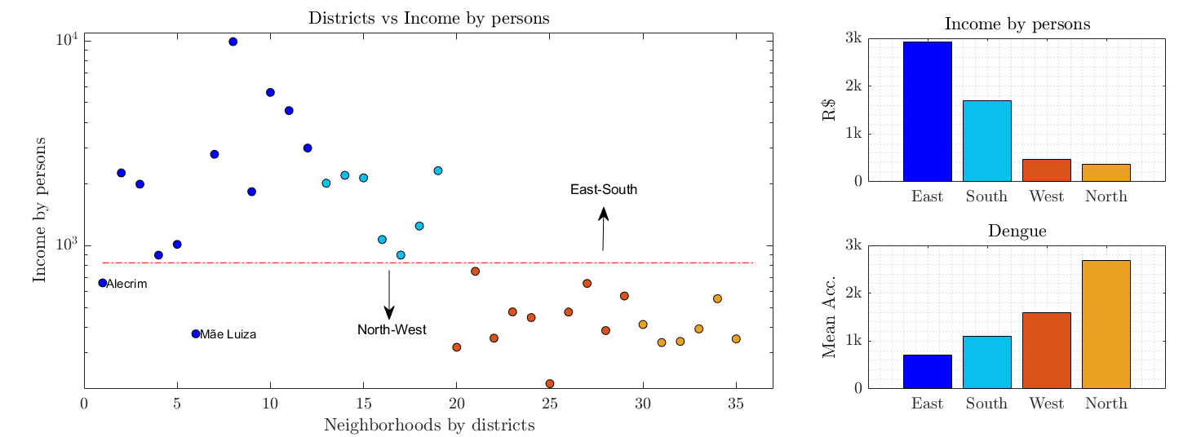
Supplementary Figure 1. Differentiating districts of Natal’s city by income and mean accumulated dengue incidence. A) A scatterplot illustrating that Natal neighborhoods can be almost perfectly separated into two groups: Group 1 neighbourhoods, East and South districts and Group 2 neighbourhoods, North and West districts. The exceptions are the low-income neighborhoods ‘Mãe Luiza’ and ‘Alecrim’ that regionally belong to the East-South group, but have socioeconomic profiles compatible with the North-West group. B) Bar graphs for Income per capita and Dengue Incidence for the districts of Natal. It is worth noting that districts with the lowest income have the highest Dengue Incidence.
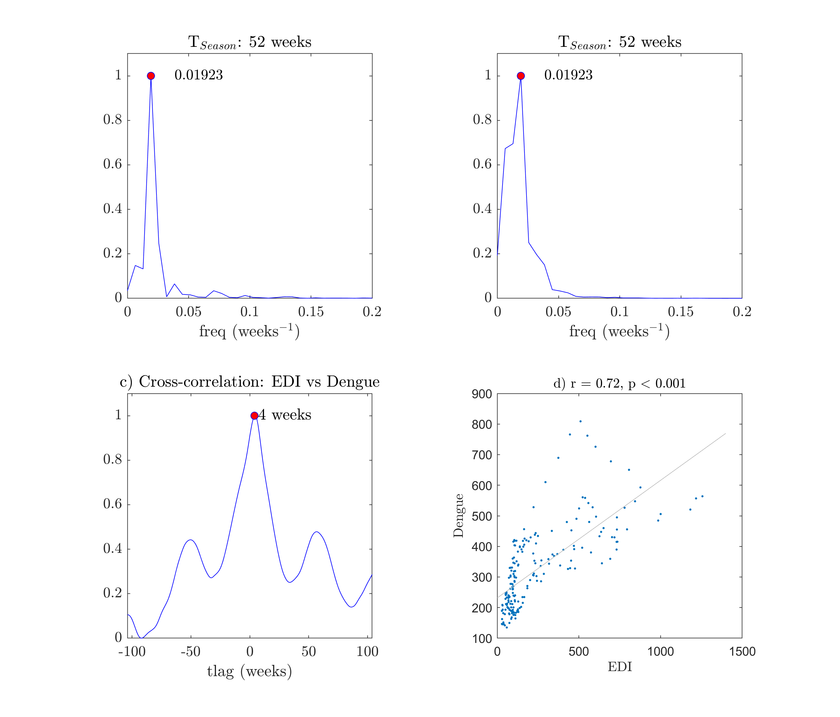
Supplementary Figure 2. Estimating periodicities for Dengue incidence and EDI time series and time lag between them; a) DFT for mean EDI time series, the estimated periodicity was 52 weeks. b) DFT for mean Dengue Incidence time series, the estimated periodicity was 52 weeks. c) time lag estimated by cross-correlation between mean EDI and mean Dengue Incidence was 4 weeks. d) Pearson correlation coefficient (r) and its p-value computed for the linear relation between mean EDI and Mean Dengue Incidence. Note: the period for seasonality (T_{season}) was estimated as 1/f_{peak}, see panels a) and b).
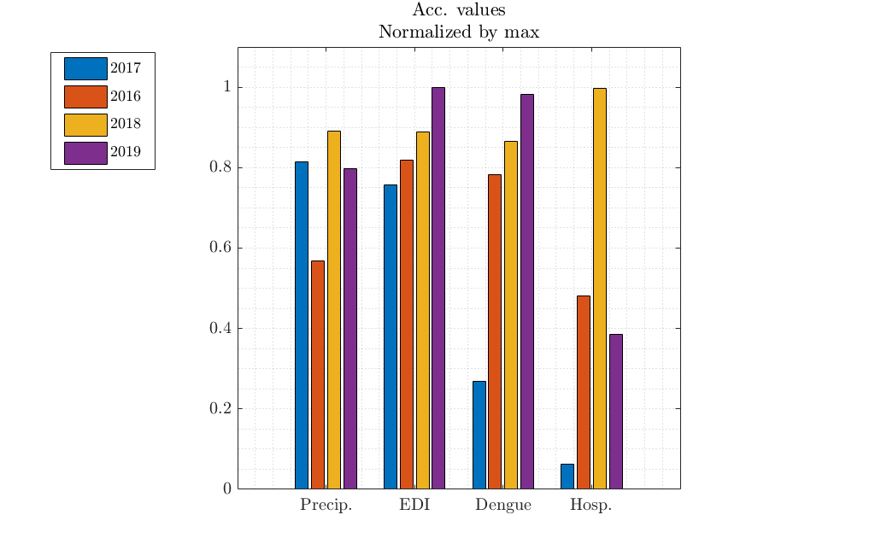
Supplementary Figure 3. Bar graph of the normalized accumulated values by years from 2016 to 2019 at Natal’s city. The variable illustrated are Precipitation (Precip.), Egg Density Index (EDI), Dengue Incidence (Dengue) and Dengue Hospitalizations (Hosp.).
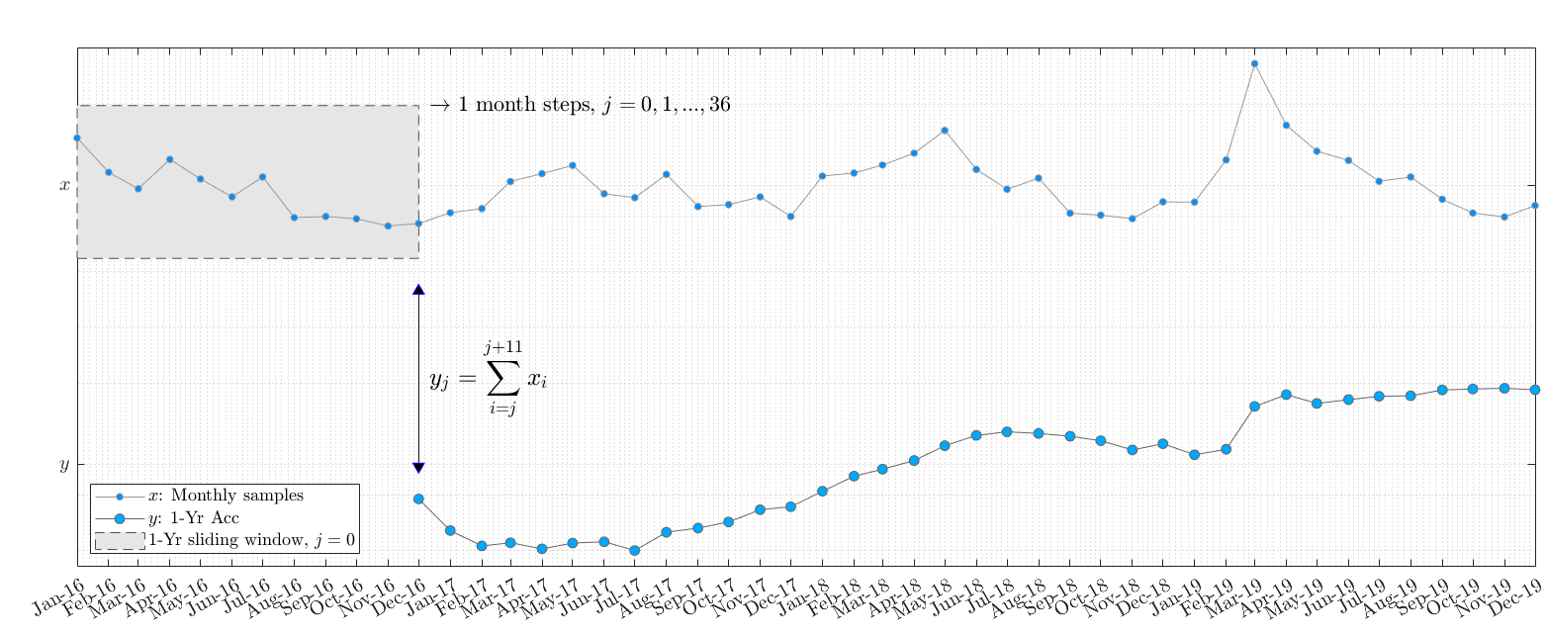
Supplementary Figure 4. Representation of the procedure used to calculate accumulated values for 1-year sliding windows. The time series represented by $x$ is used to calculates accumulated values obtained from the sum of the samples within 1-year windows. These windows slides with a one-month step, from December 2016 to December 2019. The figure represents the first sliding window, which includes the samples of x between January 2016 and December 2016. A double arrow indicates both the last sample of the 1-year window, as well as the accumulated value for that window.
$$y\left(j\right)= \sum_{i=j}^{j+11}{x(i)}, j=0, 1, …36$$

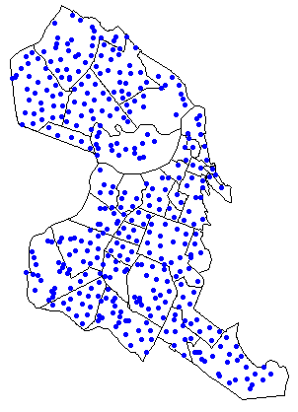
Supplementary Figure 5. Ovitrap distribution at Natal city

