Description of supplementary information

Supplementary Data Files S1 - Sequence processing and quality assessment of each sequenced sample.

Supplementary Data Files S2 - BSA -QTL candidate gene set with at least one significant SNP within 5 significant QTL regions identified by QTL seqr

Supplementary Data Files S3 - GO enrichment analysis with significantly enriched biological processes (BP) and molecular functions (MF) GO terms

Supplementary Data Files S4 - Expression of BSA-QTL candidate genes in root tip, root, and leaf tissues

Supplementary Methods

Supplementary Methods 1: Forward simulations of allele‐frequency difference under different genetic architectures

To quantify the expected allele‐frequency difference between high‐ and low‐fitness F2 bulks under alternative genetic architectures of serpentine adaptation, we performed forward simulations matching the structure of the Arabidopsis arenosa bulk segregant analysis (BSA) experiment. We aimed to determine how the number of adaptive loci (L) influences the magnitude and variance of allele‐frequency differences (ΔAF) between fitness extremes.

Genetic architecture and parental allele frequencies
We simulated L independent biallelic loci contributing additively to fitness in serpentine soil. We considered three scenarios reflecting contrasting expectations about the complexity of adaptation: (i) 6 loci — major-effect architecture, (ii) 100 loci — intermediate, moderately polygenic, (iii) 494 loci — highly polygenic, matching the number of candidate genes detected in serpentine populations (Konečná et al., 2021). At each locus i, the beneficial allele (B) increased fitness in serpentine soil, whereas the alternative allele (A) conferred no benefit. In the serpentine (S) parental population, the initial frequency of B ranged from 0.05 to 0.95 (step 0.05). The non-serpentine (N) population was assumed to have limited standing variation for B, with a fixed allele frequency of 0.1 across all loci.

Tetraploidy, outcrossing, and genotype frequencies
To match simulations with our system, we simulated fully outcrossing autotetraploid populations. Genotype frequencies were drawn from a random mating equilibrium, using multinomial expectations for polysomic inheritance (Table S2).

Mapping phenotypic differences to allelic effects
In the empirical F2 dataset, the 62 individuals of high-fitness bulk had an average rosette area of 479 mm², whereas 62 individuals of low-fitness bulk had an average rosette area of 9 mm². Assuming this difference in phenotype is generated by the extreme genotype classes among the L adaptive loci, the total contribution of these loci is 470 mm².
We assumed pure additivity and tetraploid dosage, such that a single copy of the beneficial allele contributes: α=470/(Lx4). The resulting per-allele effect sizes are shown in Table S3.

Simulating crosses and fitness bulks
For each combination of genetic architecture (L) and initial beneficial-allele frequency in the serpentine parent, we simulated a full crossing design mirroring the structure of the empirical A. arenosa experiment. We first generated two parental populations—serpentine (S) and non-serpentine (N)—each represented by nine randomly sampled maternal genotypes. These individuals served as founders for the F₁ generation, which consisted of 30 hybrids produced by randomly pairing one S and one N parent. The resulting F1 plants were then used to generate an F2 mapping population following the same structure as the experimental design: 30 F₂ families, each initially containing 45 individuals (1350 in total). To match the empirical sampling, we randomly retained 837 of these F2 individuals for further analysis.
Each F2 genotype was assigned a fitness value calculated as the additive sum of beneficial-allele dosages across all simulated loci. Individuals were subsequently ranked by fitness, and two phenotypic extremes were used to form the bulks: a high-fitness bulk consisting of the 62 individuals with the highest fitness values, and a low-fitness bulk consisting of the 62 individuals with the lowest fitness values. To explore how parental allele frequencies influence the expected allele-frequency divergence between bulks, we varied the frequency of the beneficial allele (B) in the serpentine parental population from 0.05 to 0.95 in increments of 0.05. For each allele-frequency value and each genetic architecture, we performed 100 independent simulation replicates and used these to estimate mean allele-frequency differences and their 95% confidence intervals (Fig. S4).
Supplementary Tables and Figures

Table S1: Summary of the rosette diameter sizes and rosette areas of F1 and F2 populations (including low-fitness and high-fitness bulk) after three months of cultivation.

Population | Treatment | N of individuals | Rosette diameter [cm] | Rosette area [cm²]
F1 | garden soil | 89 | (4.5) 11.20±3.43 (25) | -
F2 | garden soil | 89 | (1.63) 6.78±2.70 (13.5) | -
F2 | S1 soil | 730 | (0.2) 1.49±0.90 (6.34) | (0.03) 1.21±0.03 (10.37)
F2 low-fitness bulk | S1 soil | 62 | - | (0.03) 0.10±0.03 (0.14)
F2 high-fitness bulk | S1 soil | 62 | - | (3.05) 4.79±1.53 (10.37)

Table S2: Genotypic frequencies at a given locus for a tetraploid population under random mating. The frequency of allele A at the locus is p, and the frequency of allele B is q.
Genotype | AAAA | AAAB | AABB | ABBB | BBBB
Frequency | p⁴ | 4 p³q | 6 p²q² | 4 pq³ | q⁴

Table S3: Additive contribution of a single beneficial allele at one locus.
Scenario | Number of Loci | Additive contribution
Major effect loci | 6 | 19.6
Intermediate situation | 100 | 1.175
Infinitesimal model (high number of small effect loci) | 494 | 0.238

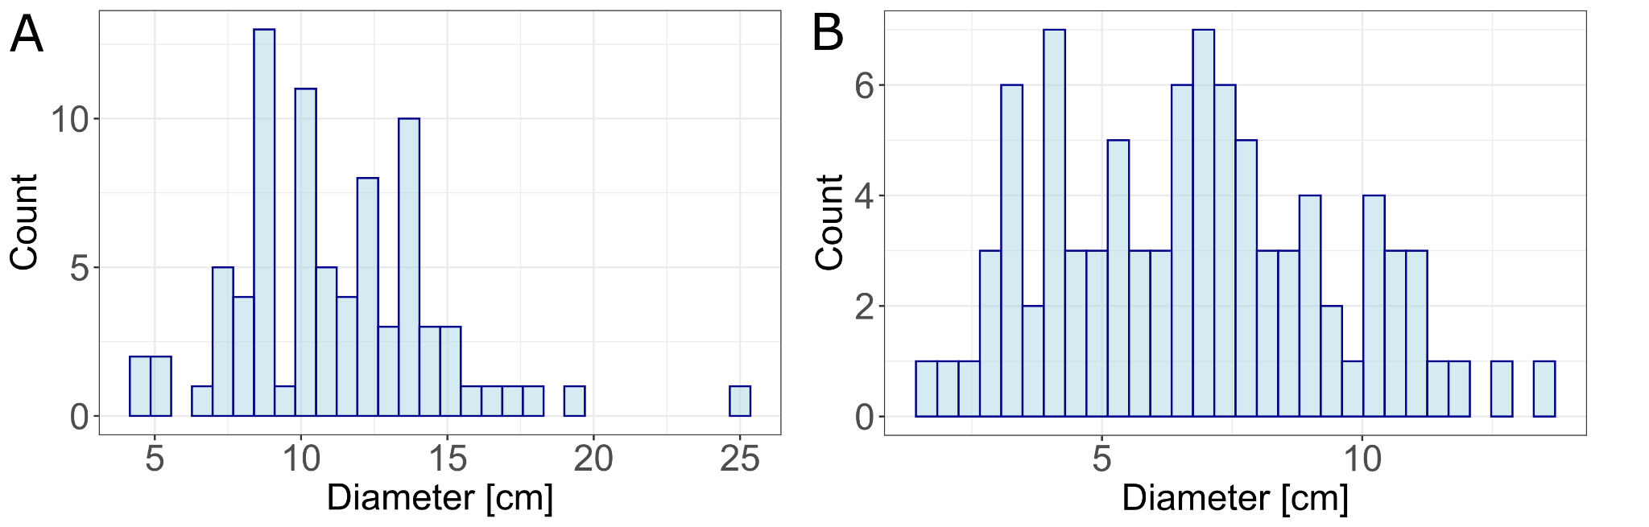
Fig. S1: Variation in rosette diameter of plants cultivated in garden soil. Distribution of rosette diameters of F1 plants (A) and F2 plants (B) measured after three months of cultivation in garden soil.

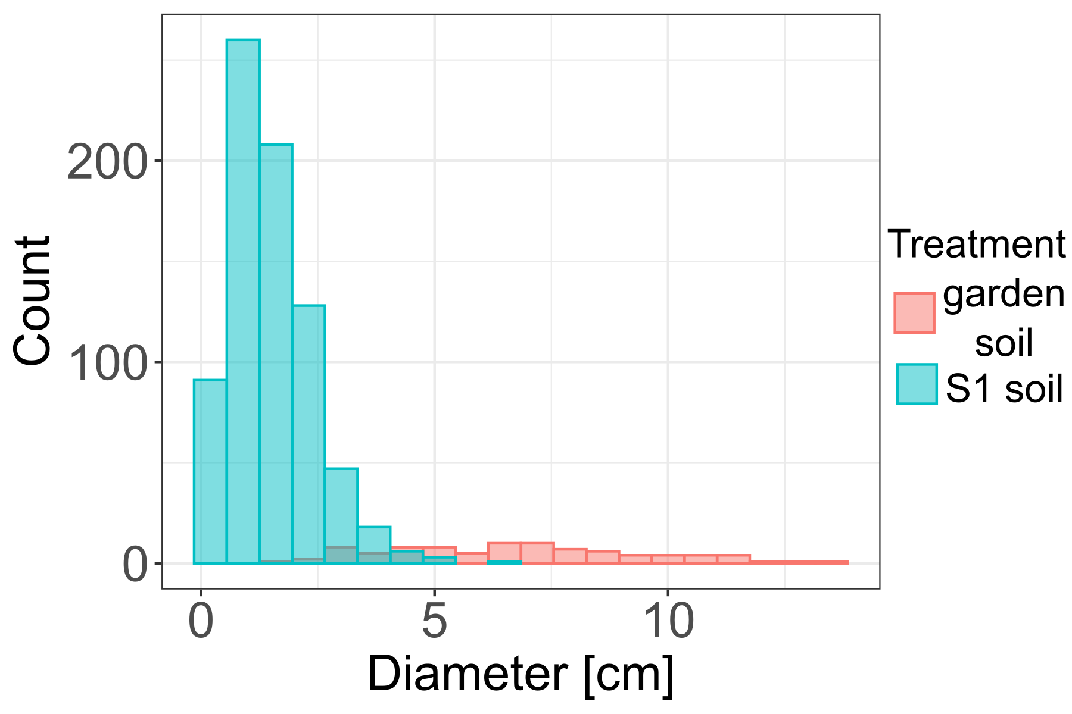
Fig. S2: The effect of soil treatment on rosette diameter of F2 plants. Comparison of rosette diameter of F2 plants grown in garden soil and S soil. Plants cultivated in S1 soil exhibited significantly smaller rosette diameters relative to those grown in garden soil (Kruskal–Wallis test: χ² = 222.61, df = 1, p < 0.001).

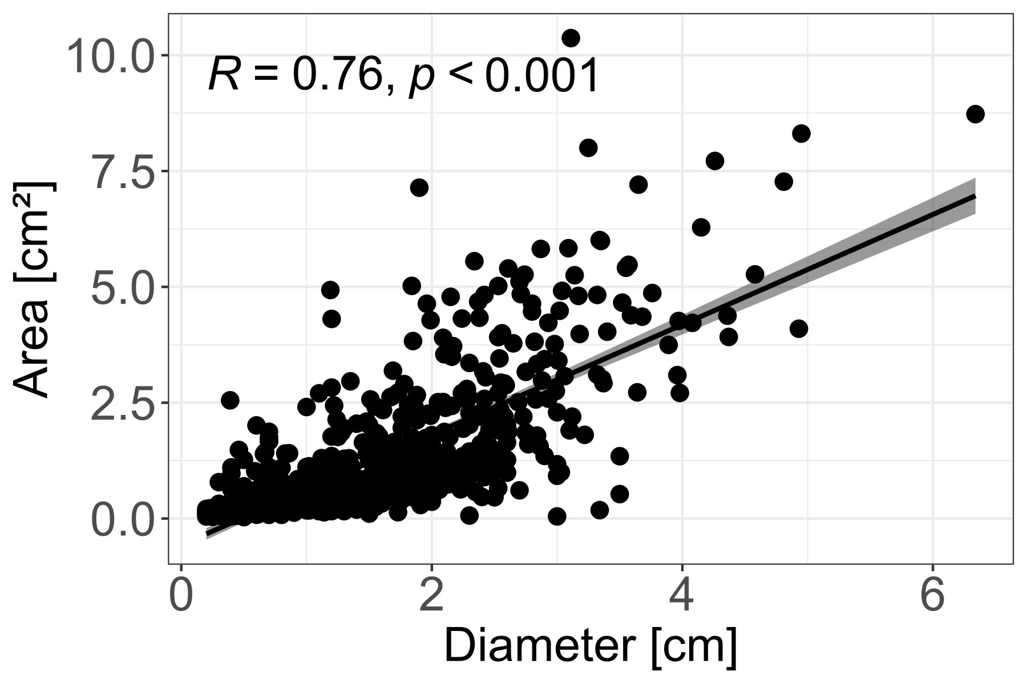

Fig. S3: Relationship between rosette diameter and rosette area. Correlation between rosette diameter and rosette area measured in F2 individuals (Spearman’s correlation: R = 0.76, p < 0.001)

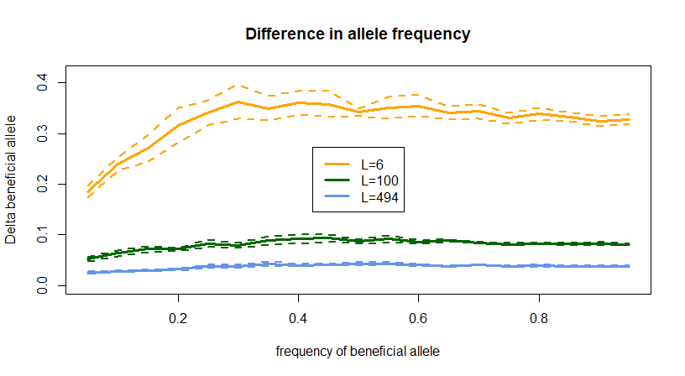
Fig. S4: Difference in allelic frequency of the beneficial allele in the high-fitness and low-fitness bulk of the F2 progenies, as a function of the frequency of the beneficial alleles in the parental S (serpentine) population. Colors represent the number of loci coding for the fitness trait. The solid lines represent the mean values calculated over 100 independent replicates. The dashed lines stand for the 95% confidence intervals.

