Developing the E-MOI: A theory-driven multidimensional inventory for general and specific problematic technology use among adults.

Figure S1
Screen plot for general e-media use items (N = 1,016).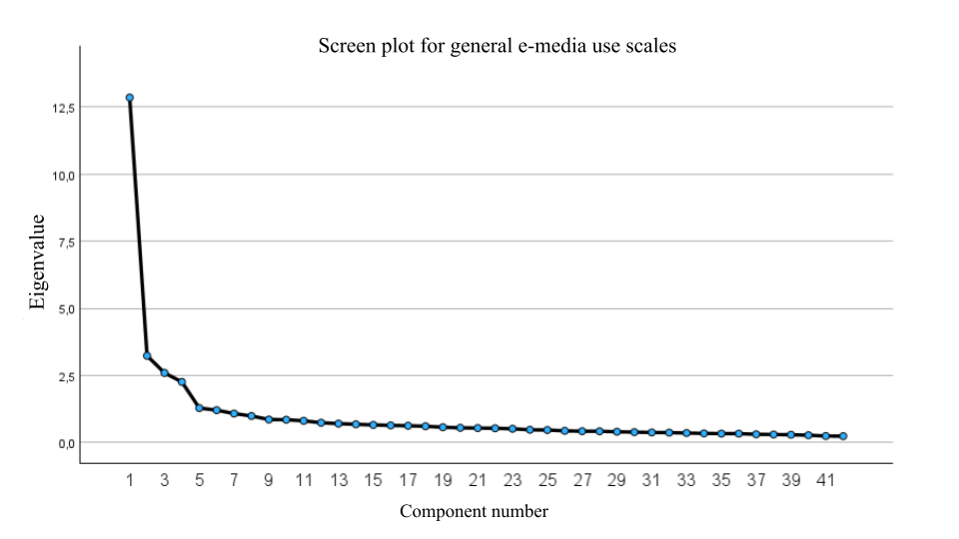

Figure S2
Screen plot for addictive-like items (N = 1,016).
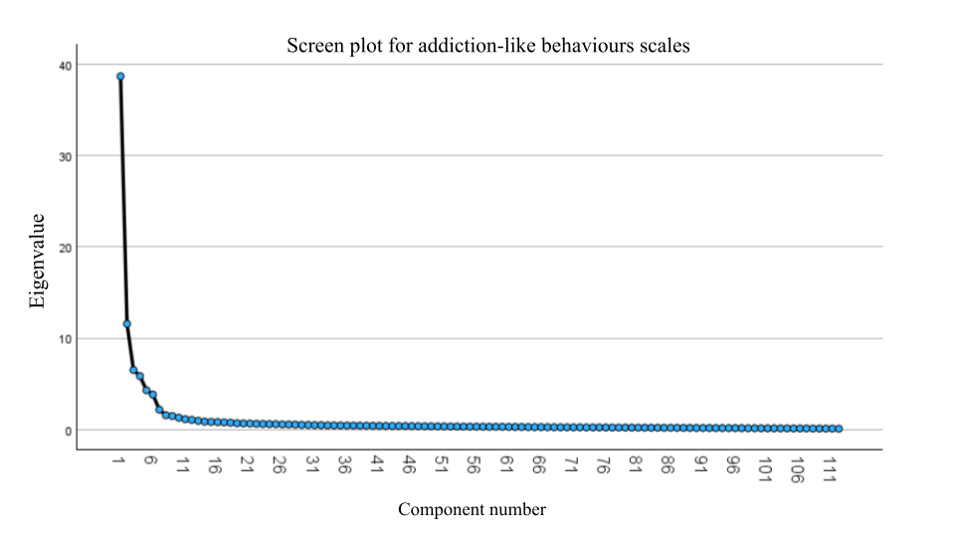
Table S1
Exploratory factor analysis for general e-media use scales; Promax rotation (N = 1,016).
item number | E-media overuse  (Eigenvalue = 12.85;  % of variance = 30.60) | Virtualisation (Eigenvalue = 3.23;  % of variance= 7.69) | Insight into losses (Eigenvalue = 2.59;  % of variance = 6.14) | Protective behaviors  (Eigenvalue = 2.25;  % of variance = 5.37)
48 | 0.786 | -0.179
7 | 0.721
4 | 0.703
9 | 0.702
3 | 0.684
53 | 0.679
1 | 0.671
8 | 0.666
5 | 0.636 |  | 0.182
45 | 0.589 | 0.236
46 | 0.562
47 | 0.229 | 0.219
37 |  | 0.88
38 |  | 0.836 | -0.169
32 |  | 0.832
34 |  | 0.763
31 | -0.178 | 0.754
33 | 0.193 | 0.733 | -0.169
35 | 0.159 | 0.649
30 | -0.231 | 0.603 | 0.367
28 |  | 0.535 | 0.263
10 |  | 0.501 | 0.174
18 | 0.237 | 0.414 | 0.25
25 |  |  | 0.87
22 |  |  | 0.867
24 |  |  | 0.772
20 | 0.176 | -0.197 | 0.738
21 | -0.192 |  | 0.723
23 |  |  | 0.712
26 |  | 0.153 | 0.688
27 | 0.153 |  | 0.677
17 |  |  | 0.67
16 | 0.199 | 0.285 | 0.339
39 |  |  |  | 0.655
41 | 0.17 |  |  | 0.623
40 |  |  |  | 0.622
52 | -0.247 |  |  | 0.556
43 |  |  |  | 0.552
42 | -0.262 | 0.216 |  | 0.539
49 |  |  |  | 0.5
44 | 0.249 | 0.164 |  | 0.498
51 | -0.394 |  |  | 0.487

Table S2
Exploratory factor analysis for addictive-like scales; Promax rotation (N = 1,016).
 | Signs of addiction of:
item number | general e-media + social media  (Eigenvalue = 38.6;  % of variance = 34.55) | cyber dating platforms  (Eigenvalue = 11.57;  % of variance = 10.34) | online pornography  (Eigenvalue = 6.52;  % of variance = 5.82) | online gambling  (Eigenvalue = 5.85;  % of variance = 5.22) | digital gaming  (Eigenvalue = 4.30;  % of variance = 3.83) | online shopping  (Eigenvalue = 3.82;  % of variance = 3.41) | (Eigenvalue = 2.17;  % of variance = 1.93)
86 | 0.889
71 | 0.865 |  |  |  |  |  | 0.265
68 | 0.863
74 | 0.84 |  |  |  |  |  | 0.344
85 | 0.836
87 | 0.833
67 | 0.823
82 | 0.799 |  |  |  |  |  | 0.161
84 | 0.797 |  |  |  |  |  | -0.173
75 | 0.795
69 | 0.788
80 | 0.785
66 | 0.764
63 | 0.748
70 | 0.744 |  |  |  |  |  | 0.186
62 | 0.743 |  |  |  |  |  | 0.407
79 | 0.734
78 | 0.721
73 | 0.686 |  |  |  |  |  | 0.525
72 | 0.658 |  |  |  |  |  | 0.464
83 | 0.646
60 | 0.627
61 | 0.566 |  |  |  |  | 0.162
59 | 0.555 |  |  |  |  |  | 0.317
65 | 0.549
54 | 0.501 |  |  |  |  |  | 0.42
171 |  | 0.942
174 |  | 0.938
169 |  | 0.905
172 |  | 0.902
178 |  | 0.892
175 |  | 0.891
173 |  | 0.889
170 |  | 0.88
179 |  | 0.862
180 |  | 0.841
181 |  | 0.812
182 |  | 0.712
186 |  | 0.682
185 |  | 0.655
183 |  | 0.624
187 |  | 0.614
184 |  | 0.613
132 |  |  | 0.867
142 |  |  | 0.863
135 |  |  | 0.856
133 |  |  | 0.85 |  |  |  | 0.19
138 |  |  | 0.847
134 |  |  | 0.838
139 |  |  | 0.827
130 |  |  | 0.82
131 |  |  | 0.818
147 |  |  | 0.792
137 |  |  | 0.788
146 |  |  | 0.776
144 |  |  | 0.775
129 |  |  | 0.76
145 |  |  | 0.743
140 |  |  | 0.673
143 |  |  | 0.665
162 |  |  |  | 0.966
158 |  |  |  | 0.893
166 |  |  |  | 0.887
152 |  |  |  | 0.884
153 |  |  |  | 0.884 |  |  | 0.157
154 |  |  |  | 0.869
159 |  |  |  | 0.862
155 |  |  |  | 0.86
164 |  |  |  | 0.855
160 |  |  |  | 0.827
150 |  |  |  | 0.819
165 |  |  |  | 0.774
163 |  |  |  | 0.771
151 |  |  | 0.154 | 0.755
149 |  |  |  | 0.678
167 |  | 0.212 |  | 0.563
91 |  |  |  |  | 0.947
94 |  |  |  |  | 0.94
102 |  |  |  |  | 0.896
92 |  |  |  |  | 0.859 |  | 0.261
105 |  |  |  |  | 0.849
95 |  |  |  |  | 0.845
98 |  |  |  |  | 0.835
93 |  |  |  |  | 0.834 |  | 0.271
104 |  |  |  |  | 0.77
100 |  |  |  |  | 0.756
103 |  |  |  |  | 0.728
107 |  |  |  |  | 0.697
99 |  |  |  |  | 0.69
90 |  |  |  |  | 0.655
106 |  |  |  |  | 0.628 | 0.18
89 | 0.309 |  |  |  | 0.599
114 |  |  |  |  |  | 0.879 | 0.254
111 |  |  |  |  |  | 0.868 | 0.197
110 |  |  |  |  |  | 0.816
115 |  |  |  |  |  | 0.808
118 |  |  |  |  |  | 0.803
119 |  |  |  |  |  | 0.798
126 |  |  |  |  |  | 0.78
112 |  |  |  |  |  | 0.775 | 0.358
117 |  |  |  |  |  | 0.773
113 |  |  |  |  |  | 0.712 | 0.43
120 |  |  |  |  |  | 0.71
127 |  |  |  |  |  | 0.694
124 |  |  |  |  |  | 0.684
123 |  |  |  |  |  | 0.681
109 | 0.154 |  |  |  |  | 0.641
125 | 0.183 |  |  |  |  | 0.609
122 |  |  |  |  |  | 0.523 | 0.152
121 |  |  |  |  |  | 0.432 | -0.211
56 | 0.548 |  |  |  |  |  | 0.562
55 | 0.509 |  |  |  |  |  | 0.534

Table S3
Confirmator factor analysis for the final version of E-MOI D1 (N = 1,095).
E-MOI items* | β | SE | Z | p
E-medias overuse
Outside of work and study, I use e-media on average for more than 2 hours a day. | 0.624 | 0.025 | 24.832 | <0.001
I feel bad when I don’t have my phone with me. | 0.705 | 0.024 | 29.700 | <0.001
Without access to the internet, I would feel cut off from the world. | 0.679 | 0.023 | 29.958 | <0.001
I use electronic devices until the moment I have to go to sleep. | 0.770 | 0.019 | 39.649 | <0.001
When I go to the bathroom, I take my phone with me. | 0.545 | 0.029 | 18.567 | <0.001
At night, I keep my phone close to me, e.g., under the pillow, next to the bed, or on the nightstand. | 0.577 | 0.027 | 21.538 | <0.001
The first thing I do after waking up, even before getting out of bed, is checking notifications on my phone. | 0.689 | 0.022 | 31.419 | <0.001
Virtualization
I would prefer to handle all matters online so that direct contact with another person is not necessary. | 0.600 | 0.026 | 23.288 | <0.001
I feel better talking to someone via a messenger than face to face. | 0.653 | 0.024 | 26.921 | <0.001
On the internet, I can create a better image of myself. | 0.719 | 0.022 | 33.34 | <0.001
There are many more interesting things to do on the internet than in the real world. | 0.700 | 0.022 | 32.039 | <0.001
I feel more comfortable online than in the real world. | 0.794 | 0.019 | 41.979 | <0.001
I like escaping into the virtual world from the difficulties of real life. | 0.791 | 0.018 | 43.213 | <0.001
The real world stresses me more than the virtual one. | 0.589 | 0.029 | 20.073 | <0.001
Insight into losses
I would achieve better results at work and/or in my studies if I spent less time using e-media. | 0.733 | 0.019 | 38.156 | <0.001
My involvement with e-media distances me from my family and loved ones. | 0.648 | 0.026 | 25.386 | <0.001
If I spent less time on e-media, I would meet friends and acquaintances more often. | 0.694 | 0.022 | 30.865 | <0.001
If I used e-media less, I would have more time or motivation for activities such as sports, reading books, etc. | 0.699 | 0.022 | 31.115 | <0.001
I feel that using electronic devices affects my behavior, e.g., I lose patience, get angry more often, and am more easily irritated. | 0.717 | 0.021 | 33.553 | <0.001
In the morning, I feel tired or discouraged because I used e-media for a long time in the evening. | 0.711 | 0.023 | 31.33 | <0.001
I feel guilty when I realize how much time I spend online. | 0.734 | 0.020 | 37.654 | <0.001
Positive protective behaviors
I am familiar with the principles of digital hygiene and follow them. | 0.377 | 0.042 | 8.934 | <0.001
I spend more of my free time on offline activities than using screens. | 0.567 | 0.046 | 12.352 | <0.001
I have many hobbies and interests that do not require screens or the internet. | 0.483 | 0.04 | 12.081 | <0.001
I set a specific amount of time for using e-media and stick to it. | 0.441 | 0.043 | 10.205 | <0.001
I love being offline. | 0.576 | 0.042 | 13.718 | <0.001
I limit my use of digital devices to a minimum. | 0.578 | 0.043 | 13.537 | <0.001
I regularly take breaks from using digital devices. | 0.564 | 0.043 | 12.978 | <0.001
Signs of e-media addiction
I spend most of my free time online. | 0.685 | 0.022 | 31.597 | <0.001
The more I try to limit my use of e-media, the stronger my need to use them becomes. | 0.758 | 0.016 | 48.086 | <0.001
I need to spend more and more time online to achieve the same level of satisfaction as before. | 0.686 | 0.023 | 30.338 | <0.001
Using e-media is my main way of coping with boredom. | 0.702 | 0.019 | 36.799 | <0.001
I feel torn between the pleasure of online activity and guilt about neglecting real life. | 0.737 | 0.018 | 41.258 | <0.001
I have tried to limit my online activity, but I failed. | 0.704 | 0.021 | 33.993 | <0.001
I should reduce the time I spend online, but I always find excuses not to do so. | 0.749 | 0.019 | 39.785 | <0.001
Signs of social media addiction
I browse social media even when I should be working or studying. | 0.767 | 0.017 | 44.584 | <0.001
Using social media is my main way of coping with boredom. | 0.732 | 0.02 | 36.728 | <0.001
I spend more and more time on social media. | 0.781 | 0.016 | 47.754 | <0.001
I feel bad when I can’t check what’s happening on social media. | 0.739 | 0.018 | 41.075 | <0.001
I feel torn between the pleasure of social media activity and guilt about neglecting real life. | 0.708 | 0.023 | 30.894 | <0.001
Even if I deleted my social media accounts, I would still come back to them. | 0.641 | 0.024 | 26.277 | <0.001
I should reduce the time I spend on social media, but I always find excuses not to do so. | 0.763 | 0.018 | 41.332 | <0.001
Signs of digital gaming addiction
I spend most of my free time playing digital games. | 0.866 | 0.017 | 51.724 | <0.001
Playing digital games is my main way of coping with boredom. | 0.875 | 0.013 | 64.887 | <0.001
I spend more and more time playing digital games. | 0.843 | 0.016 | 54.362 | <0.001
I feel bad when I can’t play digital games. | 0.848 | 0.015 | 57.158 | <0.001
I feel torn between the pleasure of playing digital games and guilt about neglecting real life. | 0.749 | 0.023 | 33.025 | <0.001
Even if I stopped playing digital games, I would still return to them. | 0.820 | 0.017 | 49.593 | <0.001
I do not control how much time I spend playing digital games. | 0.736 | 0.025 | 29.722 | <0.001
Signs of online shopping addiction
I browse online stores and/or shop online even when I should be working or studying. | 0.711 | 0.023 | 30.472 | <0.001
Shopping online allows me to forget about everyday stress and problems. | 0.727 | 0.021 | 33.948 | <0.001
I spend more and more time and/or money on online shopping. | 0.775 | 0.019 | 41.46 | <0.001
The more I try to limit online shopping, the stronger my urge to do it becomes. | 0.809 | 0.016 | 50.90 | <0.001
I feel torn between the pleasure of online shopping and guilt about spending money. | 0.736 | 0.022 | 33.066 | <0.001
I have tried to restrain myself from online shopping, but I failed. | 0.777 | 0.021 | 36.391 | <0.001
When shopping online, I lose track of time. | 0.751 | 0.023 | 32.719 | <0.001
Signs of online pornography addiction
I spend most of my free time browsing pornographic content online. | 0.763 | 0.026 | 29.653 | <0.001
Watching pornography online improves my mood and relaxes me. | 0.813 | 0.019 | 42.089 | <0.001
I need to watch more and more pornography to achieve the same level of satisfaction as before. | 0.843 | 0.017 | 49.678 | <0.001
The more I try to limit watching online pornography, the stronger my urge to watch it becomes. | 0.799 | 0.025 | 31.725 | <0.001
I feel torn between the pleasure of online pornography and guilt about neglecting my real-life sexual life. | 0.774 | 0.021 | 36.460 | <0.001
Even if I stopped watching pornography online, I would still return to it. | 0.813 | 0.02 | 41.127 | <0.001
When watching pornography online, I lose track of time. | 0.798 | 0.024 | 33.438 | <0.001
Signs of online gambling addiction
Every day I play online gambling games or at least think about them. | 0.818 | 0.020 | 40.669 | <0.001
Playing online gambling games is my main way of coping with boredom. | 0.863 | 0.016 | 54.145 | <0.001
I spend more and more time and/or money on online gambling games. | 0.807 | 0.023 | 34.910 | <0.001
I feel bad when I can’t play online gambling games. | 0.822 | 0.021 | 38.553 | <0.001
I feel torn between the pleasure of online gambling and guilt about neglecting real life. | 0.755 | 0.028 | 27.182 | <0.001
Even if I stopped playing online gambling games, I would still return to them. | 0.799 | 0.022 | 35.692 | <0.001
When playing online gambling games, I lose track of time. | 0.801 | 0.025 | 31.465 | <0.001
Signs of dating platforms addiction
I spend every free moment browsing dating websites or thinking about what’s happening on them. | 0.803 | 0.024 | 33.219 | <0.001
Using dating websites improves my mood and relaxes me. | 0.799 | 0.023 | 34.562 | <0.001
I spend more and more time on dating websites. | 0.760 | 0.034 | 22.269 | <0.001
The more I try to limit my use of dating websites, the stronger my urge to use them becomes. | 0.805 | 0.026 | 31.076 | <0.001
My dating website usage habits lead to conflicts at home, at work, at school, or at university. | 0.770 | 0.027 | 28.167 | <0.001
Even if I deleted my dating website accounts, I would still return to them. | 0.733 | 0.026 | 27.785 | <0.001
I should reduce the time I spend on dating websites, but I always find excuses not to do so. | 0.851 | 0.022 | 38.729 | <0.001
* unstandardised translation from original Polish version

Figure S2
Distribution plots of E-MOI D1 results (N = 2,111).
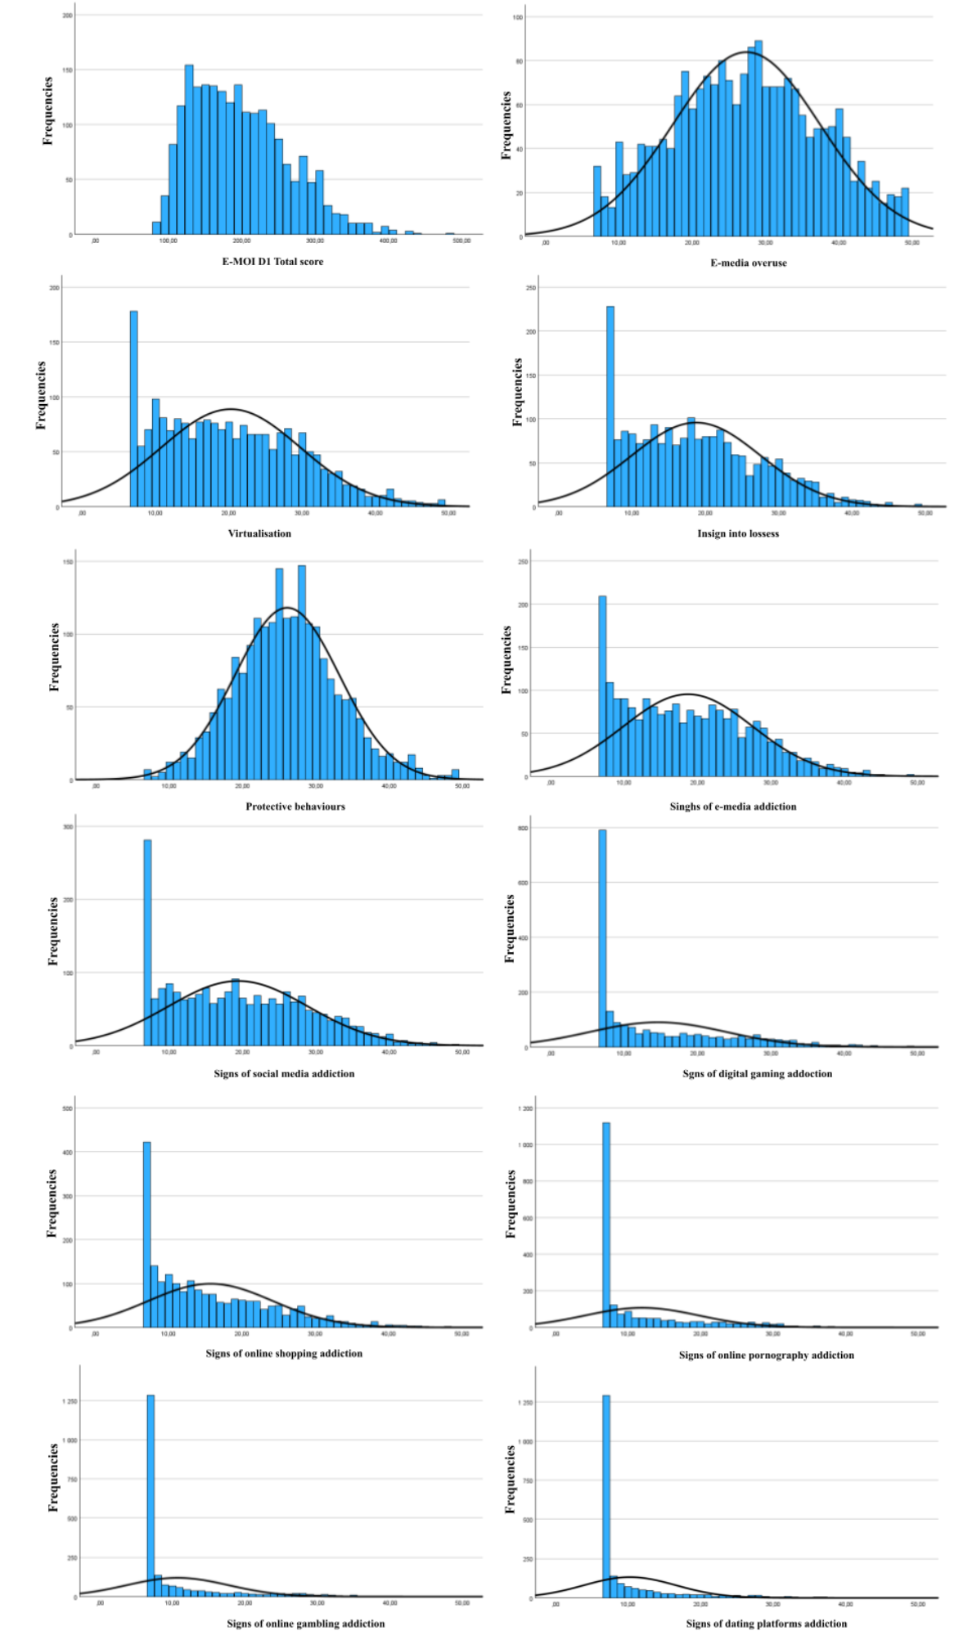
Table S4
Pearson’s correlations between E-MOI D1 total score and subscales (N = 1,095).
EMOI D1 | 1 | 2 | 3 | 4 | 5 | 6 | 7 | 8 | 9 | 10 | 11
E-MOI D1 total score | 0.707*** | 0.816*** | 0.873*** | -0.114*** | 0.910*** | 0.841*** | 0.742*** | 0.760*** | 0.705*** | 0.697*** | 0.680***
1. E-media overuse | - | 0.622*** | 0.592*** | -0.252*** | 0.696*** | 0.722*** | 0.431*** | 0.428*** | 0.336*** | 0.225*** | 0.207***
2. Virtualization |  | - | 0.641*** | -0.128*** | 0.754*** | 0.663*** | 0.559*** | 0.583*** | 0.497*** | 0.442*** | 0.451***
3. Insight into losses |  |  | - | -0.083** | 0.833*** | 0.781*** | 0.52*** | 0.643*** | 0.466*** | 0.474*** | 0.444***
4. Positive protective behaviors |  |  |  | - | -0.175*** | -0.189*** | -0.102*** | -0.017 | -0.024 | -0.072* | -0.119***
5. Signs of e-media addiction |  |  |  |  | - | 0.855*** | 0.604*** | 0.669*** | 0.537*** | 0.502*** | 0.493***
6. Signs of social media addiction |  |  |  |  |  | - | 0.488*** | 0.63*** | 0.424*** | 0.396*** | 0.493***
7. Signs of digital gaming addiction |  |  |  |  |  |  | - | 0.421*** | 0.573*** | 0.624*** | 0.512***
8. Signs of online shopping addiction |  |  |  |  |  |  |  | - | 0.431*** | 0.521*** | 0.541***
9. Signs of online pornography addiction |  |  |  |  |  |  |  |  | - | 0.633*** | 0.664***
10. Signs of online gambling addiction |  |  |  |  |  |  |  |  |  | - | 0.738***

Table S5
Gender differences in E-MOI D1 results (N = 2,108).
 | Women, n = 1069 |  | Men, n = 1039 |  | Test t-Student
 | M | SD | M | SD | t | df | p
E-MOI D1 total score | 189.11 | 58.60 | 205.63 | 71.63 | -5.804 | 2106 | <0.001
1. E-media overuse | 27.38 | 9.88 | 27.25 | 10.19 | 0.314 | 2106 | 0.754
2. Virtualization | 19.67 | 9.19 | 20.78 | 9.74 | -2.691 | 2106 | 0.007
3. Insight into losses | 18.55 | 8.67 | 18.84 | 8.95 | -0.736 | 2106 | 0.462
4. Positive protective behaviors | 26.03 | 7.11 | 26.07 | 7.17 | -0.139 | 2106 | 0.890
5. Signs of e-media addiction | 18.51 | 8.73 | 18.81 | 8.95 | -0.778 | 2106 | 0.437
6. Signs of social media addiction | 19.94 | 9.64 | 18.75 | 9.37 | 2.885 | 2106 | 0.004
7. Signs of digital gaming addiction | 12.59 | 8.22 | 16.57 | 9.98 | -10.017 | 2106 | <0.001
8. Signs of online shopping addiction | 16.02 | 8.59 | 15.33 | 8.37 | 1.866 | 2106 | 0.062
9. Signs of online pornography addiction | 8.61 | 4.50 | 15.28 | 9.08 | -21.460 | 2106 | <0.001
10. Signs of online gambling addiction | 8.98 | 4.86 | 12.47 | 8.41 | -11.703 | 2106 | <0.001
11. Signs of dating platforms addiction | 8.89 | 4.66 | 11.64 | 7.50 | -10.153 | 2106 | <0.001

Table S6
Pearson’s correlations between E-MOI D1 and sociodemographics (N = 2,111).
 | age | education | place of residence | financial situation
E-MOI D1 total score | -0.426*** | -0.220*** | 0.057** | -0.012
1. E-media overuse | -0.424*** | 0.070** | 0.076** | 0.053*
2. Virtualization | -0.370*** | -0.002 | 0.040 | -0.053*
3. Insight into losses | -0.364*** | 0.031 | 0.052* | -0.003
4. Positive protective behaviors | 0.110*** | 0.039 | -0.061** | 0.074****
5. Signs of e-media addiction | -0.385*** | -0.013 | 0.045* | -0.007
6. Signs of social media addiction | -0.413*** | 0.008 | 0.051* | 0.040
7. Signs of digital gaming addiction | -0.327*** | -0.130*** | 0.020 | -0.036
8. Signs of online shopping addiction | -0.202*** | 0.017 | 0.003 | -0.002
9. Signs of online pornography addiction | -0.248*** | -0.072*** | 0.052* | -0.008
10. Signs of online gambling addiction | -0.154*** | -0.105*** | -0.016 | -0.041
11. Signs of dating platforms addiction | -0.161*** | -0.078*** | 0.005 | -0.035
* p < 0.05; ** p < 0.01; *** p < 0.001.

Table S7
Confirmatory factor analysis for the final version of E-MOI D2 (N = 213).
E-MOI items* | β | SE | Z | p
E-medias overuse
Outside of work and study, my partner uses e-media on average for more than 2 hours a day. | 0.653 | 0.043 | 15.067 | <0.001
My partner feels bad when I don’t have my phone with me. | 0.801 | 0.029 | 27.171 | <0.001
Without access to the internet, my partner would feel cut off from the world. | 0.768 | 0.033 | 23.440 | <0.001
My partner uses electronic devices until the moment I have to go to sleep. | 0.768 | 0.033 | 23.457 | <0.001
When my partner goes to the bathroom, take his/her phone with me. | 0.499 | 0.055 | 9.028 | <0.001
At night, my partner keeps his/her phone close to, e.g., under the pillow, next to the bed, or on the nightstand. | 0.538 | 0.053 | 10.246 | <0.001
The first thing my partner does after waking up, even before getting out of bed, is checking notifications on his/her phone. | 0.614 | 0.047 | 13.143 | <0.001
Virtualization
My partner would prefer to handle all matters online so that direct contact with another person is not necessary. | 0.596 | 0.047 | 12.761 | <0.001
My partner feels better talking to someone via a messenger than face to face. | 0.671 | 0.040 | 16.693 | <0.001
On the internet, my partner can create a better image of himself/herself. | 0.724 | 0.035 | 20.572 | <0.001
There are many more interesting things to do on the internet than in the real world. | 0.802 | 0.027 | 29.458 | <0.001
My partner feels more comfortable online than in the real world. | 0.874 | 0.020 | 44.791 | <0.001
My partner likes escaping into the virtual world from the difficulties of real life. | 0.812 | 0.026 | 31.036 | <0.001
The real world stresses my partner more than the virtual one. | 0.712 | 0.036 | 19.568 | <0.001
Insight into losses
My partner would achieve better results at work and/or in studies if he/she spent less time using e-media. | 0.669 | 0.040 | 16.780 | <0.001
My partner's involvement with e-media distances him/her from his/her family and loved ones. | 0.756 | 0.031 | 24.062 | <0.001
If my partner spent less time on e-media, he/she would meet friends and acquaintances more often. | 0.776 | 0.029 | 26.475 | <0.001
If my partner used e-media less, he/she would have more time or motivation for activities such as sports, reading books, etc. | 0.782 | 0.029 | 27.268 | <0.001
My partner feels that using electronic devices affects his/her behavior, e.g., he/she loses patience, gets angry more often, and is more easily irritated. | 0.788 | 0.028 | 27.995 | <0.001
In the morning, my partner feels tired or discouraged because he/she used e-media for a long time in the evening. | 0.791 | 0.028 | 28.513 | <0.001
My partner feels guilty when he/she realizes how much time he/she spends online. | 0.634 | 0.043 | 14.748 | <0.001
Positive protective behaviors
My partner is familiar with the principles of digital hygiene and follows them. | 0.568 | 0.057 | 9.891 | <0.001
My partner spends more of his/her free time on offline activities than using screens. | 0.482 | 0.063 | 7.671 | <0.001
My partner has many hobbies and interests that do not require screens or the internet. | 0.417 | 0.066 | 6.274 | <0.001
My partner set a specific amount of time for using e-media and stuck to it. | 0.601 | 0.055 | 10.903 | <0.001
My partner loves being offline. | 0.471 | 0.063 | 7.432 | <0.001
My partner limits my use of digital devices to a minimum. | 0.697 | 0.049 | 14.314 | <0.001
My partner regularly takes breaks from using digital devices. | 0.608 | 0.055 | 11.128 | <0.001
Signs of e-media addiction
My partner spends most of his/her free time online. | 0.754 | 0.031 | 24.486 | <0.001
The more my partner tries to limit his/her use of e-media, the stronger he/she needs to use them becomes. | 0.798 | 0.026 | 30.492 | <0.001
My partner needs to spend more and more time online to achieve the same level of satisfaction as before. | 0.799 | 0.026 | 30.636 | <0.001
Using e-media is my partner’s main way of coping with boredom. | 0.701 | 0.036 | 19.440 | <0.001
My partner feels torn between the pleasure of online activity and guilt about neglecting real life. | 0.709 | 0.035 | 20.086 | <0.001
My partner has tried to limit my online activity, but I failed. | 0.758 | 0.030 | 24.918 | <0.001
My partner should reduce the time he/she spends online, but always finds excuses not to do so. | 0.839 | 0.022 | 38.743 | <0.001
Signs of social media addiction
My partner browses social media even when he/she should be working or studying. | 0.757 | 0.031 | 24.119 | <0.001
Using social media is my partner’s main way of coping with boredom. | 0.710 | 0.036 | 19.755 | <0.001
My partner spends more and more time on social media. | 0.826 | 0.024 | 34.333 | <0.001
My partner feels bad when he/she can’t check what’s happening on social media. | 0.789 | 0.028 | 28.123 | <0.001
My partner feels torn between the pleasure of social media activity and guilt about neglecting real life. | 0.755 | 0.032 | 23.908 | <0.001
Even if my partner deleted his/her social media accounts, he/she would still come back to them. | 0.727 | 0.034 | 21.182 | <0.001
My partner should reduce the time he/she spends on social media, but always find excuses not to do so. | 0.821 | 0.025 | 33.494 | <0.001
Signs of digital gaming addiction
My partner spends most of his/her free time playing digital games. | 0.874 | 0.019 | 45.125 | <0.001
Playing digital games is my partner’s main way of coping with boredom. | 0.794 | 0.028 | 28.401 | <0.001
My partner spends more and more time playing digital games. | 0.818 | 0.025 | 32.221 | <0.001
My partner feels bad when he/she can’t play digital games. | 0.829 | 0.024 | 34.090 | <0.001
My partner feels torn between the pleasure of playing digital games and guilt about neglecting real life. | 0.744 | 0.033 | 22.387 | <0.001
Even if my partner stopped playing digital games, he/she would still return to them. | 0.805 | 0.027 | 29.971 | <0.001
My partner does not control how much time I spend playing digital games. | 0.700 | 0.037 | 18.700 | <0.001
Signs of online shopping addiction
My partner browses online stores and/or shops online even when he/she should be working or studying. | 0.704 | 0.037 | 18.944 | <0.001
Shopping online allows my partner to forget about everyday stress and problems. | 0.718 | 0.036 | 20.101 | <0.001
My partner spends more and more time and/or money on online shopping. | 0.840 | 0.023 | 36.323 | <0.001
The more my partner tries to limit online shopping, the stronger his/her urge to do it becomes. | 0.864 | 0.021 | 41.962 | <0.001
My partner feels torn between the pleasure of online shopping and guilt about spending money. | 0.770 | 0.031 | 25.198 | <0.001
My partner has tried to restrain himself/herself from online shopping, but he/she failed. | 0.755 | 0.032 | 23.498 | <0.001
When shopping online, my partner loses track of time. | 0.787 | 0.029 | 27.261 | <0.001
Signs of online pornography addiction
My partner spends most of his/her free time browsing pornographic content online. | 0.684 | 0.040 | 16.977 | <0.001
Watching pornography online improves my partner’s mood and relaxes him/her. | 0.731 | 0.036 | 20.360 | <0.001
My partner needs to watch more and more pornography to achieve the same level of satisfaction as before. | 0.725 | 0.036 | 19.889 | <0.001
The more my partner tries to limit watching online pornography, the stronger his/her urge to watch it becomes. | 0.856 | 0.023 | 36.432 | <0.001
My partner feels torn between the pleasure of online pornography and guilt about neglecting real sexual life. | 0.645 | 0.044 | 14.734 | <0.001
Even if my partner stopped watching pornography online, he/she would still return to it. | 0.710 | 0.038 | 18.723 | <0.001
When watching pornography online, my partner loses track of time. | 0.698 | 0.039 | 17.883 | <0.001
Signs of online gambling addiction
Every day my partner plays online gambling games or at least thinks about them. | 0.771 | 0.030 | 25.372 | <0.001
Playing online gambling games is my partner’s main way of coping with boredom. | 0.722 | 0.035 | 20.512 | <0.001
My partner spends more and more time and/or money on online gambling games. | 0.837 | 0.023 | 35.855 | <0.001
My partner feels bad when he/she can’t play online gambling games. | 0.724 | 0.035 | 20.629 | <0.001
My partner feels torn between the pleasure of online gambling and guilt about neglecting real life. | 0.771 | 0.030 | 25.456 | <0.001
Even if my partner stopped playing online gambling games, he/she would still return to them. | 0.841 | 0.023 | 36.691 | <0.001
When playing online gambling games, my partner loses track of time. | 0.773 | 0.030 | 25.703 | <0.001
Signs of dating platforms addiction
My partner spends every free moment browsing dating websites or thinking about what’s happening on them. | 0.751 | 0.033 | 22.445 | <0.001
Using dating websites improves my partner’s mood and relaxes him/her. | 0.528 | 0.053 | 10.041 | <0.001
My partner spends more and more time on dating websites. | 0.719 | 0.037 | 19.636 | <0.001
The more my partner tries to limit his/her use of dating websites, the stronger his/her urge to use them becomes. | 0.758 | 0.033 | 23.108 | <0.001
My partner’s dating website usage habits lead to conflicts at home, at work, at school, or at university. | 0.765 | 0.032 | 23.877 | <0.001
Even if my partner deleted his/her dating website accounts, he/she would still return to them. | 0.558 | 0.050 | 11.074 | <0.001
My partner should reduce the time he/she spends on dating websites, but always find excuses not to do so. | 0.739 | 0.035 | 21.316 | <0.001
* unstandardised translation from original Polish version
Table S8
Pearson’s correlations between E-MOI D2 total score and subscales (N = 213).
EMOI D2 | 1 | 2 | 3 | 4 | 5 | 6 | 7 | 8 | 9 | 10 | 11
E-MOI D2 total score | 0.745*** | 0.860*** | 0.886*** | -0.227*** | 0.914*** | 0.887*** | 0.746*** | 0.827*** | 0.572*** | 0.685*** | 0.620***
1. E-media overusing | - | 0.692*** | 0.647*** | -0.282*** | 0.663*** | 0.673*** | 0.465*** | 0.522*** | 0.208*** | 0.297*** | 0.220***
2. Virtualization |  | - | 0.737*** | -0.170*** | 0.787*** | 0.764*** | 0.563*** | 0.685*** | 0.387** | 0.449*** | 0.497***
3. Insight into losses |  |  | - | -0.189** | 0.882*** | 0.814*** | 0.605*** | 0.715*** | 0.409*** | 0.488*** | 0.422***
4. Positive protective behaviors |  |  |  | - | -0.220*** | -0.238*** | -0.131 | -0.171* | -0.083 | -0.099 | -0.083
5. Signs of e-media addiction |  |  |  |  | - | 0.850*** | 0.629*** | 0.738*** | 0.436*** | 0.510*** | 0.490***
6. Signs of social media addiction |  |  |  |  |  | - | 0.554*** | 0.753*** | 0.360*** | 0.482*** | 0.445***
7. Signs of digital gaming addiction |  |  |  |  |  |  | - | 0.485*** | 0.495*** | 0.634*** | 0.473***
8. Signs of online shopping addiction |  |  |  |  |  |  |  | - | 0.404*** | 0.546*** | 0.536***
9. Signs of online pornography addiction |  |  |  |  |  |  |  |  | - | 0.646*** | 0.658***
10. Signs of online gambling addiction |  |  |  |  |  |  |  |  |  | - | 0.762***

Table S9
Pearson’s correlations between E-MOI D2 and other measures (N = 213).
EMOI D2 | PIUQ-9 | BFAS | GASB | BSAS | PPUS | CPGI | PTUS | SWLS
E-MOI D2 total score | 0.572*** | 0.391*** | 0.423*** | 0.448*** | 0.284*** | 0.228*** | 0.208** | -0.292***
1. E-media overusing | 0.499*** | 0.258*** | 0.292*** | 0.271*** | 0.161* | 0.075 | 0.064 | -0.28***
2. Virtualization | 0.482*** | 0.278*** | 0.308*** | 0.375*** | 0.163* | 0.111 | 0.118 | -0.386***
3. Insight into losses | 0.589*** | 0.414*** | 0.361*** | 0.408*** | 0.233*** | 0.165* | 0.176* | -0.251***
4. Positive protective behaviors | -0.145* | -0.096 | -0.126 | -0.198* | -0.077 | -0.057 | -0.024 | 0.269***
5. Signs of e-media addiction | 0.55*** | 0.371*** | 0.319*** | 0.388*** | 0.217* | 0.124 | 0.142* | -0.279***
6. Signs of social media addiction | 0.575*** | 0.463*** | 0.331*** | 0.453*** | 0.193** | 0.163* | 0.152* | -0.282***
7. Signs of digital gaming addiction | 0.363*** | 0.173* | 0.561*** | 0.23*** | 0.271*** | 0.245*** | 0.179** | -0.132
8. Signs of online shopping addiction | 0.507*** | 0.44*** | 0.292*** | 0.569*** | 0.174* | 0.174* | 0.173* | -0.252***
9. Signs of online pornography addiction | 0.128 | 0.102 | 0.217** | 0.123 | 0.513*** | 0.224*** | 0.23*** | -0.106
10. Signs of online gambling addiction | 0.331*** | 0.222** | 0.354*** | 0.322*** | 0.258*** | 0.349*** | 0.288*** | -0.076
11. Signs of dating platforms addiction | 0.21** | 0.227*** | 0.261*** | 0.276*** | 0.223** | 0.385*** | 0.285*** | -0.058
Note: PIUQ-9 - Problematic Internet Use Questionnaire, BFAS - Bergen Facebook Addiction Scale, GASB - Game Addiction Scale Brief, BSAS - Bergen Shopping Addiction Scale, PPUS - Problematic Pornography Use Scale, CPGI - Canadian Problematic Gambling Index, PTUS - Problematic Tinder Use Scale, SWLS - Satisfaction with Life Scale.
*** p < 0,001.
Tabela S10
Pearson’s correlations between E-MOI D1 and E-MOI D2 versions (N = 213).
E-MOI D1 | E-MOI D2
E-MOI D1 | Total score | Factor 1 | Factor 2 | Factor 3 | Factor 4 | Factor 5 | Factor 6 | Factor 7 | Factor 8 | Factor 9 | Factor 10 | Factor 11
Total score | 0.745*** | 0.579*** | 0.613*** | 0.667*** | -0.208** | 0.676*** | 0.698*** | 0.507*** | 0.644*** | 0.393*** | 0.436*** | 0.429***
1. E-media overuse | 0.566*** | 0.710*** | 0.472*** | 0.415*** | -0.178** | 0.478*** | 0.508*** | 0.313*** | 0.399*** | 0.098 | 0.179** | 0.206**
2. Virtualisation | 0.646*** | 0.496*** | 0.679*** | 0.513*** | -0.190** | 0.582*** | 0.572*** | 0.435*** | 0.523*** | 0.303*** | 0.325*** | 0.284***
3. Insight into losses | 0.691*** | 0.504*** | 0.528*** | 0.738*** | -0.143* | 0.670*** | 0.667*** | 0.433*** | 0.613*** | 0.319*** | 0.443*** | 0.377***
4. Protective behaviors | -0.185** | -0.263*** | -0.149* | -0.118 | 0.544*** | -0.187** | -0.161* | -0.094 | -0.161* | 0.068 | -0.048 | -0.031
5. Signs of e-media addiction | 0.694*** | 0.546*** | 0.547*** | 0.658*** | -0.214** | 0.650*** | 0.690*** | 0.451*** | 0.604*** | 0.306*** | 0.357*** | 0.353***
6. Signs of social media addiction | 0.654*** | 0.496*** | 0.508*** | 0.615*** | –.0.162* | 0.596*** | 0.736*** | 0.352*** | 0.632*** | 0.266*** | 0.298*** | 0.364***
7. Signs of digital gaming addiction | 0.462*** | 0.308*** | 0.320*** | 0.381*** | -0.190** | 0.400*** | 0.326*** | 0.604*** | 0.352*** | 0.406*** | 0.432*** | 0.322***
8. Signs of online shopping addiction | 0.591*** | 0.350*** | 0.517*** | 0.559*** | -0.165* | 0.547*** | 0.586*** | 0.325*** | 0.694*** | 0.289*** | 0.410*** | 0.385***
9. Signs of online pornography addiction | 0.365*** | 0.159* | 0.257*** | 0.304*** | -0.182** | 0.355*** | 0.258*** | 0.356*** | 0.253*** | 0.583*** | 0.386*** | 0.395***
10. Signs of online gambling addiction | 0.344*** | 0.086 | 0.218** | 0.346*** | -0.104 | 0.287*** | 0.327*** | 0.429*** | 0.351*** | 0.443*** | 0.526*** | 0.407***
11. Signs of dating platforms addiction | 0.342*** | 0.099 | 0.246*** | 0.311*** | -0.101 | 0.323*** | 0.302*** | 0.285*** | 0.332*** | 0.472*** | 0.394*** | 0.537***
* p < 0.01; ** p < 0.01; *** p < 0.001
Table S11
Sten norms of the E-MOI D for women aged 18-35 lat (n = 336).
STEN | Total score | 1.  E-media overuse | 2. Virtualisation | 3.  Insight into losses | 4.  Protective behaviors | Signs of addiction of:
 |  |  |  |  |  | 5.  E-media | 6. Social media | 7.  Digital gaming | 8.  Online shopping | 9. Online pornography | 10.  Online gambling | 11.  Dating platforms
1 | 77 - 119 | 7 - 14 | - | 7 | 7 - 11 | 7 | 7 | - | - | - | - | -
2 | 120 - 137 | 15 - 17 | 7 - 8 | 8 - 9 | 12 - 14 | 8 - 9 | 8 - 9 | - | 7 | - | - | -
3 | 138 - 156 | 18 - 22 | 9 - 13 | 10 - 12 | 15 - 17 | 10 - 12 | 10 - 13 | - | 8 | - | - | -
4 | 157 - 181 | 23 - 27 | 14 - 18 | 13 - 16 | 18 - 20 | 13 - 17 | 14 - 18 | 7 | 9 - 11 | - | - | -
5 | 182 - 217 | 28 - 33 | 19 - 23 | 17 - 22 | 21 - 24 | 18 - 22 | 19 - 25 | 8 - 10 | 12 - 16 | 7 | 7 | 7
6 | 218 - 247 | 34 - 37 | 24 - 29 | 23 - 26 | 25 - 28 | 23 - 27 | 26 - 30 | 11 - 17 | 17 - 23 | 8 | - | 8
7 | 248 - 279 | 38 - 41 | 30 - 33 | 27 - 32 | 29 - 31 | 28 - 31 | 31 - 34 | 18 - 25 | 24 - 28 | 9 - 12 | 8 - 10 | 9 - 13
8 | 280 - 305 | 42 - 45 | 34 - 38 | 33 - 35 | 32 - 36 | 32 - 36 | 35 - 39 | 26 - 31 | 29 - 33 | 13 - 20 | 11 - 20 | 14 - 20
9 | 306 - 353 | 46 - 48 | 39 - 42 | 36 - 39 | 37 - 40 | 37 - 39 | 40 - 42 | 32 - 35 | 34 - 41 | 21 - 27 | 21 - 29 | 21 - 28
10 | 354 - 539 | 49 | 43 - 49 | 40 - 49 | 41 - 49 | 40 - 49 | 43 - 49 | 36 - 49 | 42 - 49 | 28 - 49 | 30 - 49 | 29 - 49

Table S12
Sten norms of the E-MOI D for women aged 36-65 lat (n = 733).
STEN | Total score | 1.  E-media overuse | 2. Virtualisation | 3.  Insight into losses | 4.  Protective behaviors | Signs of addiction of:
 |  |  |  |  |  | 5.  E-media | 6. Social media | 7.  Digital gaming | 8.  Online shopping | 9. Online pornography | 10.  Online gambling | 11.  Dating platforms
1 | 77 - 100 | 7 | - | - | 7 - 12 | - | - | - | - | - | - | -
2 | 101 - 110 | 8 - 10 | 7 | 7 | 13 - 15 | 7 | - | - | - | - | - | -
3 | 111 - 122 | 11 - 14 | 8 | 8 | 16 - 19 | 8 | 7 - 8 | - | 7 | - | - | -
4 | 123 - 140 | 15 - 19 | 9 - 11 | 9 - 11 | 20 - 23 | 9 - 10 | 9 - 11 | 7 | 8 - 9 | - | - | -
5 | 141 - 166 | 20 - 24 | 12 - 17 | 12 - 15 | 24 - 26 | 11 - 15 | 12 - 16 | - | 10 - 12 | 7 | 7 | 7
6 | 167 - 195 | 25 - 30 | 18 - 21 | 16 - 19 | 27 - 29 | 16 - 20 | 17 - 21 | 8 - 10 | 13 - 17 | - | - | -
7 | 196 - 229 | 31 - 34 | 22 - 26 | 20 - 24 | 30 - 33 | 21 - 25 | 22 - 27 | 11 - 18 | 18 - 23 | 8 | 8 - 10 | 8 - 9
8 | 230 - 266 | 35 - 39 | 27 - 31 | 25 - 30 | 34 - 36 | 26 - 31 | 28 - 33 | 19 - 27 | 24 - 29 | 9 - 12 | 11 - 16 | 10 - 14
9 | 267 - 303 | 40 - 43 | 32 - 37 | 31 - 35 | 37 - 41 | 32 - 35 | 34 - 38 | 28 - 34 | 30 - 34 | 13 - 19 | 17 - 24 | 15 - 21
10 | 304 - 539 | 44 - 49 | 38 - 49 | 36 - 49 | 42 - 49 | 36 - 49 | 39 - 49 | 35 - 49 | 35 - 49 | 20 - 49 | 25 - 49 | 22 - 49

Table S13
Sten norms of the E-MOI D for men aged 18-35 lat (n = 349).
STEN | Total score | 1.  E-media overuse | 2. Virtualisation | 3.  Insight into losses | 4.  Protective behaviors | Signs of addiction of:
 |  |  |  |  |  | 5.  E-media | 6. Social media | 7.  Digital gaming | 8.  Online shopping | 9. Online pornography | 10.  Online gambling | 11.  Dating platforms
1 | 77 - 122 | 7 - 13 | 7 | 7 | 7 - 10 | 7 | - | - | - | - | - | -
2 | 123 - 134 | 14 - 17 | 8 - 9 | 8 - 9 | 11 - 15 | 8 | 7 - 8 | 7 | - | - | - | -
3 | 135 - 177 | 18 - 22 | 10 - 14 | 10 - 13 | 16 - 18 | 9 - 13 | 9 - 13 | 8 | 7 | 7 | - | -
4 | 178 - 210 | 23 - 28 | 15 - 18 | 14 - 18 | 19 - 21 | 14 - 18 | 14 - 18 | 9 - 14 | 8 - 10 | 8 - 11 | 7 | 7
5 | 211 - 242 | 29 - 32 | 19 - 25 | 19 - 22 | 22 - 24 | 19 - 23 | 19 - 24 | 15 - 22 | 11 - 15 | 12 - 17 | 8 - 9 | 8
6 | 243 - 280 | 33 - 38 | 26 - 30 | 23 - 28 | 25 - 27 | 24 - 27 | 25 - 28 | 23 - 28 | 16 - 20 | 18 - 24 | 10 - 16 | 9 - 14
7 | 281 - 305 | 39 - 42 | 31 - 34 | 29 - 32 | 28 - 31 | 28 - 30 | 29 - 32 | 29 - 32 | 21 - 27 | 25 - 29 | 17 - 26 | 15 - 23
8 | 306 - 340 | 43 - 46 | 35 - 39 | 33 - 36 | 32 - 35 | 31 - 35 | 33 - 35 | 33 - 37 | 28 - 32 | 30 - 34 | 27 - 31 | 24 - 29
9 | 341 - 377 | 47 - 48 | 40 - 43 | 37 - 40 | 36 - 42 | 36 - 41 | 36 - 40 | 38 - 44 | 33 - 37 | 35 - 40 | 32 - 37 | 30 - 35
10 | 378 - 539 | 49 | 44 - 49 | 41 - 49 | 43 - 49 | 42 - 49 | 41 - 49 | 45 - 49 | 38 -49 | 41 - 49 | 38 - 49 | 36 - 49

Table S14
Sten norms of the E-MOI D for men aged 36-65 (n = 690).
STEN | Total score | 1.  E-media overuse | 2. Virtualisation | 3.  Insight into losses | 4.  Protective behaviors | Signs of addiction of:
 |  |  |  |  |  | 5.  E-media | 6. Social media | 7.  Digital gaming | 8.  Online shopping | 9. Online pornography | 10.  Online gambling | 11.  Dating platforms
1 | 77 - 93 | 7 | - | - | 7 - 13 | - | - | - | - | - | - | -
2 | 94 - 107 | 8 - 10 | 7 | - | 14 - 16 | - | - | - | - | - | - | -
3 | 108 - 121 | 11 - 14 | 8 - 9 | 7 | 17 - 19 | 7 | 7 | - | 7 | - | - | -
4 | 122 - 140 | 15 - 19 | 10 - 12 | 8 - 10 | 20 - 22 | 8 - 10 | 8 - 9 | 7 | 8 | 7 | 7 | 7
5 | 141 - 173 | 20 - 23 | 13 - 17 | 11 - 15 | 23 - 26 | 11 - 15 | 10 - 14 | 8 - 10 | 9 - 11 | 8 - 9 | - | -
6 | 174 - 215 | 24 - 29 | 18 - 23 | 16 - 20 | 27 - 29 | 16 - 20 | 15 - 20 | 11 - 16 | 12 - 17 | 10 -15 | 8 - 11 | 8 - 10
7 | 216 - 250 | 30 - 34 | 24 - 28 | 21 - 25 | 30 - 33 | 21 - 25 | 21 - 25 | 17 - 23 | 18 - 23 | 16 - 22 | 12 - 18 | 11 - 15
8 | 251 - 300 | 35 - 39 | 29 - 33 | 26 - 30 | 34 - 37 | 26 - 29 | 26 - 30 | 24 - 29 | 24 - 27 | 23 - 28 | 19 - 27 | 16 - 25
9 | 301 - 341 | 40 - 44 | 34 - 40 | 31 - 34 | 38 - 42 | 30 - 35 | 31 - 35 | 30 - 36 | 28 - 33 | 29 - 33 | 28 - 32 | 26 - 31
10 | 342 - 539 | 45 - 49 | 41 - 49 | 35 - 49 | 43 - 49 | 36 - 49 | 36 - 49 | 37 - 49 | 34 - 49 | 34 - 49 | 33 - 49 | 32 - 49

