Appendix S1 for
Title: Right on Time: Evaluating the Accuracy and Timing of Initial Burn Severity Assessments to Support Post-Fire Response
Authors: Rodman, K. C. ^{a,§}; Whitman, E. ^{b}; Howe, A. A. ^{c}; Spannuth, A. ^{d}; Barrett, K. J. ^{e}; Beinhart, C. A. ^{f}; Boucher, Y. ^{g}; Busby, S. U. ^{h}; Carrasco, J. T. ^{i}; Chambers, M. E. ^{j}; Clark-Wolf, K. D. ^{k}; Corbett, M. J. ^{l}; Crouse, J. E. ^{m}; Danneyrolles, V. ^{n}; Dappen, P. R. º; Davis, K. T. ^{p}; Harvey, B. J. ^{q}; Holden, Z. A. ^{r}; Hood, S. M. ^{s}; Iniguez, J. M. ^{t}; James, P. M. A. ^{u}; Kreider, M. R. ^{v}; Laughlin, M. M. ^{w}; Mahan, K. R. ^{x}; Morris, J. E. ^{y}; Parisien, M-A. ^{z}; Roccaforte, J. P. ^{aa}; Saberi, S. J. ^{bb}; Stevens-Rumann, C. S. ^{cc}; Stoddard, M. T. ^{dd}; Tomczyk, N. ^{ee}; Twaddell, E. M. N. ^{ff}; Vieira, S. T. ^{gg}; Vorster, A. G. ^{hh}; Weimer, K. ^{ii}; Woodward, B. D. ^{jj}; Woolet, J. ^{kk}; Wooten, J. T. ^{ll}; Yannayon, E. L. ^{mm}; Yocom, L. L. ^{nn}
Affiliations:
ª Ecological Restoration Institute, Northern Arizona University. PO Box 15017, Flagstaff, AZ 86004, USA. Email: kyle.rodman@nau.edu. ORCiD: https://orcid.org/0000-0001-9538-8412.
^{b} Northern Forestry Centre, Canadian Forest Service, Natural Resources Canada. 5320-122 St. NW, Edmonton, AB T6H 3S5, Canada. Email: ellen.whitman@NRCan-RNCan.gc.ca. ORCiD: https://orcid.org/0000-0002-4562-3645.
^{c} Department of Wildland Resources, Utah State University. 5230 Old Main Hill, Logan, UT 84322, USA. Email: alex.howe@usu.edu. ORCiD: https://orcid.org/0000-0002-6815-7536.
^{d} Southwestern Region, USDA Forest Service. 333 Broadway Blvd SE, Albuquerque, NM 87102, USA. Email: alexander.spannuth@usda.gov. ORCiD: https://orcid.org/0009-0007-9401-5842.
^{e} Colorado Forest Restoration Institute, Colorado State University. Campus Mail 1472, Fort Collins, CO 80523, USA. Email: kevin.j.barrett@colostate.edu. ORCiD: N/A.
^{f} New Mexico Forest and Watershed Restoration Institute, New Mexico Highlands University. PO Box 9000, Las Vegas, NM 87701, USA. Email: corey@nmhu.edu. ORCiD: https://orcid.org/0009-0006-9282-4534.
^{g} Département des Sciences Fondamentales, Université du Québec à Chicoutimi. 555 Boulevard de l'Université, Chicoutimi, QC G7H 2B1, Canada. Email: yboucher@uqac.ca. ORCiD: https://orcid.org/0000-0003-0411-6927.
^{h} The Nature Conservancy. 4245 North Fairfax Drive, Suite 100, Arlington VA 22203, USA. Email: sebastian.busby@tnc.org. ORCiD: https://orcid.org/0000-0003-2084-0106.
^{i} Missoula Fire Lab, Rocky Mountain Research Station, USDA Forest Service. 5775 W Broadway St, Missoula, MT 59808, USA. Email: jackson.carrasco@usda.gov. ORCiD: https://orcid.org/0009-0002-3326-1306.
^{j} Colorado Forest Restoration Institute, Colorado State University. Campus Mail 1472, Fort Collins, CO 80523, USA. Email: marin.chambers@colostate.edu. ORCiD: N/A.
^{k} Cooperative Institute for Research in Environmental Sciences, University of Colorado Boulder. 216 UCB, Boulder, CO 80309, USA. Email: kyra.clark-wolf@colorado.edu. ORCiD: https://orcid.org/0000-0003-4584-0348.
^{l} Aviation Forest Fire and Emergency Services, Ontario Ministry of Natural Resources. 95 Ghost Lake Rd, Dryden, Ontario P8N 2Z5, Canada. Email: matt.corbett@ontario.ca. ORCiD: N/A.
^{m} Ecological Restoration Institute, Northern Arizona University. PO Box 15017, Flagstaff, AZ 86004, USA. Email: joseph.crouse@nau.edu. ORCiD: N/A.
^{n} Département des Sciences Fondamentales, Université du Québec à Chicoutimi. 555 Boulevard de l'Université, Chicoutimi, QC G7H 2B1, Canada. Email: vdanneyr@uqac.ca. ORCiD: https://orcid.org/0000-0002-4839-8164.
º New Mexico Forest and Watershed Restoration Institute, New Mexico Highlands University. PO Box 9000, Las Vegas, NM 87701, USA. Email: prdappen@nmhu.edu. ORCiD: https://orcid.org/0009-0004-9910-7023.
^{p} Missoula Fire Sciences Lab, Rocky Mountain Research Station, USDA Forest Service. 5775 W Broadway St, Missoula, MT 59808, USA. Email: kimberley.davis@usda.gov. ORCiD: https://orcid.org/0000-0001-9727-374X.
^{q} School of Environmental and Forest Sciences, University of Washington. Box 352100, Seattle, WA 98195, USA. Email: bjharvey@uw.edu. ORCiD: https://orcid.org/0000-0002-5902-4862.
^{r} Missoula Fire Sciences Lab, Rocky Mountain Research Station, USDA Forest Service. 5775 W Broadway St, Missoula, MT 59808, USA. Email: zachary.holden@usda.gov. ORCiD: https://orcid.org/0000-0002-9544-820.
^{s} Missoula Fire Sciences Lab, Rocky Mountain Research Station, USDA Forest Service. 5775 W Broadway St, Missoula, MT 59808, USA. Email: sharon.hood@usda.gov. ORCiD: https://orcid.org/0000-0002-9544-820.
^{t} Rocky Mountain Research Station, USDA Forest Service. 2500 Pine Knoll Dr, Flagstaff, AZ 86004, USA. Email: jose.m.iniguez@usda.gov. ORCiD: https://orcid.org/0000-0002-4566-1297.
^{u} Institute of Forestry and Conservation, University of Toronto. 33 Willcocks St. Toronto, ON M5S 3B3, Canada. Email: patrick.james@utoronto.ca. ORCiD: https://orcid.org/0000-0001-7639-7217.
^{v} Pacific Southwest Research Station, USDA Forest Service. 3644 Avtech Pkwy, Redding, CA 96002, USA. Email: mark.kreider@usda.gov. ORCiD: https://orcid.org/0000-0002-1518-8267.
^{w} School of Environmental and Forest Sciences, University of Washington. Box 352100, Seattle, WA 98195, USA. Email: laughmad@uw.edu. ORCiD: https://orcid.org/0000-0002-2706-1271.
^{x} New Mexico Forest and Watershed Restoration Institute, New Mexico Highlands University. PO Box 9000, Las Vegas, NM 87701, USA. Email: krmahan@nmhu.edu. ORCiD: https://orcid.org/0009-0002-9055-1107.
^{y} School of Environmental and Forest Sciences, University of Washington. Box 352100, Seattle, WA 98195, USA. Email: jemorris@uw.edu. ORCiD: https://orcid.org/0000-0003-3848-5915.
^{z} Northern Forestry Centre, Canadian Forest Service, Natural Resources Canada. 5320-122 St. NW, Edmonton, AB T6H 3S5, USA. Email: marc-andre.parisien@nrcan-rncan.gc.ca. ORCiD: https://orcid.org/0000-0002-8158-7434.
^{aa} Ecological Restoration Institute, Northern Arizona University. PO Box 15017, Flagstaff, AZ 86004, USA. Email: john.roccaforte@nau.edu. ORCiD: https://oricid.org/0000-0002-0952-0331.
^{bb} Department of Environmental Science and Policy, University of California, Davis. 1 Shields Ave, Davis, CA 95616, USA. Email: sjsaberi@ucdavis.edu. ORCiD: https://orcid.org/0000-0002-7841-1358.
^{cc} Colorado Forest Restoration Institute & Department of Forest and Rangeland Stewardship, Colorado State University. Campus Mail 1472, Fort Collins, CO 80523, USA. Email: c.stevens-rumann@colostate.edu. ORCiD: https://orcid.org/0000-0002-7923-0487.
^{dd} Ecological Restoration Institute, Northern Arizona University. PO Box 15017, Flagstaff, AZ 86004, USA. Email: mike.stoddard@nau.edu. ORCiD: https://orcid.org/0000-0002-9664-3873.
^{ee} New Mexico Forest and Watershed Restoration Institute, New Mexico Highlands University. PO Box 9000, Las Vegas, NM 87701, USA. Email: ntomczyk@nmhu.edu. ORCiD: https://orcid.org/0000-0002-3131-1851.
^{ff} University of Colorado Denver. 1201 Larimer St., Denver, CO 80204 USA. Email: erin.twaddell@gmail.com. ORCiD: https://orcid.org/0009-0009-7902-0197.
^{gg} Department of Ecosystem and Conservation Sciences, University of Montana. 32 Campus Dr, Missoula, MT 59812, USA. Email: stvieira@alaska.edu. ORCiD: https://orcid.org/0000-0002-7202-6192.
^{hh} Natural Resource Ecology Laboratory, Colorado State University. 1499 Campus Delivery, Fort Collins, CO 80523, USA. Email: anthony.vorster@colostate.edu. ORCiD: https://orcid.org/0000-0002-7202-6192.
^{ii} Colorado Forest Restoration Institute, Colorado State University. Campus Mail 1472, Fort Collins, CO 80523, USA. Email: weimer.kate.em@gmail.com. ORCiD: https://orcid.org/0009-0003-0347-0614.
^{jj} University of California, Cooperative Extension. 500 Westridge Drive, Watsonville, CA 95076, USA. Email: bdwoodward@ucanr.edu. ORCiD: https://orcid.org/0000-0002-1393-3956.
^{kk} Department of Forest and Rangeland Stewardship, Colorado State University. 1001 Amy Van Dyken Way, Fort Collins, CO 80521, USA. Email: jamie.woolet@colostate.edu. ORCiD: https://orcid.org/0000-0003-4333-5495.
^{ll} Department of Forest and Rangeland Stewardship, Colorado State University. 1001 Amy Van Dyken Way, Fort Collins, CO 80521, USA. Email: jessetwooten@gmail.com. ORCiD: N/A.
^{mm} New Mexico Forest and Watershed Restoration Institute, New Mexico Highlands University. PO Box 9000, Las Vegas, NM 87701, USA. Email: eyannayon@nmhu.edu. ORCiD: https://orcid.org/0009-0003-9808-0896.
^{nn} Department of Wildland Resources, Utah State University. 5230 Old Main Hill, Logan, UT 84322, USA. Email: larissa.yocom@usu.edu. ORCiD: https://orcid.org/0000-0003-2459-0765.
§Corresponding Author

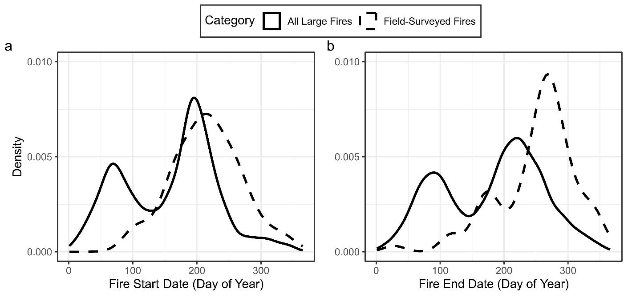
Figure S1: Density plots of fire start (a) and end dates (b) of fires across Alaska, Canada, and the contiguous US from 2016–2024. Field-surveyed fires (n = 77; dashed lines) typically ignited in summer (peak in late July) and ended in mid-to-late fall (peak in late September), whereas all large fires (≥404 ha; solid lines) showed bimodal spring and summer peaks. Spring fires occurred mostly in the US Southeast and Great Plains, while summer fires dominated elsewhere.

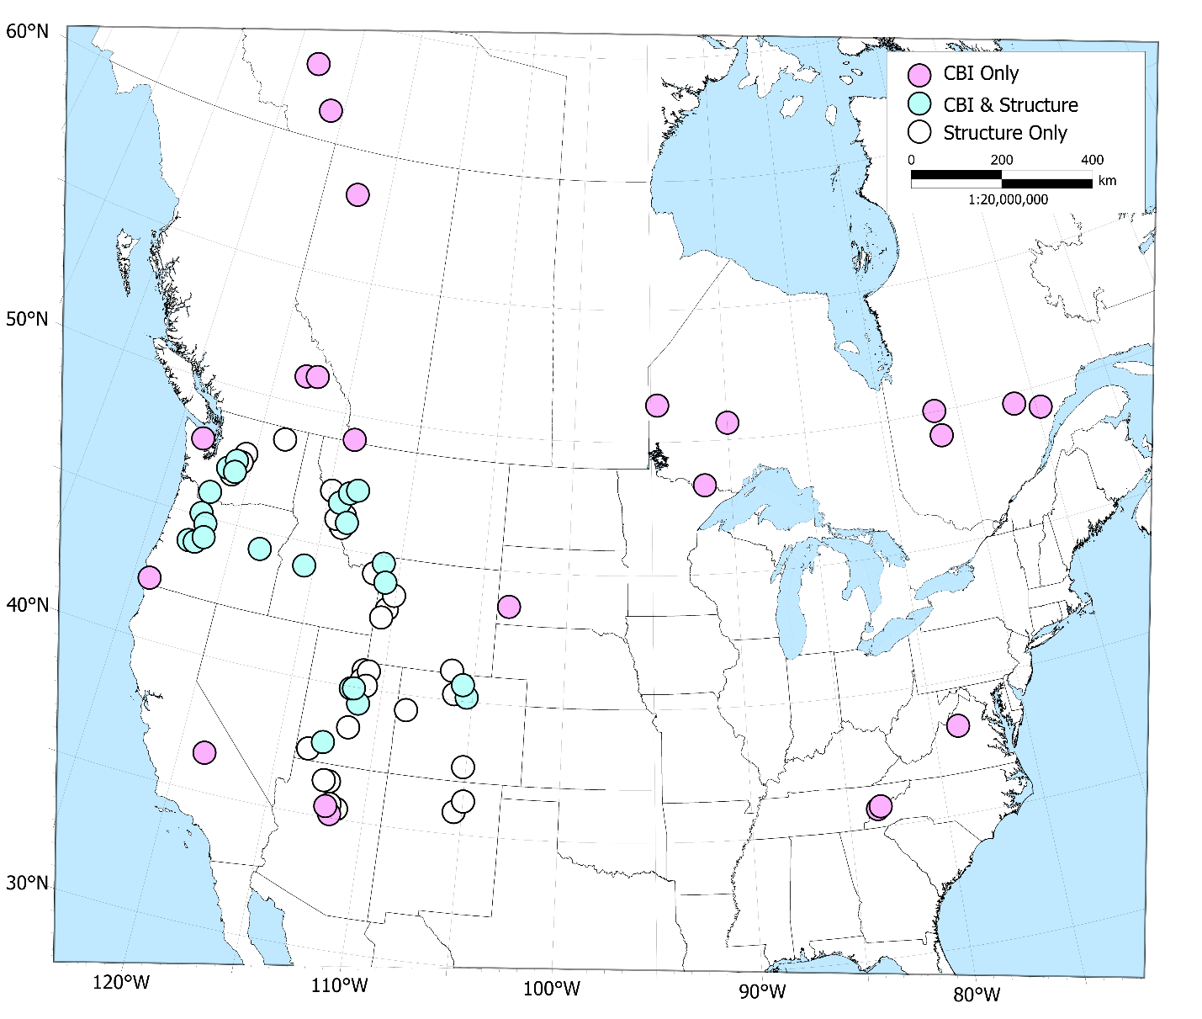
Figure S2: Fires including field-based burn severity assessments (n = 77) used in our analyses. Points represent the geographic centroid of each fire that contained field assessments, with point colors representing data type. “Structure” refers to fires with data on basal area loss and tree mortality. CBI: Composite Burn Index.

Table S1: Summary of random-intercept terms in the generalized linear mixed model (Fig. 3 in main text) of observational latency for four datasets collected after large fires (≥404 ha) across Alaska, Canada, and the contiguous US from 2016–2024.
Random Effect | Standard Deviation (σ) | No. Levels
Fire Year | 0.159 | 9
Ecoregion | 0.310 | 118
Fire ID:Ecoregion | 0.380 | 9111

Table S2: Summary of fixed-effect terms and other model details in the generalized linear mixed model (Fig. 3 in main text) of observational latency for four datasets collected after large fires (≥404 ha) across Alaska, Canada, and the contiguous US from 2016–2024. HLS: Harmonized Landsat Sentinel-2.
Term | Estimate | Standard Error | Z | P-value
Intercept (HLS) | 3.406 | 0.063 | 54.20 | <0.0001
Landsat | 0.489 | 0.013 | 37.70 | <0.0001
Sentinel-1 | -0.224 | 0.015 | -15.29 | <0.0001
Sentinel-2 | 0.204 | 0.013 | 15.39 | <0.0001
# Error Structure: Generalized Poisson (log link)
# Model Formula: Days to First Usable Scene ~ Dataset + (1 |Ecoregion/Fire ID) + (1 | Fire Year)
# N = 36,456

Table S3: Post-hoc pairwise comparisons of observational latency for four datasets collected after large fires (≥404 ha) across Alaska, Canada, and the contiguous US from 2016–2024. HLS: Harmonized Landsat Sentinel-2.
Contrast | Estimate | Standard Error | Z | P-value
HLS vs. Landsat | -0.489 | 0.013 | -37.70 | <0.0001
HLS vs. Sentinel-1 | 0.224 | 0.015 | 15.29 | <0.0001
HLS vs. Sentinel-1 | -0.204 | 0.013 | -15.39 | <0.0001
Landsat vs. Sentinel-1 | 0.713 | 0.014 | 50.19 | <0.0001
Landsat vs. Sentinel-2 | 0.286 | 0.013 | 22.19 | <0.0001
Sentinel-1 vs. Sentinel-2 | -0.427 | 0.014 | -29.91 | <0.0001

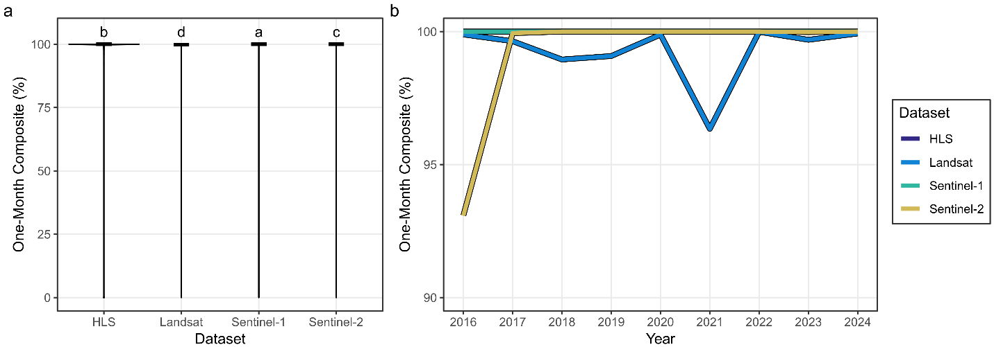
Figure S3: Composite coverage for four datasets collected after large fires (≥404 ha) across Alaska, Canada, and the contiguous US from 2016–2024. Coverage represents the percentage of the fire perimeter covered by a clear composite image within one month of the fire. In panel (a), letters denote significance groups from a generalized linear mixed model with post-hoc pairwise comparisons (α = 0.05). Panel (b) shows median coverage by fire year. HLS: Harmonized Landsat Sentinel-2.

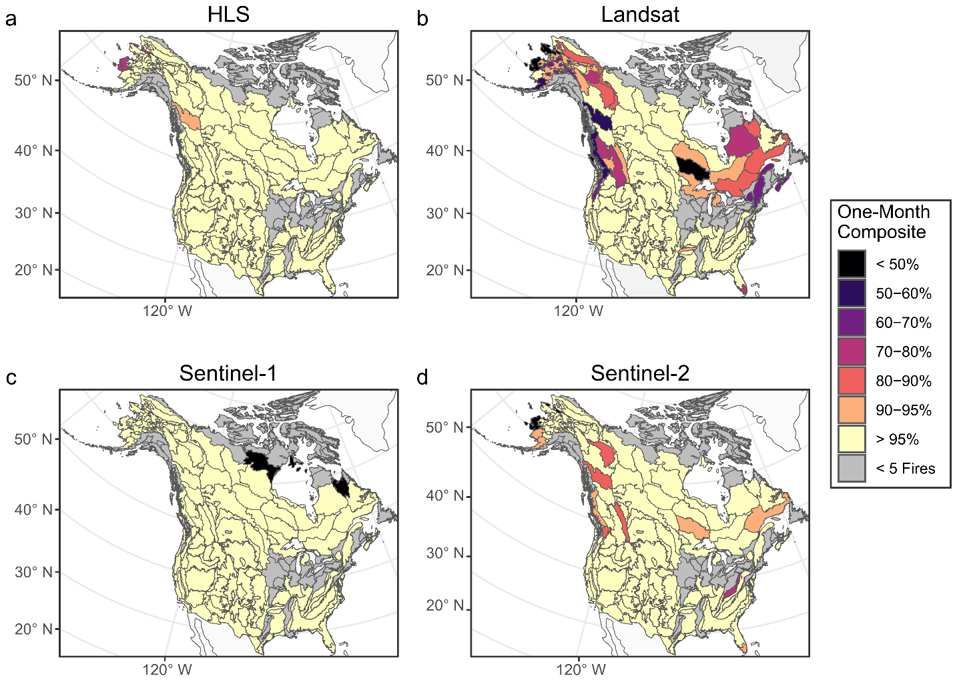
Figure S4: Composite coverage for four datasets collected after large fires (≥404 ha) across Alaska, Canada, and the contiguous US from 2016–2024. Coverage represents the percentage of the fire perimeter covered by a clear composite image within one month of the fire. Map colors show median coverage in each Level III Ecoregion (CEC, 2025). HLS: Harmonized Landsat Sentinel-2.

Table S4: Summary of random-intercept terms in the generalized linear mixed model (Fig. S3) of composite coverage for four datasets collected after large fires (≥404 ha) across Alaska, Canada, and the contiguous US from 2016–2024.
Random Effect | Standard Deviation (σ) | No. Levels
Fire Year | 0.394 | 9
Ecoregion | 0.658 | 118
Fire ID:Ecoregion | 0.868 | 9111

Table S5: Summary of fixed-effect terms and other model details in the generalized linear mixed model (Fig. S3) of composite coverage for four datasets collected after large fires (≥404 ha) across Alaska, Canada, and the contiguous US from 2016–2024. HLS: Harmonized Landsat Sentinel-2.
Term | Estimate | Standard Error | Z | P-value
Intercept (HLS) | 2.211 | 0.149 | 14.83 | <0.0001
Landsat | -1.161 | 0.022 | -53.94 | <0.0001
Sentinel-1 | 1.309 | 0.037 | 35.15 | <0.0001
Sentinel-2 | -0.569 | 0.021 | -26.59 | <0.0001
# Error Structure: Ordered Beta (logit link)
# Model Formula: Proportion Unobstructed ~ Dataset + (1 |Ecoregion/Fire ID) + (1 | Fire Year)
# N = 36,444

Table S6: Post-hoc pairwise comparisons of composite coverage for four datasets collected after large fires (≥404 ha) across Alaska, Canada, and the contiguous US from 2016–2024. HLS: Harmonized Landsat Sentinel-2.
Contrast | Estimate | Standard Error | Z | P-value
HLS vs. Landsat | 1.161 | 0.022 | 53.938 | <0.0001
HLS vs. Sentinel-1 | -1.309 | 0.037 | -35.150 | <0.0001
HLS vs. Sentinel-1 | 0.569 | 0.021 | 26.587 | <0.0001
Landsat vs. Sentinel-1 | -2.470 | 0.038 | -65.215 | <0.0001
Landsat vs. Sentinel-2 | -0.591 | 0.020 | -29.957 | <0.0001
Sentinel-1 vs. Sentinel-2 | 1.879 | 0.037 | 50.504 | <0.0001

Table S7: Summary of generalized linear mixed models predicting composite burn index (CBI; rescaled to [0,1]) from remotely sensed datasets collected at different post-fire intervals (“Months After Fire”). Coefficients represent effects of the remotely sensed index (ß_{RS}), years between fire and field measurement (ß_{Timing}), and their interaction (ß_{RS Index:Timing}). Models included a random intercept for fire ID. Accuracy metrics (R² and balanced accuracy) reflect agreement between observed and predicted CBI using fixed effects only; balanced accuracy indicates the ability to identify plots with near-total canopy loss (CBI ≥2.25 on the original scale). The index value used to delineate this is identified in the rightmost column, assuming that field data were collected one year post-fire. Parenthetical values are standard deviations across 100 imputations. The month with highest accuracy per dataset is underlined and italicized. GS: Growing season. HLS: Harmonized Landsat Sentinel-2.
Dataset | Months After Fire | ß_{RS} | ß_{Timing} | ß_{RS:Timing} | R-squared (SD) | Balanced Accuracy (SD) | High-Severity Threshold (SD)
HLS | 1 | 0.0027 | 0.4369 | 0.0002 | 0.341 (0.016) | 72.6 (0.5) | 290.5 (12.4)
HLS | 2 | 0.0033 | 0.396 | 0.0002 | 0.367 (0.012) | 72.5 (0.4) | 312.2 (15.8)
HLS | 3 | 0.0025 | 0.3339 | 0.0001 | 0.221 (0.014) | 68.3 (0.7) | 296.9 (10.3)
HLS | 4 | 0.0017 | 0.4646 | -0.0003 | 0.062 (0.013) | 61.1 (1.1) | 315.2 (54.4)
HLS | 5 | 0.0009 | 0.1891 | 0.0003 | 0.046 (0.012) | 60.9 (1.3) | 201.6 (74.4)
HLS | 6 | 0.0006 | 0.0273 | 0.0007 | 0.095 (0.016) | 63.4 (1) | 220.7 (41.4)
HLS | 7 | -0.0002 | -0.0113 | 0.0011 | 0.06 (0.011) | 63.2 (0.9) | 231.8 (33.5)
HLS | 8 | 0.0001 | -0.4088 | 0.0018 | 0.155 (0.018) | 71.3 (0.9) | 255.5 (20.5)
HLS | 9 | 0.0007 | -0.8547 | 0.0027 | 0.227 (0.018) | 71 (0.6) | 319.4 (13.3)
Landsat | 1 | 0.0027 | 0.4068 | 0.0002 | 0.366 (0.016) | 72.8 (0.6) | 317.1 (31.4)
Landsat | 2 | 0.0029 | 0.3325 | 0.0003 | 0.366 (0.014) | 71.9 (0.6) | 317.8 (25.8)
Landsat | 3 | 0.0025 | 0.2237 | 0.0002 | 0.272 (0.018) | 69.2 (0.9) | 303.1 (23.9)
Landsat | 4 | 0.0018 | 0.535 | -0.0004 | 0.069 (0.014) | 61.2 (1.1) | 285.4 (61.7)
Landsat | 5 | 0.0008 | 0.196 | 0.0003 | 0.051 (0.014) | 61.2 (1.3) | 205.4 (75.6)
Landsat | 6 | 0.0009 | 0.0442 | 0.0006 | 0.107 (0.019) | 63.8 (1) | 204.1 (45.2)
Landsat | 7 | -0.0002 | -0.05 | 0.0011 | 0.077 (0.016) | 63.8 (1) | 255.3 (44)
Landsat | 8 | 0.0002 | -0.4347 | 0.0018 | 0.171 (0.018) | 71.4 (0.9) | 256.2 (17.8)
Landsat | 9 | 0.0002 | -0.7332 | 0.0025 | 0.21 (0.015) | 70.9 (0.6) | 320.2 (13.7)
Sentinel-1 | 1 | 0.0017 | 0.2564 | 0.0001 | 0.026 (0.003) | 60.2 (0.4) | 103.9 (22.4)
Sentinel-1 | 2 | 0.0018 | 0.2614 | 0 | 0.029 (0.003) | 60.7 (0.4) | 116.7 (26.9)
Sentinel-1 | 3 | 0.0012 | 0.316 | 0.0003 | 0.023 (0.002) | 61.4 (0.4) | 178.7 (8)
Sentinel-1 | 4 | 0.0012 | 0.3128 | 0.0004 | 0.032 (0.003) | 61.1 (0.5) | 162.2 (8.6)
Sentinel-1 | 5 | 0.0012 | 0.3685 | -0.0001 | 0.017 (0.002) | 60.7 (0.5) | 181.3 (3.8)
Sentinel-1 | 6 | 0.0003 | 0.1706 | 0.001 | 0.027 (0.003) | 60.8 (0.5) | 167.4 (12.1)
Sentinel-1 | 7 | -0.0002 | 0.0287 | 0.002 | 0.058 (0.004) | 61.8 (0.4) | 144.3 (1.7)
Sentinel-1 | 8 | -0.0002 | -0.0965 | 0.0027 | 0.086 (0.006) | 62.1 (0.5) | 109.4 (4.7)
Sentinel-1 | 9 | 0.0004 | -0.0796 | 0.0026 | 0.146 (0.006) | 64.4 (0.4) | 117.3 (9.1)
Sentinel-2 | 1 | 0.0026 | 0.4126 | 0.0003 | 0.329 (0.015) | 71.4 (0.5) | 316 (32.4)
Sentinel-2 | 2 | 0.0032 | 0.3587 | 0.0002 | 0.352 (0.012) | 71.8 (0.5) | 311.9 (12.9)
Sentinel-2 | 3 | 0.0024 | 0.3097 | 0.0002 | 0.221 (0.016) | 67.9 (0.9) | 294.1 (22.8)
Sentinel-2 | 4 | 0.0015 | 0.4488 | -0.0002 | 0.054 (0.012) | 60.7 (1) | 302.3 (70.6)
Sentinel-2 | 5 | 0.0007 | 0.1719 | 0.0004 | 0.04 (0.011) | 60 (1.3) | 190.3 (75.6)
Sentinel-2 | 6 | 0.0002 | 0.0202 | 0.0009 | 0.068 (0.015) | 61.9 (1) | 259 (45.1)
Sentinel-2 | 7 | -0.0003 | 0.0108 | 0.0011 | 0.05 (0.01) | 62.4 (0.9) | 229.5 (39.5)
Sentinel-2 | 8 | 0 | -0.3904 | 0.0019 | 0.144 (0.017) | 70.6 (0.9) | 267.1 (32.5)
Sentinel-2 | 9 | 0.0004 | -0.7706 | 0.0026 | 0.19 (0.011) | 70 (0.6) | 325.2 (9.1)
Mean Composite | Next GS | 0.0056 | 0.268 | 0.0005 | 0.581 (0.001) | 77.4 (0.1) | 315.7 (0.8)

Table S8: Summary of generalized linear mixed models predicting tree basal area loss (BA loss; proportion of live basal area killed by fire) from remotely sensed datasets collected at different post-fire intervals (“Months After Fire”). Coefficients represent effects of the remotely sensed index (ß_{RS}), years between fire and field measurement (ß_{Timing}), and their interaction (ß_{RS:Timing}). Models included a random intercept for fire ID. Accuracy metrics (R² and balanced accuracy) reflect agreement between observed and predicted BA loss using fixed effects only; balanced accuracy indicates the ability to identify plots with near-total canopy loss (BA loss ≥0.95). The index value used to delineate this threshold is identified in the rightmost column, assuming that field data were collected one year post-fire; ∞ indicates that the threshold used to maximize the true skill statistic (Allouche et al. 2006) was above all model-predicted values in the data. Parenthetical values are standard deviations across 100 imputations. The month with highest accuracy per dataset is underlined and italicized. GS: Growing season. HLS: Harmonized Landsat Sentinel-2.
Dataset | Month | ß_{RS} | ß_{Timing} | ß_{RS:Timing} | R² (SD) | Balanced Accuracy (SD) | High-Severity Threshold (SD)
HLS | 1 | 0.0103 | 1.199 | -0.0024 | 0.5 (0.009) | 81.5 (0.4) | 362 (14.8)
HLS | 2 | 0.0083 | 0.9424 | -0.0017 | 0.489 (0.008) | 80.5 (0.4) | 312.1 (21.1)
HLS | 3 | 0.0048 | 0.8293 | -0.0012 | 0.347 (0.017) | 73.4 (0.8) | 236.2 (22.1)
HLS | 4 | 0.0025 | 0.7972 | -0.0008 | 0.235 (0.01) | 70.6 (0.6) | 202.7 (23.8)
HLS | 5 | 0.0011 | 0.7499 | -0.0004 | 0.214 (0.004) | 69.7 (0.6) | ∞
HLS | 6 | 0.0008 | 0.7333 | -0.0003 | 0.207 (0.007) | 69.1 (0.3) | ∞
HLS | 7 | 0.0047 | 0.7697 | -0.0014 | 0.273 (0.013) | 70.6 (0.8) | 223 (33.2)
HLS | 8 | 0.0073 | 0.9862 | -0.0019 | 0.45 (0.014) | 77 (0.6) | 334.3 (28.7)
HLS | 9 | 0.0108 | 1.1791 | -0.0028 | 0.578 (0.009) | 82.5 (0.4) | 295.7 (4.3)
Landsat | 1 | 0.0098 | 1.183 | -0.0021 | 0.512 (0.009) | 81.5 (0.5) | 386.8 (14.5)
Landsat | 2 | 0.0081 | 0.9963 | -0.0017 | 0.49 (0.009) | 80.3 (0.5) | 323.4 (15.6)
Landsat | 3 | 0.0051 | 0.9266 | -0.0012 | 0.37 (0.022) | 74 (1) | 263.4 (29.4)
Landsat | 4 | 0.0024 | 0.8003 | -0.0008 | 0.23 (0.01) | 70.4 (0.5) | 249.7 (56.3)
Landsat | 5 | 0.0016 | 0.7563 | -0.0004 | 0.22 (0.006) | 69.8 (0.6) | 291.7 (156.5)
Landsat | 6 | 0.0013 | 0.7238 | -0.0003 | 0.202 (0.006) | 69.1 (0.3) | 518.6 (411.6)
Landsat | 7 | 0.0062 | 0.7096 | -0.0016 | 0.332 (0.019) | 73.3 (1) | 199 (16.5)
Landsat | 8 | 0.0072 | 0.948 | -0.0018 | 0.457 (0.015) | 77.3 (0.7) | 321.7 (27.9)
Landsat | 9 | 0.0109 | 0.9133 | -0.002 | 0.643 (0.01) | 84.3 (0.5) | 294 (11.3)
Sentinel-1 | 1 | 0.0041 | 0.7365 | -0.0008 | 0.236 (0.003) | 67.7 (0.2) | 195.4 (13.9)
Sentinel-1 | 2 | 0.005 | 0.6931 | -0.0012 | 0.261 (0.003) | 68.4 (0.3) | 136.2 (17)
Sentinel-1 | 3 | 0.0049 | 0.684 | -0.0011 | 0.292 (0.003) | 70.4 (0.2) | 186.2 (10.7)
Sentinel-1 | 4 | 0.0043 | 0.7059 | -0.0007 | 0.286 (0.003) | 69.6 (0.2) | 186.2 (8.5)
Sentinel-1 | 5 | 0.0048 | 0.717 | -0.0012 | 0.302 (0.003) | 71 (0.2) | 210.6 (7.6)
Sentinel-1 | 6 | 0.0042 | 0.7136 | -0.0006 | 0.319 (0.004) | 71.5 (0.2) | 226.1 (6.4)
Sentinel-1 | 7 | 0.0046 | 0.6611 | -0.0006 | 0.316 (0.004) | 71.8 (0.2) | 190.2 (7.6)
Sentinel-1 | 8 | 0.0061 | 0.7479 | -0.0014 | 0.358 (0.004) | 74.2 (0.2) | 215 (7.3)
Sentinel-1 | 9 | 0.0069 | 0.6852 | -0.0011 | 0.353 (0.004) | 74 (0.2) | 150.4 (2.5)
Sentinel-2 | 1 | 0.0105 | 1.195 | -0.0025 | 0.491 (0.01) | 81 (0.4) | 352.1 (20.9)
Sentinel-2 | 2 | 0.0082 | 0.9102 | -0.0016 | 0.491 (0.008) | 80.7 (0.5) | 301.9 (9.9)
Sentinel-2 | 3 | 0.0047 | 0.7878 | -0.0011 | 0.344 (0.016) | 73.4 (0.8) | 237.1 (19.9)
Sentinel-2 | 4 | 0.0025 | 0.7907 | -0.0008 | 0.235 (0.011) | 70.6 (0.6) | 200.6 (30.6)
Sentinel-2 | 5 | 0.0011 | 0.7486 | -0.0004 | 0.214 (0.004) | 69.7 (0.6) | ∞
Sentinel-2 | 6 | 0.0007 | 0.7248 | -0.0003 | 0.208 (0.007) | 69.1 (0.4) | ∞
Sentinel-2 | 7 | 0.0045 | 0.7773 | -0.0014 | 0.266 (0.013) | 70.5 (0.7) | 221.8 (39.1)
Sentinel-2 | 8 | 0.0072 | 0.995 | -0.002 | 0.446 (0.016) | 76.9 (0.6) | 335.1 (28.8)
Sentinel-2 | 9 | 0.0103 | 1.2082 | -0.0027 | 0.559 (0.009) | 81.7 (0.4) | 320.9 (7.2)
Mean Composite | Next GS | 0.0148 | 0.6624 | -0.0025 | 0.675 (0.001) | 85.3 (0) | 246.7 (1.4)

Table S9: Summary of generalized linear mixed models predicting tree mortality (proportion of live trees killed by fire) from remotely sensed datasets collected at different post-fire intervals (“Months After Fire”). Coefficients represent effects of the remotely sensed index (ß_{RS}), years between fire and field measurement (ß_{Timing}), and their interaction (ß_{RS:Timing}). Models included a random intercept for fire ID. Models included a random intercept for fire ID. Accuracy metrics (R² and balanced accuracy) reflect agreement between observed and predicted mortality using fixed effects only; balanced accuracy indicates the ability to identify plots with near-total canopy loss (mortality ≥0.95). The index value used to delineate this is identified in the rightmost column, assuming that field data were collected one year post-fire; ∞ indicates that the threshold used to maximize the true skill statistic (Allouche et al. 2006) was above all model-predicted values in the data. Parenthetical values are standard deviations across 100 imputations. The month with highest accuracy per dataset is underlined and italicized. GS: Growing season. HLS: Harmonized Landsat Sentinel-2.
Dataset | Month | ß_{RS Index} | ß_{Timing} | ß_{RS Index:Timing} | R-squared (SD) | Balanced Accuracy (SD) | High-Severity Threshold (SD)
HLS | 1 | 0.0087 | 0.8808 | -0.0014 | 0.416 (0.01) | 82.1 (0.4) | 365.6 (15.6)
HLS | 2 | 0.0065 | 0.6949 | -0.0007 | 0.408 (0.008) | 80.9 (0.4) | 317.4 (29.5)
HLS | 3 | 0.0036 | 0.5883 | -0.0004 | 0.304 (0.017) | 74.8 (1) | 219.6 (17.8)
HLS | 4 | 0.0018 | 0.6006 | -0.0003 | 0.201 (0.012) | 70.9 (1.4) | 169 (24.3)
HLS | 5 | 0.0006 | 0.5636 | 0 | 0.195 (0.011) | 72.1 (0.8) | ∞
HLS | 6 | 0.0004 | 0.5291 | 0.0001 | 0.179 (0.014) | 72.1 (0.6) | ∞
HLS | 7 | 0.0039 | 0.5379 | -0.0008 | 0.213 (0.013) | 71.9 (0.8) | 186.1 (17)
HLS | 8 | 0.0054 | 0.7031 | -0.001 | 0.379 (0.017) | 77.5 (0.7) | 327.2 (25.7)
HLS | 9 | 0.0082 | 0.7353 | -0.0013 | 0.515 (0.012) | 84.5 (0.4) | 291.3 (4.8)
Landsat | 1 | 0.0082 | 0.8756 | -0.0013 | 0.434 (0.01) | 82.2 (0.5) | 383.4 (13)
Landsat | 2 | 0.0063 | 0.7339 | -0.0007 | 0.417 (0.009) | 81.2 (0.4) | 314.8 (28.7)
Landsat | 3 | 0.0038 | 0.6944 | -0.0004 | 0.343 (0.02) | 75.5 (1) | 240.5 (31.3)
Landsat | 4 | 0.0017 | 0.5952 | -0.0002 | 0.2 (0.011) | 70.9 (1.8) | 180 (53.1)
Landsat | 5 | 0.001 | 0.5385 | 0.0001 | 0.196 (0.01) | 71.8 (0.8) | 217.2 (45.9)
Landsat | 6 | 0.0008 | 0.5011 | 0.0002 | 0.17 (0.011) | 71.7 (0.9) | 265 (141.4)
Landsat | 7 | 0.005 | 0.4226 | -0.0008 | 0.267 (0.017) | 74.2 (0.9) | 170.5 (15.7)
Landsat | 8 | 0.0055 | 0.6594 | -0.0009 | 0.391 (0.019) | 77.8 (0.7) | 315.3 (22)
Landsat | 9 | 0.0083 | 0.4661 | -0.0005 | 0.621 (0.013) | 86.3 (0.5) | 276 (20.5)
Sentinel-1 | 1 | 0.0032 | 0.5611 | -0.0001 | 0.228 (0.003) | 68.6 (0.3) | 176.5 (13.6)
Sentinel-1 | 2 | 0.0037 | 0.5259 | -0.0004 | 0.258 (0.003) | 69.9 (0.3) | 130.4 (18.9)
Sentinel-1 | 3 | 0.0036 | 0.474 | -0.0002 | 0.286 (0.003) | 72 (0.2) | 162.2 (6.2)
Sentinel-1 | 4 | 0.0033 | 0.5078 | 0.0004 | 0.287 (0.003) | 71.2 (0.2) | 226 (10.6)
Sentinel-1 | 5 | 0.0033 | 0.483 | 0.0002 | 0.293 (0.003) | 72.9 (0.2) | 185 (8.7)
Sentinel-1 | 6 | 0.0031 | 0.4861 | 0.0003 | 0.314 (0.003) | 73.1 (0.2) | 232.4 (19)
Sentinel-1 | 7 | 0.0038 | 0.4083 | 0.0003 | 0.309 (0.004) | 73.3 (0.2) | 148 (10.9)
Sentinel-1 | 8 | 0.0054 | 0.5082 | -0.0005 | 0.366 (0.005) | 75.3 (0.2) | 171.9 (6.2)
Sentinel-1 | 9 | 0.0054 | 0.3831 | -0.0001 | 0.342 (0.004) | 75 (0.2) | 123.5 (3.5)
Sentinel-2 | 1 | 0.0087 | 0.8716 | -0.0016 | 0.409 (0.01) | 81.3 (0.4) | 347.4 (24.4)
Sentinel-2 | 2 | 0.0064 | 0.6714 | -0.0007 | 0.41 (0.009) | 81 (0.4) | 297.8 (11.5)
Sentinel-2 | 3 | 0.0036 | 0.5575 | -0.0004 | 0.299 (0.019) | 74.7 (1) | 229.3 (15.5)
Sentinel-2 | 4 | 0.0017 | 0.5969 | -0.0003 | 0.201 (0.012) | 71.1 (1.4) | 159.9 (25.3)
Sentinel-2 | 5 | 0.0007 | 0.5648 | 0 | 0.196 (0.01) | 72 (0.8) | ∞
Sentinel-2 | 6 | 0.0003 | 0.5296 | 0.0001 | 0.183 (0.015) | 72 (0.7) | ∞
Sentinel-2 | 7 | 0.0037 | 0.5434 | -0.0008 | 0.21 (0.013) | 71.9 (0.8) | 184.3 (20.1)
Sentinel-2 | 8 | 0.0054 | 0.725 | -0.0011 | 0.381 (0.019) | 77.4 (0.6) | 330.2 (26.9)
Sentinel-2 | 9 | 0.0079 | 0.784 | -0.0014 | 0.494 (0.012) | 83.5 (0.4) | 306.7 (20.8)
Mean Composite | Next GS | 0.0129 | 0.233 | -0.0009 | 0.689 (0.001) | 86.5 (0) | 252.1 (1.4)

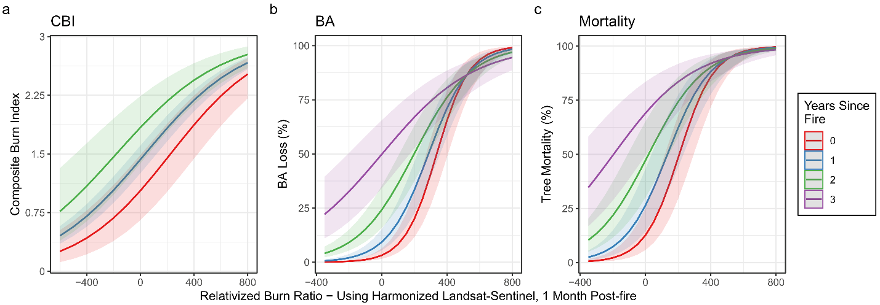
Figure S5: Marginal effects plots showing relationships between remotely sensed estimates of burn severity (RBR) and field survey timing for each field-based severity metric. RBR was derived from all Harmonized Landsat Sentinel-2 scenes within one month of fire containment and pre-fire scens from a similar season in the previous year. In each panel, lines show model predictions (Tables S7–S9) at the mean values of random intercepts. CBI (a) exhibits no clear RBR-timing interaction, whereas BA loss (b) and tree mortality (c) show strong interactions, suggesting that field collection timing has a weaker effect at high RBR values. Note: CBI plots (a) do not include any information from three years post-fire.

References
Allouche O, Tsoar A, Kadmon R (2006) Assessing the accuracy of species distribution models: prevalence, kappa and the true skill statistic (TSS). Journal of Applied Ecology 43:1223–1232. https://doi.org/10.1111/j.1365-2664.2006.01214.x
Commission for Environmental Cooperation (2025). Ecological Regions of North America: Level III. https://www.cec.org/north-american-environmental-atlas/terrestrial-ecoregions-level-iii/

