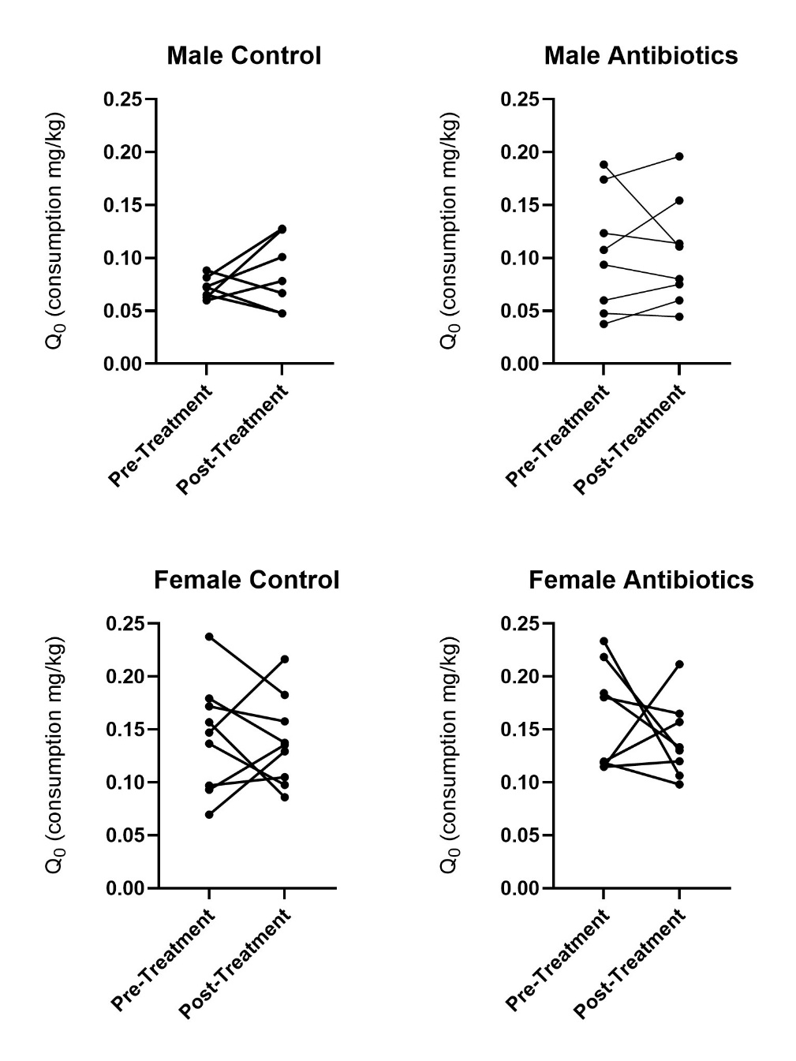

Figure S1. Individual Q₀ pre- vs. post-treatment by sex. No significant differences in values pre- vs. post-treatment were determined with a paired t-test within each sex and treatment group.

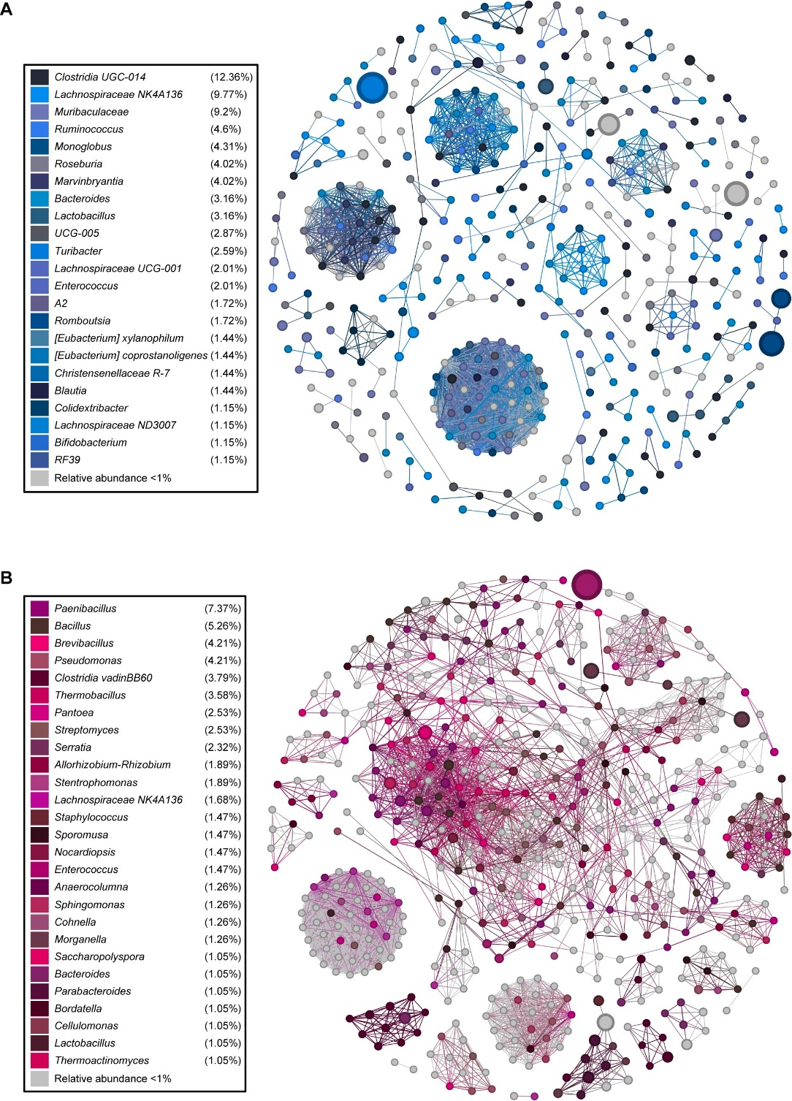
Figure S2. Genus-level co-occurrence networks. A) Control rats. B) Antibiotic-treated rats.
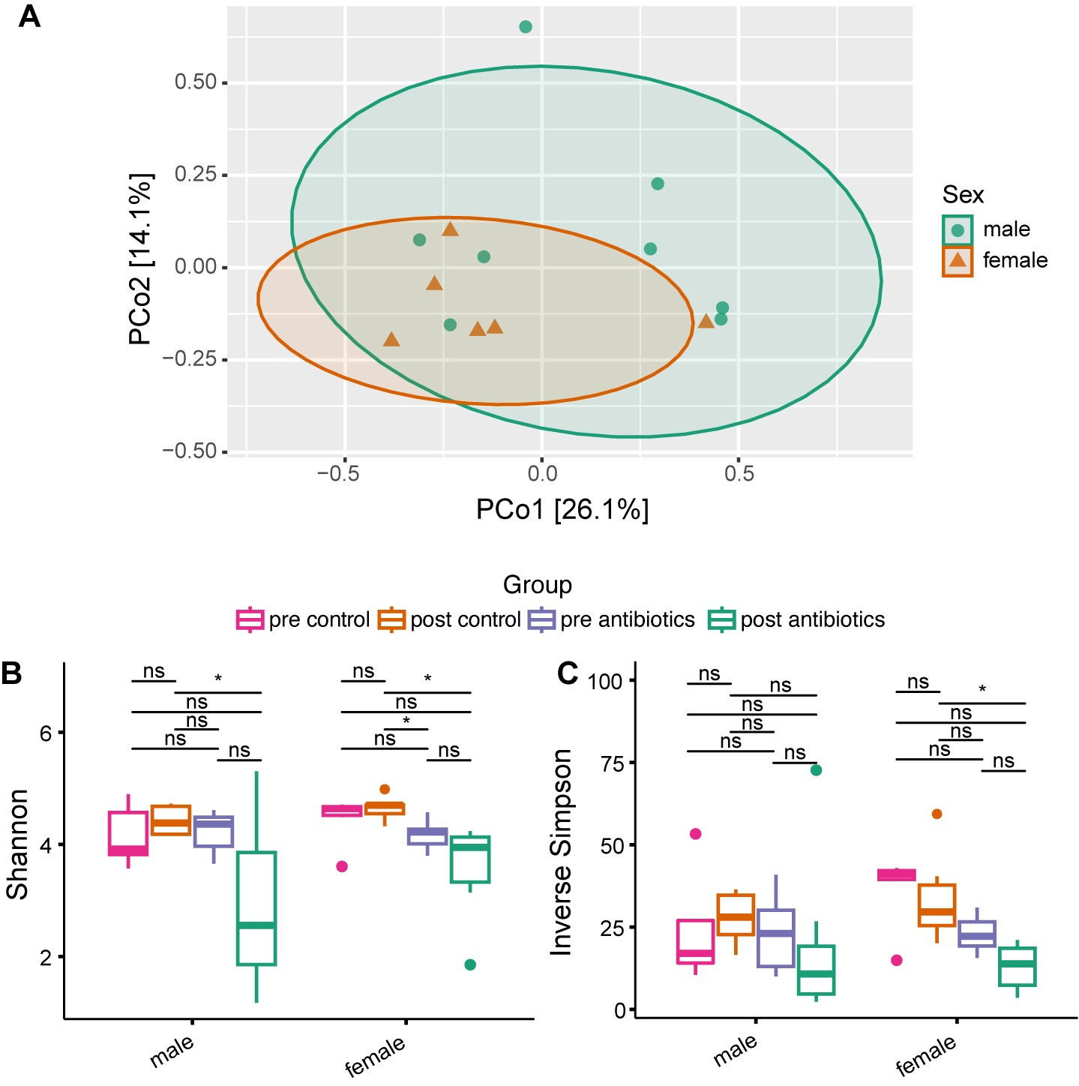 Figure S3. Sex does not significantly influence the fecal microbiome community structure. A) Principal Coordinate Analysis (PCoA) of fecal microbiota from rats post-antibiotic treatment, based on Bray–Curtis dissimilarity of Amplicon Sequence Variant (ASV) abundances. B) Shannon diversity index and C) Inverse Simpson diversity index calculated from rat fecal samples separated by sex and treatment. Statistical significance between males and females was assessed using the Wilcoxon rank-sum test (*p<0.01).

