Supplementary Results
Sensitivity Analyses for Neuroimaging-based Predictive Models
Regarding the data, we 1) balanced the number of participants by race, and 2) corrected for covariates and site. These analyses were conducted across 20 behavioral phenotypes and resting-state connectivity features. In the first, one FDR-corrected (p<=0.001) significant difference and two additional nominally significant (p<0.05) differences in the variance were observed, all of which had higher variance in Black participants. After incorporating site correction and covariate regression (age, self-reported sex, mean framewise displacement, parental income), only two models demonstrated nominally significant (p<0.05) variance differences, with higher variance in Black participants (Table S3). The attenuation of significance after controlling for sample size is consistent with the interpretation that these effects are driven by differences in variance rather than differences in mean or association strength.
In addition, we considered a sensitivity analysis based on model complexity, running the analysis for three more complex models: Kernel Ridge Regression (KRR), Random Forest Regression (RFR), and an Artificial Neural Network (ANN). Across models and phenotypes, the variance of predicted values (i.e., prediction variance) was consistently greater for Black participants, suggesting that more complex machine learning algorithms do not mitigate these problems (Figure S4). Here, we distinguish between variance in the original measures and variance in model predictions; this analysis focuses on the latter. This pattern may reflect reduced prediction stability, rather than simply lower overall performance. Subgroup differences can persist even when aggregate performance appears acceptable. Importantly, increased spread in predicted values is not inherently beneficial; when disproportionate to the variance in true outcomes, it contributes to increased prediction error and instability. Together, these findings indicate that differences in prediction performance are closely linked to differences in prediction variance, rather than solely to differences in underlying associations.
Tests of Heteroscedasticity for Brain-behavior Summary Scores
To further investigate racialized heteroscedasticity in brain-behavior relationships, we conducted Levene’s test and the Breusch-Pagan test on brain-behavior summary scores. We used summary scores generated in the entire dataset (i.e., not cross-validated), representing the sum of edge weights significantly associated with the behavior of interest. These brain-behavior summary scores represent non-cross-validated aggregate association scores derived from CPM feature weights and are used here as a proxy to assess variance in model-derived signals independent of cross-validated prediction. This distinction is necessary because formal tests of variance differences (e.g., Levene’s and Breusch-Pagan tests) cannot be applied directly to cross-validated prediction outputs. Overall, 36 summary scores were generated, one for each of the 36 behavioral measures.
For Levene’s test, we observed significant variance differences for nine of 36 summary scores after FDR correction (14 uncorrected; Table S4). Six of the nine showed greater variance in Black participants (nine of 14 uncorrected), providing additional evidence of brain-behavior variance differences by race. Furthermore, for the Breusch-Pagan test, we performed 100 iterations of bootstrapping with replacement to robustly estimate the variability in residual (i.e., error) patterns across racial groups. Breusch-Pagan test results are shown in Table S5, highlighting the higher dispersion of residuals for Black participants compared to the White counterparts and thus indicating greater prediction uncertainty. Moreover, some summary scores exhibited systematic skew in residuals for Black participants, suggesting systematic biases in Black participants (Table S6). In contrast, residuals for White participants in these same measures were symmetrically distributed.

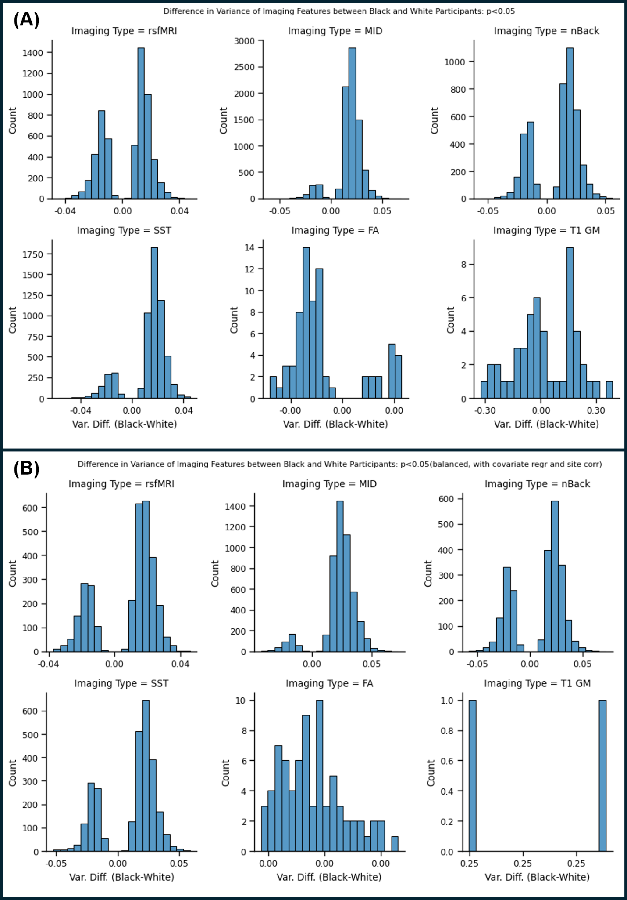
Figure S1. Distribution of variance differences in imaging features between Black and White participants. Histograms depict the distribution of variance differences (Black-White) across six key neuroimaging modalities. A) presents results without covariates, and B) includes covariate regression (age, sex, head motion), site correction (ComBat), and balanced sample sizes between Black and White participants. Neuroimaging modalities include resting-state fMRI (rsfMRI), Monetary Incentive Delay task (MID), nBack task, Stop-Signal Task (SST), Diffusion Tensor Imaging fractional anisotropy (FA), and T1-weighted gray matter structural MRI (T1 GM). The x-axis represents the difference in variance (positive values indicate greater variance in Black participants, while negative values indicate greater variance in White participants), and the y-axis represents the count of features with corresponding variance differences. Across all modalities, features demonstrating significant variance differences (p < 0.05) are included. For any results including balancing, a single representative random iteration is shown.

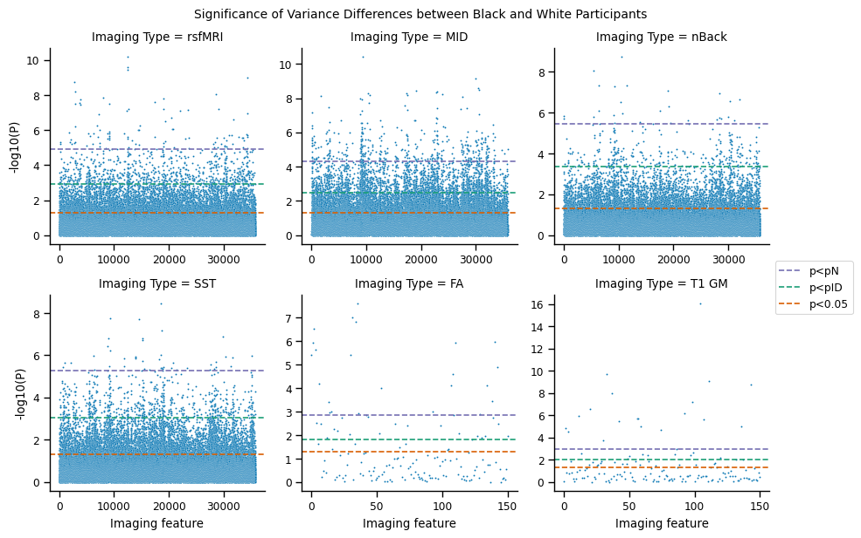
Figure S2. Significance of variance differences between Black and White participants across six neuroimaging modalities. The -log10(p) values represent the statistical significance of Levene's test for each imaging feature. Dashed lines indicate significance thresholds: p < 0.05 (orange), less stringent FDR threshold (pID, green), and more stringent FDR threshold (pN, purple). Results are shown for resting-state fMRI (rsfMRI), task-based fMRI (Monetary Incentive Delay [MID], nBack, and Stop-Signal Task [SST]), Diffusion Tensor Imaging (FA), and T1-weighted structural MRI (T1 GM). Positive findings highlight features with greater variance in Black participants compared to White participants.

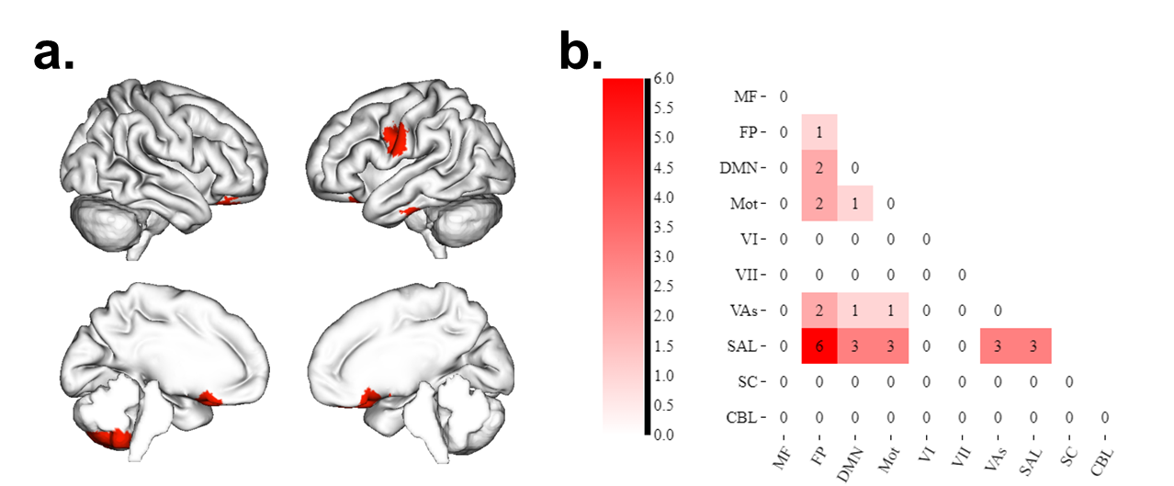
Figure S3. Regions with higher variance in Black relative to White participants across all four functional modalities. A degree threshold of 10 was set so that each region must contain at least 10 edges exhibiting higher variance in Black participants in all four modalities. The distribution of the regions is plotted in (A), and their distribution across networks is shown in (B).
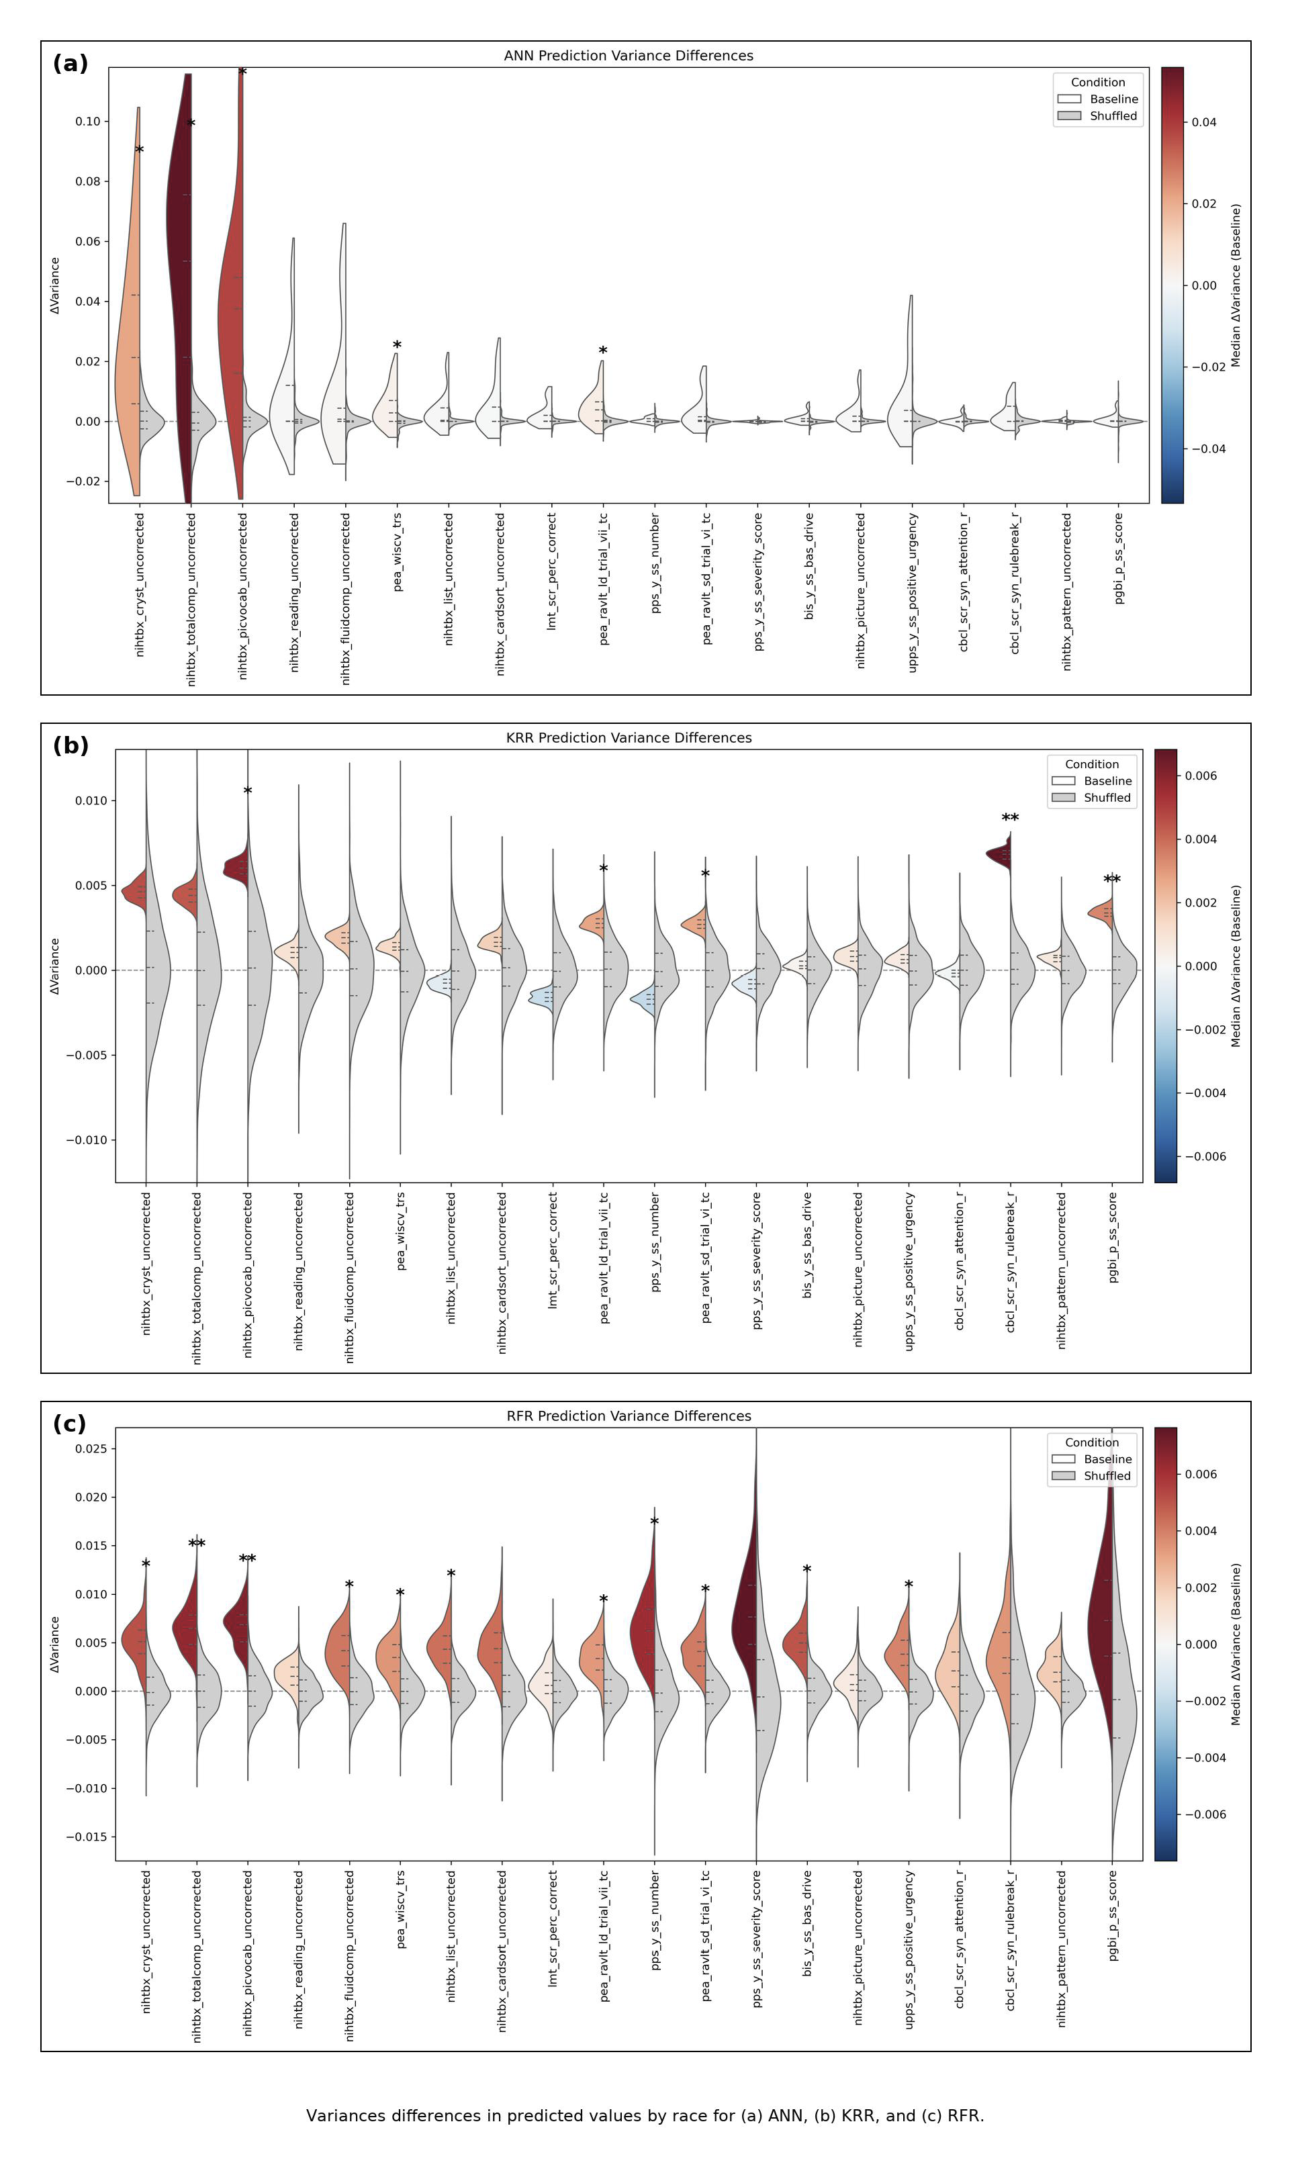
Figure S4. Variance differences in predicted values by race. The figure presents results for predictive models with at least modest (r>0.1) and significant (p<0.05) predictions from A) artificial neural network (ANN), B) kernel ridge regression (KRR), and C) random forest regression (RFR). In the left violin plot, the observed variance difference (variance in predicted values of Black participants minus variance in predicted values of White participants) is shown, colored by median variance difference. In the right violin plot, the null distribution of variance differences resulting from 1000 permutations shuffling the race is shown. *p<0.05. **FDR-significant.

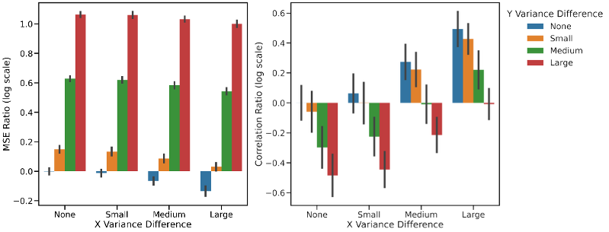
Figure S5. Simulation of heteroscedasticity. Mean squared error ratio increases with increasing outcome variable (Y) variance ratio but decreases with increasing predictor variable (X) variance ratio. Conversely, correlation ratio increases with increasing outcome variable (X) variance ratio but decreases with increasing predictor variable (Y) variance ratio. X variance appears to have a greater effect on correlation than MSE. Whereas Y variance impacts both performance measures similarly. X and Y data for group 1 were generated with their variance held constant in each iteration of the simulation. The variances for X and Y in group 2 were set to 1x (no difference), 1.1x (small difference), 1.5x (medium difference), and 2x (large difference) compared to their respective variances in group 1. For each possible pair of X and Y variances in group 2, 100 iterations of the simulation were performed in which unique data was generated for both groups. The relationship between X and Y was the same for both groups. Each bar indicates the average log of the MSE (or correlation) ratio between group 2 and group 1 for a given pair of X and Y variances for group 2. Error bars indicate one standard deviation

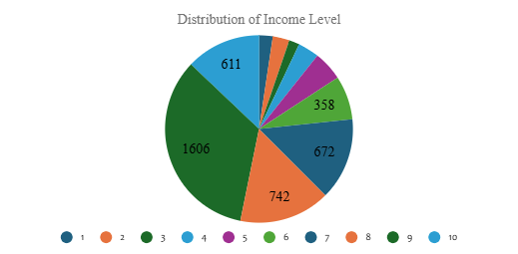 | 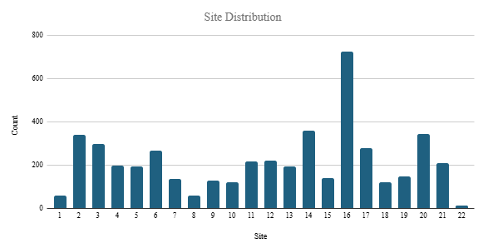
(a) | (b)

Supplementary Figure 6. Demographic distribution of the dataset used in this study, focusing on (A) income levels and (B) data collection sites. In (A), the pie chart represents the distribution of participants across ten income brackets. Income level 9 accounts for the highest number of participants, with 1,606 individuals, followed by levels 8 (742), 6 (672), and 10 (611), indicating a concentration in the mid-to-higher income ranges. (B) Shows the distribution of participants across 22 collection sites, with site 16 having the highest count of 723 participants, suggesting it contributed the most data to the study. Several other sites, such as 2, 14, and 20, also show relatively high participant counts, while sites like 1 and 22 had notably fewer participants.

