Supplemental Materials

GEO-Ring observations reveal substantially overestimated global land aerosol cooling

Contents
Texts S1-S5
Figures S1-S20
Tables S1-S4
References

Text S1. Independent validation of global hourly AOD retrievals
By integrating a deep transfer learning framework with observations from eight geostationary satellites, we produced the first global hourly aerosol optical depth (AOD) map at 2 km resolution over land during 2021–2023 (Fig. 1). Sample-based ten-fold cross-validation at 477 sites yields high CV coefficients of determination (CV-R²) > 0.6 at over 87% of stations, with RMSE < 0.12 and biases within ±0.02 at 78% of sites (Fig. S1a-c). Overall, the model achieves high retrieval accuracy (CV-R² = 0.85, slope = 0.81) with low errors (RMSE = 0.086, MAE = 0.046).

Temporal generalization is similarly strong: hour-based cross-validation produces CV-R² > 0.60 at over 86% of stations, with RMSE < 0.12 and biases within ±0.02 at approximately 78% of sites (Fig. S1g-i). The modest decline in CV-R² from daily (0.82) to monthly (0.80) timescales further demonstrates robust performance during periods lacking ground observations (Fig. S2a-c). Spatially, the model shows strong generalization in under-monitored regions, with more than 83% of stations exhibiting site-based CV-R² > 0.60 and ~66% meeting RMSE < 0.12 and bias < ±0.02 criteria (Fig. S1j-l). Spatial cross-validation across increasing separation scales (state, country, and continent) results in only modest reductions in CV-R² (0.77 to 0.67; Fig. S2d-f), underscoring the model’s applicability in regions without monitoring stations.

Finally, independent validation against SKYNET measurements (M = 61,489) during 2021–2023 confirms the robustness of the retrievals, yielding a Pearson correlation coefficient (R) of 0.63 and an RMSE of 0.113 (Fig. S3).

Text S2. Training process of pre-training and fine-tuning for the AeroTrans-GEO model
The AeroTrans-GEO model is trained using mean squared error (MSE) loss and optimized with the Adam optimizer, starting with an initial learning rate of 0.001. A StepLR scheduler is employed to reduce the learning rate by a factor of 10 every 50 epochs (step size = 50 epochs; gamma = 0.1). Training is conducted for up to 400 epochs, with early stopping triggered if the validation loss does not improve by at least δ = 1 × 10⁻⁴ for 15 consecutive epochs.

The dataset is split into 80% training and 20% validation using a fixed random seed for reproducibility. Training is performed using mini-batches, with batch sizes of 2048 for pre-training and 128 for fine-tuning. To ensure numerical stability, preprocessing includes clipping or filtering extreme values, robust handling of NaNs/Infs, and consistent device management. Random seeds are fixed across both NumPy and PyTorch RNGs.

Figure S19 shows the training and validation loss curves for different satellites, demonstrating effective convergence during training and indicating that pre-training substantially accelerates the fine-tuning stage. At completion (or upon early stopping), model checkpoints are saved, including weights, optimizer state, and the preprocessing scaler, enabling fine-tuning and exact resumption.

Text S3. SBDART radiative transfer model
SBDART (Santa Barbara DISORT Atmospheric Radiative Transfer) is a FORTRAN computer code designed for the analysis of a wide variety of plane-parallel radiative transfer problems encountered in satellite remote sensing and atmospheric energy budget studies. The code is built upon a collection of well-established physical models developed by the atmospheric science community over several decades.

In this study, the SBDART executable is compiled using the gfortran compiler via a Makefile within a Windows 11 environment running Cygwin. Because SBDART reads inputs from an input file (INPUT) and writes text output to standard output (stdout) only once per run, we use Python to automate repeated executions across different combinations of solar, aerosol, and land parameters (Table S4). The Python script generates the input files and calls SBDART iteratively until all parameter combinations have been traversed. In addition, other inputs are set to reasonable default values, including spectral dependence, gas concentrations, temperature, and the vertical distribution of aerosols and atmospheric components.

Text S4. Validation of daily DARE estimates
To evaluate real-world applicability, we applied the approach to AERONET-derived aerosol properties and TOA radiative forcing. The results show high correlation (R > 0.8) with low RMSE (< 10 W m⁻²) at more than 72% of stations worldwide (Fig. S20a–b). When aggregating all ground measurements (N = 718,748), the model maintains strong overall performance, with an average correlation of R = 0.95 and low errors (RMSE = 8.8 W m⁻²; MAE = 5.9 W m⁻²) (Fig. S20c). These results demonstrate robust adaptability for estimating real-world DARE and provide a reliable basis for subsequent comparisons of DARE derived from geostationary and polar-orbiting satellites, as the same model is applied to both. Using SBDART-simulated samples, our approach achieves highly accurate DARE estimates in sample-based 10-fold cross-validation, with near-perfect agreement to reference calculations (R = 1.00, bias = 0.02 W m⁻²) and low uncertainty (RMSE = 3.45 W m⁻², MAE = 1.57 W m⁻²) (Fig. S20d). Importantly, the method remains robust across varying surface albedos, as indicated by SA-based 10-fold cross-validation, which yields only marginal reductions in performance (R = 0.99; RMSE = 9.73 W m⁻²) (Fig. S20e).

Text S5: Data availability
AERONET AOD and DARE data is available at https://aeronet.gsfc.nasa.gov/; SONET AOD measurements are available at https://spaceclimateobservatory.aerss.net/; SKYNET AOD measurements are available at https://skynet.irie-lab.jp/; MCD19A2 and MxD04 AOD retrievals are available at https://ladsweb.modaps.eosdis.nasa.gov/archive/allData/61/; MERRA-2 MAOD is available at https://disc.gsfc.nasa.gov/datasets/M2T1NXAER_5.12.4/summary/; Satellite observations and angles from GOES‑16/ABI, GOES‑17/ABI, MSG-1/SEVIRI, and Himawari‑8/AHI geostationary satellites are available at https://www.icare.univ-lille.fr/; FY‑4A/AGRI satellite observation is available at https://satellite.nsmc.org.cn/; MERRA-2 and MACv3 aerosol character data including SSA and AF is available at https://disc.gsfc.nasa.gov/datasets/M2T1NXAER_5.12.4/summary/; and Index of ftp://ftp-projects.zmaw.de/aerocom/climatology/, respectively; MERRA-2 absorbing gases (TOZ and TPW) are available at https://disc.gsfc.nasa.gov/datasets/M2I1NXASM_5.12.4/summary; SYN1deg SA is available at https://ceres.larc.nasa.gov/, and SRTM DEM is available at https://www2.jpl.nasa.gov/srtm/.

Figure S1. Spatial patterns of accuracy and uncertainty in hourly AOD retrievals during 2021–2023 at individual sites from GEO-Ring observations using the AeroTrans-GEO model, evaluated by (a–c) sample-based, (d–f) hour-based, and (g–i) site-based ten-fold cross-validation approaches.

Figure S2. Density scatterplots of hourly AOD retrievals from GEO-Ring observations using the AeroTrans-GEO model versus ground-based measurements during 2021–2023, evaluated by (a–c) time-based ten-fold cross-validation with increasing temporal intervals (daily, weekly, and monthly) and (d–f) space-based ten-fold cross-validation with increasing spatial scales (state, country, and continent). In each panel, the black dotted line represents the 1:1 reference line, and the red solid line denotes the linear regression line.

Figure S3. Density scatter plots of hourly AOD retrievals from GEO-Ring observations using the AeroTrans-GEO model versus ground-based AOD measurements from SKYNET. In each panel, the black dotted line indicates the 1:1 line, and the red solid line shows the linear regression line.

Figure S4. Density scatterplots of daily AOD retrievals versus AERONET AOD measurements, evaluated by (a) matching GEO-Ring AOD with AERONET at all available times, (b) restricting the match to the Terra (10:30 local time) and Aqua (13:30 local time) overpass times, and (c) sampling GEO-Ring only at the Terra and Aqua overpass times and comparing with daily AERONET values. In each panel, the black dotted line represents the 1:1 reference line, and the red solid line denotes the linear regression line.

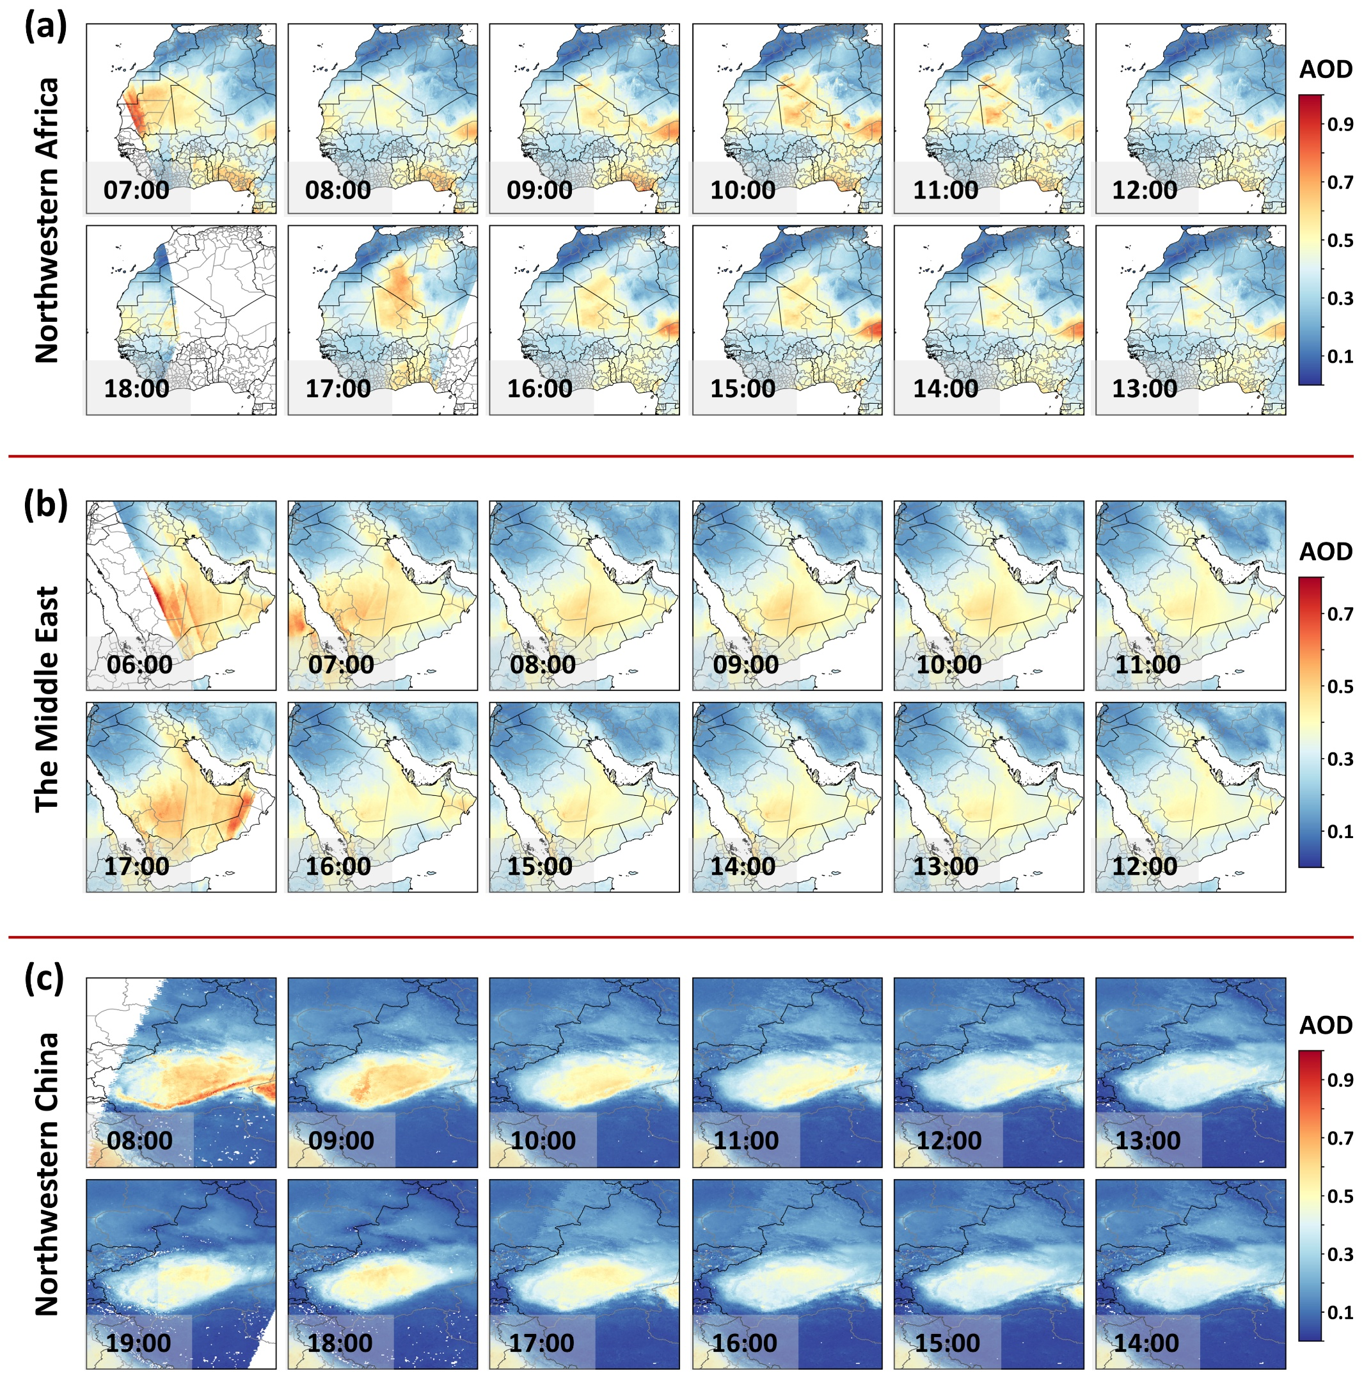

Figure S5. Hourly 2-km AOD distributions for 2021 over (a) northwestern Africa, (b) the Middle East, and (c) northwestern China, derived from GEO-Ring observations using the AeroTrans-GEO model during local daytime periods (07:00–18:00, 06:00–17:00, and 08:00–19:00, respectively).

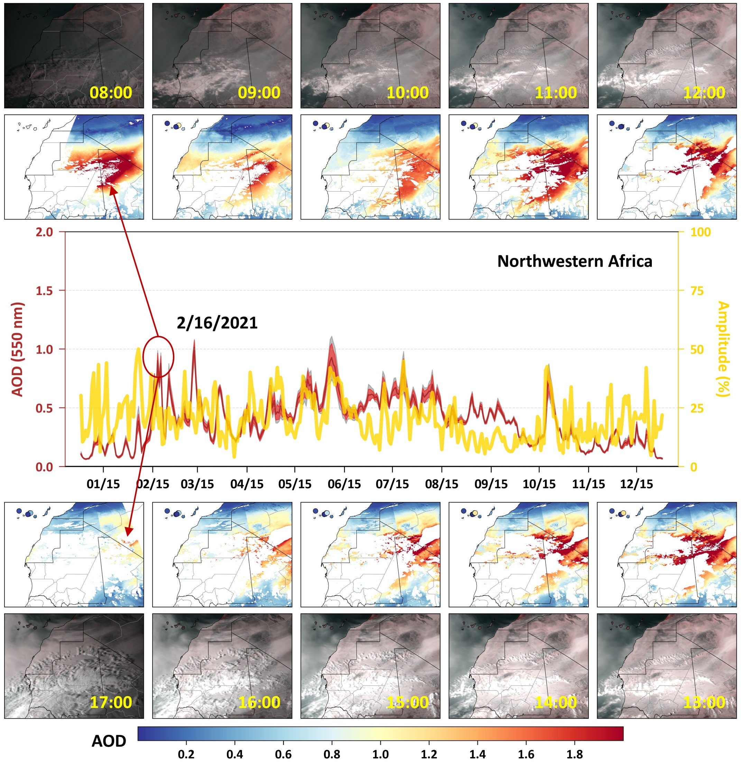

Figure S6. Diurnal variation of GEO-Ring AOD over northwestern Africa. Hourly AOD spatial patterns during a representative dust event (08:00–17:00 local time) on 16 February 2021, and the 2021 daily AOD time series showing the daily mean (red line), maximum–minimum range (red shading), ±1 standard deviation (gray shading), and diurnal aerosol amplitude (yellow line), defined as the difference between the maximum and minimum hourly AOD relative to the daily mean. The red circle marks the selected dust event day.

Figure S7. Hourly 2-km AOD distributions for 2021 over (a) the Indo-Gangetic Plain and (b) eastern China, derived from GEO-Ring observations using the AeroTrans-GEO model during the local daytime period (07:00–18:00 for both regions).

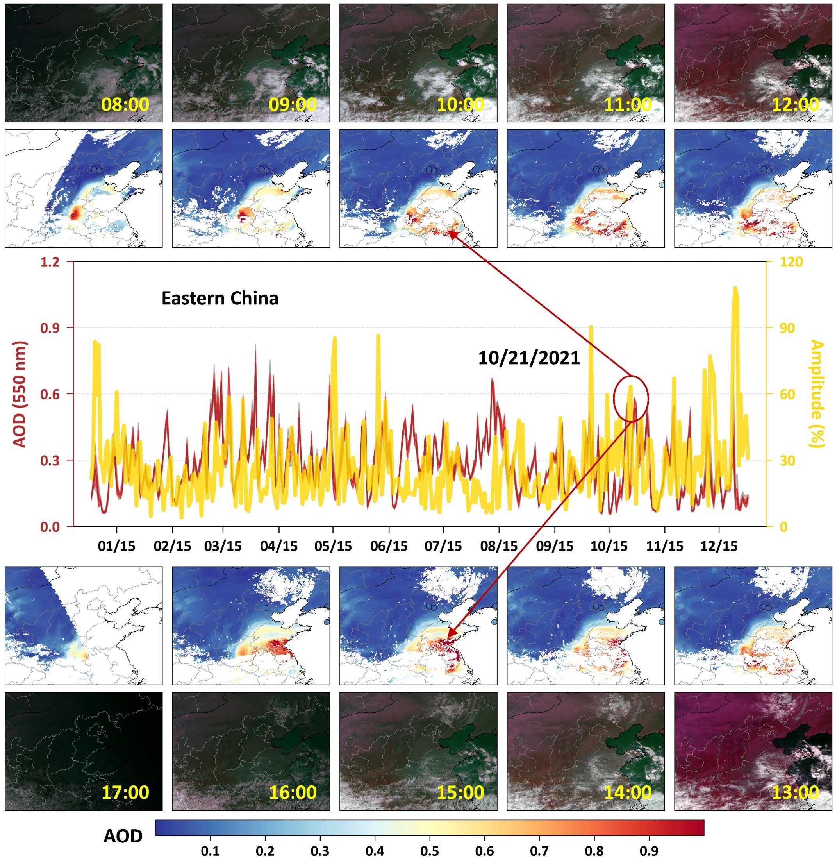

Figure S8. Diurnal variation of GEO-Ring AOD over eastern China. Hourly spatial patterns of AOD during a representative haze event (08:00–17:00 local time) on 15 December 2021, and the 2021 daily AOD time series showing the daily mean (red line), maximum–minimum range (red shading), ±1 standard deviation (gray shading), and diurnal aerosol amplitude (yellow line), defined as the difference between the maximum and minimum hourly AOD relative to the daily mean. The red circle marks the selected haze event day.

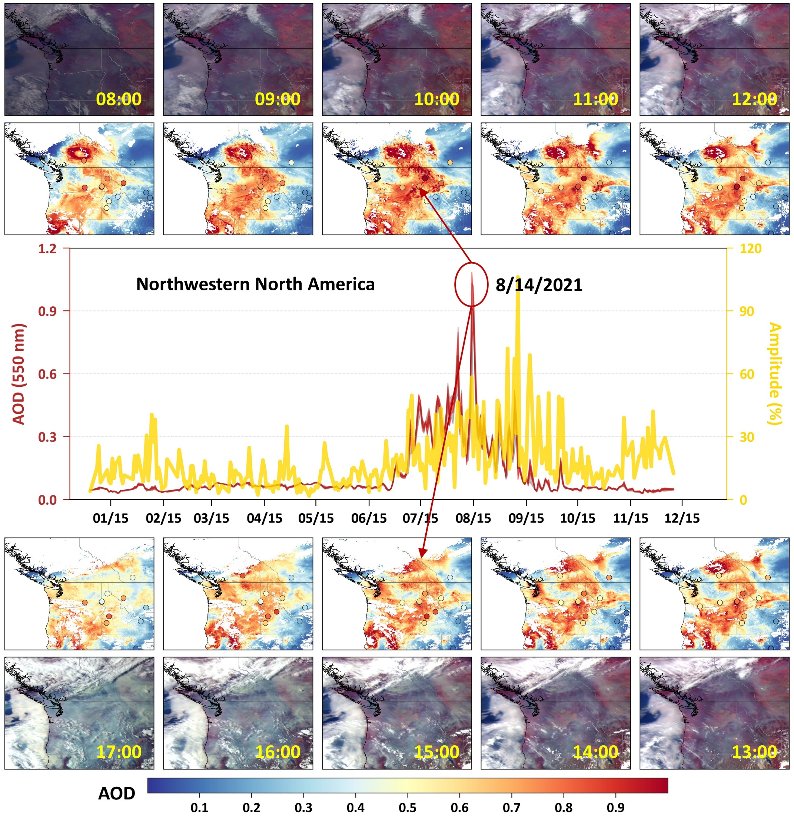

Figure S9. Diurnal variation of GEO-Ring AOD over northwestern North America. Hourly AOD spatial patterns during a representative wildfire event (08:00–17:00 local time) on 14 August 2021, and the 2021 daily AOD time series showing the daily mean (red line), maximum–minimum range (red shading), ±1 standard deviation (gray shading), and diurnal aerosol amplitude (yellow line), defined as the difference between the maximum and minimum hourly AOD relative to the daily mean. The red circle marks the selected wildfire event day.

Figure S10. Relative differences (%) between GEO-Ring and GEO-Ring-sampled (LEO-like overpass at 10:30 and 13:30 local time) daily AOD during 2021–2023.

Figure S11. Seasonal relative differences (%) between GEO-Ring and MODIS MAIAC daily AOD during 2021–2023, shown for (a) DJF (December–February), (b) MAM (March–May), (c) JJA (June–August), and (d) SON (September–November).

Figure S12. Diurnal AOD amplitude, defined as (maximum − minimum) / daily mean, from ground-based measurements during 2021–2023.
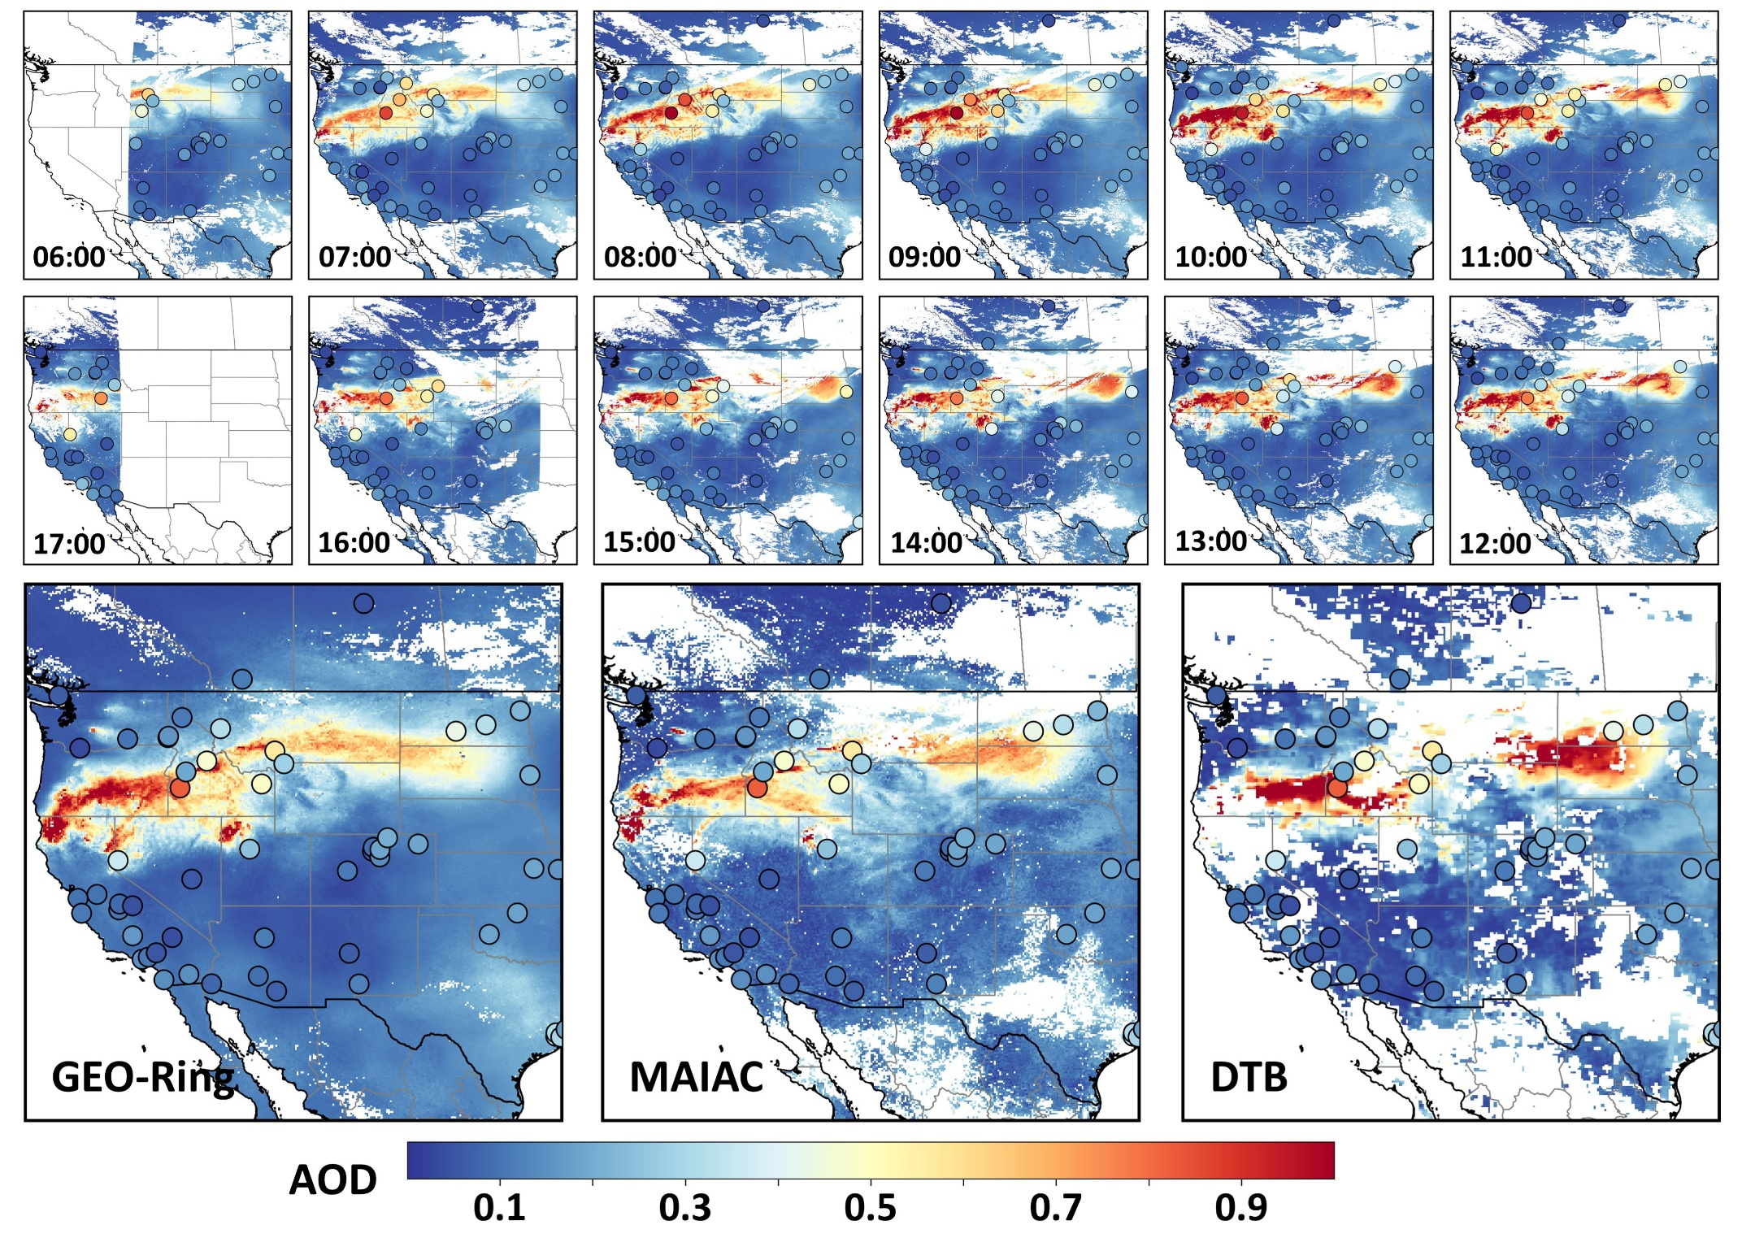

Figure S13. Diurnal distribution and variation of AOD from 06:00 to 17:00 local time (top), derived from GEO-Ring, and daily mean AOD from GEO-Ring, MAIAC, and DTB (bottom) over the northwestern United States during a representative wildfire event on 6 September 2021. Colored dots indicate ground-based AOD measurements.

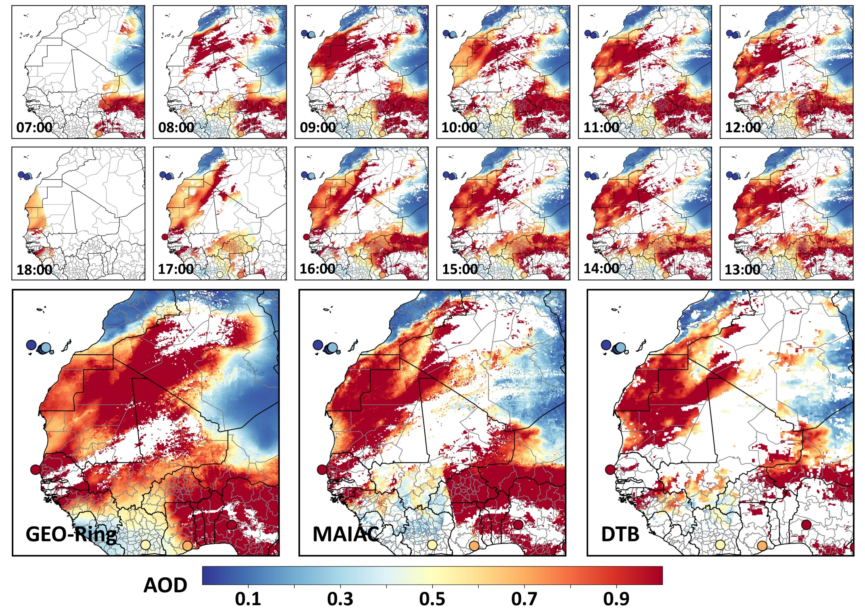

Figure S14. Diurnal distribution and variation of AOD from 07:00 to 18:00 local time (top), derived from GEO-Ring, and daily mean AOD from GEO-Ring, MAIAC, and DTB (bottom) over northwestern Africa during a representative dust storm event on 19 February 2021. Colored dots indicate ground-based AOD measurements.

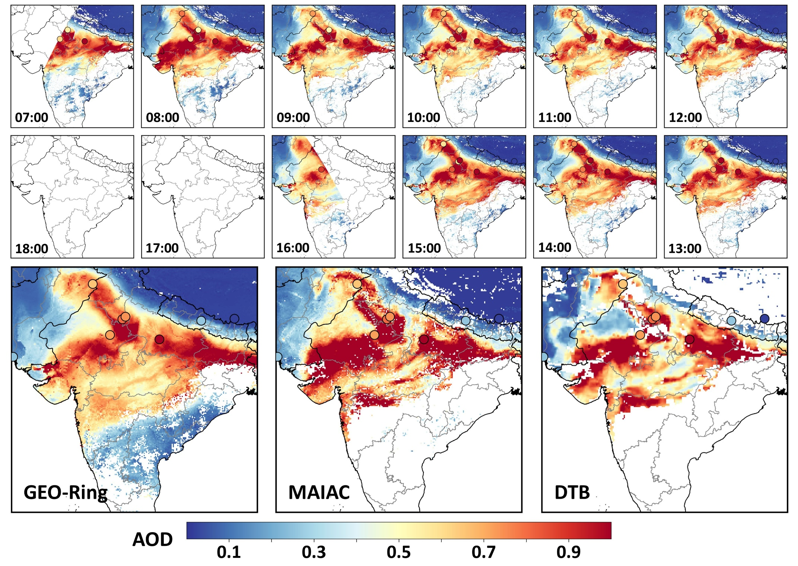

Figure S15. Diurnal distribution and variation of AOD from 07:00 to 18:00 local time (top), derived from GEO-Ring, and daily mean AOD from GEO-Ring, MAIAC, and DTB (bottom) over northern India during a representative haze-pollution event on 14 November 2021. Colored dots indicate ground-based AOD measurements.

Figure S16. Spatial distributions of spatial coverage and corresponding relative differences during 2013–2023 between GEO-Ring and various satellite retrieval algorithms and platforms, including MODIS Dark Target (DT), Dark Blue (DB), combined DT and DB (DTB), and Terra Multi-angle Imaging SpectroRadiometer (MISR). Insets show frequency histograms. Red numbers denote the mean values in the left panels and the percentage of pixels with positive differences in the right panels.

Figure S17. Spatial distributions of (a) AOD from AERONET, (b) relative AOD differences between AERONET and GEO-Ring, (c) DARE from AERONET, and (d) relative DARE differences between AERONET and GEO-Ring during 2013–2023. Dots represent all GEO-Ring–AERONET matched samples. Insets show frequency histograms. Red annotations denote the mean values in (a) and (c), and the percentage of pixels with positive differences in (b) and (d).

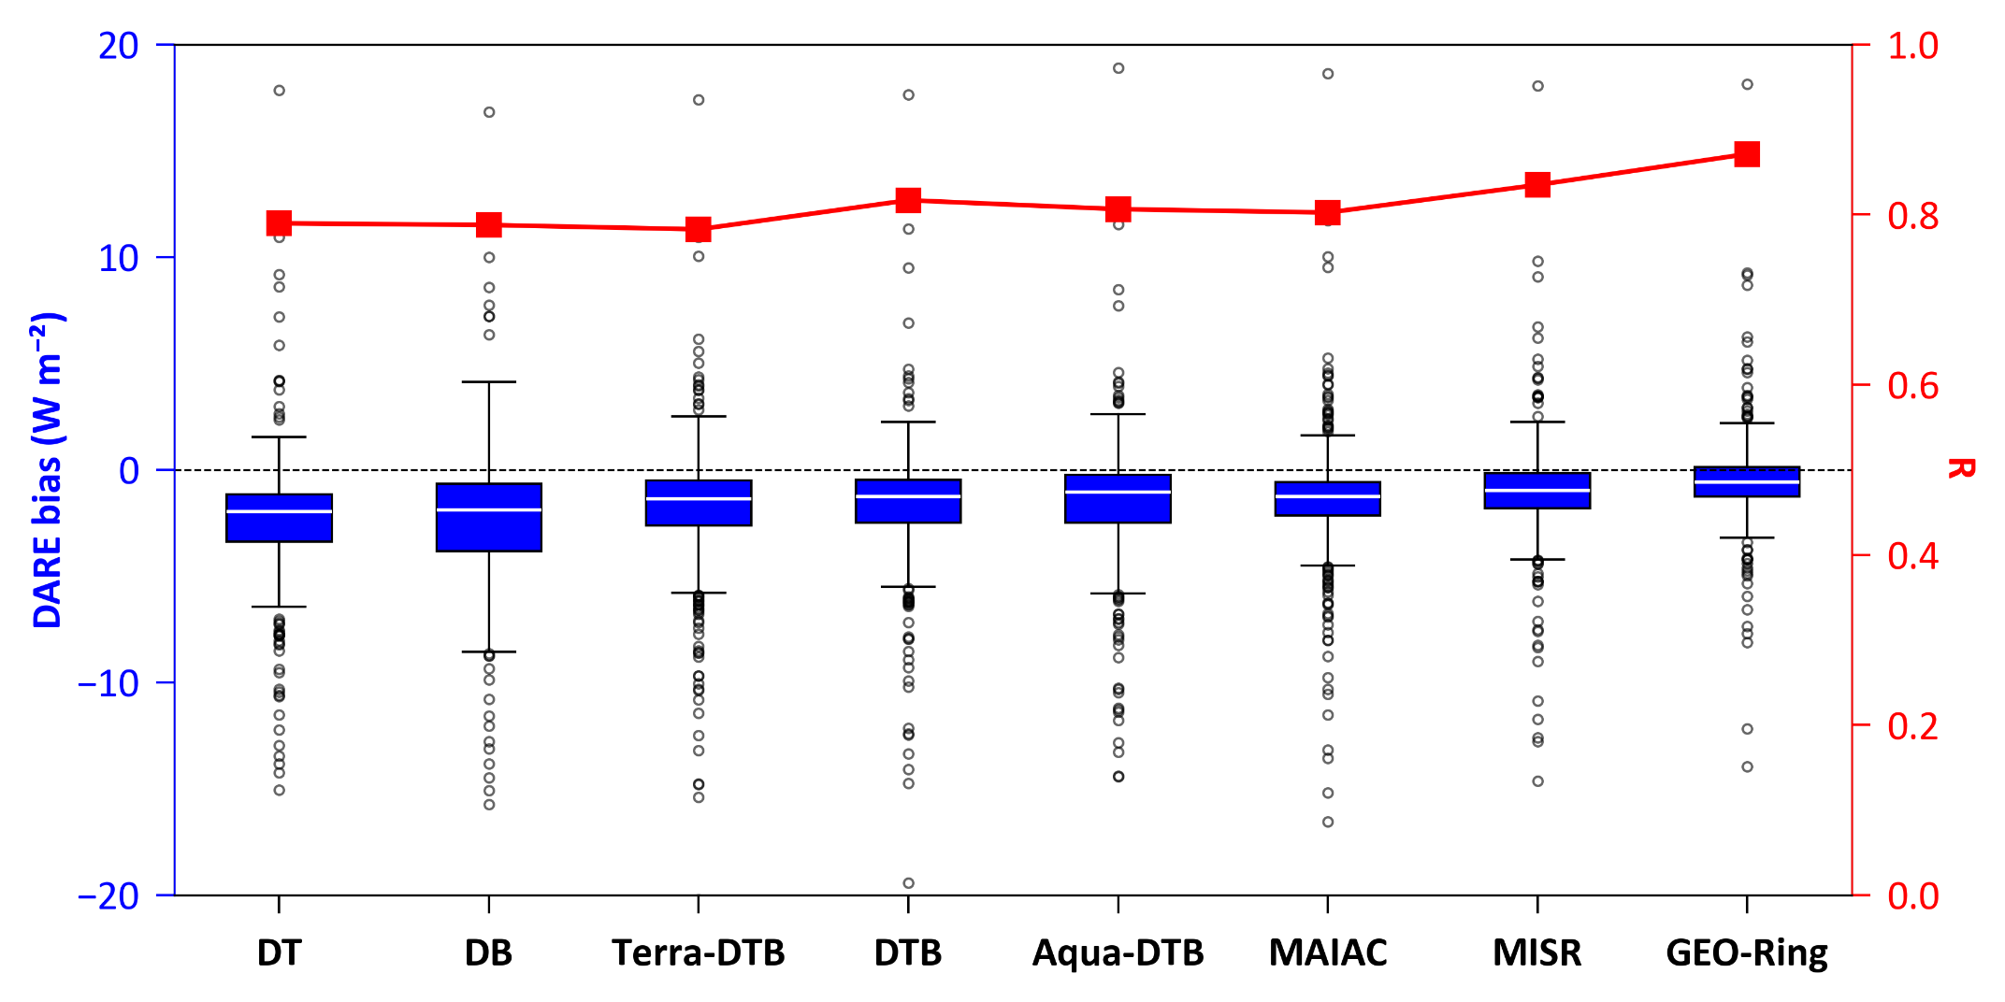

Figure S18. Boxplots (blue) of DARE bias and line plots (red) of the correlation coefficient (R) for satellite retrieval algorithms (DT, DB, DTB, and MAIAC) across platforms (MODIS, MISR, and GEO-Ring) relative to AERONET. Results are based on all satellite–AERONET matched samples. In the boxplots, circles denote outliers; black whiskers indicate the range (minimum and maximum values within 1.5 × the interquartile range); box boundaries represent the 25th and 75th percentiles; and the white horizontal line marks the median. The horizontal dotted line denotes zero bias.

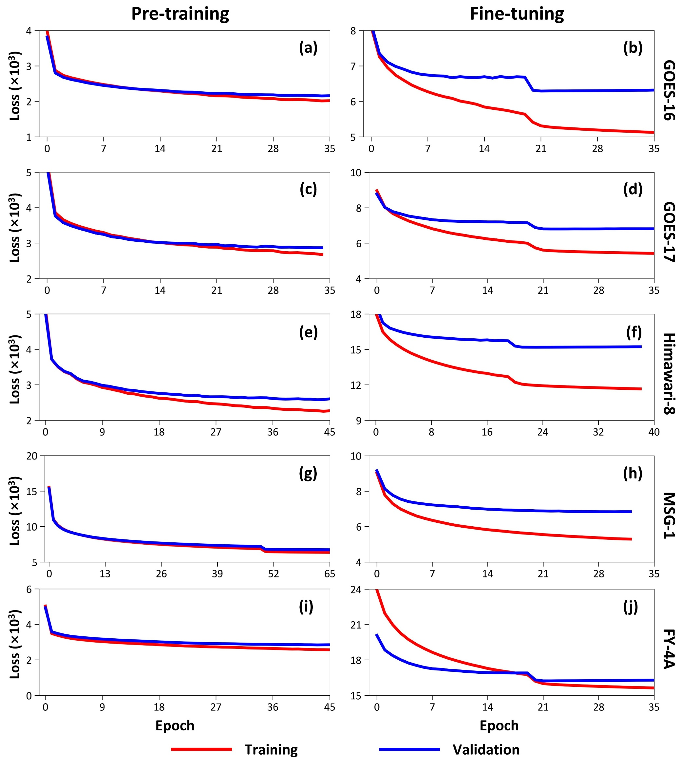

Figure S19. Training process of the AeroTrans-GEO model during pre-training and fine-tuning for different satellites in 2021: (a–b) GOES-16, (c–d) GOES-17, (e–f) Himawari-8, (g–h) MSG-1, and (i–j) FY-4A. The red line represents the training loss (×10³) computed from 80% of the samples, and the blue line represents the validation loss computed from the remaining 20%.

Figure S20. DARE model validation and uncertainties. Spatial distributions of (a) Pearson correlation coefficient (R) and (b) root mean square error (RMSE; W m⁻²) of DARE estimates against ground-based measurements during 2021–2023 at each monitoring station, and density scatterplots comparing estimated DARE with (c) AERONET measurements, (d) SBDART simulations using the sample-based ten-fold cross-validation (10CV) approach, and (e) SBDART simulations using the albedo-based 10-CV approach. In panels (c–e), the black solid line represents the 1:1 reference line, and the red solid line denotes the linear regression line.

Table S1. Summary and comparison of previous studies estimating global AOD and DARE.
Platform | Study region | AOD |  | DARE (W m⁻²) | Reference
Platform | Study region | Annual mean | Spatial resolution | Annual mean | Reference
AERONET | Selected main land regions | 0.22 | – | -7 | Zhou et al. (2005)¹
Terra MODIS DT | Land  (60°S–60°N) | 0.28 | 1° × 1° | -5.5 | Yu et al. (2006)²
Terra MISR | Land  (60°S–60°N) | 0.23 | 1° × 1° | -4.9 | Yu et al. (2006)²
Terra MISR | Land  (60°S–60°N) | 0.18 | 0.2° × 0.2° | -5.1 | Patadia et al. (2008)³
Terra MODIS DT | Land and Ocean | 0.16 | 1° × 1° | -6.8 | Zhao et al. (2011)⁴
Terra MODIS DT | Land  (60°S–60°N) | – | 1° × 1° | -4.72 | Ma et al. (2014)⁵*
MACv2 | Land and Ocean | 0.12 | 1° × 1° | -11.5 | Kinne et al. (2019)⁶*
Terra MODIS DT/DB, AATSR, and CALIPSO | Land and Ocean | 0.13-0.17 | 1° –5° | – | Bellouin et al. (2020)⁷
MODIS | Land and Ocean | 0.17 | 1° × 1° | -6.4 | IPCC (2023)⁸*
MODIS | Land | 0.18–0.25 | 0.1° × 0.1° | -6.8–-5.3 | This study
MISR | Land | 0.18 | 0.1° × 0.1° | -5.1 | This study
AERONET | Land | 0.17 | – | -4.9 | This study
GEO-Ring | Land | 0.17 | 0.1° × 0.1° | -3.8 | This study
*Results are converted to clear-sky TOA DARE following IPCC (2023) and the methodologies described in Ma et al. (2014) and Yu et al. (2006).

Table S2. Detailed specifications of GEO-Ring sensors.
Satellite (sensor) | Sub-satellite point | Coverage region | Nadir pixel* (km) | Full-disk cadence (min) | SNR* | Band center* (μm) | Bandwidth* (nm) | Employed* VIS-SWIR bands (μm)
GOES-18 (ABI) | 137.2°W | Americas (West) | 0.5–2.0 | 10 | >300 | 0.640 | 64 | 0.47, 0.64, 0.86, 1.61, 2.25
GOES-17 (ABI) | 137.2°W | Americas (West) | 0.5–2.0 | 10 | >300 | 0.640 | 64 | 0.47, 0.64, 0.86, 1.61, 2.25
GOES-16 (ABI) | 75.2°W | Americas (East) | 0.5–2.0 | 10 | >300 | 0.640 | 64 | 0.47, 0.64, 0.86, 1.61, 2.25
MSG-1 (SEVIRI) | 41.5°E | Europe-Africa | 3 | 15 | >30 | 0.635 | 71 | 0.64, 0.81, 1.64
MSG-2 (SEVIRI) | 45.5°E | Europe-Africa | 3 | 15 | >30 | 0.635 | 71 | 0.64, 0.81, 1.64
FY-4A (AGRI) | 104.7°E | Asia-Oceania (West) | 0.5–2.0 | 15 | >100 | 0.606 | 210 | 0.47, 0.65, 0.86, 1.38, 1.61, 2.25
Himawari-8 (AHI) | 140.7°E | Asia–Oceania (East) | 0.5–2.0 | 10 | >300 | 0.645 | 82 | 0.47, 0.51, 0.64, 0.86, 1.61, 2.26
Himawari-9 (AHI) | 140.7°E | Asia–Oceania (East) | 0.5–2.0 | 10 | >300 | 0.645 | 82 | 0.47, 0.51, 0.64, 0.86, 1.61, 2.26
*Notes:
- Nadir pixel denotes nominal Level-1 pixel size at the sub-satellite point. SEVIRI HRV (1 km) is panoramic and not used here.
- Employed bands approximately list VIS-SWIR channels used in this study.
- SNR stands for signal-to-noise ratio. Bandwidth refers full width at half maximum
- Cadence values refer to nominal full-disk scans; regional/rapid scans differ by platform.

Table S3. Summary of all datasets used in this study.
Dataset | Abbreviation | Content | Unit | Spatial Resolution | Temporal  Resolution | Data Source
AOD | GAOD | Ground-based AOD | – | In situ | 15 min | AERONET, SONET, and SKYNET
Radiative forcing | DARE | Aerosol radiative effect | W m⁻² | In situ | 15 min | AERONET
AOD | SAOD | Satellite AOD | – | 1 km (10 km) | Daily | MCD19A2 (MxD04)
AOD | MAOD | Model AOD | – | 0.5°× 0.625° | Hourly | MERRA-2
Satellite observation | TOA | Satellite TOA reflectance | – | 2–3 km | Hourly | GEO-Ring
Observation geometry | SZA | Solar zenith angle | ° | 2–3 km | Hourly | GEO-Ring
Observation geometry | VZA | View zenith angle | ° | 2–3 km | Hourly | GEO-Ring
Observation geometry | SAA | Solar azimuth angle | ° | 2–3 km | Hourly | GEO-Ring
Observation geometry | VAA | View azimuth angle | ° | 2–3 km | Hourly | GEO-Ring
Aerosol character | SSA | Single scatter albedo | – | 0.5°× 0.625° | Hourly | MERRA-2
 |  |  |  | 1° × 1° | Monthly | MACv3
Aerosol character | AF | Asymmetry factor | – | 0.5°× 0.625° | Hourly | MERRA-2
 |  |  |  | 1° × 1° | Monthly | MACv3
Absorbing gases | TOZ | Total ozone column | Dobsons | 0.5°× 0.625° | Hourly | MERRA-2
Absorbing gases | TPW | Total precipitable water | Kg m⁻² | 0.5°× 0.625° | Hourly | MERRA-2
Land surface | SA | Surface albedo | – | 1° × 1° | Monthly | SYN1deg
Land surface | DEM | Elevation model | m | 90 m | Annual | SRTM

Table S4. Parameter settings used for DARE estimation with the SBDART radiative transfer model.
Category | Name | Values
Aerosol | TBAER (AOD) | [0.001, 0.02, 0.05, 0.1, 0.2, 0.3, 0.4, 0.5, 0.6,0.7,0.8,0.9,1.25,1.5,2]
Aerosol | IAER | 5 (users)
Aerosol | WBAER (SSA) | [0.8,0.9,0.95,0.99]
Aerosol | GBAER (AF) | [0.6,0.7,0.8]
Cloud | LWP | 0 (clear sky)
Land surface | ALBCON (SA) | [0.01, 0.1, 0.2, 0.3, 0.4, 0.5, 0.6, 0.7, 0.8, 0.9]
Land surface | Lambert reflector | 0 (yes)
Solar geometry | SZA | [0°, 10°, 20°, 30°, 40°, 50°, 60°, 70°, 80°]
Atmosphere | IDATM | 6 (US Standard)
Spectral | wlinf | 0.25 µm
Spectral | wlsup | 4 µm

References:
1 Zhou, M. et al. A normalized description of the direct effect of key aerosol types on solar radiation as estimated from Aerosol Robotic Network aerosols and Moderate Resolution Imaging Spectroradiometer albedos. J. Geophys. Res. Atmos. 110 (2005).
2 Yu, H. et al. A review of measurement-based assessments of the aerosol direct radiative effect and forcing. Atmos. Chem. Phys. 6, 613-666 (2006).
3 Patadia, F. et al. First observational estimates of global clear sky shortwave aerosol direct radiative effect over land. Geophys. Res. Lett. 35 (2008).
4 Zhao, T. X. P. et al. Global component aerosol direct radiative effect at the top of atmosphere. Int. J. Remote Sens. 32, 633-655 (2011).
5 Ma, X. et al. Reassessment of satellite-based estimate of aerosol climate forcing. J. Geophys. Res. Atmos. 119, 10,394-310,409 (2014).
6 Kinne, S. Aerosol radiative effects with MACv2. Atmos. Chem. Phys. 19, 10919-10959 (2019).
7 Bellouin, N. et al. Bounding Global Aerosol Radiative Forcing of Climate Change. Rev. Geophys. 58, e2019RG000660 (2020).
8 IPCC. in Climate Change 2021 – The Physical Science Basis: Working Group I Contribution to the Sixth Assessment Report of the Intergovernmental Panel on Climate Change (ed Change Intergovernmental Panel on Climate) 923-1054 (Cambridge University Press, 2023).

