Adaptive and scalable catalyst discovery with composable intelligence
Wentao Li^{⸸1}, Qilong Cai^{⸸2}, Qi Lei^{⸸1}, Jinxing Chen², Ruixuan Chen¹, Jiangjie Qiu¹, Botian Wang³, Kai Zhao¹, Zemeng Wang¹, Yijun Li¹, Jun Yin², Fangfang Li⁵, Hongxuan Liu⁴, Yingdong Lu⁵, Yawen Ouyang³, Manu Suvarna⁶, Wei-Ying Ma³, Ya-Qin Zhang³, Kostya S. Novoselov⁷, Hao Zhou*^{3,8}, Jiong Lu*², Xiaonan Wang*¹
Affiliations:
¹ Beijing Key Laboratory of Artificial Intelligence for Advanced Chemical Engineering Materials, Department of Chemical Engineering, Tsinghua University, Beijing, China
² Department of Chemistry, National University of Singapore, Singapore, Singapore
³ Institute for AI Industry Research (AIR), Tsinghua University, Beijing, China
⁴ Department of Chemical Engineering, Massachusetts Institute of Technology, Cambridge, MA, USA
⁵ State Key Laboratory of Advanced Optical Polymer and Manufacturing Technology, Wanhua Chemical Group Co., Ltd., Yantai 264000, P. R. China
⁶ Department of Biotechnology & Enzyme Catalysis, University of Greifswald, Greifswald, Germany
⁷ Institute for Functional Intelligent Materials, National University of Singapore, Singapore, Singapore
⁸ Shanghai Artificial Intelligence Laboratory, Shanghai, China

Corresponding author
* Hao Zhou, Jiong Lu, Xiaonan Wang.
Email: zhouhao@air.tsinghua.edu.cn, chmluj@nus.edu.sg, wangxiaonan@tsinghua.edu.cn
Author Contributions
⸸ These authors contribute equally.

Supplementary Information
This Supplementary Information mirrors the main text and provides full technical detail for each component of CatAI. Section S1 describes the model architecture and pretrained module library. Section S2 summarizes baseline methods and presents benchmark evaluations that validate CatAI's universality, transferability, and module fusion mechanism. Section S3 details large-scale virtual screening for polyolefin elastomer catalysts. Section S4 describes closed-loop optimization for heterogeneous photocatalytic C–O coupling. Section S5 examines CatAI's extensibility through extensible learning experiments, life-cycle analysis of the discovered catalysts, and the community platform interface. Section S6 provides references, and Section S7 presents NMR spectra of purified products.
Contents
S1. Technical Architecture and Pretrained Module Library of CatAI 7
1.1 Geometric graph neural network backbone 8
1.2 The module library 10
S2. Benchmark Evaluation: Universality, Transferability, and Module Fusion 15
2.1 Baseline model descriptions 16
2.2 Benchmark results of general catalytic property prediction 19
2.3 Benchmark results of few-shot catalytic property prediction 22
2.4 Benchmark results of active learning minimal adsorption energy discovery 27
2.5 Benchmark results of domain catalytic property prediction 30
2.6 Ablation study of module fusion mechanism 32
S3. Large-Scale Virtual Screening for Polyolefin Elastomer Catalysts 35
3.1 Design space definition by literature mining 36
3.2 Computational workflow 38
3.3 Automated catalyst generation 43
3.4 Large-scale catalyst screening 47
3.5 Synthetic route of CPP-Zr 48
3.6 Catalyst performance and polymer property 52
S4. Closed-Loop Optimization for Heterogeneous Photocatalytic C–O Coupling 58
4.1 Design space definition by literature mining 59
4.2 Model architecture for active learning framework 60
4.3 Synthesis of optimized catalysts 61
4.4 Substrate scope 62
4.5 Catalyst performance comparison 66
4.6 Catalyst stability performance 67
S5. Extensibility: Extensible Learning, Life-Cycle Analysis, and Community Platform 68
5.1 Extensibility of CatAI 69
5.2 Life cycle analysis of CG-Ti and CPP-Zr 72
5.3 CatAI platform for community usage 77
S6. References 78
S7. NMR spectra of purified products 81

Supplementary Figures
Supplementary Fig 1. Property distribution in different module training dataset (Part 1). 13
Supplementary Fig 2. Property distribution in different module training dataset (Part 2). 14
Supplementary Fig 3. Per-round Active-learning average performance for adsorption-energy minimization. Mean optimization curves over 40 independent repeats for ten active-learning rounds targeting minimal *CH₂ (top) and *O (bottom) adsorption energies. Each panel reports the round-wise average of the best value identified so far and the corresponding Top-3 hit rate. 27
Supplementary Fig 4. Active-learning performance for identifying catalysts with minimal adsorption energies. The points along each horizontal line denote the minimum adsorption energies identified in individual runs, and the collection of 40 such values defines the corresponding empirical distribution. 28
Supplementary Fig 5. Active-learning performance for adsorption-energy minimization. Per-round mean minimal validation loss for *CH₂ (left) and *O (right) adsorption benchmarks, illustrating the rate at which different models improve under active learning. 29
Supplementary Fig 6. Literature-derived activity distribution of metallocene catalysts by metal center. 36
Supplementary Fig 7. Catalytic mechanisms for ethylene/1-octene copolymerization to POE. 38
Supplementary Fig 8. Energy profiles for the elementary steps catalyzed by Cat 2. 41
Supplementary Fig 9. Energy profiles for the elementary steps catalyzed by CPP-Zr. 42
Supplementary Fig 10. POE catalyst ligands with CatAI-predicted activity [10⁴ kg/(mol·h)]. 47
Supplementary Fig 11. Synthetic route of CPP-Zr. 48
Supplementary Fig 12. Morphological comparison of CG-Ti (left) and CPP-Zr (right). 51
Supplement Fig 13. Molecular weight characterization of polymer synthesized with CG-Ti. (a) GPC chromatogram and (b) molecular weight distribution. 55
Supplement Fig 14. Molecular weight characterization of polymer synthesized with CPP-Zr. (a) GPC chromatogram and (b) molecular weight distribution. 56
Supplement Fig 15. Macroscopic morphology of POE produced using CG-Ti (left) and CPP-Zr (right) catalysts. 57
Supplementary Fig 16. Architecture of the condition-encoded model. 60
Supplementary Fig 17. Catalyst performance comparison. 66
Supplementary Fig 18. Recycling experiment. 67
Supplementary Fig 19. Input information of CG-Ti for GWP prediction. 72
Supplementary Fig 20. Input information of CPP-Zr for GWP prediction. 73
Supplementary Fig 21. CatAI interface for catalyst property prediction. 77

Supplementary Tables
Supplementary Table 1. Hyperparameters of geometric graph neural network backbone. 9
Supplementary Table 2. Task taxonomy and data volume for the CatAI pretraining corpus across stability, mechanical, electronic, transport, thermodynamic and surface property prediction tasks. 10
Supplementary Table 3. Model performance on Alloy-GMAE (5-fold experiments). 19
Supplementary Table 4. Model performance on FG-GMAE (5-fold experiments). 19
Supplementary Table 5. Model performance on OCD-GMAE (5-fold experiments). 19
Supplementary Table 6. Model performance on Desorption-OC20 (5-fold experiments). 20
Supplementary Table 7. Model performance on Dissociation-OC20 (5-fold experiments). 20
Supplementary Table 8. Model performance on Transfer-OC20 (5-fold experiments). 21
Supplementary Table 9. Comparison between CatAI and the originally reported AdsMT results on Alloy-GMAE. (random split; different split partitions). 21
Supplementary Table 10. Comparison between CatAI and the originally reported AdsMT results on FG-GMAE. (random split; different split partitions). 21
Supplementary Table 11. Model performance on 8-shot Alloy-GMAE (5-fold experiments). 22
Supplementary Table 12. Model performance on 16-shot Alloy-GMAE (5-fold experiments). 22
Supplementary Table 13. Model performance on 32-shot Alloy-GMAE (5-fold experiments). 22
Supplementary Table 14. Model performance on 64-shot Alloy-GMAE (5-fold experiments). 23
Supplementary Table 15. Model performance on 128-shot Alloy-GMAE (5-fold experiments). 23
Supplementary Table 16. Model performance on 256-shot Alloy-GMAE (5-fold experiments). 24
Supplementary Table 17. Model performance on 8-shot FG-GMAE (5-fold experiments). 24
Supplementary Table 18. Model performance on 16-shot FG-GMAE (5-fold experiments). 24
Supplementary Table 19. Model performance on 32-shot FG-GMAE (5-fold experiments). 25
Supplementary Table 20. Model performance on 64-shot FG-GMAE (5-fold experiments). 25
Supplementary Table 21. Model performance on 128-shot FG-GMAE (5-fold experiments). 25
Supplementary Table 22. Model performance on 256-shot FG-GMAE (5-fold experiments). 26
Supplementary Table 23. Model performance on thermocatalysis ethylene binding energy (5-fold experiments). 30
Supplementary Table 24. Model performance on photocatalysis electron affinity energy (5-fold experiments). 30
Supplementary Table 25. Model performance on electrocatalysis OH* adsorption energy (5-fold experiments). 30
Supplementary Table 26. Model performance on electrocatalysis O* adsorption energy (5-fold experiments). 31
Supplementary Table 27. Ablation study of module fusion mechanism on Alloy-GMAE (5-fold experiments). 32
Supplementary Table 28. Ablation study of module fusion mechanism on FG-GMAE (5-fold experiments). 32
Supplementary Table 29. Ablation study of module fusion mechanism on OCD-GMAE (5-fold experiments). 32
Supplementary Table 30. Ablation study of module fusion mechanism on Desorption-OC20 (5-fold experiments). 33
Supplementary Table 31. Ablation study of module fusion mechanism on Dissociation-OC20 (5-fold experiments). 33
Supplementary Table 32. Ablation study of module fusion mechanism on Transfer-OC20 (5-fold experiments). 34
Supplementary Table 33. Visualization of automated generated structures. 44
Supplementary Table 34. Performance comparison of CatAI-recommended catalysts with previously reported POE catalysts. 52
Supplementary Table 35. Comparison of calculated and experimental catalyst activities. 53
Supplementary Table 36. CPP-Zr activity across reactor scales. 54
Supplementary Table 37. Properties introduced with each five-module increment in the extensible learning experiment. 69
Supplementary Table 38. Model performance on Alloy-GMAE with module increase (5-fold experiments). 69
Supplementary Table 39. Model performance on FG-GMAE with module increase (5-fold experiments). 70
Supplementary Table 40. Model performance on Dissociation-OC20 with module increase (5-fold experiments). 70
Supplementary Table 41. Model performance on Transfer-OC20 with module increase (5-fold experiments). 70
Supplementary Table 42. Life cycle inventory of CG-Ti. 74
Supplementary Table 43. Carbon footprint factor of CG-Ti. 74
Supplementary Table 44. Life cycle inventory of CatAI-designed catalyst CPP-Zr. 75
Supplementary Table 45. Carbon footprint factor of CatAI-designed catalyst CPP-Zr. 75

Technical Architecture and Pretrained Module Library of CatAI
CatAI rests on two design principles: a geometric graph neural network backbone that encodes rotation- and translation-equivariant atomic interactions, and a modular library of independently pretrained encoders, each targeting a distinct physicochemical property family. Section 1.1 describes the backbone architecture and hyperparameters; Section 1.2 details the composition and data sources of the 30-module pretrained library. Together, these components underpin the module fusion and task-specific adaptation presented in the main text.

Geometric graph neural network backbone
CatAI follows the JMP¹ architecture, using GemNet-OC² as its geometric backbone. GemNet-OC is a directional graph neural network designed for atomistic systems in which nodes represent atoms and edges represent interatomic interactions. GemNet-OC enriches message passing with distance-, angle-, and dihedral-informed geometric features by combining radial basis functions with angular bases. It extends beyond pairwise interactions by incorporating triplet and quadruplet coupling terms, enabling the model to represent higher-order local geometry that is important for catalysis-related energetics.
The hyperparameters of geometric graph neural network backbone are shown in Supplementary Table 1.

Supplementary Table 1. Hyperparameters of geometric graph neural network backbone.
Name | Value
Num spherical | 7
Num radial | 128
Num blocks | 6
Emb size atom | 256
Emb size edge | 1024
Emb size trip in | 64
Emb size trip out | 128
Emb size quad in | 64
Emb size quad out | 32
Emb size rbf | 32
Emb size sbf | 64
Num before skip | 2
Num after skip | 2
Cutoff (Å) | 12.0
Max neighbors | 30
Max neighbors aint | 1000
Rbf | Gaussian
Envelope | Polynomial (Exponent 5)
Cbf | Spherical harmonics
Sbf | Legendre outer
Extensive | True
Output init | HeOrthogonal
Activation | SiLU
Quad interaction | True
Atom edge interaction | True
Edge atom interaction | True
Atom interaction | True
Num atom emb layers | 2
Otf graph | True

The module library
Supplementary Table 2. Task taxonomy and data volume for the CatAI pretraining corpus across stability, mechanical, electronic, transport, thermodynamic and surface property prediction tasks.
Group | Property | Description | Size
Stability | MP formation energy³ | Formation energy ($ΔE_{f}$) relative to the constituent elemental reference states, quantifying the thermodynamic driving force for compound formation. | 132752
Stability | MP energy above hull³ | Energy above the convex hull ( $E_{hull}$), a thermodynamic metric of (meta)stability with respect to decomposition into competing phases. | 116625
Stability | Castelli formation energy⁴ | Formation energy ($ΔE_{f}$) relative to elemental reference states for perovskite compositions, quantifying the thermodynamic driving force for compound formation. | 18928
Stability | JARVIS formation energy⁵ | Formation energy ($ΔE_{f}$) relative to elemental reference states, quantifying the thermodynamic driving force for compound formation. | 25923
Stability | JARVIS total energy⁵ | Total energy from first-principles calculations, serving as the thermodynamic potential used to compare relative stability across structures. | 66119
Stability | OQMD energy above hull⁶ | Energy above the convex hull ($E_{hull}$), used to quantify phase stability within the OQMD dataset. | 207851
Stability | OQMD stability label⁶ | Binary/ordinal label indicating phase stability, typically based on whether a structure lies on or sufficiently close to the convex hull. | 201085
Stability | QMOF total energy^{7,8} | Total energy of the MOF system from electronic-structure calculations, used as the thermodynamic potential for assessing relative stability. | 31675
Mechanical | JARVIS shear modulus (VRH)⁵ | Shear modulus ($G_{VRH}$) obtained via Voigt–Reuss–Hill averaging, quantifying resistance to shear deformation. | 10855
Mechanical | JARVIS bulk modulus (VRH)⁵ | Bulk modulus ($K_{VRH}$) obtained via Voigt–Reuss–Hill averaging, quantifying resistance to volumetric compression. | 11028
Mechanical | MP shear modulus (VRH)³ | Shear modulus ($G_{VRH}$) obtained via Voigt–Reuss–Hill averaging, quantifying resistance to shear deformation. | 10987
Mechanical | MP bulk modulus (VRH)³ | Bulk modulus ($K_{VRH}$) obtained via Voigt–Reuss–Hill averaging, quantifying resistance to volumetric compression. | 10987
Electronic | MP band gap³ | Electronic band gap ($E_{g}$), defined as the energy separation between the valence-band maximum and the conduction-band minimum in semiconductors and insulators. | 106113
Electronic | MP Fermi level³ | Fermi level ($E_{F}$), i.e., the electronic chemical potential; operationally the highest occupied energy at 0 K. | 150980
Electronic | JARVIS band gap⁵ | Electronic band gap ($E_{g}$), defined as the energy separation between the valence-band maximum and the conduction-band minimum in semiconductors and insulators. | 23455
Electronic | Electronic energy⁹ | Total electronic energy of the system, representing the energy of the electronic state in the underlying quantum-mechanical description. | 108538
Electronic | Metal partial charge⁹ | Partial charge on the metal center derived from charge-density analysis (e.g., Bader-type partitioning). | 108538
Electronic | HOMO–LUMO gap⁹ | HOMO–LUMO gap, defined as the energy difference between the highest occupied molecular orbital and the lowest unoccupied molecular orbital. | 108538
Electronic | DOS Fermi level³ | Fermi level ($E_{F}$), i.e., the electronic chemical potential; operationally the highest occupied energy at 0 K. | 16044
Electronic | OQMD band gap⁶ | Electronic band gap ($E_{g}$), defined as the energy separation between the valence-band maximum and the conduction-band minimum in semiconductors and insulators. | 4889
Electronic | QMOF band gap^{7,8} | MOF electronic band gap ($E_{g}$), defined as the energy separation between the valence-band maximum and the conduction-band minimum. | 31675
Electronic | CEPDB power conversion efficiency¹⁰ | Power conversion efficiency (PCE), defined as the ratio of electrical output power to incident optical power under standardized illumination conditions. | 126315
Transport | n-type thermal conductivity¹¹ | Electronic thermal conductivity for n-type transport, describing heat carried by electrons under a temperature gradient. | 37390
Transport | p-type thermal conductivity¹¹ | Electronic thermal conductivity for p-type transport, describing heat carried by holes under a temperature gradient. | 37390
Transport | n-type electrical conductivity¹¹ | Electrical conductivity for n-type transport, describing charge carried by electrons under an applied electric field. | 37390
Transport | p-type electrical conductivity¹¹ | Electrical conductivity for p-type transport, describing charge carried by holes under an applied electric field. | 37390
Thermodynamic | Gibbs free energy | Gibbs free energy (G), the thermodynamic potential governing reaction spontaneity under constant temperature and pressure. | 16718
Thermodynamic | Activation energy barrier | Activation energy barrier ($E_{a}$) for catalytic elementary steps, capturing kinetic accessibility by the minimum energy required to reach the transition state. | 6350
Surface | Surface energy¹² | Surface energy (γ), the excess free energy per unit area associated with creating a surface from the bulk. | 4519
Surface | Single atom catalyst adsorption energy¹³ | Adsorption energy ($E_{ads}$), defined as the total-energy change upon binding an adsorbate to a catalyst surface. | 1648

Supplementary Fig 1. Property distribution in different module training dataset (Part 1).
Supplementary Fig 2. Property distribution in different module training dataset (Part 2).

Benchmark Evaluation: Universality, Transferability, and Module Fusion
This section documents the benchmark evaluation of CatAI. Section 2.1 summarizes the baseline methods. The remainder of this section evaluates CatAI along three axes: universality across catalytic property prediction tasks (Sections 2.2 and 2.5), transferability under data-scarce conditions via few-shot learning and active learning (Sections 2.3 and 2.4), and the contribution of the module fusion mechanism as assessed through ablation studies (Section 2.6).

Baseline model descriptions
CGCNN (Crystal Graph Convolutional Neural Network)¹⁴
CGCNN is an early and influential graph neural network designed specifically for periodic crystalline materials. It represents each crystal as a crystal graph in which nodes correspond to atoms and edges correspond to near-neighbour connections derived from the crystal structure. Each atom is initialized with a learnable embedding of its elemental identity, and each bond is encoded by a fixed-length feature vector that summarizes the local geometric relationship between two atoms, most notably interatomic distance and related radial descriptors.
DimeNet++¹⁵
DimeNet models atomistic systems with directional message passing that explicitly encodes local geometry. Messages are updated using both interatomic distances and angular information from atom triplets, where bond angles are expanded in a spherical Fourier–Bessel basis to capture orientation-dependent interactions. This design improves accuracy for properties that depend on local coordination geometry, but it is computationally demanding because message updates scale with the number of interacting pairs and triplets.
DimeNet++ retains the geometric inductive bias while reducing cost. It replaces the expensive bilinear interaction used in the directional block with an element-wise (Hadamard) product and compensates with lightweight MLPs applied to the basis features. In addition, it introduces down- and up-projection layers to use smaller embeddings in the most expensive parts of the network. These modifications preserve predictive performance while substantially improving efficiency.
GemNet-OC²
GemNet-OC is a directional graph neural network developed for large and chemically diverse catalytic datasets, in particular the Open Catalyst 2020 (OC20) benchmark. Building on the GemNet family, it augments atom–atom message passing with higher-order geometric context, including angular and dihedral information, to better represent the local coordination and reaction-relevant geometry that govern adsorption and surface reactivity.
To make such higher-order interactions practical at OC20 scale, GemNet-OC introduces architectural and implementation choices aimed at improving throughput while retaining accuracy, including an interaction hierarchy that better captures longer-range effects in extended adsorbate–surface systems.
Equiformer¹⁶
Equiformer is an E(3)-equivariant Transformer designed for 3D atomistic graphs, where atoms are nodes and geometry-dependent interactions are encoded on edges. Its core idea is to lift standard Transformer operations into an equivariant feature space built from irreducible representations, so that intermediate features and predictions transform correctly under rotations and translations. Practically, Equiformer combines equivariant attention with tensor-product–based mixing of scalar and higher-order features, allowing the model to exploit angular information beyond distance-only message passing.
eSCN (Equivariant Spherical Channel Network)¹⁷
eSCN is an SO(3)-equivariant graph neural network for atomistic systems that is built around a more efficient equivariant convolution operator. The key idea is to align each node embedding’s primary axis with the corresponding edge direction during message passing, which reduces the effective rotational freedom to SO(2). Under this alignment, the SO(3) tensor product becomes sparse, lowering the asymptotic cost from $O(L^{6})$ to $O(L^{3})$ in the representation degree $L$, while also removing the need to explicitly compute Clebsch–Gordan coefficients.
AdsMT (Adsorption Graph Transformer)¹⁸
AdsMT is a surface-specific graph Transformer for encoding catalyst slabs in adsorption-energy prediction. It addresses a key limitation of existing GNN encoders—insufficient discrimination between top-layer and subsurface atoms—by introducing a height-based positional encoding derived from each atom’s fractional elevation relative to the underlying atomic plane. Architecturally, AdsMT combines RBF-expanded interatomic distances with element embeddings and stacked attention layers, and implements an edge-wise attention mechanism that computes attention and messages per edge before updating node states with normalization. This physically informed design enhances surface-structure understanding while emphasising adsorption-active atomic environments.
JMP¹
JMP is an atomistic multi task model built on a shared GemNet-OC backbone. It encodes atoms and neighbouring pairs with a geometric message passing network, and couples this common 3D representation space to dataset specific energy and force heads for joint training across molecular and materials domains. In this way, JMP uses joint training over molecules and materials to produce transferable features for downstream atomic property prediction.
ORB-v2¹⁹
ORB-v2 is a universal neural network potential built on a graph network simulator with smoothed graph attention. It represents atomistic systems as periodic graphs, processes them through an encoder, a stack of message passing layers, and a decoder, and predicts energy, forces, and stress in a single forward pass. Rather than enforcing conservatism through energy gradients, ORB-v2 predicts forces directly and then imposes zero-net-force and torque corrections, which improves speed and scalability.
ORB-v3²⁰
ORB-v3 is a family of universal interatomic potentials that retains the basic architecture of ORB-v2 while varying three structural choices: whether forces and stress are obtained directly or as energy gradients, whether local graphs use a finite neighbour cap, and which training corpus defines the final model. In this design, conservative variants can be regularized by equigrad to improve learned rotational invariance, whereas direct sparse graph variants favor much lower latency and memory cost. ORB-v3 therefore organizes model design as a controlled trade-off between physical constraint and computational scale.

Benchmark results of general catalytic property prediction
Supplementary Table 3. Model performance on Alloy-GMAE (5-fold experiments).
Model name | Split 0 | Split 1 | Split 2 | Split 3 | Split 4 | Mean MAE
CGCNN | 0.157 | 0.128 | 0.120 | 0.135 | 0.125 | 0.133
SchNet | 0.140 | 0.121 | 0.113 | 0.111 | 0.120 | 0.121
DimeNet++ | 0.098 | 0.094 | 0.087 | 0.081 | 0.089 | 0.090
Equiformer | 0.117 | 0.107 | 0.092 | 0.091 | 0.109 | 0.103
ESCN | 0.123 | 0.114 | 0.100 | 0.103 | 0.113 | 0.111
GemNet-OC | 0.123 | 0.117 | 0.100 | 0.098 | 0.106 | 0.109
ADSMT | 0.109 | 0.101 | 0.085 | 0.095 | 0.099 | 0.098
JMP | 0.079 | 0.074 | 0.063 | 0.068 | 0.070 | 0.071
ORB-v2 | 0.074 | 0.073 | 0.061 | 0.065 | 0.077 | 0.070
ORB-v3 | 0.081 | 0.083 | 0.065 | 0.069 | 0.076 | 0.075
CatAI | 0.071 | 0.069 | 0.063 | 0.053 | 0.063 | 0.064

Supplementary Table 4. Model performance on FG-GMAE (5-fold experiments).
Model name | Split 0 | Split 1 | Split 2 | Split 3 | Split 4 | Mean MAE
CGCNN | 0.110 | 0.111 | 0.111 | 0.118 | 0.115 | 0.113
SchNet | 0.070 | 0.070 | 0.073 | 0.071 | 0.078 | 0.073
DimeNet++ | 0.038 | 0.044 | 0.042 | 0.042 | 0.040 | 0.041
Equiformer | 0.039 | 0.039 | 0.044 | 0.043 | 0.047 | 0.042
ESCN | 0.069 | 0.059 | 0.066 | 0.062 | 0.064 | 0.064
GemNet-OC | 0.048 | 0.054 | 0.054 | 0.053 | 0.057 | 0.053
ADSMT | 0.084 | 0.096 | 0.093 | 0.105 | 0.100 | 0.095
JMP | 0.034 | 0.044 | 0.045 | 0.041 | 0.040 | 0.041
ORB-v2 | 0.037 | 0.042 | 0.042 | 0.046 | 0.046 | 0.042
ORB-v3 | 0.060 | 0.051 | 0.064 | 0.068 | 0.062 | 0.061
CatAI | 0.030 | 0.034 | 0.031 | 0.038 | 0.045 | 0.036

Supplementary Table 5. Model performance on OCD-GMAE (5-fold experiments).
Model name | Split 0 | Split 1 | Split 2 | Split 3 | Split 4 | Mean MAE
CGCNN | 0.881 | 1.094 | 0.821 | 0.860 | 0.969 | 0.925
SchNet | 0.979 | 0.885 | 0.740 | 0.806 | 0.741 | 0.830
DimeNet++ | 0.715 | 0.661 | 0.633 | 0.708 | 0.653 | 0.674
Equiformer | 0.818 | 0.690 | 0.652 | 0.805 | 0.757 | 0.744
ESCN | 0.829 | 0.788 | 0.702 | 0.766 | 0.806 | 0.778
GemNet-OC | 0.774 | 0.748 | 0.742 | 0.799 | 0.697 | 0.752
ADSMT | 0.958 | 0.739 | 0.739 | 0.859 | 0.700 | 0.799
JMP | 0.813 | 0.707 | 0.666 | 0.658 | 0.741 | 0.717
ORB-v2 | 0.630 | 0.852 | 0.554 | 0.547 | 0.659 | 0.648
ORB-v3 | 0.580 | 0.672 | 0.530 | 0.587 | 0.801 | 0.634
CatAI | 0.607 | 0.521 | 0.568 | 0.551 | 0.619 | 0.573

Supplementary Table 6. Model performance on Desorption-OC20 (5-fold experiments).
Model name | Split 0 | Split 1 | Split 2 | Split 3 | Split 4 | Mean MAE
CGCNN | 0.449 | 0.464 | 0.648 | 0.783 | 0.824 | 0.634
SchNet | 0.481 | 0.555 | 0.599 | 0.697 | 0.841 | 0.634
DimeNet++ | 0.460 | 0.294 | 0.452 | 0.619 | 0.814 | 0.528
Equiformer | 0.652 | 0.456 | 0.657 | 0.871 | 0.818 | 0.691
ESCN | 0.570 | 0.479 | 0.515 | 0.726 | 0.851 | 0.628
GemNet-OC | 0.592 | 0.514 | 0.529 | 0.749 | 0.784 | 0.634
ADSMT | 0.377 | 0.655 | 0.828 | 0.917 | 0.741 | 0.703
JMP | 0.440 | 0.294 | 0.295 | 0.580 | 0.447 | 0.411
ORB-v2 | 0.359 | 0.441 | 0.320 | 0.501 | 0.670 | 0.458
ORB-v3 | 0.319 | 0.522 | 0.381 | 0.503 | 0.819 | 0.509
CatAI | 0.295 | 0.386 | 0.318 | 0.480 | 0.372 | 0.370

Supplementary Table 7. Model performance on Dissociation-OC20 (5-fold experiments).
Model name | Split 0 | Split 1 | Split 2 | Split 3 | Split 4 | Mean MAE
CGCNN | 0.863 | 0.635 | 0.813 | 1.137 | 0.672 | 0.824
SchNet | 1.080 | 1.115 | 1.243 | 1.039 | 0.579 | 1.011
DimeNet++ | 0.685 | 0.706 | 0.839 | 0.876 | 0.538 | 0.729
Equiformer | 0.975 | 1.078 | 1.249 | 1.069 | 0.601 | 0.994
ESCN | 0.697 | 0.728 | 0.939 | 1.091 | 0.547 | 0.800
GemNet-OC | 0.733 | 0.710 | 0.830 | 0.970 | 0.556 | 0.760
ADSMT | 0.731 | 0.709 | 0.741 | 0.980 | 0.578 | 0.748
JMP | 0.609 | 0.547 | 0.796 | 0.930 | 0.749 | 0.726
ORB-v2 | 0.592 | 0.707 | 0.821 | 0.971 | 0.592 | 0.737
ORB-v3 | 0.915 | 0.675 | 0.704 | 0.961 | 0.562 | 0.763
CatAI | 0.683 | 0.621 | 0.776 | 0.844 | 0.503 | 0.685

Supplementary Table 8. Model performance on Transfer-OC20 (5-fold experiments).
Model name | Split 0 | Split 1 | Split 2 | Split 3 | Split 4 | Mean MAE
CGCNN | 0.688 | 0.702 | 0.596 | 0.761 | 0.559 | 0.661
SchNet | 0.768 | 0.729 | 0.591 | 0.690 | 0.615 | 0.679
DimeNet++ | 0.670 | 0.627 | 0.552 | 0.679 | 0.583 | 0.622
Equiformer | 0.742 | 0.704 | 0.568 | 0.752 | 0.571 | 0.667
ESCN | 0.647 | 0.643 | 0.597 | 0.724 | 0.583 | 0.639
GemNet-OC | 0.652 | 0.632 | 0.552 | 0.676 | 0.590 | 0.620
ADSMT | 0.734 | 0.749 | 0.707 | 0.771 | 0.528 | 0.698
JMP | 0.628 | 0.609 | 0.506 | 0.689 | 0.523 | 0.591
ORB-v2 | 0.638 | 0.647 | 0.511 | 0.618 | 0.546 | 0.592
ORB-v3 | 0.677 | 0.662 | 0.704 | 0.958 | 0.660 | 0.732
CatAI | 0.648 | 0.596 | 0.520 | 0.554 | 0.564 | 0.576

Supplementary Table 9. Comparison between CatAI and the originally reported AdsMT results on Alloy-GMAE. (random split; different split partitions).
Model name | Mean MAE
AdsMT w/o transfer learning on OC20-LMAE | 0.143
AdsMT w transfer learning on OC20-LMAE | 0.140
CatAI | 0.065

Supplementary Table 10. Comparison between CatAI and the originally reported AdsMT results on FG-GMAE. (random split; different split partitions).
Model name | Mean MAE
AdsMT w/o transfer learning on OC20-LMAE | 0.095
AdsMT w transfer learning on OC20-LMAE | 0.094
CatAI | 0.036

Benchmark results of few-shot catalytic property prediction
Supplementary Table 11. Model performance on 8-shot Alloy-GMAE (5-fold experiments).
Model name | Split 0 | Split 1 | Split 2 | Split 3 | Split 4 | Mean MAE
CGCNN | 1.424 | 1.510 | 1.487 | 1.428 | 1.525 | 1.474
SchNet | 1.506 | 1.405 | 1.518 | 1.458 | 1.469 | 1.471
DimeNet++ | 1.395 | 1.396 | 1.548 | 1.444 | 1.495 | 1.455
Equiformer | 1.548 | 1.435 | 1.602 | 1.596 | 1.525 | 1.541
ESCN | 1.491 | 1.396 | 1.541 | 1.512 | 1.495 | 1.487
GemNet-OC | 1.500 | 1.404 | 1.545 | 1.516 | 1.504 | 1.494
ADSMT | 1.430 | 1.470 | 1.628 | 1.405 | 1.444 | 1.475
CatAI | 1.270 | 1.378 | 1.394 | 1.373 | 1.461 | 1.375

Supplementary Table 12. Model performance on 16-shot Alloy-GMAE (5-fold experiments).
Model name | Split 0 | Split 1 | Split 2 | Split 3 | Split 4 | Mean MAE
CGCNN | 1.423 | 1.452 | 1.547 | 1.419 | 1.454 | 1.459
SchNet | 1.540 | 1.419 | 1.650 | 1.406 | 1.586 | 1.520
DimeNet++ | 1.438 | 1.397 | 1.714 | 1.411 | 1.555 | 1.503
Equiformer | 1.554 | 1.438 | 1.780 | 1.539 | 1.608 | 1.584
ESCN | 1.613 | 1.397 | 1.702 | 1.434 | 1.558 | 1.541
GemNet-OC | 1.617 | 1.406 | 1.703 | 1.436 | 1.563 | 1.545
ADSMT | 1.381 | 1.453 | 1.643 | 1.364 | 1.525 | 1.473
CatAI | 1.075 | 1.385 | 1.508 | 1.289 | 1.450 | 1.341

Supplementary Table 13. Model performance on 32-shot Alloy-GMAE (5-fold experiments).
Model name | Split 0 | Split 1 | Split 2 | Split 3 | Split 4 | Mean MAE
CGCNN | 1.334 | 1.508 | 1.453 | 1.447 | 1.603 | 1.469
SchNet | 1.348 | 1.395 | 1.432 | 1.381 | 1.531 | 1.417
DimeNet++ | 1.384 | 1.394 | 1.525 | 1.368 | 1.498 | 1.434
Equiformer | 1.452 | 1.514 | 1.584 | 1.516 | 1.592 | 1.532
ESCN | 1.432 | 1.427 | 1.525 | 1.443 | 1.538 | 1.473
GemNet-OC | 1.420 | 1.430 | 1.523 | 1.416 | 1.493 | 1.456
ADSMT | 1.275 | 1.356 | 1.498 | 1.364 | 1.488 | 1.396
CatAI | 0.760 | 1.346 | 1.050 | 1.244 | 0.849 | 1.050

Supplementary Table 14. Model performance on 64-shot Alloy-GMAE (5-fold experiments).
Model name | Split 0 | Split 1 | Split 2 | Split 3 | Split 4 | Mean MAE
CGCNN | 1.334 | 1.409 | 1.459 | 1.396 | 1.425 | 1.405
SchNet | 1.283 | 1.280 | 1.415 | 1.353 | 1.479 | 1.362
DimeNet++ | 1.272 | 1.371 | 1.429 | 1.402 | 1.459 | 1.387
Equiformer | 1.338 | 1.251 | 1.383 | 1.408 | 1.485 | 1.373
ESCN | 1.440 | 1.393 | 1.499 | 1.435 | 1.491 | 1.452
GemNet-OC | 1.358 | 1.343 | 1.447 | 1.391 | 1.436 | 1.395
ADSMT | 1.122 | 1.196 | 1.200 | 1.380 | 1.127 | 1.205
CatAI | 0.455 | 0.878 | 0.909 | 0.745 | 0.574 | 0.712

Supplementary Table 15. Model performance on 128-shot Alloy-GMAE (5-fold experiments).
Model name | Split 0 | Split 1 | Split 2 | Split 3 | Split 4 | Mean MAE
CGCNN | 1.294 | 1.236 | 1.372 | 1.292 | 1.081 | 1.255
SchNet | 1.148 | 1.128 | 1.149 | 1.159 | 1.259 | 1.169
DimeNet++ | 1.087 | 0.933 | 1.323 | 0.815 | 1.328 | 1.097
Equiformer | 1.153 | 1.141 | 1.129 | 1.113 | 1.252 | 1.158
ESCN | 1.423 | 1.383 | 1.386 | 1.421 | 1.484 | 1.420
GemNet-OC | 1.205 | 1.176 | 1.204 | 1.177 | 1.266 | 1.206
ADSMT | 0.837 | 0.898 | 0.755 | 0.876 | 0.777 | 0.829
CatAI | 0.376 | 0.547 | 0.392 | 0.367 | 0.468 | 0.430

Supplementary Table 16. Model performance on 256-shot Alloy-GMAE (5-fold experiments).
Model name | Split 0 | Split 1 | Split 2 | Split 3 | Split 4 | Mean MAE
CGCNN | 0.639 | 0.616 | 0.809 | 0.604 | 0.681 | 0.670
SchNet | 0.857 | 0.883 | 0.849 | 0.817 | 0.933 | 0.868
DimeNet++ | 0.612 | 0.636 | 0.667 | 0.648 | 0.633 | 0.639
Equiformer | 0.704 | 0.826 | 0.779 | 0.705 | 0.826 | 0.768
ESCN | 1.325 | 1.269 | 1.230 | 1.282 | 1.336 | 1.288
GemNet-OC | 0.727 | 0.686 | 0.730 | 0.705 | 0.758 | 0.721
ADSMT | 0.496 | 0.477 | 0.493 | 0.491 | 0.509 | 0.493
CatAI | 0.276 | 0.322 | 0.269 | 0.355 | 0.299 | 0.304

Supplementary Table 17. Model performance on 8-shot FG-GMAE (5-fold experiments).
Model name | Split 0 | Split 1 | Split 2 | Split 3 | Split 4 | Mean MAE
CGCNN | 0.544 | 0.486 | 0.606 | 0.487 | 0.471 | 0.519
SchNet | 0.547 | 0.578 | 0.520 | 0.479 | 0.509 | 0.527
DimeNet++ | 0.524 | 0.515 | 0.480 | 0.467 | 0.488 | 0.495
Equiformer | 0.575 | 0.605 | 0.536 | 0.501 | 0.515 | 0.546
ESCN | 0.584 | 0.548 | 0.516 | 0.488 | 0.546 | 0.536
GemNet-OC | 0.580 | 0.540 | 0.510 | 0.481 | 0.536 | 0.530
ADSMT | 0.504 | 0.522 | 0.561 | 0.468 | 0.494 | 0.510
CatAI | 0.460 | 0.478 | 0.499 | 0.454 | 0.519 | 0.482

Supplementary Table 18. Model performance on 16-shot FG-GMAE (5-fold experiments).
Model name | Split 0 | Split 1 | Split 2 | Split 3 | Split 4 | Mean MAE
CGCNN | 0.525 | 0.568 | 0.535 | 0.466 | 0.521 | 0.523
SchNet | 0.479 | 0.555 | 0.522 | 0.493 | 0.577 | 0.525
DimeNet++ | 0.472 | 0.529 | 0.432 | 0.468 | 0.508 | 0.482
Equiformer | 0.547 | 0.572 | 0.590 | 0.495 | 0.556 | 0.552
ESCN | 0.576 | 0.535 | 0.511 | 0.489 | 0.558 | 0.534
GemNet-OC | 0.567 | 0.523 | 0.511 | 0.482 | 0.551 | 0.527
ADSMT | 0.431 | 0.545 | 0.501 | 0.434 | 0.488 | 0.480
CatAI | 0.374 | 0.502 | 0.488 | 0.396 | 0.431 | 0.438

Supplementary Table 19. Model performance on 32-shot FG-GMAE (5-fold experiments).
Model name | Split 0 | Split 1 | Split 2 | Split 3 | Split 4 | Mean MAE
CGCNN | 0.432 | 0.469 | 0.444 | 0.507 | 0.493 | 0.469
SchNet | 0.371 | 0.490 | 0.491 | 0.532 | 0.473 | 0.471
DimeNet++ | 0.325 | 0.382 | 0.398 | 0.479 | 0.409 | 0.399
Equiformer | 0.386 | 0.565 | 0.489 | 0.508 | 0.476 | 0.485
ESCN | 0.538 | 0.537 | 0.503 | 0.488 | 0.536 | 0.521
GemNet-OC | 0.511 | 0.519 | 0.480 | 0.481 | 0.508 | 0.500
ADSMT | 0.392 | 0.460 | 0.408 | 0.461 | 0.443 | 0.433
CatAI | 0.284 | 0.415 | 0.371 | 0.463 | 0.357 | 0.378

Supplementary Table 20. Model performance on 64-shot FG-GMAE (5-fold experiments).
Model name | Split 0 | Split 1 | Split 2 | Split 3 | Split 4 | Mean MAE
CGCNN | 0.441 | 0.451 | 0.415 | 0.451 | 0.417 | 0.435
SchNet | 0.372 | 0.486 | 0.385 | 0.435 | 0.360 | 0.408
DimeNet++ | 0.397 | 0.332 | 0.281 | 0.384 | 0.296 | 0.338
Equiformer | 0.440 | 0.454 | 0.360 | 0.458 | 0.421 | 0.426
ESCN | 0.548 | 0.534 | 0.508 | 0.487 | 0.534 | 0.522
GemNet-OC | 0.519 | 0.508 | 0.475 | 0.461 | 0.491 | 0.491
ADSMT | 0.381 | 0.350 | 0.380 | 0.394 | 0.374 | 0.376
CatAI | 0.238 | 0.286 | 0.248 | 0.428 | 0.383 | 0.316

Supplementary Table 21. Model performance on 128-shot FG-GMAE (5-fold experiments).
Model name | Split 0 | Split 1 | Split 2 | Split 3 | Split 4 | Mean MAE
CGCNN | 0.370 | 0.423 | 0.413 | 0.422 | 0.423 | 0.410
SchNet | 0.240 | 0.294 | 0.313 | 0.266 | 0.298 | 0.282
DimeNet++ | 0.190 | 0.226 | 0.202 | 0.194 | 0.217 | 0.206
Equiformer | 0.216 | 0.296 | 0.298 | 0.236 | 0.291 | 0.267
ESCN | 0.516 | 0.535 | 0.487 | 0.476 | 0.514 | 0.505
GemNet-OC | 0.449 | 0.489 | 0.435 | 0.422 | 0.447 | 0.449
ADSMT | 0.327 | 0.328 | 0.357 | 0.303 | 0.341 | 0.331
CatAI | 0.167 | 0.205 | 0.209 | 0.187 | 0.220 | 0.197

Supplementary Table 22. Model performance on 256-shot FG-GMAE (5-fold experiments).
Model name | Split 0 | Split 1 | Split 2 | Split 3 | Split 4 | Mean MAE
CGCNN | 0.211 | 0.382 | 0.240 | 0.218 | 0.264 | 0.263
SchNet | 0.200 | 0.231 | 0.208 | 0.218 | 0.250 | 0.221
DimeNet++ | 0.124 | 0.137 | 0.142 | 0.142 | 0.140 | 0.137
Equiformer | 0.159 | 0.146 | 0.191 | 0.186 | 0.185 | 0.173
ESCN | 0.406 | 0.426 | 0.401 | 0.384 | 0.405 | 0.404
GemNet-OC | 0.341 | 0.396 | 0.342 | 0.335 | 0.365 | 0.356
ADSMT | 0.227 | 0.210 | 0.212 | 0.221 | 0.289 | 0.232
CatAI | 0.110 | 0.139 | 0.112 | 0.134 | 0.161 | 0.131

Benchmark results of active learning minimal adsorption energy discovery
Supplementary Fig 3. Per-round Active-learning average performance for adsorption-energy minimization. Mean optimization curves over 40 independent repeats for ten active-learning rounds targeting minimal *CH₂ (top) and *O (bottom) adsorption energies. Each panel reports the round-wise average of the best value identified so far and the corresponding Top-3 hit rate.

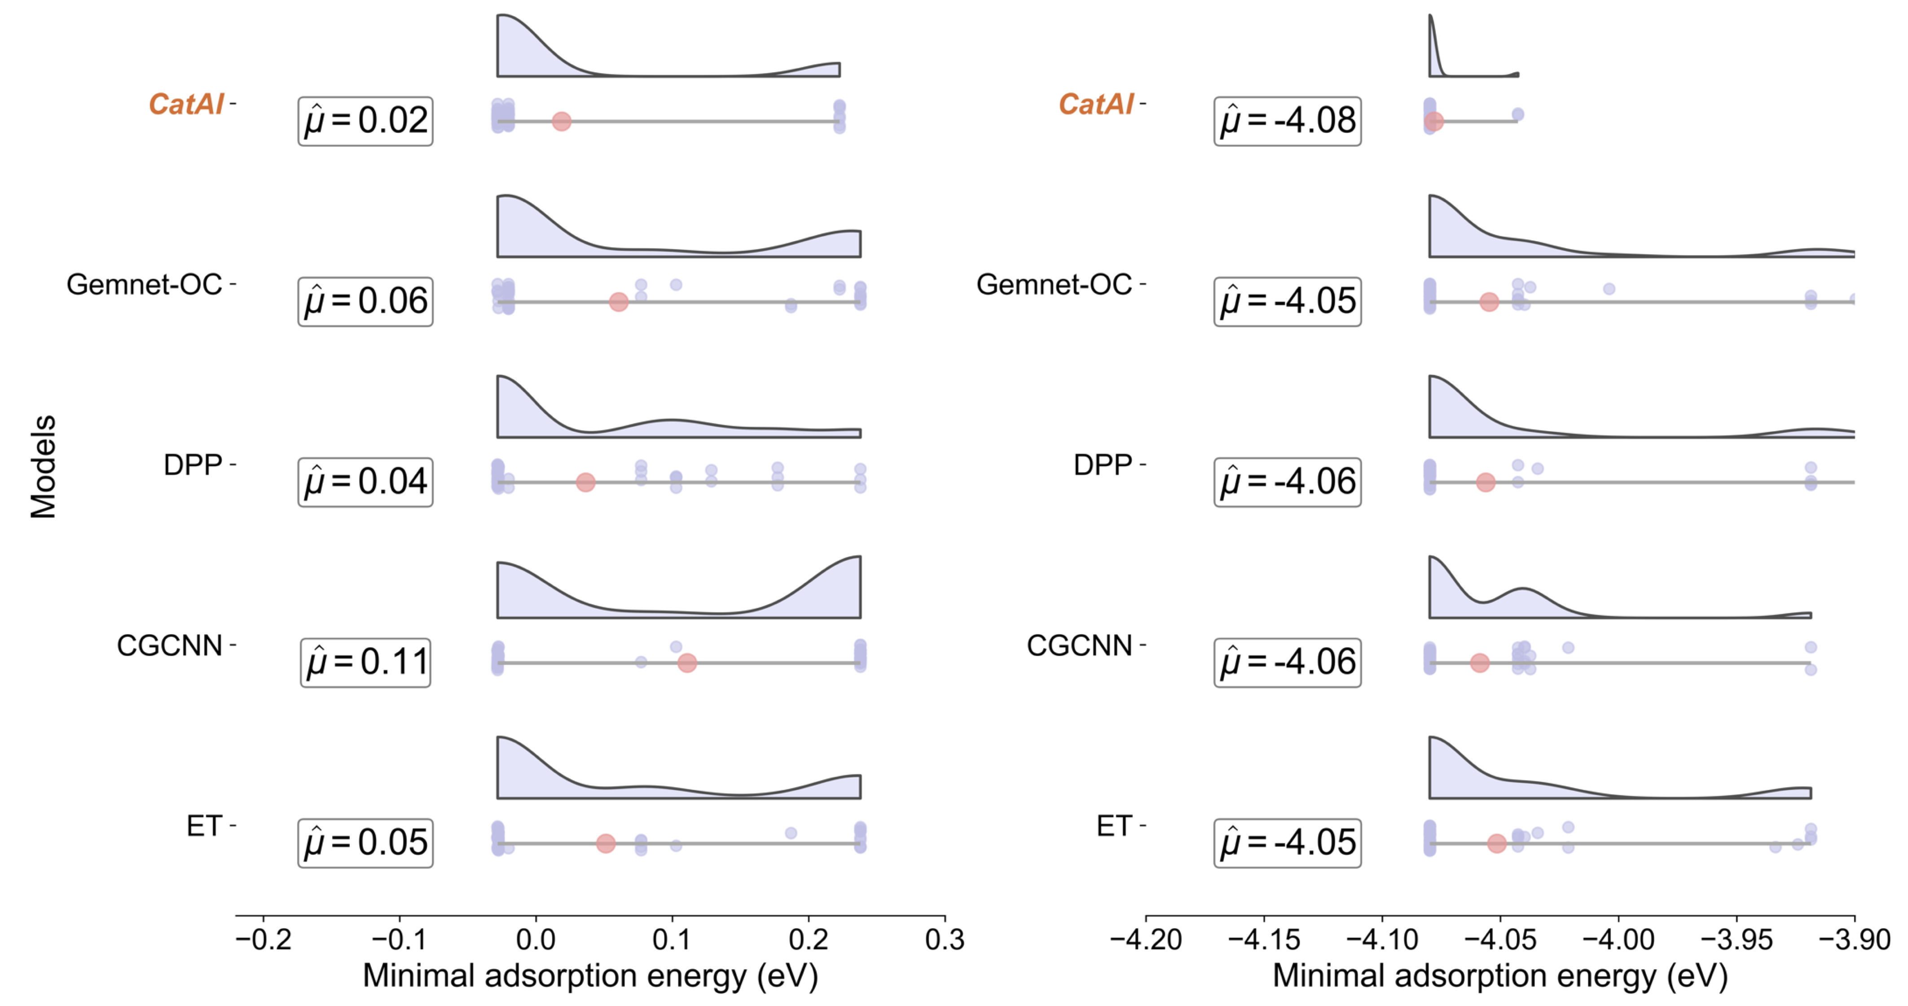
Supplementary Fig 4. Active-learning performance for identifying catalysts with minimal adsorption energies. The points along each horizontal line denote the minimum adsorption energies identified in individual runs, and the collection of 40 such values defines the corresponding empirical distribution.

Supplementary Fig 5. Active-learning performance for adsorption-energy minimization. Per-round mean minimal validation loss for *CH₂ (left) and *O (right) adsorption benchmarks, illustrating the rate at which different models improve under active learning.

Benchmark results of domain catalytic property prediction
Supplementary Table 23. Model performance on thermocatalysis ethylene binding energy (5-fold experiments).
Model name | Split 0 | Split 1 | Split 2 | Split 3 | Split 4 | Mean MAE
CGCNN | 0.338 | 0.361 | 0.315 | 0.551 | 0.329 | 0.379
SchNet | 0.440 | 0.353 | 0.321 | 0.333 | 0.277 | 0.345
DimeNet++ | 0.413 | 0.264 | 0.424 | 0.331 | 0.309 | 0.348
Equiformer | 0.362 | 0.291 | 0.344 | 0.383 | 0.319 | 0.340
ESCN | 0.440 | 0.353 | 0.321 | 0.333 | 0.277 | 0.345
GemNet-OC | 0.442 | 0.330 | 0.317 | 0.340 | 0.268 | 0.339
ADSMT | 0.367 | 0.263 | 0.466 | 0.526 | 0.145 | 0.353
JMP | 0.355 | 0.300 | 0.201 | 0.250 | 0.536 | 0.328
ORB-v2 | 0.380 | 0.250 | 0.400 | 0.370 | 0.260 | 0.332
ORB-v3 | 0.340 | 0.170 | 0.350 | 0.380 | 0.320 | 0.312
CatAI | 0.322 | 0.259 | 0.306 | 0.357 | 0.232 | 0.295

Supplementary Table 24. Model performance on photocatalysis electron affinity energy (5-fold experiments).
Model name | Split 0 | Split 1 | Split 2 | Split 3 | Split 4 | Mean MAE
CGCNN | 0.008 | 0.027 | 0.010 | 0.008 | 0.008 | 0.012
SchNet | 0.028 | 0.030 | 0.026 | 0.021 | 0.023 | 0.026
DimeNet++ | 0.005 | 0.024 | 0.004 | 0.004 | 0.006 | 0.009
Equiformer | 0.004 | 0.023 | 0.005 | 0.003 | 0.004 | 0.008
ESCN | 0.051 | 0.065 | 0.047 | 0.041 | 0.040 | 0.049
GemNet-OC | 0.016 | 0.031 | 0.015 | 0.012 | 0.014 | 0.017
ADSMT | 0.020 | 0.034 | 0.016 | 0.017 | 0.020 | 0.021
JMP | 0.024 | 0.031 | 0.053 | 0.045 | 0.029 | 0.036
ORB-v2 | 0.029 | 0.041 | 0.026 | 0.029 | 0.027 | 0.030
ORB-v3 | 0.034 | 0.048 | 0.026 | 0.025 | 0.029 | 0.033
CatAI | 0.005 | 0.004 | 0.024 | 0.007 | 0.004 | 0.009

Supplementary Table 25. Model performance on electrocatalysis OH* adsorption energy (5-fold experiments).
Model name | Split 0 | Split 1 | Split 2 | Split 3 | Split 4 | Mean MAE
CGCNN | 0.519 | 0.452 | 0.495 | 0.578 | 0.457 | 0.500
SchNet | 0.507 | 0.707 | 0.519 | 0.635 | 0.426 | 0.559
DimeNet++ | 0.451 | 0.467 | 0.578 | 0.625 | 0.452 | 0.515
Equiformer | 0.474 | 0.366 | 0.547 | 0.615 | 0.424 | 0.485
ESCN | 0.980 | 0.893 | 0.952 | 1.108 | 1.113 | 1.009
GemNet-OC | 0.680 | 0.900 | 0.704 | 0.844 | 1.027 | 0.831
ADSMT | 0.508 | 0.374 | 0.520 | 0.601 | 0.439 | 0.488
JMP | 0.410 | 0.553 | 0.467 | 0.634 | 0.575 | 0.528
ORB-v2 | 0.431 | 0.382 | 0.493 | 0.667 | 0.361 | 0.467
ORB-v3 | 0.447 | 0.579 | 0.624 | 0.520 | 0.523 | 0.538
CatAI | 0.346 | 0.525 | 0.477 | 0.525 | 0.444 | 0.463

Supplementary Table 26. Model performance on electrocatalysis O* adsorption energy (5-fold experiments).
Model name | Split 0 | Split 1 | Split 2 | Split 3 | Split 4 | Mean MAE
CGCNN | 0.500 | 0.612 | 0.512 | 0.481 | 0.500 | 0.521
SchNet | 0.669 | 0.891 | 0.666 | 0.651 | 0.565 | 0.688
DimeNet++ | 0.561 | 0.678 | 0.575 | 0.646 | 0.585 | 0.609
Equiformer | 0.433 | 0.615 | 0.426 | 0.459 | 0.487 | 0.484
ESCN | 1.698 | 1.638 | 1.361 | 1.180 | 1.621 | 1.500
GemNet-OC | 1.072 | 1.175 | 1.435 | 1.258 | 0.931 | 1.174
ADSMT | 0.435 | 0.529 | 0.453 | 0.490 | 0.579 | 0.497
JMP | 0.684 | 0.673 | 0.832 | 0.704 | 0.373 | 0.653
ORB-v2 | 0.383 | 0.539 | 0.682 | 0.474 | 0.507 | 0.517
ORB-v3 | 0.430 | 0.494 | 0.509 | 0.738 | 0.424 | 0.519
CatAI | 0.438 | 0.512 | 0.690 | 0.493 | 0.310 | 0.489

Ablation study of module fusion mechanism
Supplementary Table 27. Ablation study of module fusion mechanism on Alloy-GMAE (5-fold experiments).
Model name | Split 0 | Split 1 | Split 2 | Split 3 | Split 4 | Mean MAE
MP formation energy | 0.077 | 0.072 | 0.062 | 0.066 | 0.073 | 0.070
MP band gap | 0.107 | 0.093 | 0.086 | 0.089 | 0.094 | 0.094
Single atom catalyst adsorption energy | 0.093 | 0.091 | 0.076 | 0.080 | 0.090 | 0.086
Random Select 1 | 0.096 | 0.091 | 0.081 | 0.086 | 0.089 | 0.089
Random Select 2 | 0.104 | 0.089 | 0.086 | 0.085 | 0.092 | 0.091
Multi-task | 0.079 | 0.074 | 0.063 | 0.068 | 0.070 | 0.071
CatAI | 0.071 | 0.069 | 0.063 | 0.053 | 0.063 | 0.064

Supplementary Table 28. Ablation study of module fusion mechanism on FG-GMAE (5-fold experiments).
Model name | Split 0 | Split 1 | Split 2 | Split 3 | Split 4 | Mean MAE
MP formation energy | 0.044 | 0.041 | 0.043 | 0.043 | 0.048 | 0.044
MP band gap | 0.042 | 0.047 | 0.045 | 0.047 | 0.051 | 0.046
Single atom catalyst adsorption energy | 0.044 | 0.050 | 0.051 | 0.047 | 0.055 | 0.050
Random Select 1 | 0.044 | 0.043 | 0.047 | 0.049 | 0.052 | 0.047
Random Select 2 | 0.040 | 0.041 | 0.053 | 0.045 | 0.057 | 0.047
Multi-task | 0.034 | 0.044 | 0.045 | 0.041 | 0.040 | 0.041
CatAI | 0.030 | 0.034 | 0.031 | 0.038 | 0.045 | 0.036

Supplementary Table 29. Ablation study of module fusion mechanism on OCD-GMAE (5-fold experiments).
Model name | Split 0 | Split 1 | Split 2 | Split 3 | Split 4 | Mean MAE
MP formation energy | 0.701 | 0.616 | 0.734 | 0.658 | 0.748 | 0.691
MP band gap | 0.621 | 0.666 | 0.767 | 0.562 | 0.784 | 0.680
Single atom catalyst adsorption energy | 0.749 | 0.770 | 0.654 | 0.706 | 0.870 | 0.750
Random Select 1 | 0.682 | 0.713 | 0.506 | 0.657 | 0.677 | 0.647
Random Select 2 | 0.608 | 0.684 | 0.597 | 0.657 | 0.573 | 0.624
Multi-task | 0.813 | 0.707 | 0.666 | 0.658 | 0.741 | 0.717
CatAI | 0.607 | 0.521 | 0.568 | 0.551 | 0.619 | 0.573

Supplementary Table 30. Ablation study of module fusion mechanism on Desorption-OC20 (5-fold experiments).
Model name | Split 0 | Split 1 | Split 2 | Split 3 | Split 4 | Mean MAE
MP formation energy | 0.413 | 0.474 | 0.325 | 0.477 | 0.498 | 0.437
MP band gap | 0.418 | 0.404 | 0.488 | 0.660 | 0.870 | 0.568
Single atom catalyst adsorption energy | 0.417 | 0.448 | 0.469 | 0.636 | 0.860 | 0.566
Random Select 1 | 0.287 | 0.346 | 0.442 | 0.563 | 0.485 | 0.425
Random Select 2 | 0.335 | 0.336 | 0.349 | 0.442 | 0.657 | 0.424
Multi-task | 0.440 | 0.294 | 0.295 | 0.580 | 0.447 | 0.411
CatAI | 0.295 | 0.386 | 0.318 | 0.480 | 0.372 | 0.370

Supplementary Table 31. Ablation study of module fusion mechanism on Dissociation-OC20 (5-fold experiments).
Model name | Split 0 | Split 1 | Split 2 | Split 3 | Split 4 | Mean MAE
MP formation energy | 0.778 | 0.678 | 0.767 | 0.880 | 0.619 | 0.744
MP band gap | 0.629 | 0.620 | 0.852 | 0.907 | 0.547 | 0.711
Single atom catalyst adsorption energy | 0.635 | 0.696 | 0.852 | 0.843 | 0.583 | 0.722
Random Select 1 | 0.678 | 0.605 | 0.717 | 0.920 | 0.514 | 0.687
Random Select 2 | 0.703 | 0.613 | 0.725 | 0.876 | 0.552 | 0.694
Multi-task | 0.609 | 0.547 | 0.796 | 0.930 | 0.749 | 0.726
CatAI | 0.683 | 0.621 | 0.776 | 0.844 | 0.503 | 0.685

Supplementary Table 32. Ablation study of module fusion mechanism on Transfer-OC20 (5-fold experiments).
Model name | Split 0 | Split 1 | Split 2 | Split 3 | Split 4 | Mean MAE
MP formation energy | 0.613 | 0.577 | 0.521 | 0.634 | 0.569 | 0.583
MP band gap | 0.636 | 0.662 | 0.540 | 0.697 | 0.485 | 0.604
Single atom catalyst adsorption energy | 0.577 | 0.774 | 0.515 | 0.616 | 0.562 | 0.609
Random Select 1 | 0.677 | 0.630 | 0.522 | 0.652 | 0.543 | 0.605
Random Select 2 | 0.652 | 0.637 | 0.539 | 0.789 | 0.571 | 0.638
Multi-task | 0.628 | 0.609 | 0.506 | 0.689 | 0.523 | 0.591
CatAI | 0.648 | 0.596 | 0.520 | 0.554 | 0.564 | 0.576

Large-Scale Virtual Screening for Polyolefin Elastomer Catalysts
This section documents the large-scale virtual screening campaign for polyolefin elastomer (POE) catalysts. The workflow follows the standardized discovery pipeline introduced in the main text: design-space definition via literature-derived priors (Section 3.1), data initialization through a coupled DFT–KMC computational workflow (Section 3.2), CatAI-driven screening of 7,097 candidates generated by automated structure enumeration (Sections 3.3–3.4), and experimental synthesis of the top-ranked catalysts (Sections 3.5).

Design space definition by literature mining
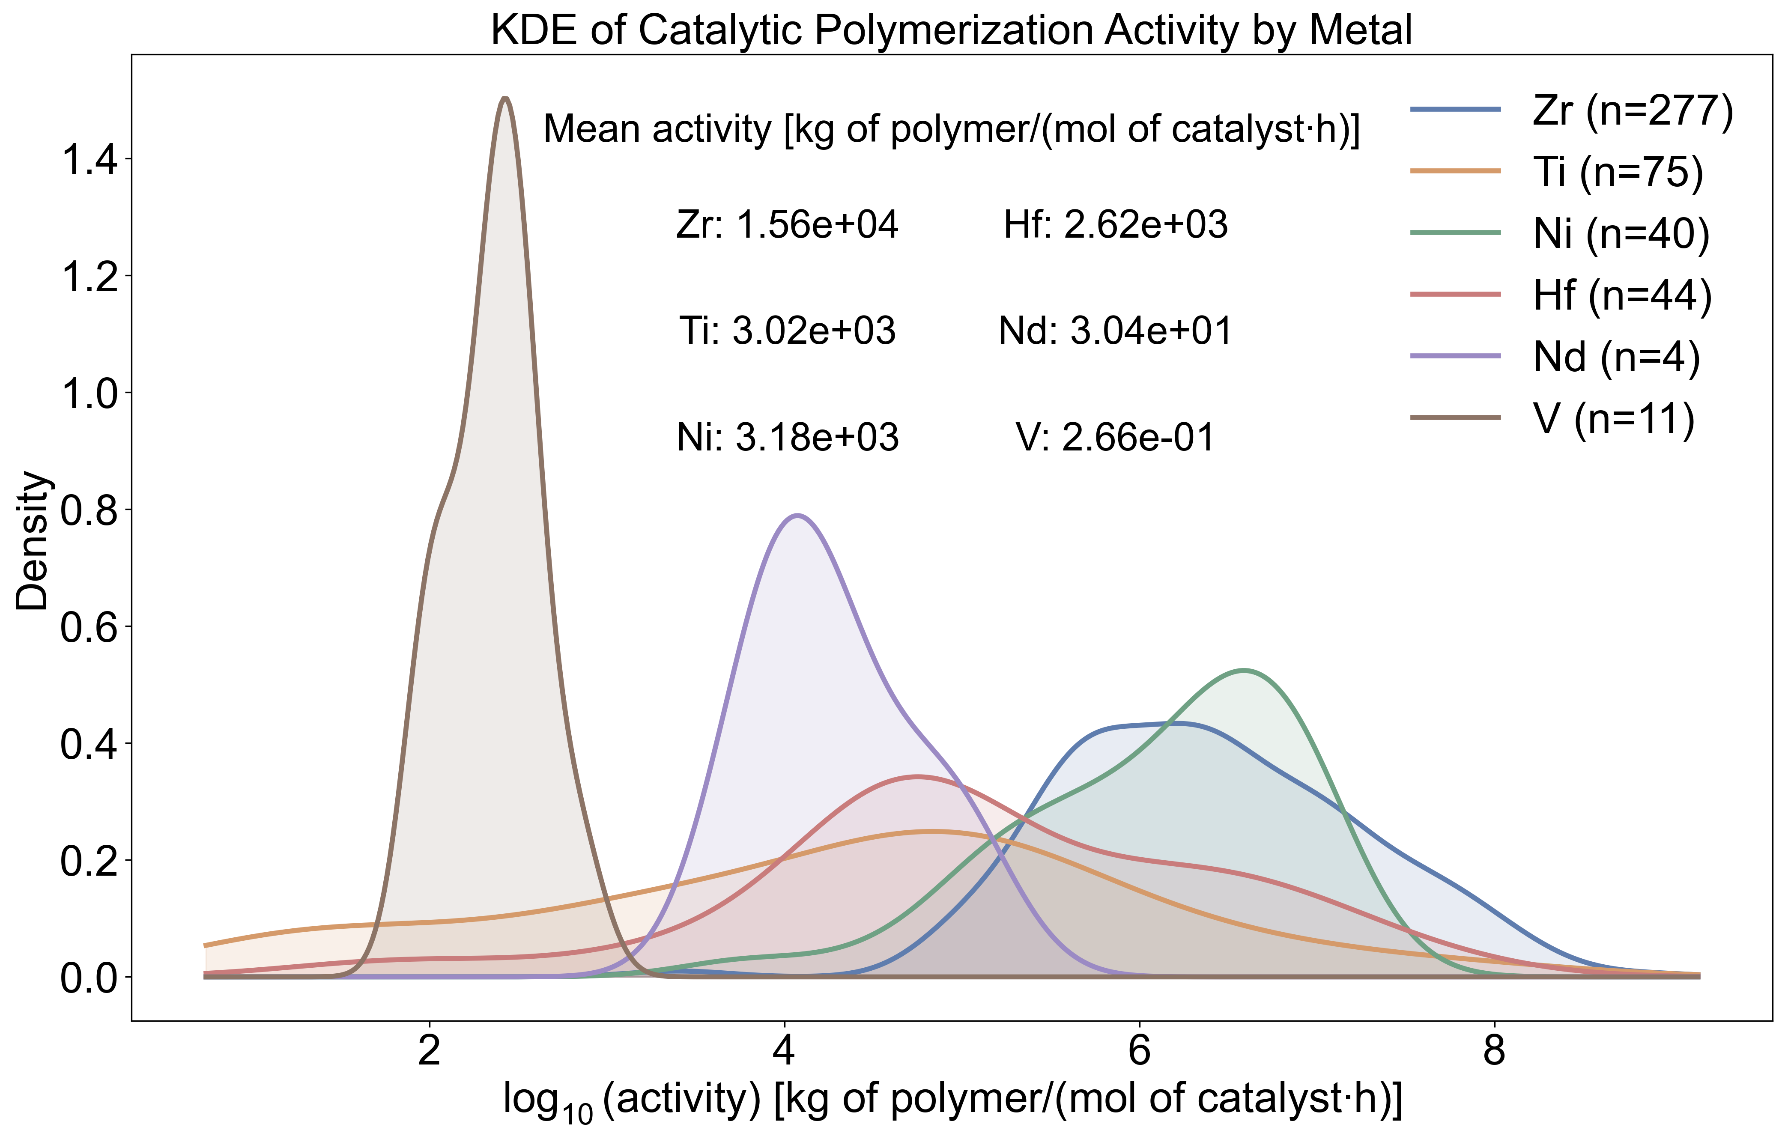
Supplementary Fig 6. Literature-derived activity distribution of metallocene catalysts by metal center.
We performed AI-assisted literature mining using a multimodal large language model (MLLM) agent to enable high-throughput screening and structured extraction of polyolefin catalyst information, following the agent-based knowledge distillation framework. The workflow comprised three stages. First, a two-stage pre-filtering pipeline was applied to a corpus of 6,381 literature records: keyword scoring with a domain-specific lexicon (e.g., metallocene, Ziegler–Natta, catalyst activity, kg polymer/mol·h) selected a candidate pool, which was subsequently reranked by cosine similarity of SentenceTransformer embeddings against a polymerization-activity-focused query, yielding a prioritized set of 2,500 manuscripts. Second, for each article passing this filter, the MLLM agent parsed the full-text markdown and embedded figures using a structured prompt (POE-CatalystSlim), extracting a minimal knowledge graph comprising catalyst nodes—each annotated with a canonical SMILES string—and polymerization testing nodes recording the measured catalyst activity, linked by tested_in edges. Third, the structured graph outputs were deterministically linearized into a tabular CSV format without additional LLM calls. After deduplication and unit normalization, this pipeline yielded 451 unique catalyst–activity entries with canonical SMILES annotations across 127 source papers.
Because reaction conditions (temperature, pressure, cocatalyst loading) were not harmonized at this stage, these records were not used for direct activity benchmarking but rather served to delineate the accessible design space of catalytically relevant center metals and ligand scaffolds.
To further refine the generative target space, we performed a manual expert evaluation of the mined catalyst set to determine the most appropriate center metal for large-scale exploration. Among the metals represented in the literature-derived graph, zirconium was selected as the core metal for subsequent design because it offered the best overall combination of industrial relevance, mechanistic maturity, and structural tunability. In particular, Zr-based olefin polymerization catalysts are supported by a broad and chemically diverse literature, are compatible with a wide range of ligand frameworks, and have repeatedly demonstrated their utility in ethylene/α-olefin copolymerization systems closely related to POE synthesis. Subsequent large-scale generation was thus carried out in a Zr-center design space, where structural diversity was introduced primarily through systematic variation of ligand architectures.

Computational workflow
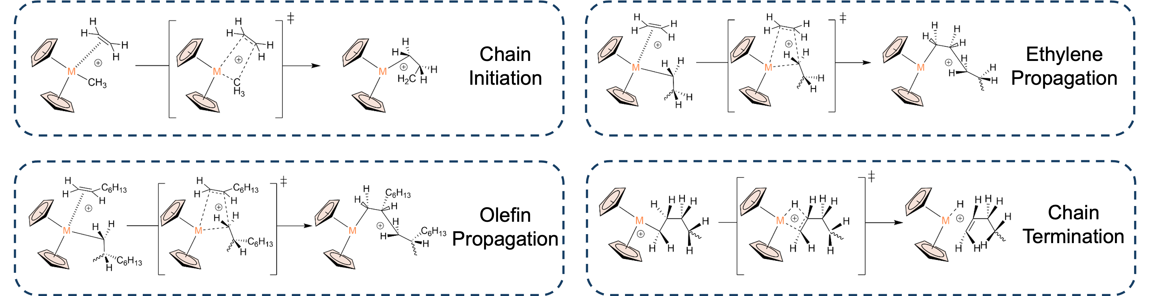
Supplementary Fig 7. Catalytic mechanisms for ethylene/1-octene copolymerization to POE.

In this work, we established an automated computational workflow for high-throughput density functional theory (DFT) calculations. A self-developed high-throughput structure generation script was employed to automatically construct a large number of candidate intermediates and transition-state geometries based on predefined catalyst frameworks and monomer identities. These initial configurations were designed to be geometrically close to their final optimized structures, requiring only minimal structural relaxation prior to DFT refinement. This strategy substantially reduced the time cost associated with manual model construction and pre-optimization.
All identified intermediates and transition states were subjected to systematic geometry optimizations and single-point energy calculations. Thermal corrections were further included to obtain the Gibbs free energy change (ΔG) and the activation free energy (ΔG‡) for each elementary step. The corresponding rate constants (k) were derived using the Eyring equation, enabling direct comparison across different catalytic systems and reaction pathways at the same temperature:
$$\begin{aligned}k=\frac{k_{\text{B}}T}{h}\exp\left(-\frac{ΔG^{‡}}{RT}\right)\#\left(1\right)\end{aligned}$$
where ($k_{\text{B}}$) is the Boltzmann constant, ($h$) is the Planck constant, ($R$) is the gas constant, and (T) is the absolute temperature.
Kinetic Monte Carlo (KMC) simulations
The elementary-step rate constants obtained from DFT calculations were subsequently incorporated into a kinetic Monte Carlo (KMC) framework to reconstruct the discrete time evolution of the polymerization process. At each simulation step, the probability $P_{i}$ of selecting a given event is proportional to its rate constant:
$$\begin{aligned}P_{i}=\frac{k_{i}}{\sum_{j}{k_{j}}}\#\left(2\right)\end{aligned}$$
The corresponding time increment (($Δt$)) was determined from a random number ($r∈\left(0,1\right)$) according to:
$$\begin{aligned}Δt=-\frac{\ln{r}}{\sum_{j}{k_{j}}}\#\left(3\right)\end{aligned}$$
By iteratively executing the cycle of “event selection–execution–time update”, the KMC model enables explicit tracking of chain propagation, chain transfer, and chain termination processes at both single-chain and multi-chain levels. After long-time, multi-chain simulations, polymer ensembles with different chain lengths and microstructural features were collected, from which the number-average molecular weight ($M_{n}$), weight-average molecular weight ($M_{w}$), and dispersity index ($Đ$) were computed:
$$\begin{aligned}M_{n}=\frac{\sum_{i}{N_{i}M_{i}}}{\sum_{i}{N_{i}}}\#\left(4\right)\end{aligned}$$
$$\begin{aligned}M_{w}=\frac{\sum_{i}{N_{i}M_{i}^{2}}}{\sum_{i}{N_{i}M_{i}}}\#\left(5\right)\end{aligned}$$
$$\begin{aligned}Đ=\frac{M_{w}}{M_{n}}\#\left(6\right)\end{aligned}$$
In addition, the simulations quantified insertion events of ethylene and comonomers (for example, 1-octene), allowing prediction of comonomer incorporation ratios, sequence distribution along the polymer chain, and chain-end unsaturation. This provides an interpretable mapping from microscopic mechanistic pathways to macroscopic experimentally accessible polymer characterization parameters.

Supplementary Fig 8. Energy profiles for the elementary steps catalyzed by Cat 2.

Supplementary Fig 9. Energy profiles for the elementary steps catalyzed by CPP-Zr.

Automated catalyst generation
In this study, we employed our in-house automated builder, ComplexGen, to construct chemically plausible starting geometries for Zr-based organometallic catalysts featuring a metallocene-like (ferrocene-inspired) scaffold. Given a prescribed coordination geometry at the metal center and ligand specifications, ComplexGen assembles candidate complexes across diverse binding patterns, spanning mono- and bidentate coordination as well as σ- and π-interactions.
ComplexGen explores the configurational space by systematically optimising ligand conformers and their placement around the Zr center, with simultaneous refinement of key geometric parameters (bond lengths, bond angles and inter-ligand separations). Each candidate is evaluated using chemically motivated criteria—including minimum ligand–ligand distances, acceptable Zr–donor bond lengths and target coordination angles—and the search proceeds for a fixed number of iterations before returning the highest-ranked structure. For more details and source codes of ComplexGen, please refer to its GitHub repository: (https://github.com/Long1Corn/Complex_Gen)
Using this workflow, we generated reactant, transition-state and product structures in a unified and consistent manner. The resulting geometries were subsequently subjected to DFT optimization to obtain the final stationary points used throughout this work.

Supplementary Table 33. Visualization of automated generated structures.
Ligands | Reactants | Transition states | Products
 | 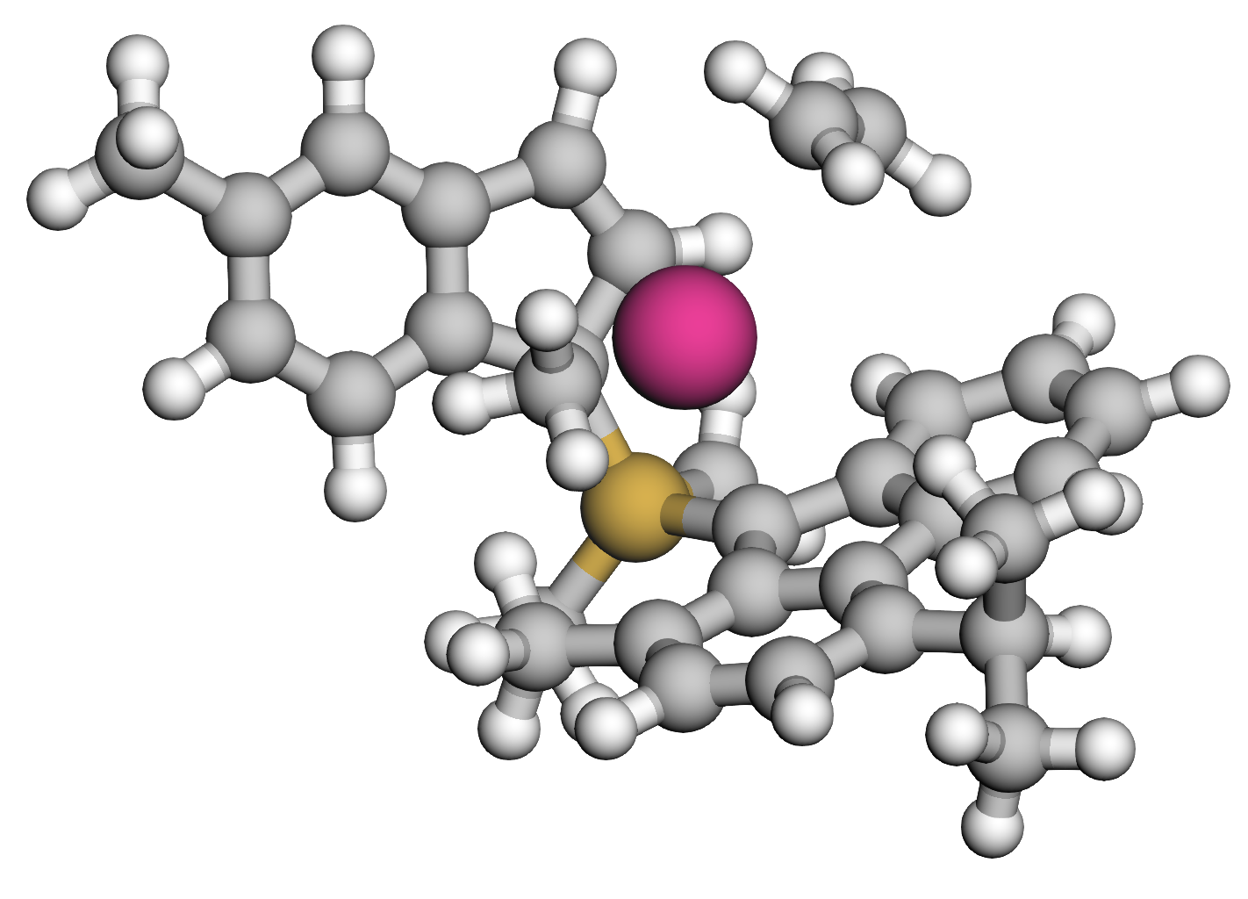 | 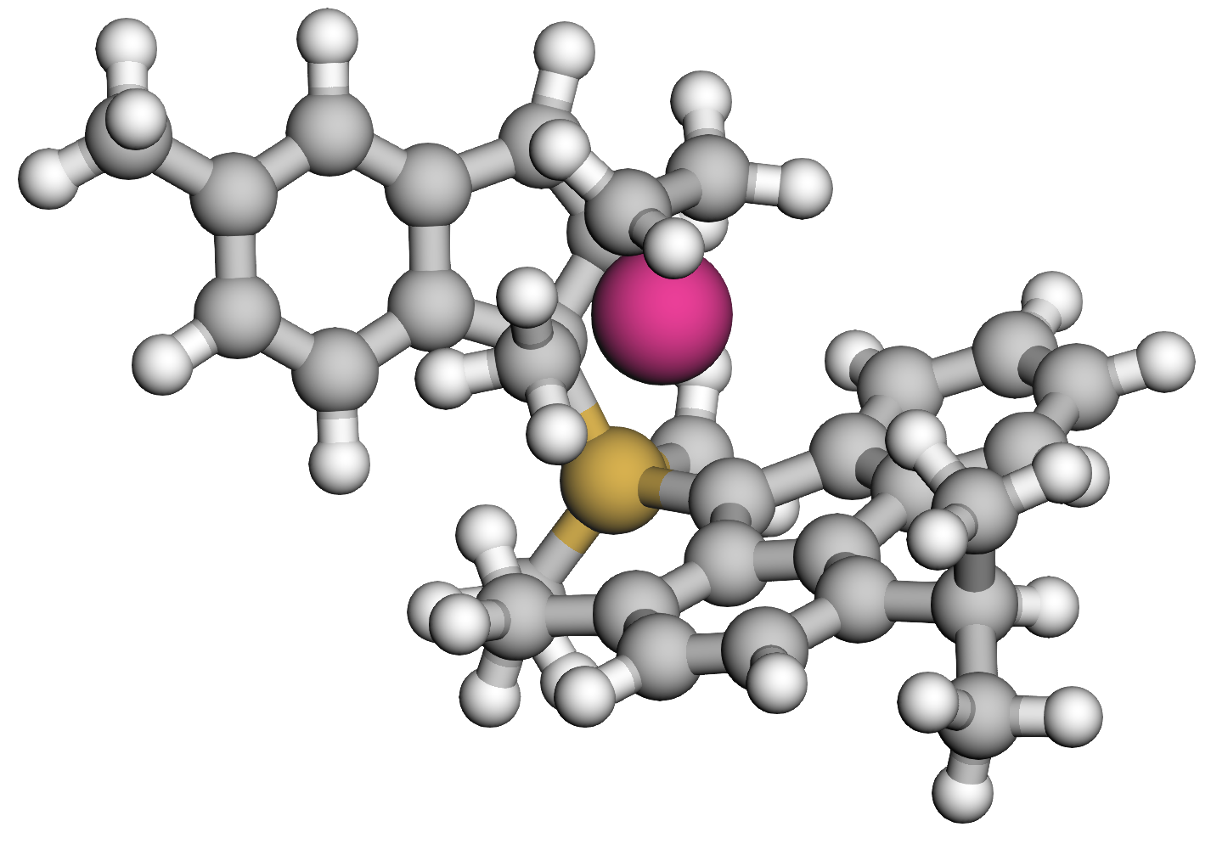 | 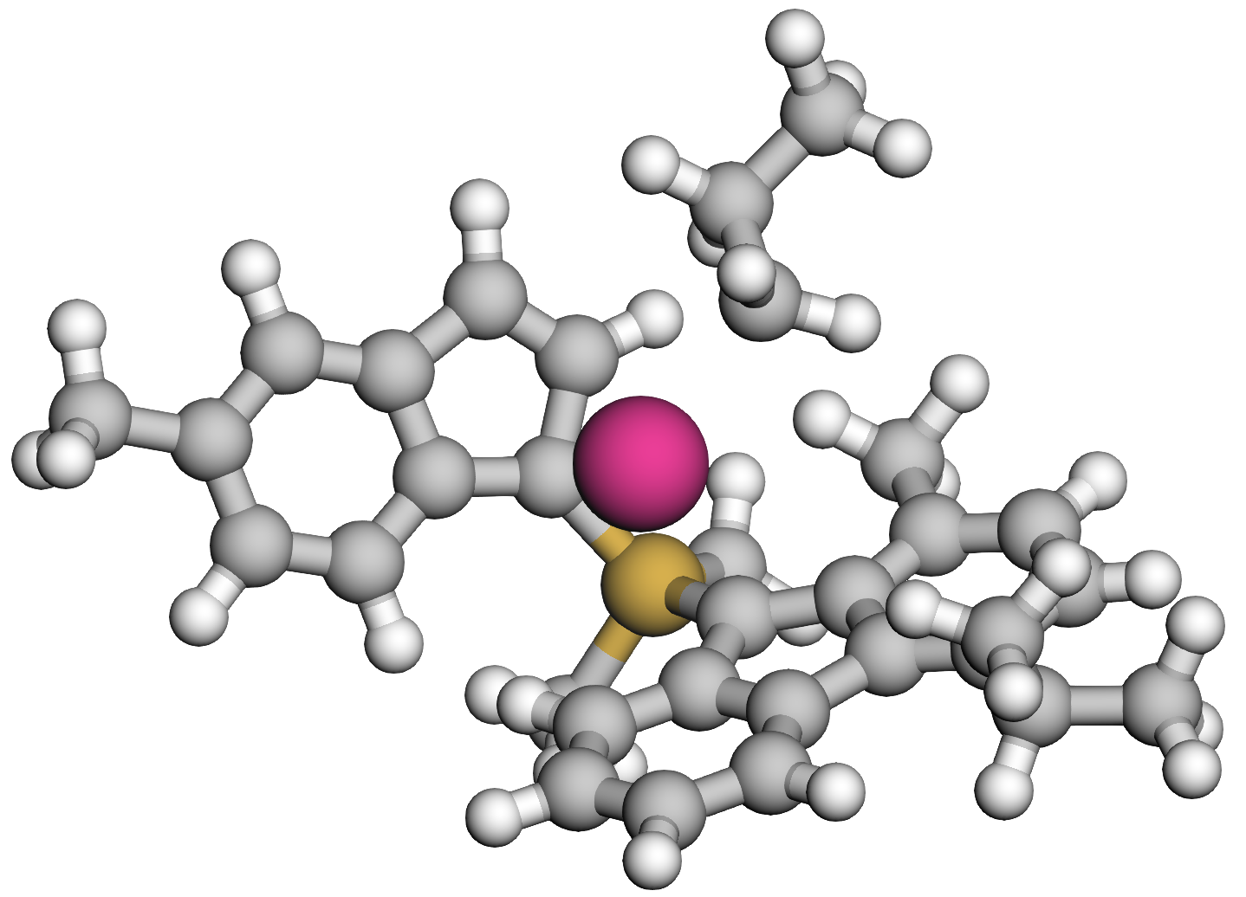
 | 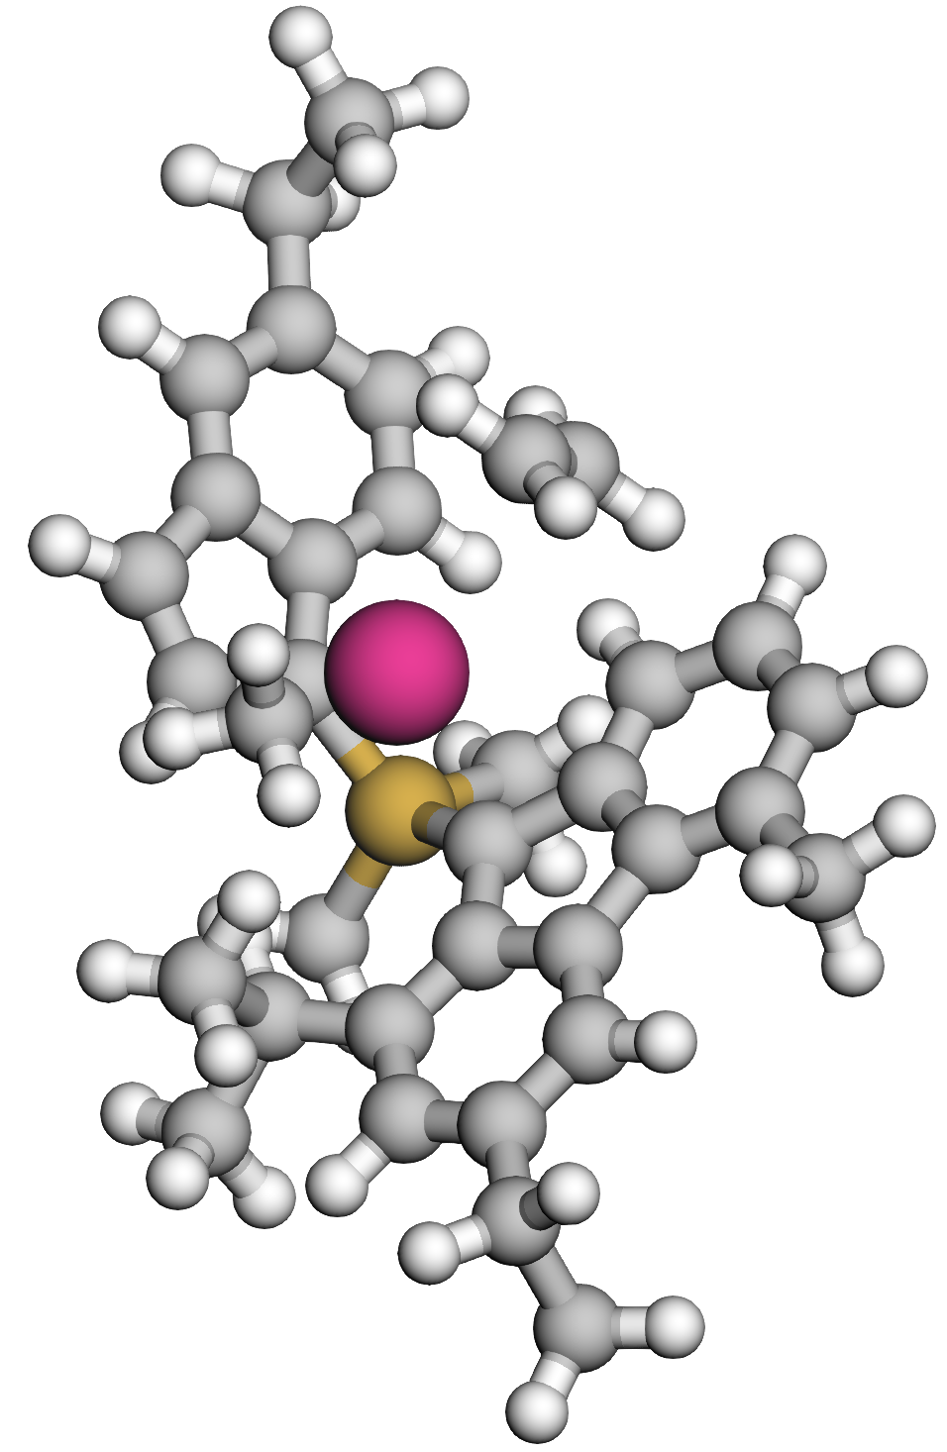 | 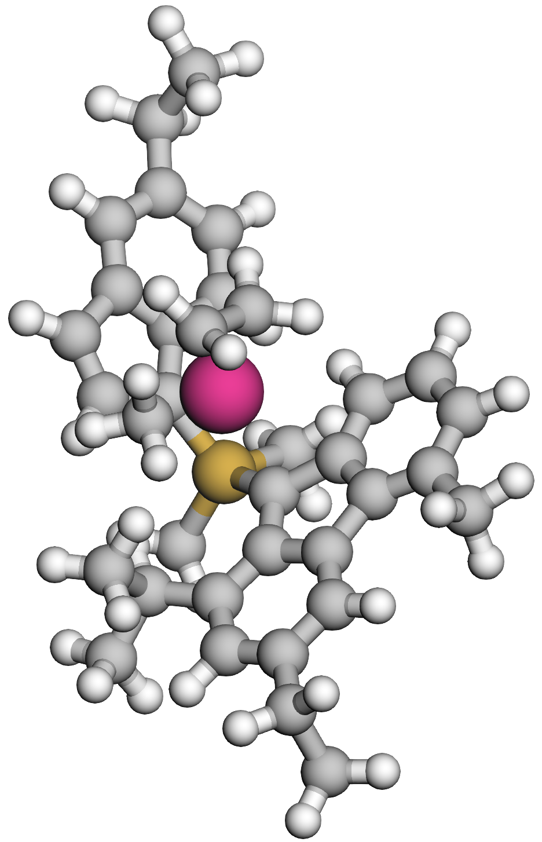 | 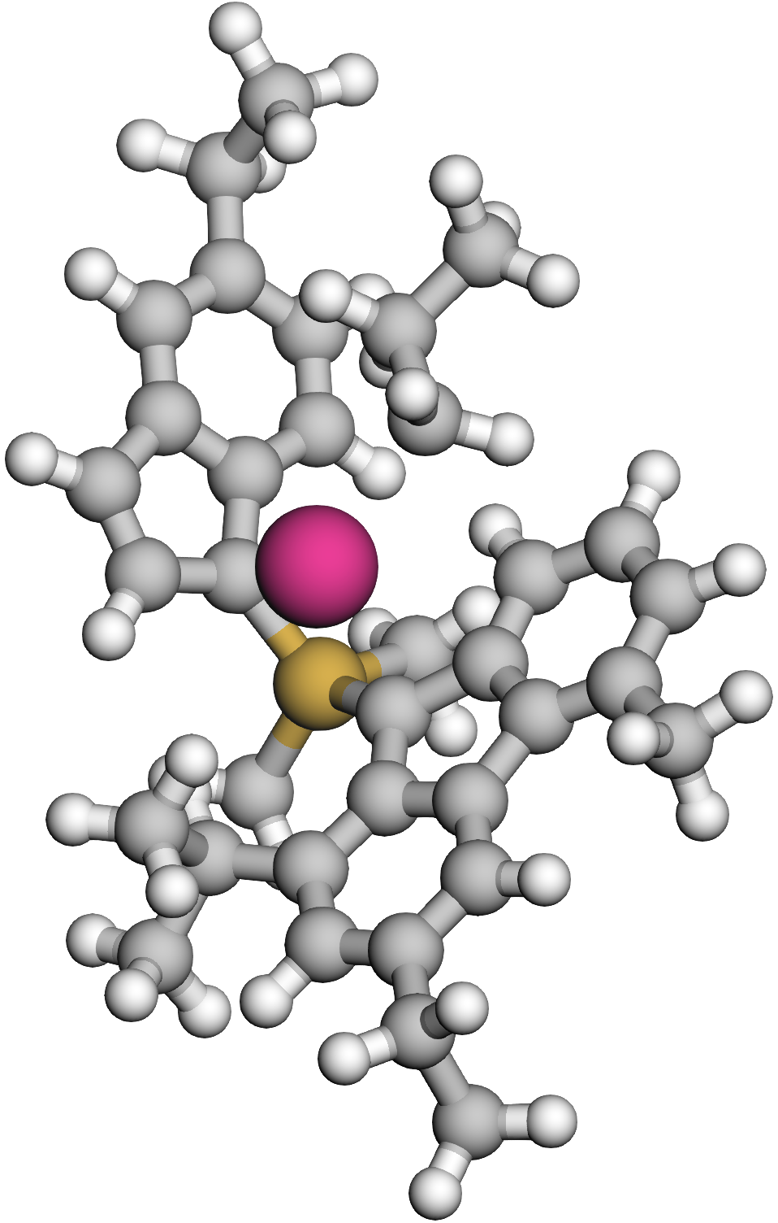
 | 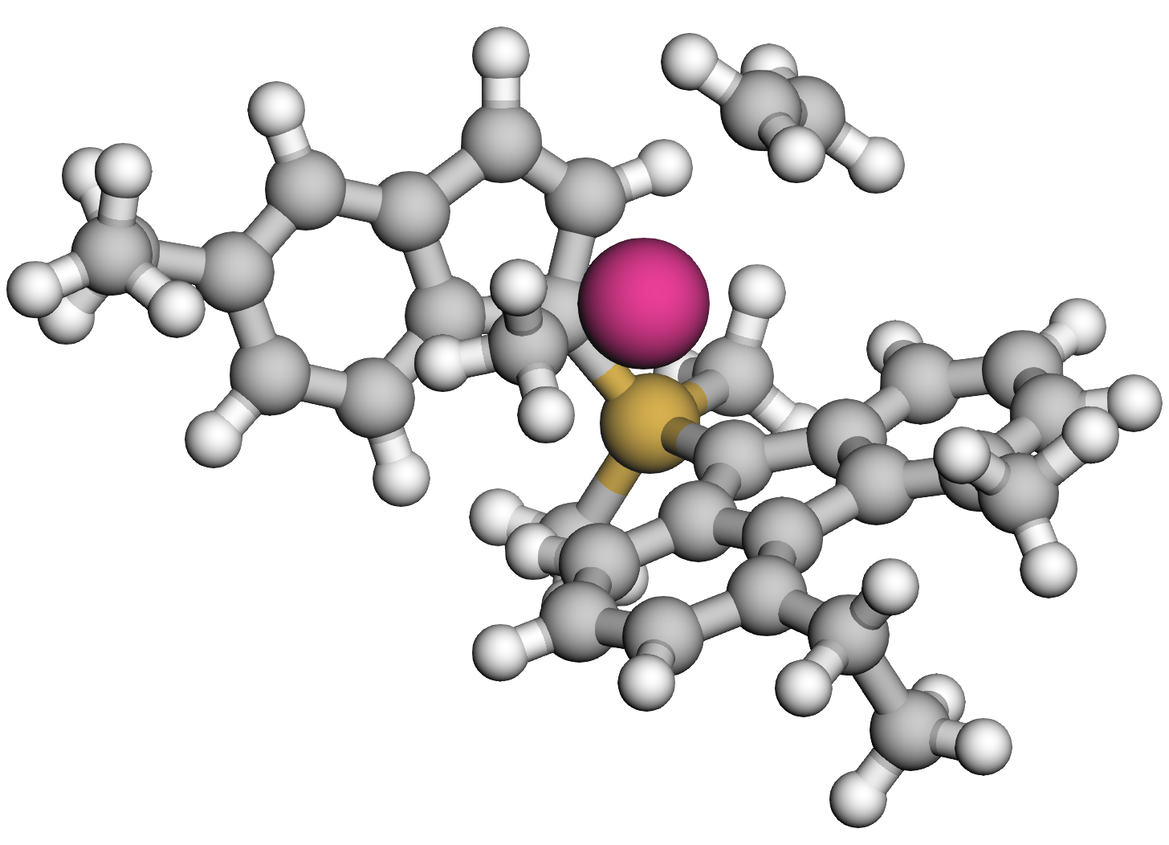 | 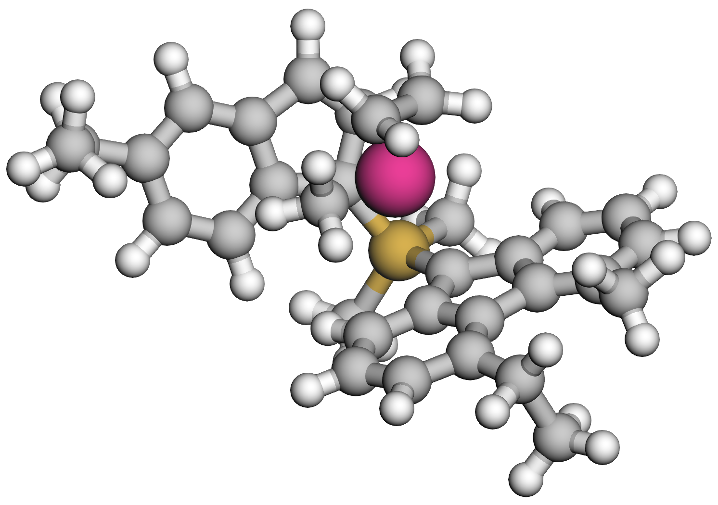 | 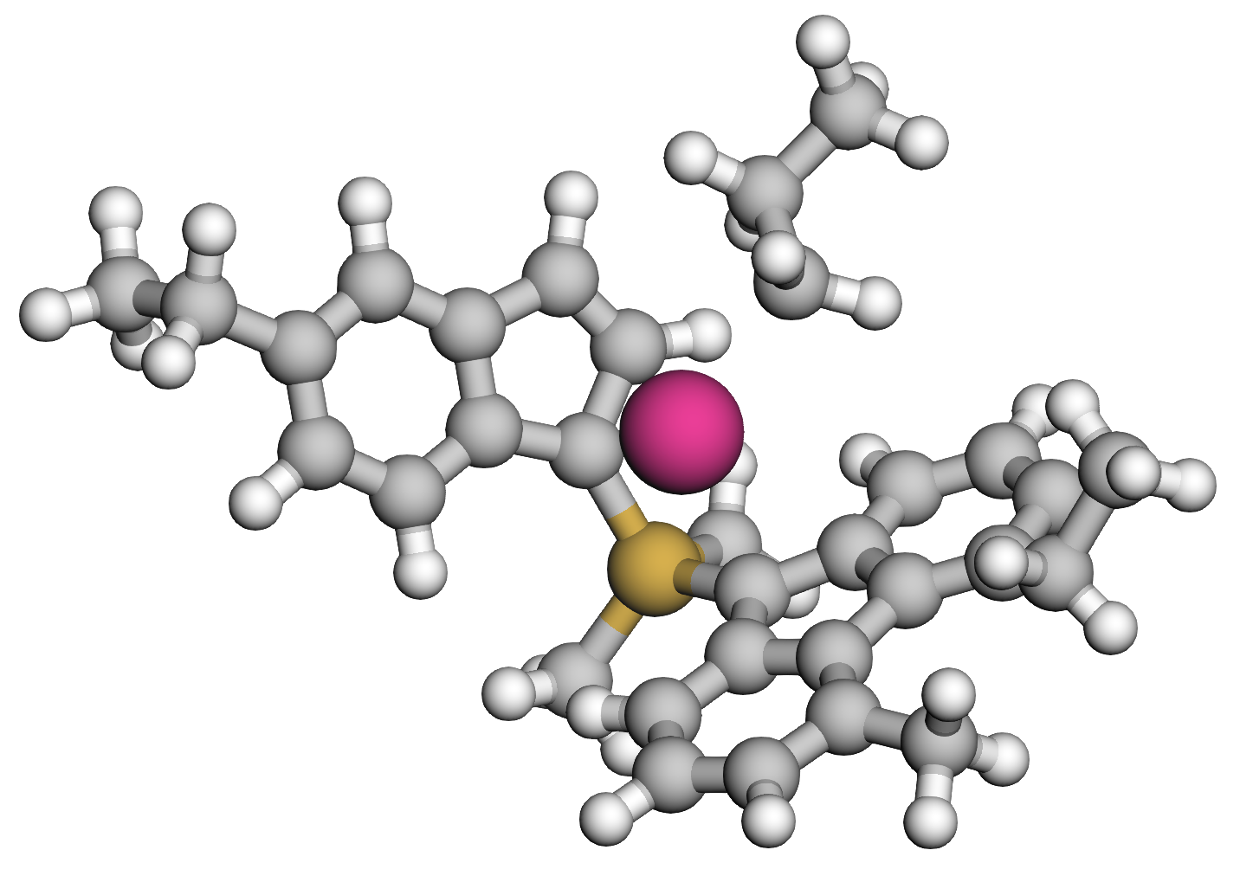
 | 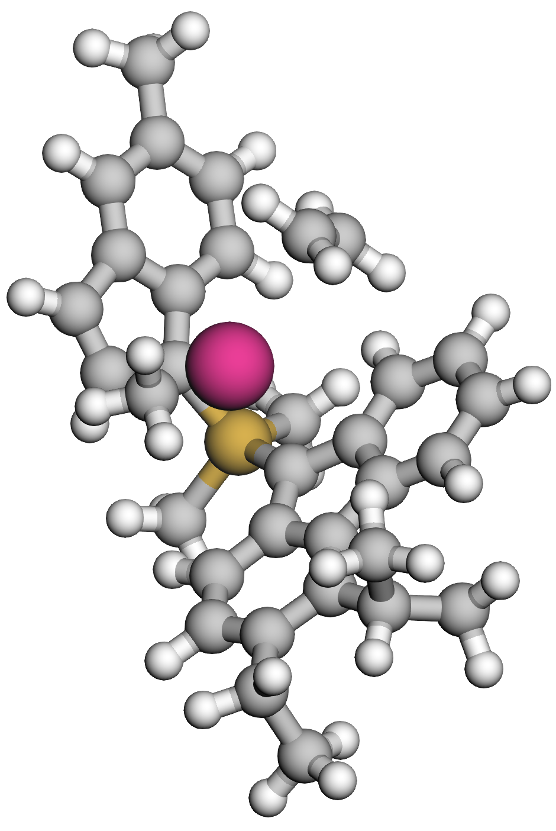 | 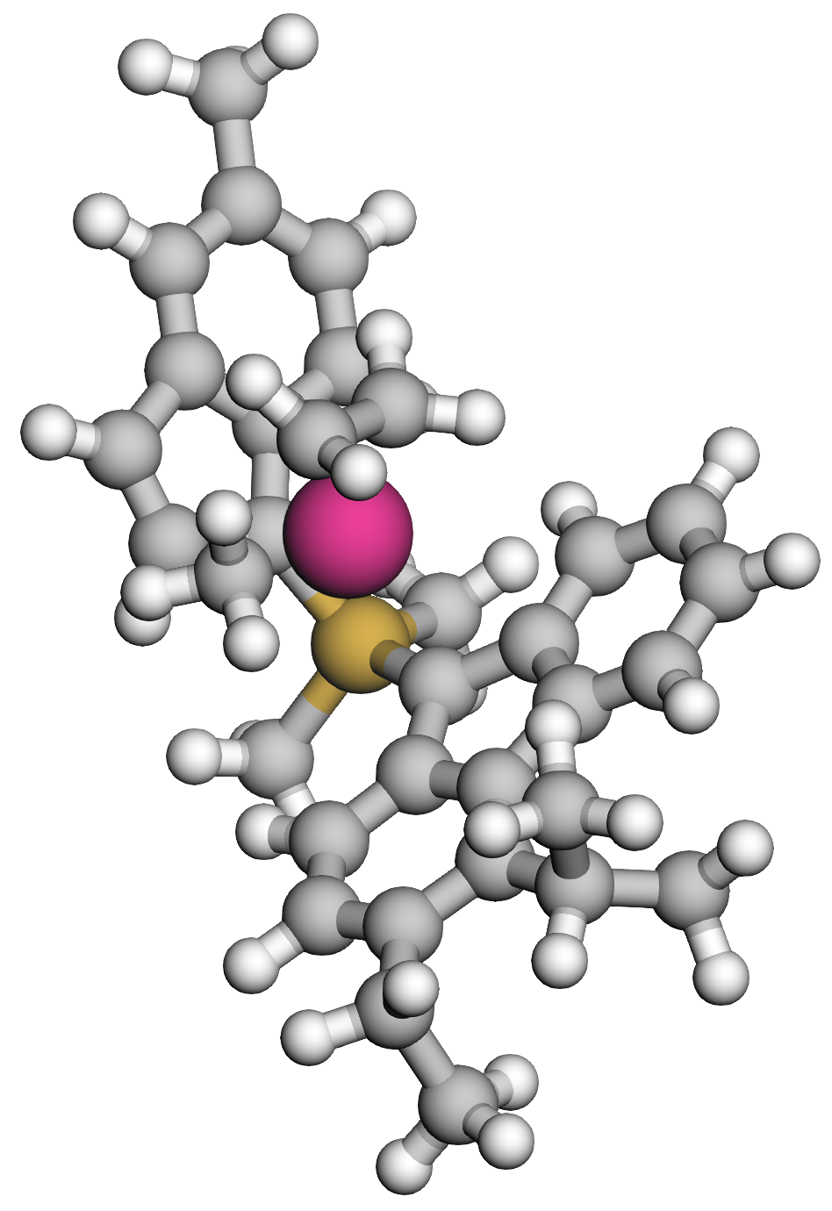 | 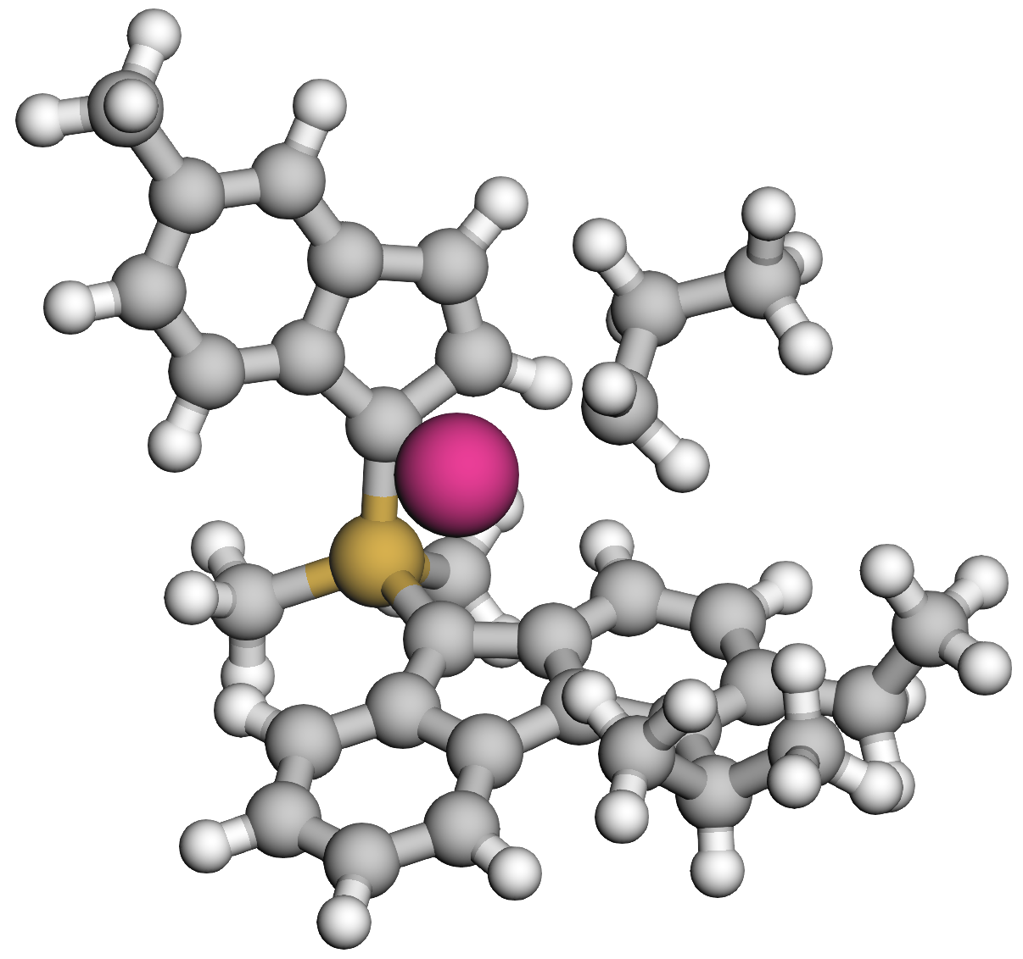
 | 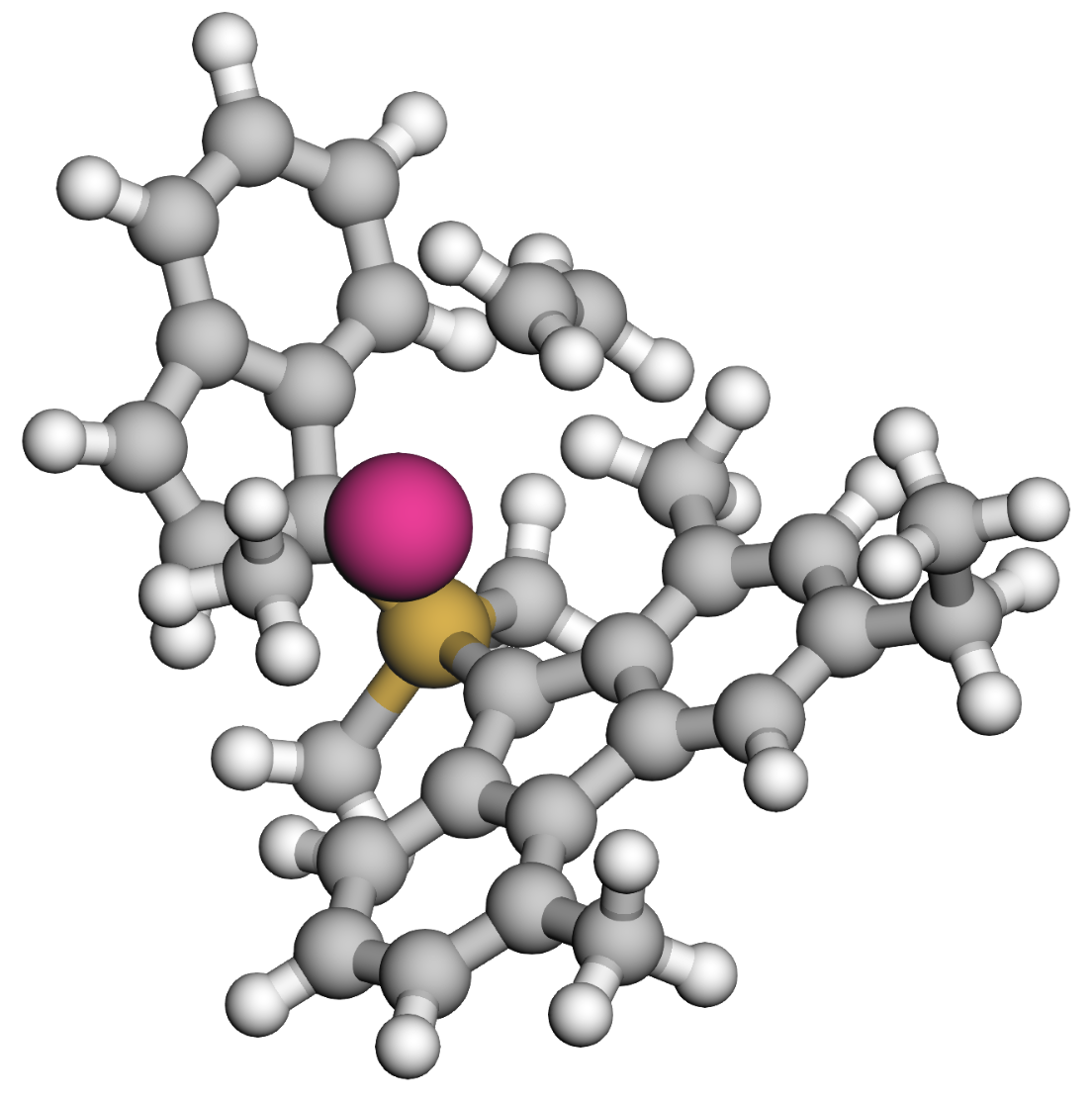 | 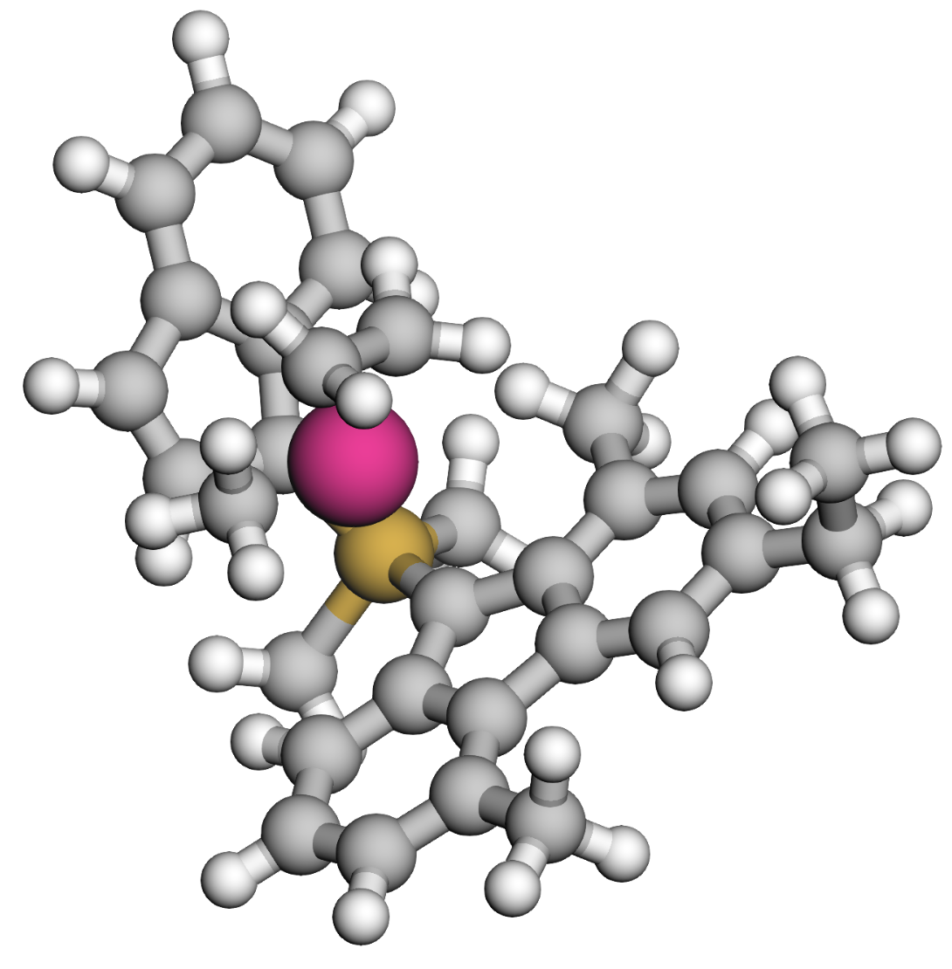 | 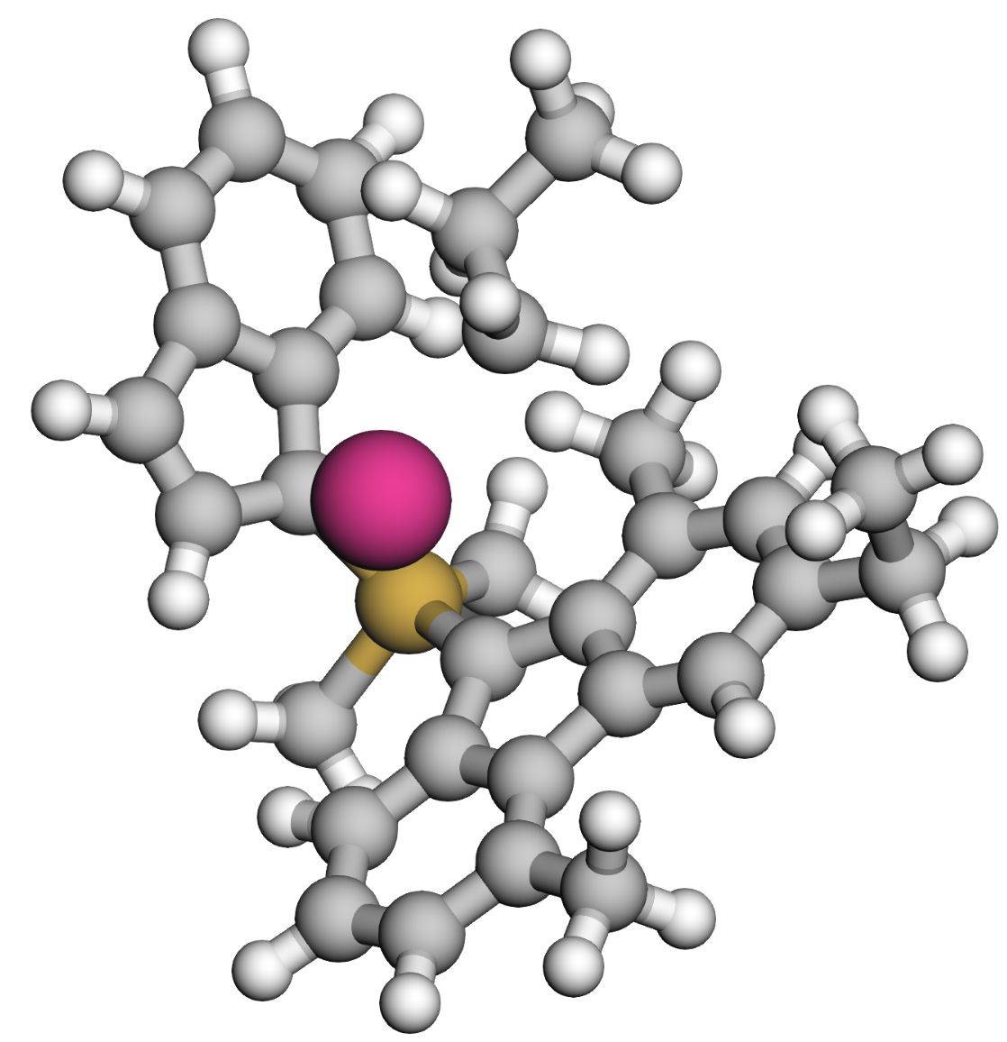
 | 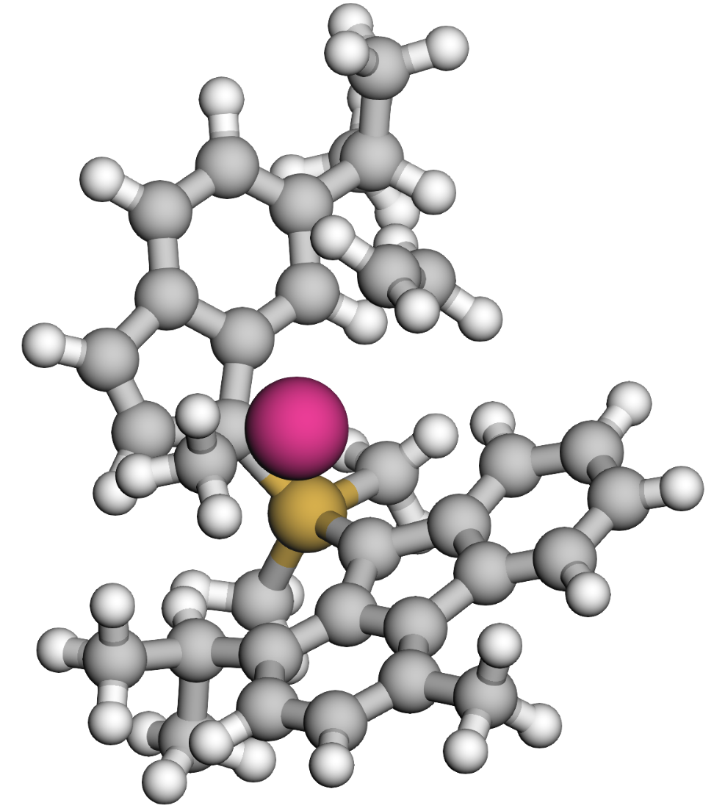 | 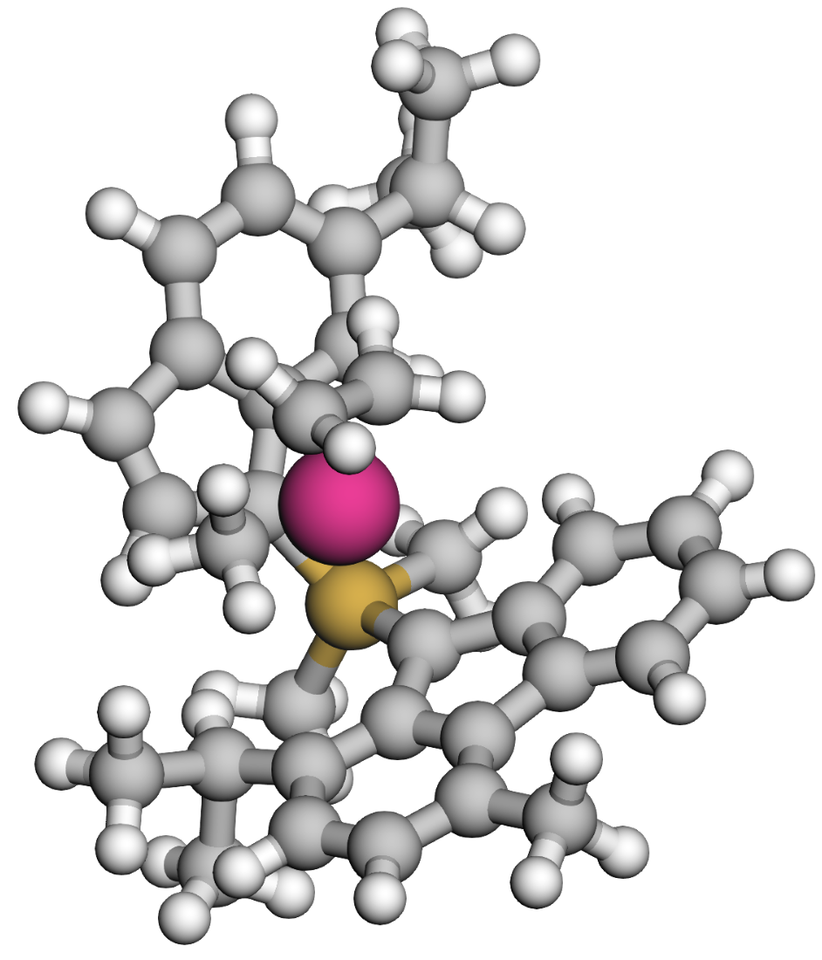 | 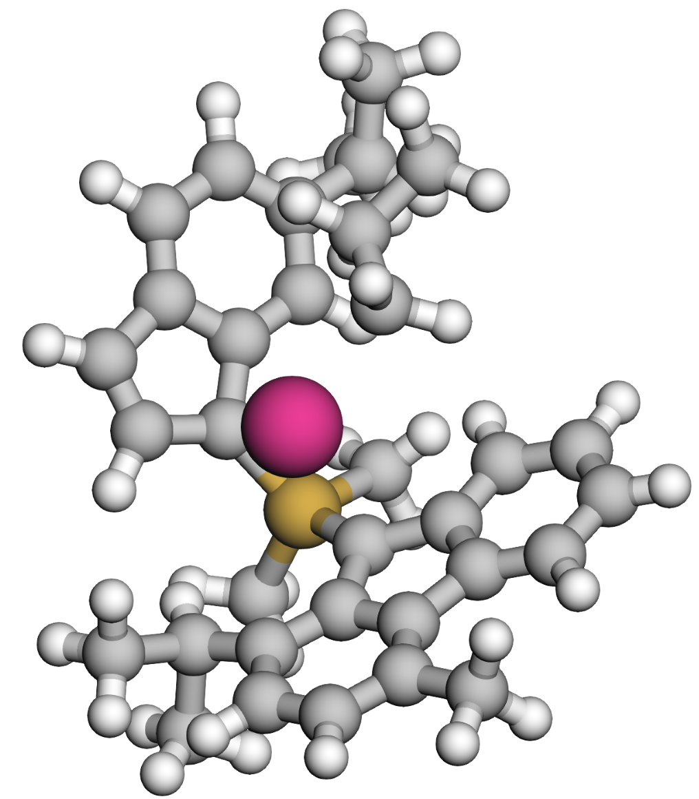
 | 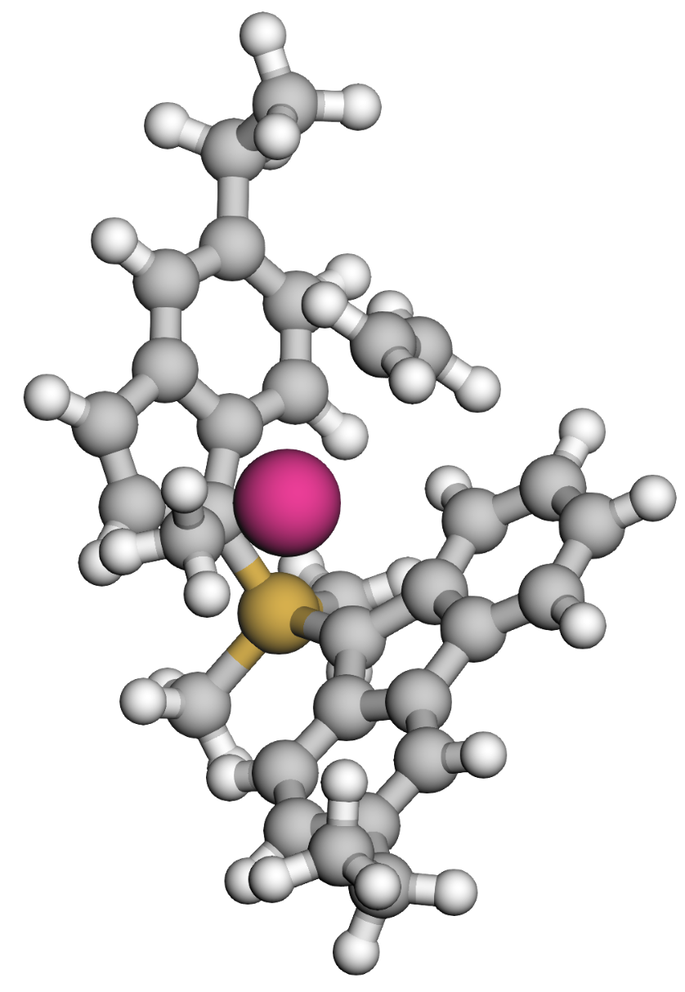 | 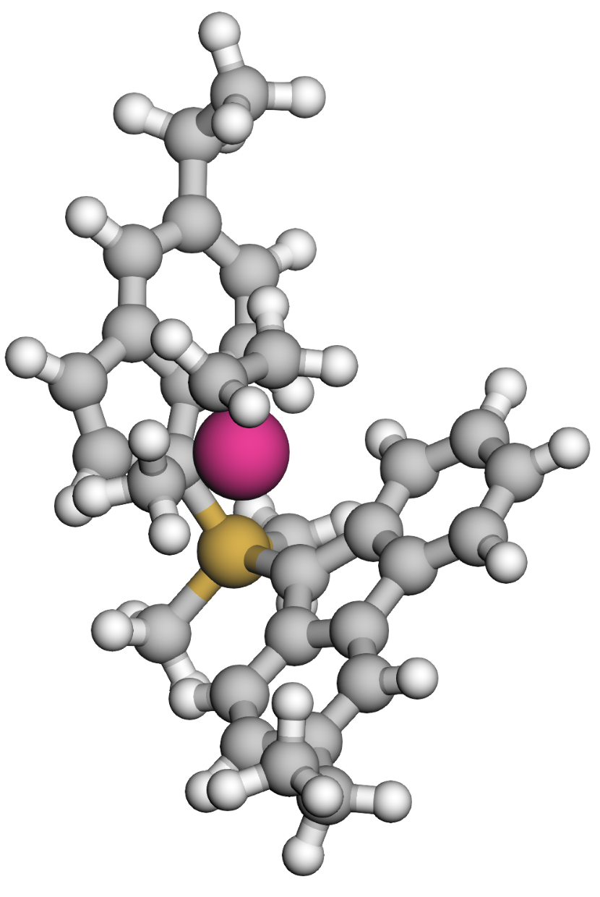 | 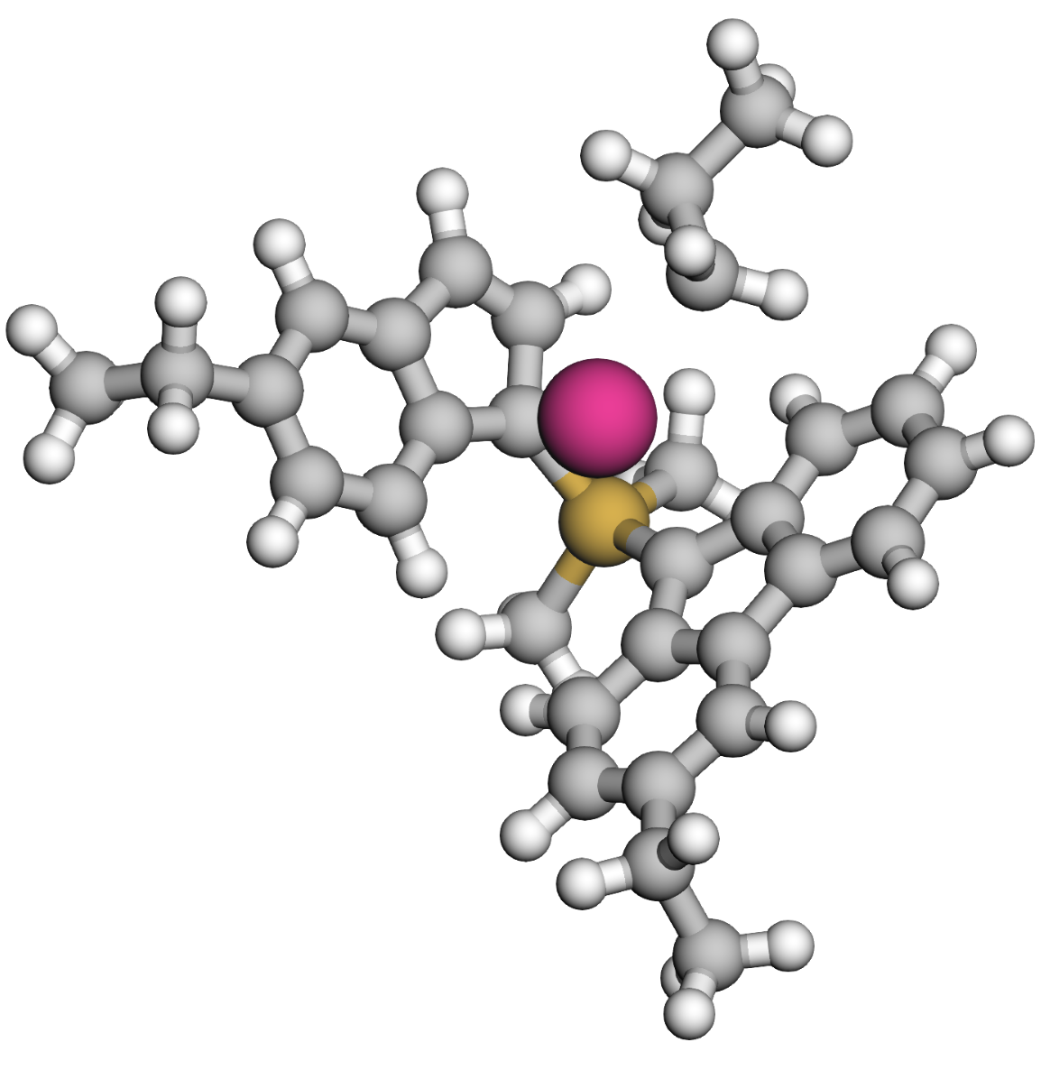
 | 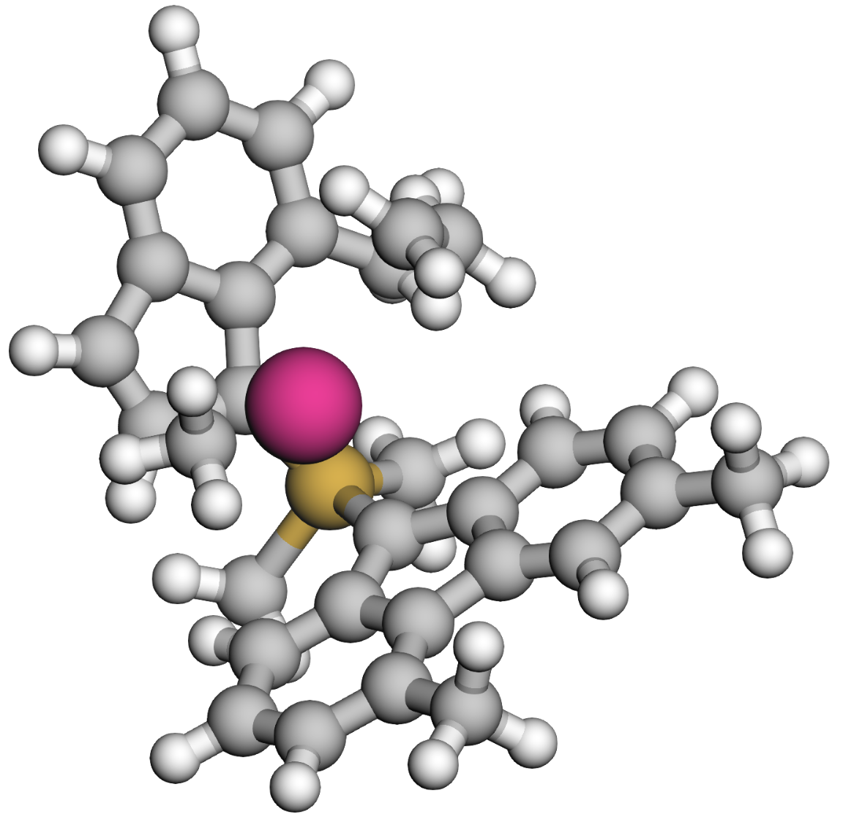 | 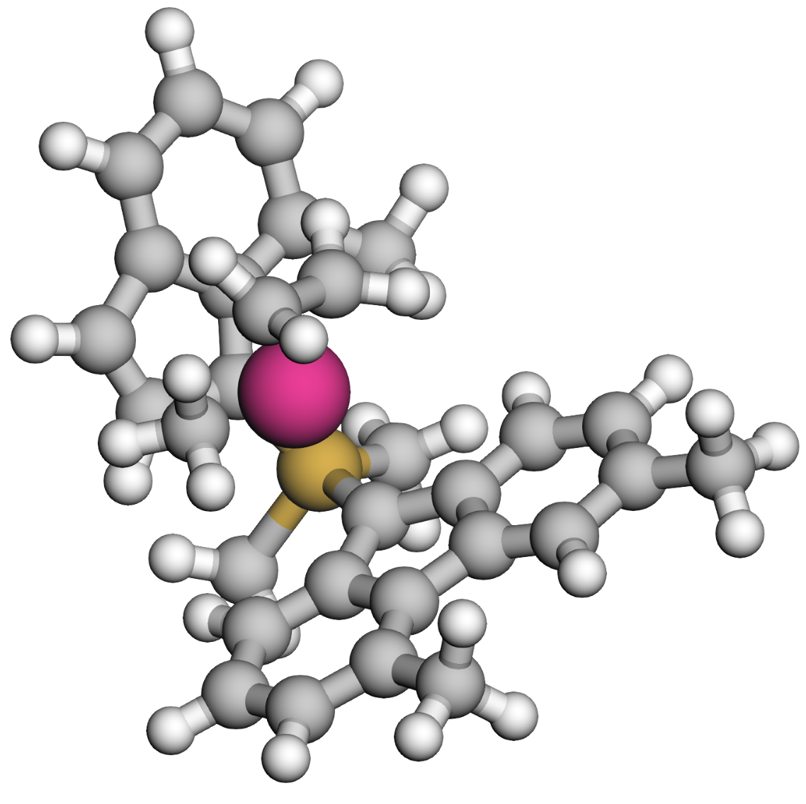 | 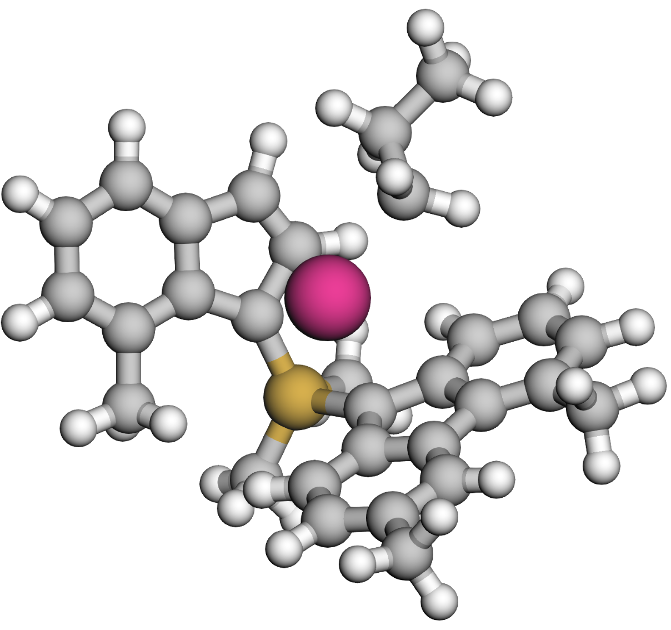
 | 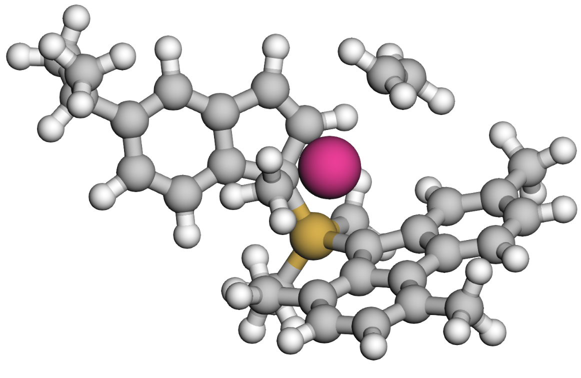 | 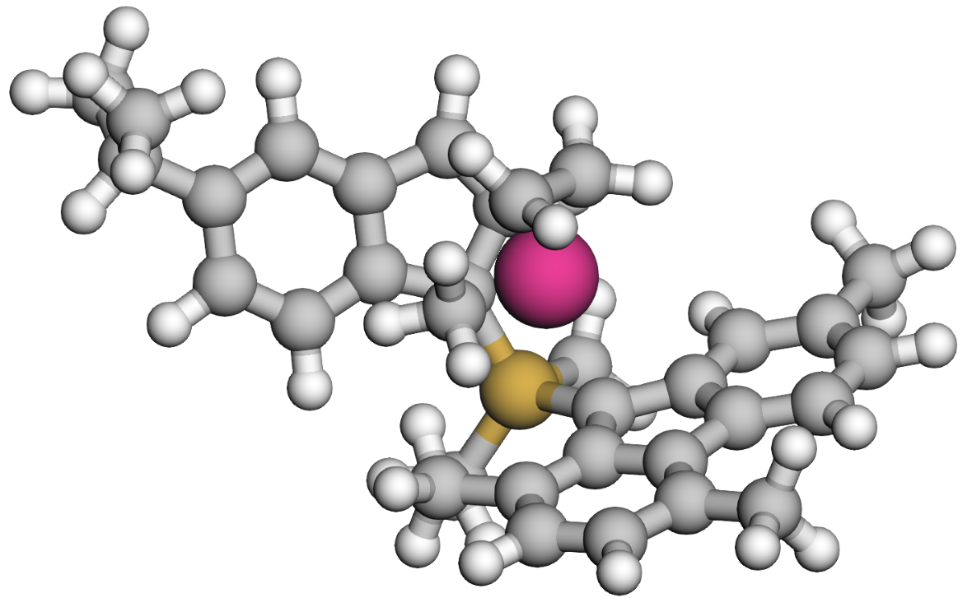 | 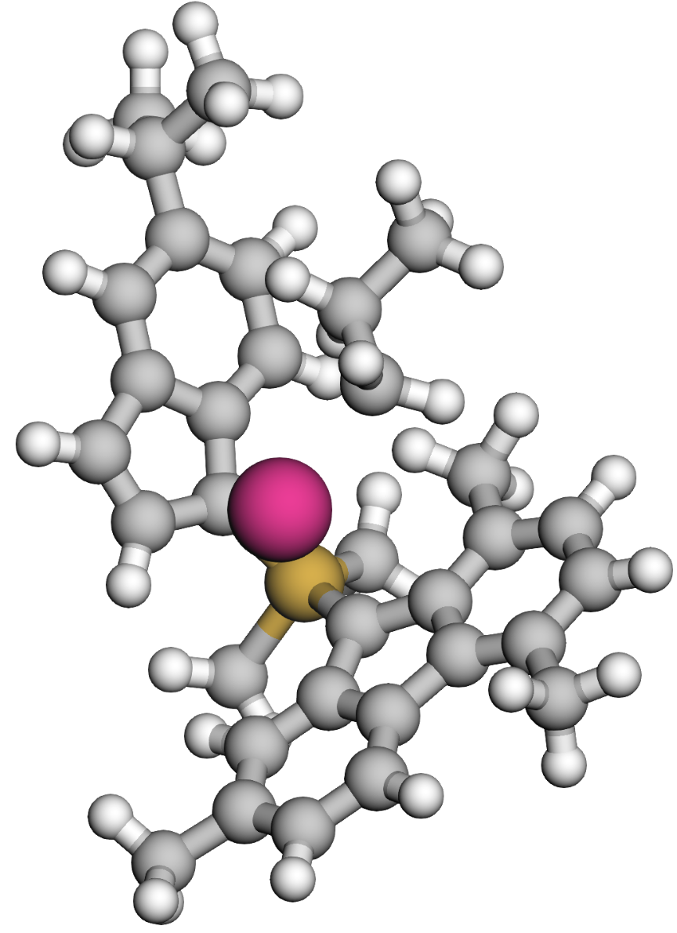
 | 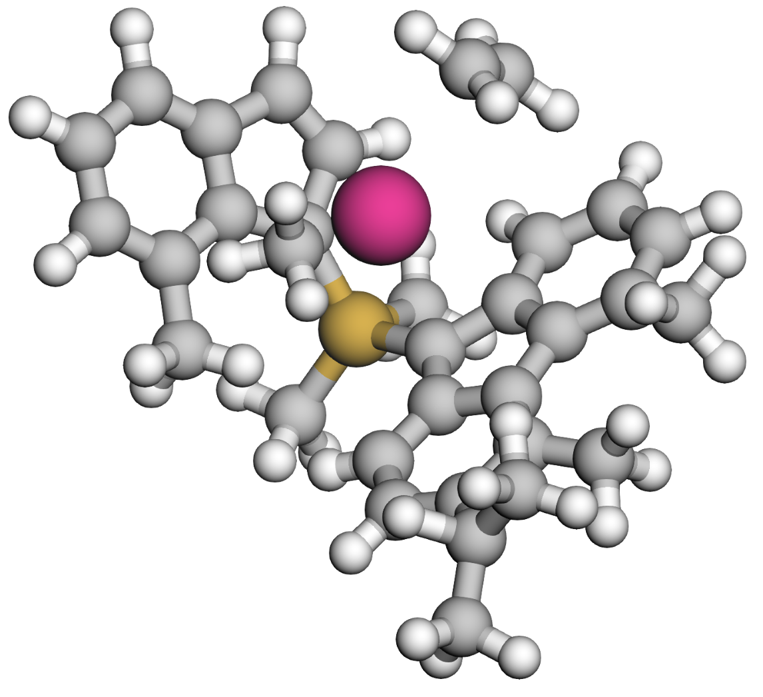 | 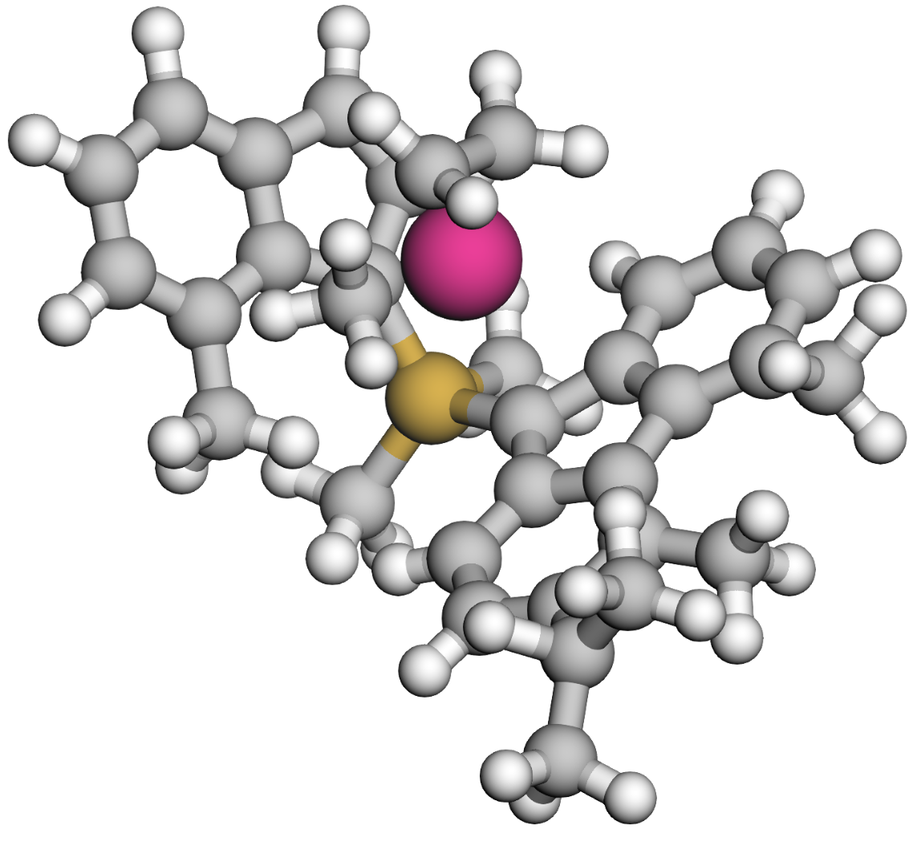 | 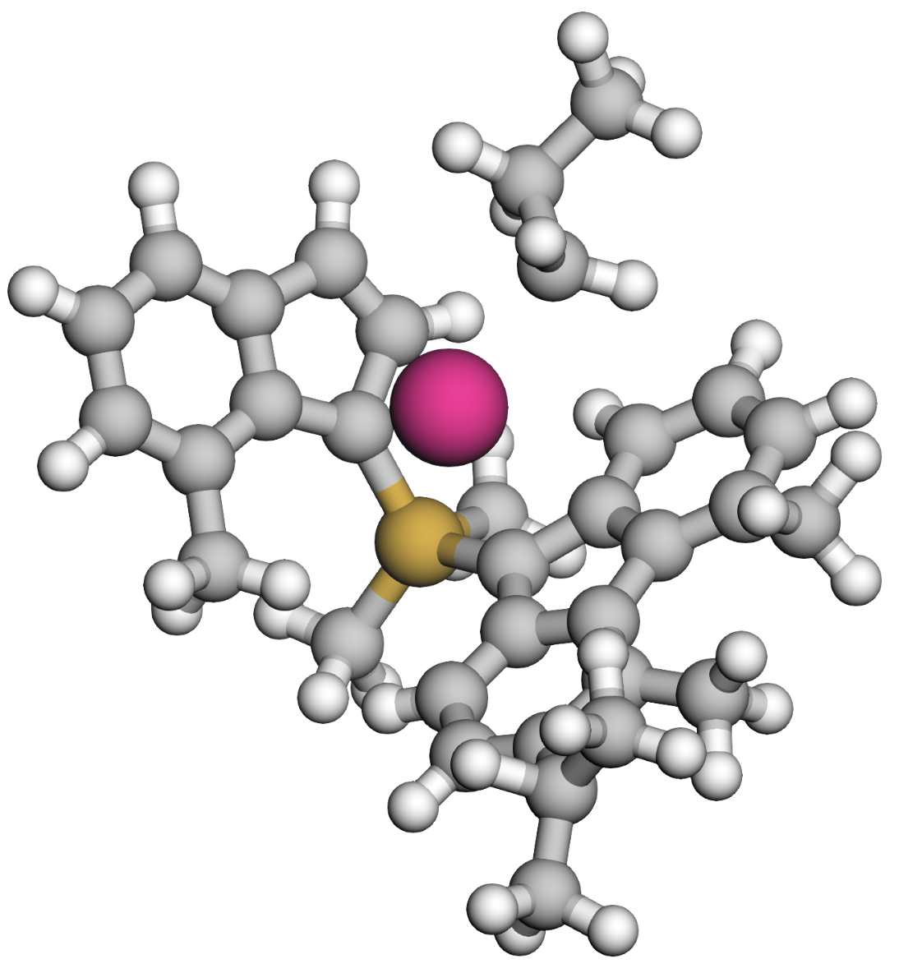

Large-scale catalyst screening
Supplementary Fig 10. POE catalyst ligands with CatAI-predicted activity [10⁴ kg/(mol·h)].

Synthetic route of CPP-Zr
Supplementary Fig 11. Synthetic route of CPP-Zr.
Synthesis of the L₃:
To the flask was added 2,7-di-tert-butyl-9H-fluorene (1.94 g, 6.96 mmol, 1 equiv.) and MTBE (8 mL). Under a nitrogen atmosphere in an ice-water bath, n-hexyllithium (2.2 M in hexane, 3.8 mL, 8.35 mmol, 1.2 equiv.) was added. The mixture was stirred at room temperature for 2 hours. Then cyclopenta-2,4-dien-1-ylidenecyclohexane (800 mg) was added and stirred at room temperature overnight. The reaction was quenched with EtOH (2 mL), and extracted with saturated aqueous ammonium chloride solution one time and ethyl acetate three times (3 × 10 mL). The organic phase was collected and dried over anhydrous sodium sulfate. Purification by column chromatography (eluted with pure petroleum ether) to afford 652 mg of L₃ (white solid), with a yield of 22%.
Synthesis of the CPP-Zr
In a glove box, to a 25 mL round-bottom flask was added the ligand (200 mg, 0.41 mmol, 1 equiv.) and ^{n}Bu₂O (2 mL). The mixture was cooled for 1 hour. Then n-hexyllithium (0.5 mL, 2.2 M in hexane) was added. The system was heated to 100 °C and stirred for 6 hours. After completion, the mixture was cooled to room temperature, and zirconium(IV) chloride (1.1 equiv.) was added. The mixture was stirred at room temperature for 1 hour, the reaction mixture was filtered and the cake was dissolved in toluene, evaporation of toluene under reduced pressure afforded 153 mg yellow solid, with a yield of 56%. The spectroscopic data of all catalysts are as follows.

Cat 1, ¹H NMR (400 MHz, C₆D₆) δ 7.39 (dt, J = 8.6, 1.1 Hz, 2H), 7.24 – 7.22 (m, 2H), 7.18 (d, J = 1.0 Hz, 2H), 7.14 (d, J = 1.0 Hz, 2H), 6.87 – 6.84 (m, 2H), 6.80 (dd, J = 3.3, 1.0 Hz, 2H), 5.76 (d, J = 3.3 Hz, 2H), 0.54 (s, 6H) ppm.

Cat 2, ¹H NMR (400 MHz, C₆D₆) δ 7.28 (dt, J = 8.6, 1.1 Hz, 2H), 7.15 (d, J = 3.9 Hz, 4H), 7.11 – 7.07 (m, 2H), 6.91 (ddd, J = 8.6, 6.6, 1.0 Hz, 2H), 6.46 (dd, J = 3.3, 0.9 Hz, 2H), 5.75 (d, J = 3.4 Hz, 2H), 2.99 – 2.91 (m, 4H) ppm.

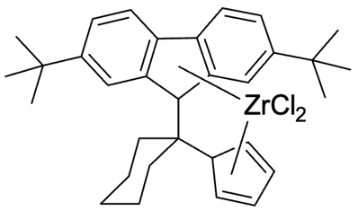
CPP-Zr, red solid, 153 mg, 56% yield. ¹H NMR (400 MHz, C₆D₆) δ 8.04 (d, J = 8.8 Hz, 2H), 7.73 – 7.61 (m, 4H), 6.33 (t, J = 2.7 Hz, 2H), 5.68 (d, J = 2.7 Hz, 2H), 3.43 – 3.35 (m, 2H), 2.39 – 2.28 (m, 2H), 2.05 – 1.95 (m, 4H), 1.37 (s, 18H), 0.98 – 0.87 (m, 2H) ppm.

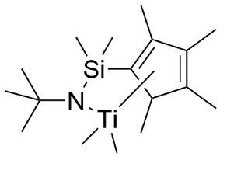
CG-Ti, ¹H NMR (400 MHz, C₆D₆) δ 1.97 (s, 6H), 1.86 (s, 6H), 1.57 (s, 9H), 0.51 (s, 6H), 0.43 (s, 6H) ppm.

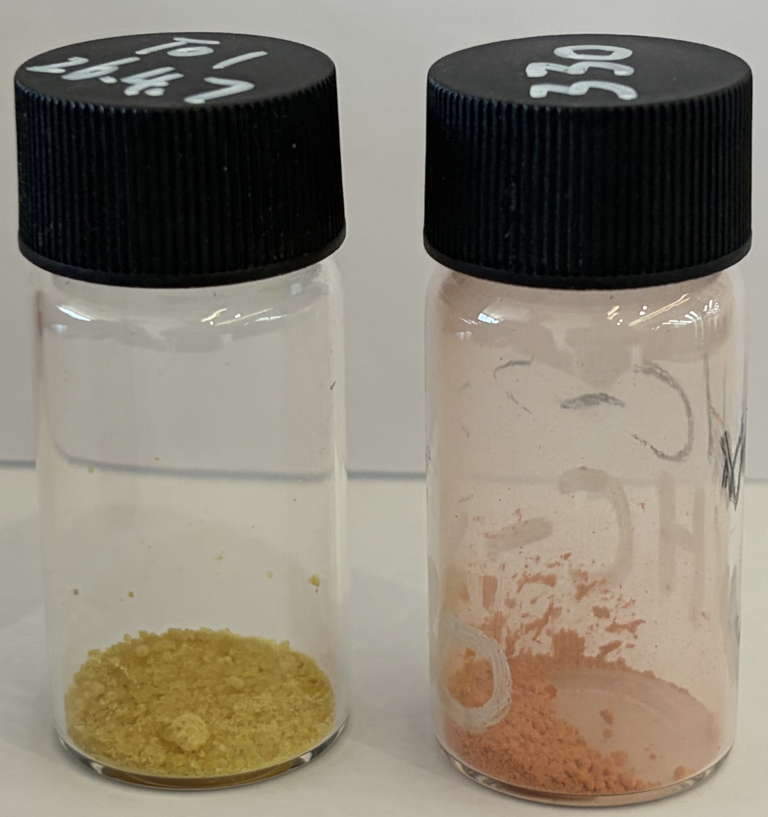
Supplementary Fig 12. Morphological comparison of CG-Ti (left) and CPP-Zr (right).

Catalyst performance and polymer property
Supplementary Table 34. Performance comparison of CatAI-recommended catalysts with previously reported POE catalysts.
Catalyst | Ownership | Metal | Experimental Catalyst activity ↑  10⁴ kg /(mol·h)
Homogeneous rac-Et(Ind)₂ZrCl₂/dMMAO | Open literature²¹ | Zr | 2.8
SiO₂(LP)-supported rac- Et(Ind)₂ZrCl₂/dMMAO | Open literature²¹ | Zr | 2.5
SiO₂(SP)-supported rac- Et(Ind)₂ZrCl₂/dMMAO | Open literature²¹ | Zr | 1.3
Si-Al(BP)-supported rac- Et(Ind)₂ZrCl₂/dMMAO | Open literature²¹ | Zr | 0.5
rac-Me₂Si[2,4-Me₂Ind]₂ZrCl₂ (EO-21, comparative C-1) | ExxonMobil patent literature²² | Zr | 9.9
rac-Me₂Si[2,4-Me₂Ind]₂ZrCl₂ (EO-23, comparative C-1) | ExxonMobil patent literature²² | Zr | 23.3
Dow INSITE/CGC direct-family benchmark | Dow²² | Ti | 4.6
ExxonMobil metallocene-family public benchmark | ExxonMobil²² | Zr | 23.3
Mitsui EVOLUE/TAFMER-like public benchmark | Mitsui Chemicals²² | Zr | 20.5
Cat 1 | CatAI-recommended | Zr | 55.2
Cat 2 | CatAI-recommended | Zr | 91.2
CPP-Zr | CatAI-recommended | Zr | 194.4

Supplementary Table 35. Comparison of calculated and experimental catalyst activities.
Catalyst | Calculated catalyst activity ↑  10⁴ kg/(mol·h) | Experimental catalyst activity ↑  10⁴ kg/(mol·h)
CG-Ti | 47.9 | 21.6
Cat 1 | 82.8 | 55.2
Cat 2 | 125.6 | 91.2
CPP-Zr | 169.2 | 194.4

Supplementary Table 36. CPP-Zr activity across reactor scales.
Catalyst | Experimental catalyst activity ↑  10⁴ kg/(mol·h)  (scale: 20 mL) | Experimental catalyst activity ↑  10⁴ kg/(mol·h)  (scale: 2 L)
CPP-Zr | 194.4 | 144.8

Supplement Fig 13. Molecular weight characterization of polymer synthesized with CG-Ti. (a) GPC chromatogram and (b) molecular weight distribution.

Supplement Fig 14. Molecular weight characterization of polymer synthesized with CPP-Zr. (a) GPC chromatogram and (b) molecular weight distribution.

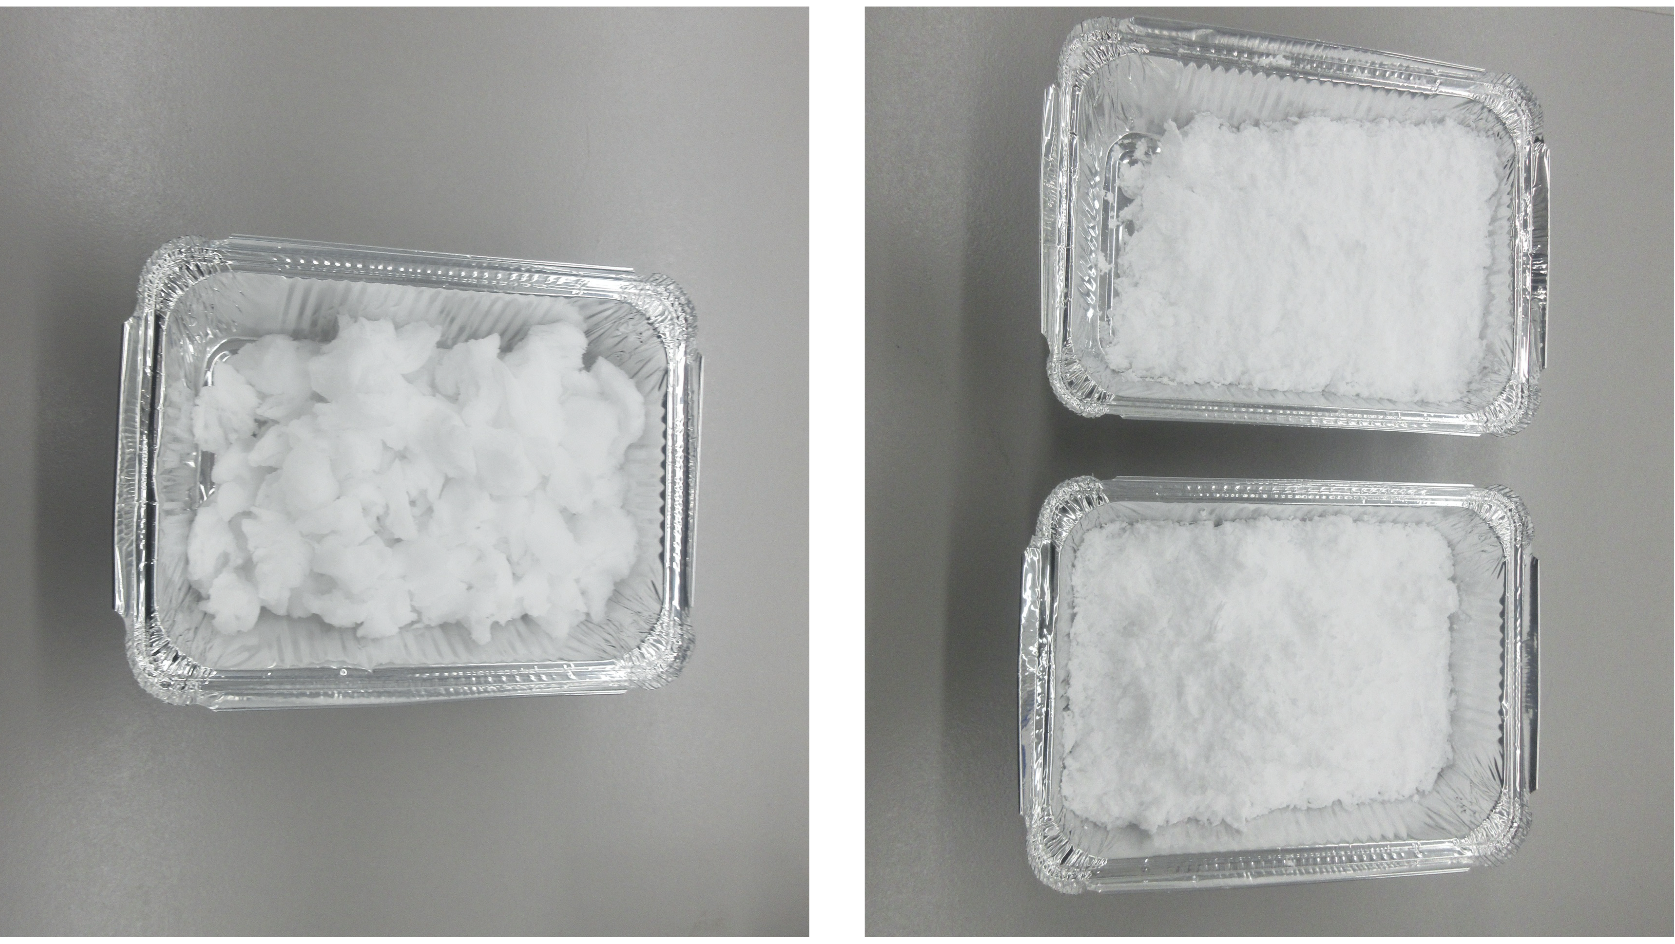
Supplement Fig 15. Macroscopic morphology of POE produced using CG-Ti (left) and CPP-Zr (right) catalysts.

Closed-Loop Optimization for Heterogeneous Photocatalytic C–O Coupling
This section documents the closed-loop catalyst optimization campaign for heterogeneous photocatalytic C–O coupling. The workflow follows the standardized discovery pipeline: design-space definition through AI-assisted literature mining (Section 4.1), data initialization from a small expert-curated seed set, CatAI model architecture for catalyst-condition co-optimization (Section 4.2), and experimental validation comprising catalyst synthesis (Section 4.3), substrate scope evaluation (Section 4.4), performance comparison with representative heterogeneous catalysts (Section 4.5) and stability performance evaluation (Section 4.6).

Design space definition by literature mining
We performed AI-assisted literature mining using a DeepSeek-based agent to enable high-throughput structured extraction of catalyst from cross coupling literature. Because this task required only categorical descriptors (metal identity and support type) rather than quantitative activity values, a lighter text-only extraction pipeline was sufficient and multimodal figure parsing was not necessary.
The workflow comprised two stages. First, articles matching the Boolean query ((cross coupling OR cross-coupling) AND (catalyst* OR catalyst OR catalysis)) were automatically retrieved in HTML format via the large language model agent and subsequently converted into structured JSON representations, in which embedded tables were rendered as Markdown to preserve tabular data for downstream parsing and figure captions were retained as separate text fields. Second, for each article the DeepSeek agent performed a two-pass analysis. In the first pass, an autonomous relevance classifier determined whether the manuscript described a catalyst-mediated coupling reaction within the predefined scope. In the second pass, the agent extracted catalyst-related entities—including catalysis type, coupling bond type, metal identity and support material—and normalized them into a unified JSON schema with controlled vocabularies and fixed keys. An automated self-audit was applied to the generated outputs, comprising JSON validity checks, schema compliance verification and internal consistency checks; entries failing validation were automatically regenerated until all constraints were satisfied.
After deduplication and normalization, this pipeline yielded 1790 metal entries and 214 support entries, which were subsequently used to delineate the accessible catalyst design space rather than for direct performance benchmarking.

Model architecture for active learning framework
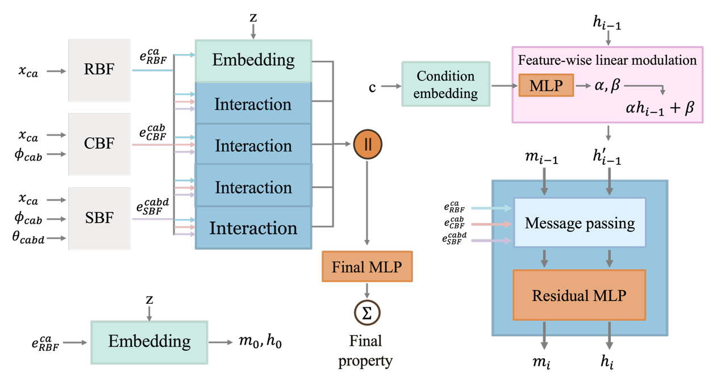
Supplementary Fig 16. Architecture of the condition-encoded model.

Synthesis of optimized catalysts
The preparation of Cu_{g}/PCN followed a previously reported two-step annealing protocol²³, CuCl₂ (0.36 g) and exfoliated PCN (0.70 g) were dispersed in 200 mL formamide, sonicated for 10 min and then stirred in an oil bath (120 °C) for 12 h, following centrifugation and washing thoroughly by ethanol several times. The oven-dried powder (80 °C) was subsequently heated to 500 °C with a heating rate of 2 °C min⁻¹ and kept for 5 h with the protection of N₂ flow. Other heterogeneous single-atom catalysts were prepared according to the previously reported protocol^{24,25}. Further details on catalyst synthesis and characterization, experimental setups, and the overall metallaphotocatalytic protocol are provided in the Supplementary Information (Materials and Methods).

Substrate scope
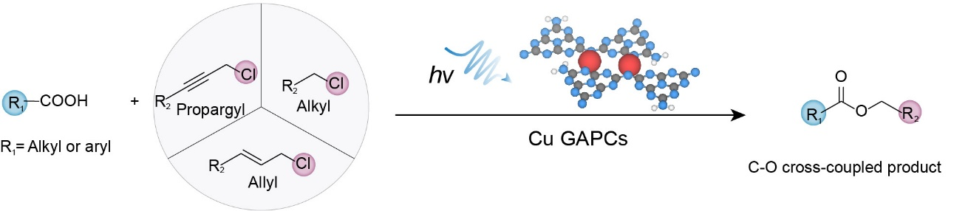
General Procedure: Cu GAPC (12.6·wt%, 5.0 mg, 10 mmol%), N-Boc-L-proline 1 (0.1 mmol, 23.2 mg), cinnamyl chloride 2 (22.8 mg, 0.15 mmol) and BTMG (34.2 mg, 0.2 mmol), DMSO (0.5 mL) and a magnetic stirrer bar were transferred into a 4 mL vial equipped with a screw-cap rubber septum, which in turn functioned as the batch photoreactor. All compounds were weighed using a high-throughput system manufactured by Huixiang inside an argon-filled glovebox. Photocatalytic batch experiments were irradiated for 12 h in a PhotoCubeTM reactor, and products were analyzed by ¹H and ¹³C NMR spectroscopy. During system optimization, quantitative data on conversion and product selectivity were obtained by taking a 50 μL aliquot of the reaction mixture with tridecane as an internal standard, diluting with ethyl acetate, filtering, and analyzing by gas chromatography (GC). The synthesis of other products (5–16) was also carried out using this method or closely related procedures.
Spectroscopic data of 3-16 are as follows.
1-(tert-butyl)-2-cinnamylpyrrolidine-1,2-dicarboxylate (±3)²⁶
Colorless oil, 29.8 mg, 90% yield. ¹H NMR (400 MHz, CDCl₃) δ 7.43 – 7.37 (m, 2H), 7.36 – 7.26 (m, 3H), 6.68 (dd, J = 15.9, 5.4 Hz, 1H), 6.42 – 6.24 (m, 1H), 4.91 – 4.67 (m, 2H), 4.33 (ddd, J = 44.7, 8.6, 3.8 Hz, 1H), 3.64 – 3.34 (m, 2H), 2.32 – 2.14 (m, 1H), 2.05 – 1.85 (m, 3H), 1.44 (d, J = 29.2 Hz, 9H) ppm.
3-phenylprop-2-yn-1-yl ((tert-butoxycarbonyl)oxy)prolinate (±5)
Colorless oil, 29.4 mg, 85% yield. ¹H NMR (400 MHz, CDCl₃) δ 7.37 (d, J = 6.1 Hz, 2H), 7.25 (tq, J = 9.1, 6.1, 4.8 Hz, 3H), 4.99 – 4.77 (m, 2H), 4.27 (ddd, J = 57.5, 8.6, 4.0 Hz, 1H), 3.55 – 3.27 (m, 2H), 2.23 – 2.10 (m, 1H), 1.99 – 1.76 (m, 3H), 1.37 (d, J = 31.8 Hz, 9H) ppm. ¹³C NMR (101 MHz, CDCl₃) δ 172.63, 172.35, 154.45, 153.79, 131.91, 131.90, 128.85, 128.72, 128.32, 128.28, 122.24, 122.07, 86.67, 86.58, 82.82, 82.72, 80.09, 79.92, 59.04, 58.76, 53.37, 53.16, 46.60, 46.34, 30.88, 29.86, 28.44, 28.29, 24.34, 23.67 ppm.
2-benzyl 1-(tert-butyl) pyrrolidine-1,2-dicarboxylate (±7)²⁷
Colorless oil, 28.1 mg, 92% yield. ¹H NMR (400 MHz, CDCl₃) δ 7.28 (d, J = 4.5 Hz, 5H), 5.20 – 4.97 (m, 2H), 4.25 (ddd, J = 49.1, 8.6, 3.6 Hz, 1H), 3.54 – 3.22 (m, 2H), 2.23 – 2.04 (m, 1H), 1.95 – 1.72 (m, 3H), 1.33 (d, J = 46.2 Hz, 9H) ppm.
1-(tert-butyl) 2-(3-phenylpropyl) pyrrolidine-1,2-dicarboxylate (±9)²⁶
Colorless oil, 28.0 mg, 84% yield. ¹H NMR (400 MHz, CDCl₃) δ 7.26 – 7.20 (m, 2H), 7.15 (td, J = 7.1, 1.7 Hz, 3H), 4.38 – 4.06 (m, 3H), 3.51 – 3.23 (m, 2H), 2.88 (t, J = 7.0 Hz, 2H), 2.15 – 1.99 (m, 1H), 1.83 – 1.40 (m, 5H), 1.35 (d, J = 30.5 Hz, 9H) ppm.
cinnamyl 2-acetoxybenzoate (10)
Yellow solid, 21.9 mg, 74% yield. ¹H NMR (400 MHz, CDCl₃) δ 8.00 (dd, J = 7.9, 1.7 Hz, 1H), 7.53 – 7.48 (m, 1H), 7.35 (d, J = 7.2 Hz, 2H), 7.26 (q, J = 6.8, 6.3 Hz, 3H), 7.21 (d, J = 7.1 Hz, 1H), 7.05 (d, J = 8.0 Hz, 1H), 6.66 (d, J = 15.8 Hz, 1H), 6.30 (dt, J = 15.8, 6.5 Hz, 1H), 4.87 (d, J = 6.5 Hz, 2H), 2.26 (s, 3H) ppm. ¹³C NMR (101 MHz, CDCl₃) δ 169.76, 164.37, 150.66, 136.11, 134.66, 133.96, 131.92, 128.68, 128.21, 126.67, 126.09, 123.84, 123.35, 122.84, 65.76, 21.08 ppm.
cinnamyl 2-(4-isobutylphenyl)propanoate (11)²⁸
Yellow solid, 28.4 mg, 88% yield. ¹H NMR (400 MHz, CDCl₃) δ 7.39 – 7.31 (m, 4H), 7.32 – 7.25 (m, 3H), 7.15 (d, J = 8.1 Hz, 2H), 6.56 (d, J = 15.9 Hz, 1H), 6.26 (dt, J = 15.9, 6.1 Hz, 1H), 4.77 (d, J = 6.1 Hz, 2H), 3.79 (q, J = 7.1 Hz, 1H), 2.50 (d, J = 7.1 Hz, 2H), 1.89 (dq, J = 13.5, 6.8 Hz, 1H), 1.56 (d, J = 7.1 Hz, 3H), 0.94 (d, J = 6.6 Hz, 6H) ppm. ¹³C NMR (101 MHz, CDCl₃) δ 174.52, 140.62, 137.74, 136.30, 133.63, 129.40, 128.58, 127.98, 127.26, 126.60, 123.27, 65.09, 45.22, 45.08, 30.21, 22.44, 18.60 ppm.
cinnamyl (S)-2-(6-methoxynaphthalen-2-yl)propanoate (12)
Yellow solid, 31.9 mg, 92% yield. ¹H NMR (400 MHz, CDCl₃) δ 7.80 – 7.69 (m, 3H), 7.48 (dd, J = 8.4, 1.9 Hz, 1H), 7.30 – 7.24 (m, 2H), 7.22 – 7.12 (m, 2H), 6.52 (d, J = 15.9 Hz, 1H), 6.25 (dt, J = 15.9, 6.2 Hz, 1H), 4.78 (d, J = 6.2 Hz, 2H), 3.97 – 3.92 (m, 1H), 3.95 (s, 3H), 1.65 (d, J = 7.1 Hz, 3H) ppm. ¹³C NMR (101 MHz, CDCl₃) δ 174.44, 157.70, 136.22, 135.68, 133.78, 133.76, 129.35, 128.99, 128.56, 127.99, 127.24, 126.59, 126.32, 126.06, 123.16, 119.03, 105.63, 65.20, 55.34, 45.54, 18.58 ppm.

cinnamyl 2-hydroxybenzoate (13)²⁹
Yellow solid, 17.5 mg, 69% yield. ¹H NMR (400 MHz, CDCl₃) δ 10.70 (s, 1H), 7.82 (dd, J = 8.0, 1.8 Hz, 1H), 7.38 (ddd, J = 8.7, 7.2, 1.8 Hz, 1H), 7.35 (d, J = 8.1 Hz, 2H), 7.26 (t, J = 7.6 Hz, 2H), 7.20 (t, J = 7.3 Hz, 1H), 6.91 (d, J = 8.3 Hz, 1H), 6.84 – 6.78 (m, 1H), 6.68 (d, J = 15.9 Hz, 1H), 6.31 (dt, J = 15.9, 6.5 Hz, 1H), 4.93 (dd, J = 6.5, 1.4 Hz, 2H) ppm.
Caffeic Acid Cinnamyl Ester (16)³⁰
Yellow solid, 15.4 mg, 52% yield. ¹H NMR (400 MHz, CDCl₃) δ 7.52 (d, J = 16.0 Hz, 1H), 7.29 – 7.24 (m, 5H), 7.03 (s, 1H), 6.99 (d, J = 8.4 Hz, 1H), 6.83 (d, J = 8.4 Hz, 1H), 6.64 (d, J = 5.2 Hz, 1H), 6.61 – 6.59 (m, 1H), 6.35 (s, 1H), 6.31 (d, J = 7.8 Hz, 1H), 4.73 (d, J = 6.5 Hz, 2H) ppm.

Catalyst performance comparison
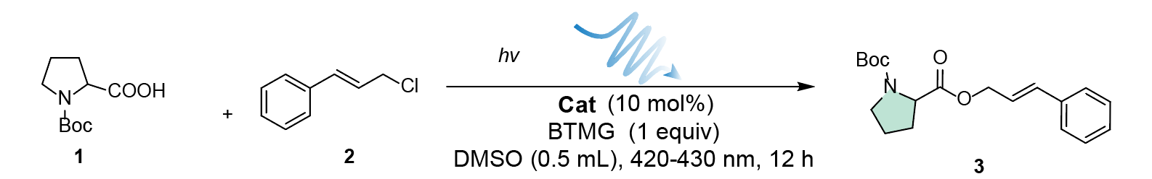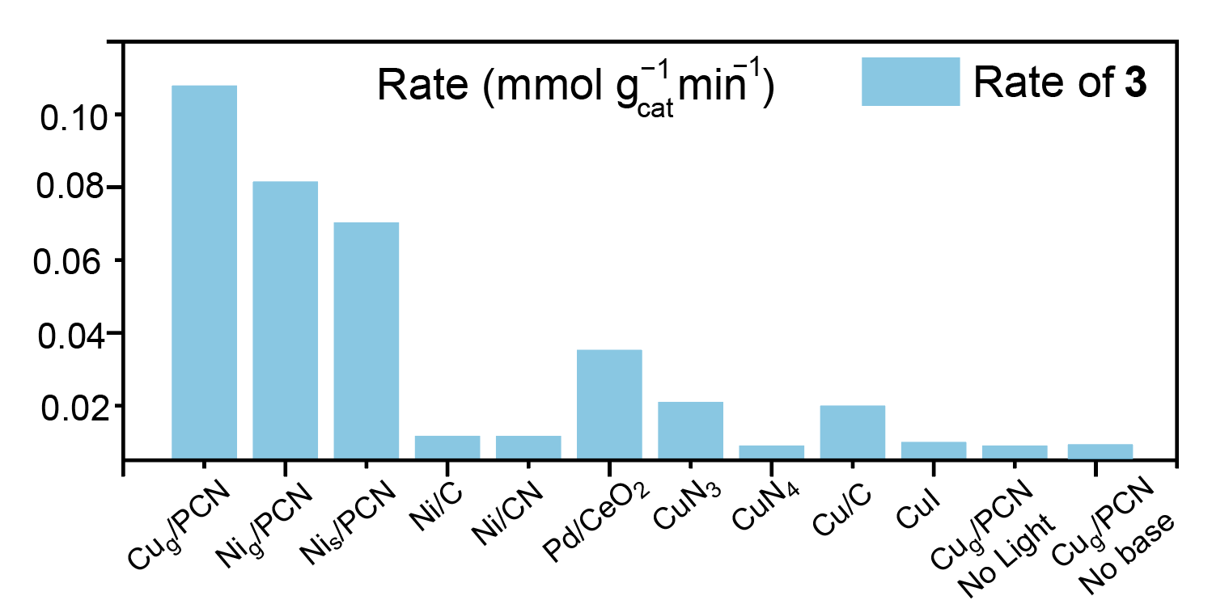
Supplementary Fig 17. Catalyst performance comparison.
Reaction conditions: N-Boc-L-proline 1 (0.1 mmol, 23.2 mg), cinnamyl chloride (22.8 mg, 0.15 mmol), BTMG (34.2 mg, 0.2 mmol), Cat (10 mmol%), DMSO (0.5 mL) Photocatalytic batch experiments were irradiated (420-430 nm) for 12 h using a PhotoCubeTM reactor.

Catalyst stability performance
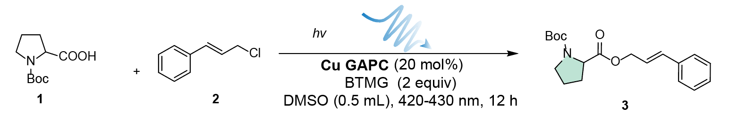
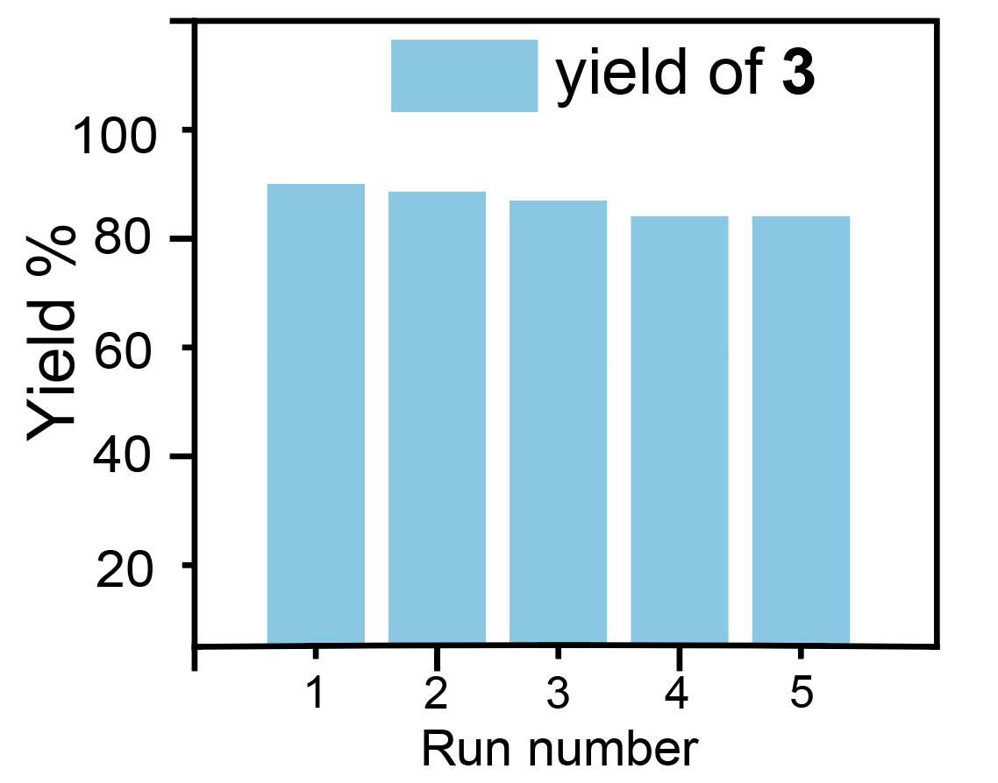
Supplementary Fig 18. Recycling experiment.
Reaction conditions: N-Boc-L-proline 1 (1 mmol, 232 mg), cinnamyl chloride (228 mg, 1.5 mmol), BTMG (342 mg, 2 mmol), Cu GAPC (20.0 mmol%), DMSO (4 mL) Photocatalytic batch experiments were irradiated (420-430 nm) for 12 h using a PhotoCubeTM reactor.

Extensibility: Extensible Learning, Life-Cycle Analysis, and Community Platform
This section documents the extensibility of CatAI across three aspects: extensible learning with progressively expanded property modules (Section 5.1), life cycle analysis comparing commercial and CatAI designed POE catalysts (Section 5.2), and a community platform for catalyst property prediction and usage (Section 5.3).

Extensibility of CatAI
Supplementary Table 37. Properties introduced with each five-module increment in the extensible learning experiment.
Index | Property 1 | Property 2 | Property 3 | Property 4 | Property 5
0→5 | p-type electrical conductivity | HOMO–LUMO gap | QMOF band gap | n-type electrical conductivity | CEPDB power conversion efficiency
5→10 | QMOF total energy | DOS Fermi level | OQMD ΔE (hull) | OQMD stability label | OPMD band gap
10→15 | Surface energy | Activation energy barrier | Gibbs free energy | Electronic energy | Metal partial charge
15→20 | Castelli formation energy | JARVIS band gap | JARVIS formation energy | JARVIS total energy | Single atom catalyst adsorption energy
20→25 | MP Fermi level | n-type thermal conductivity | MP energy above hull | MP band gap | p-type thermal conductivity
25→30 | MP formation energy | JARVIS shear modulus (VRH) | JARVIS bulk modulus (VRH) | MP shear modulus (VRH) | MP bulk modulus (VRH)

Supplementary Table 38. Model performance on Alloy-GMAE with module increase (5-fold experiments).
Module number | Split 0 | Split 1 | Split 2 | Split 3 | Split 4 | Mean MAE | Improvement  %
5 | 0.155 | 0.163 | 0.128 | 0.124 | 0.132 | 0.140 | -
10 | 0.121 | 0.102 | 0.096 | 0.111 | 0.101 | 0.106 | 24.4
15 | 0.093 | 0.098 | 0.099 | 0.081 | 0.091 | 0.092 | 12.9
20 | 0.086 | 0.080 | 0.087 | 0.072 | 0.080 | 0.081 | 12.5
25 | 0.084 | 0.081 | 0.086 | 0.069 | 0.079 | 0.079 | 1.8
30 | 0.071 | 0.069 | 0.063 | 0.060 | 0.063 | 0.065 | 17.9

Supplementary Table 39. Model performance on FG-GMAE with module increase (5-fold experiments).
Module number | Split 0 | Split 1 | Split 2 | Split 3 | Split 4 | Mean MAE | Improvement  %
5 | 0.065 | 0.070 | 0.075 | 0.072 | 0.067 | 0.070 | -
10 | 0.052 | 0.050 | 0.064 | 0.052 | 0.054 | 0.054 | 22.3
15 | 0.037 | 0.038 | 0.031 | 0.042 | 0.052 | 0.040 | 26.2
20 | 0.033 | 0.034 | 0.032 | 0.039 | 0.045 | 0.037 | 8.4
25 | 0.033 | 0.033 | 0.034 | 0.039 | 0.046 | 0.037 | -0.5
30 | 0.030 | 0.034 | 0.031 | 0.038 | 0.045 | 0.036 | 3.3

Supplementary Table 40. Model performance on Dissociation-OC20 with module increase (5-fold experiments).
Module number | Split 0 | Split 1 | Split 2 | Split 3 | Split 4 | Mean MAE | Improvement  %
5 | 0.748 | 0.594 | 0.783 | 0.885 | 0.591 | 0.720 | -
10 | 0.767 | 0.554 | 0.723 | 0.902 | 0.534 | 0.696 | 3.4
15 | 0.847 | 0.755 | 0.696 | 0.887 | 0.527 | 0.742 | -6.7
20 | 0.729 | 0.637 | 0.782 | 0.865 | 0.539 | 0.710 | 4.4
25 | 0.687 | 0.594 | 0.761 | 0.836 | 0.499 | 0.675 | 4.9
30 | 0.683 | 0.621 | 0.776 | 0.844 | 0.503 | 0.685 | -1.5

Supplementary Table 41. Model performance on Transfer-OC20 with module increase (5-fold experiments).
Module number | Split 0 | Split 1 | Split 2 | Split 3 | Split 4 | Mean MAE | Improvement  %
5 | 0.689 | 0.638 | 0.598 | 0.676 | 0.568 | 0.634 | -
10 | 0.677 | 0.615 | 0.570 | 0.696 | 0.572 | 0.626 | 1.2
15 | 0.656 | 0.647 | 0.515 | 0.677 | 0.567 | 0.612 | 2.2
20 | 0.653 | 0.642 | 0.547 | 0.694 | 0.562 | 0.619 | -1.2
25 | 0.657 | 0.637 | 0.566 | 0.611 | 0.564 | 0.607 | 2
30 | 0.648 | 0.638 | 0.520 | 0.554 | 0.564 | 0.585 | 3.7

Life cycle analysis of CG-Ti and CPP-Zr
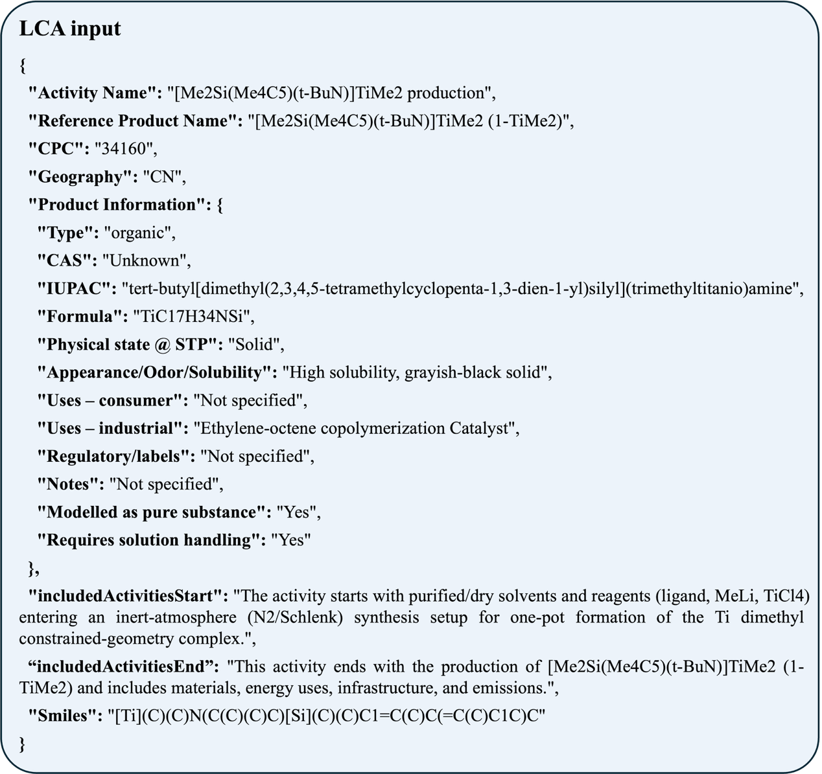
Supplementary Fig 19. Input information of CG-Ti for GWP prediction.

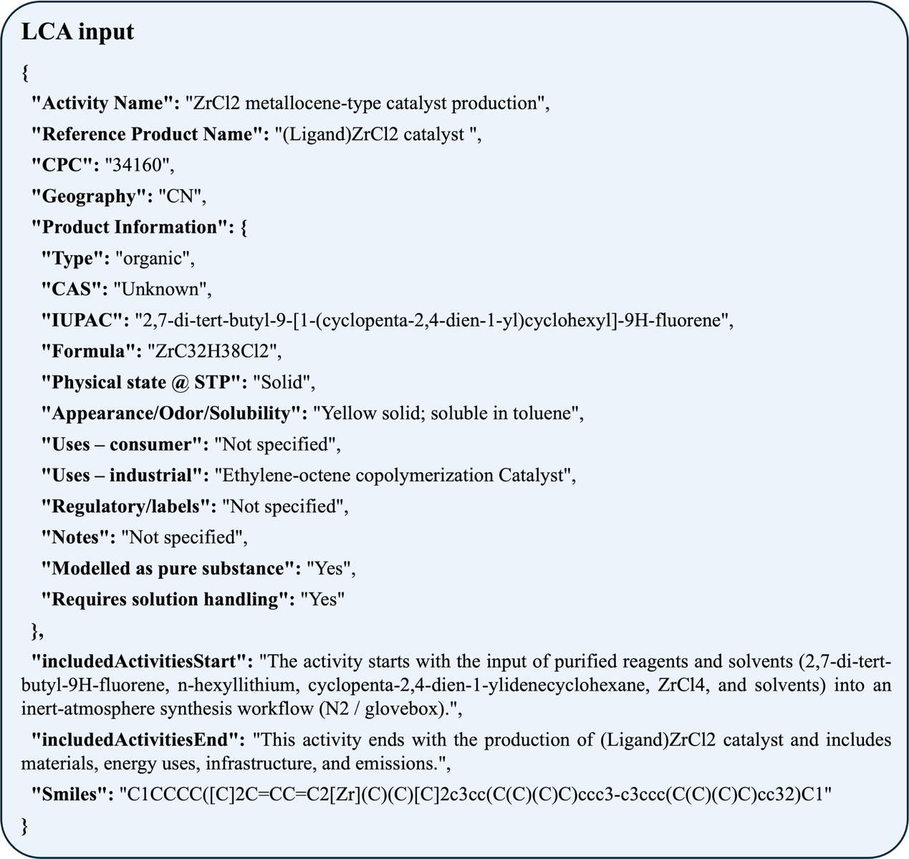
Supplementary Fig 20. Input information of CPP-Zr for GWP prediction.

Supplementary Table 42. Life cycle inventory of CG-Ti.
Process | Activity Name | Category | Value | Unit | Data type
POE Production | POE | Product | 1.0000 | kg | Measured primary data
POE Production | Ethylene | Raw material | 0.6173 | kg | Measured primary data
POE Production | 1-octene | Raw material | 0.3827 | kg | Measured primary data
POE Production | [Me₂Si(Me₄C₅)(t-BuN)]TiMe₂(1-TiMe₂) | Auxiliary material | 0.0094 | kg | Measured primary data
POE Production | IsoparE | Auxiliary material | 0.9985 | kg | Measured primary data
POE Production | Toluene | Auxiliary material | 0.0173 | kg | Assumed estimate
POE Production | Modified Methylaluminoxane, Type 7 (MMAO-7) | Auxiliary material | 0.0057 | kg | Measured primary data
POE Production | Electricity | Energy and energy carriers | 2.9300 | kWh | Measured primary data
POE Production | Wastewater | Waste | 1.0214 | kg | Measured primary data

Supplementary Table 43. Carbon footprint factor of CG-Ti.
Process | Activity Name | GWP100 (IPCC 2021 method) | Region | Data source category
POE Production | POE | \ | \ | \
POE Production | Ethylene | 2.9657 | China | LCA database
POE Production | 1-octene | 14.9500 | South Korea | Literature data
POE Production | [Me₂Si(Me₄C₅)(t-BuN)]TiMe₂ (1-TiMe₂) | 5.4270 | China | Predicted value based on AI
POE Production | IsoparE | 1.2662 | Rest of World | LCA database (proxy)
POE Production | Toluene | 1.6799 | Rest of World | LCA database
POE Production | Modified Methylaluminoxane, Type 7 (MMAO-7) | 3.0876 | Global | LCA database (proxy)
POE Production | Electricity | 0.7022 | China | LCA database
POE Production | Wastewater | 0.0203 | Rest of World | LCA database

Supplementary Table 44. Life cycle inventory of CatAI-designed catalyst CPP-Zr.
Process | Activity Name | Category | Value | Unit | Data type
POE Production | POE | Product | 1.0000 | kg | Measured primary data
POE Production | Ethylene | Raw material | 0.6920 | kg | Measured primary data
POE Production | 1-octene | Raw material | 0.3080 | kg | Measured primary data
POE Production | ZrCl₂ metallocene-type catalyst | Auxiliary material | 0.0045 | kg | Measured primary data
POE Production | IsoparE | Auxiliary material | 0.8036 | kg | Measured primary data
POE Production | Toluene | Auxiliary material | 0.0173 | kg | Assumed estimate
POE Production | Modified Methylaluminoxane, Type 7 (MMAO-7) | Auxiliary material | 0.0046 | kg | Measured primary data
POE Production | Electricity | Energy and energy carriers | 2.9300 | kWh | Measured primary data
POE Production | Wastewater | Waste | 0.8254 | kg | Measured primary data

Supplementary Table 45. Carbon footprint factor of CatAI-designed catalyst CPP-Zr.
Process | Activity Name | GWP100 (IPCC 2021 method) | Region | Data source category
POE Production | POE | \ | \ | \
POE Production | Ethylene | 2.9657 | China | LCA database
POE Production | 1-octene | 14.9500 | South Korea | Literature data
POE Production | ZrCl₂ metallocene-type catalyst | 2.6728 | China | Predicted value based on AI
POE Production | IsoparE | 1.2662 | Rest of World | LCA database (proxy)
POE Production | Toluene | 1.6799 | Rest of World | LCA database
POE Production | Modified Methylaluminoxane, Type 7 (MMAO-7) | 3.0876 | Global | LCA database (proxy)
POE Production | Electricity | 0.7022 | China | LCA database
POE Production | Wastewater | 0.0203 | Rest of World | LCA database

CatAI platform for community usage
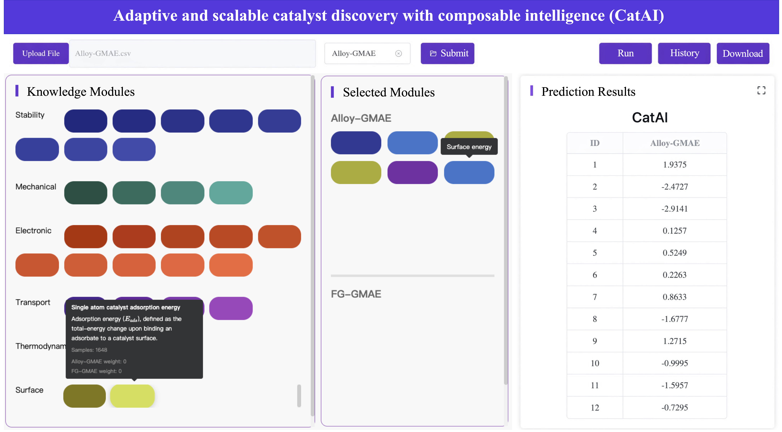
Supplementary Fig 21. CatAI interface for catalyst property prediction.

References
1. Shoghi, N. et al. From Molecules to Materials: Pre-training Large Generalizable Models for Atomic Property Prediction. Preprint at https://doi.org/10.48550/arXiv.2310.16802 (2024).
2. Gasteiger, J. et al. GemNet-OC: developing graph neural networks for large and diverse molecular simulation datasets. Preprint at https://doi.org/10.48550/arXiv.2204.02782 (2022).
3. Jain, A. et al. Commentary: the materials project: a materials genome approach to accelerating materials innovation. APL Mater. 1, 11002 (2013).
4. Castelli, I. E. et al. New cubic perovskites for one- and two-photon water splitting using the computational materials repository. Energy Environ. Sci. 5, 9034–9043 (2012).
5. Choudhary, K. et al. The joint automated repository for various integrated simulations (JARVIS) for data-driven materials design. npj Comput. Mater. 6, 173 (2020).
6. Kirklin, S. et al. The open quantum materials database (OQMD): assessing the accuracy of DFT formation energies. npj Comput. Mater. 1, 15010 (2015).
7. Rosen, A. S. et al. Machine learning the quantum-chemical properties of metal–organic frameworks for accelerated materials discovery. Matter 4, 1578–1597 (2021).
8. Rosen, A. S. et al. High-throughput predictions of metal–organic framework electronic properties: theoretical challenges, graph neural networks, and data exploration. npj Comput. Mater. 8, 112 (2022).
9. Balcells, D. & Skjelstad, B. B. tmQM dataset—quantum geometries and properties of 86k transition metal complexes. J. Chem. Inf. Model. 60, 6135–6146 (2020).
10. Hachmann, J. et al. The harvard clean energy project: large-scale computational screening and design of organic photovoltaics on the world community grid. J. Phys. Chem. Lett. 2, 2241–2251 (2011).
11. Ricci, F. et al. An ab initio electronic transport database for inorganic materials. Sci. Data 4, 170085 (2017).
12. Yin, J. et al. SurFF: a foundation model for surface exposure and morphology across intermetallic crystals. Nat. Comput. Sci. 5, 782–792 (2025).
13. Chen, H., Yin, J., Li, J. & Wang, X. Theoretical high-throughput screening of single-atom CO₂ electroreduction catalysts to methanol using active learning. Engineering 52, 172–182 (2025).
14. Xie, T. & Grossman, J. C. Crystal Graph Convolutional Neural Networks for an Accurate and Interpretable Prediction of Material Properties. Phys. Rev. Lett. 120, 145301 (2018).
15. Gasteiger, J., Giri, S., Margraf, J. T. & Günnemann, S. Fast and Uncertainty-Aware Directional Message Passing for Non-Equilibrium Molecules. Preprint at https://doi.org/10.48550/arXiv.2011.14115 (2022).
16. Liao, Y.-L. & Smidt, T. Equiformer: Equivariant Graph Attention Transformer for 3D Atomistic Graphs. https://openreview.net/forum?id=_efamP7PSjg (2022).
17. Passaro, S. & Zitnick, C. L. Reducing SO(3) Convolutions to SO(2) for Efficient Equivariant GNNs. Preprint at https://doi.org/10.48550/arXiv.2302.03655 (2023).
18. Chen, J., Huang, X., Hua, C., He, Y. & Schwaller, P. A multi-modal transformer for predicting global minimum adsorption energy. Nat. Commun. 16, 3232 (2025).
19. Neumann, M. et al. Orb: a fast, scalable neural network potential. Preprint at https://doi.org/10.48550/2410.22570v1 (2024).
20. Rhodes, B. et al. Orb-v3: atomistic simulation at scale. Preprint at https://doi.org/10.48550/arXiv.2504.06231v2 (2025).
21. Wongwaiwattanakul, P. & Jongsomjit, B. Copolymerization of ethylene/1-octene via different pore sized silica-based-supported zirconocene/dMMAO catalysts. Catal. Commun. 10, 118–122 (2008).
22. Canich, J. A. M., Izmer, V. V., Kononovich, D. S. & Voskoboynikov, A. Z. Tetrahydro-as-indacenyl catalyst composition, catalyst system, and processes for use thereof. US patent 9803037B1 (2017).
23. Hai, X. et al. Geminal-atom catalysis for cross-coupling. Nature 622, 754–760 (2023).
24. Cai, Q. et al. De-Saturation of Single-Atom Copper Catalysts for Accelerating Propargylic Substitution Reactions. Adv. Mater. 37, e09221 (2025).
25. Shi, J. et al. Defying the oxidative-addition prerequisite in cross-coupling through artful single-atom catalysts. Nat. Commun. 16, 3223 (2025).
26. Bajada, M. A. et al. Light-driven C–O coupling of carboxylic acids and alkyl halides over a Ni single-atom catalyst. Nat. Synth. 2, 1092–1103 (2023).
27. Wang, Y., Wen, X., Cui, X. & Zhang, X. P. Enantioselective Radical Cyclization for Construction of 5-Membered Ring Structures by Metalloradical C–H Alkylation. J. Am. Chem. Soc. 140, 4792–4796 (2018).
28. Theodosis-Nobelos, P., Kourti, M., Tziona, P., Kourounakis, P. N. & Rekka, E. A. Esters of some non-steroidal anti-inflammatory drugs with cinnamyl alcohol are potent lipoxygenase inhibitors with enhanced anti-inflammatory activity. Bioorg. Med. Chem. Lett. 25, 5028–5031 (2015).
29. Palladium-Catalyzed ipso-Didefluoroannulation of Allylic gem-Difluorides with Salicylic Acids. Org. Lett. 27, 12200–12205 (2025).
30. Shi, H., Xie, D., Yang, R. & Cheng, Y. Synthesis of Caffeic Acid Phenethyl Ester Derivatives, and Their Cytoprotective and Neuritogenic Activities in PC12 Cells. J. Agric. Food Chem. 62, 5046–5053 (2014).

NMR spectra of purified products
¹H NMR spectra (400 MHz, C₆D₆) of Cat 1

¹H NMR spectra (400 MHz, C₆D₆) of Cat 2
¹H NMR spectra (400 MHz, C₆D₆) of CPP-Zr
¹H NMR spectra (400 MHz, C₆D₆) of CG-Ti

¹H NMR spectra (400 MHz, CDCl₃) of ±3
¹H NMR spectra (400 MHz, CDCl₃) of ±5
¹³C NMR spectra (101 MHz, CDCl₃) of ±5
¹H NMR spectra (400 MHz, CDCl₃) of ±7
¹H NMR spectra (400 MHz, CDCl₃) of ±9
¹H NMR spectra (400 MHz, CDCl₃) of 10
¹³C NMR spectra (101 MHz, CDCl₃) of 10
¹H NMR spectra (400 MHz, CDCl₃) of 11
¹³C NMR spectra (101 MHz, CDCl₃) of 11
¹H NMR spectra (400 MHz, CDCl₃) of 12
¹³C NMR spectra (101 MHz, CDCl₃) of 12

¹H NMR spectra (400 MHz, CDCl₃) of 13
¹H NMR spectra (400 MHz, CDCl₃) of 16

