Lessons from the BEAT Trial: Implications for Inhaled treprostinil
Running title: Lessons from the BEAT Trial
Mordechai R Kramer¹, Sonja Bartolome², Rajan Saggar³, Robert C Bourge⁴, H James Ford⁵, Boris Medarov⁶, Jeffrey S Sager⁷, Shelly M Shapiro³, Aaron B Waxman⁸, David Ishizawar⁹, Ronald J Oudiz¹⁰, Jordan Shin*¹¹, Prakash Sista*¹¹, Michael DiMarino¹¹, Aimee Smart¹¹, Mary-Lou Tomson¹¹, Mark I Lorber¹², Youlan Rao¹², Meredith Broderick¹², Franck Rahaghi¹² and Robert Naeije¹³
¹Pulmonary Division, Rabin Medical Center, Petah Tikva, Israel; ²University of Texas-Southwestern Medical Center, Dallas, TX, USA; ³David Geffen Medical Center at Los Angeles, Los Angeles, CA, USA; ⁴University of Alabama at Birmingham, Birmingham, AL, USA; ⁵University of North Carolina at Chapel Hill, Chapel Hill, NC, USA; ⁶Albany Medical College, Albany, NY, USA; ⁷Cottage Pulmonary Hypertension Center, Santa Barbara, CA, USA; ⁸Brigham & Women’s Hospital, Boston, MA, USA; ⁹Medical College of Wisconsin, Milwaukee, WI, USA; ¹⁰Lundquist Institute at Harbor, University of California-Los Angeles Medical Center, Torrance, CA, USA; ¹¹United Therapeutics, Silver Spring, MD, USA; ¹²United Therapeutics Corp, RTP, NC, USA; ¹³Free University of Brussels, Brussels, Belgium.
*Formerly at United Therapeutics
Corresponding Author: Dr. Franck Rahaghi, MD
55 TW Alexander Dr, Durham, NC 27709
frahaghi@unither.com
Supplementary Material

The double-blind, event-driven Beraprost-314d Added on to Tyvaso (BEAT) study, reported in the accompanying article, provided an opportunity to examine the durability of inhaled treprostinil (ITRE) effects over a longer period in both naïve (ITRE-N) and experienced (ITRE-E) pulmonary arterial hypertension (PAH) patients. This post-hoc exploratory analysis was thus undertaken to examine the results of the BEAT study and more thoroughly evaluate the effect of ITRE on clinical efficacy and safety outcomes.

In the BEAT study [1], FC-III/IV patients receiving no, single, or dual background PAH therapy were randomized to esuberaprost (ESU) or placebo (PBO), with randomization stratified based on length of ITRE exposure at screening. Differences in time to clinical worsening event (CWE), 6MWD, NT-proBNP, FC, French noninvasive low-risk criteria [2], REVEAL 2.0 score [3], and treatment-emergent adverse events (TEAEs) were assessed across four patient subgroups. Subgroups were determined based on ITRE exposure at screening and treatment assignment as: 1) ITRE-N+PBO; 2) ITRE-N+ESU; 3) ITRE-E+PBO; and 4) ITRE-E+ESU.

Table S1. Summary of Patient Characteristics at Screening
 | Inhaled Treprostinil
Characteristic* | Naïve |  | Experienced
Characteristic* | PBO  N = 73 | ESUB  N = 78 | PBO  N = 62 | ESUB  N = 58
Age, years | 57.9 ± 13.3 | 56 ± 14.2 | 53.9 ± 13.1 | 53.4 ± 12.7
Female sex, n (%) | 51 (69.9) | 56 (71.8) | 47 (75.8) | 43 (74.1)
Race, n (%)
Asian | 1 (1.4) | 1 (1.3) | 2 (3.2) | 3 (5.2)
Black or African American | 11 (15.1) | 7 (9) | 8 (12.9) | 7 (12.1)
White | 61 (83.6) | 68 (87.2) | 51 (82.3) | 47 (81)
Unknown | 0 | 1 (1.3) | 1 (1.6) | 1 (1.7)
Multiple | 0 | 1 (1.3) | 0 | 0
Time since PAH diagnosis, years† | 2.7 ± 4.3 | 2.4 ± 3.08 | 5.8 ± 4.09 | 5.3 ± 4.23
Etiology of PAH, n (%)
Idiopathic or familial | 45 (61.6) | 41 (52.6) | 36 (58.1) | 31 (53.4)
Associated w/ CVD | 21 (28.8) | 31 (39.7) | 19 (30.6) | 23 (39.7)
Associated w/ HIV infection | 2 (2.7) | 3 (3.8) | 4 (6.5) | 3 (3.8)
Associated w/ repaired congenital dysfunction‡ | 2 (2.7) | 1 (1.3) | 0 | 1 (1.3)
Induced by anorexigens, toxins | 3 (4.1) | 2 (2.6) | 3 (4.8) | 2 (2.6)
6MWD (meters) | 320 ± 115.4 | 337 ± 107.3 | 349 ± 117.2 | 367 ± 108.7
NT-proBNP, pg/mL; median (IQR) | 561 (211, 1210) | 596 (221, 1713) | 359 (113, 1135) | 342 (140, 729)
WHO functional class, n (%)
III | 67 (91.8) | 72 (92.3) | 60 (96.8) | 56 (96.6)
IV | 6 (8.2) | 6 (7.7) | 2 (3.2) | 2 (3.4)
Background PAH therapy, n (%)
None | 13 (17.8) | 11 (14.1) | 4 (6.5) | 1 (1.7)
PDE5 inhibitor alone | 16 (21.9) | 21 (26.9) | 14 (22.6) | 8 (13.8)
ERA alone | 8 (11) | 6 (7.7) | 8 (12.9) | 5 (8.6)
PDE5 inhibitor and ERA | 34 (46.6) | 39 (50) | 36 (58.1) | 40 (69.0)
SGC stimulator and ERA | 2 (2.7) | 1 (1.3) | 0 | 4 (6.9)
Time on ITRE, days; median (IQR) | NA | NA | 330 (125,786) | 454 (162,1227)
French Noninvasive, n (%)
3 low-risk criteria | 0 | 0 | 0 | 0
2 low-risk criteria | 7 (9.6) | 7 (9.2) | 10 (16.4) | 8 (14)
1 low-risk criteria | 22 (30.1) | 25 (32.9) | 25 (41) | 22 (39.3)
0 low-risk criteria | 44 (60.3) | 44 (57.9) | 26 (42.6) | 26 (46.4)

*Plus-minus values are means ± SD. †p<0.05. ‡Associated with repaired (≥ 1 year) congenital systemic-to-pulmonary shunts.

6MWD, six-minute walk distance; CVD, cardiovascular disease; HIV, human immunodeficiency virus; ERA, endothelin receptor antagonist; ESUB, esuberaprost; IQR, interquartile range; ITRE, inhaled treprostinil; NT-proBNP, N terminal pro-brain natriuretic peptide; PAH, pulmonary arterial hypertension; PBO, placebo; PDE5, phosphodiesterase type 5; SGC, soluble guanylate cyclase; WHO, World Health Organization.

Median time between screening and baseline visits was 115 days for ITRE-N+PBO, 117 days for ITRE-N+ESU, 28 days for ITRE-E+PBO, and 25 days for ITRE-E+ESU. Median time on ITRE at baseline was 98 days for ITRE-N+PBO, 97 days for ITRE-N+ESU, 349 days for ITRE-E+PBO, and 528 days for ITRE-E+ESU. Median ITRE dose at baseline was 9 breaths for all treatment groups.

Table S2. Most Frequent Adverse Events
 | Inhaled Treprostinil
Adverse Event, n (%)* | Naïve |  | Experienced
Adverse Event, n (%)* | PBO  N = 73 | ESUB  N = 78 | PBO  N = 62 | ESUB  N = 58
Upper respiratory infection | 17 (23.3) | 6 (7.7) | 18 (29.0) | 14 (24.1)
Nausea | 16 (21.9) | 27 (34.6) | 12 (19.4) | 14 (24.1)
Diarrhea | 13 (17.8) | 12 (15.4) | 9 (14.5) | 11 (19.0)
Cough | 12 (16.4) | 12 (15.4) | 6 (9.7) | 7 (12.1)
Fatigue | 12 (16.4) | 7 (9.0) | 8 (12.9) | 5 (8.6)
Headache | 11 (15.1) | 20 (25.6) | 12 (19.4) | 16 (27.6)
Pneumonia | 10 (13.7) | 7 (9.0) | 2 (3.2) | 5 (8.6)
Vomiting | 10 (13.7) | 10 (12.8) | 5 (8.1) | 3 (5.2)
Urinary tract infection | 9 (12.3) | 5 (6.4) | 10 (16.1) | 3 (5.2)
Dizziness | 7 (9.6) | 8 (10.3) | 11 (17.7) | 7 (12.1)
Fever | 7 (9.6) | 3 (3.8) | 3 (4.8) | 9 (15.5)
Nasal congestion | 7 (9.6) | 6 (7.7) | 3 (4.8) | 8 (13.8)
Bronchitis | 5 (6.8) | 8 (10.3) | 5 (8.1) | 3 (5.2)
Constipation | 5 (6.8) | 8 (10.3) | 5 (8.1) | 3 (5.2)
Jaw pain | 5 (6.8) | 7 (9.0) | 4 (6.5) | 8 (13.8)
Cold | 4 (5.5) | 7 (9.0) | 3 (4.8) | 7 (12.1)
Sinus infection | 4 (5.5) | 4 (5.1) | 3 (4.8) | 8 (13.8)
Hypokalemia | 3 (4.1) | 9 (11.5) | 5 (8.1) | 5 (8.6)

*At least 10% of in one treatment arm.

ESUB, esuberaprost; ITRE-E, inhaled treprostinil experienced; ITRE-N, inhaled treprostinil naïve; PBO, placebo.
Table S3. Post-hoc REVEAL 2.0 Risk Assessments
 | Inhaled Treprostinil
Risk Score,  n (%) | Naïve |  | Experienced
Risk Score,  n (%) | PBO | ESUB | PBO | ESUB
Screening
 | N = 73 | N = 76 | N = 61 | N = 56
Low risk | 13 (17.8) | 14 (18.4) | 22 (36.1) | 22 (39.3)
Intermediate risk | 25 (34.2) | 23 (30.3) | 15 (24.6) | 13 (23.2)
High risk | 35 (47.9) | 39 (51.3) | 24 (39.9) | 21 (37.5)
Baseline
 | N = 73 | N = 76 | N = 62 | N = 57
Low risk | 19 (26.0) | 18 (23.7) | 19 (30.6) | 24 (42.1)
Intermediate risk | 21 (28.8) | 24 (31.6) | 20 (32.3) | 16 (28.1)
High risk | 33 (45.2) | 34 (44.7) | 23 (37.1) | 17 (29.8)
Week 52
 | N = 49 | N = 51 | N = 32 | N = 34
Low risk | 27 (55.1) | 19 (37.3) | 13 (40.6) | 19 (55.9)
Intermediate risk | 9 (18.4) | 15 (29.4) | 11 (34.4) | 7 (20.6)
High risk | 13 (26.5) | 17 (33.3) | 8 (25.0) | 8 (23.5)

All values in n(%). §Scores were only calculated for subjects with all variables available. Score 0-6: low risk; score 7 or 8: intermediate risk; and score ≥9: high risk.

Table S4. Summary of Breaths at Baseline by Background Therapy
Variable | None  N = 24 | Single  N = 48 | Dual  N = 73
Mean (SD) | 3.21(1.56) | 3.79 (2.16) | 4.99 (3.11)
Min | 1.75 | 1.25 | 1.50
Max | 9.00 | 12.00 | 18.00

Figure S1. REVEAL 2.0 Categorical Shift from Screening by Subgroup

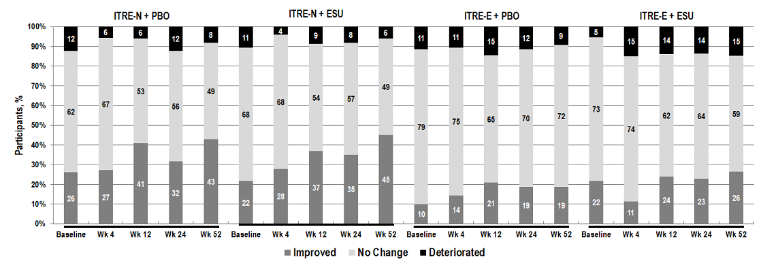

“Improved” indicates a shift from a higher to lower risk category; “No Change” indicates the same category; and “Deteriorated” indicates a shift from a lower to higher risk category.

Baseline: N=73 ITRE-N-PBO; N=74 ITRE-N + ESU; N=61 ITRE-E + PBO; and N=55 ITRE-E + ESU.

Week 52: N=49 ITRE-N-PBO; N=51 ITRE-N + ESU; N=32 ITRE-E + PBO; and N=34 ITRE-E + ESU.

Median (IQR) time on ITRE at baseline was 98 days for ITRE-N+PBO, 97 days for ITRE-N+ESU, 349 days for ITRE-E+PBO, and 528 days for ITRE-E+ESU.

ESU, esuberaprost; ITRE-E, inhaled treprostinil experienced; ITRE-N, inhaled treprostinil naïve; PBO, placebo; Wk, week.

Figure S2. Noninvasive Low-Risk Criteria Shift from Screening by Subgroup

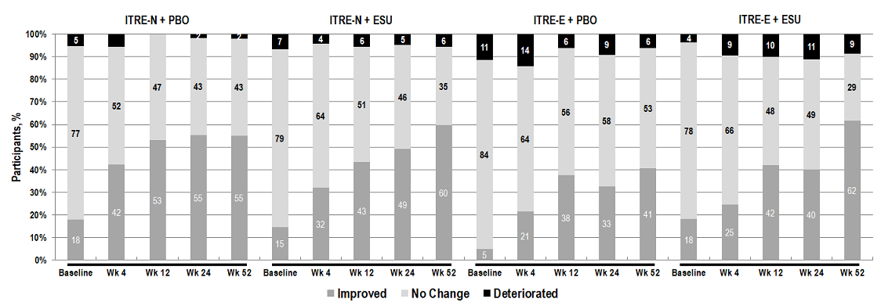
“Improved” indicates any increase in the number of low-risk criteria met; “No Change” indicates the same number; and “Deteriorated” indicates any decrease in the number of low-risk criteria met.
Baseline: N=73 ITRE-N-PBO; N=75 ITRE-N + ESU; N=61 ITRE-E + PBO; and N=55 ITRE-E + ESU. Week 52: N=49 ITRE-N-PBO; N=52 ITRE-N + ESU; N=32 ITRE-E + PBO; and N=34 ITRE-E + ESU.
Median (IQR) time on ITRE at baseline was 98 days for ITRE-N+PBO, 97 days for ITRE-N+ESU, 349 days for ITRE-E+PBO, and 528 days for ITRE-E+ESU.
ESU, esuberaprost; IQR, interquartile range; ITRE-E, inhaled treprostinil experienced; ITRE-N, inhaled treprostinil naïve; PBO, placebo; Wk, week.

Figure S3. WHO functional class categorical shift from screening

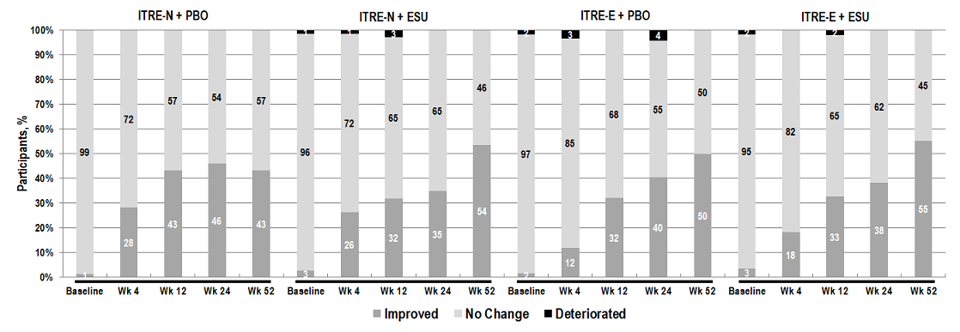
“Improved” indicates a shift from a higher to lower FC; “No Change” indicates the same FC; and “Deteriorated” indicates a shift from a lower to higher risk FC.
Baseline: N=73 ITRE-N-PBO; N=78 ITRE-N + ESU; N=62 ITRE-E + PBO; and N=58 ITRE-E + ESU. Week 52: N=51 ITRE-N-PBO; N=56 ITRE-N + ESU; N=36 ITRE-E + PBO; and N=38 ITRE-E + ESU.
Median (IQR) time on ITRE at baseline was 98 days for ITRE-N+PBO, 97 days for ITRE-N+ESU, 349 days for ITRE-E+PBO, and 528 days for ITRE-E+ESU.
ESU, esuberaprost; IQR, interquartile range; ITRE-E, inhaled treprostinil experienced; ITRE-N, inhaled treprostinil naïve; PBO, placebo; Wk, week.

Figure S4. Kaplan-Meier Estimates of Time to Clinical Worsening from Baseline

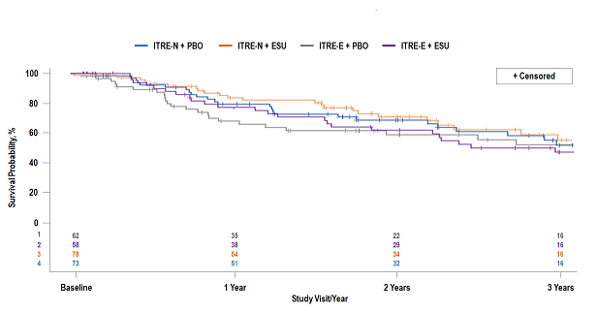

Estimates are provided from baseline, as clinical worsening events prior to baseline would have resulted in screen failure. Estimates from screening would be confounded by selection bias.

ESU, esuberaprost; ITRE-E, inhaled treprostinil experienced; ITRE-N, inhaled treprostinil naïve; and PBO, placebo.

There was no statistically significant difference in time to clinical worsening from baseline when evaluated across the four subgroups (Figure S1). The percentage of patients experiencing a CWE 1 year from baseline was 18% for ITRE-N+PBO, 14% for ITRE-N+ESU, 27% for ITRE-E+PBO, and 19% for ITRE-E+ESU.

References

- Ford HJ, Kramer MR, Bartolome S, et al. Primary results from the randomized, double-blind, placebo-controlled phase 3 trial –Beraprost-314d Added to Tyvaso (BEAT) in World Health Organization (WHO) Functional Class (FC) III and IV patients with pulmonary arterial hypertension (PAH). Presented at the PVRI Annual World Congress 2020, January 30–February 2, 2020, Lima, Peru

- Boucly A, Weatherald J, Savale L, et al (2017) Risk assessment, prognosis and guideline implementation in pulmonary arterial hypertension. Eur Respir J 50:1700889.

- Benza RL, Gomberg-Maitland M, Elliot CG, et al (2019) Predicting Survival in Patients with Pulmonary Arterial Hypertension: The REVEAL risk score calculator 2.0 and comparison with ESC/ERS-based risk assessment strategies. Chest 156(2):323–337.

