Supplementary materials
 | Spearman ρ | p-value | 95% CI
ICV (cm³) | 0.39 | 0.003 | [0.13, 0.60]
CSF (cm³) | -0.03 | 0.848 | [-0.26, 0.22]
ea-CSF (cm³) | 0.04 | 0.796 | [-0.21, 0.28]
PSD Total (cm³) | -0.01 | 0.953 | [-0.27, 0.22]
PSD Prefrontal (cm³) | -0.06 | 0.644 | [-0.31, 0.18]
PSD Fronto-Parietal (cm³) | 0.03 | 0.830 | [-0.24, 0.27]
PSD Occipital (cm³) | -0.10 | 0.466 | [-0.35, 0.17]

Table S1: Spearman rank correlations (ρ) between age, brain volume measures (intracranial volume[ICV], cerebrospinal fluid [CSF], and extra-axial CSF [ea-CSF]) and PSD volumes, p-values and corresponding 95% confidence intervals (CIs), in ASD children.
 | Spearman ρ | p-value | 95% CI
ICV (cm³) | 0.22 | 0.05 | [-0.05, 0.46]
CSF (cm³) | -0.17 | 0.184 | [-0.43, 0.10]
ea-CSF (cm³) | -0.18 | 0.159 | [-0.43, 0.09]
PSD Total (cm³) | -0.05 | 0.725 | [-0.21, 0.29]
PSD Prefrontal (cm³) | 0.01 | 0.965 | [-0.25, 0.26]
PSD Fronto-Parietal (cm³) | 0.02 | 0.852 | [-0.22, 0.26]
PSD Occipital (cm³) | -0.11 | 0.420 | [-0.16, 0.35]

Table S2: Spearman rank correlations (ρ) between age, brain volume measures (intracranial volume[ICV], cerebrospinal fluid [CSF], and extra-axial CSF [ea-CSF]) and PSD volumes, p-values and corresponding 95% confidence intervals (CIs), in TD children.

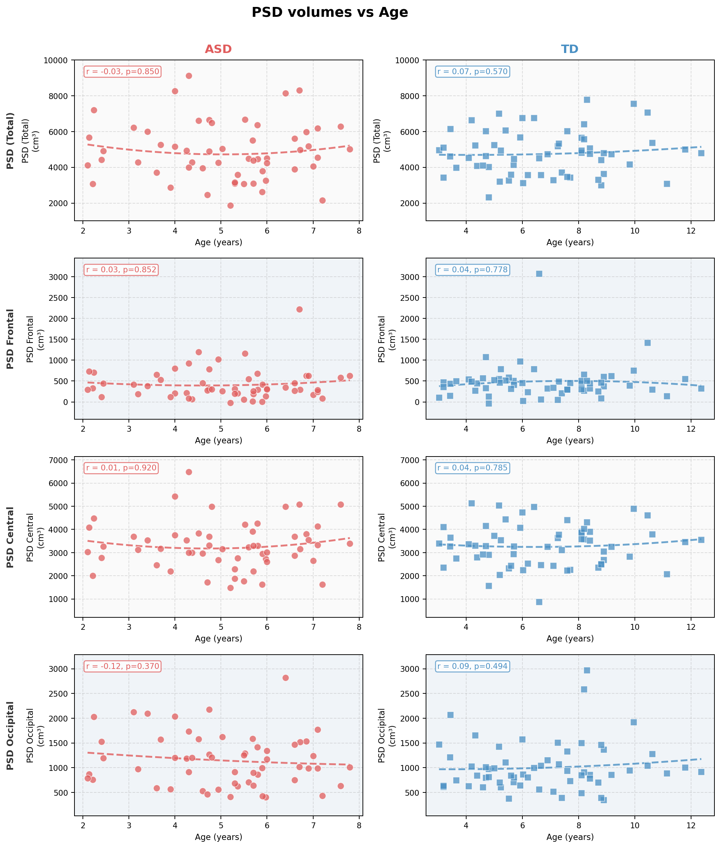
Figure S1: Scatter plots of total and regional PSD volumes (prefrontal, fronto-parietal, and occipital) as a function of age in the ASD and TD groups. Each panel shows individual data points with a fitted quadratic curve (dashed line) and Spearman correlation coefficient (r) with corresponding p-value. No significant linear or non-linear age-related effects were observed in either group.
 | Coefficient (β) | Std_Error | p_value | 95% CI
C(Group)[T.TD] | -0.002 | 0.290 | 0.995 | [−0.576, 0.572]
C(Sex)[T.M] | 0.364 | 0.279 | 0.194 | [−0.188, 0.916]
Age | 0.008 | 0.065 | 0.902 | [−0.121, 0.137]
CSF | 0.016 | 0.004 | <0.001 | [0.008, 0.024]
Table S3: Linear regression analysis of PSD Total volume including diagnostic group (ASD vs TD), age, sex, and CSF as covariates. Reported are regression coefficients (β), standard errors (Std_Error), p-values, and 95% confidence intervals (95% CI).

 | Coefficient (β) | Std_Error | p_value | 95% CI
C(Group)[T.TD] | 0.046 | 0.087 | 0.597 | [−0.127, 0.219]
C(Sex)[T.M] | 0.035 | 0.084 | 0.680 | [−0.132, 0.201]
Age | 0.006 | 0.020 | 0.772 | [−0.033, 0.045]
CSF | 0.001 | 0.001 | 0.536 | [−0.002, 0.003]
Table S4: Linear regression analysis of PSD Prefrontal volume including diagnostic group (ASD vs TD), age, sex, and CSF as covariates. Reported are regression coefficients (β), standard errors (Std_Error), p-values, and 95% confidence intervals (95% CI).

 | Coefficient (β) | Std_Error | p_value | 95% CI
C(Group)[T.TD] | 0.075 | 0.196 | 0.701 | [−0.313, 0.464]
C(Sex)[T.M] | 0.269 | 0.189 | 0.157 | [−0.105, 0.642]
Age | 0.004 | 0.044 | 0.934 | [−0.084, 0.091]
CSF | 0.010 | 0.003 | 0.001 | [0.004, 0.015]

Table S5: Linear regression analysis of PSD Frontoparietal volume including diagnostic group (ASD vs TD), age, sex, and CSF as covariates. Reported are regression coefficients (β), standard errors (Std_Error), p-values, and 95% confidence intervals (95% CI).

 | Coefficient (β) | Std_Error | p_value | 95% CI
C(Group)[T.TD] | -0.124 | 0.106 | 0.247 | [−0.334, 0.087]
C(Sex)[T.M] | 0.061 | 0.102 | 0.554 | [−0.142, 0.263]
Age | -0.001 | 0.024 | 0.957 | [−0.049, 0.046]
CSF | 0.005 | 0.001 | 0.001 | [0.002, 0.008]

Table S6: Linear regression analysis of PSD Occipital volume including diagnostic group (ASD vs TD), age, sex, and CSF as covariates. Reported are regression coefficients (β), standard errors (Std_Error), p-values, and 95% confidence intervals (95% CI).

 | Coefficient (β) | Std_Error | p_value | 95% CI
C(Group)[T.TD] | -0.061 | 0.291 | 0.833 | [−0.638, 0.515]
C(Sex)[T.M] | 0.268 | 0.288 | 0.354 | [−0.303, 0.840]
Age | -0.002 | 0.079 | 0.983 | [−0.159, 0.156]
CSF | 0.018 | 0.005 | <0.001 | [0.009, 0.027]

Table S7: Results of the linear regression model for PSD volume in the age-matched sample, including diagnostic group (ASD vs TD), age, sex, and CSF as covariates. Reported are regression coefficients (β), standard errors (Std_Error), p-values, and 95% confidence intervals (95% CI).

