Supplementary data
Enhanced endoglucanase production using agro-waste in solid-state fermentation by Penicillium citrinum M5
Hang T. T. Nguyenª*, Thien-Nhu Phanª, Gia-Bao Bang Nguyenª, Bao-Tran Huynhª, Truong-Giang Ngoc Nguyenª, Tuyet-Nhung Tranª
ª Faculty of Applied Sciences, Ton Duc Thang University, Ho Chi Minh city, 700000, Vietnam
* Corresponding author: nguyenthithuhang@tdtu.edu.vn

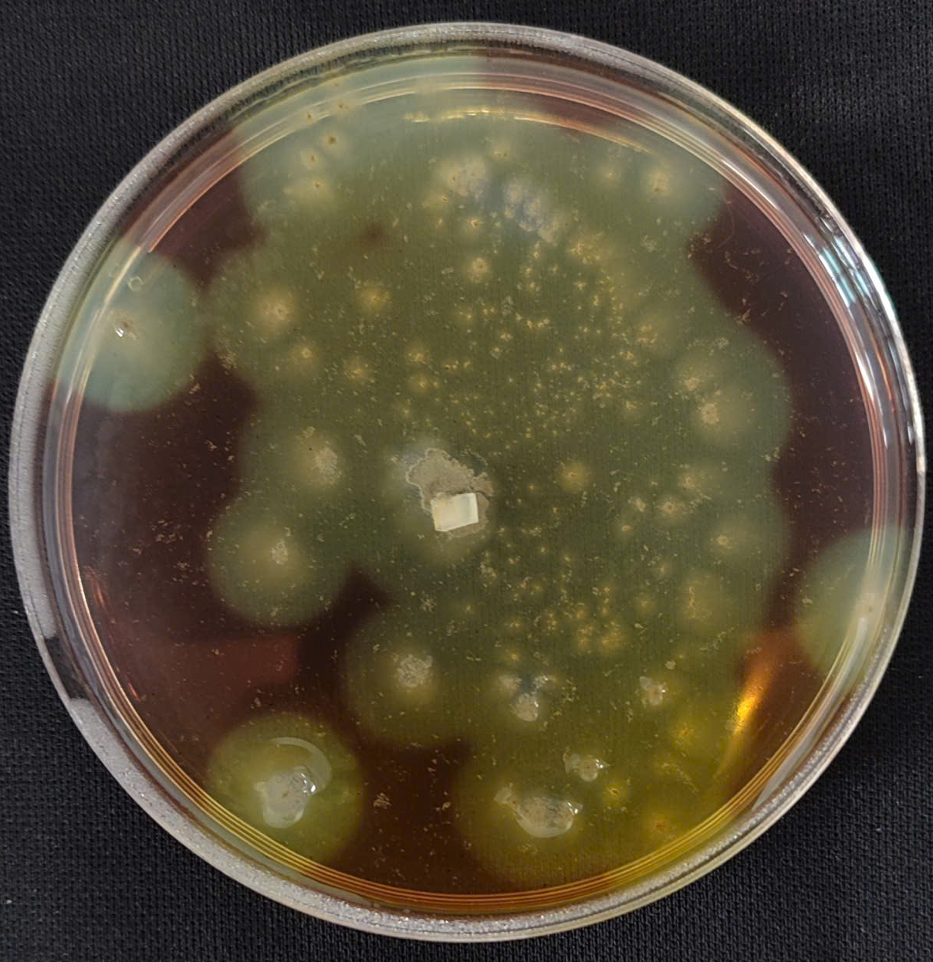
Figure S1. Endoglucanase activity of Penicillium citrinum M5 on plate by using CMC staining by Lugol's iodine solution
Supplementary Table S1. List of fungi and oomycetes used in this study.
Test fungus | Disease | Host and/or origin*
Armillaria rolfsii KACC40170 | Southern blight | Apple, KACC
Botryosphaeria dothidea KACC45481 | Apple botryosphaeria canker | Crab apple, KACC
Botrytis cinerea KACC40574 | Grey mold disease | Tomato, KACC
Colletotrichum coccodes KACC40010 | Anthracnose | Red pepper, KACC
Collectotrichum horri | Anthracnose | Persimmon, KRICT
Curvularia lunata KACC41020 | Curvularia blight | Turf grass, KACC
Cryphonectria parasitica KACC40323 | Chestnut blight | Chestnut, KACC
Fusarium fujikuroi | Bakana | Rice, KRICT
Fusarium graminearum Z-3639 | Fusarium head blight | Wheat (Nguyen et al., 2021)
Fusarium oxysporum f.sp. lycorpersici KR5 | Fusarium wilt | Tomato, KRICT
Fusarium oxysporum f.sp. niveum | Fusarium wilt | Watermelon, KRICT
Fusarium oxysporum f.sp. raphanin | Fusarium wilt | Radish, KRICT
Fusarium verticillioides | Ear rots | Maize, KRICT
Gaeumannomyces graminis | Take-all | Turfgrass, DJ
Magnaporthe oryzae KACC46522 | Rice blast | Rice, KACC
Magnaporthiopsis poae | Summer patch | Kentucky blue grass, DJ
Ophiostoma ulmi KACC40252 | Dutch elm disease | Elm, KACC
Pseudocercospora circumcissa | Cherry leaf spot | Cherry tree, KRICT
Raffaelea quercus-mongolicae KACC44403 | Oak wilt | Oak, KACC
Rhizoctonia solani AG-4 KACC40140 | Damping off disease | Cucumber, KACC
Rhizoctonia solani | Brown patch disease | Zoysia grass, DJ
Rhizoctonia cerealis | Sharp eyespot | Wheat, KRICT
Clarireedia jacksonii | Dollar spot disease | Creeping bentgrass, DJ
Valsa ceratosperma KACC40830 | Canker | Apple, KACC
Phytophthora cactorum KACC40166 | Phytophthora stem rot | Apple, KACC
Phytophthora cambivora KACC40159 | Phytophthora collar rot | Apple, KACC
Phytophthora capsici KACC40158 | Phytophthora blight | Pepper, KACC
Phytophthora cinnamomi KACC40182 | Mating type, root rot, blight | Larch, KACC
Pythium ultimum KACC40705 | Damping off | Cucumber, KACC
*KACC = Korean Agriculture collection culture, KRICT = Korean Research Institute of Chemical Technology, DJ=Daejeong-Golf Engineering Co. Ltd.

Supplementary Table S2. Cultural characteristics of Streptomyces sp. JCK-6116
JCK-6116 | Cultural characteritistics
JCK-6116 | Aerial mycelium | Substrate mycelium | Soluble pigment
ISP1 | White | Dark-brown | Brown
ISP2 | White | Dark-grey | brown
ISP3 | White-violet | Pale-yellow | None
ISP4 | White-pink | Pale-yellow | None
ISP5 | White | White | None
Bennet’s | White | Brown | None
PDA | white | Brown | None

Table 3. Carbon utilization of JCK-6116
No. | Carbohydrate sources | JCK-6116 | No. | Carbohydrate sources | JCK-6116
1 | Glycerol | - | 26 | Salicin | -
2 | Erytrol | - | 27 | D-Celobiose | -
3 | D-Arabinose | - | 28 | D-Maltose | -
4 | L-Arabinose | - | 29 | D-Lactose | -
5 | Ribose | - | 30 | D-Melibiose | -
6 | D-Xylose | - | 31 | D-Sucrose | ₊
7 | L-Xylose | - | 32 | D-Trehalose | -
8 | D-Adonitol | - | 33 | Inuline | -
9 | Metil-β-D-Xylopyranoside | - | 34 | D-Melezitose | -
10 | Galactose | - | 35 | D-Rafinose | -
11 | Glucose | - | 36 | Starch | -
12 | Fructose | - | 37 | Glycogen | -
13 | Manose | - | 38 | Xylitol | -
14 | Sorbose | - | 39 | Gentiobiose | -
15 | Rhamnose | - | 40 | D-Turanose | -
16 | Dulcitol | - | 41 | D-Lyxose | -
17 | Inozitol | - | 42 | D-Tagatose | -
18 | Manitol | - | 43 | D-Fucose | -
19 | Sorbitol | - | 44 | L-Fucose | -
20 | Metil-α-DManopyranoside | - | 45 | D -Arabitol | -
21 | Metil-α-DGlucopyranoside | - | 46 | L -Arabitol | -
22 | N-Acetyl-glucosamine | - | 47 | Potasium gluconate | -
23 | Amygdaline | - | 48 | 2 -Ketogluconate | -
24 | Arbutine | - | 49 | 5 -Ketogluconate | -
25 | Esculin | +
^{+ Positive; - negative}

Table S4. Enzyme activity of strain JCK-6116
No. | Enzyme assayed for | JCK-6116
1 | Control | -
2 | Alkaline phosphatase | +
3 | Esterase (C4) | +
4 | Esterase Lipase (C8) | +
5 | Lipase (C14) | +
6 | Leucine arylamidase | +
7 | Valinearyl lamidase | +
8 | Cysteine arylamidase | +
9 | Trypsin | +
10 | α-Chymotrypsin | +
11 | Acid phosphatase | +
12 | Naphthol-AS-BI-phosphohydrolase | +
13 | α-Galactosidase | -
14 | β-Galactosidase | -
15 | β-Glucuronidase | -
16 | α-Glucosidase | -
17 | β-Glucosidase | +
18 | N-acetyl-β-gucosaminidase | +
19 | α-Mannosidase | +
20 | α-Fucosidase | -
21 | Protease | +
22 | Chitinase | +
23 | Cellulase | -
^{+ Positive; - negative}

Supplementary Table S5
Carbon utilization of strain JCK-6116 and Streptomyces mauvecolor ATCC 29835
Characteristics |  | JCK-6116 | Streptomyces mauvecolor ATCC 29835
Carbon utilization | D-glucose | - | +
Carbon utilization | Arabinose | - | +
Carbon utilization | Sucrose | + | -
^{+ Positive; - negative}

Supplementary Table S6. In vitro antifungal activity of culture filtrate against mycelial growth of fungi and oomycete
No. | Number of Isolates | MIC (%)
No. | Number of Isolates | Pythium ultimum | Rhizoctonia solani AG-4 | F.oxy. f.sp. cucumberinum KR5 | F graminearum | S. homoeocarpa | R. solani
1 | JCK-6016 | 10 | >10 | - | 1.25 | >10 | -
2 | JCK-6022 | 5 | 5 | 5 | 1.25 | 10 | -
3 | JCK-6030 | 1.25 | 0.63 | 2.5 | >10 | - | -
4 | JCK-6032 | >10 | 0.16 | 2.5 | >10 | 5 | -
5 | JCK-6036 | 1.25 | 10 | >10 | 2.5 | 5 | -
6 | JCK-6043 | 0.63 | >10 | >10 | 1.25 | 2.5 | -
7 | JCK-6063 | 0.16 | 1.25 | 1.25 | 2.5 | 10 | 2.5
8 | JCK-6068 | 1.25 | 1.25 | 5 | 2.5 | 0.63 | 1.25
9 | JCK-6072 | 0.63 | 0.16 | - | 1.25 | 1.25 | 2.5
10 | JCK-6095 | 10 | >10 | - | >10 | 5 | -
11 | JCK-6099 | 10 | 0.63 | 5 | >10 | 2.5 | 10
12 | JCK-6102 | 1.25 | 0.16 | 2.5 | 2.5 | 0.63 | 1.25
13 | JCK-6110 | 1.25 | 1.25 | 1.25 | 2.5 | 2.5 | 0.625
14 | JCK-6116 | 1.25 | 0.16 | 2.5 | 2.5 | 0.63 | 0.31
15 | Streptomyces sp. JCK-6141 (Nguyen et al., 2021) | 0.31 | 0.63 | 0.31 | 0.08 | 0.63 | 2.5
-: No activity at test concentration

Supplementary Figure S1 : HPLC chromatograms of BuOH extract (A), rimocidin C (B), rimocidin B (C), rimocidin A (D) and UV spectra of rimocidin C (E), rimocidin B (F), rimocidin A (G) which derived from JCK-6116

Supplementary Figure S2: Standard curve of rimocidin A

Luo, F., Gwak, H., Park, A.R., Nguyen, V.T., Kim, J.-C., Biocontrol potential of natamycin-producing Streptomyces lydicus JCK-6019 against soil-borne fungal diseases of cucumber and characterization of its biocontrol mechanism. Pest Management Science n/a.
Nguyen, H.T.T., Park, A.R., Hwang, I.M., Kim, J.-C., 2021. Identification and delineation of action mechanism of antifungal agents: Reveromycin E and its new derivative isolated from Streptomyces sp. JCK-6141. Postharvest Biology and Technology 182, 111700.
Nguyen, L.T.T., Park, A.R., Van Le, V., Hwang, I., Kim, J.-C., 2024. Exploration of a multifunctional biocontrol agent Streptomyces sp. JCK-8055 for the management of apple fire blight. Applied Microbiology and Biotechnology 108, 49.

