The microbial garden of fungus-growing ants: Distinct lignocellulosic profile and spatial structure, yet a similar microbiota

Mariana O. Barcoto, Rodrigo H. S. Garcia, Gabriel G. P. Pennachioni, João G. S. Soares, Eduardo R. de Azevedo, Lucas W. Mendes, Alessandra I. Coan, Mauricio Bacci Jr, Andre Rodrigues

Supplementary material
Table S1 - Sample metadata for microbiota analysis.
Species | Replicate | Colony code | Sampling site | Lat S / Long W
Atta sexdens | 1 | MOB231127-01 | Ubatuba, SP, Brazil | 23°20'19.2" / 44°50'17.4"
Atta sexdens | 2 | RLS231126-04 | Ubatuba, SP, Brazil | 23°20'20.1" / 44°50'17.0"
Atta sexdens | 3 | MOB230420-02 | Ubatuba, SP, Brazil | 23°21'38.5'' / 44°50'59.4''
Atta sexdens | 4 | MOB230420-01 | Ubatuba, SP, Brazil | 23°21'16.7'' / 44°50'52.4''
Acromyrmex coronatus | 1 | MOB240114-02 | Itatiaia, RJ, Brazil | 22°27'18.70" / 44°36'29.90"
Acromyrmex coronatus | 2 | RLS240114-01 | Itatiaia, RJ, Brazil | 22°27'18.70" / 44°36'29.90"
Acromyrmex coronatus | 3 | RLS240114-03 | Itatiaia, RJ, Brazil | 22°27'4" / 44°36'45"
Mycetomoellerius sp. | 1 | MOB240115-01 | Itatiaia, RJ, Brazil | 22°27'15.0" / 44°36'24.8"
Mycetomoellerius sp. | 2 | RLS240115-02 | Itatiaia, RJ, Brazil | 22°27'15.0" / 44°36'24.8"
Mycetomoellerius sp. | 3 | MOB240114-01 | Itatiaia, RJ, Brazil | 22°27'14.70" / 44°36'25.40"
Mycetophylax sp. | 1 | PK231125-04 | Ubatuba, SP, Brazil | 23°21'19.7" / 44°46'10.0"
Mycetophylax sp. | 2 | MOB230419-05 | Ubatuba, SP, Brazil | 23°21'38.5'' / 44°50'59.2''
Mycetophylax sp. | 3 | MOB240113-03 | Itatiaia, RJ, Brazil | 22°27'17.0" / 44°36'28.4"
Apterostigma sp. | 1 | AR240115-01 | Itatiaia, RJ, Brazil | 22°25'09.4" / 44°07'11.4"
Apterostigma sp. | 2 | AR240113-04 | Itatiaia, RJ, Brazil | 22°27'18.8" / 44°36'30.5"
Apterostigma sp. | 3 | RAPS240114-03 | Itatiaia, RJ, Brazil | 22°27'06.5" / 44°36'40.4"
Mycocepurus sp. | 1 | RLS230421-01 | Ubatuba, SP, Brazil | 23°21'40.4'' / 44°50'54.4''
Mycocepurus sp. | 2 | MOB230421-03 | Ubatuba, SP, Brazil | 23°21'40.4'' / 44°50'54.4''
Mycocepurus sp. | 3 | MOB230421-01 | Ubatuba, SP, Brazil | 23°21'35.1'' / 44°50'54.2''

Fig. S1 - Rarefaction curves of 16S rRNA sequences of distinct garden regions, colored by ant species
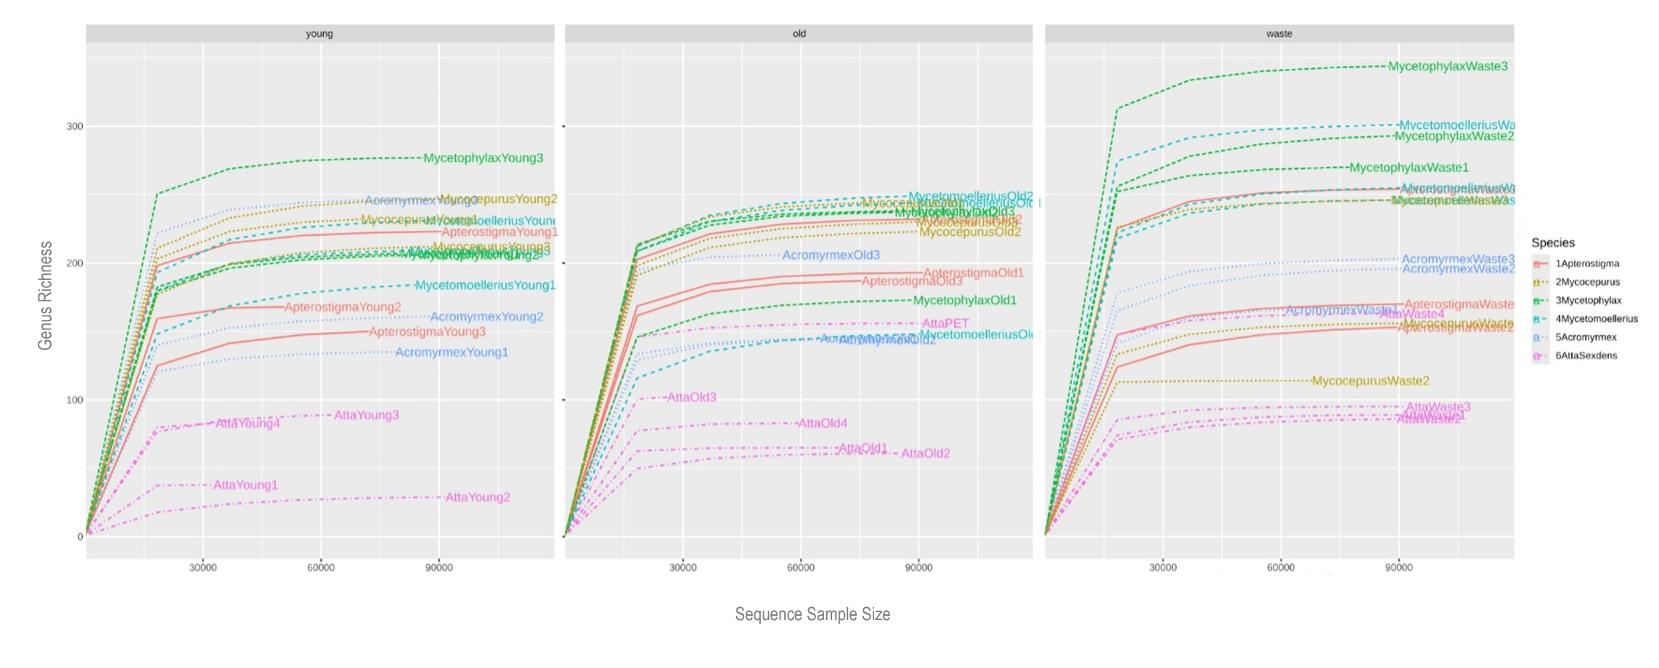

Fig. S2 - Rarefaction curves of 16S rRNA sequences in distinct ant species, colored by garden region
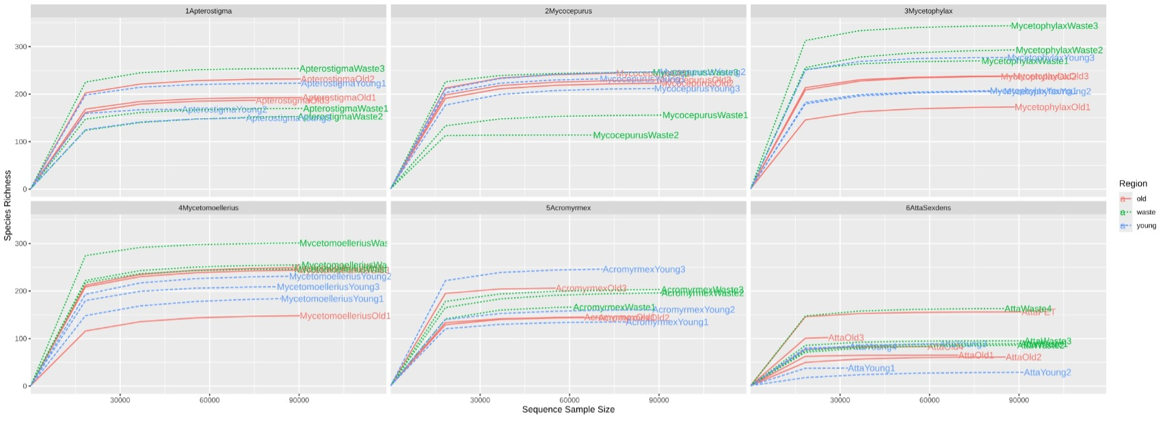
Genus Richness

Fig. S3 – Bacterial diversity of different garden regions, grouping all fungiculture systems. Alpha-diversity indices were estimated at genus level, based on Observed Features (Richness), Shannon, Simpson, and Fisher. Significant differences were estimated by Mann-Whitney/Kruskal-Wallis, with the Wilcoxon test for post hoc pairwise comparisons. Significant differences between garden regions (Wilcoxon test, FDR-adjusted p < 0.05) are indicated by letters (y: young garden; w: waste).
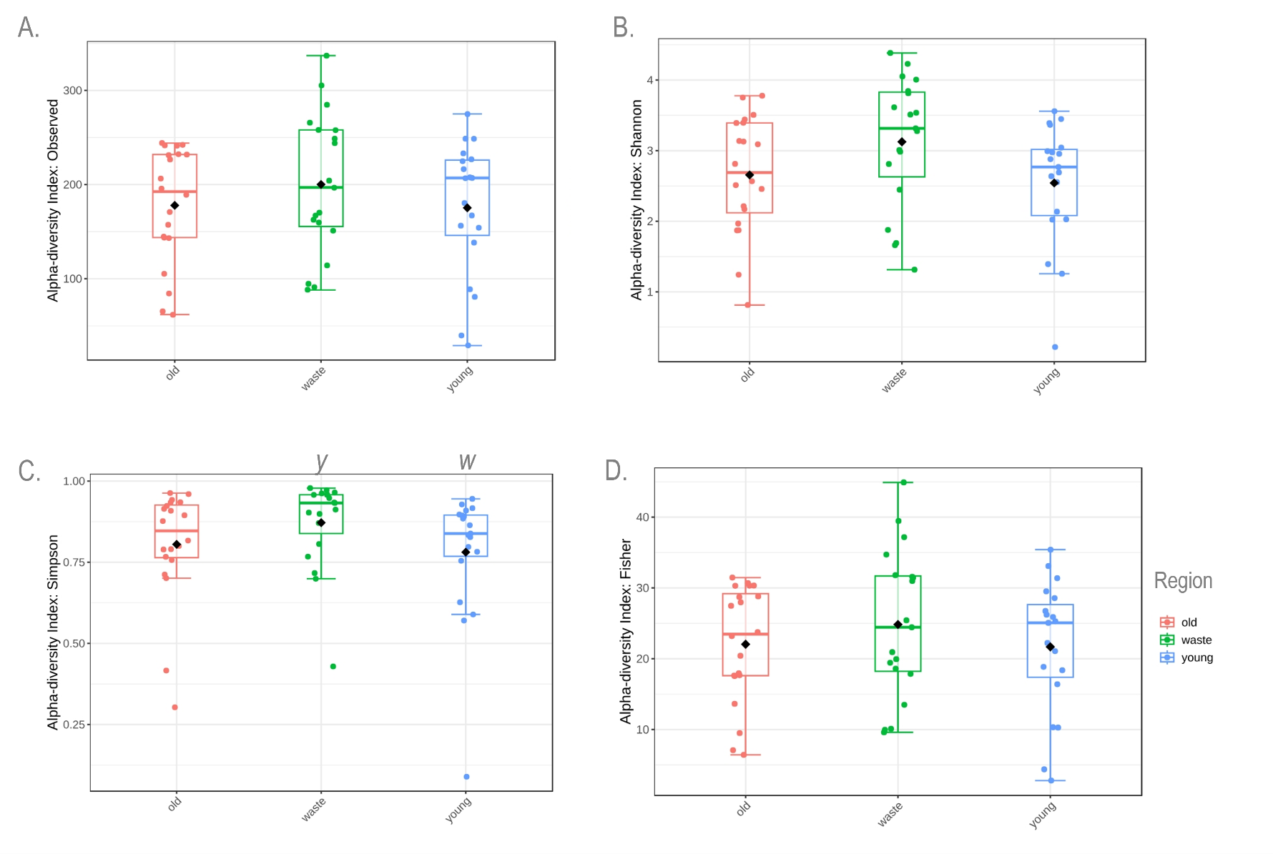

Fig. S4 - Relative abundance of bacterial phylum in different garden regions, shown for distinct ant species
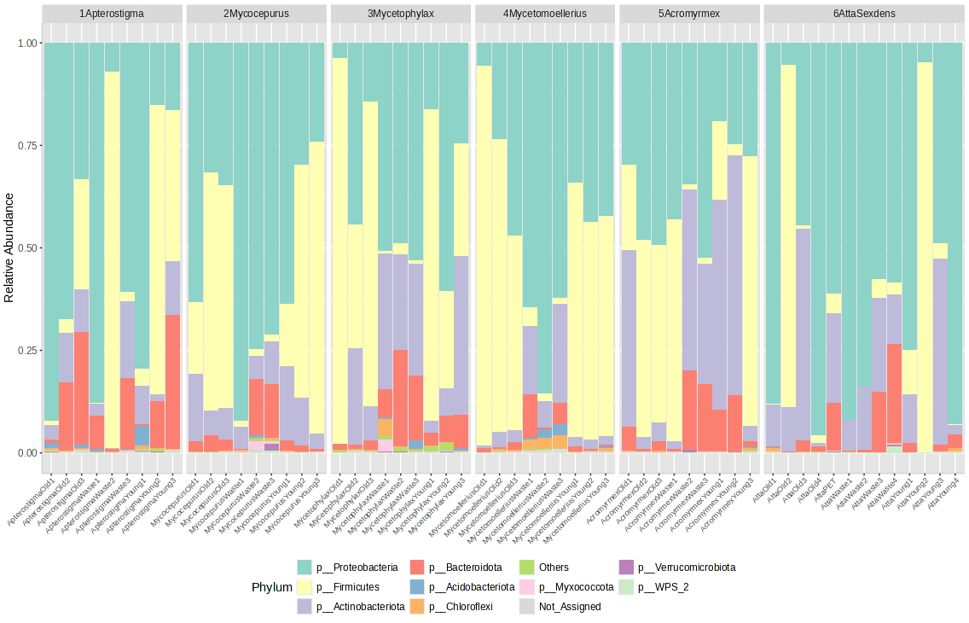

Fig. S5 – Core microbiota of young gardens defined by the ASV prevalence, compared between ant species
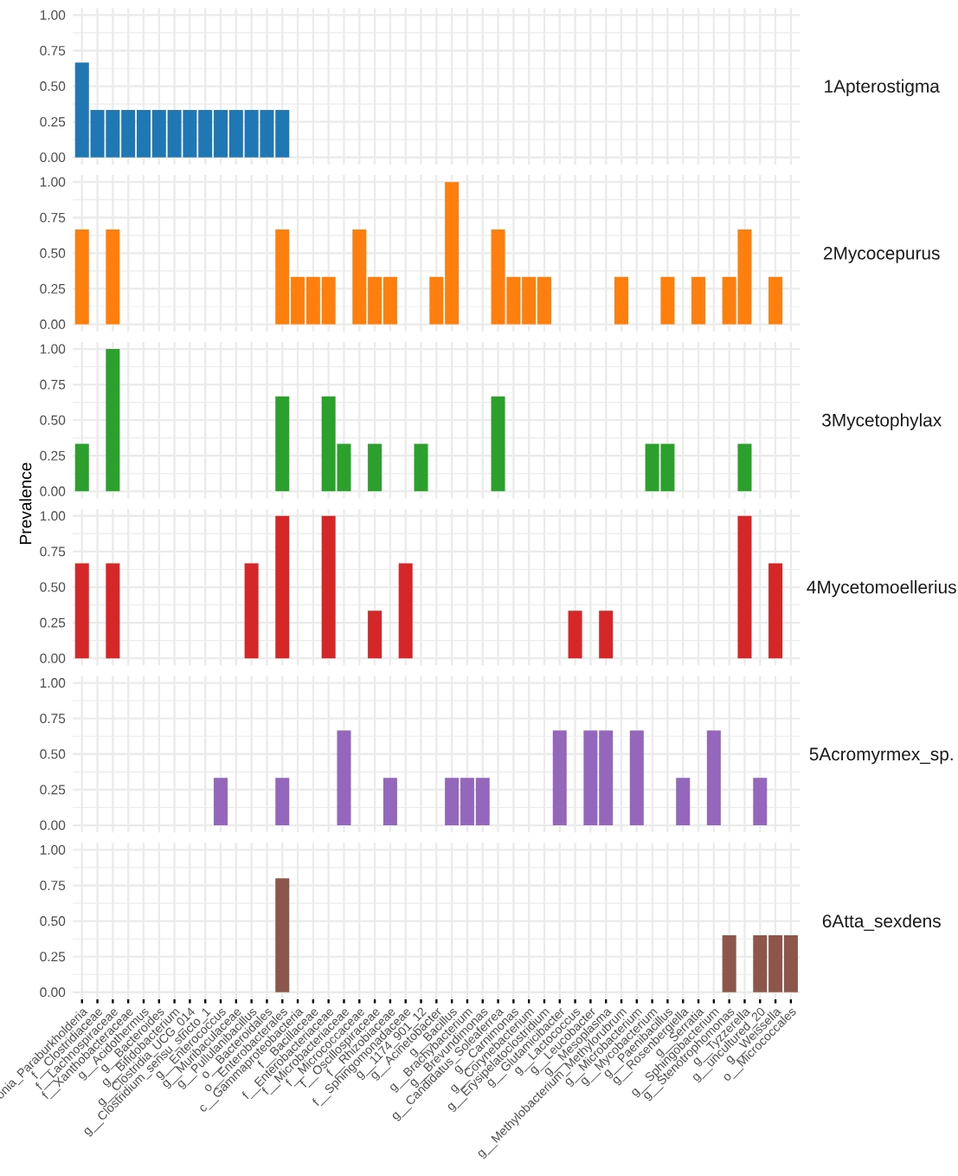

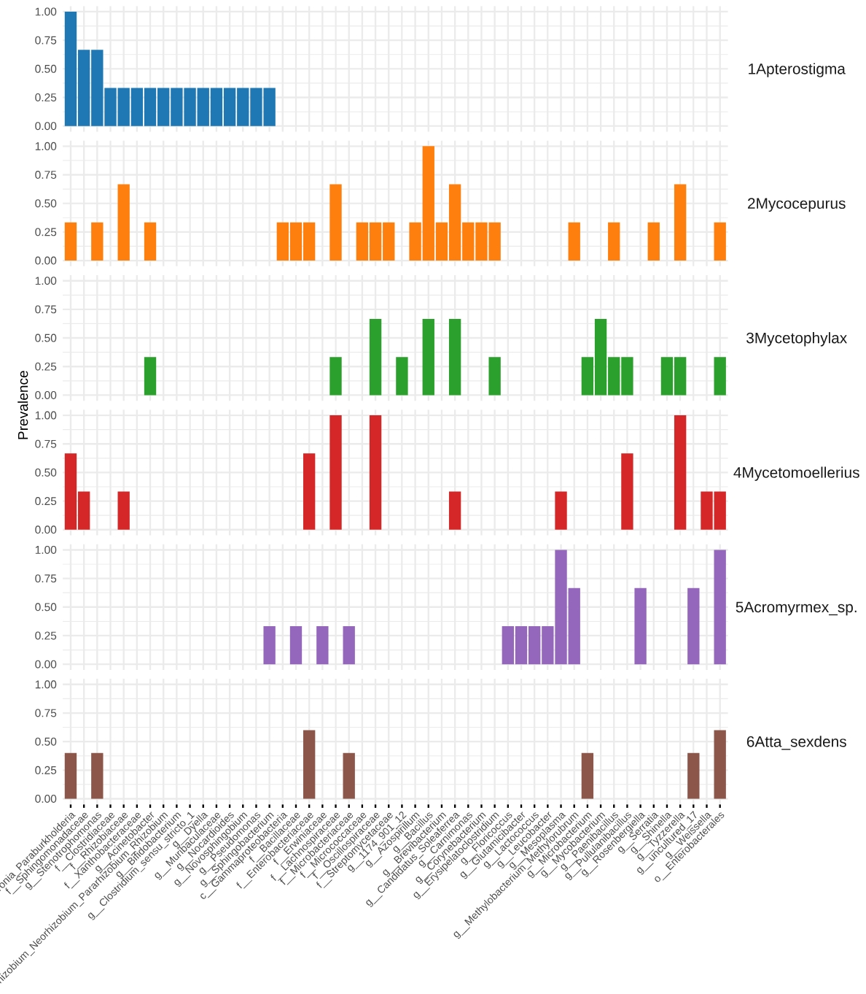
Fig. S6 – Core microbiota of old gardens defined by the ASV prevalence, compared between ant species

Fig. S7 – Core microbiota of waste samples defined by the ASV prevalence, compared between ant species
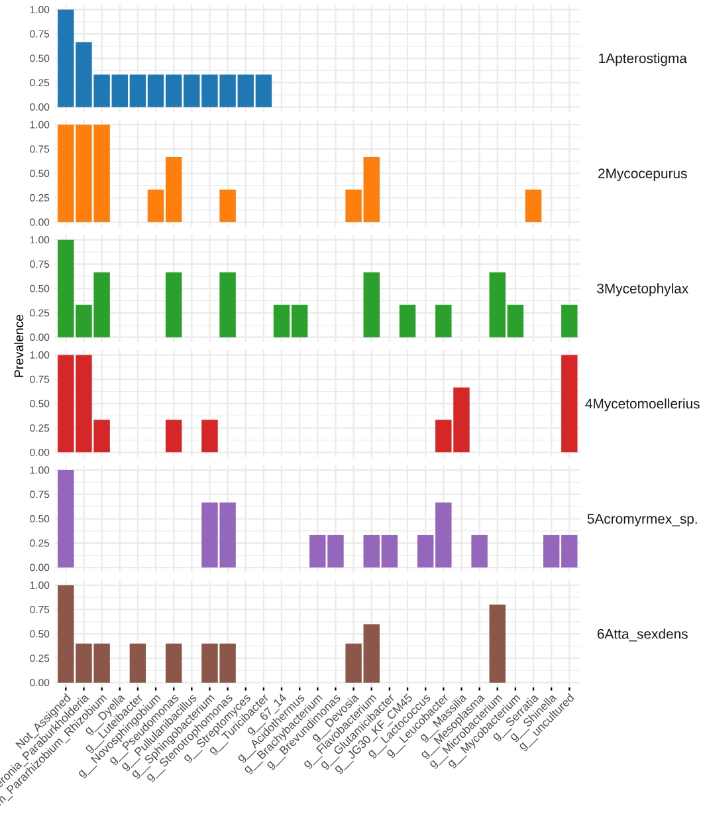

Fig. S8 – Biomarker genera determination based on linear discriminant analysis effect size. LEfSe detect features significantly more abundant in one or more ant gardens, with the heatmap indicating which taxa are differentially abundant in which fungiculture system.
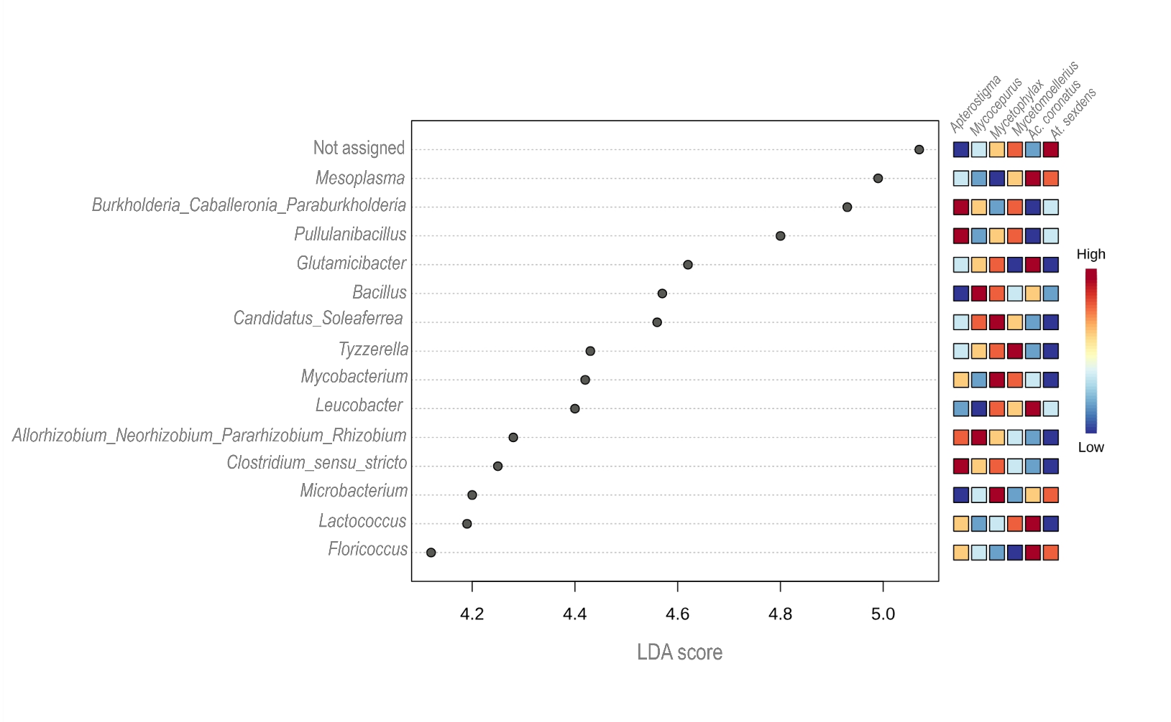

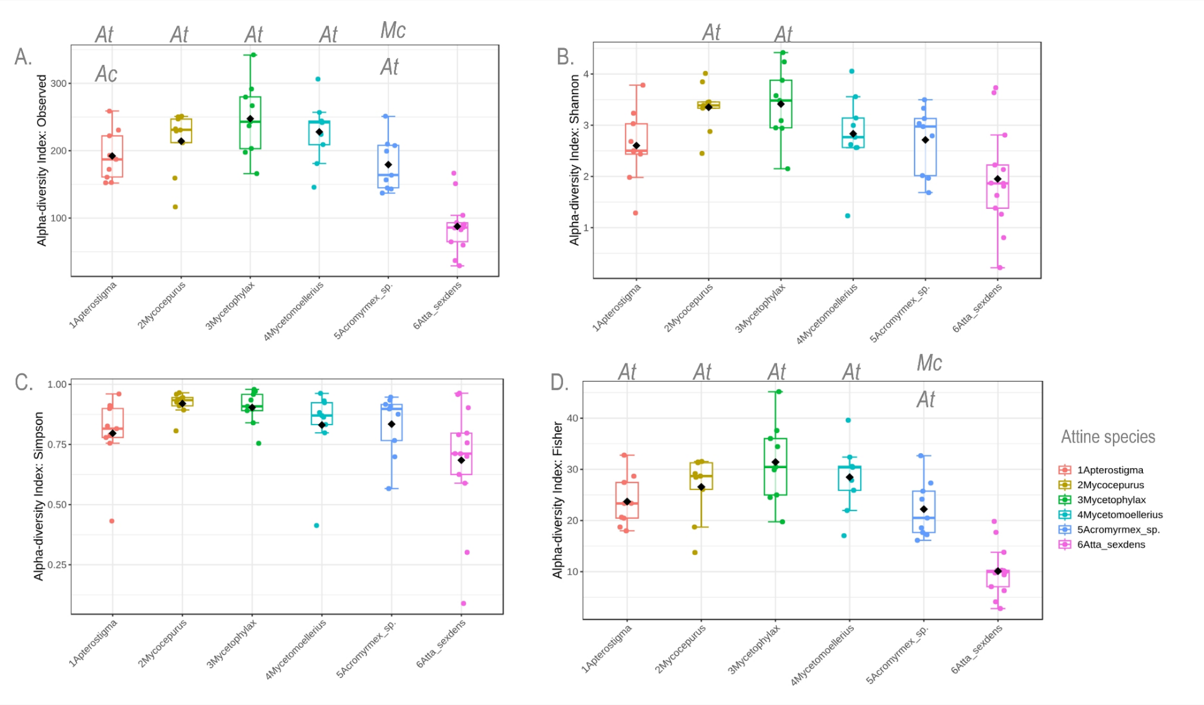
Fig. S9 – Bacterial diversity of different garden regions. Alpha-diversity indices were estimated at genus level, based on Observed Features (Richness), Shannon, Simpson, and Fisher. Significant differences were estimated by Mann-Whitney/Kruskal-Wallis, with the Wilcoxon test for post hoc pairwise comparisons. Significant differences between attine species (Wilcoxon test, FDR-adjusted p < 0.05) are indicated by letters (At: Atta sexdens; Ac: Acromyrmex; Mc: Mycetophylax.)

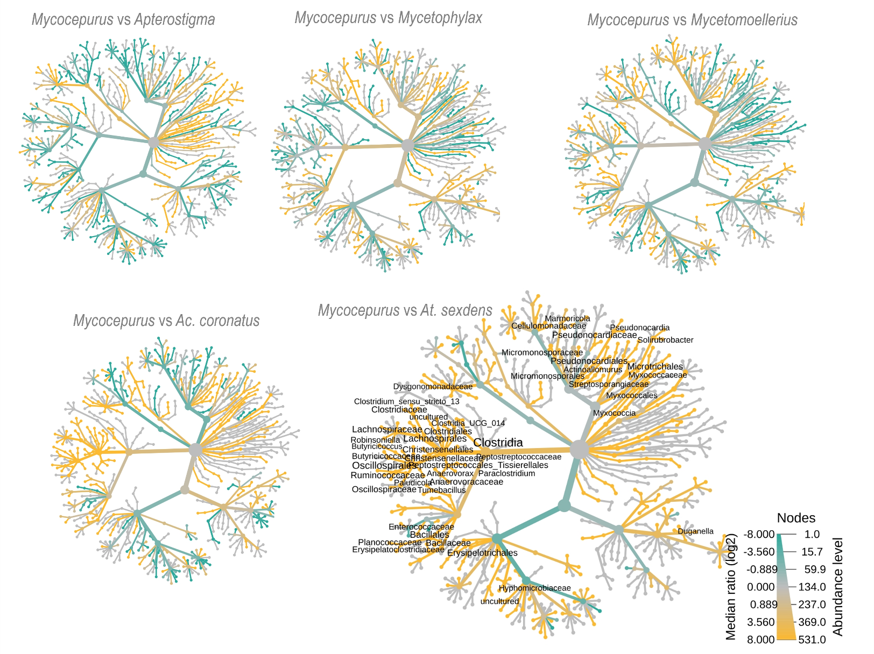
Fig. S10 - Bacterial genus-level heat tree, comparing group-wise relative abundances (Wilcoxon test, P < 0.05) between Mycocepurus sp. and other attine in young gardens. Bacterial genera are denoted (i.e., whose names are written) in the heat-tree only when significantly differ between attine being compared.

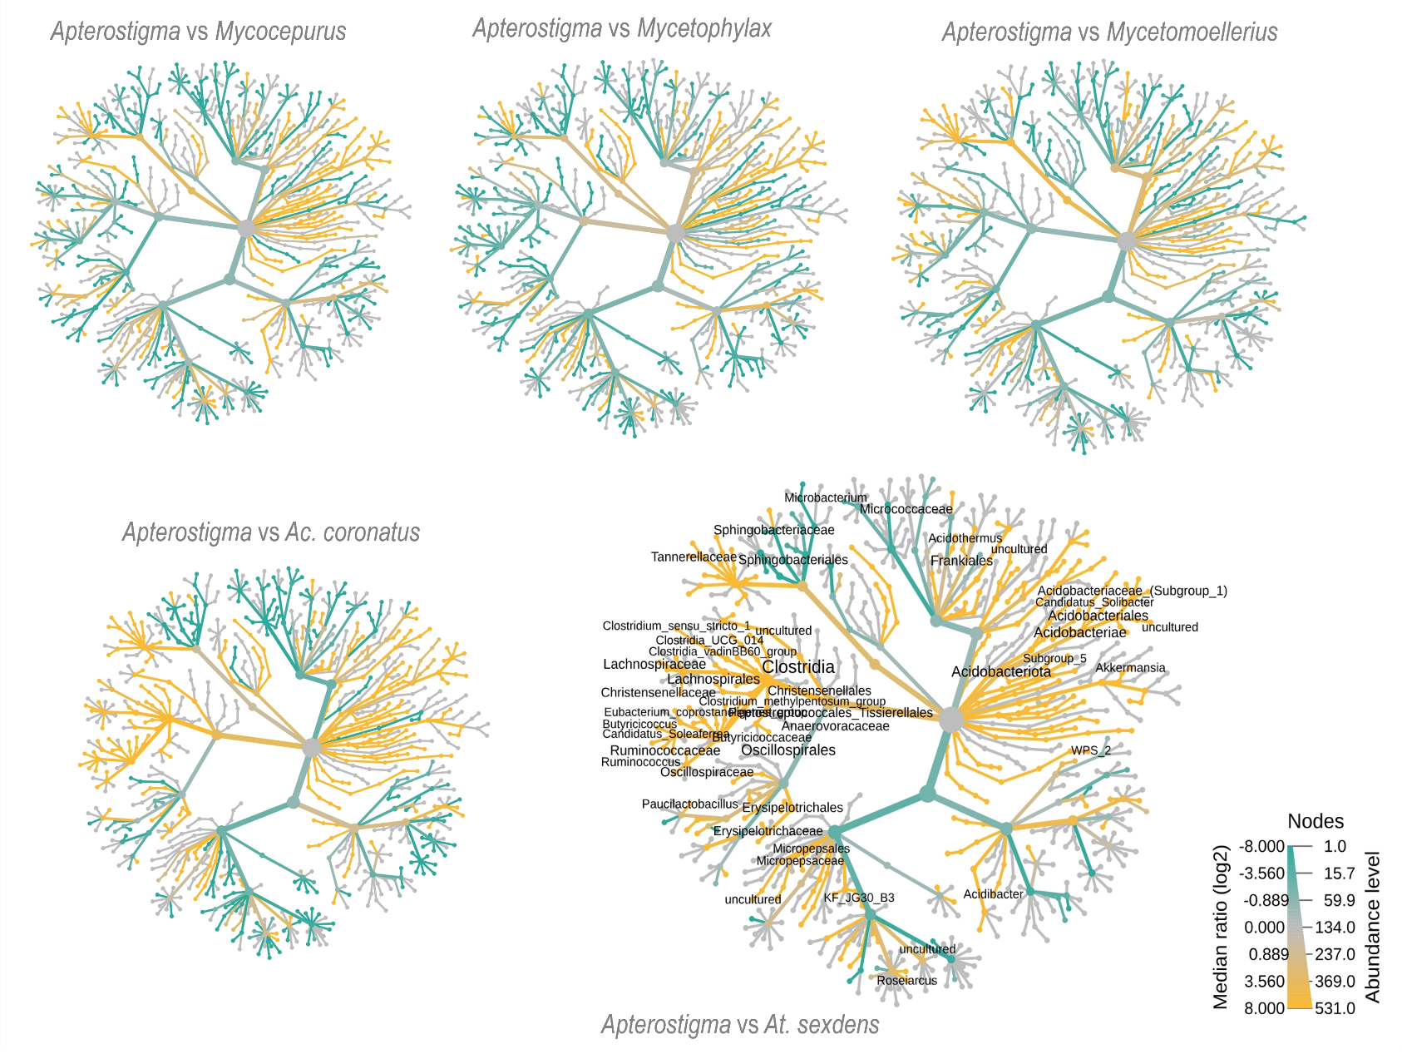
Fig. S11 - Bacterial genus-level heat tree, comparing group-wise relative abundances (Wilcoxon test, P < 0.05) between Apterostigma sp. and other attine in young gardens. Bacterial genera are denoted (i.e., whose names are written) in the heat-tree only when significantly differ between attine being compared.

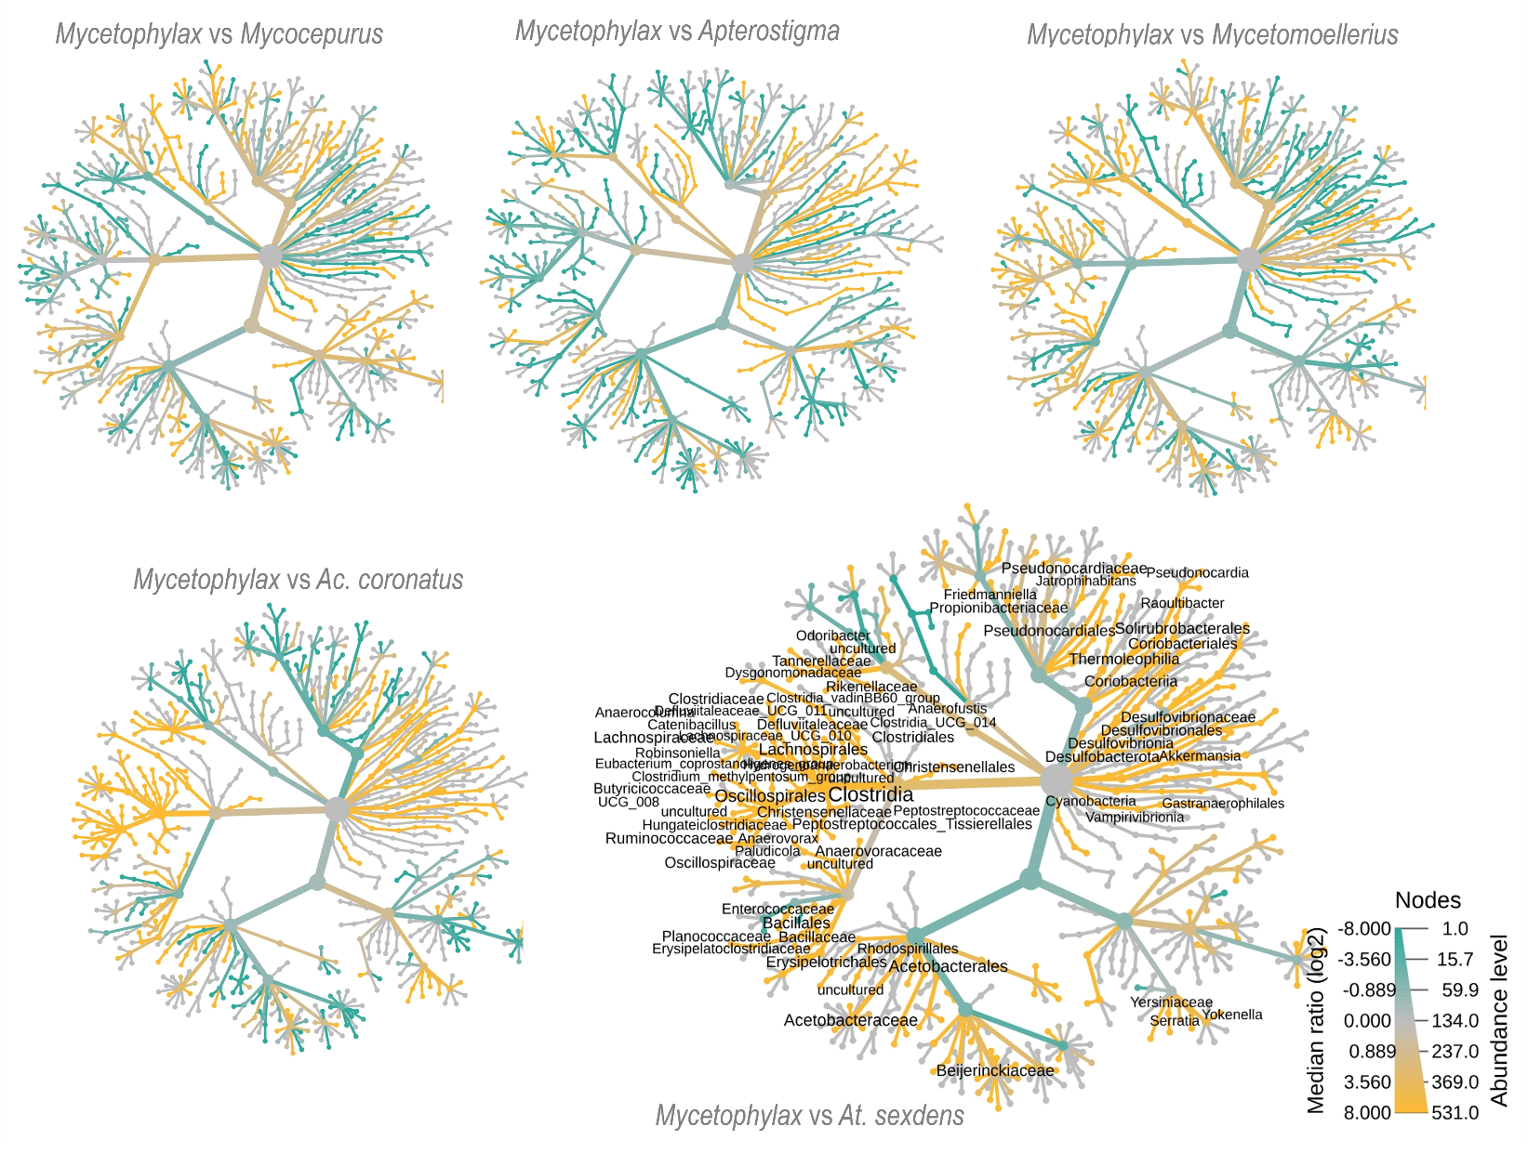
Fig. S12 - Bacterial genus-level heat tree, comparing group-wise relative abundances (Wilcoxon test, P < 0.05) between Mycetophylax sp. and other attine in young gardens. Bacterial genera are denoted (i.e., whose names are written) in the heat-tree only when significantly differ between attine being compared.

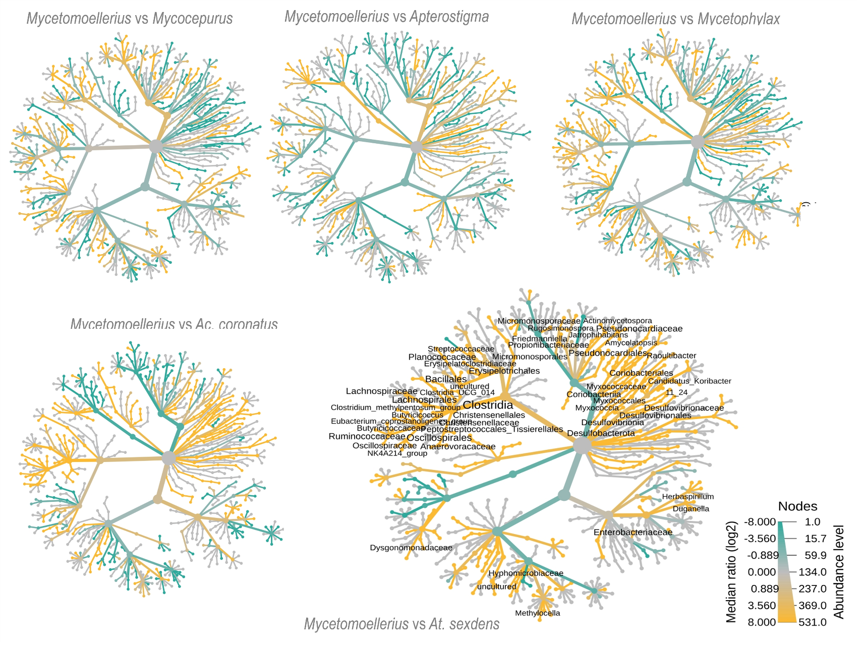
Fig. S13 - Bacterial genus-level heat tree, comparing group-wise relative abundances (Wilcoxon test, P < 0.05) between Mycetomoellerius sp. and other attine in young gardens. Bacterial genera are denoted (i.e., whose names are written) in the heat-tree only when significantly differ between attine being compared.

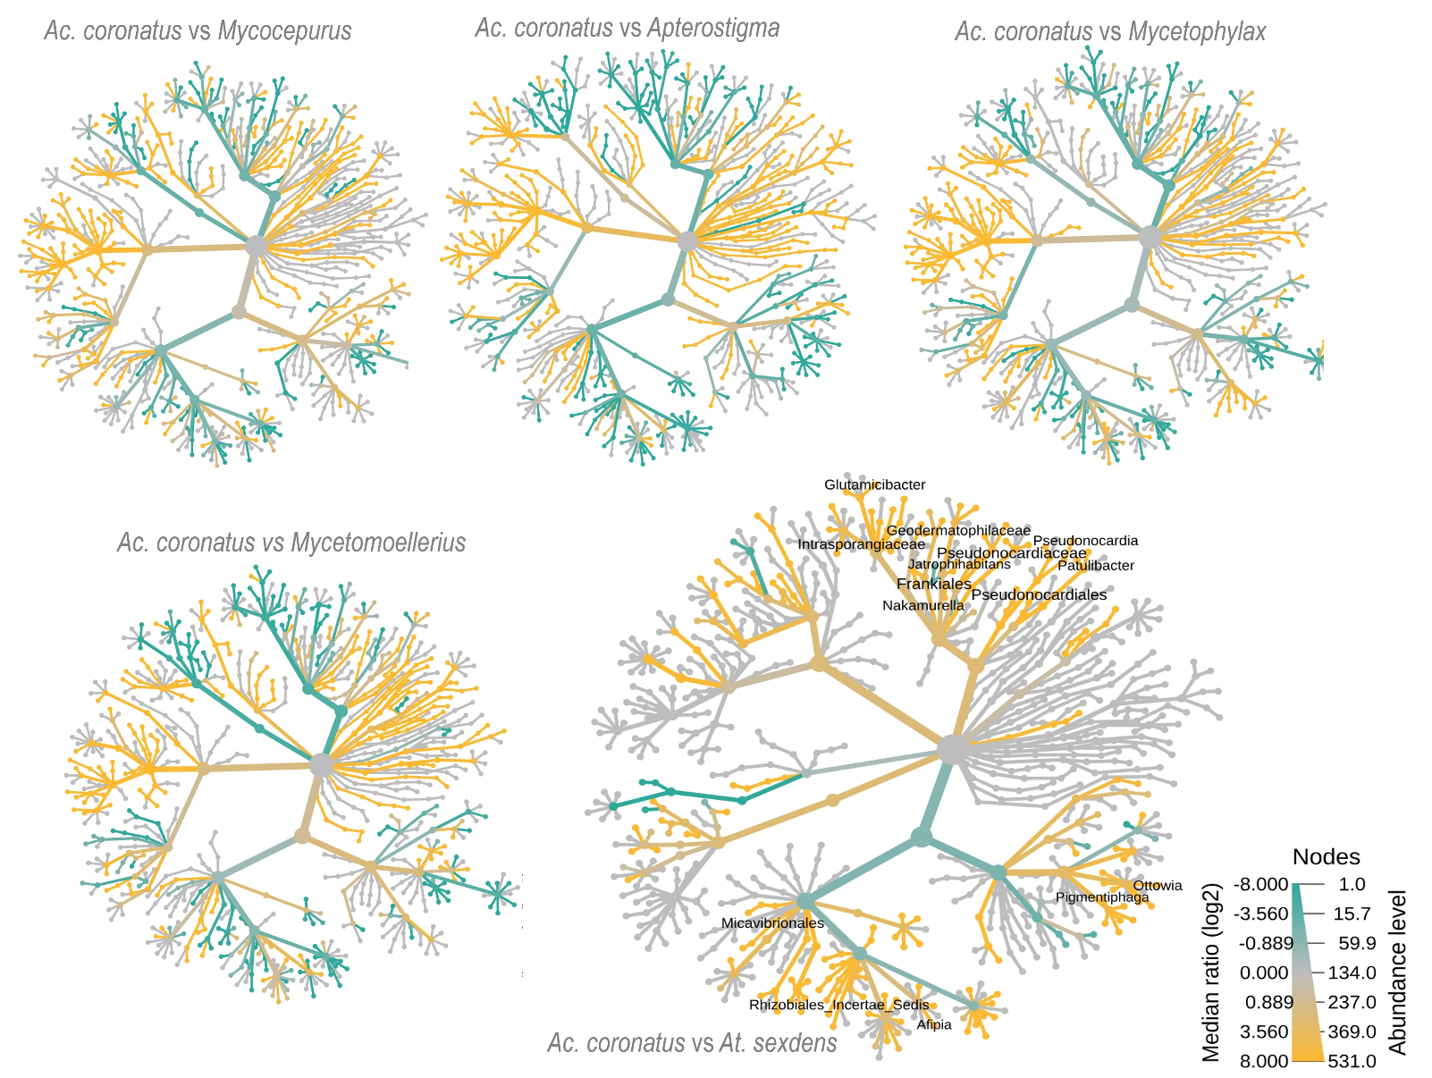
Fig. S14 - Bacterial genus-level heat tree, comparing group-wise relative abundances (Wilcoxon test, P < 0.05) between Acromyrmex coronatus and other attine in young gardens. Bacterial genera are denoted (i.e., whose names are written) in the heat-tree only when significantly differ between attine being compared.

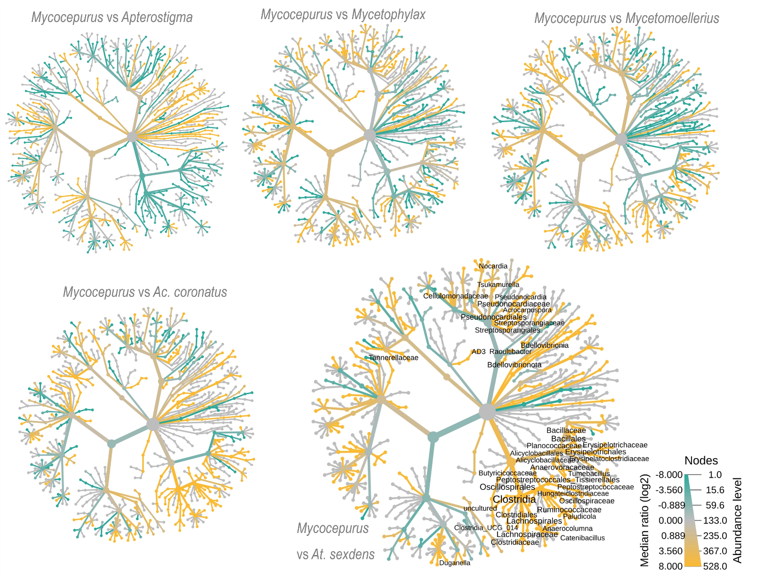
Fig. S15 - Bacterial genus-level heat tree, comparing group-wise relative abundances (Wilcoxon test, P < 0.05) between Mycocepurus sp. and other attine in old gardens. Bacterial genera are denoted (i.e., whose names are written) in the heat-tree only when significantly differ between attine being compared.

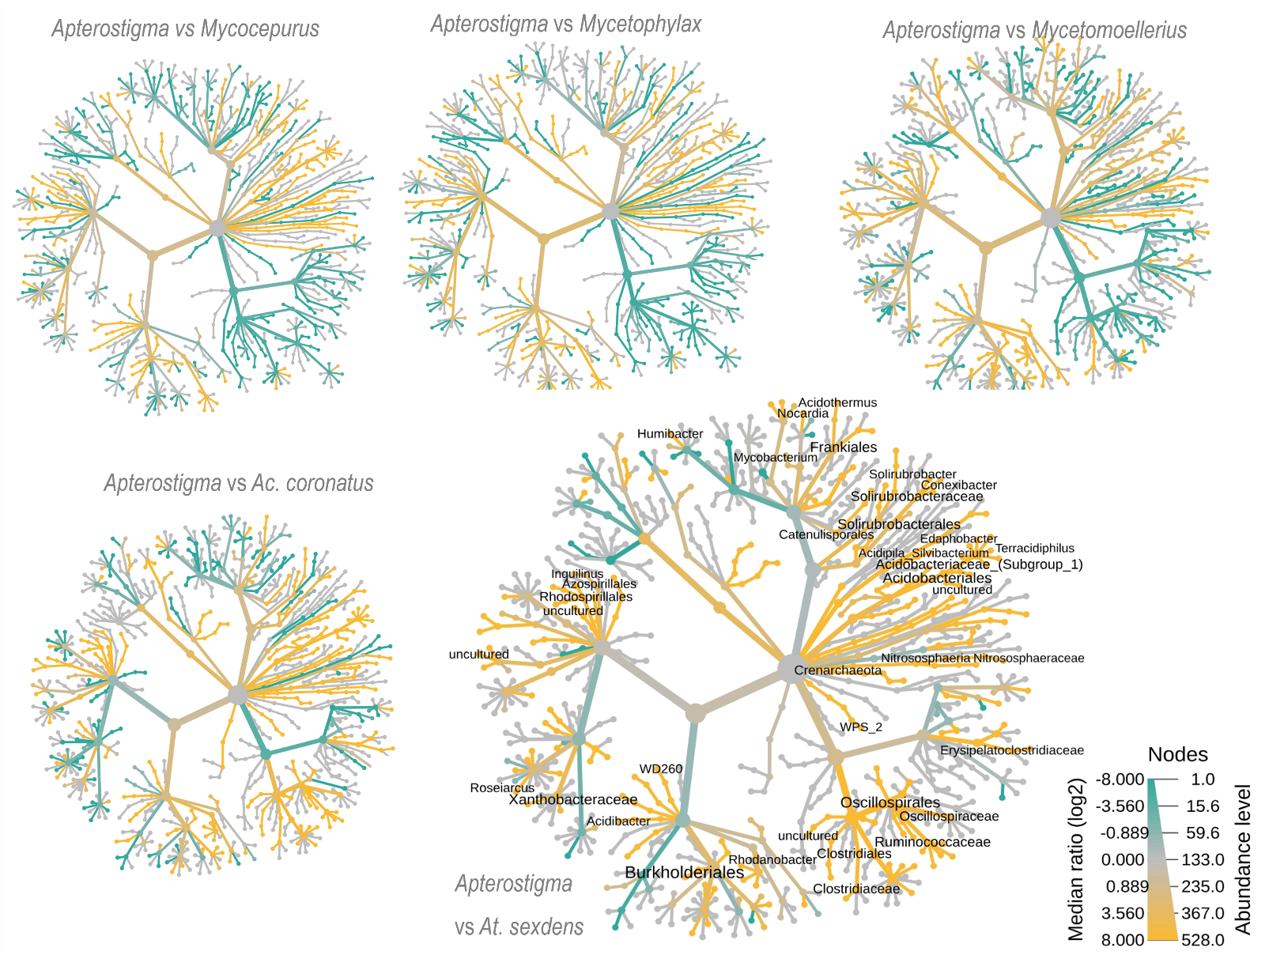
Fig. S16 - Bacterial genus-level heat tree, comparing group-wise relative abundances (Wilcoxon test, P < 0.05) between Apterostigma sp. and other attine in old gardens. Bacterial genera are denoted (i.e., whose names are written) in the heat-tree only when significantly differ between attine being compared.

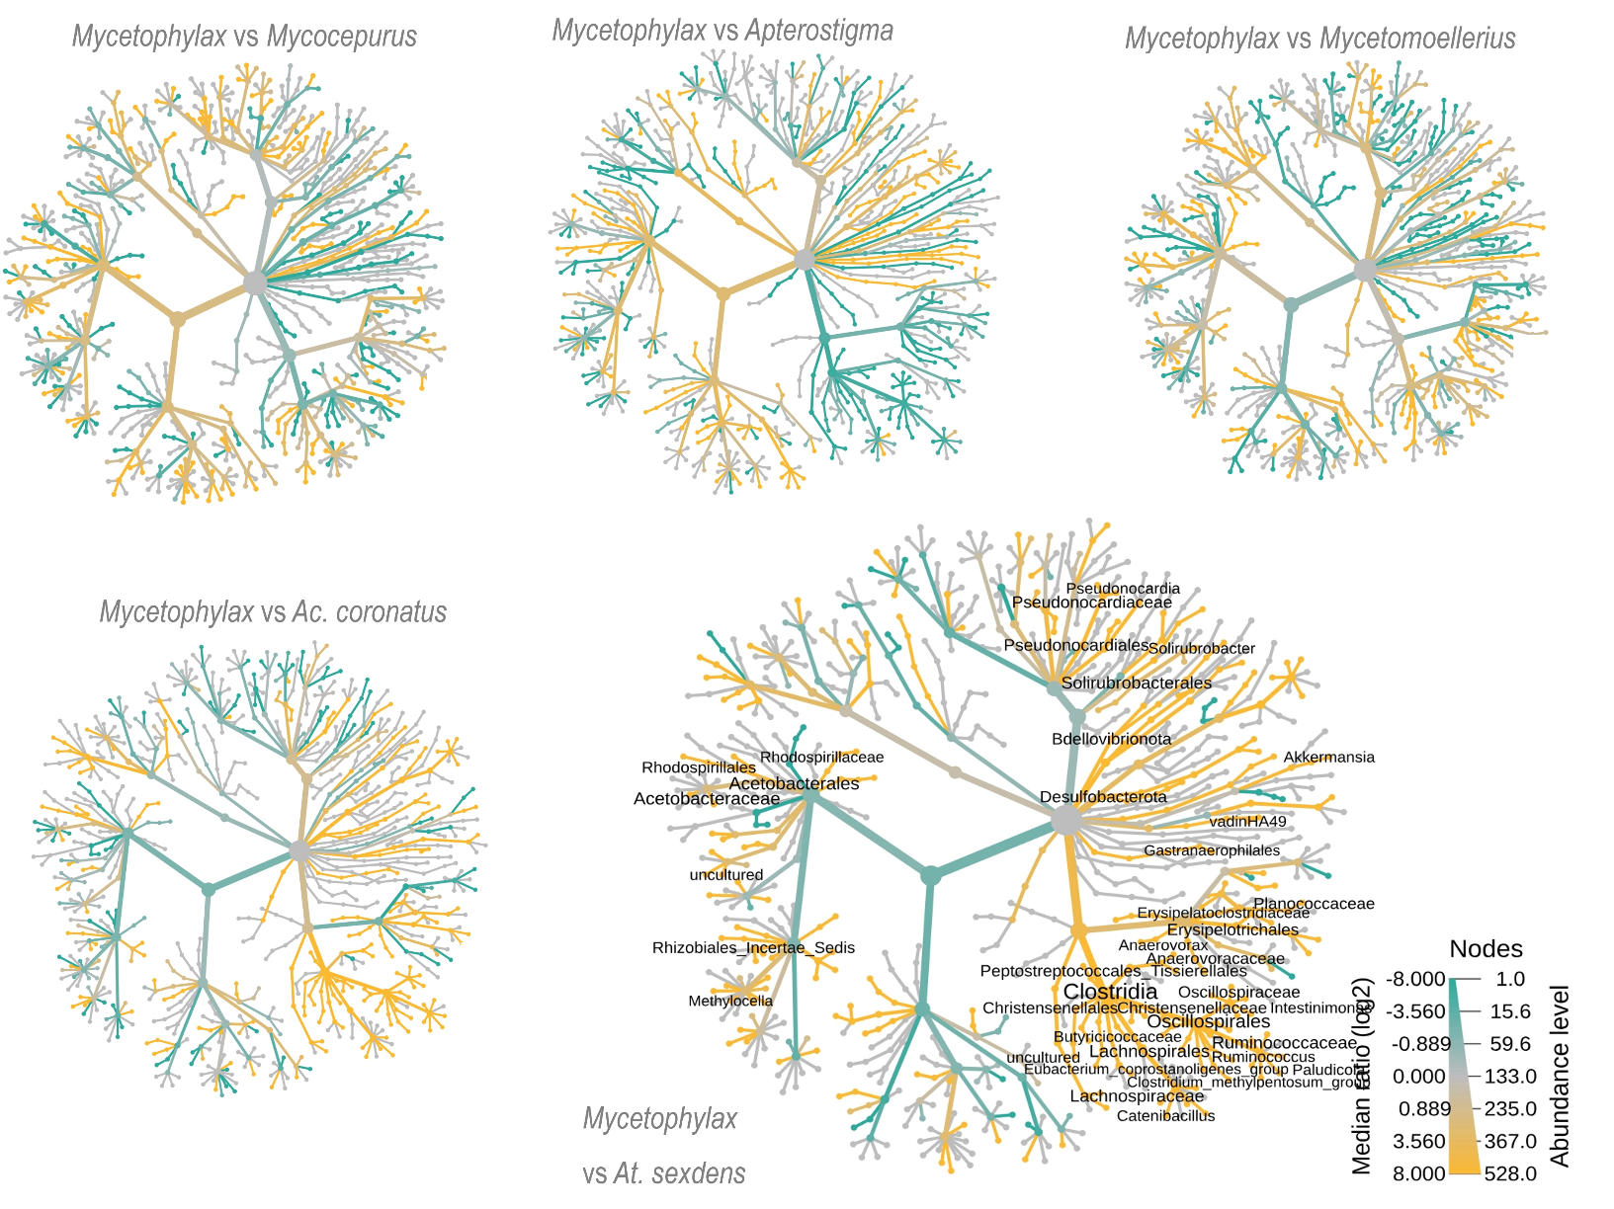
Fig. S17 - Bacterial genus-level heat tree, comparing group-wise relative abundances (Wilcoxon test, P < 0.05) between Mycetophylax sp. and other attine in old gardens. Bacterial genera are denoted (i.e., whose names are written) in the heat-tree only when significantly differ between attine being compared.

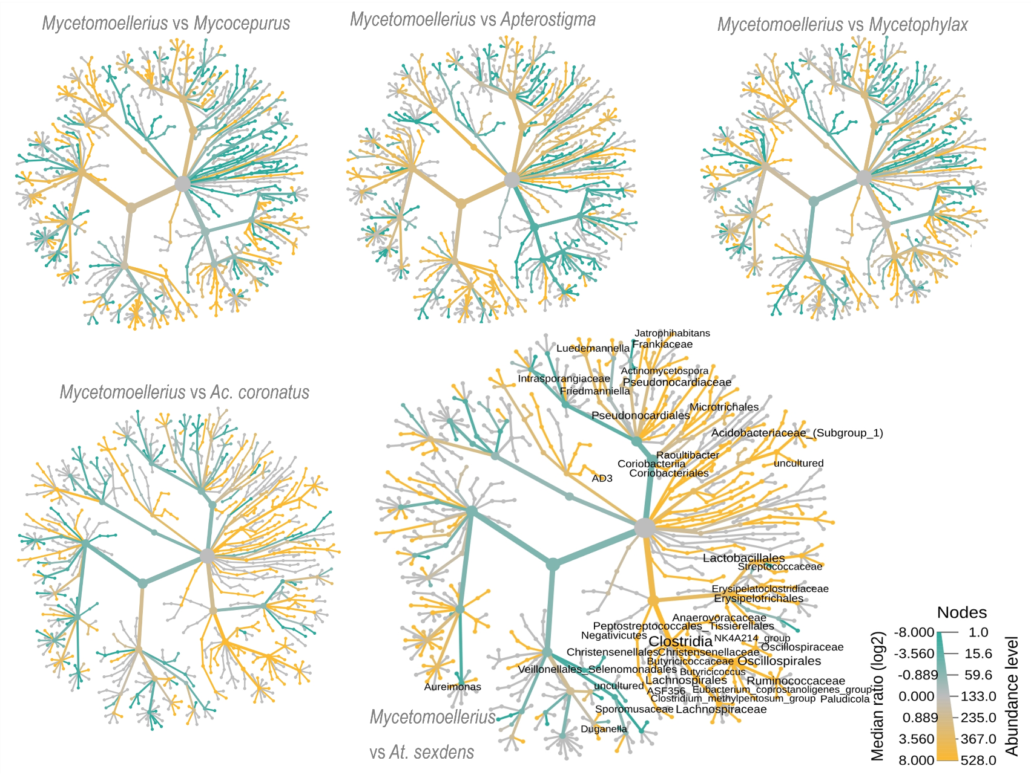
Fig. S18 - Bacterial genus-level heat tree, comparing group-wise relative abundances (Wilcoxon test, P < 0.05) between Mycetomoellerius sp. and other attine in old gardens. Bacterial genera are denoted (i.e., whose names are written) in the heat-tree only when significantly differ between attine being compared.

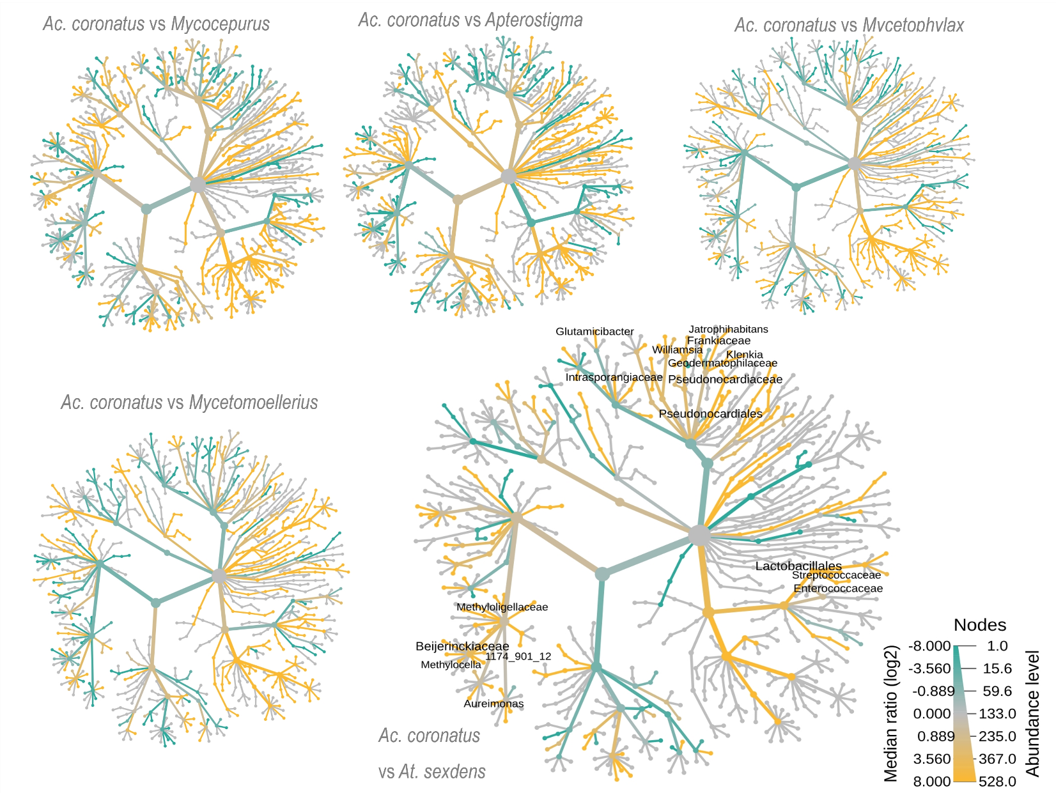
Fig. S19 - Bacterial genus-level heat tree, comparing group-wise relative abundances (Wilcoxon test, P < 0.05) between Acromyrmex coronatus and other attine in old gardens. Bacterial genera are denoted (i.e., whose names are written) in the heat-tree only when significantly differ between attine being compared.

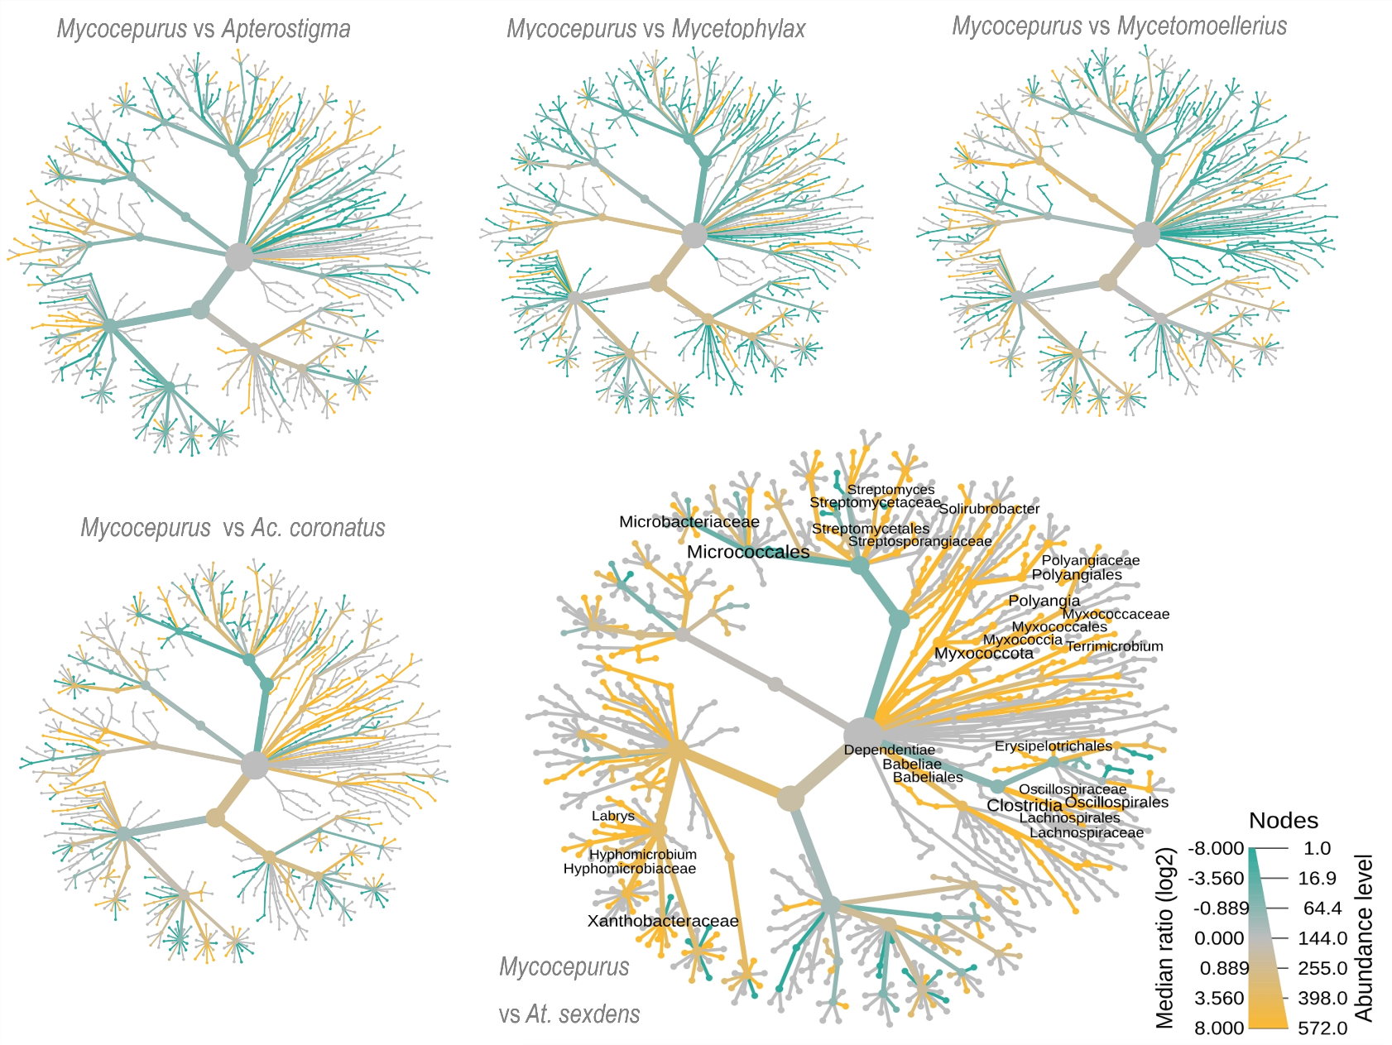
Fig. S20 - Bacterial genus-level heat tree, comparing group-wise relative abundances (Wilcoxon test, P < 0.05) between Mycocepurus sp. and other attine in the waste. Bacterial genera are denoted (i.e., whose names are written) in the heat-tree only when significantly differ between attine being compared.

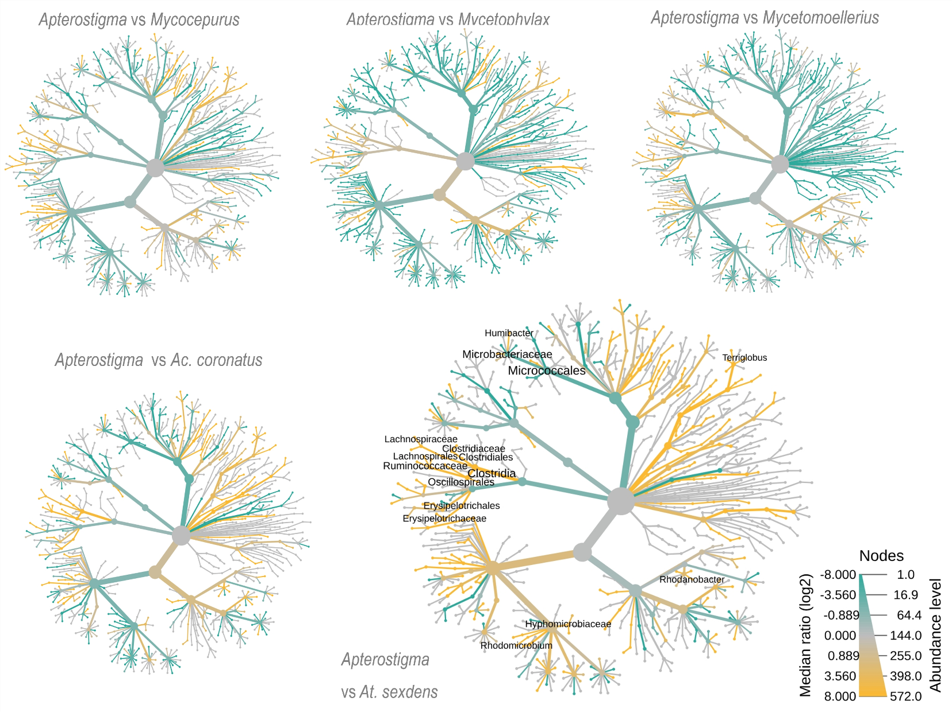
Fig. S21 - Bacterial genus-level heat tree, comparing group-wise relative abundances (Wilcoxon test, P < 0.05) between Apterostigma sp. and other attine in the waste. Bacterial genera are denoted (i.e., whose names are written) in the heat-tree only when significantly differ between attine being compared.

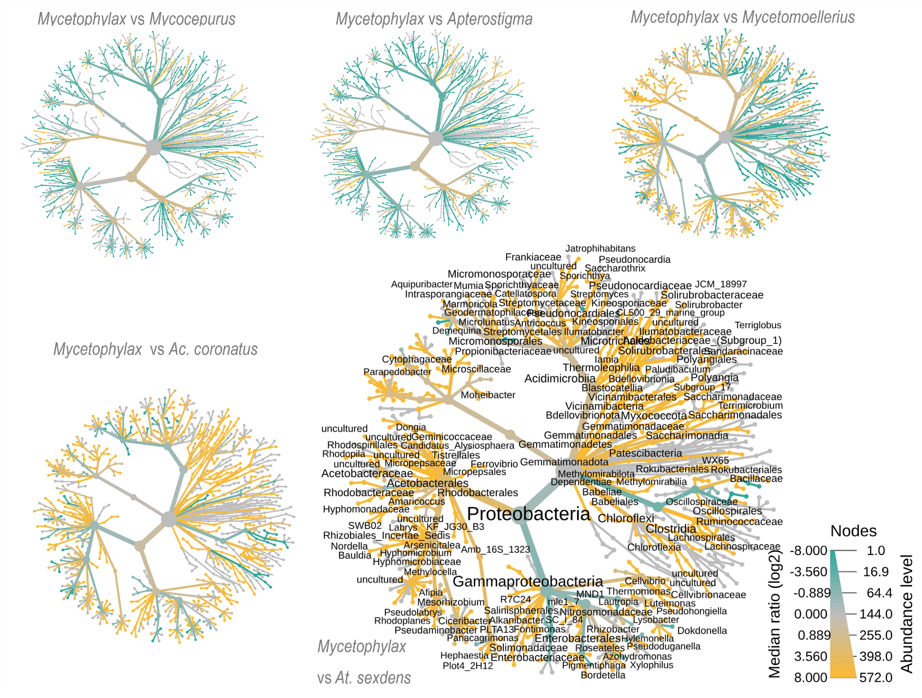
Fig. S22 - Bacterial genus-level heat tree, comparing group-wise relative abundances (Wilcoxon test, P < 0.05) between Mycetophylax sp. and other attine in the waste. Bacterial genera are denoted (i.e., whose names are written) in the heat-tree only when significantly differ between attine being compared.

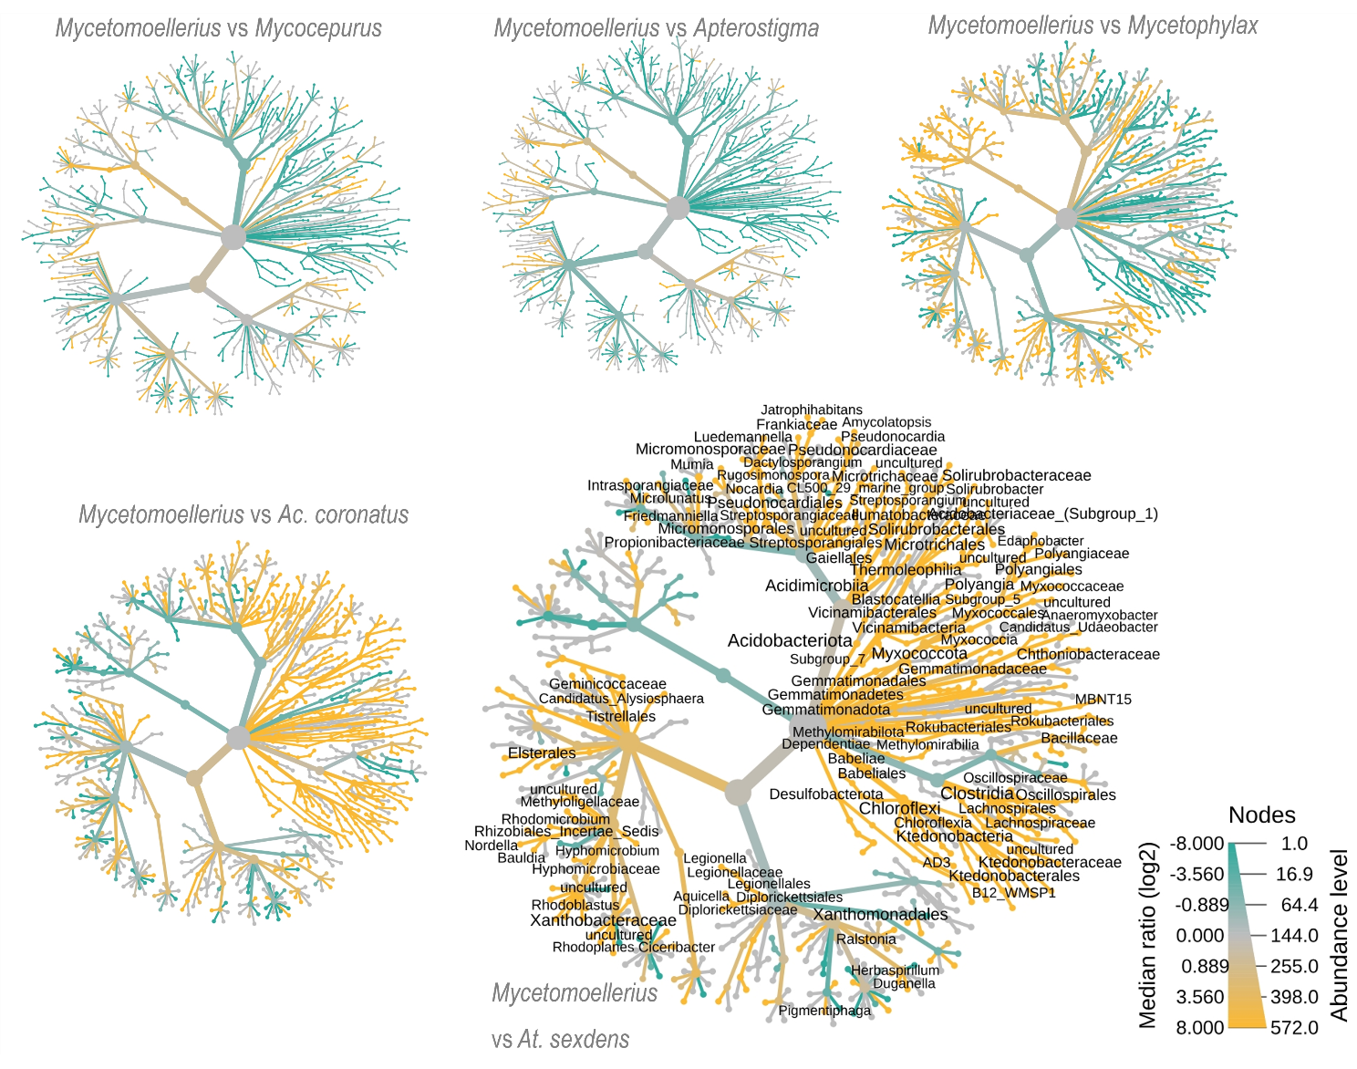
Fig. S23 - Bacterial genus-level heat tree, comparing group-wise relative abundances (Wilcoxon test, P < 0.05) between Mycetomoellerius sp. and other attine in the waste. Bacterial genera are denoted (i.e., whose names are written) in the heat-tree only when significantly differ between attine being compared.

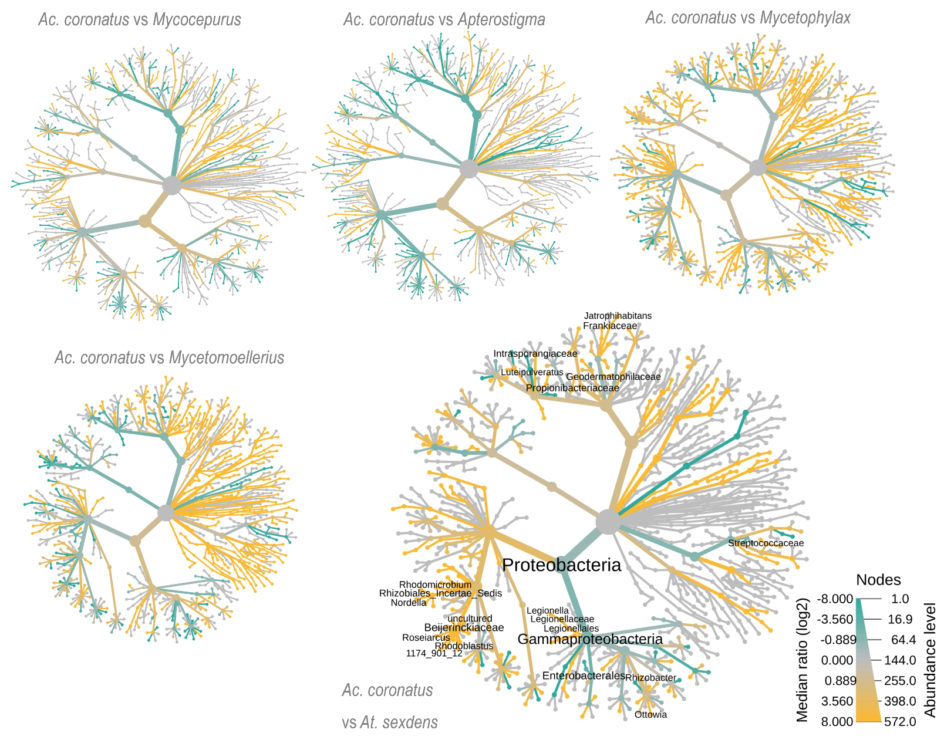
Fig. S24 - Bacterial genus-level heat tree, comparing group-wise relative abundances (Wilcoxon test, P < 0.05) between Acromyrmex coronatus and other attine in the waste. Bacterial genera are denoted (i.e., whose names are written) in the heat-tree only when significantly differ between attine being compared.

Fig. S25 - Relative abundance of bacterial phylum and class in young gardens of different attine species.
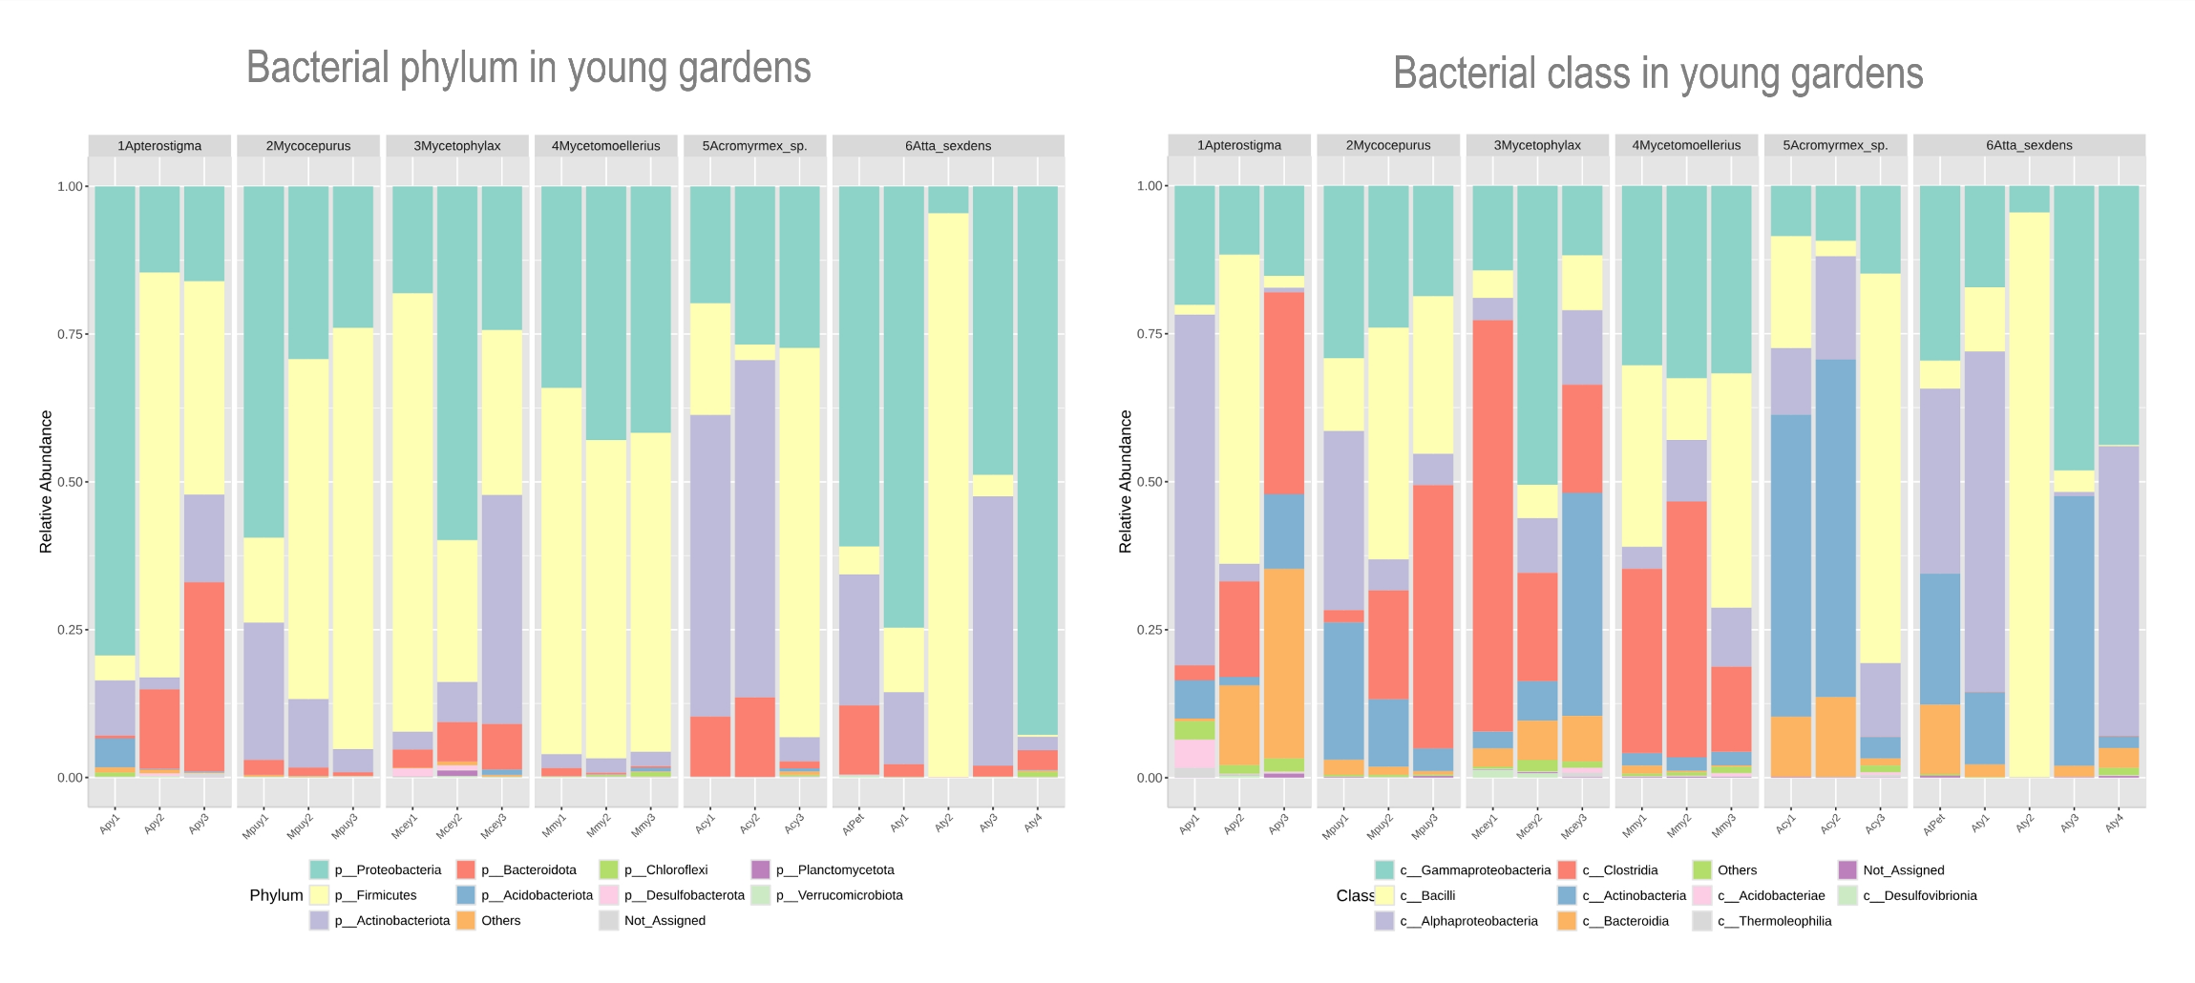

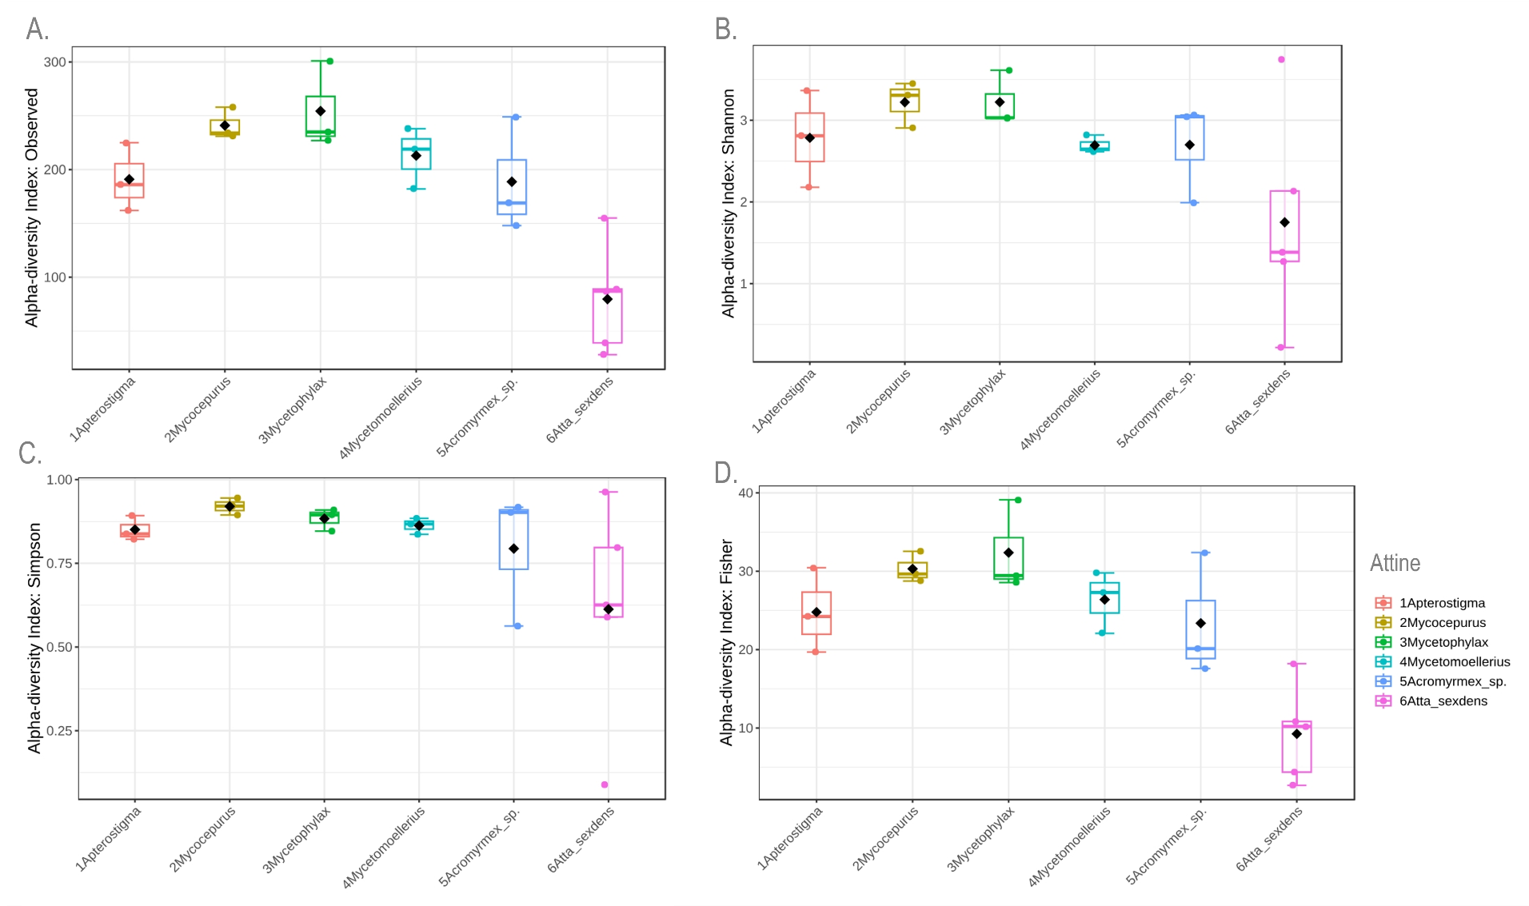
Fig. S26 - Bacterial diversity of young gardens. Alpha-diversity indices were estimated at genus level, based on Observed Features (Richness), Shannon, Simpson, and Fisher. No significant differences were found by Mann-Whitney/Kruskal-Wallis, with the Wilcoxon test for post hoc pairwise comparisons.

Fig. S27 - Relative abundance of bacterial phylum and class in old gardens of different attine species.
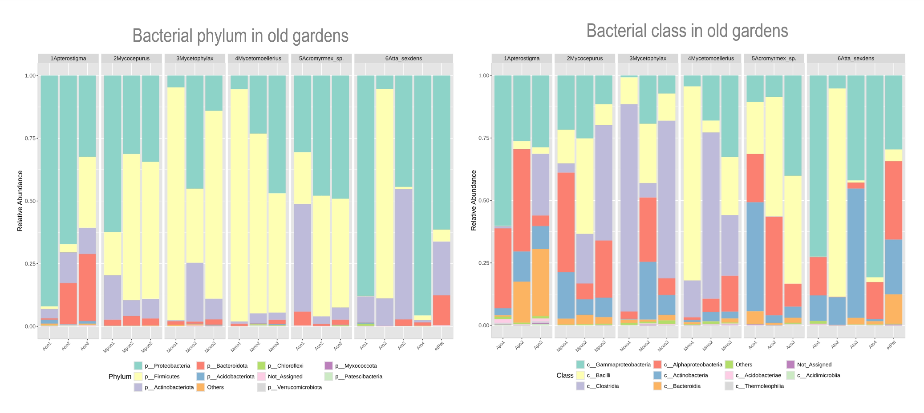

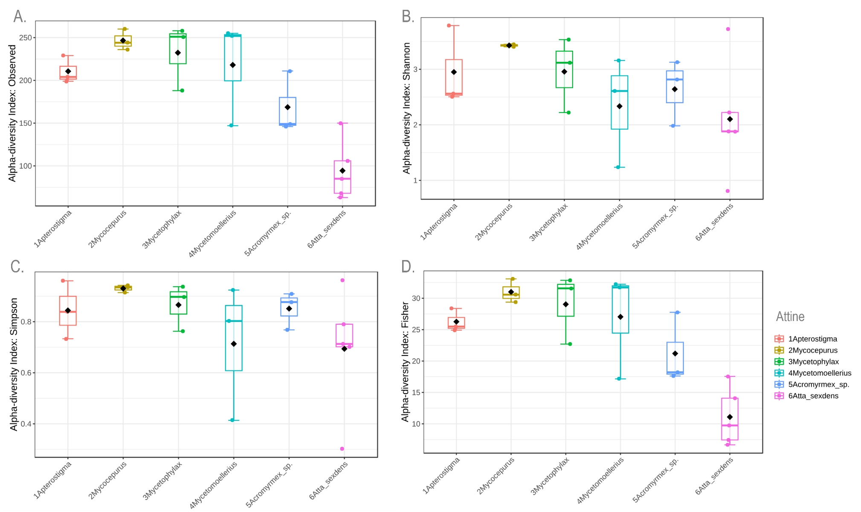
Fig. S28 - Bacterial diversity of old gardens. Alpha-diversity indices were estimated at genus level, based on Observed Features (Richness), Shannon, Simpson, and Fisher. No significant differences were found by Mann-Whitney/Kruskal-Wallis, with the Wilcoxon test for post hoc pairwise comparisons.

Fig. S29 - Relative abundance of bacterial phylum and class in the waste of different attine species.
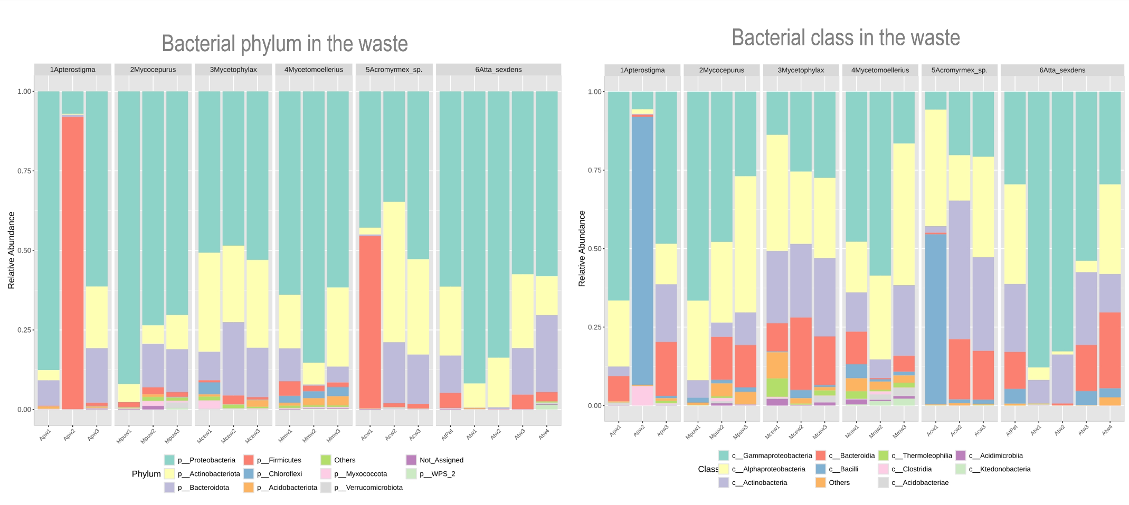

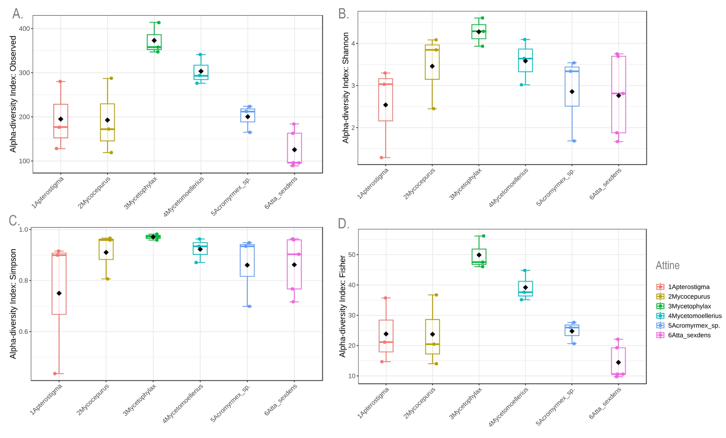
Fig. S30 - Bacterial diversity of waste samples. Alpha-diversity indices were estimated at genus level, based on Observed Features (Richness), Shannon, Simpson, and Fisher. No significant differences were found by Mann-Whitney/Kruskal-Wallis, with the Wilcoxon test for post hoc pairwise comparisons.

Fig. S31 - Garden structure, microbiota, and biofilm spatial distribution across attine fungiculture systems. Garden features observed by SEM imaging along the experiment, including: hyphal density, presence of gongylidia, signs of substrate deterioration, substrate-colonizing microbiota, hyphae-colonizing microbiota, and presence of yeasts. SEM imaging allowed us to characterize the garden and waste of A. Mycocepurus sp.; B. Apterostigma sp.; C. Mycetophylax sp.; D. Mycetomoellerius sp.; E. Ac. coronatus; and F. At. sexdens. Illustrations by Mariana Barcoto.
