Supporting Information
SIRT1/MFN2-Mediated Regulation of Mitochondrial Dynamics and Mitophagy in Age-Related Decline of Leydig Cell Function
Zheng-Mei Lv^{1,#}, Chao Liu^{1, #}, Zi-meng Xu¹, Chong-kang Wu^{1,},Ya-jing Liu², Xin Chen^{3, *}, Yuan-Hua Chen^{1,*}
¹School of Basic Medical Sciences, Anhui Medical University, Hefei 230032, China.
²Anhui Province Key Laboratory of Reproductive Disorders and Obstetrics and Gynaecology Diseases, Anhui Medical University, Hefei 230022, China
³Department of Urology, The Second Affiliated Hospital of Anhui Medical University, Hefei, Anhui, China
*Corresponding author: Prof. Yuan-Hua Chen (yuanhuachen@ahmu.edu.cn) and Prof. Xin Chen (chenxin01@ahmu.edu.cn)
#These authors have contributed equally to this work.
Keywords: Zearalenone; placental barrier; glucocorticoid; integrated stress response; adverse pregnancy outcomes.

Supplementary Figures
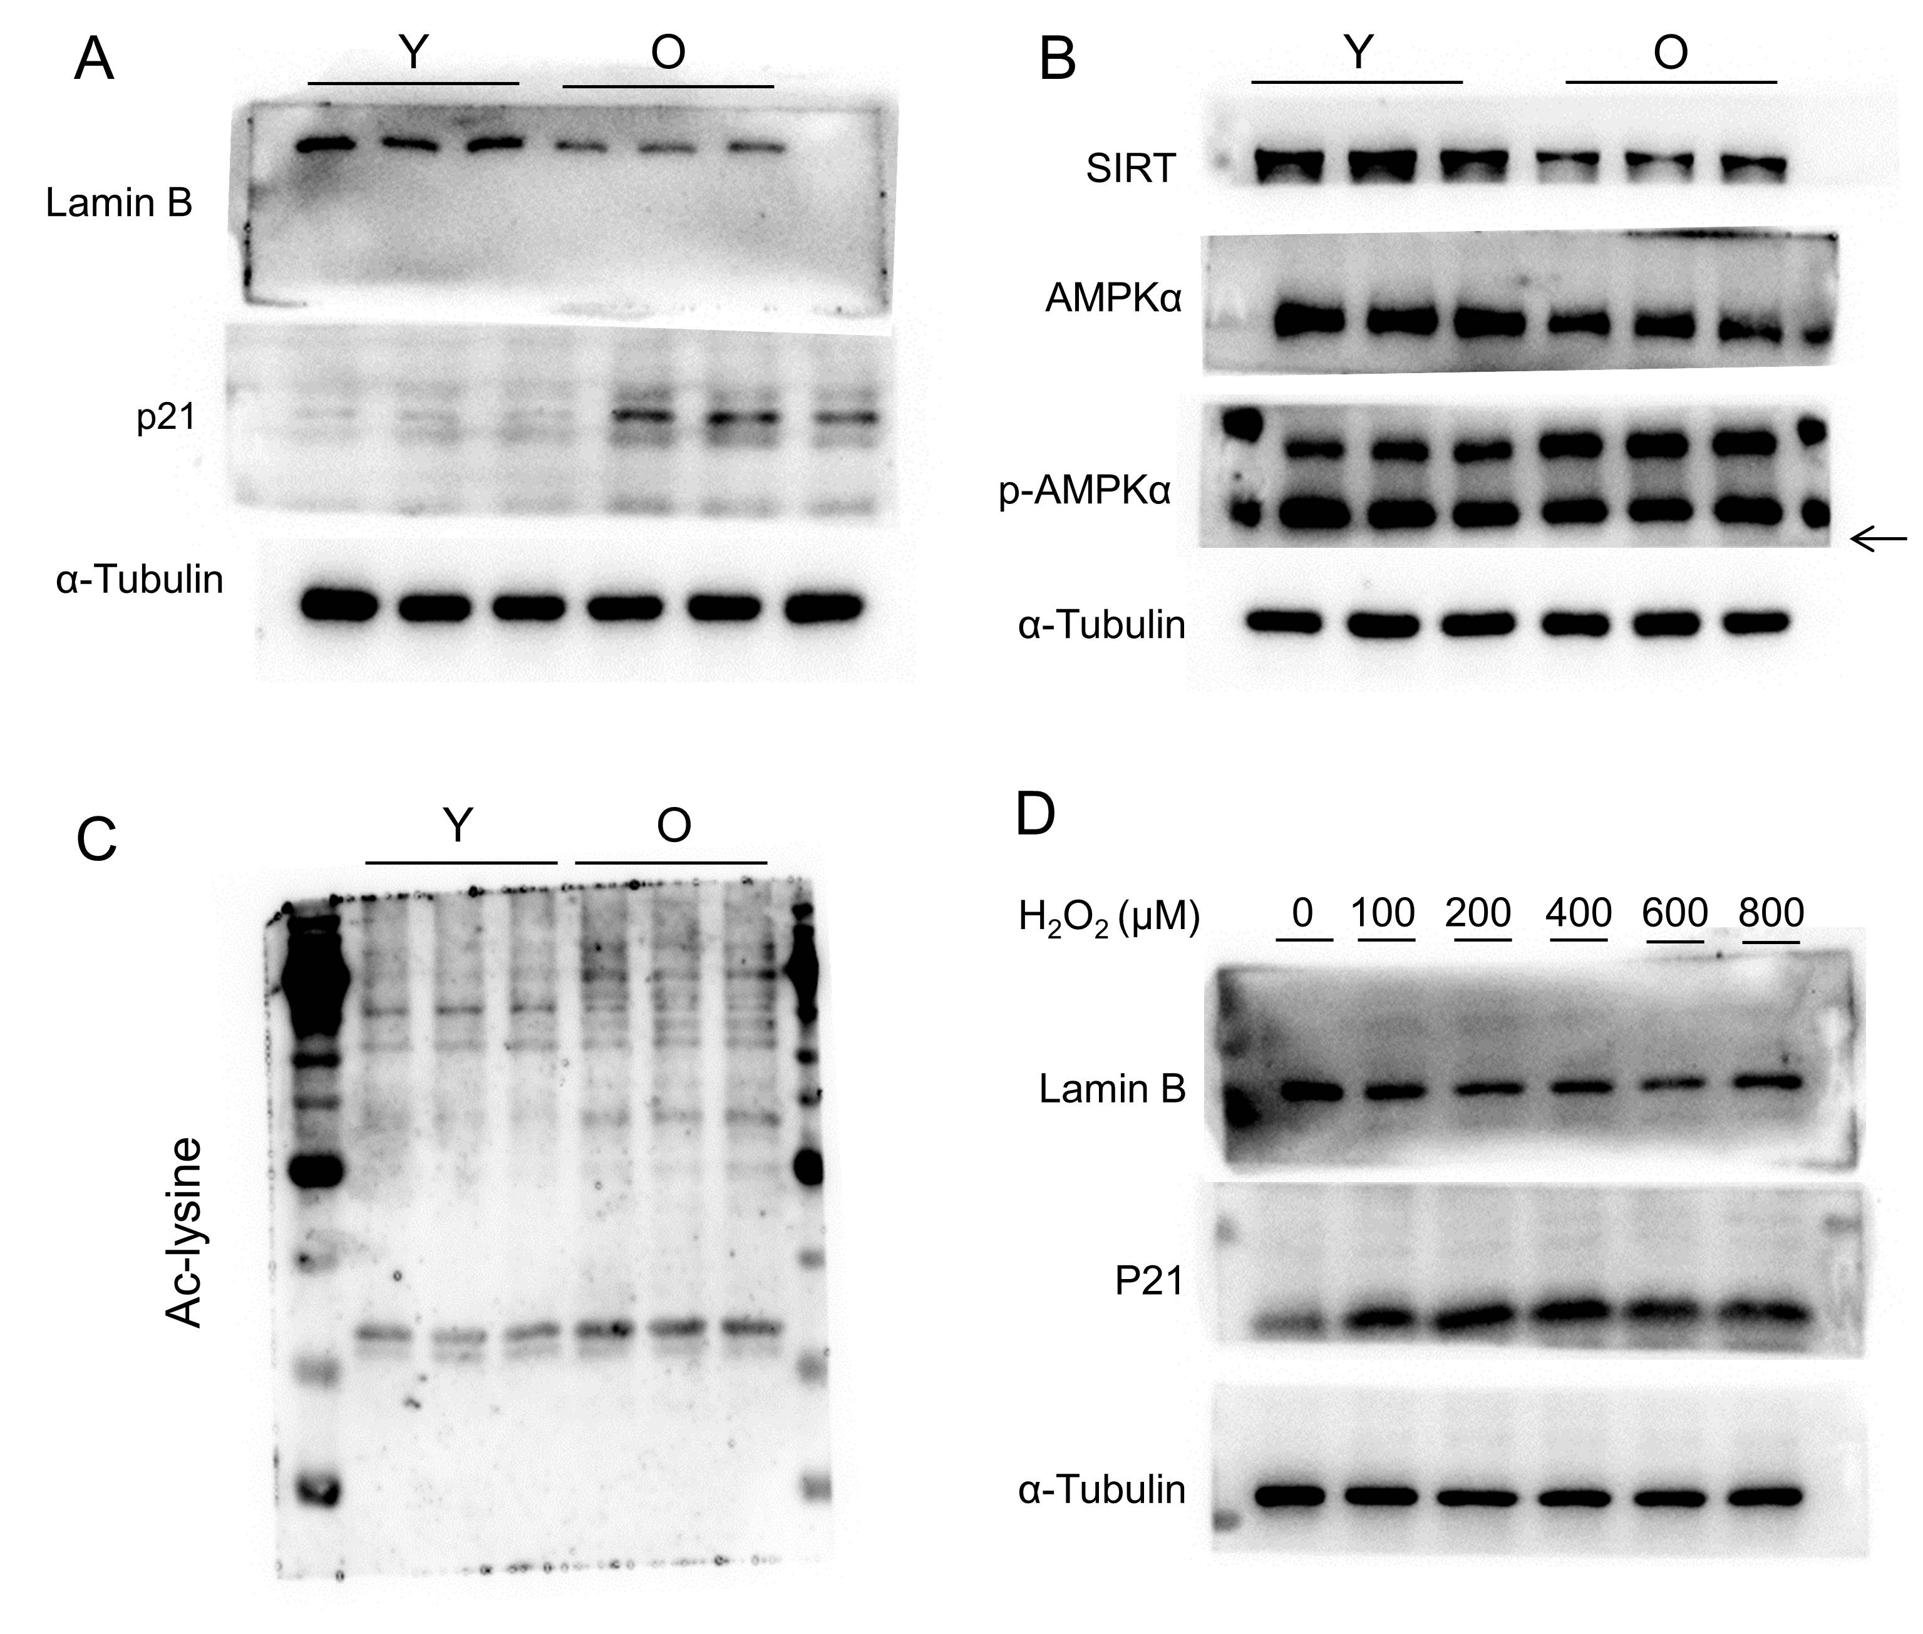
Figure S1 Original images of the Western blots. (A) Original Blot images for Figure 1C. (B) Original Blot images for Figure 1E. (C) Original Blot images for Figure 1G. (D) Original Blot images for Figure 1L.
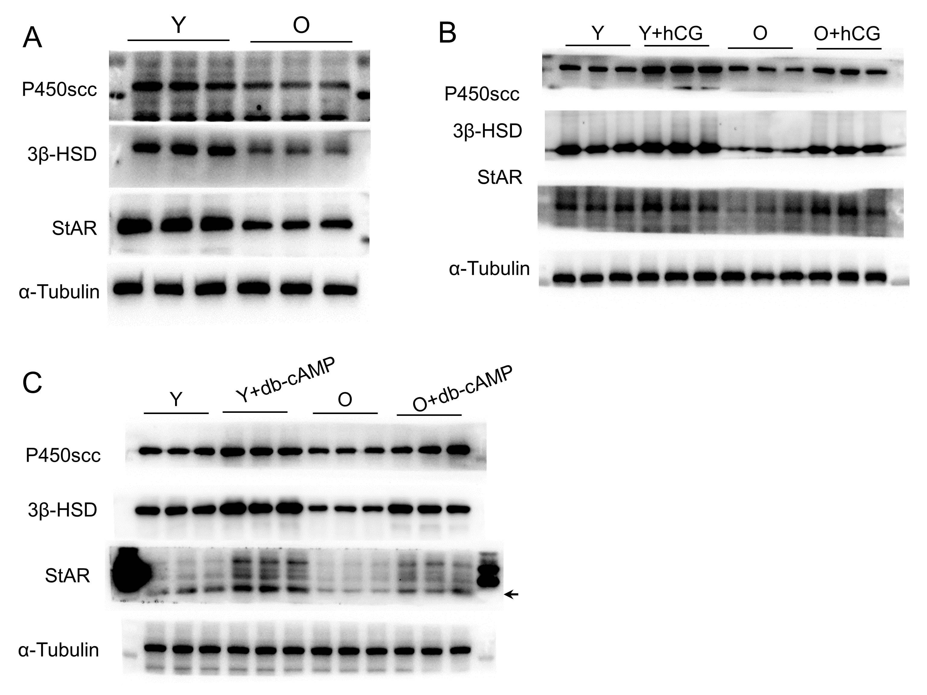
Figure S2 Original images of the Western blots. (A) Original Blot images for Figure 2B. (B) Original Blot images for Figure 2F. (C) Original Blot images for Figure 2G.
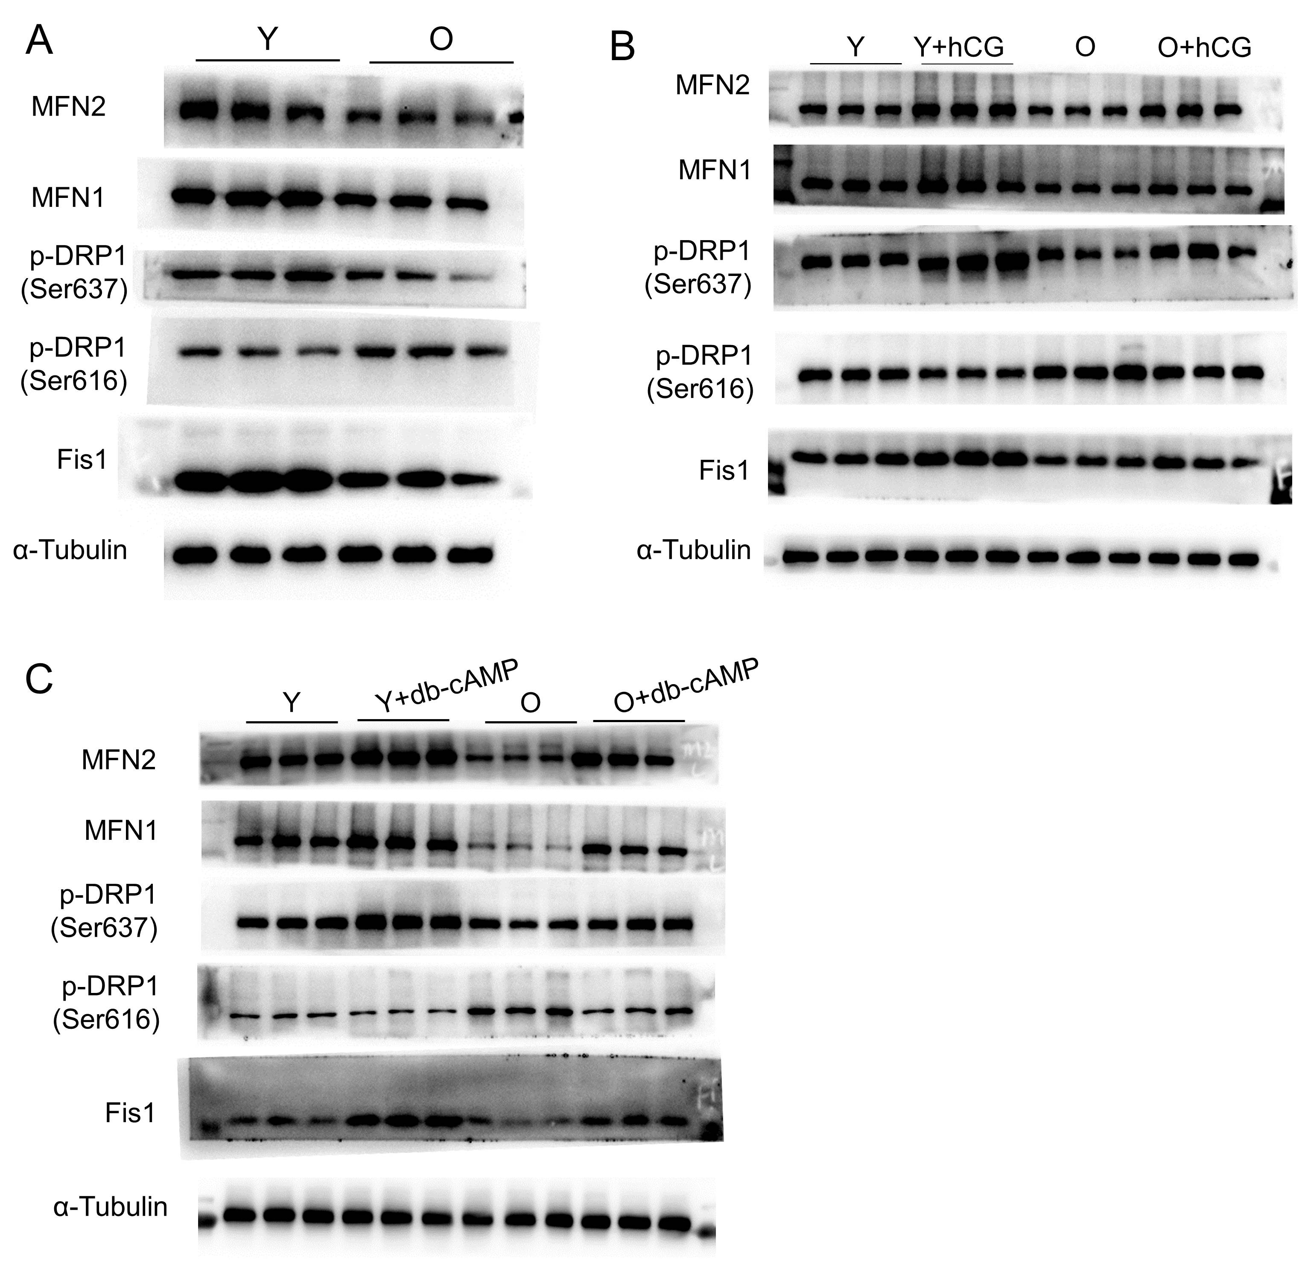
Figure S3 Original images of the Western blots. (A) Original Blot images for Figure 3C. (B) Original Blot images for Figure 3E. (C) Original Blot images for Figure 3F.
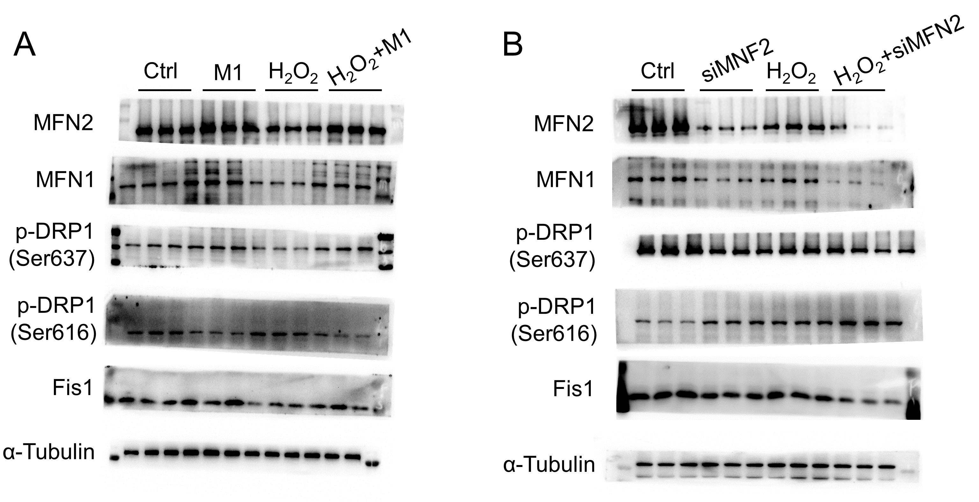
Figure S4 Original images of the Western blots. (A) Original Blot images for Figure 4C. (B) Original Blot images for Figure 4D.
Figure S5 Original images of the Western blots. (A) Original Blot images for Figure 5C. (B) Original Blot images for Figure 5E. (C) Original Blot images for Figure 5F. (D) Original Blot images for Figure 5I. (E) Original Blot images for Figure 5J.

Figure S6 Original images of the Western blots. (A) Original Blot images Figure 6A. (B) Original Blot images for Figure 6C. (C) Original Blot images Figure 6D. (D) Original Blot images for Figure 6F. (E) Original Blot images Figure 6G.

Figure S7 Original images of the Western blots. (A) Original Blot images Figure 7A. (B) Original Blot images for Figure 7B. (C) Original Blot images Figure 7C.
Figure S8 Original images of the Western blots. (A) Original Blot images Figure 8A. (B) Original Blot images for Figure 8B. (C) Original Blot images Figure 8C.

