SUPPORTING INFORMATION

Discovery of EDA-Complex Photocatalyzed Reactions Using Multidimensional Image Processing: Iminophosphorane Synthesis as a Case Study

Rodrigo C. Silva¹*; Gabriel M. F. Batista²; Timothy J. Brocksom¹; Kleber T. de Oliveira¹*

TABLE OF CONTENTS

1. General information 3
2. Substrate Selection 3
3. EDA-mediated reaction 3D screening using computer vision 4
4. Homemade MDF photo box for acquiring microplate images 5
5. Microplate digital image processing validation 6
6. Homemade MDF photo box for acquiring TLC images 8
7. TLC-mediated screening method validation 10
8. Homemade 12-wells photoreactor 11
9. Computational Methods 13
10. Operation manual of the code 13
11. Discovery of the iminophosphorane synthesis 23
12. Reaction conditions screening 24
13. Control reactions 27
14. General procedure for iminophosphoranes synthesis 28
15. Experimental Data 28
16. References 30
17. HRMS Data 31
18. NMR Data 33

General information

All reagents were purchased and used without further purification. Reactions were monitored by thin-layer chromatography (TLC) carried out on 0.25 mm silica plates, using short-wave UV light (254 nm) for visualization. Flash column chromatography was performed on silica gel (70 – 230 mesh). NMR spectra were recorded on a Bruker Avance 400 MHz instrument, and chemical shifts for ¹H, ¹³C, and ³¹P NMR were reported in ppm relative to TMS peaks. All coupling constants (J values) were reported in Hertz (Hz). The following abbreviations were used to explain NMR peak multiplicities: s = singlet, d = doublet, t = triplet, q = quartet, and m = multiplet. High-resolution mass spectra (HRMS) were obtained on an Agilent LC-6545, Q-TOF MS with Jet Stream ESI ionization. UV-Vis absorption spectra were recorded on a Perkin Elmer Lambda 25 UV-visible absorption spectrophotometer.

Substrate Selection

The 50 substrates (Figure S1), of which 4 (pyridine, 4-methoxybenzenediazonium tetrafluoroborate, Umemoto’s reagent, and N,N-dimethylaniline) were intentionally added as a positive control,^{1,2} were aleatorily selected from our organic compounds stockroom list
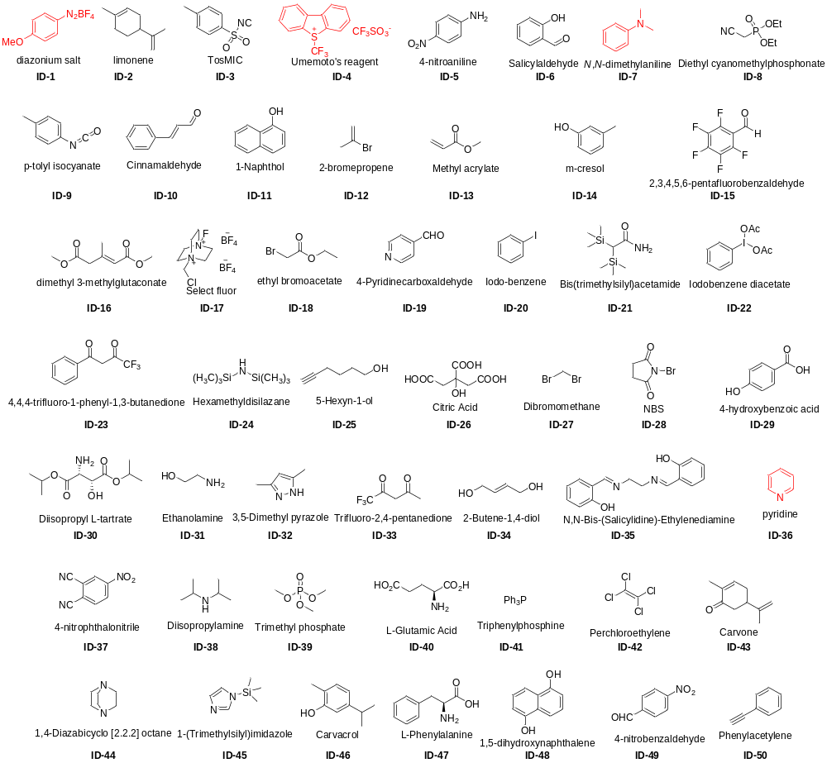

Figure S1: Compounds used for the EDA-photoinduced reaction screening. The compounds in red were intentionally added as a positive control.

EDA-mediated reaction 3D screening using computer vision

The first dimension has the purpose of identifying mixtures that provoke a color change by using digital image processing methods and an algorithm to make decisions. The second and third dimensions are reaction-based screenings (TLC). The code recognizes the TLC from digital images and extracts the blurs of each dot for a graphical representation, which we call “tlcgram”. Then, the algorithm classifies the mixture as reactive or non-reactive by comparison of both substrates- and mixture-tlcgrams, respectively (Figure S2).
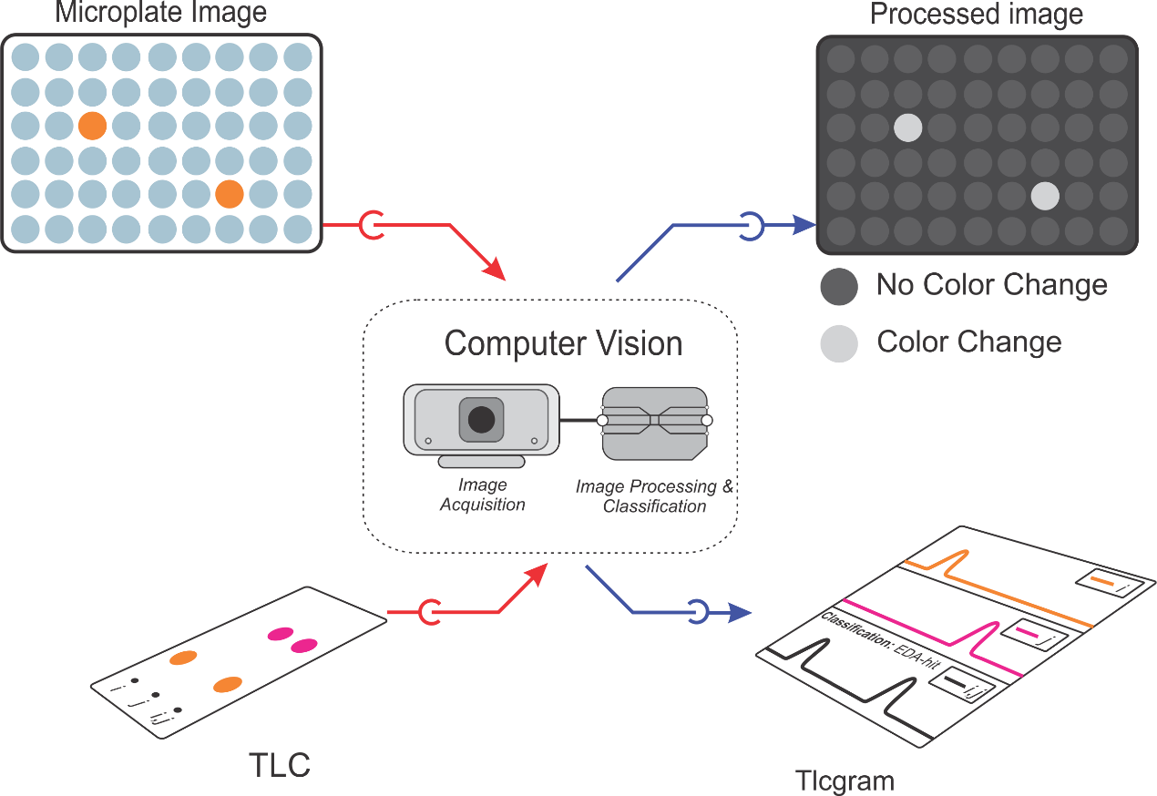
Figure S2: Identification and classification of mixtures using computer vision and TLC.

Homemade MDF photo box for acquiring microplate images

A prototype of the photo box was built using a simple shoebox (Figure S3, A-B). After the success of the prototype, a new photo box was built in MDF (Medium Density Fiberboard) material (Figure S3, C-D) to maintain the structural rigidity and guarantee the quality and reproducibility of the image acquisition. The MDF photo box was built with the following dimensions: 24 cm in length, 19 cm in width, and 28 cm in height. This photo box was equipped with an on/off LED setup containing 4 LED strips (2 W each) of 9 cm in each internal wall, a microplate holder with a white background, and a viewer for the photo device, which can be a webcam or cellphone. In this study, the microplate images were acquired using a cellphone (8 Megapixels, zoom up to 5x).
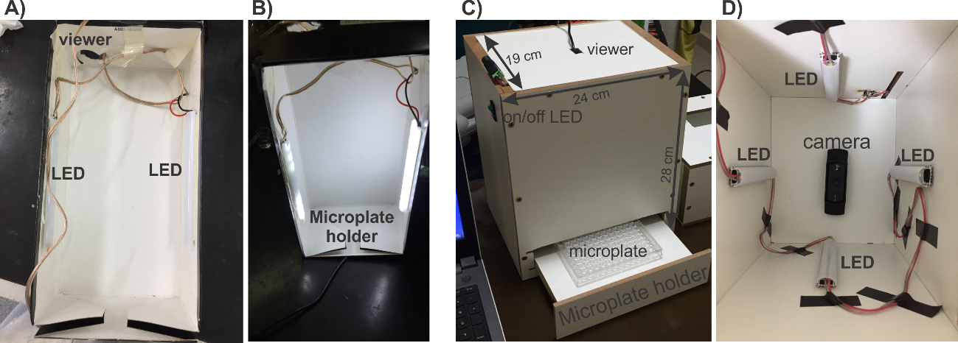
Figure S3: Photo box built for image acquisition of the microplate. A) Superior and B) operational view of the prototype shoebox. C) External and D) internal view of the homemade MDF photo box.

Transparent 96-well microplates (12 columns x 8 rows) equipped with a lid that highlights the wells were used to visualize the color of the mixtures. The lid was crucial for the automatic recognizing of the wells by the algorithm because it causes an increase of contrast between wells and the microplate background. Although a 96-well microplate has been used in our study, the images were acquired in a region containing 30 wells (6 columns x 5 rows) due to the superior image quality and the better precision of the algorithm of automatic recognition of the wells. Thus, each microplate was used in up to 2 image acquisitions (Figure S4).
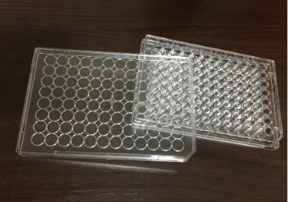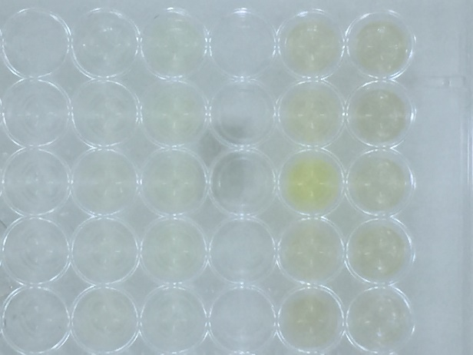
Figure S4: Transparent 96-well microplate with the lid and image acquisition region.

Microplate digital image processing validation

The validation of the microplate image processing method was carried out with 208 mixtures with grayscale values up to 40. UV-Vis spectroscopy was used as a reference method, whose measurements were performed in the same concentrations used for the microplate method. Examples of this validation are demonstrated below (Figure S5).
The code has efficiently classified the mixtures with grayscale lower than 20 as colorless mixtures (Figure S5, A and D). Mixtures with grayscale values between 20 and 40 have been classified as a colored mixture with an error of up to 20% (Figure S5-B and C).
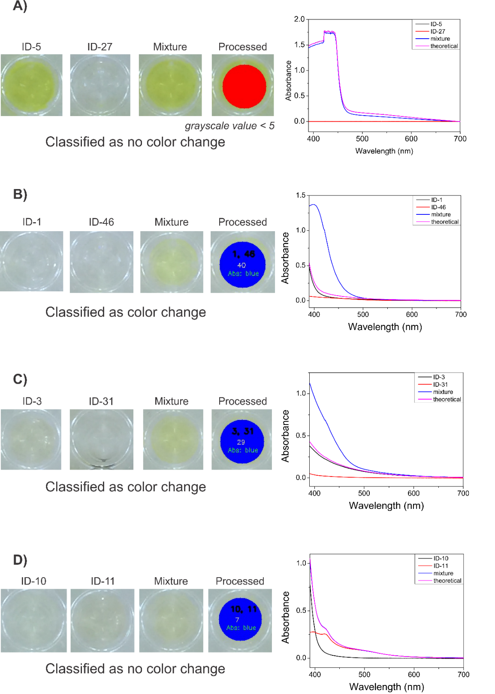
Figure S5: Comparison between microplate digital image processing data and UV-Visible spectroscopy data for mixtures A) ID: 5-27, B) ID: 1-44, C) ID: 3-31, and D) ID: 10-11.

Homemade MDF photo box for acquiring TLC images

A prototype of the photo box was also built using a simple shoebox (Figure S6, A-B). Subsequently, a new photo box was built in MDF material (Figure S6, C-D). The MDF photo box, with dimensions of 28 cm in length, 19 cm in width, and 12 cm in height, was equipped with a TLC holder with a black background, a hole of 21.0 cm² for the UV-light device (254 nm, 6 W), and a viewer for image acquisition with a webcam of 5 megapixels resolution.
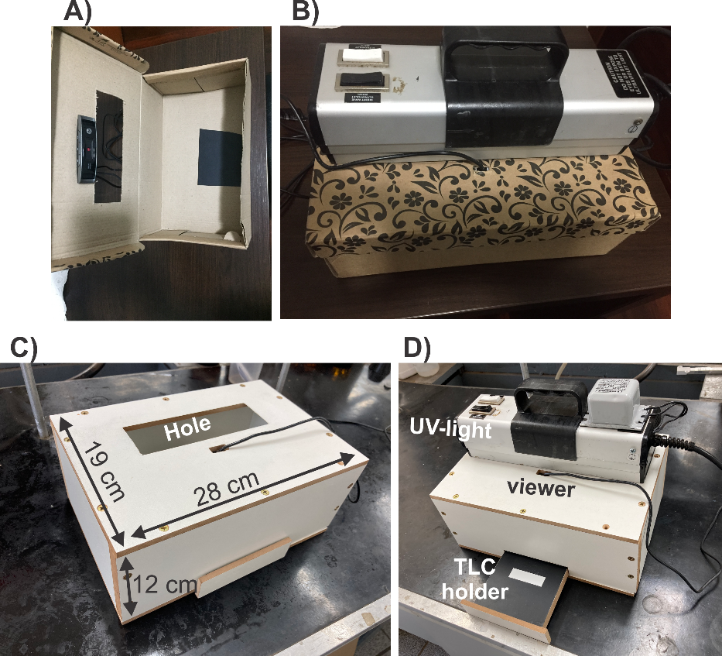
Figure S6: TLC photo box. Prototype built with a shoebox, A) internal view and B) external view. TLC photo box built-in MDF material highlighting C) the dimensions of the box, and D) TLC holder and the UV-light device.

The length of the TLC plate (50 mm) has been standardized to facilitate the comparison between different plates. The algorithm developed in this study was able to process TLC plates with various spot numbers, as long as they are symmetrically divided in the TLC plate. The spot identifications were standardized with the respective ID numbers of the substrates contained in the mixtures (Figure S7). The code recognizes the borders of the TLC by a red line (Figure S8B) and subdivides the plate following the spot number (Figure S8C). Grayscale values of 300 micro-rectangles were measured along the length of each plate subdivision (Figure S8D). Then, a graph of grayscale values in function of the number of micro-rectangles was plotted, giving origin to what we call “tlcgram” (Figure S8E). The code recognizes the peaks of each mixture and saves the data in a database for automatic classification of the mixture as a reaction product or not. Alternatively, the mixture classification can be carried out manually, in this case, the code shows the TLC images and the overlapping of the tlcgram plots of the reference compounds and mixture, respectively, to easily allow the classification by an organic chemist (Figure S9) (details of the operation of this code are shown below).
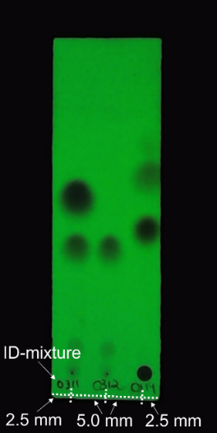
Figure S7: TLC plate showing spot distances and identifications.
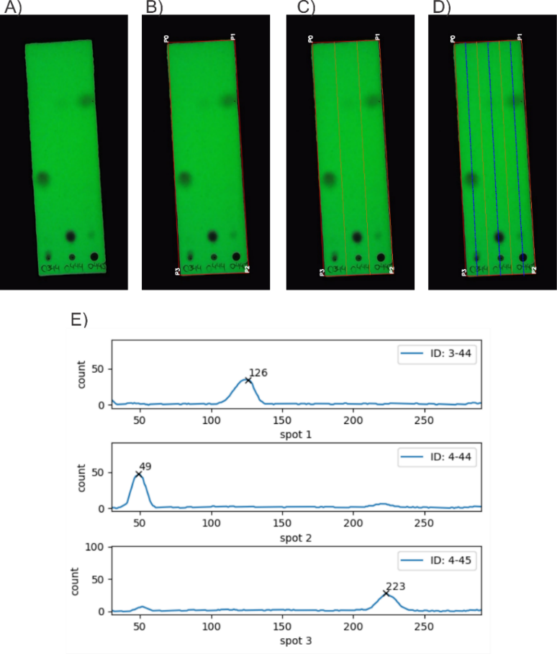
Figure S8: A) Original TLC image. B) Automatic recognition of the TLC edges with a red line and of the vertices with a white text. C) Subdivision of TLC with an orange line. D) Demarcation of micro-rectangle centroids with blue dots. The micro-rectangles are used for grayscale measurements. E) tlcgram plot for each spot.
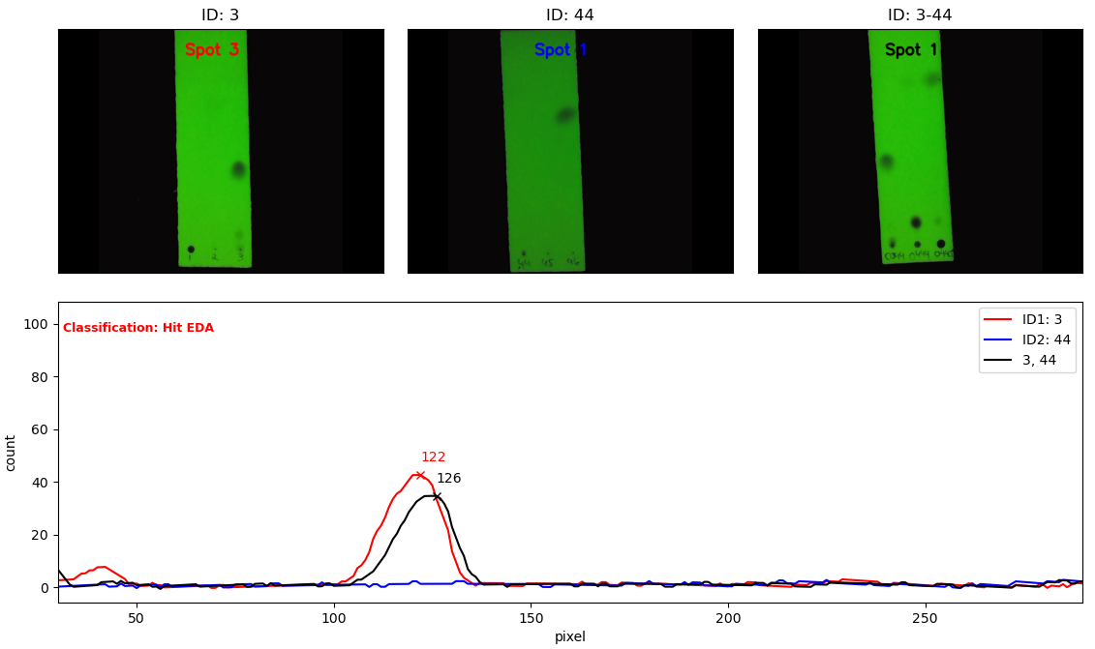
Figure S9: Manual classification of the mixture between the compounds of ID-3 and 44, respectively. The screen shows the plate image (with the spot identification) and overlapping tlcgram plot of reference compounds and mixture, respectively. The code also shows the automatic classification that the algorithm carried out for the mixture.

TLC-mediated screening method validation

The TLC-mediated screening was validated using gas chromatography coupled to a mass spectrometer (GC-MS). We selected, aleatorily, 75 colored mixtures, of which 29 have been classified as colorimetric reactions and 46 as hit-EDA by the TLC classification method. Examples of this validation are demonstrated for mixtures ID 4-44, ID 3-28 and, ID 11-37 that were classified as reactive (ID 4-44 and ID 3-28) and non-reactive (ID 11-37) (Figure S10).

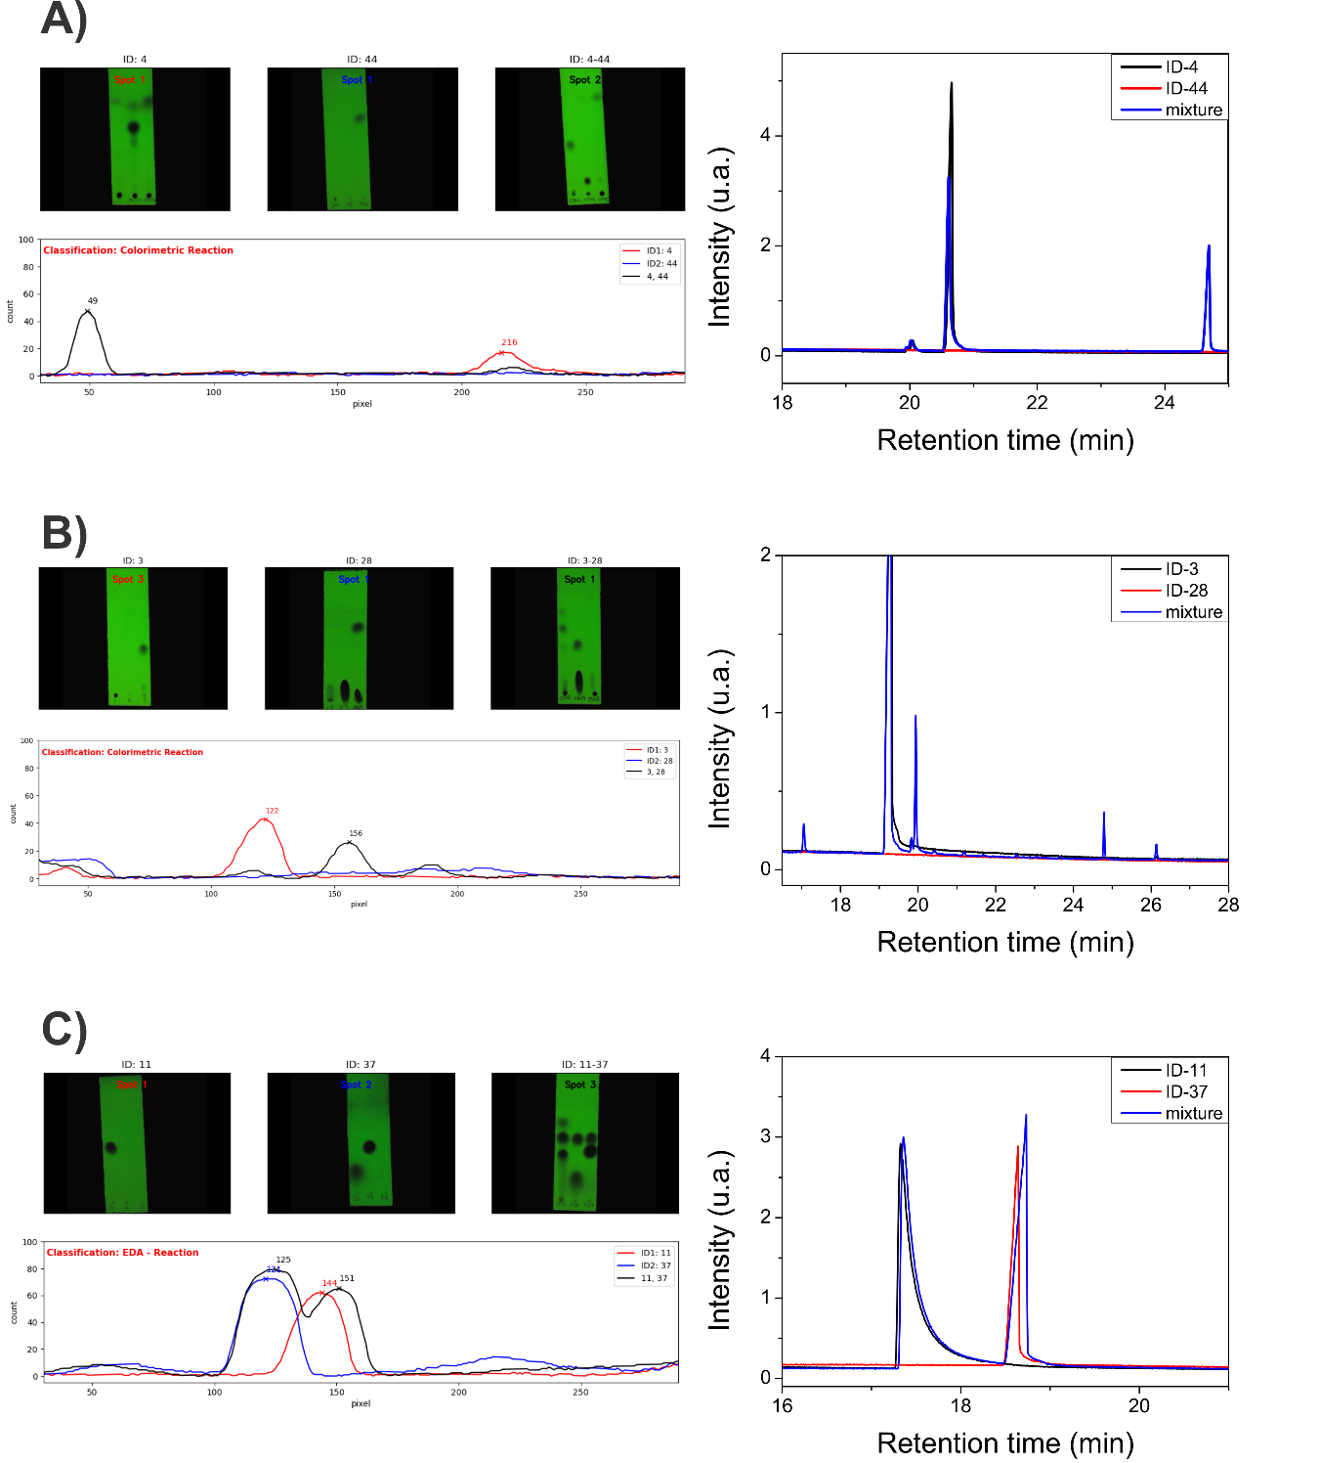
Figure S10: TLC Image, tlcgram and GC-MS cromatogram for the mixtures A) ID: 4-44 (colorimetric reaction), B) ID: 3-28 (colorimetric reaction), and C) ID: 11-37 (Hit-EDA)

Homemade 12-wells photoreactor

The blue LEDs (450 nm, 10 W) equipped with built-in drives were attached to the 12 wells (2.6 cm diameter each) of the Teflon® plate (23x15x1.5 cm in length, width, and thickness, respectively) using impermeable silicone glue. The wells were covered with thin borosilicate glass and the LEDs were connected to the power cable (220 V). The electrical connections and LEDs' bottom faces were covered with a thermal paste, which was lined with an aluminum plate (19x15x0.3 cm in length, width, and thickness, respectively) (Figure S11, A).
A 12-well aluminum block (19x15x6 cm in length, width, and height, respectively) was used as reactor support. All wells have a short aluminum edge at the bottom to accommodate the glass vials (Figure S11, B). Each well was connected to a vacuum line, which was coupled to a portable pump, to avoid water condensation on the thin glass which protects the LEDs (Figure S11, C). The 12-well aluminum block was placed above the Teflon® plate. Above the 12-well aluminum block and below the Teflon® plate were placed aluminum heat sinks. A refrigerant liquid (10 °C) was pumped by internal channels of each heat sink to temperature control the reaction content at 25 °C during irradiation (Figure S11, D).
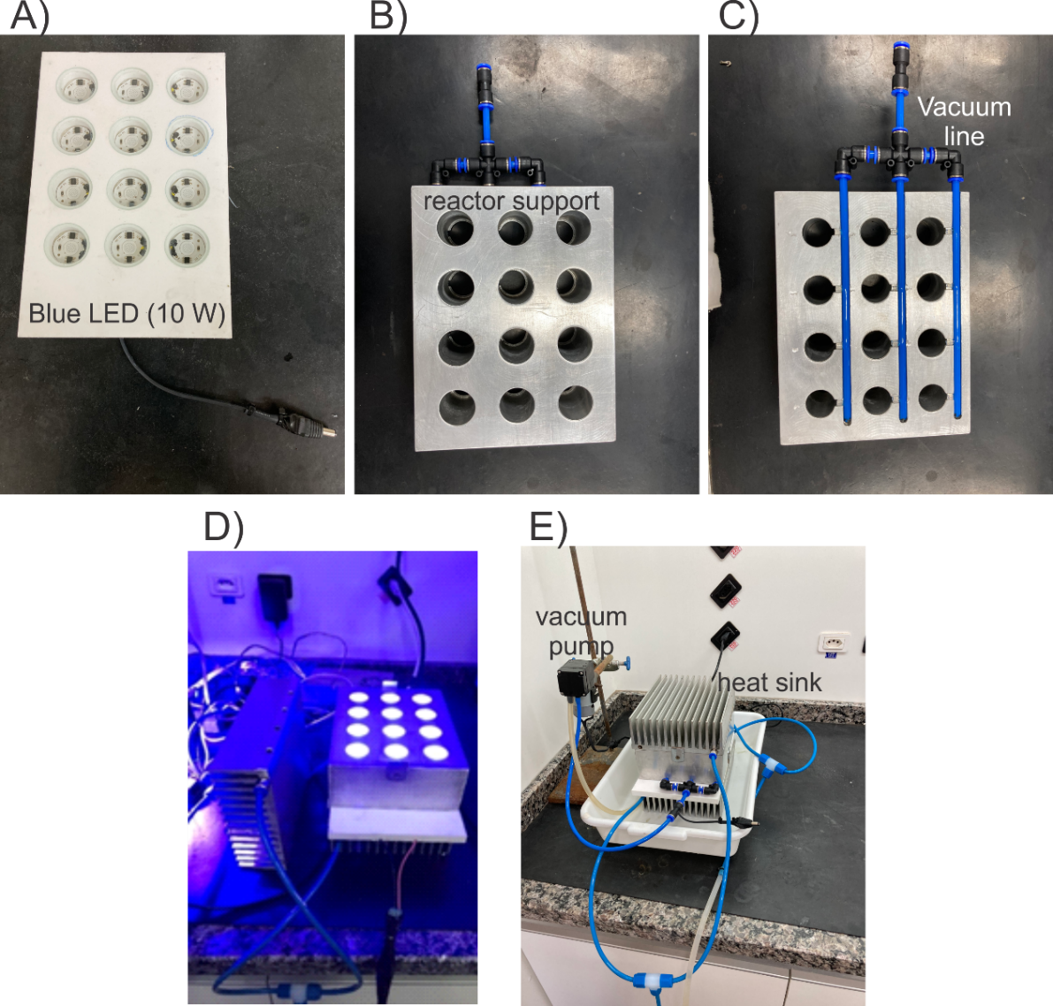
Figure S11: Homemade 12-wells photoreactor. A) Teflon® plate containing the blue LED (10 W). B) 12-well aluminum block for reactor support. C) Vacuum line interconnected to wells of the aluminum block. D) Homemade 12-wells photoreactor showing the irradiation E) Photoreactor assembled.

Computational Methods

An intelligent modular algorithm was designed to identify autonomously EDA-mediated reactions. The software was implemented as a Python 3 code using the PyCharm IDE, and built on the program packages OpenCV (for digital image processing). Some other python common libraries must be installed for the correct code operation, such as Pandas, NumPy, and Matplotlib.
The main (root) module is responsible for the management, visualization, and data analyses. The other 3 modules, which are accessible from the main module, are (1) the microplate digital image processing with the automatic classification of the mixtures as colored or colorless, (2) TLC image-based tlcgram plotting with image registration in a database, and (3) mixtures automatic/manual classification in colorimetric reaction, EDA-hit or EDA-mediated reaction (EDA-reaction).

Operation manual of the code

The root module (Main.py) shows 9 options that the user can access, such as new compound registration, print of the registered compounds, make the binary combination, print the binary combinations, microplate image registration, TLC image registration, mixture classification, print a heatmap and the data statistics (Figure S12).

Figure S12: Main menu.

Option 1: New compound registration
This option makes the register of new compounds to the study. The code asks the user to confirm the registration of subsequent ID to the last registered compound. Then the user must enter the commercial name and SMILE representation of the compounds (Figure S13). The SMILE representation is useful for chemical data extraction of the compounds used in this study.
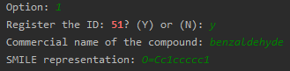
Figure S13: Data entry for the registration of new compounds.

Option 2: Show registered compounds
After the registration of the compounds that will be used in the study, the user can check all registered compounds by option 2 (Show registered compounds), which prints a table with all registered compounds (Figure S14).
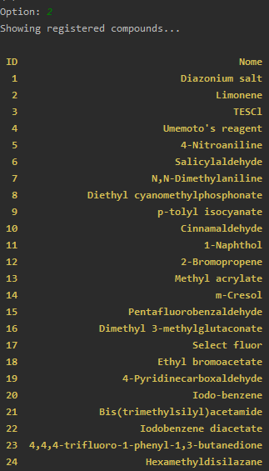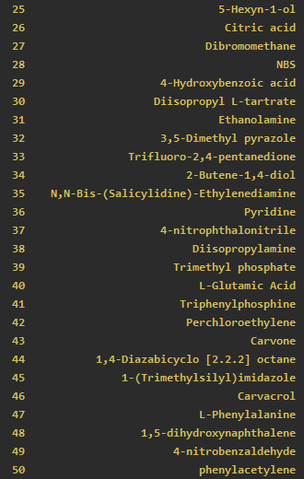
Figure S14: List of the compounds used in the study.

Option 3: Make the binary combination
This study has focused on the discovery of EDA-mediated reactions between electron-donor and -acceptor species. Because of this, the study was performed only for binary mixtures. The creation of the database with all the possible combinations between the species is carried out by option 3 (Make the binary combination). Before performing alterations on the original database, the code asks the user if he really would like to save the data (Figure S15A). The code runs the binary combination only for newly registered compounds. In the negative cases, the code prints a message for the user with this information (Figure S15B).

 | 
(A) | (B)
Figure S15: A) Screen of confirmation for saving data after the binary combination. B) Warning message to the user.

Option 4: Show the binary combination
The user can visualize the combinations by option 4 (Show the binary combination), which prints a table with all binary combinations and the total amounts of combinations (Figure S16).
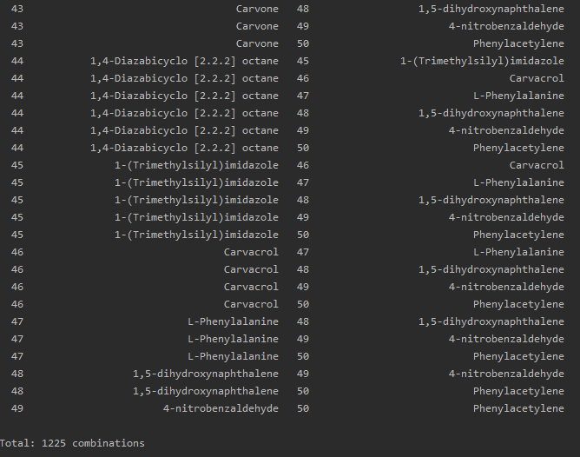
Figure S16: List of the binary combinations.
Option 5: Microplate image registration
After the image acquisition in the microplate photo box, the data and images are processed and registered by option 5 (Microplate image registration). The user must inform the amounts of compounds that will be processed, the name of the microplate image saved on the “Micro” directory (insert with the extension jpg, png, tiff, etc), and the ID-identification of the compounds (Figure S17). The code opens the microplate image with its size redimensioned for better visualization of the image on the computer screen. The resizing percentage can be tuned directly in the code (Micro_eng.py, line 68).

Figure S17: Screen for the microplate image processing.

The code automatically recognizes all the microplate wells and highlights them by a pink circle after pressing any key (Figure S18).
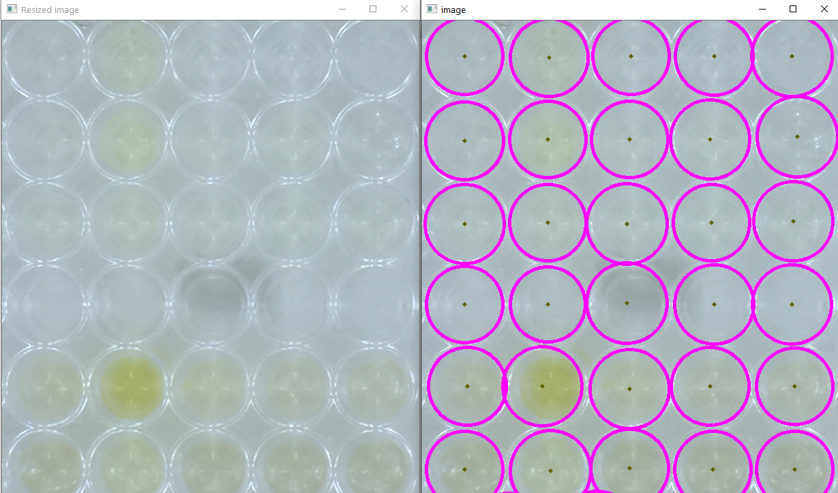
Figure S18: Microplate image and automatic recognition of the microplate wells.

The identification of the wells with the respective compounds is carried out by clicking on the circle corresponding to which the compound is present. The identification must follow the order that the compounds were arranged. That is, starting with the compound of sample 1, proceeding to sample 2, until the last sample (Figure S17, Figure S19).
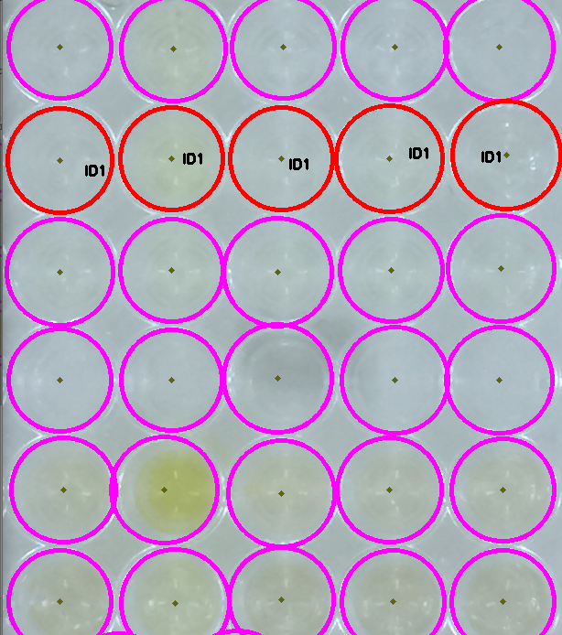 | 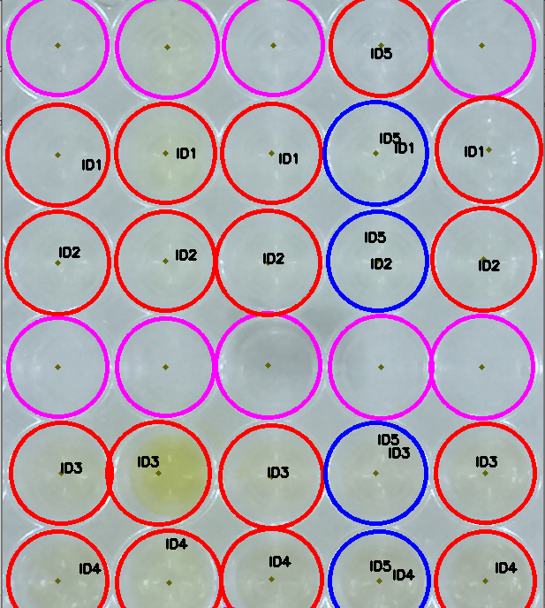
(A) | (B)
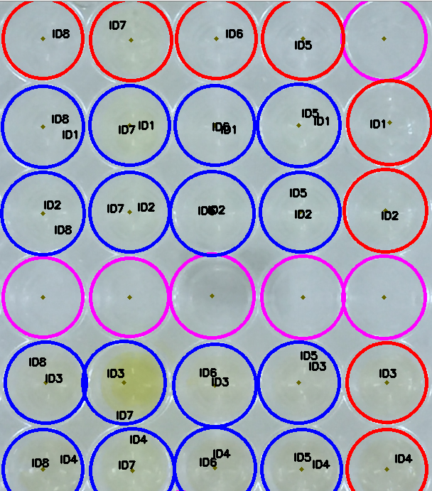 | 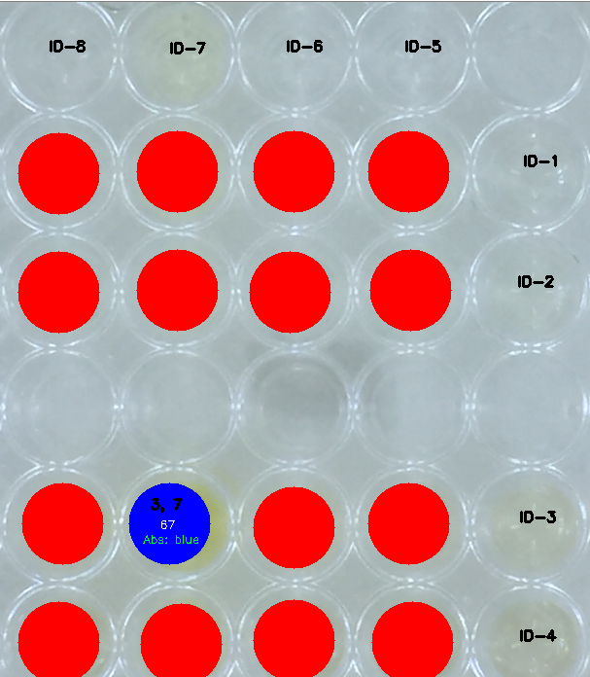
(C) | (D)
Figure S19: Wells identification with the respective compounds. A) Start of the filling. B) Middle of the filling. C) Completed identification. The blue and red circles highlight the wells with mixtures and reference compounds, respectively. D) Processed image. Red circles are the colorless mixtures and the blue circle is the colored mixture. In the colored mixture are highlighted the ID of the compounds, the sum grayscale value of each channel, and the electromagnetic spectrum region that the mixture absorbs.
Then, the code asks the user if he desires to save the processed image and the data in the database (Figure S20). The image is saved in the “\Micro\Placa_Image” directory and the data in the file “pxeda.csv”.
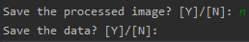
Figure S20: Screen to save the data and processed image of the microplate in the database.

Option 6: TLC image registration
The colored mixtures were selected for TLC-mediated screening. This screening was performed in two moments: before and after irradiation. For the classification of the mixture, the registration of the TLC is required, which was carried out by option 6 (TLC image registration). First, the user must inform the number of spots on the plate, which must be symmetrically distributed, and the ID of each compound of each spot. In situations where the spot contains a reference compound, the ID of this compound must be the same for the first and second ID samples. Then, the user must inform if the TLC refers to before or after irradiation of the mixture and the file name with extension. The image must be saved on the “TLC” directory (Figure S21).

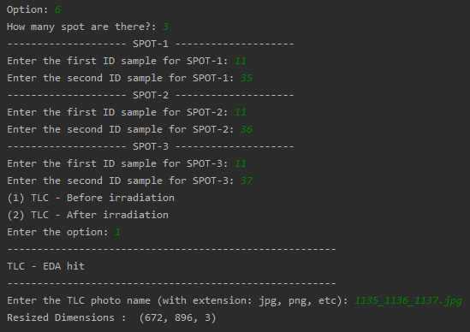
Figure S21: Information required for the register of a TLC.

The code opens the TLC image for the conference of the user (Figure S22-A). After pressing any key, the code recognizes the TLC borders by a red rectangle (Figure S22-B) and, subsequently, subdivides the TLC by the spot number (orange line) (Figure S22-C). The code slices each subdivision of the plate into 300 micro-rectangles, whose centroids are highlighted by blue dots (Figure S22-C), and measures the average grayscale value of each micro-rectangle. The plotting of micro-rectangle numbers by the grayscale values provides what we call the tlcgram (Figure S22-D).
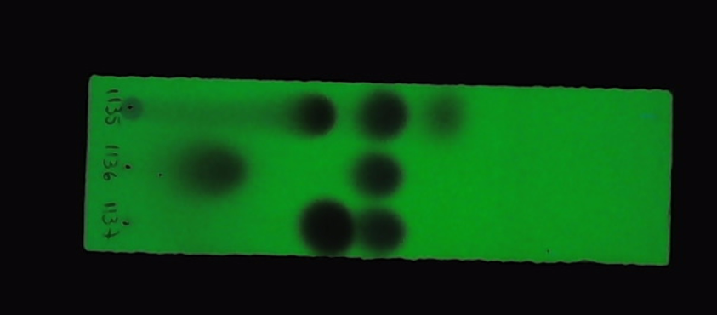 | 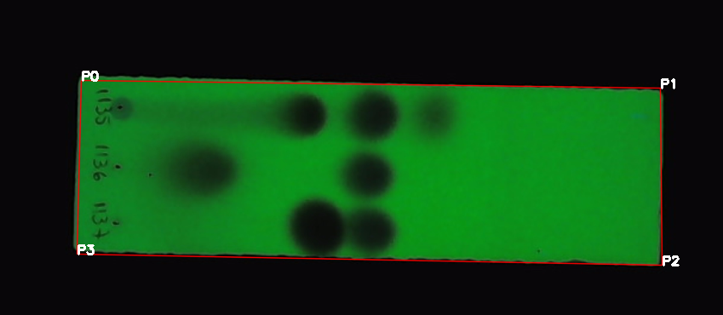 | 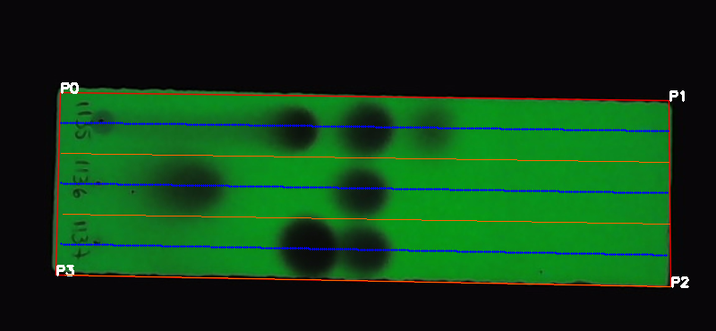
(A) | (B) | (C)
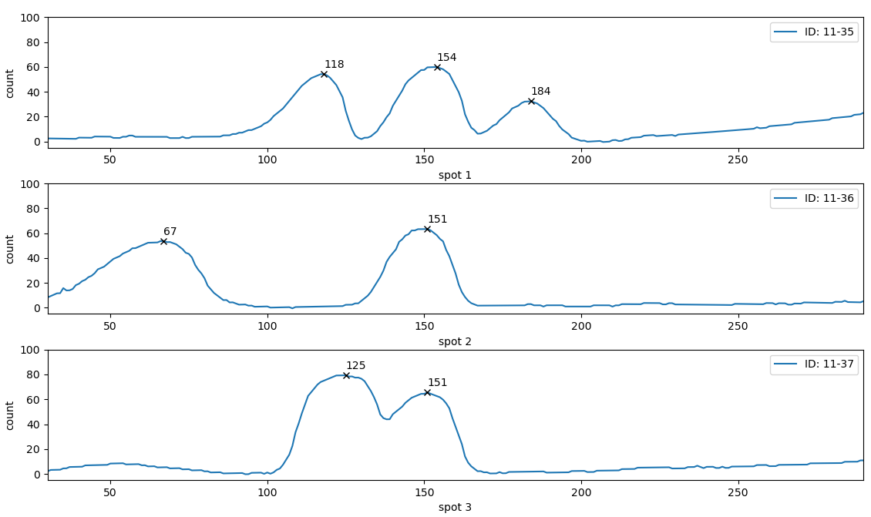
(D)
Figure S22: A) TLC image. B) Subdivision of the TLC by the spot number. C) TLC Slicing by 300 micro-rectangles, whose centroids are highlighted in blue dots. D) Tlcgram built for each TLC spot.
Then, the code asks the user if he desires to save the processed image and the data. The image is saved in the “\TLC\TLC_Image” directory and the data in the file “tlcgram.csv”.

Option 7: Mixture classification
After TLC registration, the mixtures are classified following the criteria below (Table S1). Colorless mixtures are classified by option 5 (Microplate image registration). The colored mixtures that show some reactivity by TLC screening before irradiation are classified as a colorimetric reaction. The colored mixtures that do not show any reactivity before and after irradiation are classified as an EDA-hit, and finally, the colored mixtures that do not show any reactivity before irradiation, but present reactivity after irradiation are classified as EDA-mediated reactions (EDA-reaction). The classification of the colored mixtures is carried out by option 7 (Mixture classification).

Table S1: Criteria for mixture classification
Grayscale value | TLC – before irradiation | TLC – after irradiation | Classification
<20 | - | - | Colorless Mixtureª
≥20 | Reactive | - | Colorimetric reaction
≥20 | Non-reactive | Non-reactive | EDA-hit
≥20 | Non-reactive | Reactive | EDA-reaction
ª Colorless mixtures are classified by option 5 (Microplate image registration).

Initially, the user must select the moment to which TLC analysis refers: before or after irradiation, and the classification type: automatic or manual (Figure S23-A). Automatic classification is performed only for mixtures for which there is no classification registered in the database; in this case, the code identifies the mixture, analyzes the TLC correspondents, and autonomously classifies the mixture (Figure S23-B). In situations where there are no mixtures to be classified in the database, the code prints a message with this information (Figure S23-C).
The manual classification can be performed at any time, even to reclassify a mixture. In this case, the code prints all colored mixtures, and the user selects the desired mixture (Figure S23-D). Subsequently, the code prints the TLC image and tlcgram overlap graph of the references and mixture, respectively. In the tlcgram, the code shows how the mixture was classified by the automatic classification (Figure S24). Finally, the user can save the mixture with another classification or maintain the current one (Figure S25).
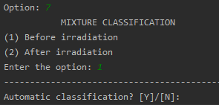
(A)
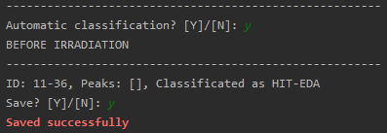 | 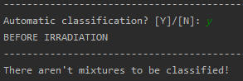
(B) | (C)
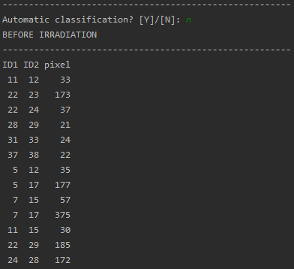
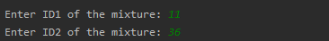
(D)
Figure S23: A) Selection of the moment that the TLC analysis refers: before or after irradiation and the classification type: automatic or manual. B) Identification and automatic classification of the mixture. C) Message indicating that there is no mixture to be classified in the database. D) Selection of mixture for manual classification.

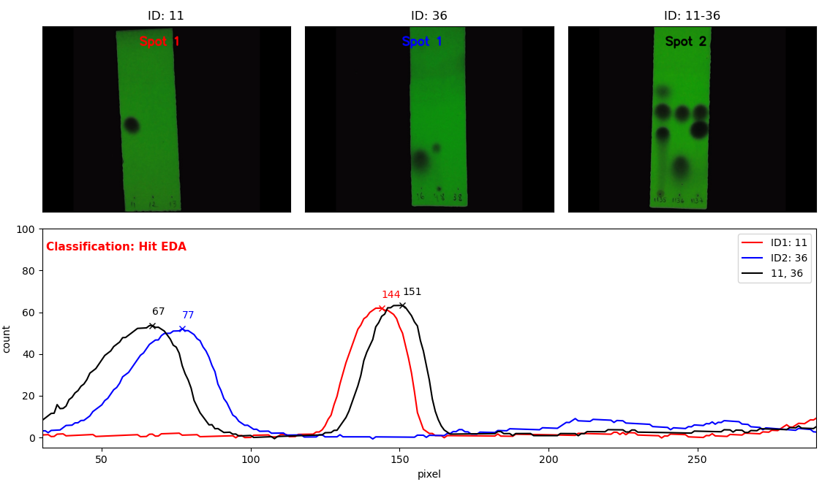
Figure S24: Screen for TLC and tlcgram analysis.

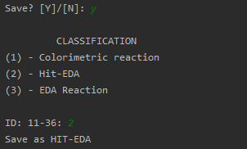
Figure S25: Screen for mixture manual classification.

Option 8: Heatmap and statistics
At any moment of study, the user can visualize a graph with the chemical space of the EDA reactions (Figure S26) discovered by the study after selecting option 8 (Heatmap and statistics). In addition, the code prints the total mixture of the study, the amount and percentage of each classification concerning total mixtures (Figure S27).
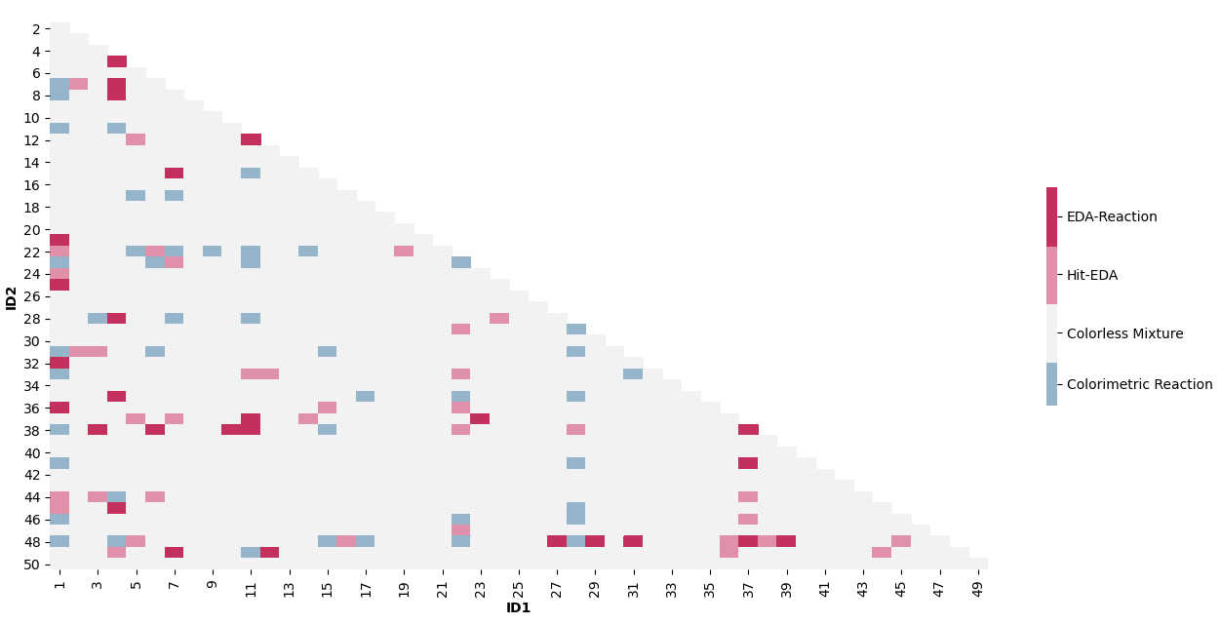
Figure S26: Chemical space for EDA reaction
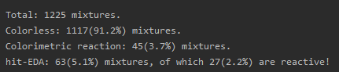
Figure S27: Screen with some statistical data about the study.

Option 9: Exit
The software is finished by option 9 (Exit) (Figure S26).
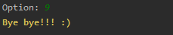
Figure S28: Exit of the software.

Discovery of the iminophosphorane synthesis

The mixture of 4-nitro-phthalonitrile (ID-37) and triphenylphosphine (ID-41) showed a grayscale value of 38 and a red-shift band in the UV-Vis spectrum. The TLC-mediated screening classified the mixture as an EDA-photoinduced reaction, with the complete consumption of triphenylphosphine after irradiation (Figure S29).
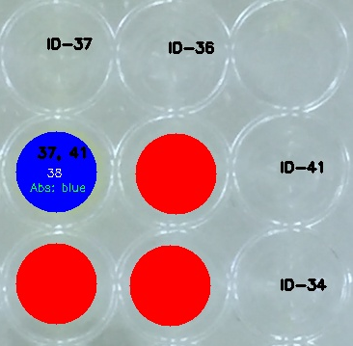
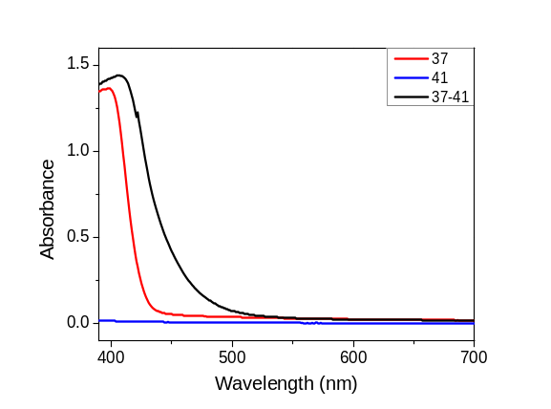
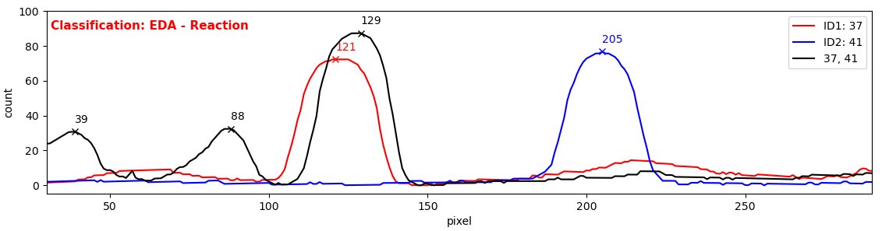
Figure S29: A) Processed microplate image of the mixture of 4-nitrophthalonitrile (ID-37) and triphenylphosphine (ID-41). B) UV-Vis spectra of 4-nitrophthalonitrile (ID-37, red line), triphenylphosphine (ID-41, blue line), and the respective mixture (37-41, black line). C) tlcgram of 4-nitrophthalonitrile (ID-37, red line), triphenylphosphine (ID-41, blue line), and the respective mixture (37-41, black line).

Reaction conditions screening

Initially, a solvent screening was performed for the mixture of 4-nitrophthalonitrile (0.2 mmol) and triphenylphosphine (0.8 mmol) in 2 mL of solvent at 25 ºC and irradiated for 12 hours with blue LED (450 nm, 10 W). The evaluated solvents were MeCN, CH₂Cl₂, CHCl₃, toluene, ethyl acetate, 1,4-dioxane, 1,2-dichloroethane, dimethyl carbonate, propyl carbonate, and DMSO. Halogenated solvents presented higher efficiency for this transformation, giving the corresponding product in 76, 50, and 42% yields for CH₂Cl₂, CHCl_{3,} and 1,2-dichloroethane, respectively (Table S2). The CH₂Cl₂ mixture did not show the darkness of the solution after irradiation and provided a higher yield (Figure S30). Because of this, CH₂Cl₂ was chosen for subsequent studies.
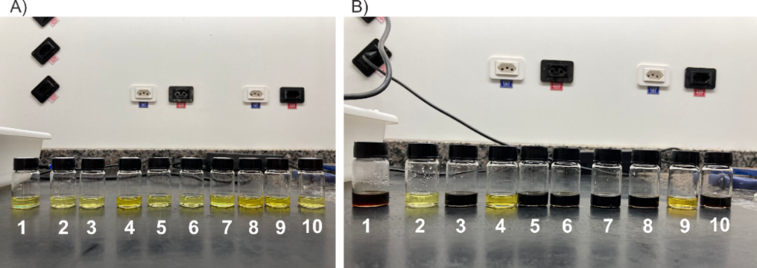
Figure S30: Mixture image using MeCN (1), CH₂Cl₂ (2), CHCl₃ (3), toluene (4), ethyl acetate (5), 1,4-dioxane (6), 1,2-dichloroethane (7), dimethyl carbonate (8), propyl carbonate (9), and DMSO (10) A) before, and B) after irradiation.

Table S2: Solvent screening for the reaction between 4-nitrophthalonitrile (ID-37) and triphenylphosphine (ID-41)
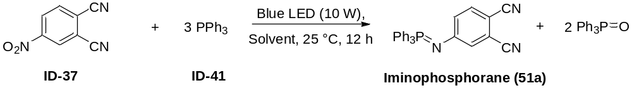
Entry | Solvent | Yield (%)ª
1 | MeCN | 21
2 | CH₂Cl₂ | 76
3 | CHCl₃ | 50
4 | Toluene | 16
5 | Ethyl acetate | 5
6 | 1,4-Dioxane | 15
7 | 1,2-dichloroethane | 42
8 | Dimethyl carbonate | 30
9 | Propyl carbonate | 0
10 | DMSO | 0
a) Determined by ¹H NMR using 1,3,5-trimethoxybenzene as internal standard. Reaction conditions: 4-nitrophthalonitrile (0.2 mmol) and triphenylphosphine (0.8 mmol) in 2 mL of solvent at 25 ºC, irradiated for 12 h with blue LED (10 W).

The chemometric technique Two-Level Factorial Design³ was employed to evaluate the principal and interaction effects of the i) number of equivalents of triphenylphosphine, ii) 4-nitrophthalonitrile concentration, and iii) irradiation time in the reaction between 4-nitrophthalonitrile and triphenylphosphine, whose results are shown below (Table S3).

Table S3: Factorial planning for the reaction between 4-nitrophthalonitrile and triphenylphosphine.
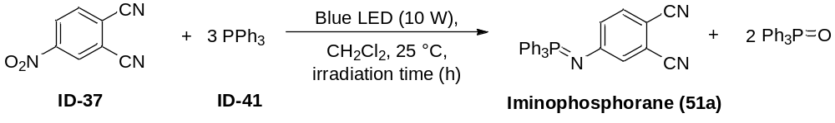
Entry | PPh₃ equivalent (1) |  | 4-nitrophthalonitrile concentration (2) |  | Irradiation time (3) |  | Yield (%)ª
Entry | Level | Real  (equiv.) | Level | Real  (mol L⁻¹) | Level | Real  (h) | Yield (%)ª
1 | 1 | 5 | 1 | 0,15 | 1 | 12 | 87
2 | -1 | 3 | 1 | 0,15 | 1 | 12 | 76
3 | 1 | 5 | -1 | 0,05 | 1 | 12 | 88
4 | -1 | 3 | -1 | 0,05 | 1 | 12 | 72
5 | 1 | 5 | 1 | 0,15 | -1 | 6 | 46
6 | -1 | 3 | 1 | 0,15 | -1 | 6 | 52
7 | 1 | 5 | -1 | 0,05 | -1 | 6 | 81
8 | -1 | 3 | -1 | 0,05 | -1 | 6 | 68
9 | 0 | 4 | 0 | 0,10 | 0 | 9 | 74
10 | 0 | 4 | 0 | 0,10 | 0 | 9 | 74
11 | 0 | 4 | 0 | 0,10 | 0 | 9 | 75
ª Determined by ¹H NMR using 1,3,5-trimethoxybenzene as internal standard. Reaction conditions: 4-nitrophthalonitrile and triphenylphosphine in 2 mL of CH₂Cl₂ at 25 ºC, irradiated with blue LED (10 W).

All effects, which were determined using the free software Octave and the calculation routine developed by Pereira and Pereira-Filho⁴, were significant statistically (95% confidence) (Figure S31A). The plotting effect (Figure S31B) showed that the optimal reaction conditions must use an excess of triphenylphosphine (positive effect), high irradiation time (positive effect) in a diluted solution of 4-nitrophthalonitrile (negative effect). The reaction yield is affected mainly by the variation of irradiation time and concentration of 4-nitrophthalonitrile due to the high weight of this variable, 43% and 17%, respectively. Thus, the experimental conditions chosen for this transformation were 4 equivalents of triphenylphosphine with 4-nitrophthalonitrile (0.5 mmol) in CH₂Cl₂ (5 mL, 0.10 M) irradiated with blue LED (120 W) for 24 h at room temperature, and which afforded the iminophosphorane (51a) in 82% yield.
However, the adoption of these experimental conditions for other nitroaromatic compounds provoked the darkness of the reaction mixture, probably due to the formation of azo compounds. Lowering the temperature to -20 °C avoided this problem, and the other iminophosphoranes were obtained by this protocol.
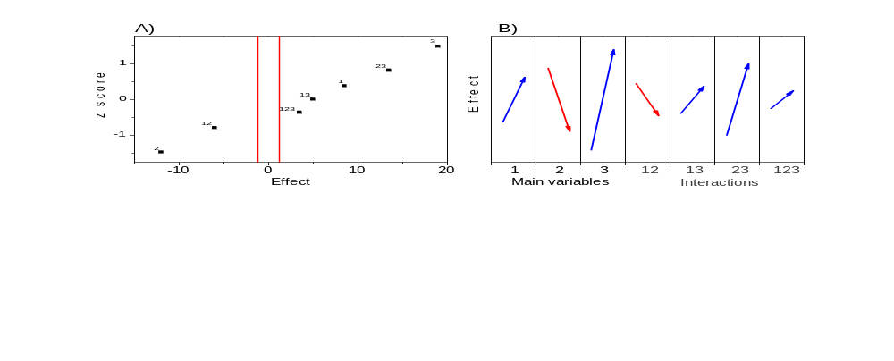
Figure S31: Probability plotting for the reaction between 4-nitrophthalonitrile and triphenylphosphine. A) Plotting effects of the principal variables and their interactions. The blue region highlights the significant statistical effects (95% confidence). B) Plotting effects. Red and blue arrows are the negative and positive effects, respectively. The size of the arrows represents the weight of the interaction on the reaction yield.

Control reactions

The mechanistic studies for this transformation are ongoing in our laboratory. Some control reactions suggest a photo-induced transformation with the formation of radical intermediates (Figure S32).
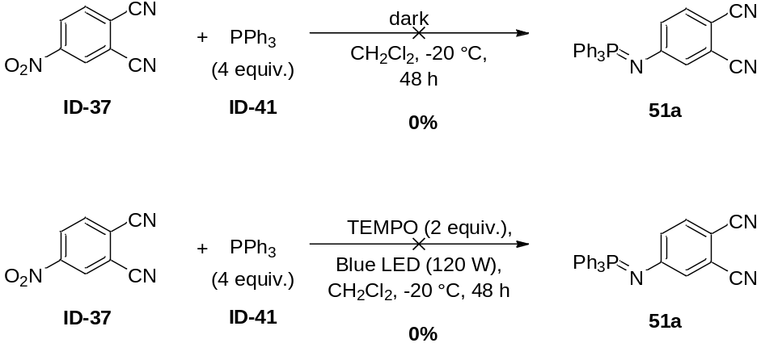
Figure S32: Control reactions for the formation of the iminophosphorane (51a).

General procedure for iminophosphoranes synthesis

To a Schlenk tube (10 mL) containing dichloromethane (5 mL), nitroarene (0.5 mmol) and triphenylphosphine (2 mmol, 4 equiv) were added. The tube was closed with a cold finger, which was attached to a cryostat (Huber Minichiller model). The solvent was degassed via freeze-pump-thaw for three cycles. The reaction mixture was stirred and irradiated using a homemade batch photoreactor (blue LED, 120 W) at -20 °C for 48 h. The solvent was removed under reduced pressure and the crude product was purified by column chromatography on silica gel.

Experimental Data

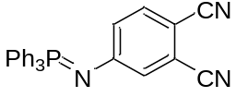
4-((triphenylphosphoranylidene)amino)phthalonitrile (51a). The title compound (new compound) was obtained following the general procedure. It was obtained in 82% yield (165.2 mg; 0.41 mmol) as a white solid after purification over silica gel column chromatography using a mixture of hexane/dichloromethane/EtOAc (5/3/2) as eluent. mp: 194–195 °C, ¹H NMR (400 MHz, CDCl₃): δ 7.70 (dd, ³J_{PH} = 12.0, ³J_{HH} = 7.9 Hz, 6H), 7.65 – 7.58 (m, 3H), 7.52 (dt, ³J_{HH} = 7.7, ⁴J_{PH} = 3.0 Hz, 6H), 7.29 (d, J = 8.6 Hz, 1H), 6.99 (d, J = 2.0 Hz, 1H), 6.84 (dd, J = 8.6, 2.0 Hz, 1H). ¹³C{¹H} NMR (100 MHz, CDCl₃): δ 157.2, 134.0, 132.7 (J_{CP} = 2.1 Hz), 132.4 (J_{CP} = 10.5 Hz), 129.2 (J_{CP} = 12.1 Hz), 128.5 (J_{CP} = 100.7 Hz), 127.6 (J_{CP} = 20.7 Hz), 126.7 (J_{CP} = 19.0 Hz), 117.5, 116.6, 116.1, 100.8. ³¹P NMR (160 MHz, CDCl₃) = 8.3. HRMS (m/z): [M+H] calcd for C₂₆H₁₉N₃P, 404.1317; found, 404.1312.
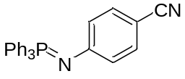
4-((triphenylphosphoranylidene)amino)benzonitrile (51b): The title compound (known compound) was obtained following the general procedure. It was obtained in 90% yield (170.6 mg; 0.45 mmol) as a yellow solid after purification over silica gel column chromatography using a mixture of hexane/dichloromethane/EtOAc (6/2/2) as eluent. mp: 193–194 °C (lit.⁵ 192–193 °C); ¹H NMR (400 MHz, CDCl₃): δ 7.72 (dd, ³J_{PH} = 12.3, ³J_{HH} = 8.0 Hz, 6H), 7.60 – 7.52 (m, 3H), 7.48 (dt, ³J_{HH} = 7.4, ⁴J_{PH} = 2.6 Hz, 6H), 7.25 (d, J = 8.4 Hz, 2H), 6.73 (d, J = 8.4 Hz, 2H); ¹³C{¹H} NMR (100 MHz, CDCl₃): δ 156.2, 133.0, 132.5 (J_{CP} = 9.6 Hz), 132.3 (d, J_{CP} = 2.1 Hz), 129.6 (d, J_{CP} = 99.6 Hz), 128.9 (d, J_{CP} = 12.2 Hz), 123.4 (d, J_{CP} = 18.9 Hz), 121.1, 98.5; ³¹P NMR (160 MHz, CDCl₃) = 6.3.
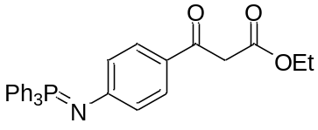
ethyl 3-oxo-3-(4-((triphenylphosphoranylidene)amino)phenyl)propanoate (51c): The title compound (new compound) was obtained following the general procedure. It was obtained in 33% yield (76.2 mg; 0.16 mmol) as a yellow oil after purification over silica gel column chromatography using a mixture of hexane/toluene/EtOAc (5/2/3) as eluent. ¹H NMR (400 MHz, CDCl₃): δ 7.73 (dd, ³J_{PH} = 12.1, ³J_{HH} = 8.1 Hz, 6H), 7.64 (d, J = 8.4 Hz, 2H), 7.60 – 7.53 (m, 3H), 7.52 – 7.44 (m, 6H), 6.75 (d, J = 8.4 Hz, 2H), 4.18 (q, J = 7.1 Hz, 2H), 3.85 (s, 2H), 1.23 (t, J = 7.1 Hz, 3H). ¹³C{¹H} NMR (100 MHz, CDCl₃): δ 190.5, 168.5, 158.5, 132.6 (d, J_{CP} = 9.6 Hz), 132.2 (d, J_{CP} = 2.1 Hz), 130.3, 129.7 (d, J_{CP} = 99.2 Hz), 128.9 (d, J_{CP} = 12.1 Hz), 125.4, 122.8 (d, J_{CP} = 19.0 Hz), 61.2, 45.5, 14.1. ³¹P NMR (160 MHz, CDCl₃) = 6.5. HRMS (m/z): [M+H] calcd for C₂₉H₂₇NO₃P, 468.1728; found, 168.1733.
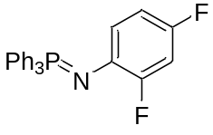
2,4-difluoro-N-(triphenylphosphoranylidene)aniline (51d): The title compound (new compound) was obtained following the general procedure. However, triphenylphosphine was used at 8 equivalents. It was obtained in 72% yield (140.2 mg; 0.36 mmol) as a yellow solid after purification over silica gel column chromatography using a mixture of hexane/dichloromethane/EtOAc (6/2/2) as eluent. mp: 110–111 °C; ¹H NMR (400 MHz, CDCl₃): δ 7.73 (dd, ³J_{PH} = 12.1, ³J_{HH} = 8.0 Hz, 6H), 7.57 – 7.49 (m, 3H), 7.44 (dt, ³J_{HH} = 7.6, ⁴J_{PH} = 2.5 Hz, 6H), 6.72 – 6.61 (m, 2H), 6.49 (t, J_{FH} = 8.0, J_{HH} = 1.9 Hz, 1H). ¹³C{¹H} NMR (100 MHz, CDCl₃): δ 155.2 (dt, ¹J_{CF} = 243.6, ³J_{CF} = ³J_{CP} = 12.9 Hz), 153.8 (dd, ¹J_{CF} = 237.4, ³J_{CF} = 10.9 Hz), 133.7 (d, ²J_{CF} = 13.2 Hz), 131.4 (d, ³J_{CP} = 9.8 Hz), 130.6 (d, ⁴J_{CP} = 2.1 Hz), 130.2 (d, ¹J_{CP} = 100.5 Hz), 127.5 (d, J_{CP} = 12.1 Hz), 123.8 (ddd, ³J_{CF} = 13.6, ³J_{CF} = 8.2, ³J_{CP} = 4.2 Hz), 109.0 (dd, ²J_{CF} = 21.1, ⁴J_{CF} = 3.3 Hz), 102.5 (t, ²J_{CF} = 25.6 Hz). ¹⁹F NMR (376.5 MHz, CDCl₃) = -120.7, -125.0. ³¹P NMR (160 MHz, CDCl₃) = 5.5. HRMS (m/z): [M+H] calcd for C₂₄H₁₉F₂NP, 390.1223; found, 390.1225.
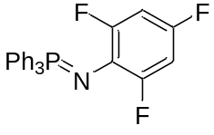
2,4,6-trifluoro-N-(triphenylphosphoranylidene)aniline (51e): The title compound (new compound) was obtained following the general procedure. However, triphenylphosphine was used at 8 equivalents. It was obtained in 88% yield (180.0 mg; 0.44 mmol) as a yellow solid after purification over silica gel column chromatography using a mixture of hexane/EtOAc (9/1) as eluent. mp: 98–99 °C; ¹H NMR (400 MHz, CDCl₃): δ 7.72 (dd, ³J_{PH} = 12.2, ³J_{HH} = 8.1 Hz, 6H), 7.56 – 7.48 (m, 3H), 7.43 (dt, ³J_{HH} = 8.0, ⁴J_{PH} = 2.6 Hz, 6H), 6.48 (t, J_{FH} = 8.2 Hz, 2H). ¹³C{¹H} NMR (100 MHz, CDCl₃): δ 158.9 – 156.0 (m), 153.4 (dt, ¹J_{CF} = 237.5, ³J_{CF} = 14.0 Hz), 132.5 (d, ³J_{CP} = 9.8 Hz), 131.7 (d, ⁴J_{CP} = 2.1 Hz), 131.6 (d, ¹J_{CP} = 102.3 Hz), 128.4 (d, J_{CP} = 12.2 Hz), 124.0 (m), 99.4 (m). ¹⁹F NMR (376.5 MHz, CDCl₃) = -119.4, -124.3. ³¹P NMR (160 MHz, CDCl₃) = 7.5. HRMS (m/z): [M+H] calcd for C₂₄H₁₈F₃NP, 408.1129; found, 408.1131.

References

1. Bartolomeu, A. D. A., Silva, R. C., Brocksom, T. J., Noël, T. & de Oliveira, K. T. Photoarylation of Pyridines Using Aryldiazonium Salts and Visible Light: An EDA Approach. J. Org. Chem. 84, 10459–10471 (2019).
2. Batista, G. M. F., de Castro, P. P., Dos Santos, H. F., de Oliveira, K. T. & Amarante, G. W. Electron-Donor–Acceptor Complex-Enabled Flow Methodology for the Hydrotrifluoromethylation of Unsaturated β-Keto Esters. Org. Lett. 22, 8598–8602 (2020).
3. Silva, J. B. P. da. Application of factorial design for the ab initio study of cis- and trans-1,2 dihaloethylene stabilities. J. Braz. Chem. Soc. 11, 219–223 (2000).
4. Pereira, F. & Pereira-Filho, E. APLICAÇÃO DE PROGRAMA COMPUTACIONAL LIVRE EM PLANEJAMENTO DE EXPERIMENTOS: UM TUTORIAL. Quim. Nova 2018, 1061–1071 (2018).
5. Briggs, E. M., Brown, G. W., Jiricny, J. & Meidine, M. F. Synthetic Uses of Iminophosphoranes. Monoalkylation of Primary Aromatic Amines. Synthesis (Stuttg). 1980, 295–296 (1980).

HRMS Data

Iminophosphorane (51a)
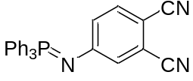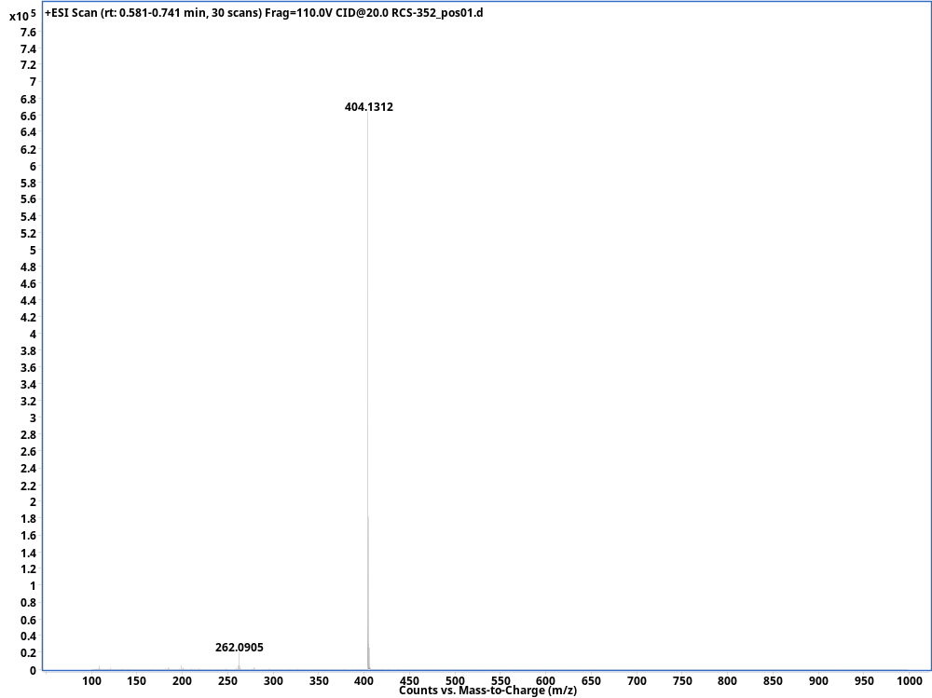

Iminophosphorane (51c)
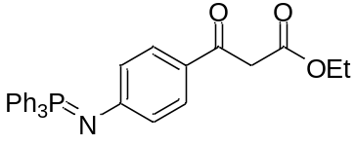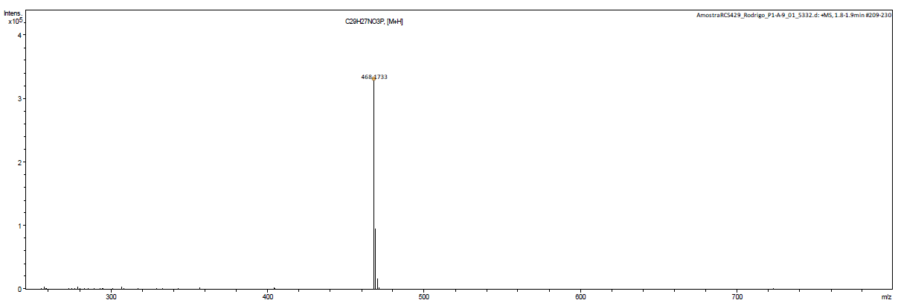

Iminophosphorane (51d)
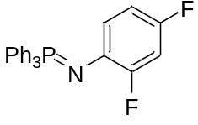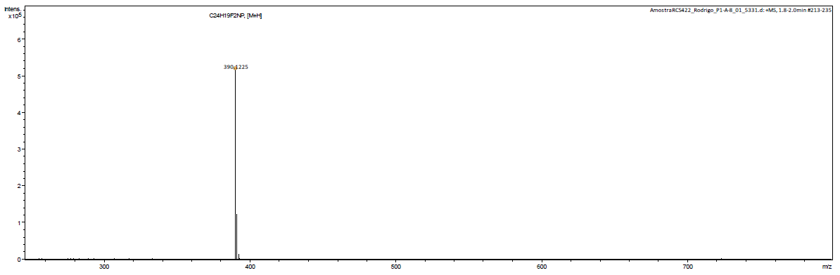

Iminophosphorane (51e)
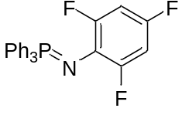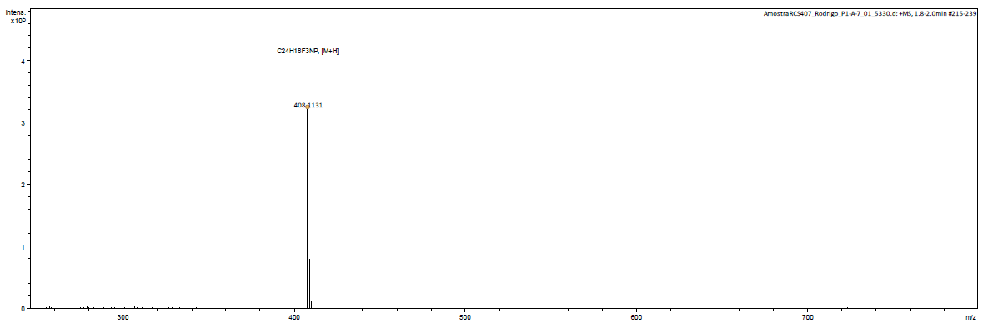

NMR Data

NMR ¹H – Iminophosphorane (51a)
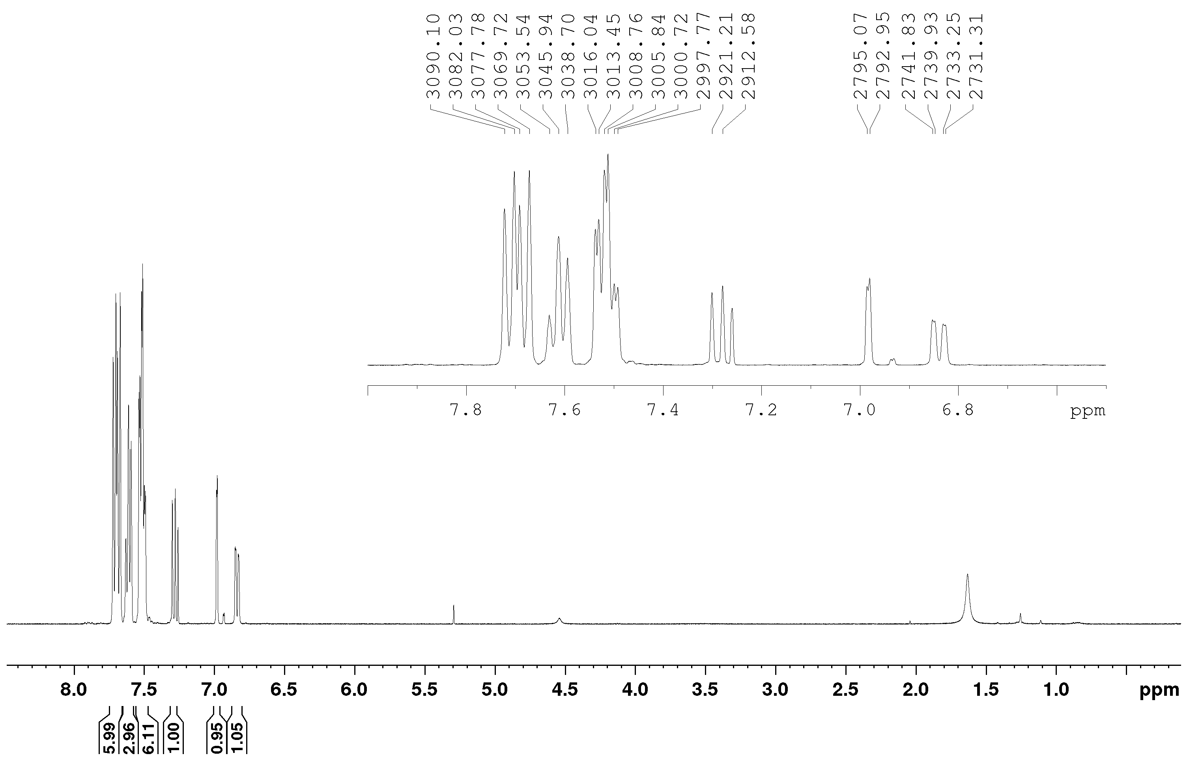
NMR ¹³C – Iminophosphorane (51a)
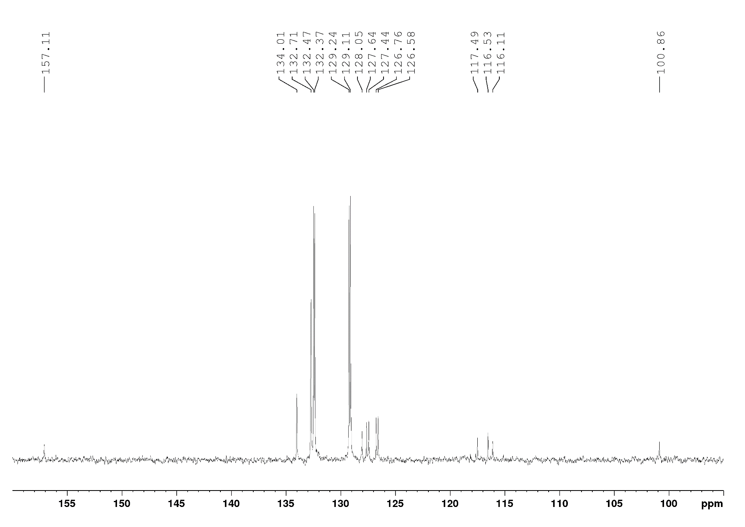
NMR ³¹P – Iminophosphorane (51a)
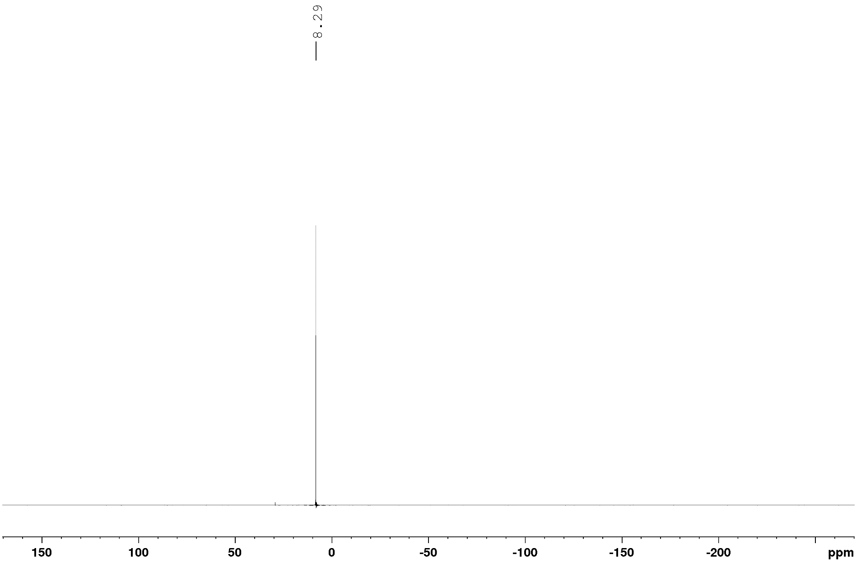
NMR ¹H – (51b)
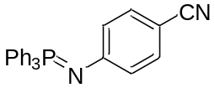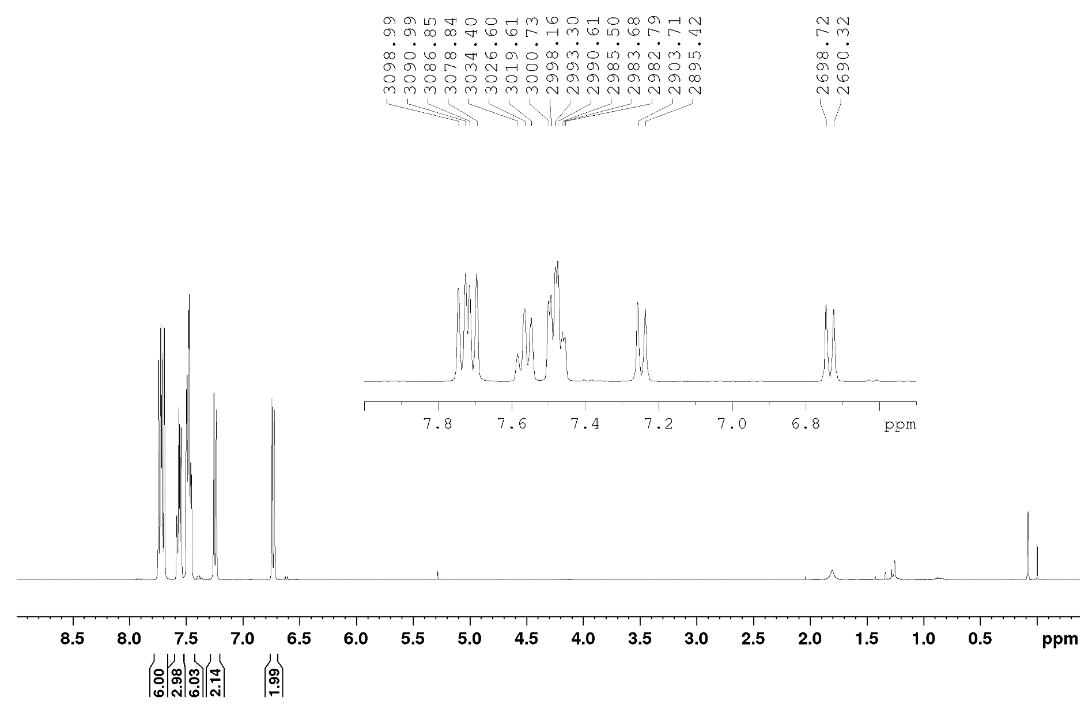
NMR ¹³C – (51b)
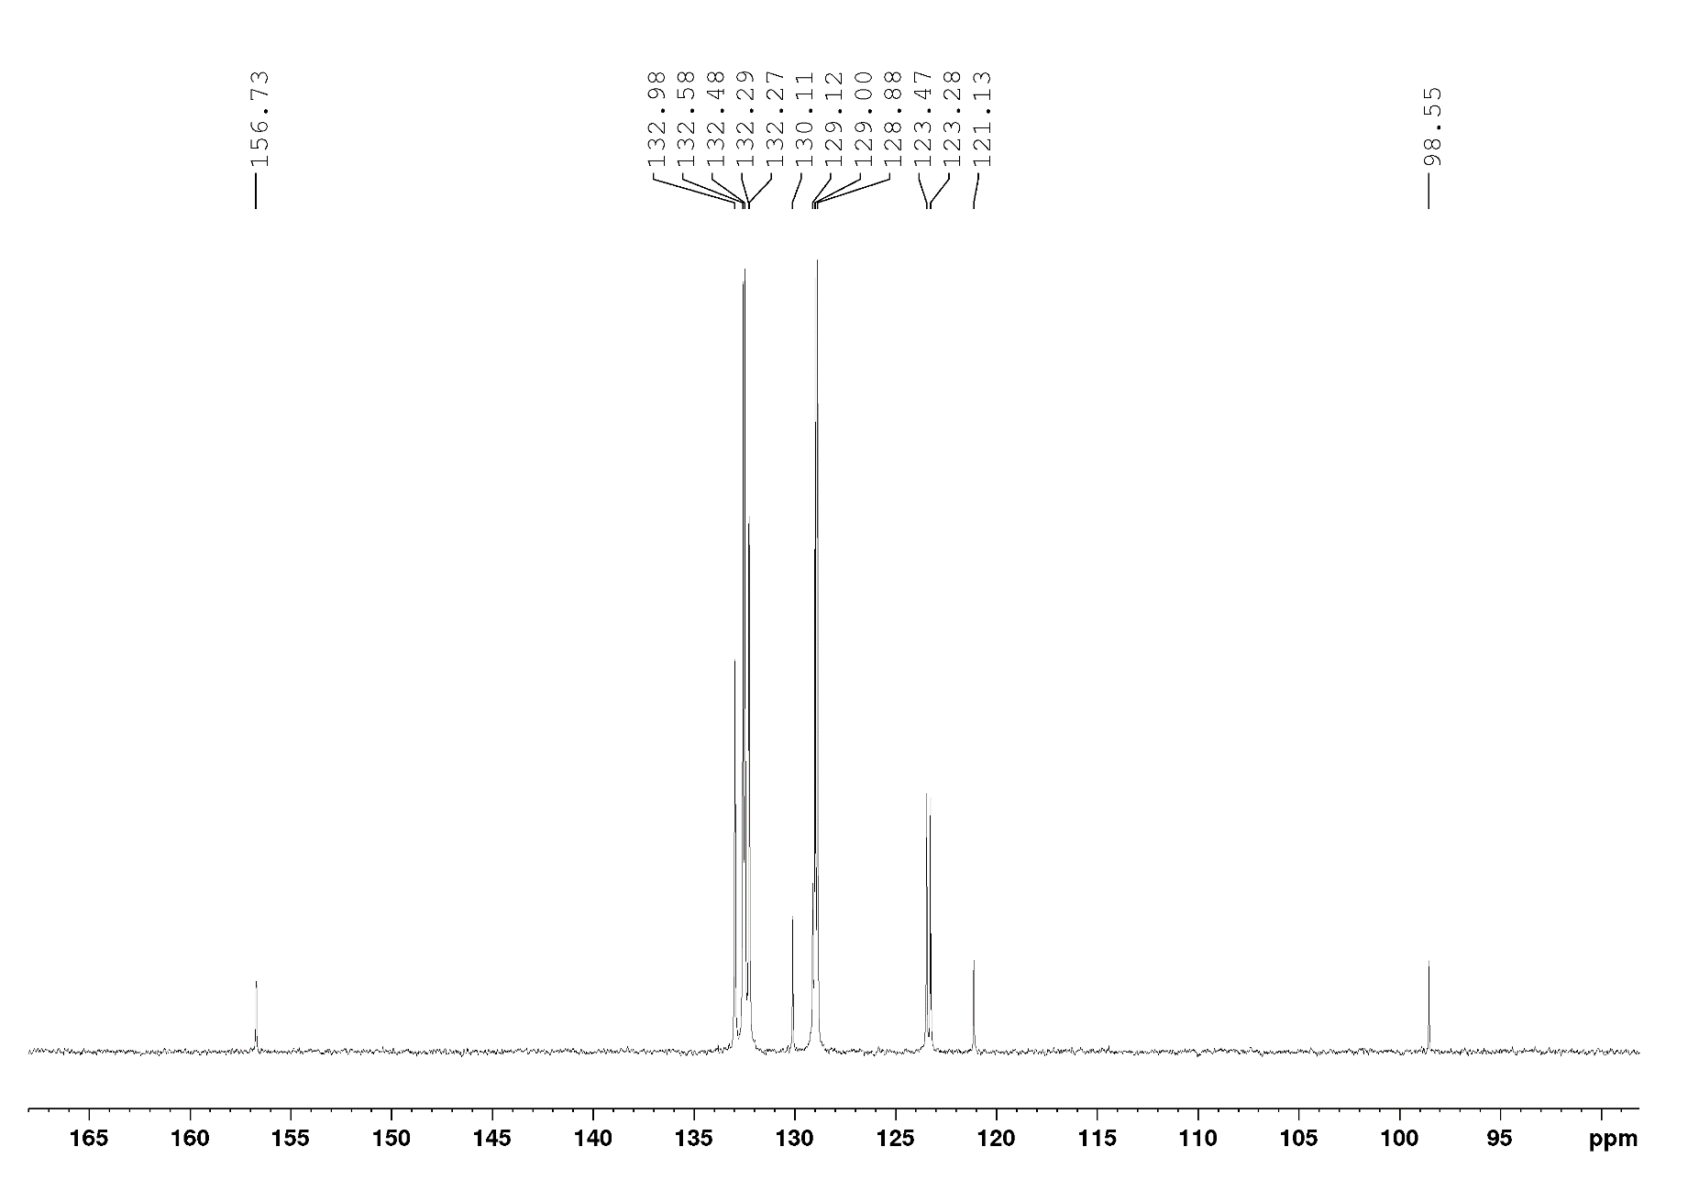
NMR ³¹P – (51b)
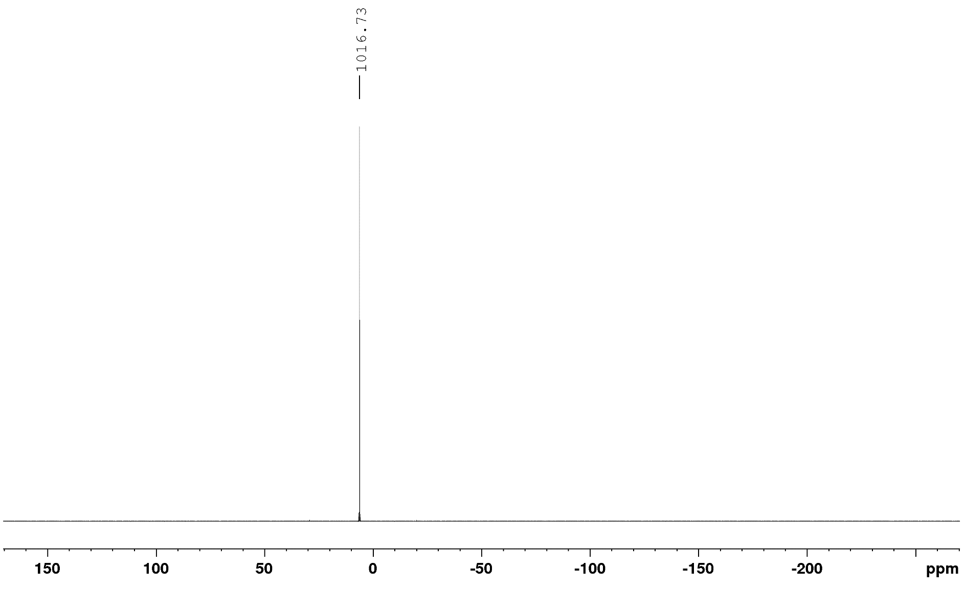

NMR ¹H – (51c)
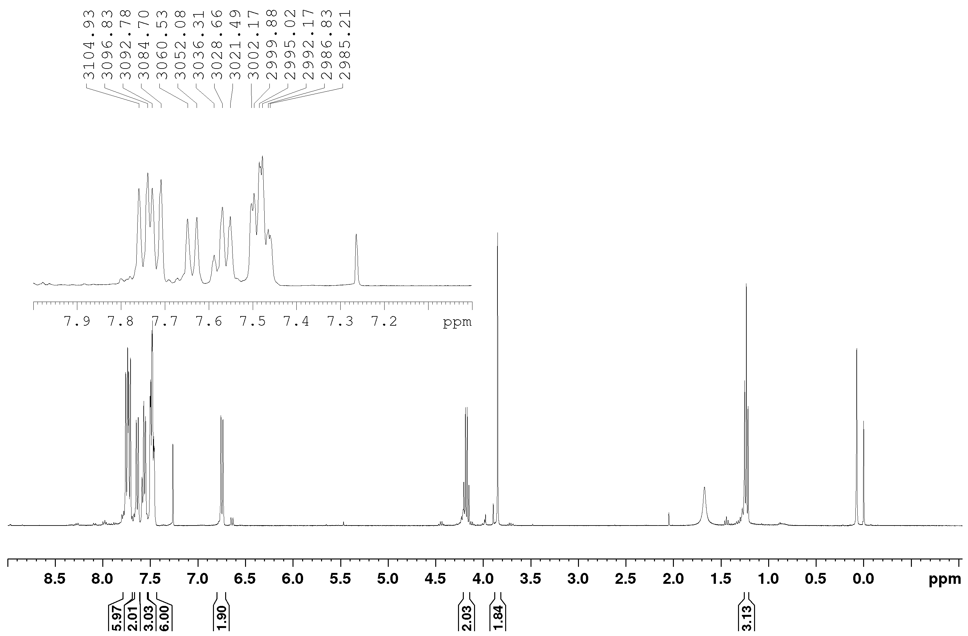
NMR ¹³C – (51c)
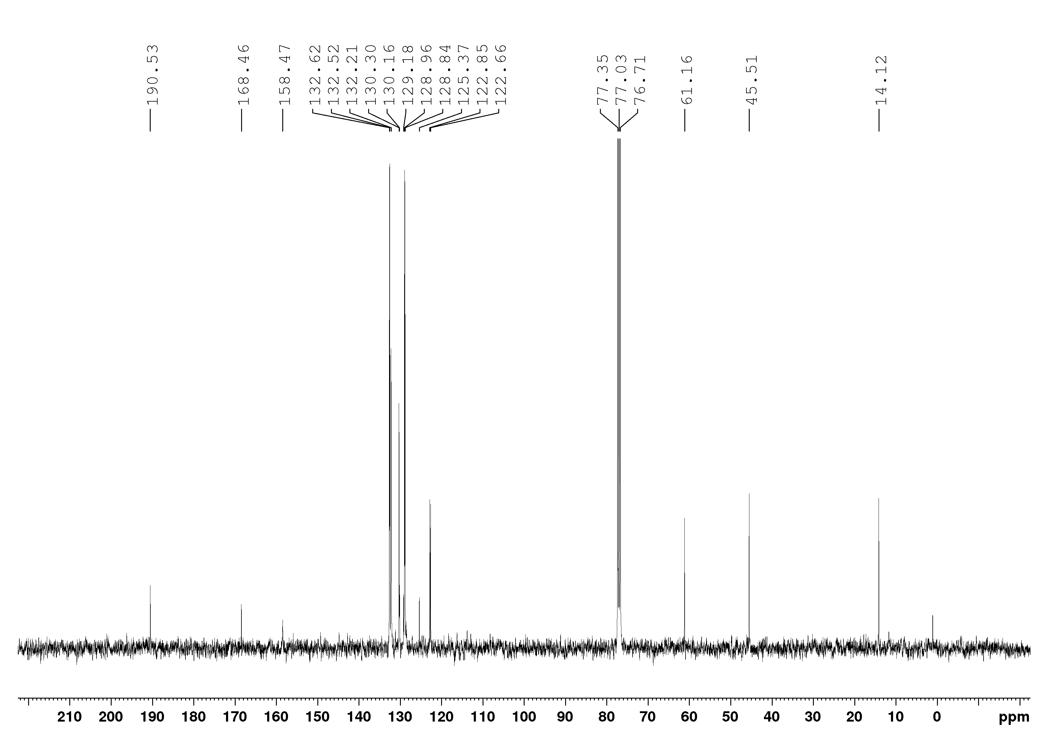
NMR ³¹P – (51c)
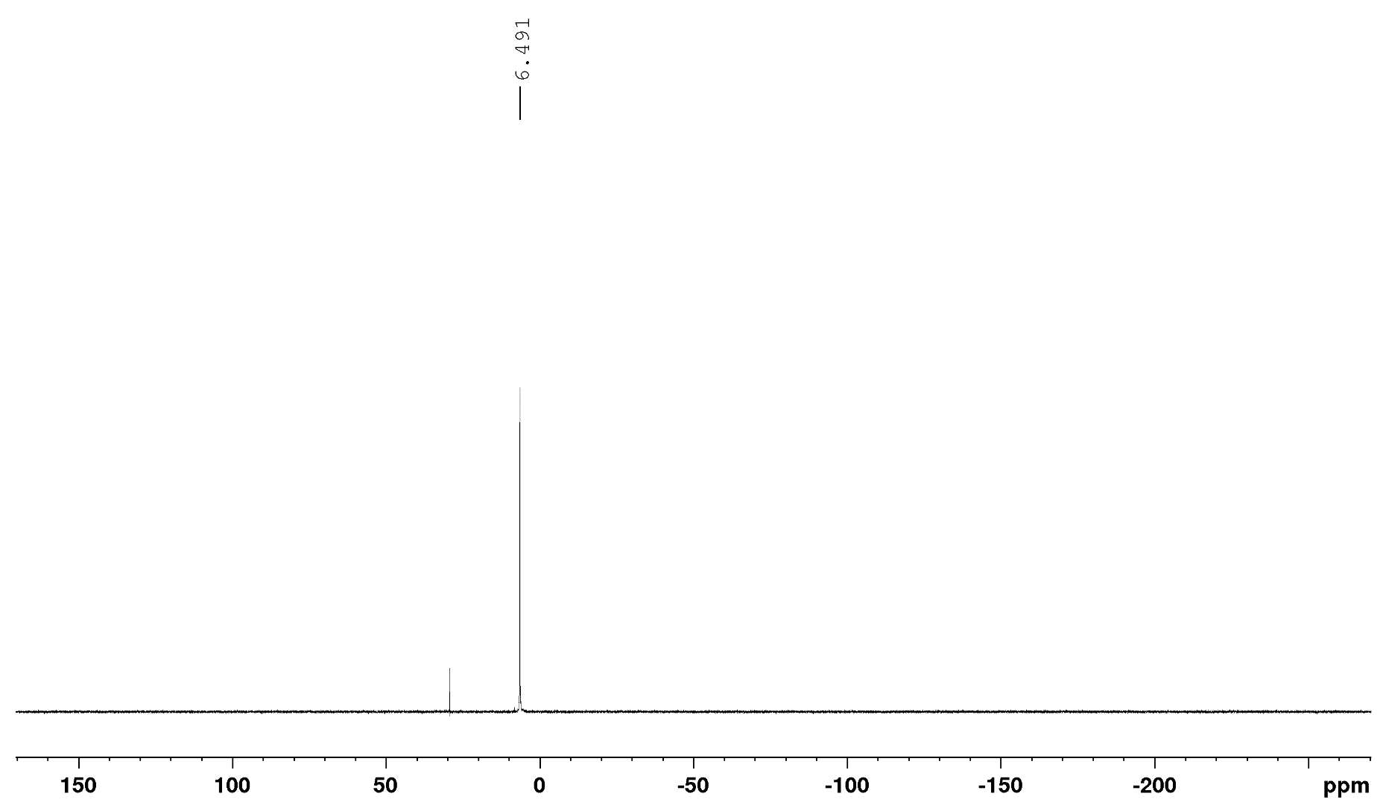

NMR ¹H – (51d)
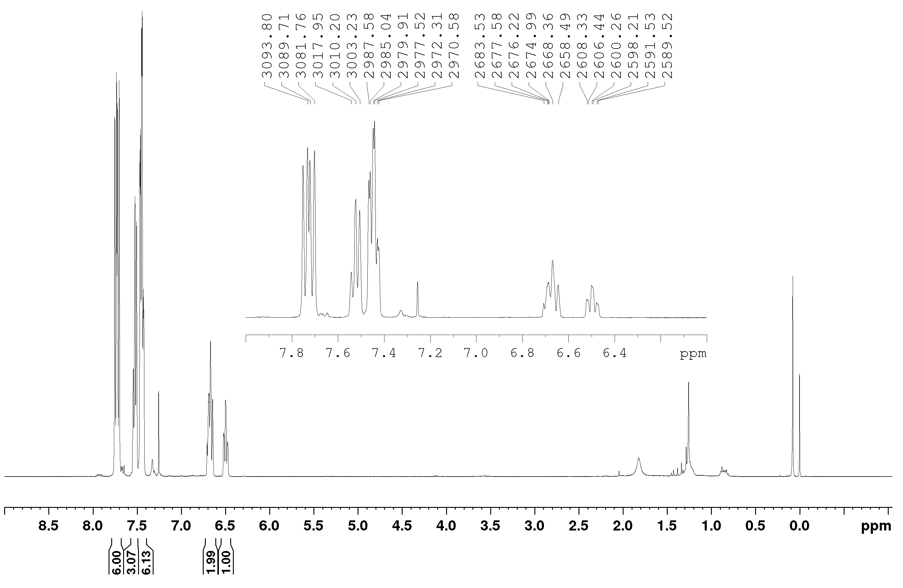
NMR ¹³C – (51d)
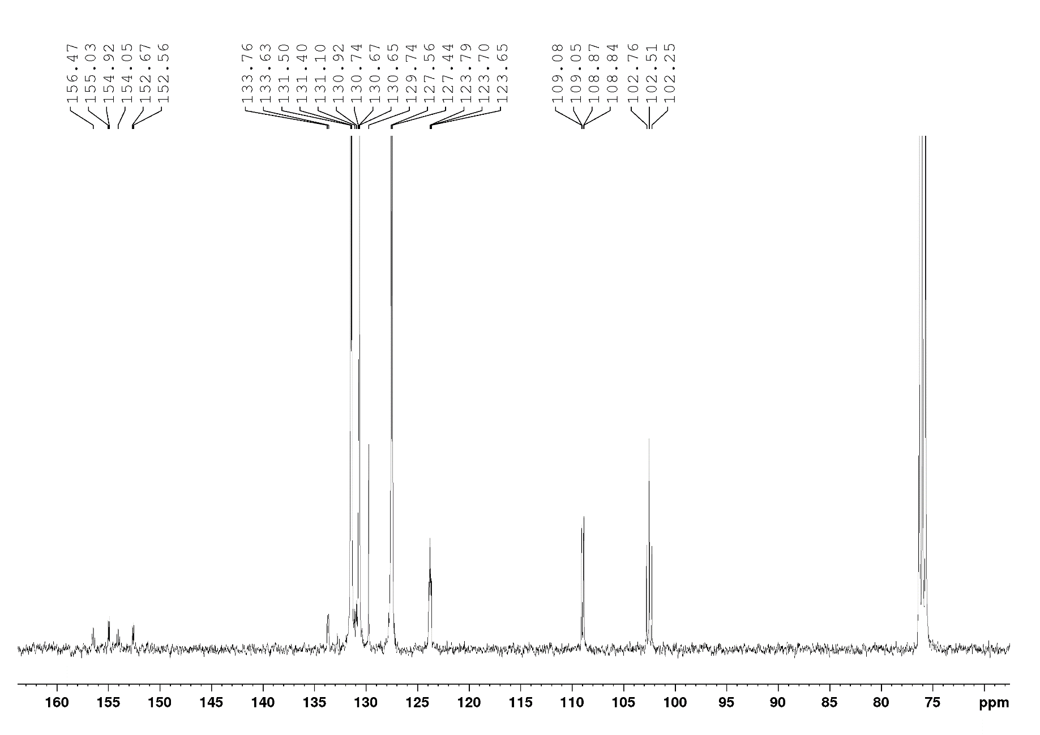
NMR ¹⁹F – (51d)
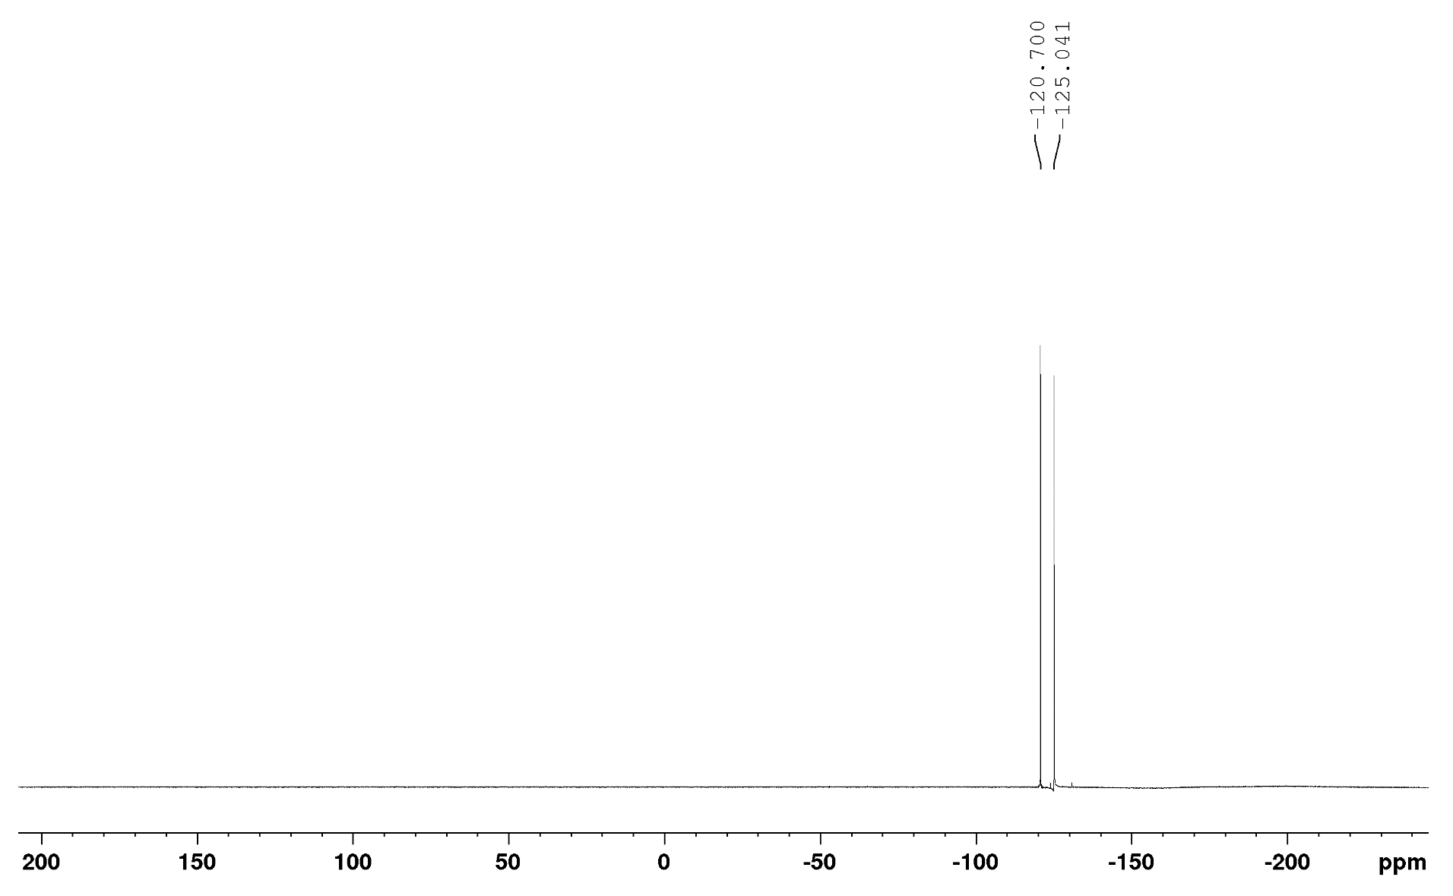
NMR ³¹P – (51d)
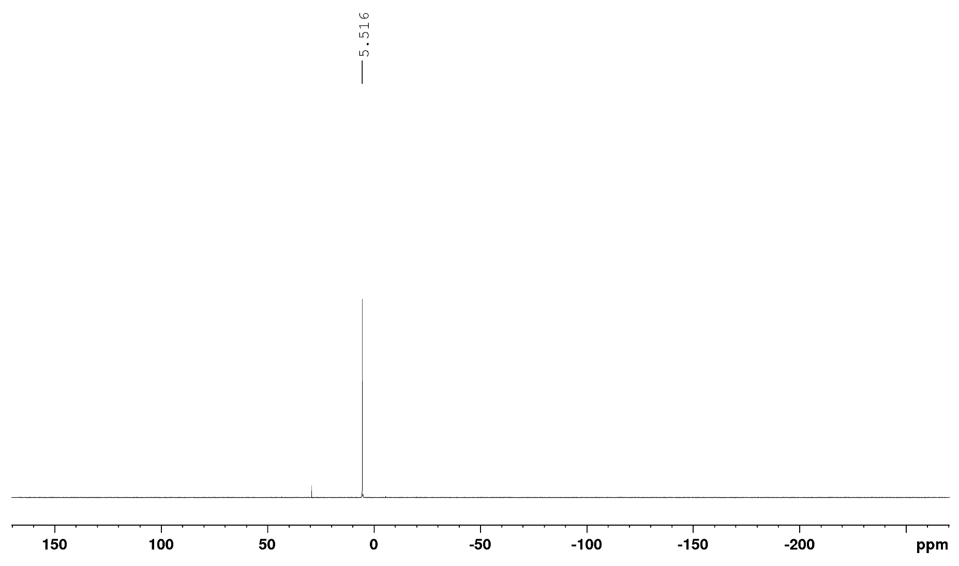

NMR ¹H – (51e)
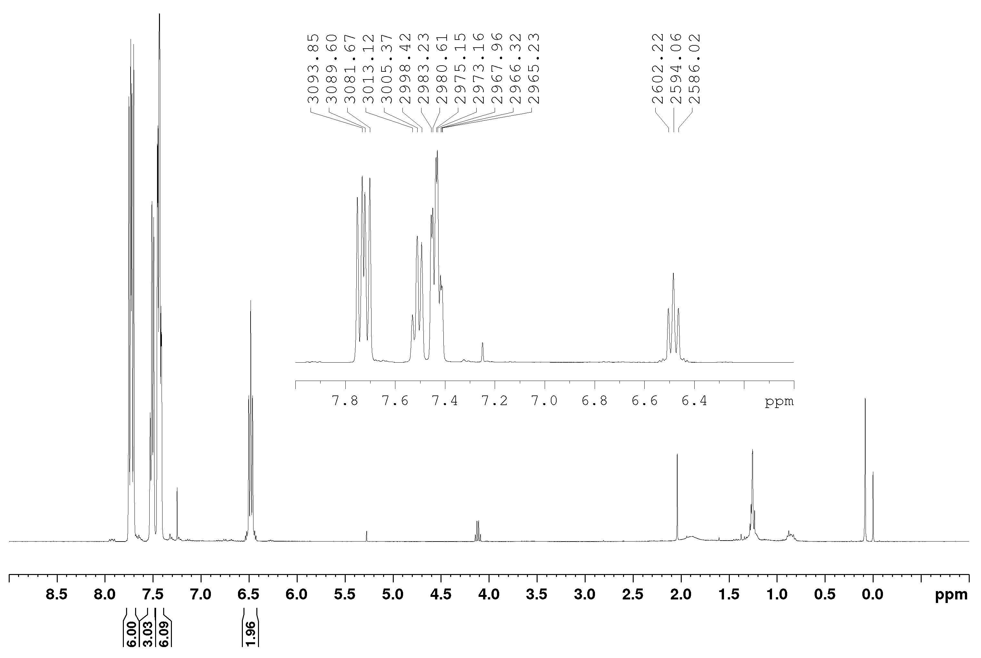
NMR ¹³C – (51e)
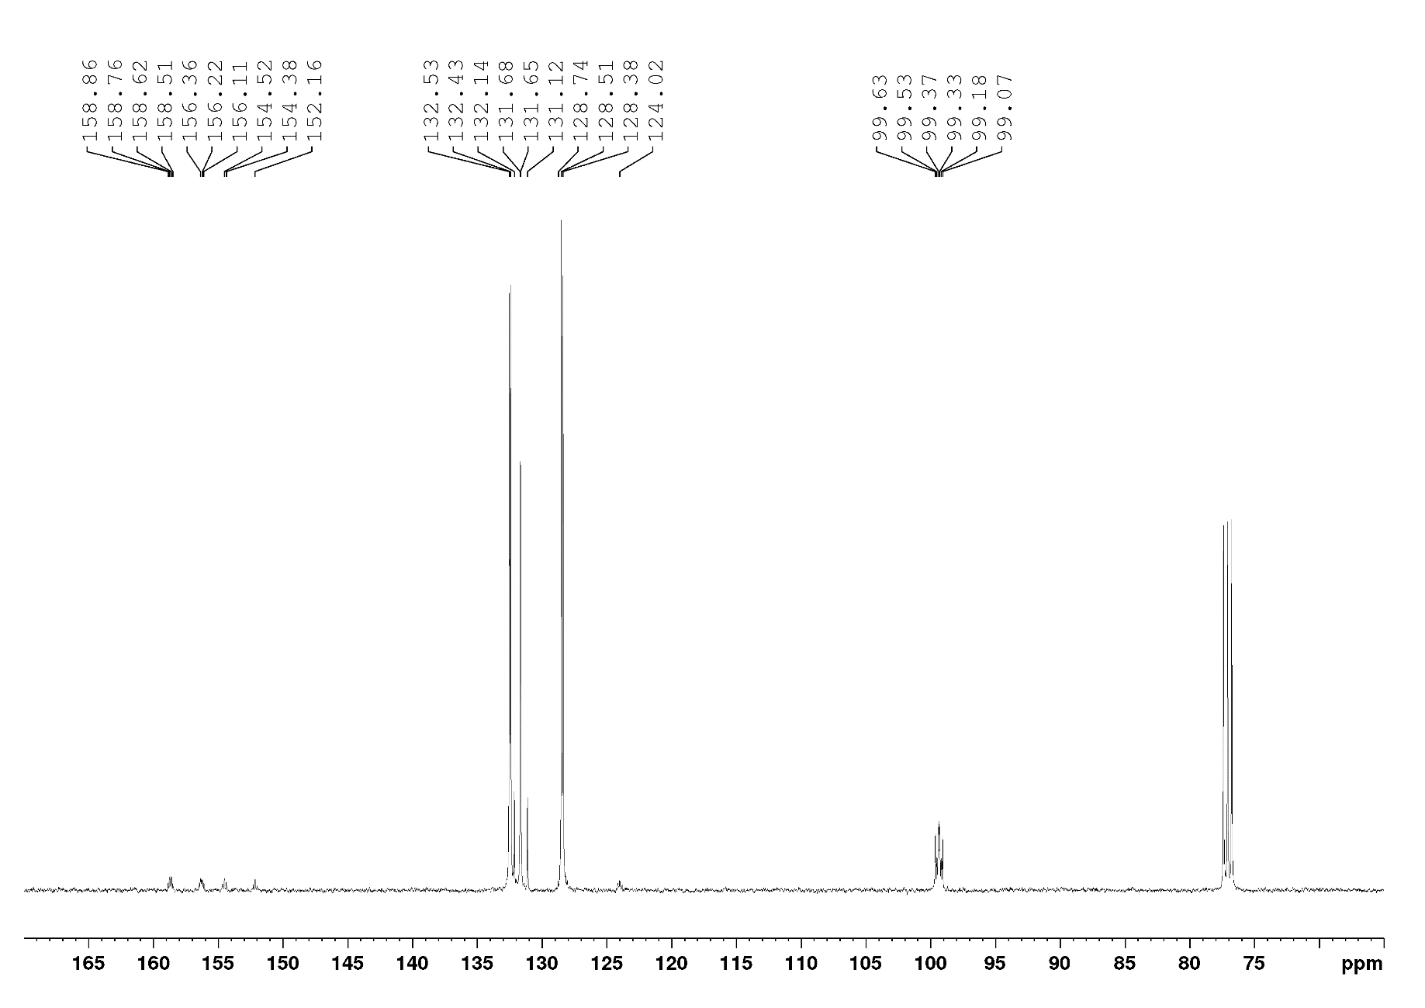
NMR ¹⁹F – (51e)
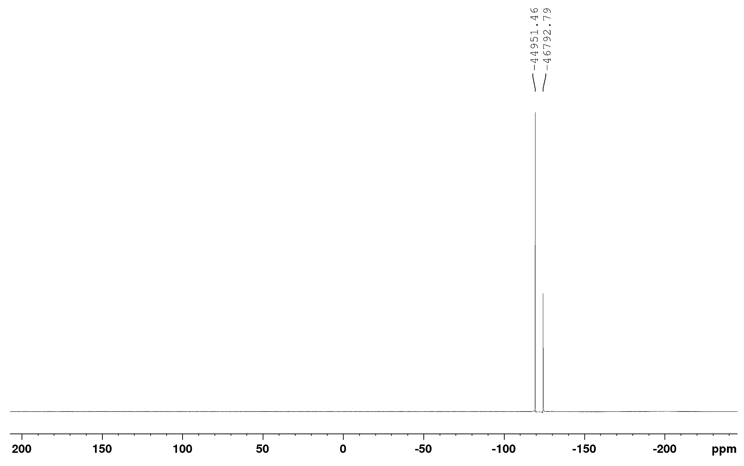
NMR ³¹P – (51e)
