Prediction of COVID-19 prognosis by heterogeneity analysis based on chest CT scans


Bo Yang^{1,3}，Bei Zhang^{2,3}, Jiani Zou¹，Lichen Gao¹，Jian Zhang¹，Huaiming Qiu^{1,*}，Wencai Huang^{1,*}

Supplementary materials

Parameters | Specificity (%) | Sensitivity (%) | Cut-off | AUC | p-value
SCORE | 56.52 | 88.24 | 0.4476 | 0.753 | 0.0002
GGO_kurtosis | 83.33 | 50.00 | 0.3333 | 0.614 | 0.1761
GGO_skewness | 66.67 | 78.12 | 0.4479 | 0.706 | 0.0094
GGO_mode | 77.78 | 59.38 | 0.3715 | 0.707 | 0.0059
GGO_mean | 83.33 | 62.5 | 0.4583 | 0.742 | 0.0008
CLO_kurtosis | 65.00 | 65.38 | 0.3038 | 0.579 | 0.3778
CLO_skewness | 45.00 | 73.08 | 0.1808 | 0.563 | 0.4698
CLO_mode | 80.00 | 57.69 | 0.3769 | 0.680 | 0.024
CLO_mean | 70.00 | 76.92 | 0.4692 | 0.746 | 0.001
Table.S1 Statistical values of histogram parameters for ROC analysis in COVID-19 patient classification (mild/moderate vs severe type) GGO, ground-glass opacity; CLO, Consolidation opacity. * p<0.05

Parameters | mean±std |  |  | Odds ratio (OR) | 95% CI | p value
Parameters | Survival  （n=42） | Deceased（n=15） |  | Odds ratio (OR) | 95% CI | p value
Age | 62.33±18.50 | 75.47±16.99 |  | 1.085 | 0.990 to 1.189 | 0.081
Gender | N/A | N/A |  | 10.716 | 0.546 to 210.351 | 0.118
GGO_kurtosis | 3.50±1.10 | 3.18±0.81 |  | 7.607 | 1.383 to 41.829 | 0.02*
GGO_skewness | 0.35±0.52 | 0.11±0.53 |  | 0.122 | 0.019 to 0.773 | 0.026*
GGO_mode | 8.60±6.62 | 9.45±3.43 |  | 3.566 | 1.425 to 8.925 | 0.007*
GGO_mean | 9.25±6.17 | 9.55±2.59 |  | 0.254 | 0.097 to 0.665 | 0.005*
CLO_kurtosis | 3.12±0.90 | 2.92±0.40 |  | 1.703 | 0.357 to 8.116 | 0.504
CLO_skewness | -0.32±0.64 | -0.05±0.35 |  | 3.185 | 0.472 to 21.507 | 0.234
CLO_mode | 12.68±5.32 | 16.59±7.83 |  | 0.609 | 0.383 to 0.968 | 0.036*
CLO_mean | 11.55±5.11 | 17.41±7.63 |  | 2.016 | 1.206 to 3.371 | 0.007*
Table.S2 Statistical values of Cox survival model for histogram parameters in patients with COVID-19. GGO, ground-glass opacity; CLO, Consolidation opacity. * p<0.

Parameters | mean±std |  |  | Odds ratio (OR) | 95% CI | p value
Parameters | Prolonged LOS（n=22） | Normal LOS（n=20） |  | Odds ratio (OR) | 95% CI | p value
Age | 58.50±17.15 | 66.55±19.44 |  | 0.972 | 0.903 to 1.047 | 0.455
Gender | N/A | N/A |  | 1.193 | 0.153 to 9.277 | 0.866
GGO_kurtosis | 3.74±1.36 | 3.23±0.64 |  | 0.416 | 0.041 to 4.184 | 0.456
GGO_skewness | 0.54±0.46 | 0.14±0.51 |  | 13.927 | 0.01 to 19484.806 | 0.476
GGO_mode | 9.12±7.83 | 8.03±5.12 |  | 0.290 | 0.076 to 1.113 | 0.071
GGO_mean | 9.67±7.39 | 8.79±4.63 |  | 3.155 | 0.551 to 17.613 | 0.199
CLO_kurtosis | 3.25±1.158 | 2.95±0.44 |  | 0.11 | 0 to 0.445 | 0.017*
CLO_skewness | -0.30±0.79 | -0.33±0.43 |  | 0.202 | 0.019 to 2.136 | 0.184
CLO_mode | 12.94±6.60 | 12.37±3.42 |  | 1.439 | 0.571 to 3.626 | 0.440
CLO_mean | 11.77±6.50 | 11.29±2.86 |  | 0.965 | 0.273 to 3.410 | 0.956
Table.S3 Statistical values of Cox proportional hazards regression model for predicting median length of hospital stay (LOS) in survival patients with CORV-2019. GGO, ground-glass opacity; CLO, Consolidation opacity. * p<0.05

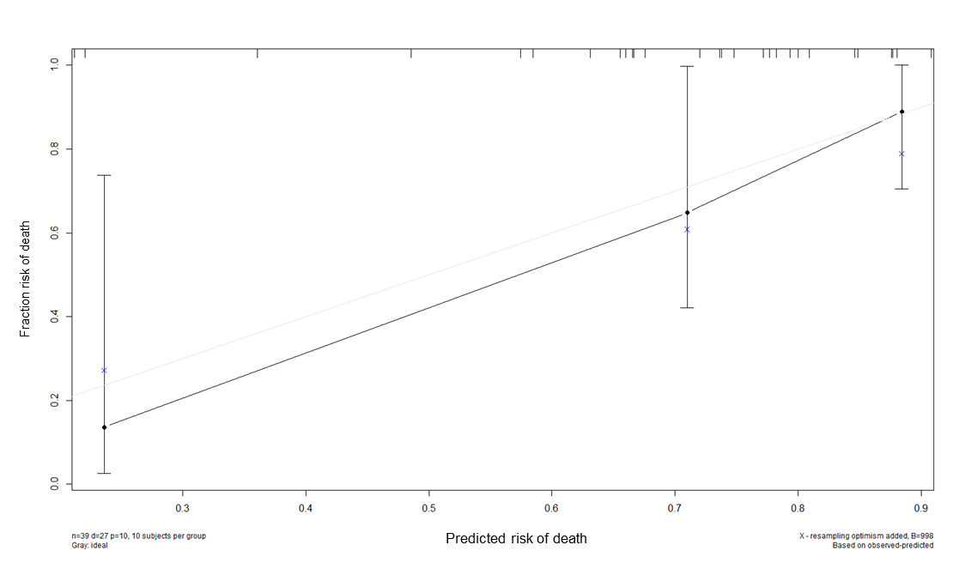
Figure.S1 Calibration curve for 30-day risk of death using the nomogram for COVID-19 patient

Figure.S2 Calibration curve for prolonged LOS (>30 days) using the nomogram for COVID-19 survival patients.

