Supplementary Figure 1. Flow of the inclusion

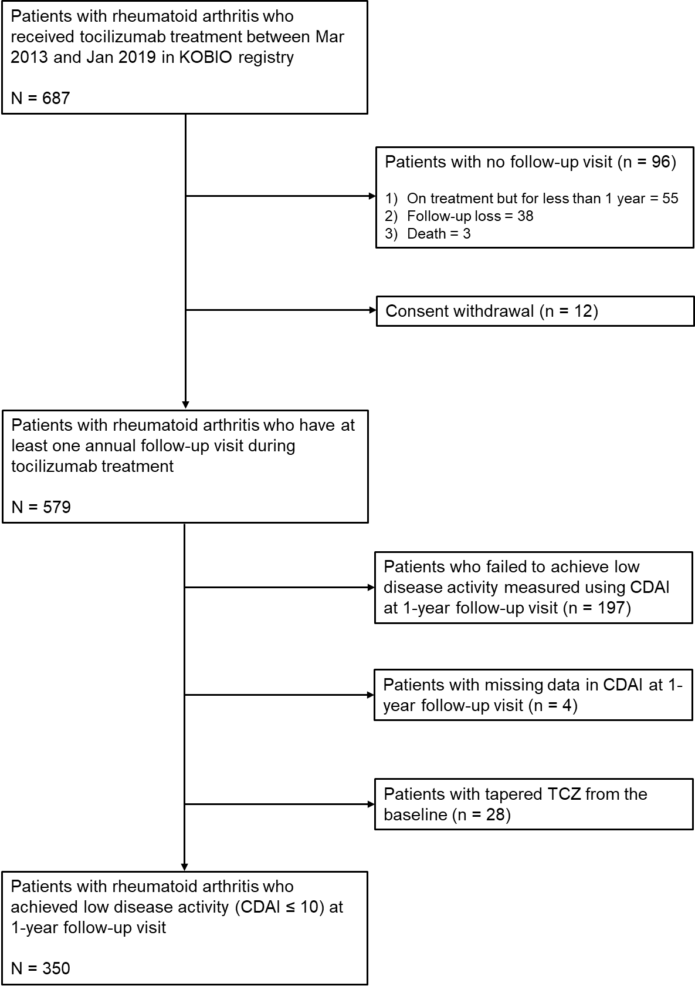

Supplementary Figure 2. Change in dose quotient (DQ) of tocilizumab over time in study population

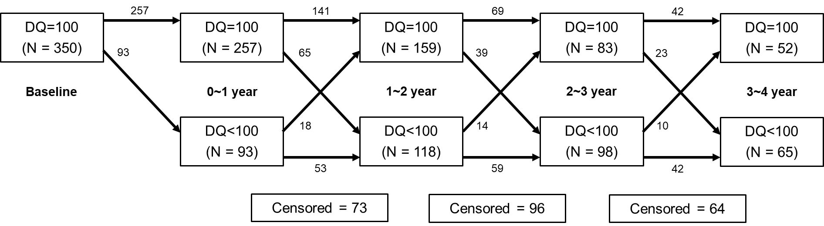

Supplementary Table 1. Disease activity of the study population after 1 year of tocilizumab treatment
SJC (0-44), mean (SD) | 0.4 (0.9)
TJC (0-44), mean (SD) | 0.6 (1.0)
ESR, mm/hr, mean (SD) (n=348) | 10.0 (12.0)
CRP, mg/dL, mean (SD) (n=348) | 0.3 (1.1)
Patient global assessment (0-10), mean (SD) | 2.7 (1.4)
Physician global assessment (0-10), mean (SD) | 2.3 (1.3)
DAS28-ESR, mean (SD) (n=348) | 1.87 (0.83)
CDAI, mean (SD) | 5.8 (2.7)
SDAI, mean (SD) | 6.1 (3.0)
HAQ (0-3), mean (SD) | 0.7 (0.5)
CDAI, clinical disease activity index; CRP, C-reactive protein; DAS, disease activity score; ESR, erythrocyte sedimentation rate; HAQ, health assessment questionnaire; SD, standard deviation; SDAI, simplified disease activity index

Supplementary Table 2. Clinical factors associated with achieving CDAI-remission
 | Univariable analysis |  | Multivariable analysis*
Clinical factors | OR (95% CI) | P | OR (95% CI) | P
Age, year | 0.97 (0.95 to 0.996) | 0.021 | 0.99 (0.97 to 1.09) | 0.244
Female sex | 0.96 (0.44 to 2.06) | 0.908
Disease duration, year | 0.94 (0.90 to 0.99) | 0.010 | 0.96 (0.87 to 1.00) | 0.049
BMI | 0.93 (0.85 to 1.01) | 0.086 | 0.94 (0.87 to 1.02) | 0.159
Smoking history (vs. never-smoker) |  | 0.879 | †
Ex-smoker | 1.07 (0.40 to 2.90)
Current-smoker | 0.62 (0.08 to 4.48)
Seropositive RA (vs. seronegative RA) | 0.68 (0.25 to 1.90) | 0.465 | †
bDMARD-naïve | 1.33 (0.65 to 2.72) | 0.444 | †
SC tocilizumab (vs. IV tocilizumab) | 0.88 (0.42 to 1.61) | 0.573 | †
Baseline CDAI | 0.98 (0.95 to 1.01) | 0.207 | †
Baseline ESR (mm/hr) | 0.995 (0.98 to 1.01) | 0.441 | †
Baseline CRP (mg/dL) | 0.99 (0.90 to 1.08) | 0.773 | †
Baseline HAQ | 0.72 (0.50 to 1.02) | 0.061 | 0.79 (0.58 to 1.08) | 0.141
Concomitant MTX use | 0.42 (0.24 to 0.74) | 0.003 | 0.57 (0.34 to 0.97) | 0.037
Concomitant steroid use | 0.30 (0.16 to 0.55) | <0.001 | 0.47 (0.27 to 0.81) | 0.007
CDAI measured at previous visit | 0.83 (0.75 to 0.93) | 0.001 | 0.83 (0.74 to 0.93) | 0.002
bDMARD, biologic disease-modifying anti-rheumatic drug; BMI, body mass index; CDAI, clinical disease activity index; CI, confidence interval; CRP, C-reactive protein; ESR, erythrocyte sedimentation rate; HAQ, health assessment questionnaire; HR, hazard ratio; IV, intravenous; MTX, methotrexate; RA, rheumatoid arthritis; SC, subcutaneous.
*, Including covariates with relevant association (P < 0.2) with the outcome in the univariable analysis
†, was not included in the multivariable model
Supplementary Table 3. Clinical factors associated with achieving DAS28-ESR remission
 | Univariable analysis |  | Multivariable analysis*
Clinical factors | OR (95% CI) | P | OR (95% CI) | P
Age, year | 0.99 (0.98 to 1.01) | 0.354 | †
Female sex | 1.03 (0.59 to 1.87) | 0.924 | †
Disease duration, year | 0.99 (0.97 to 1.02) | 0.534 | †
BMI | 0.95 (0.89 to 1.02) | 0.160 | 0.95 (0.88 to 1.01) | 0.120
Smoking history (vs. never-smoker) |  | 0.110 |  | 0.822
Ex-smoker | 1.20 (0.52 to 2.74) |  | 0.97 (0.38 to 2.47)
Current-smoker | 0.30 (0.10 to 0.96) |  | 0.69 (0.21 to 2.22)
Seropositive RA (vs. seronegative RA) | 0.49 (0.22 to 1.07) | 0.072 | 0.61 (0.24 to 1.53) | 0.291
bDMARD-naïve | 2.36 (1.46 to 3.81) | <0.001 | 2.30 (1.48 to 3.60) | <0.001
SC tocilizumab (vs. IV tocilizumab) | 0.73 (0.45 to 1.20) | 0.219 | †
Baseline DAS28-ESR | 0.80 (0.67 to 0.96) | 0.014 | 0.94 (0.79 to 1.12) | 0.476
Baseline HAQ | 0.81 (0.61 to 1.07) | 0.135 | 0.76 (0.59 to 0.99) | 0.045
Concomitant MTX use | 0.91 (0.59 to 1.39) | 0.656 | †
Concomitant steroid use | 0.37 (0.25 to 0.55) | <0.001 | 0.44 (0.29 to 0.67) | <0.001
DAS29-ESR measured at previous visit | 0.25 (0.19 to 0.35) | <0.001 | 0.27 (0.19 to 0.37) | <0.001
bDMARD, biologic disease-modifying anti-rheumatic drug; BMI, body mass index; DAS, disease activity score; CDAI, clinical disease activity index; CI, confidence interval; CRP, C-reactive protein; ESR, erythrocyte sedimentation rate; HAQ, health assessment questionnaire; HR, hazard ratio; IV, intravenous; MTX, methotrexate; RA, rheumatoid arthritis; SC, subcutaneous.
*, Including covariates with relevant association (P < 0.2) with the outcome in the univariable analysis
†, was not included in the multivariable model

Supplementary Table 4. Clinical factors associated with achieving DAS28-ESR deep remission
 | Univariable analysis |  | Multivariable analysis*
Clinical factors | OR (95% CI) | P | OR (95% CI) | P
Age, year | 0.99 (0.98 to 1.01) | 0.483 | †
Female sex | 0.90 (0.51 to 1.57) | 0.703 | †
Disease duration, year | 1.002 (0.98 to 1.03) | 0.895 | †
BMI | 0.96 (0.90 to 1.01) | 0.129 | 0.94 (0.89 to 1.01) | 0.084
Smoking history (vs. never-smoker) |  | 0.145 |  | 0.521
Ex-smoker | 1.32 (0.62 to 2.84) |  | 1.20 (0.58 to 2.48)
Current-smoker | 0.30 (0.08 to 1.12) |  | 0.54 (0.16 to 1.83)
Seropositive RA (vs. seronegative RA) | 0.55 (0.29 to 1.06) | 0.072 | 0.61 (0.30 to 1.24)
bDMARD-naïve | 1.63 (1.03 to 2.59) | 0.027 | 1.58 (1.03 to 2.43) | 0.037
SC tocilizumab (vs. IV tocilizumab) | 0.81 (0.52 to 1.26) | 0.353 | †
Baseline DAS28-ESR | 0.91 (0.79 to 1.05) | 0.202 | †
Baseline HAQ | 0.88 (0.69 to 1.11) | 0.279 | †
Concomitant MTX use | 0.89 (0.61 to 1.29) | 0.532 | †
Concomitant steroid use | 0.53 (0.37 to 0.75) | <0.001 | 0.69 (0.47 to 1.01) | 0.059
DAS29-ESR measured at previous visit | 0.25 (0.19 to 0.34) | <0.001 | 0.27 (0.20 to 0.370 | <0.001
bDMARD, biologic disease-modifying anti-rheumatic drug; BMI, body mass index; DAS, disease activity score; CDAI, clinical disease activity index; CI, confidence interval; CRP, C-reactive protein; ESR, erythrocyte sedimentation rate; HAQ, health assessment questionnaire; HR, hazard ratio; IV, intravenous; MTX, methotrexate; RA, rheumatoid arthritis; SC, subcutaneous.
*, Including covariates with relevant association (P < 0.2) with the outcome in the univariable analysis
†, was not included in the multivariable model

Supplementary Table 5. Clinical factors associated with achieving SDAI remission
 | Univariable analysis |  | Multivariable analysis*
Clinical factors | OR (95% CI) | P | OR (95% CI) | P
Age, year | 0.98 (0.96 to 0.99) | 0.010 | 0.99 (0.97 to 1.004) | 0.117
Female sex | 1.34 (0.66 to 2.71) | 0.423
Disease duration, year | 0.97 (0.94 to 1.002) | 0.063 | 0.98 (0.95 to 1.01) | 0.290
BMI | 0.90 (0.84 to 0.97) | 0.006 | 0.93 (0.87 to 1.001) | 0.055
Smoking history (vs. never-smoker) |  | 0.527 | †
Ex-smoker | 0.63 (0.24 to 1.67)
Current-smoker | 0.61 (0.15 to 2.50)
Seropositive RA (vs. seronegative RA) | 0.95 (0.34 to 2.64) | 0.919 | †
bDMARD-naïve | 1.33 (0.74 to 2.40) | 0.342 | †
SC tocilizumab (vs. IV tocilizumab) | 0.96 (0.54 to 1.68) | 0.872 | †
Baseline SDAI | 0.99 (0.96 to 1.01) | 0.203 | †
Baseline HAQ | 0.80 (0.60 to 1.07) | 0.125 | 0.88 (0.67 to 1.15) | 0.349
Concomitant MTX use | 0.57 (0.34 to 0.93) | 0.024 | 0.67 (0.41 to 1.08) | 0.102
Concomitant steroid use | 0.45 (0.28 to 0.74) | 0.001 | 0.68 (0.42 to 1.10) | 0.114
SDAI measured at previous visit | 0.79 (0.72 to 0.87) | <0.001 | 0.80 (0.72 to 0.88) | <0.001
bDMARD, biologic disease-modifying anti-rheumatic drug; BMI, body mass index; CI, confidence interval; CRP, C-reactive protein; ESR, erythrocyte sedimentation rate; HAQ, health assessment questionnaire; HR, hazard ratio; IV, intravenous; MTX, methotrexate; RA, rheumatoid arthritis; SC, subcutaneous; SDAI, simplified disease activity index
*, Including covariates with relevant association (P < 0.2) with the outcome in the univariable analysis
†, was not included in the multivariable model

Supplementary Table 6. Clinical factors associated with achieving ACR/EULAR-remission
 | Univariable analysis |  | Multivariable analysis*
Clinical factors | OR (95% CI) | P | OR (95% CI) | P
Age, year | 0.98 (0.96 to 0.996 | 0.018 | 0.98 (0.97 to 1.003) | 0.093
Female sex | 1.26 (0.65 to 2.48) | 0.494 | †
Disease duration, year | 0.98 (0.95 to 1.004) | 0.093 | 0.99 (0.96 to 1.02) | 0.343
BMI | 0.92 (0.85 to 0.99) | 0.024 | 0.93 (0.87 to 0.999) | 0.047
Smoking history (vs. never-smoker) |  | 0.629 | †
Ex-smoker | 0.67 (0.25 to 1.78)
Current-smoker | 0.66 (0.16 to 2.74)
Seropositive RA (vs. seronegative RA) | 0.84 (0.34 to 2.05) | 0.703 | †
bDMARD-naïve | 1.51 (0.84 to 2.72) | 0.172 | 1.52 (0.89 to 2.60) | 0.122
SC tocilizumab (vs. IV tocilizumab) | 1.13 (0.67 to 1.89) | 0.648 | †
Baseline CDAI | 0.99 (0.97 to 1.01) | 0.408 | †
Baseline ESR (mm/hr) | 0.99 (0.98 to 1.004) | 0.195 | 0.998 (0.99 to 1.01) | 0.680
Baseline CRP (mg/dL) | 0.997 (0.93 to 1.07) | 0.930 | †
Baseline HAQ | 0.94 (0.71 to 1.26) | 0.686 | †
Concomitant MTX use | 0.71 (0.44 to 1.15) | 0.161 | 0.84 (0.53 to 1.34) | 0.467
Concomitant steroid use | 0.49 (0.31 to 0.80) | 0.004 | 0.68 (0.43 to 1.08) | 0.105
CDAI measured at previous visit | 0.80 (0.73 to 0.88) | <0.001 | 0.80 (0.72 to 0.89) | <0.001
bDMARD, biologic disease-modifying anti-rheumatic drug; BMI, body mass index; CDAI, clinical disease activity index; CI, confidence interval; CRP, C-reactive protein; ESR, erythrocyte sedimentation rate; HAQ, health assessment questionnaire; HR, hazard ratio; IV, intravenous; MTX, methotrexate; RA, rheumatoid arthritis; SC, subcutaneous.
*, Including covariates with relevant association (P < 0.2) with the outcome in the univariable analysis
†, was not included in the multivariable model

Supplementary Figure 3 Change in DQ over time between the two groups

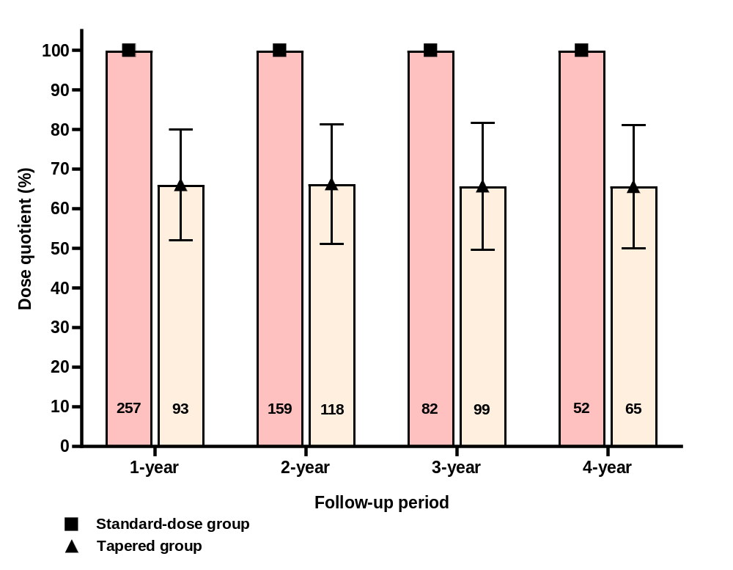

Supplementary Figure 4 Interaction between tapering tocilizumab and clinical factors on likelihood of maintaining CDAI-LDA
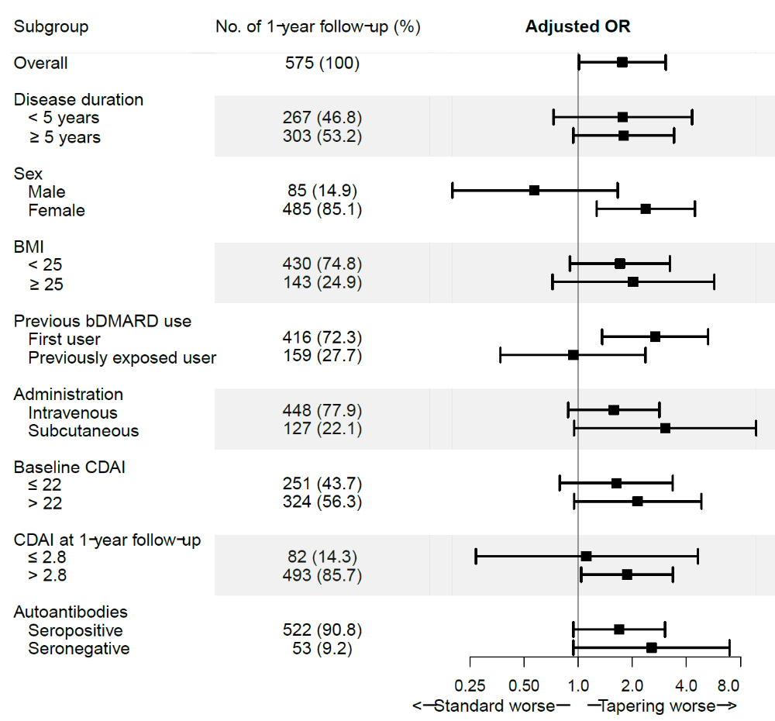

Supplementary Figure 5 Estimated HAQ-DI over time between the two groups
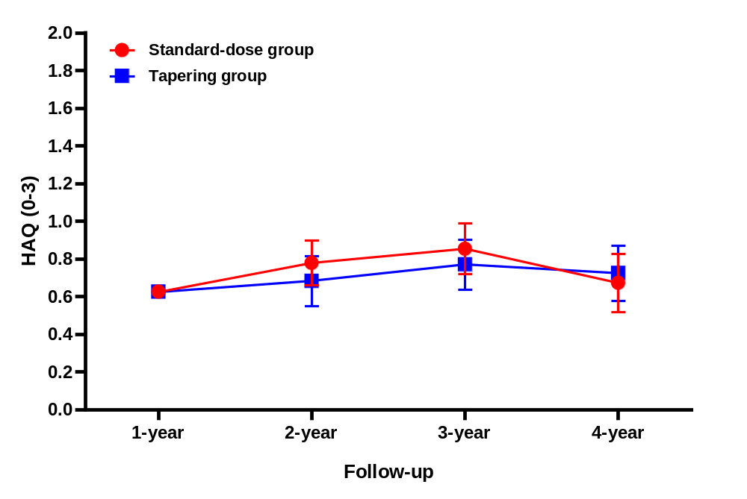

Supplementary Table 7. Effect of tapering tocilizumab on loss of CDAI-LDA in the multivariable GEE model including all clinically relevant factors
 | Univariable analysis |  | Multivariable analysis
Clinical factors | OR (95% CI) | P | OR (95% CI) | P
Age, year | 1.01 (0.99 to 1.03) | 0.472 | 0.996 (0.98 to 1.02) | 0.721
Female sex | 0.83 (0.42 to 1.64) | 0.592 | 0.995 (0.31 to 3.16) | 0.993
Disease duration, year | 1.02 (0.99 to 1.05) | 0.215 | 1.02 (0.99 to 1.05) | 0.283
BMI | 1.09 (1.002 to 1.18) | 0.046 | 1.10 (1.01 to 1.20) | 0.029
Smoking history (vs. never-smoker) |  | 0.057 |  | 0.630
Ex-smoker | 0.87 (0.34 to 2.25) |  | 1.38 (0.32 to 5.97)
Current-smoker | 3.32 (1.22 to 9.09) |  | 2.06 (0.47 to 9.05)
Seropositive RA (vs. seronegative RA) | 1.33 (0.54 to 3.26) | 0.532 | 1.13 (0.50 to 2.56) | 0.779
bDMARD-naïve | 0.56 (0.32 to 0.97) | 0.039 | 0.56 (0.31 to 0.98) | 0.044
SC tocilizumab (vs. IV tocilizumab) | 2.03 (1.19 to 3.49) | 0.010 | 3.31 (1.65 to 6.62) | 0.001
Baseline CDAI | 1.01 (0.98 to 1.03) | 0.646 | 0.99 (0.96 to 1.01) | 0.266
Baseline ESR (mm/hr) | 1.01 (1.001 to 1.02) | 0.036 | 1.01 (1.001 to 1.02) | 0.033
Baseline HAQ | 1.39 (1.01 to 1.91) | 0.043 | 1.23 (0.85 to 1.79) | 0.272
Concomitant MTX use | 1.15 (0.67 to 2.00) | 0.614 | 1.11 (0.63 to 1.94) | 0.718
Concomitant steroid use | 2.18 (1.28 to 3.70) | 0.004 | 1.91 (1.10 to 3.33) | 0.023
CDAI measured at previous visit | 1.18 (1.11 to 1.27) | <0.001 | 1.11 (1.04 to 1.19) | 0.003
Tapering group | 1.02 (0.67 to 1.55) | 0.929 | 1.75 (1.01 to 3.03) | 0.045
bDMARD, biologic disease-modifying anti-rheumatic drug; BMI, body mass index; CDAI, clinical disease activity index; CI, confidence interval; CRP, C-reactive protein; ESR, erythrocyte sedimentation rate; HAQ, health assessment questionnaire; HR, hazard ratio; IV, intravenous; MTX, methotrexate; RA, rheumatoid arthritis; SC, subcutaneous.

Supplementary Table 8. Effect of tapering tocilizumab on loss of CDAI-LDA in the multivariable GEE model with ‘exchangeable’ correlation matrix
 | Univariable analysis |  | Multivariable analysis*
Clinical factors | OR (95% CI) | P | OR (95% CI) | P
Age, year | 1.01 (0.99 to 1.03) | 0.552 | †
Female sex | 0.79 (0.39 to 1.61) | 0.524 | †
Disease duration, year | 1.02 (0.99 to 1.05) | 0.208 | †
BMI | 1.09 (1.003 to 1.18) | 0.043 | 1.01 (1.00 to 1.02) | 0.058
Smoking history (vs. never-smoker) |  | 0.055 |  | 0.459
Ex-smoker | 0.91 (0.32 to 2.62) |  | 1.39 (0.48 to 3.99)
Current-smoker | 3.46 (1.25 to 9.58) |  | 1.96 (0.62 to 6.19)
Seropositive RA (vs. seronegative RA) | 1.07 (0.39 to 2.97) | 0.902 | †
bDMARD-naïve | 0.58 (0.33 to 1.01) | 0.054 | 0.53 (0.30 to 0.92) | 0.024
SC tocilizumab (vs. IV tocilizumab) | 2.03 (1.18 to 3.49) | 0.010 | 3.13 (1.58 to 6.21) | 0.001
Baseline CDAI | 1.01 (0.98 to 1.03) | 0.683 | †
Baseline ESR (mm/hr) | 1.01 (1.001 to 1.02) | 0.026 | 1.01 (1.00 to 1.02) | 0.058
Baseline CRP (mg/dL) | 1.04 (0.97 to 1.11) | 0.230 | †
Baseline HAQ | 1.40 (1.02 to 1.92) | 0.037 | 1.12 (0.79 to 1.59) | 0.535
Concomitant MTX use | 1.31 (0.77 to 2.23) | 0.325 | †
Concomitant steroid use | 2.07 (1.20 to 3.56) | 0.009 | 1.87 (1.08 to 3.26) | 0.026
CDAI measured at previous visit | 1.16 (1.09 to 1.24) | <0.001 | 1.13 (1.06 to 1.21) | <0.001
Tapering group | 1.04 (0.68 to 1.59) | 0.866 | 1.79 (1.01 to 3.16) | 0.045
bDMARD, biologic disease-modifying anti-rheumatic drug; BMI, body mass index; CDAI, clinical disease activity index; CI, confidence interval; CRP, C-reactive protein; ESR, erythrocyte sedimentation rate; HAQ, health assessment questionnaire; HR, hazard ratio; IV, intravenous; MTX, methotrexate; RA, rheumatoid arthritis; SC, subcutaneous.
*, Including covariates with relevant association (P < 0.2) with the outcome in the univariable analysis
†, was not included in the multivariable model

