SUPPLEMENTAL MATERIALS
SUPPLEMENTAL TABLES

Table S1. Mediation model test with neuroticism as the mediator and the SAS as the dependent variable.
Outcome variable | Predictor variables | β | SE | t | R² | F
SAS (Y) | ASLEC (X) | 0.559 | 0.091 | 6.139*** | 0.363 | 15.199***
(X→Y) | Sex | 0.104 | 0.213 | 1.142
 | Age | 0.193 | 0.039 | 2.132*
Neuroticism (M) | ASLEC (X) | 0.506 | 0.086 | 5.908*** | 0.435 | 20.537***
(X→M) | Sex | -0.085 | 0.201 | -0.985
 | Age | 0.493 | 0.036 | 5.782***
SAS (Y) | ASLEC (X) | 0.384 | 0.104 | 3.697*** | 0.431 | 14.936***
(X→M→Y) | Neuroticism (M) | 0.346 | 0.113 | 3.062**
 | Sex | 0.312 | 0.204 | 1.528
 | Age | 0.010 | 0.044 | 0.220
Note. *p < 0.05; **p < 0.01; ***p < 0.001.

Table S2. Path analysis of mediation model with neuroticism as the mediator.
 | Intermediary Path | Effect size | SE | Bootstrap 95% CI | Mediating effect ratio
SAS | Total Effect | 0.559 | 0.091 | 0.378,0.740
SAS | Direct Effect | 0.384 | 0.104 | 0.177,0.590
SAS | Indirect effects | 0.175 | 0.063 | 0.062,0.307 | 31.3%

Table S3. Mediation model test with psychoticism as the mediator and the SAS as the dependent variable.
Outcome variable | Predictor variables | β | SE | t | R² | F
SAS (Y) | ASLEC (X) | 0.559 | 0.091 | 6.139*** | 0.363 | 15.199***
(X→Y) | Sex | 0.104 | 0.213 | 1.142
 | Age | 0.193 | 0.039 | 2.132*
Psychoticism (M) | ASLEC (X) | 0.274 | 0.107 | 2.571* | 0.126 | 3.837*
(X→M) | Sex | 0.063 | 0.250 | 0.587
 | Age | 0.222 | 0.045 | 2.097*
SAS (Y) | ASLEC (X) | 0.491 | 0.091 | 5.383*** | 0.416 | 14.086***
(X→M→Y) | Psychoticism (M) | 0.247 | 0.092 | 2.685**
 | Sex | 0.089 | 0.256 | 1.007
 | Age | 0.138 | 0.038 | 1.542
Note. *p < 0.05; **p < 0.01; ***p < 0.001.

Table S4. Path analysis of mediation model with psychoticism as the mediator.
 | Intermediary Path | Effect size | SE | Bootstrap 95% CI | Mediating effect ratio
SAS | Total Effect | 0.559 | 0.091 | 0.378,0.740
SAS | Direct Effect | 0.491 | 0.091 | 0.310,0.673
SAS | Indirect effects | 0.068 | 0.037 | 0.007,0.151 | 12.0%

Table S5. Tests the mediation model with SAS as the dependent variable
Variables | Neuroticism |  |  |  | SAS
Variables | β | SE | t | β | SE | t
ASLEC(A) | 0.434 | 0.086 | 5.027*** | 0.384 | 0.104 | 3.697***
AAQ(B) | -0.188 | 0.090 | -2.104*
A×B | 0.223 | 0.086 | 2.581*
Neuroticism |  |  |  | 0.346 | 0.113 | 3.062**
Sex | -0.175 | 0.194 | -0.903 | 0.312 | 0.204 | 1.528
Age | 0.203 | 0.036 | 5.691*** | 0.010 | 0.044 | 0.220
R2 | 0.490 |  |  | 0.431
F | 14.965*** |  |  | 14.936***
Note: *p < 0.05; **p < 0.01; ***p < 0.001.

SUPPLEMENTAL FIGURES.

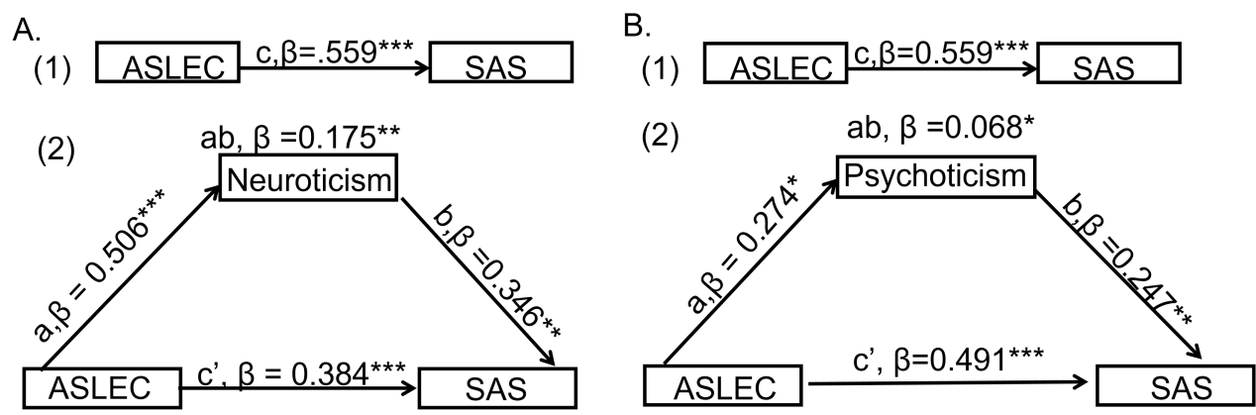
Figure. 1 Direct and mediation effect models with neuroticism and psychoticism as the mediating variables. Panels A and B display the mediation model using the SAS as the dependent variable and neuroticism and psychoticism as the mediator, respectively; Here, (1) refers to the direct effect model and (2) denotes the mediation effect model; a and b represent the path coefficients of the mediation path, ab indicates the mediation effect value, c stands for the total effect coefficient, and c’ is the direct effect coefficient, controlled for the mediating variable. β is the standardized path coefficient, with *p < 0.05, **p < 0.01, and ***p < 0.001;

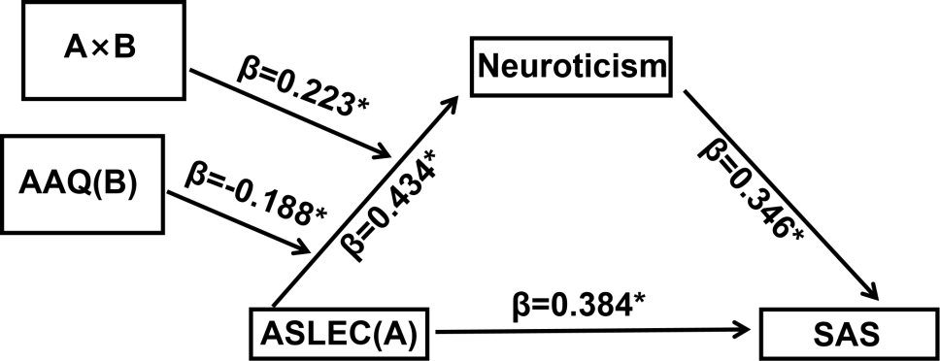
Figure. 2 Neuroticism serves as the mediator and SAS acts as the dependent variable. It represents model with the AAQ as moderators. A×B denotes the interaction term (AAQ × ASLEC score). β is the standardized path coefficient; * indicates a significant result at the 95% confidence interval.

CALCULATION FORMULAS FOR THE 6 ATTENTION SCALE QUOTIENTS
1.AVQ
The Auditory Vigilance Quotient (AVQ) in the Attention Scale evaluates an individual’s ability to maintain sustained attention and avoid omission errors under auditory stimulation. It specifically reflects the capacity to detect and respond to infrequently occurring auditory target stimuli, with a focus on reducing missed responses during prolonged attention tasks. As a key component of auditory attention assessment The calculation method of AVQ is shown in Formula (1).
AVQ = 100 - ( VIA / 45 ) × 100 (1)
where VIA denotes the number of auditory omission errors, referring to the total number of times participants failed to make click responses to the target auditory stimulus (the number "1") in the IVA-CPT test. Only omission behaviors occurring in the Rare Blocks were included in the statistics, and this indicator reflects the attention maintenance ability of the auditory channel.
2.VVQ
The Visual Vigilance Quotient (VVQ) belongs to the Attention Scale and measures an individual’s sustained attention maintenance and omission error control under visual stimulation. It assesses the ability to continuously monitor and respond to infrequently presented visual target stimuli, reflecting the stability of visual attention over time. The calculation method of VVQ is shown in Formula (2).
VVQ = 100 - ( VIV / 45 ) × 100 (2)
Where VIV denotes the number of visual omission errors, referring to the total times participants failed to click when the visual target stimulus (the number "1") appeared in the IVA - CPT test. Similar to AVQ, only omission errors in the Rare Blocks are counted. A higher VVQ score signifies superior visual vigilance and more reliable sustained attention to sparse visual targets.
3.AAQ
The Auditory Attention Quotient (AAQ) in the Attention Scale comprehensively assesses an individual’s overall ability of attention maintenance, concentration and processing speed under the auditory stimulation mode. As a core composite quotient for the auditory attention dimension, it is calculated by the weighted summation of the Auditory Vigilance Quotient (AVQ), the Auditory Focus Attention Quotient (FOCA) and the Auditory Speed Quotient (MNA). Specifically, the calculation method of AAQ is shown in Formula (3).
AAQ = ( AVQ + FOCA + MNA ) / 3 (3)
The calculation method of FOCA is shown in Formula (4).
FOCA = ( 1 - SD_A / MN_A ) × 100 (4)
where SD_A denotes the standard deviation of auditory reaction time, which refers to the dispersion of reaction times for participants’ correct responses to the auditory target stimulus ("1") and reflects the stability of auditory reaction speed. MN_A represents the mean auditory reaction time, which is the average of reaction times for participants’ responses to all auditory stimuli (including the target "1" and the distractor "2") in the IVA-CPT test, covering both correct and incorrect responses. MNA is the mean reaction time (in milliseconds) of correct auditory responses, which refers to the average of reaction times for participants’ correct click responses to the auditory target "1", excluding incorrect and invalid clicks. It is a core indicator for calculating the Auditory Speed Quotient. A higher AAQ score indicates better performance in auditory attention, including auditory vigilance, attention concentration and reaction speed.
4.VAQ
The Visual Attention Quotient (VAQ) is a core composite quotient in the Attention Scale that comprehensively evaluates an individual’s integrated visual attention abilities, including sustained vigilance, concentration stability and processing speed under visual stimulation. It is derived from the weighted average of the Visual Vigilance Quotient (VVQ), the Visual Focus Attention Quotient (FOCV) and the Visual Speed Quotient (MNV). The calculation method of VAQ is shown in Formula (5).
VAQ = ( VVQ + FOCV + MNV ) / 3 (5)
The calculation method of VVQ is shown in Formula (5) (detailed above). FOCV is calculated using Formula (6):
FOCV = ( 1 - SD_V / MN_V ) × 100 (6)
Where SD_V denotes the standard deviation of visual reaction time, reflecting the variability of reaction times for participants’ correct responses to the visual target stimulus ("1") and indicating the stability of visual attention. MN_V represents the mean visual reaction time, which is the average of reaction times for participants’ responses to all visual stimuli (both target "1" and distractor "2") in the IVA - CPT test, including both correct and incorrect responses. MNV is the mean reaction time (in milliseconds) of correct visual responses, referring to the average of reaction times for participants’ accurate click responses to the visual target "1", excluding invalid or incorrect clicks. A higher VAQ score indicates stronger overall visual attention capabilities, including reliable visual vigilance, stable concentration and efficient visual processing.
5.APSQ
The Auditory Processing Speed Quotient (APSQ) belongs to the Attention Scale and specifically measures an individual’s speed of processing auditory target stimuli and making timely responses. It reflects the efficiency of the auditory system in receiving, encoding and responding to relevant information, with a focus on the rapidity of correct responses to auditory targets. The calculation method of APSQ is shown in Formula(7).
$APSQ = 100 + 15 × ( MNA − Nor{\text{m}}_{\text{MN}\text{A}} ) / Nor{\text{m}}_{\text{S}{\text{D}}_{\text{MN}\text{A}}}$ (7)
Where MNA is the mean reaction time (in milliseconds) of correct auditory responses, which is the average of reaction times for participants’ accurate click responses to the auditory target "1" in the IVA - CPT test (excluding incorrect, premature or prolonged clicks). Norm_MNA denotes the normative mean auditory reaction time for the corresponding age group, and Norm_SD_MNA represents the normative standard deviation of auditory reaction time. A higher APSQ score indicates faster auditory processing speed and more efficient response to auditory target stimuli.
6.VPSQ
The Visual Processing Speed Quotient (VPSQ) is part of the Attention Scale that assesses an individual’s speed in processing visual target stimuli and executing correct motor responses. It reflects the efficiency of the visual system in perceiving, recognizing and responding to visual target information, emphasizing the rapidity and timeliness of correct responses. The calculation method of VPSQ is shown in Formula (8).
$VPSQ = 100 + 15 × ( MNV − Nor{\text{m}}_{\text{MN}\text{V}} ) / Nor{\text{m}}_{\text{S}{\text{D}}_{\text{MN}\text{V}}}$ (8)
Where MNV is the mean reaction time (in milliseconds) of correct visual responses, referring to the average of reaction times for participants’ accurate click responses to the visual target "1" in the IVA - CPT test (excluding invalid clicks such as double-clicks or delayed responses). Norm_MNV denotes the normative mean visual reaction time for the corresponding age group, and Norm_SD_MNV represents the normative standard deviation of visual reaction time. A higher VPSQ score indicates faster visual processing speed and more efficient response to visual target stimuli.

