Supplementary material

Summary of supplementary results
The supplementary results contain further analyses of the Flex and JPS conditions.
The aim of the supplementary analysis is to confirm the validity of the contrasts regarding the research questions (JPS > Rest) > (Flex > Rest) and to verify that the conditions irrespectively of each other activate expected brain regions.
The conditions [JPS > Rest] and [Flex > Rest] provide similar functional brain responses, and, as expected, during the JPS condition a larger brain network is activated than during the Flex condition. Activation is most intense on the contralateral side, but bilateral activation occurs, as expected (see Table S1 and S2).

Table S1. Brain regions significantly activated during the main condition [JPS > Rest]. For left test side n = 30 (CTRL 19 and L-ACLR 11) and for right test side n = 29 (CTRL 19 and R-ACLR 10). Statistics: familywise correction p = 0.05, cluster threshold level 15.
Test side | Brain regions | Voxel # | P | Z max | MNI coordinate
 |  |  |  |  | X Y Z
Left | Right insula | 1699 | .000 | 6.39 | 45 | 5 | 6
Left | Left insula | 1563 | .000 | 6.32 | -45 | 0 | 6
Left | Right supramarginal gyrus | 429 | .000 | 6.27 | 48 | -32 | 26
Left | Left middle occipital cortex | 41 | .001 | 5.42 | -18 | -101 | 2
Left | Right precuneus | 1273 | .001 | 5.38 | 12 | -45 | 68
Left | Left rolandic operculum | 43 | .009 | 4.83 | -44 | -32 | 21
Left | Left precuneus | 88 | .009 | 4.81 | -11 | -47 | 66
Right | Left precuneus | 41360 | .000 | 7.56 | -8 | -42 | 65
Right | Left superior temporal gyrus | 513 | .000 | 5.99 | -47 | -2 | 6
Right | Right calcarine sulcus | 227 | .000 | 5.81 | 8 | -93 | -14
Right | Left rolandic operculum | 235 | .000 | 5.81 | -41 | -32 | 20
Right | Left middle cingulum | 590 | .001 | 5.32 | -2 | -5 | 48
Right | Right insula | 82 | .005 | 4.92 | 36 | 17 | 8
 | Left putamen | 226 | .007 | 4.84 | -29 | 0 | 8
Contra, contralateral; CTRL, asymptomatic control group; Ipsi, ipsilateral; JPS, joint position sense condition; L-ACLR, left-side anterior cruciate ligament-reconstructed group; MNI, Montreal Neurological Institute; Rest, rest condition; R-ACLR, right-side anterior cruciate ligament-reconstructed group.

Table S2. Brain regions significantly activated during the main condition [Flex >Rest]. For left test side n = 30 (CTRL 19 and L-ACLR 11) and for right test side n = 29 (CTRL 19 and R-ACLR 10). Statistics: familywise correction p= 0.05, cluster threshold level 15
Test side | Brain regions | Voxel # | P | Z max | MNI coordinate
 |  |  |  |  | X Y Z
Left | Left middle occipital cortex | 92 | .000 | 6.15 | -18 | -101 | 2
Left | Right precuneus | 1928 | .000 | 5.89 | 11 | -45 | 66
Left | Left rolandic operculum | 340 | .000 | 5.87 | -47 | -2 | 6
Left | Right rolandic operculum | 204 | .000 | 5.82 | 45 | -30 | 23
Left | Right insula | 150 | .000 | 5.56 | 45 | 3 | 5
Left | Left rolandic operculum | 92 | .001 | 5.34 | -44 | -32 | 21
Left | Right superior occipital cortex | 41 | .003 | 5.04 | 21 | -99 | 6
Left | Cerebellum | 249 | .003 | 5.04 | -3 | -48 | -15
Right | Left precuneus | 33960 | .000 | inf | -8 | -44 | 65
Right | Left rolandic operculum | 154 | .000 | 5.95 | -41 | -32 | 20
Right | Left rolandic operculum | 91 | .001 | 5.37 | -47 | -2 | 5
Contra, contralateral; CTRL, asymptomatic control group; Ipsi, ipsilateral; JPS, joint position sense condition; L-ACLR, left-side anterior cruciate ligament-reconstructed group; MNI, Montreal Neurological Institute; Rest, rest condition; R-ACLR, right-side anterior cruciate ligament-reconstructed group.

Comparisons JPS-Rest and Flex-Rest
Figure S1 illustrates similarities and differences between brain activation during the JPS>Rest and Flex>Rest test conditions. The activation is mainly contralateral to the engaged leg, but bilateral activation occurs as well. The activation pattern is rather similar between the two conditions, but note that more extensive brain activation occurs during JPS>Rest than during Flex> Rest, as expected.
.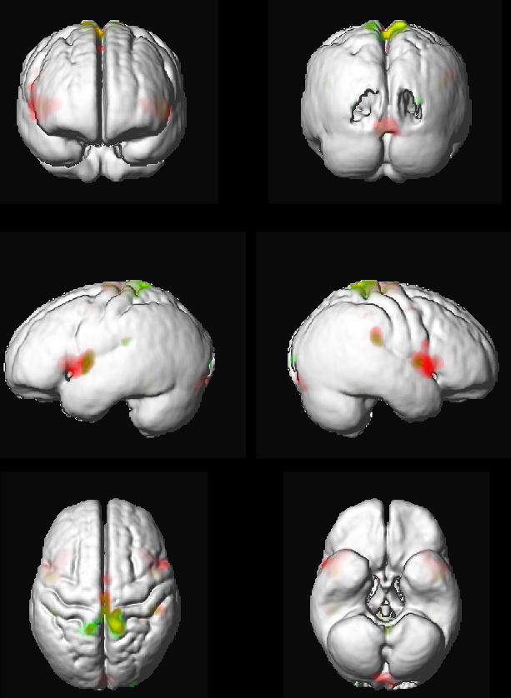 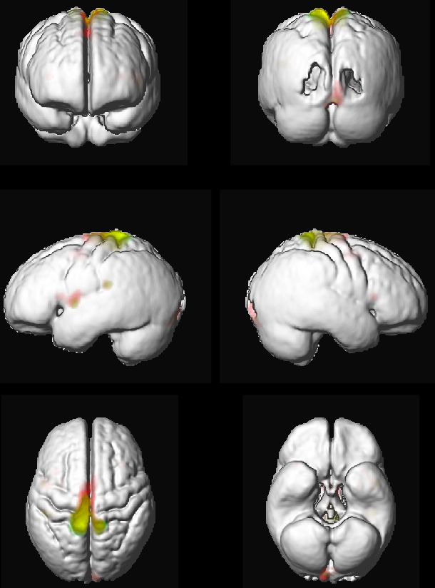
Figure S1. Left-knee injured ACL individuals and Controls moving their left knee (left image) and Right-knee injured ACL individuals and Controls moving their right knee (right image) . The two conditions Flex>Rest and JPS>Rest are illustrated. Red = JPS>Rest, Green = Flex-Rest, Yellow = common areas (activated during both conditions). The colour intensity illustrates the activation intensity.

