Supplementary Information

Of

Coseismic InSAR reveals stronger topographic amplification proxies far from faults

Congwei Yu^{1,2}, Ashok Dahal², Islam Fadel², A. Arda Özacar³, Tolga Görüm⁴, Weile Li¹, Hakan Tanyaş²*
¹ State Key Laboratory of Geohazard Prevention and Geoenvironment Protection, Chengdu University of Technology, Chengdu, China
² Faculty of Geo-Information Science and Earth Observation (ITC), University of Twente, Enschede, the Netherlands
³Department of Geological Engineering, Faculty of Engineering, Middle East Technical University, Ankara, Türkiye
⁴Eurasia Institute of Earth Sciences, Istanbul Technical University, Istanbul, Türkiye
* Corresponding author: Hakan Tanyaş (h.tanyas@utwente.nl)

Supplementary Table 1 Details of InSAR sources and causative raptures in every earthquake events
Event | Time | Raptures | InSAR
Event | Time | Raptures | Satellite | Method | Pre-event | Post-event | Resolution (m) | Reference
Gorkha | 25/04/2015 | Styron & Pagani¹ | ALOS-2, T048 | D-InSAR | 22/02/2015 | 17/05/2015 | 90 | Lindsey et al.³
Italy | 24/08/2016 | Lavecchia et al⁴; Pucci et al.⁵ | Sentinel-1, Ascending 44 | D-InSAR | 22/08/2016 | 28/08/2016 | 30 | This study
Kaikōura | 14/11/2016 | Langridge et al.⁶;  Du et al.⁷ | Sentinel-1, Ascending 52 | POT | 03/11/2016 | 15/11/2016 | 50 | This study
Halabja | 12/11/2017 | Styron & Pagani¹;  Babaie Mahani & Kazemian⁸ | Sentinel-1, Ascending 174 | D-InSAR | 06/11/2017 | 18/11/2017 | 30 | This study
Antelope Valley | 08/07/2021 | Pollitz et al.⁹ | Sentinel-1, Ascending 64 | D-InSAR | 05/07/2021 | 17/07/2021 | 100 | Wang et al.¹⁰
Greece | 03/03/2021 | Koukouvelas et al.¹¹ | Sentinel-1, Ascending 102 | D-InSAR | 25/02/2021 | 03/03/2021 | 30 | Tolomei et al.¹²
Haiti | 14/08/2021 | Styron & Pagani¹ | ALOS-2, Descending 138 | D-InSAR | 10/12/2019 | 17/08/2021 | 80 | This study
Menyuan | 08/01/2022 | Li et al.¹³;  Wu et al.¹⁴ | Sentinel-1, Ascending 128 | D-InSAR | 05/01/2022 | 17/01/2022 | 50 | Liu et al.¹⁶
Noto Peninsula | 01/01/2024 | Inoue & Okamura¹⁷ | ALOS-2 & Sentinel-1 | D-InSAR, POT, RSSI | 06/06/2022 | 15/01/2024 | 120 | Ma et al.¹⁸

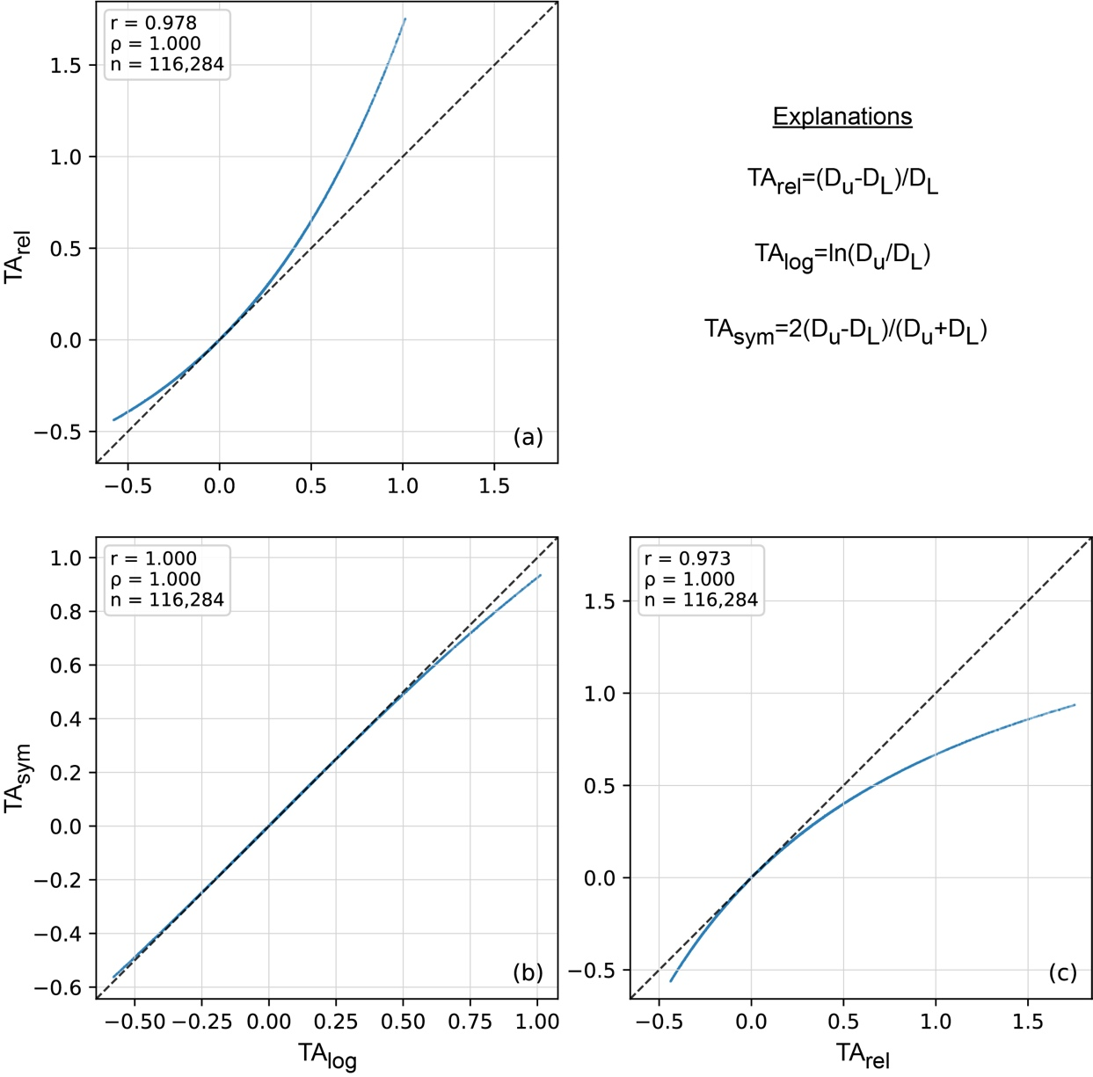
Supplementary Fig. 1 Pairwise comparison of alternative relative formulations of topographic amplification (TA). Panel (a) shows the relationship between the relative ratio and the logarithmic ratio, panel (b) shows the relationship between the symmetric relative difference and the logarithmic ratio, and panel (c) shows the relationship between the symmetric relative difference and the relative ratio. Dashed lines indicate the 1:1 relationship. In each panel, 𝑛 is the number of slope units, 𝜌 is Spearman’s rank correlation coefficient, and 𝑟 is Pearson’s correlation coefficient. The high correspondence among the three formulations indicates that the observed TA patterns are robust to the choice of relative metric.

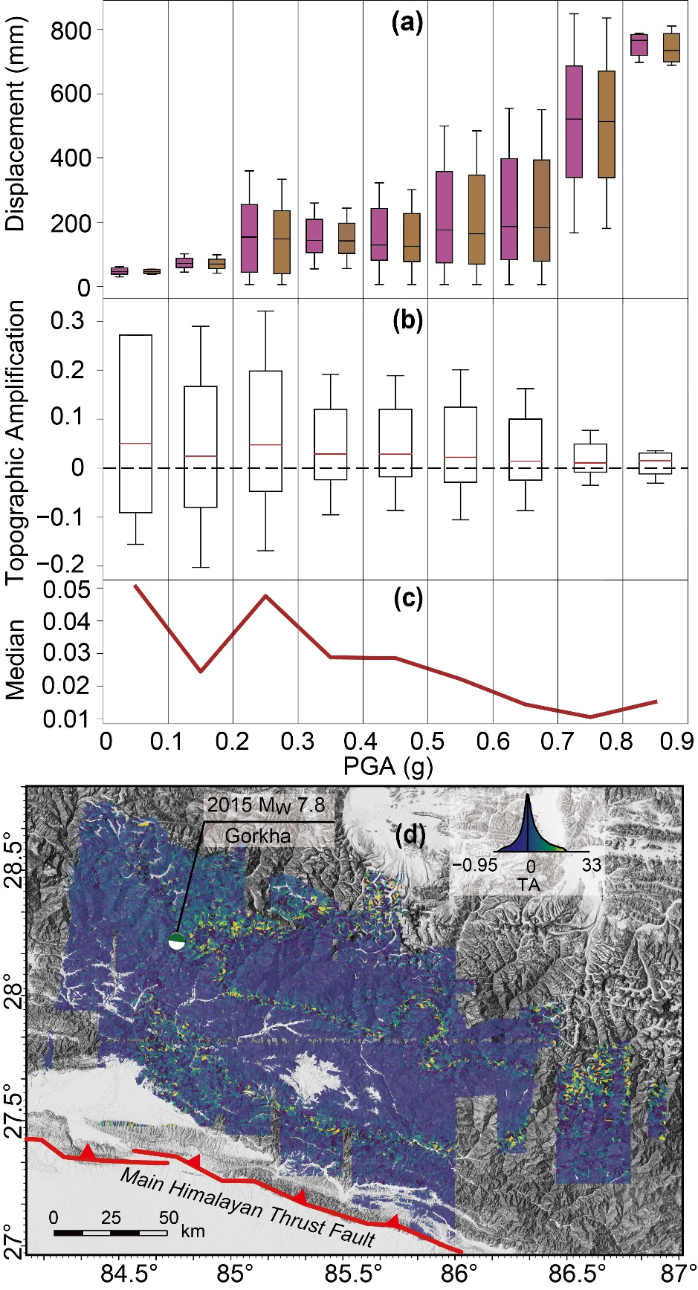
Supplementary Fig. 2 Coseismic deformation and topographic amplification in Gorkha. (a) InSAR-derived permanent displacements for the upper and lower parts of SUs across PGA bins. (b) Distribution of TA values for each PGA bin. (c) Median TA variations across PGA bins, showing decreasing amplification with increasing shaking intensity. (d) Spatial distribution of TA across the study area.
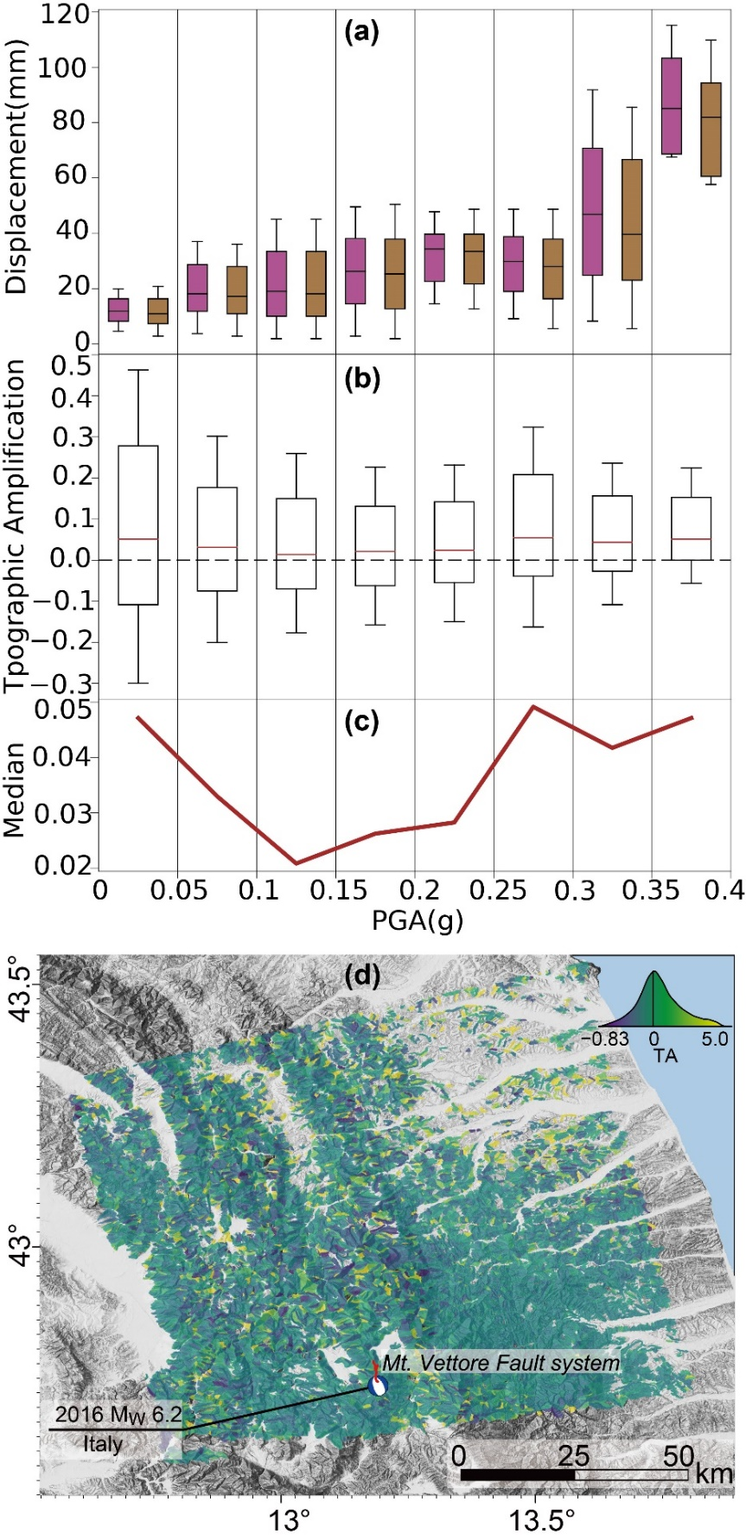
Supplementary Fig. 3 Coseismic deformation and topographic amplification in Italy. (a) InSAR-derived permanent displacements for the upper and lower parts of SUs across PGA bins. (b) Distribution of TA values for each PGA bin. (c) Median TA variations across PGA bins, showing decreasing amplification with increasing shaking intensity. (d) Spatial distribution of TA across the study area.

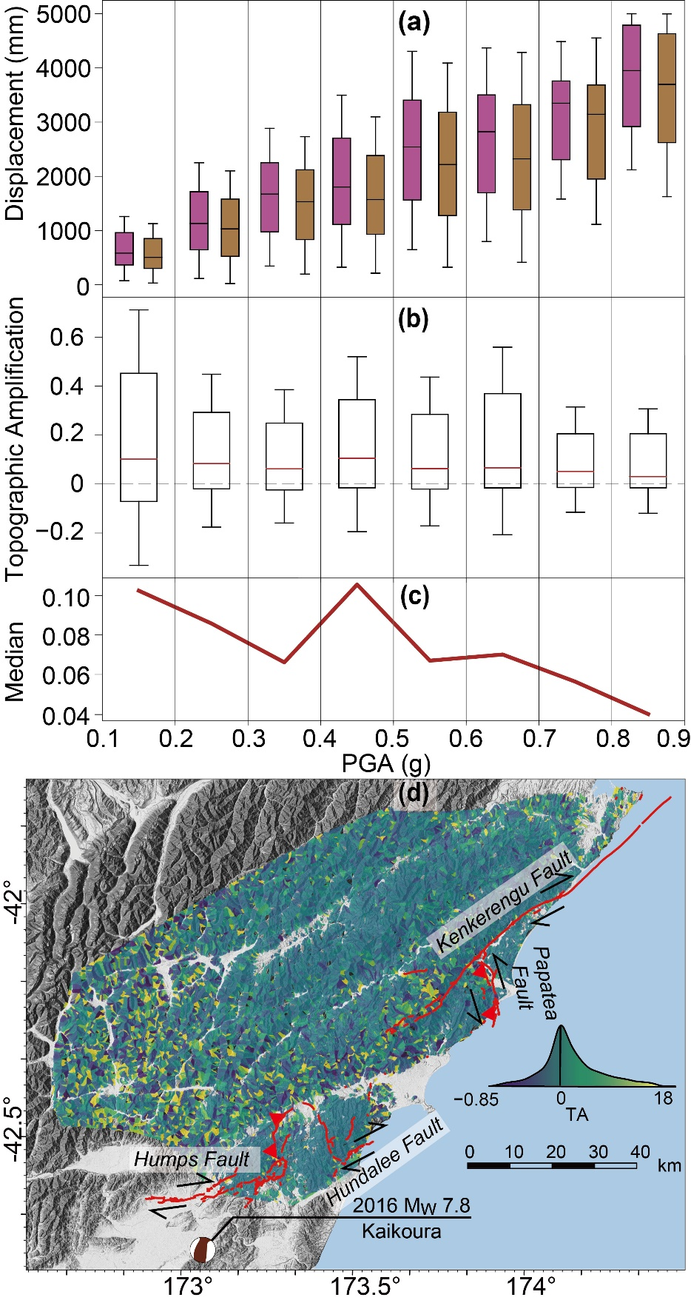
Supplementary Fig. 4 Coseismic deformation and topographic amplification in Kaikoura. (a) InSAR-derived permanent displacements for the upper and lower parts of SUs across PGA bins. (b) Distribution of TA values for each PGA bin. (c) Median TA variations across PGA bins, showing decreasing amplification with increasing shaking intensity. (d) Spatial distribution of TA across the study area.
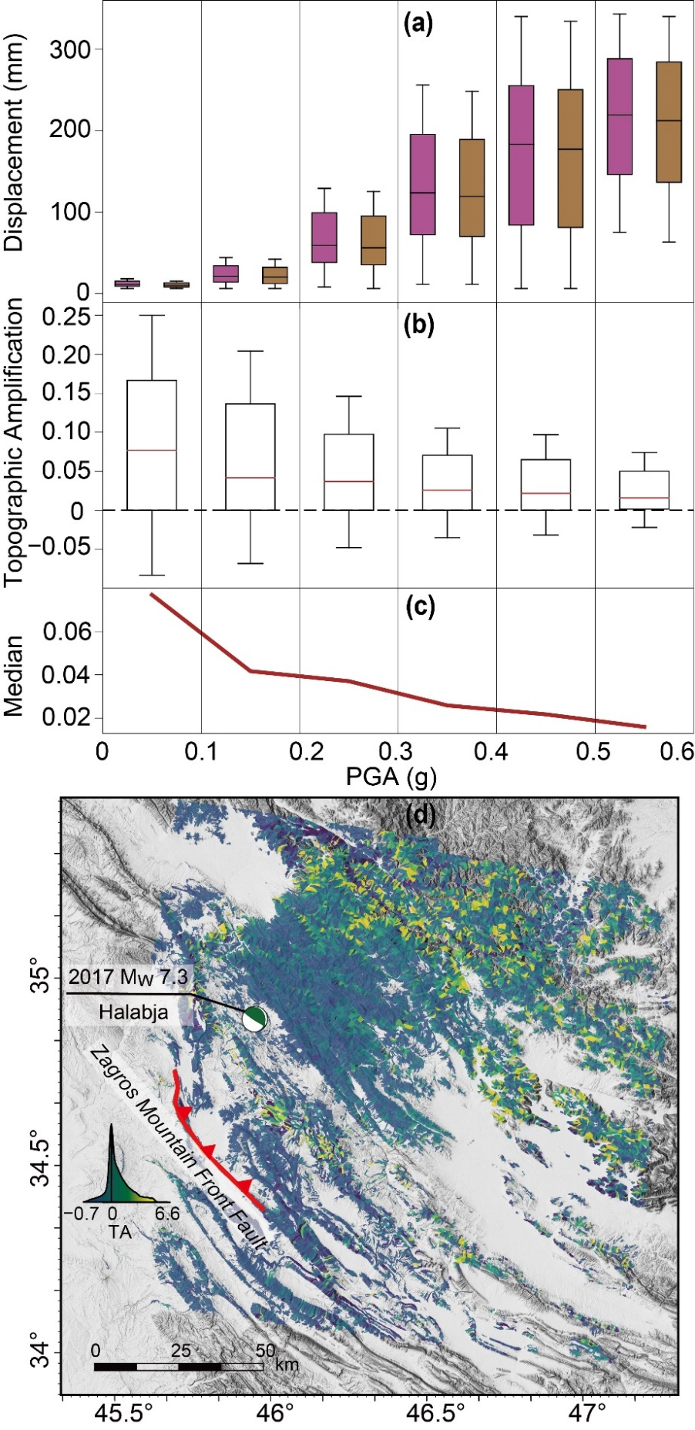
Supplementary Fig. 5 Coseismic deformation and topographic amplification in Halabja. (a) InSAR-derived permanent displacements for the upper and lower parts of SUs across PGA bins. (b) Distribution of TA values for each PGA bin. (c) Median TA variations across PGA bins, showing decreasing amplification with increasing shaking intensity. (d) Spatial distribution of TA across the study area.
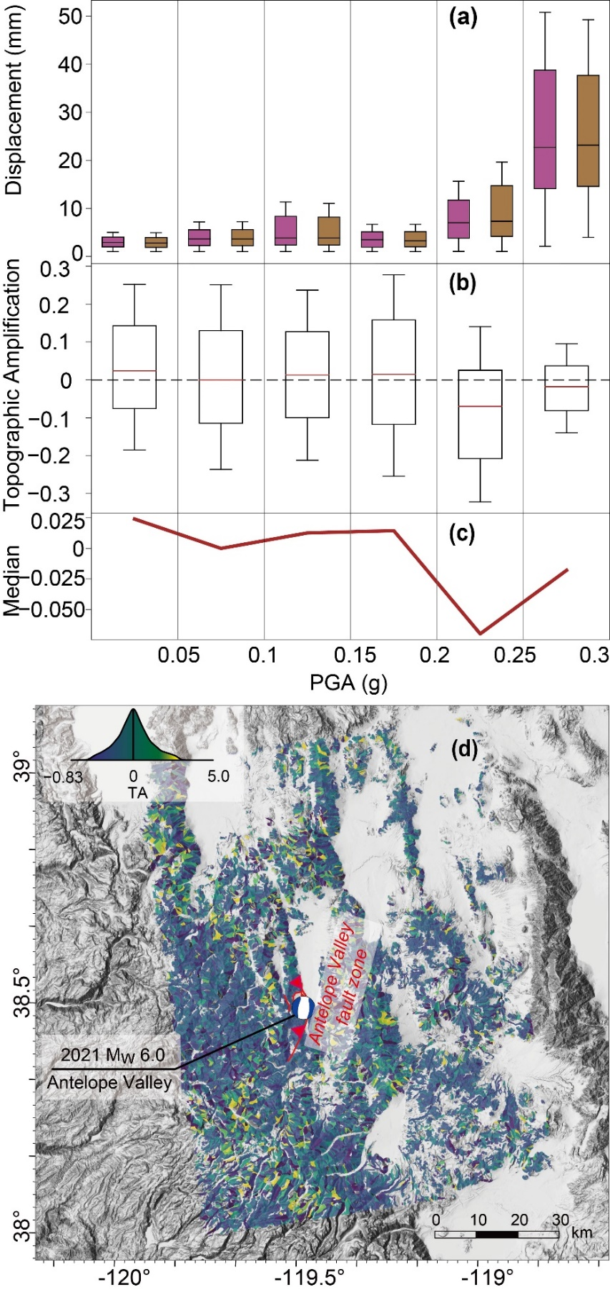
Supplementary Fig. 6 Coseismic deformation and topographic amplification in Antelope Valley. (a) InSAR-derived permanent displacements for the upper and lower parts of SUs across PGA bins. (b) Distribution of TA values for each PGA bin. (c) Median TA variations across PGA bins, showing decreasing amplification with increasing shaking intensity. (d) Spatial distribution of TA across the study area.

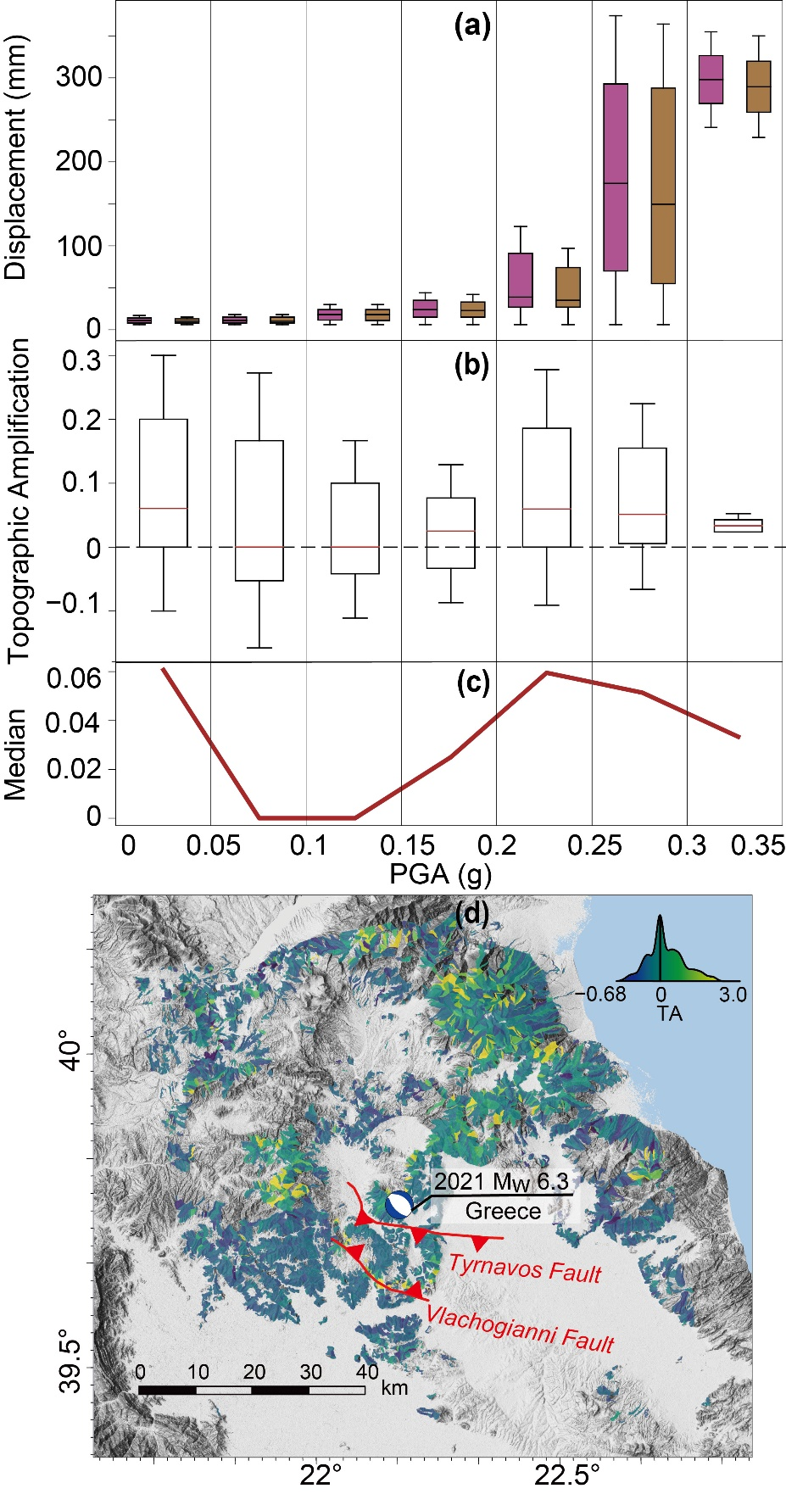
Supplementary Fig. 7 Coseismic deformation and topographic amplification in Greece. (a) InSAR-derived permanent displacements for the upper and lower parts of SUs across PGA bins. (b) Distribution of TA values for each PGA bin. (c) Median TA variations across PGA bins, showing decreasing amplification with increasing shaking intensity. (d) Spatial distribution of TA across the study area.
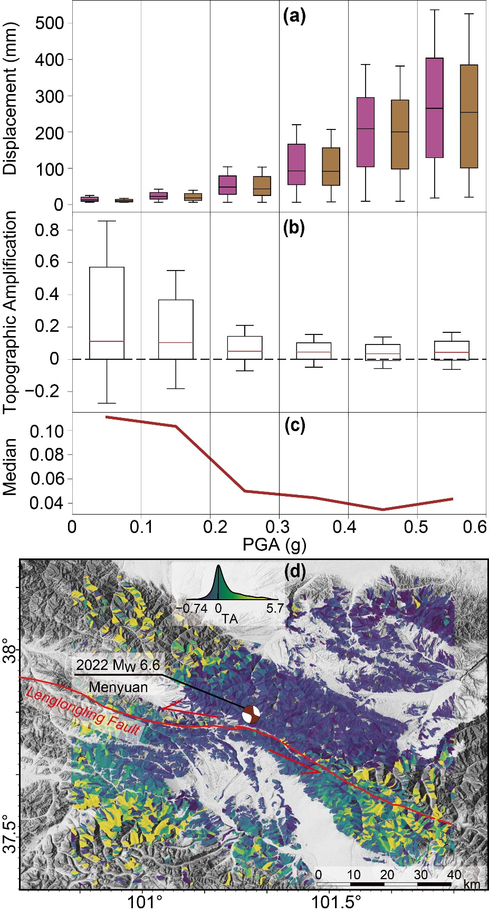
Supplementary Fig. 8 Coseismic deformation and topographic amplification in Menyuan. (a) InSAR-derived permanent displacements for the upper and lower parts of SUs across PGA bins. (b) Distribution of TA values for each PGA bin. (c) Median TA variations across PGA bins, showing decreasing amplification with increasing shaking intensity. (d) Spatial distribution of TA across the study area.
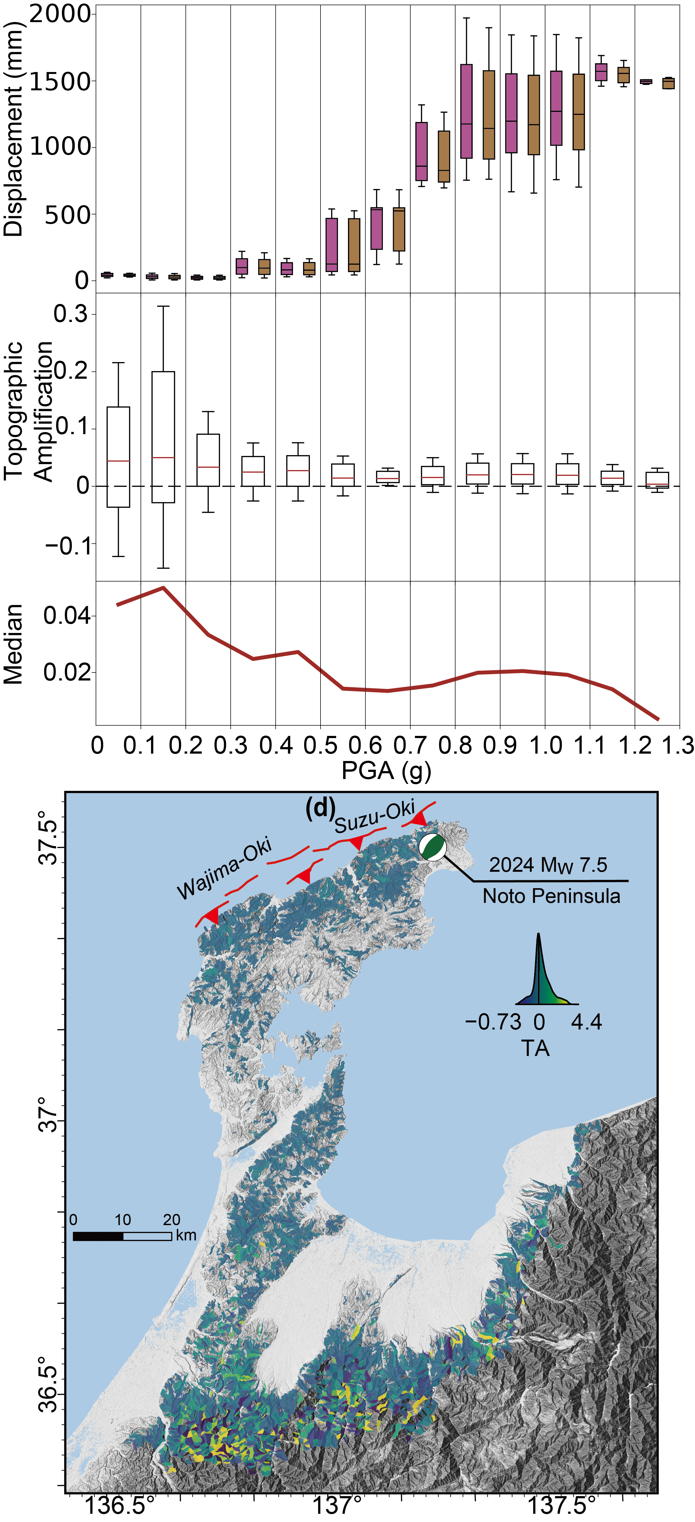
Supplementary Fig. 9 Coseismic deformation and topographic amplification in Noto Peninsula. (a) InSAR-derived permanent displacements for the upper and lower parts of SUs across PGA bins. (b) Distribution of TA values for each PGA bin. (c) Median TA variations across PGA bins, showing decreasing amplification with increasing shaking intensity. (d) Spatial distribution of TA across the study area.

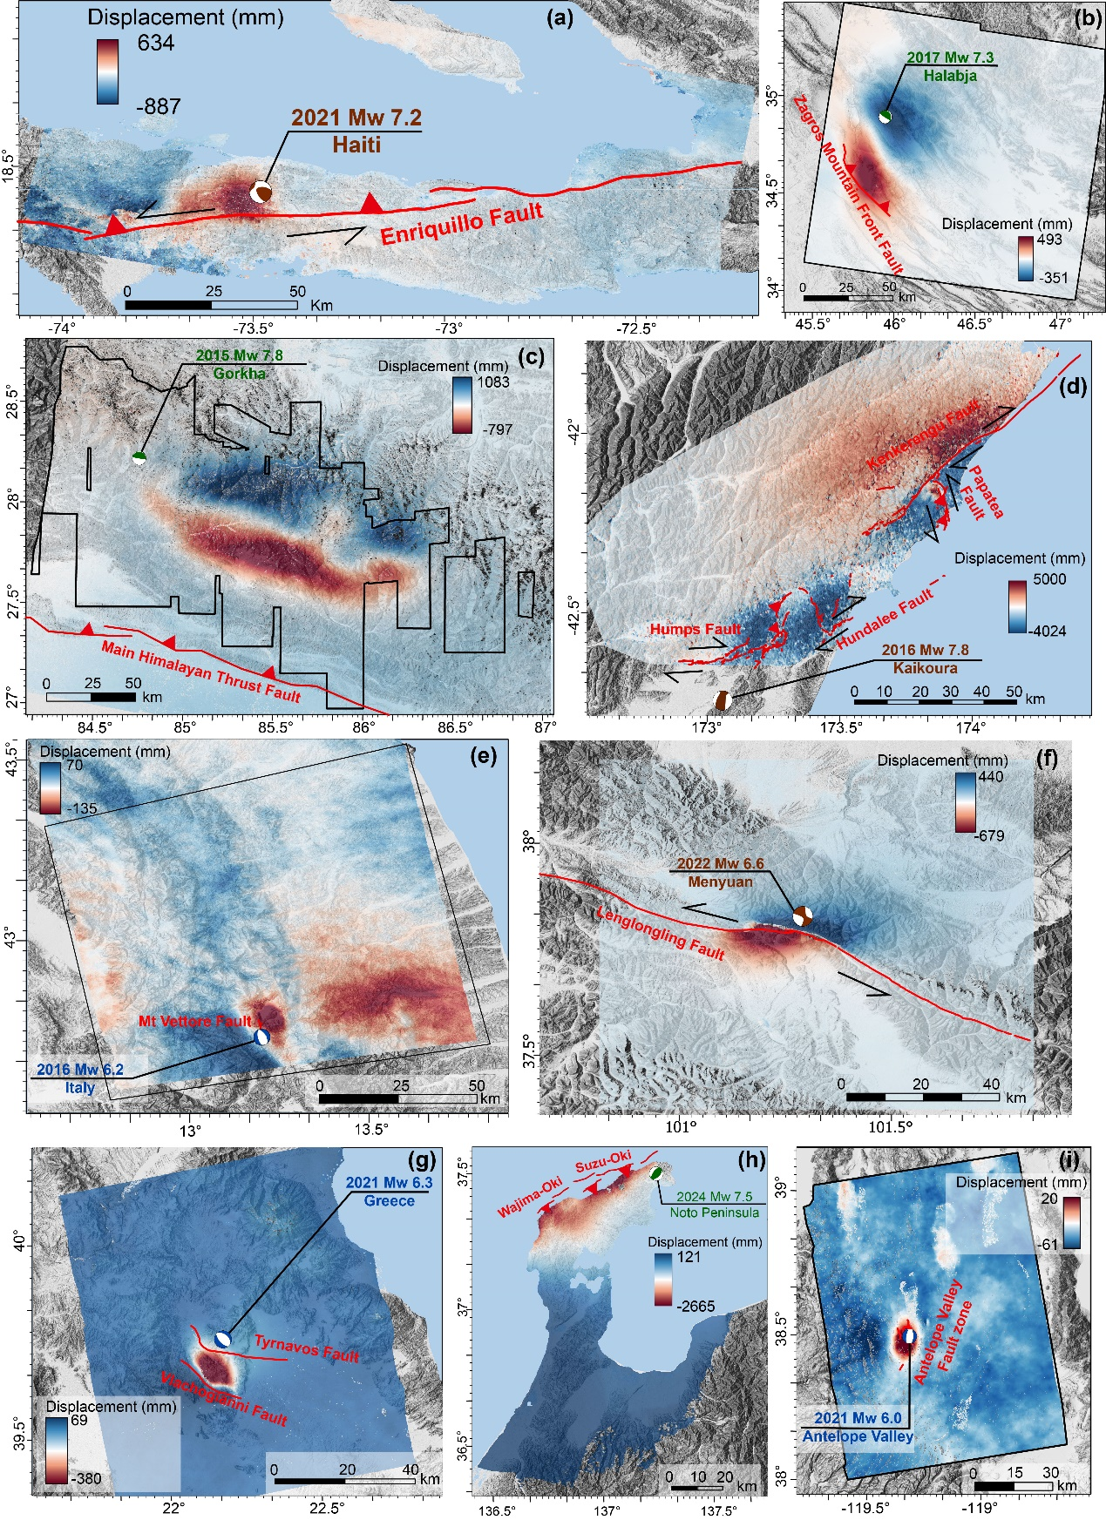
Supplementary Fig. 10 InSAR-derived coseismic displacement fields during nine earthquakes: (a) 2021 Haiti, (b) 2017 Halabja, (c) 2015 Gorkha, (d) 2016 Kaikōura, (e) 2016 Italy, (f) 2022 Menyuan, (g) 2021 Greece, (h) 2024 Noto Peninsula, (i) 2021 Antelope valley.

References
1. Styron, R. & Pagani, M. The GEM Global Active Faults Database. Earthq. Spectra 36, 160–180 (2020).
2. Koketsu, K. et al. Widespread ground motion distribution caused by rupture directivity during the 2015 Gorkha, Nepal earthquake. Sci. Rep. 6, 28536 (2016).
3. Lindsey, E. O. et al. Line‐of‐sight displacement from ALOS‐2 interferometry: M_{w} 7.8 Gorkha Earthquake and M_{w} 7.3 aftershock. Geophys. Res. Lett. 42, 6655–6661 (2015).
4. Lavecchia, G. et al. Host Faults Database of central Italy. Zenodo https://doi.org/10.5281/ZENODO.5603003 (2021).
5. Pucci, S. et al. Coseismic ruptures of the 24 August 2016, M_{w} 6.0 Amatrice earthquake (central Italy). Geophys. Res. Lett. 44, 2138–2147 (2017).
6. Langridge, R. et al. The New Zealand Active Faults Database. N. Z. J. Geol. Geophys. 59, 86–96 (2016).
7. Du, H. et al. Source complexity of the 2016 M_{W}7.8 Kaikoura (New Zealand) earthquake revealed from teleseismic and InSAR data. Earth Planet. Phys. 2, 1–17 (2018).
8. Babaie Mahani, A. & Kazemian, J. Strong ground motion from the November 12, 2017, M 7.3 Kermanshah earthquake in western Iran. J. Seismol. 22, 1339–1358 (2018).
9. Pollitz, F. F., Wicks, C. W. & Hammond, W. C. Kinematic Slip Model of the 2021 M 6.0 Antelope Valley, California, Earthquake. Seism. Rec. 2, 20–28 (2022).
10. Wang, K., Dreger, D. S., Burgmann, R. & Taira, T. Finite-Source Model of the 8 July 2021 M 6.0 Antelope Valley, California, Earthquake. Seismol. Res. Lett. (2023) doi:10.1785/0220220262.
11. Koukouvelas, I. K., Caputo, R., Nikolakopoulos, K. G., Kyriou, A. & Famiglietti, N. A. Is the Mesochori Fault a Key Structure for Understanding the Earthquake Activity during the 2021 Damasi Earthquakes in Northern Thessaly, Greece? Geosciences 13, 331 (2023).
12. Tolomei, C. et al. The Use of Interferometric Synthetic Aperture Radar for Isolating the Contribution of Major Shocks: The Case of the March 2021 Thessaly, Greece, Seismic Sequence. Geosciences 11, 191 (2021).
13. Li, K., Tapponnier, P., Xu, X. & Kang, W. The 2022, Ms 6.9 Menyuan earthquake: Surface rupture, Paleozoic suture re-activation, slip-rate and seismic gap along the Haiyuan fault system, NE Tibet. Earth Planet. Sci. Lett. 622, 118412 (2023).
14. Wu, X. et al. The China Active Faults Database (CAFD) and its web system. Earth Syst. Sci. Data 16, 3391–3417 (2024).
15. Xie, J. et al. Quantification of rupture directivity effects on strong ground motion during the 8 January 2022 MS6.9 Menyuan earthquake in Qinghai, China. Front. Earth Sci. 10, 1068536 (2023).
16. Liu, J. et al. Three-Dimensional Surface Displacements of the 8 January 2022 Mw6.7 Menyuan Earthquake, China from Sentinel-1 and ALOS-2 SAR Observations. Remote Sens. 14, 1404 (2022).
17. Inoue T. & Okamura Y. Explanatory notes of 1:200,000 marine geological map around the northern part of Noto Peninsula. S-1, (2010).
18. Ma, Z. et al. Slow rupture in a fluid-rich fault zone initiated the 2024 M_{w} 7.5 Noto earthquake. Science 385, 866–871 (2024).

