Pt-WO_{x}/TiO₂ catalyst for nitrogen oxide to ammonia reaction using H₂ reductant

Chandan Chaudhari,^{*a} Yuichi Manaka ^{*a,b} and Tetsuya Nanbaª

ªRenewable Energy Advanced Research Center, National Institute of Advanced Industrial Science and Technology (AIST), 2-2-9 Machiikedai, Koriyama, Fukushima, 963-0298 Japan
^{b}School of Materials and Chemical Technology, Institute of Science Tokyo, 2-12-1 Okayama, Meguro-ku, Tokyo, 152-8552 Japan
*Corresponding authors
Chandan Chaudhari and Yuichi Manaka
Email: chandan.chaudhari@aist.go.jp
Email: yuichi.manaka@aist.go.jp

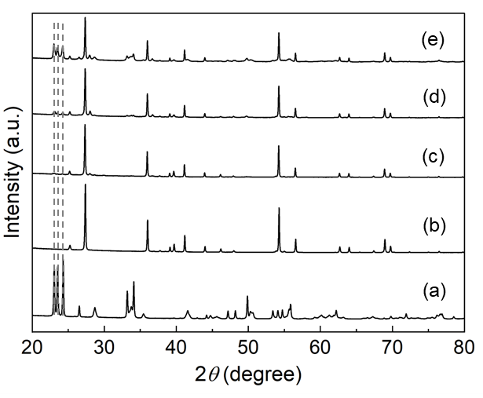
Fig. S1 XRD analysis of commercial WO₃ (a) and unreduced catalysts; Pt-1WO_{x}/TiO₂ (b), Pt-5WO_{x}/TiO₂ (c) Pt-10WO_{x}/TiO₂ (d) and Pt-20WO_{x}/TiO₂ (e)

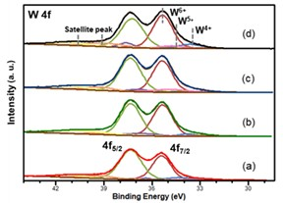

Fig. S2 XRS spectra of W 4f of Pt-1 wt% WO_{x}/TiO₂ (a), Pt-5 wt% WO_{x}/TiO₂ (b) Pt-10 wt% WO_{x}/TiO₂ (c) and Pt-20 wt% WO_{x}/TiO₂ (d)

Table S1 Percentage of the various oxidation states of WO₃ in WO_{x}-doped Pt/TiO₂ catalyst
Catalyst | W reduction degree (%) |  | W concentration
Catalyst |  |  | W⁶⁺ (%) | W⁵⁺ (%) | W⁴⁺ (%)
Pt-1 wt% WO_{x}/TiO₂ |  | 5 | 94.6 | 5.4 | -
Pt-5 wt% WO_{x}/TiO₂ |  | 6 | 94.0 | 0.9 | 5.1
Pt-10 wt% WO_{x}/TiO₂ |  | 12 | 91.2 | 2.1 | 6.7
Pt-20 wt% WO_{x}/TiO₂ |  | 14 | 87.7 | 5.4 | 6.9

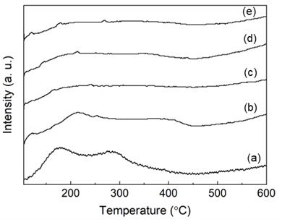

Fig. S3 NH₃-TPD Pt/TiO₂ (a) Pt-1 wt% WO_{x}/TiO₂ (b), Pt-5 wt% WO_{x}/TiO₂ (c) Pt-10 wt% WO_{x}/TiO₂ (d) and Pt-20 wt% WO_{x}/TiO₂ (e)

Table S2 Physiochemical properties of undoped Pt/TiO₂ and WO_{x}-doped Pt/TiO₂ catalyst

Catalyst | CO uptake  (mmol/g)ª |  | Desorbed NH₃  (mmol/g)^{b}
Pt-/TiO₂ |  | 0.269 | 0.046
Pt-1 wt% WO_{x}/TiO₂ |  | 0.005 | 0.057
Pt-5 wt% WO_{x}/TiO₂ |  | 0.002 | 0.049
Pt-10 wt% WO_{x}/TiO₂ |  | 0.001 | 0.044
Pt-20 wt% WO_{x}/TiO₂ |  | 0 | 0.041

ªCO-Chemisorption
^{b}NH₃-TPD

