Supplementary Information for
Asymmetric Plant Polyphenol Linkers Enable Robust Metal–Organic Frameworks with Structural Heterogeneity

Zijun Zhu,¹ Tong Shao,^{1,} Lantao He¹, Jun Deng², Yang Chu², Xuemei Zhou², Jiajing Zhou^{1,3}, Shaojian Lin¹, Jianwu Lan¹, Jiaojiao Shang^{1,3,}*
1 College of Biomass Science and Engineering, Sichuan University, Chengdu, Sichuan 610065, China
2 School of Chemical Engineering, Sichuan University, Chengdu, Sichuan 610065, China
3 National Engineering Laboratory for Clean Technology of Leather Manufacture, Sichuan University, Chengdu, Sichuan 610065, China

*Correspondence to: Email: jiaoj.shang@scu.edu.cn (J.S.)

Contents
1. Supplementary Figures 3
2. Supplementary Tables 23
3. Supplemental References 27

1. Supplementary Figures

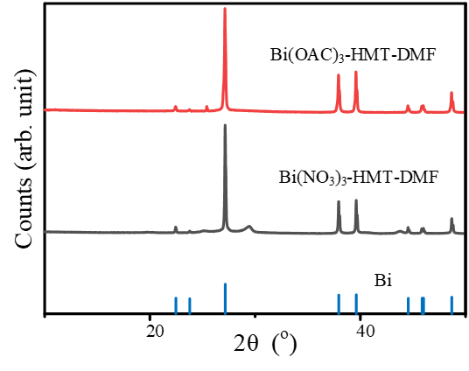
Figure S1. PXRD of products synthesized under the solvothermal conditions in DMF.

Figure S2. SEM and EDX patterns of products synthesized under the solvothermal conditions in DMF.

Figure S3. Coordination unit structure of SCU-1. O1, O2, and O3 are derived from HMT, O4 belongs to a water molecule, and O5 and O6 are coordinated oxygen.
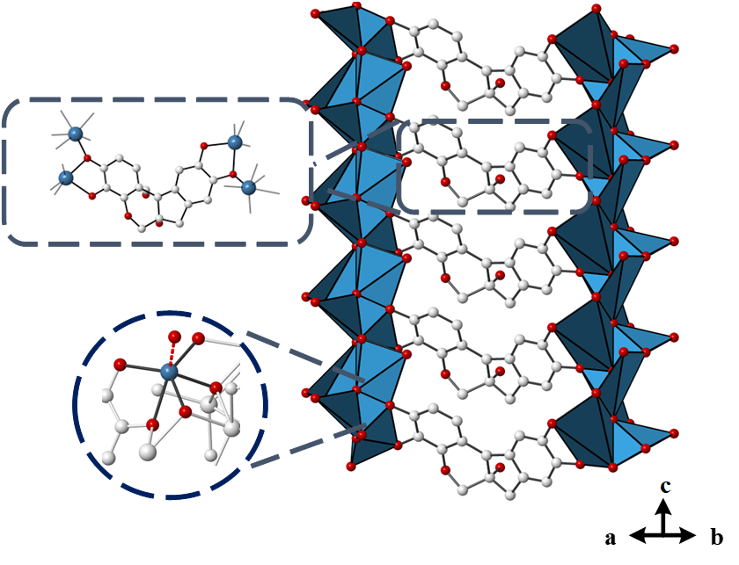
Figure S4. Chelation of HMT toward the bismuth oxo rods.

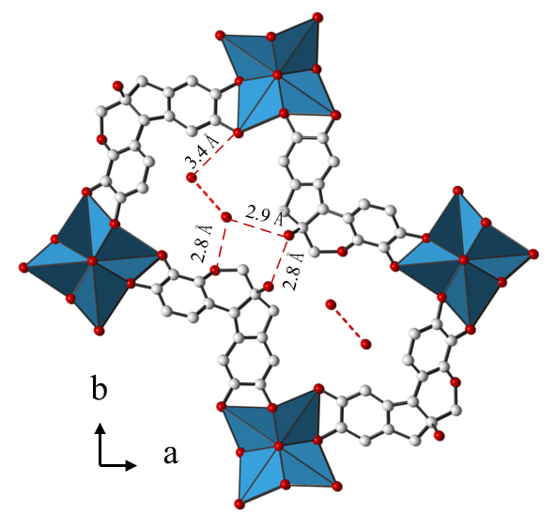
Figure S5. The observed hydrogen bond distances between the water molecules occupying the one-dimensional channels in SCU-1 and the hydroxyl oxygen and pyran oxygen of the HMT linker.

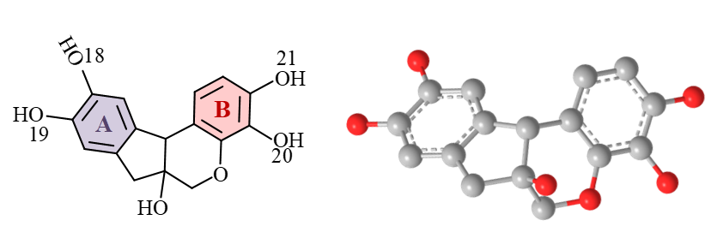
Figure S6. Structural formula of the HMT molecule and schematic diagram of the geometrically optimized molecular structure

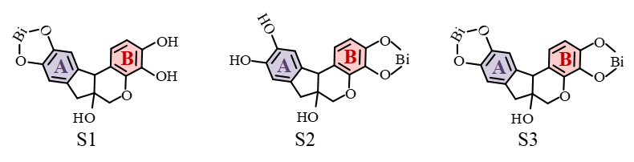
Figure S7. Proposed coordinated complexes of HMT and Bi³⁺ ions. Ring A and Ring B of HMT have different chemical environments.

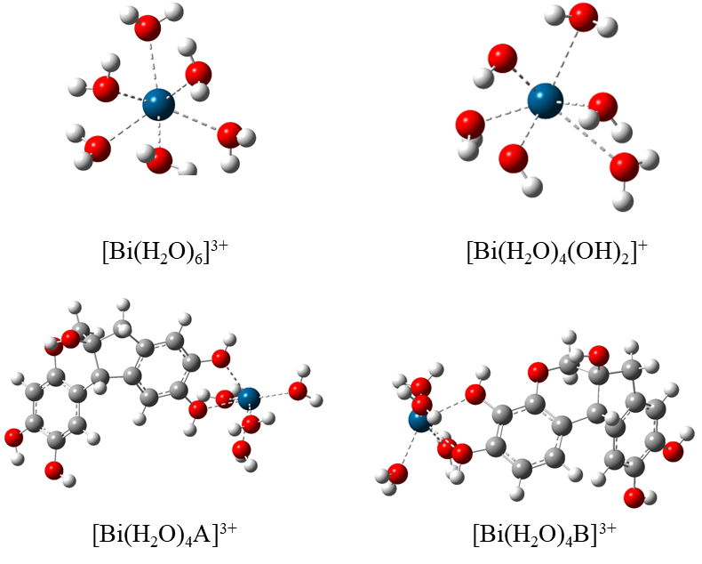
Figure S8. Optimized structure of different complexes

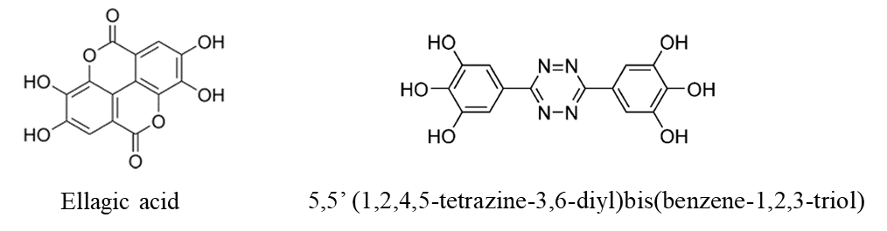
Figure S9. The structural formulas of ellagic acid and (1,2,4,5-tetrazine-3,6-diyl)bis(benzene-1,2,3-triol).
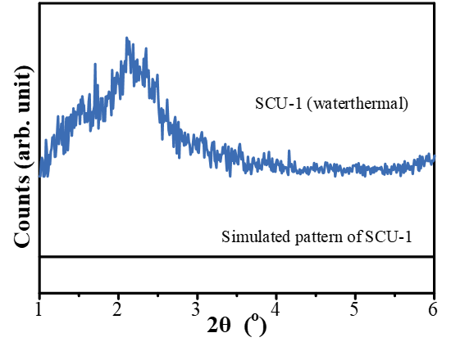
Figure S10. PXRD patterns of SCU-1 at the low 2θ region (1–6°).
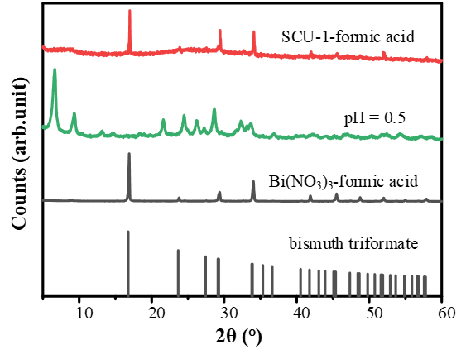
Figure S11. PXRD of: (1) SCU-1 stirred in formic acid, (2) sulfuric acid (at corresponding pH), (3) bismuth nitrate stirred in formic acid, and (4) the standard bismuthtris(formate) sample.

Figure S12. Cell viability of the B16 cell line after 24 h incubation with SCU-1, HMT, and bismuth acetate.

Figure S13. PXRD of SCU-1 after being stirred in aqueous solutions of L-cysteine and L-cystine, as well as patterns of the as-synthesized material and L-cystine for comparison.

Figure S14. Colloidal stability of SCU-1 in water (red) and RPMI (grey), representing ζ-potential evolution vs. time.

Figure S15. Ar adsorption-desorption isotherm of as-synthesized SCU-1, all recorded at liquid Ar temperature (87 K). The adsorption points are shown as solid symbols and the desorption points as hollow symbols. BET surface area 190 m²g⁻¹.

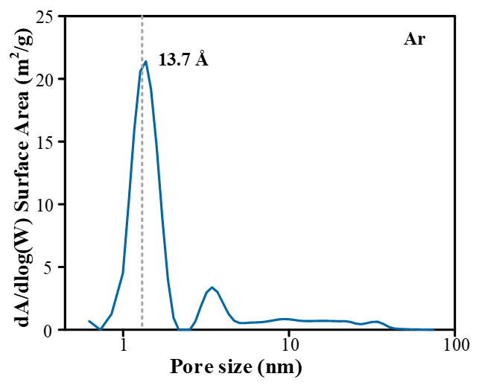
Figure S16. Pore size distribution as determined for SCU-1, using an Ar slit pore model. The dashed line is drawn at a pore-size value of 13.7 Å.

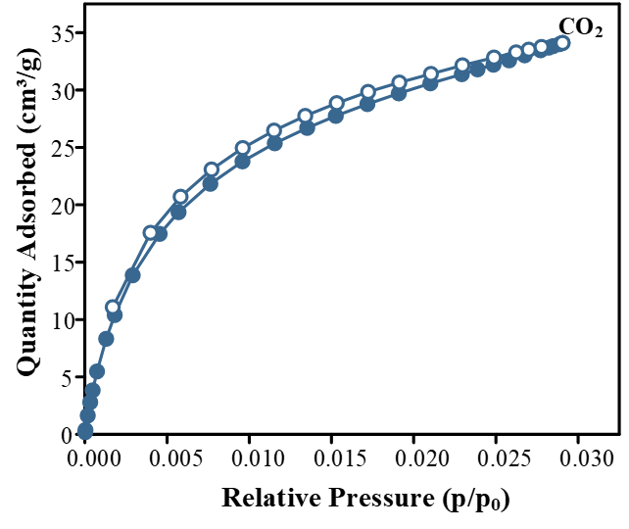
Figure S17. CO₂ adsorption/desorption isotherms of SCU-1 at 0 °C

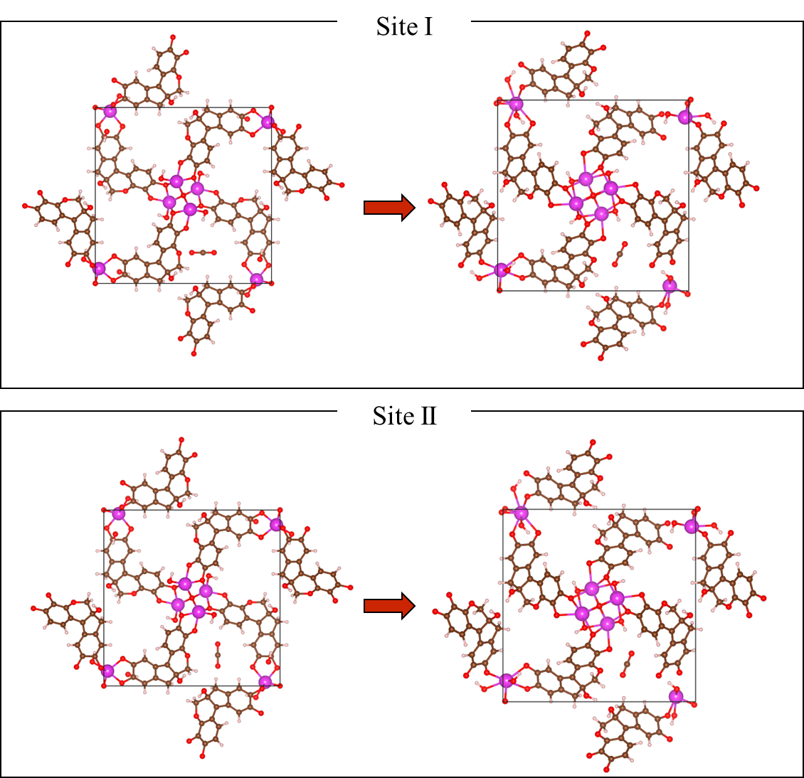
Figure S18. DFT-optimized structures of different CO₂ adsorption sites. Color code: red, O; gray, C; purple, Bi; light gray, H

Figure S19. HPLC signals for liquid products formed in the CO₂ reduction.

Figure S20. SEM and PXRD patterns of SCU-1 after 4 photocatalytic tests.

2. Supplementary Tables

Table S1. Crystallographic table for 3DED data of SCU-1.
Specimen | SCU-1
Crystal system | Tetragonal
Unit cell dimensions | a = 18.62  c = 5.54
Volume (Å³) | 1924 Å³
Z | 4
Rotation range | 73.48° (–54.98° to 18.50°)
Table S2. Crystallographic table for the structure refinement of SCU-1 against PXRD data.
Identification code | SCU-1
Crystal system | Tetragonal
Space group | P 4₂ (NO. 77)
Unit cell dimensions | a = 18.967 (19) Å  c = 5.666 (5) Å
Volume (Å³) | 2038.15 (500) Å³
Wavelength | 1.54060 Å
Refinement method | Profile method
Refinement statistics | R_{wp} = 3.69 %  GOF = 2.24

Table S3. The condensed Fukui function and dual descriptor (based on Hirshfeld population analysis) for the catechol moiety in HMT.
Different structures | condensed Fukui function | condensed dual descriptor
O18 | 0.08642320 | -0.05579429
O19 | 0.09422894 | -0.05761236
O20 | 0.00844601 | -0.00387382
O21 | 0.00479343 | -0.00106236

Table S4. Summary of the photocatalytic CO₂ reduction performance of Bi-based photocatalysts.
Catalysts | Reaction medium | light | Products (μmol g⁻¹ h⁻¹) | Refs.
SCU-1 (this work) | H₂O | Vis | C₂H₅OH: 50.13  CH₃OH: 26.08  HCOOH: 6.46 | This work
BP/Bi₂WO₆ Heterojunction | Benzylamine | UV-vis | CO: 12.4  CH₃OH: 8.6  C₂H₅OH: 61.3 | 1
Bi₁₉S₂₇Cl₃ | Na₂SO₃/Na₂S/H₂O | Vis | CO: 0.5  CH₄: 0.4  CH₃OH: 1.2 | 2
RP-Bi₂MoO₆ | H₂O | Vis | CH₄: 11.3  HCOOH: 20.1  CH₃OH: 31.2  C₂H₅OH: 51.8 | 3
Bi₄TaO₈Cl/Bi | H₂O | Vis | CH₃OH: 2.3  C₂H₅OH: 5.1 | 4
FAPbBr₃/Bi₂WO₆ | Benzyl alcohol | Vis | CO: 170 | 5
Bi₂WO₆-V | H₂O | UV−vis | CO: 3.7  CH_{4:} 9.95 | 6
Bi₂S₃/TiO₂/MoS₂ | NaHCO₃/HCl | UV-vis-NIR | CH₃OH: 29.7  C₂H₅OH: 25.6 | 7
Cu₄Pd-BTO | H₂O | 300 W Xe lamp | C₂H₅OH: 30.4 | 8
Bi@Bi₂MoO₆ | NaHCO₃ | Vis | CO: 0.85  CH₃OH: 0.59  C₂H₅OH: 17.93 | 9

3. Supplemental References

1. Zhang, M. et al. Coupling benzylamine oxidation with CO₂ photoconversion to ethanol over a black phosphorus and bismuth tungstate s‐scheme heterojunction. Angew. Chem. 135, e202302919 (2023).
2. Das, K. et al. Intrinsic charge polarization in Bi₁₉S₂₇Cl₃ nanorods promotes selective C-C coupling reaction during photoreduction of CO₂ to ethanol. Adv. Mater. 35, 2205994 (2023).
3. Das, R., Das, K., Ray, B., Vinod, C. P. & Peter, S. C. Green transformation of CO₂ to ethanol using water and sunlight by the combined effect of naturally abundant red phosphorus and Bi₂MoO₆. Energy Environ. Sci. 15, 1967–1976 (2022).
4. Songmei, Li. et al. Bi₄TaO₈Cl/Bi heterojunction enables high-selectivity photothermal catalytic conversion of CO₂-H₂O flow to liquid alcohol. Chem. Eng. J. 435, 135133 (2022).
5. Huang, H. et al. Direct Z-scheme heterojunction of semicoherent FAPbBr₃/Bi₂WO₆ interface for photoredox reaction with large driving force. ACS Nano 14, 16689–16697 (2020).
6. Lu, C. et al. Constructing surface plasmon resonance on Bi₂WO₆ to boost high-selective CO₂ reduction for methane. ACS Nano 15, 3529–3539 (2021).
7. Alkanad, K. et al. Construction of Bi₂S₃/TiO₂/MoS₂ S-scheme heterostructure with a switchable charge migration pathway for selective CO₂ reduction. Sol. RRL 5, 2100501 (2021).
8. Cheng, T. et al. Tandem synergistic catalysis on Cu-Pd/Bi₄Ti₃O₁₂ nanorods promoting highly selective photoconversion of CO₂ to ethyl alcohol. Inorg. Chem. 64, 5455–5462 (2025).
9. Zhao, D., Xuan, Y., Zhang, K. & Liu, X. Highly selective production of ethanol over hierarchical Bi@Bi₂MoO₆ composite via bicarbonate-assisted photocatalytic CO₂ reduction. ChemSusChem 14, 3293–3302 (2021).

