Supplemental materials for: School Performance Explains Socioeconomic Differences in Mental Health (Nordmo, Melby-Lervåg, Torvik)
This supplementary text provides additional methodological details to support the findings presented in the main manuscript.
Supplementary Figure 1: Distribution of GPA Scores
To assess Grade Point Average (GPA) in a format close to its original scale for survival analysis, continuous GPA scores were rounded to the nearest integer, ranging from 1 to 60. To ensure statistical reliability, bins containing fewer than 500 individuals were excluded, resulting in a truncated score range of 15 to 59 used for the analysis shown in Supplemental Figure 3.

Supplementary Figure 1

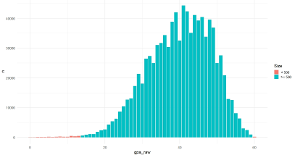
Supplementary Figure 2: Cohort Follow-up and Age Distribution
This figure illustrates the age of each birth year cohort (1985–2000) for every year that primary care data was available (2006–2024). To maximize data utility, the study focused on mental disorder diagnoses received between age 17 and adulthood. The specific follow-up duration for each cohort was determined by the availability of registry data.

Supplementary Figure 2

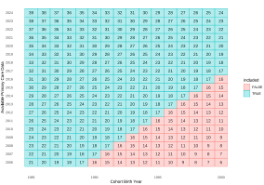

Supplementary Figure 3: Typical Mental Health Diagnoses
Supplemental Figure 3 replicates Figure 3 using GPA rounded to the nearest integer. After excluding bins with fewer than 500 individuals (range 15–59), a robust linear association is observed. This contrasts with the percentile-based analysis, where risk appears accelerated at the lower end. This divergence is an inherent property of the rank-view of GPA: because raw GPA is normally distributed, transforming it to a uniform percentile scale 'stretches' the tails of the distribution. The steepening observed in the percentile analysis thus reflects the greater outcome variation associated with shifting rank positions at the extremes of the distribution. Further technical details regarding this distributional transformation are provided in the supplemental materials.
Supplemental Figure 3
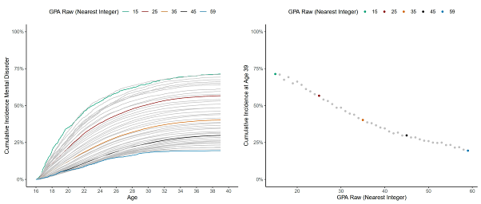

Supplementary Figure 4: Typical Mental Health Diagnoses
This figure displays the distribution of the most common mental health diagnoses recorded during the follow-up period, counting only the first diagnostic event for each individual. The data reflect general incidence trends for young adults, with anxiety and depression accounting for the largest proportion of primary care visits.
Supplemental Figure 4
What diagnoses are most typical across the follow-up period. We only count the first diagnosis event.
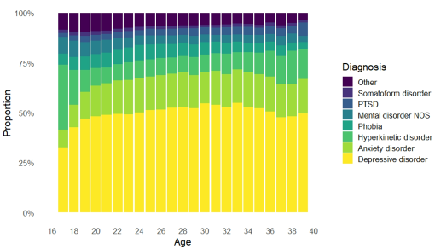

Predictor | Estimate | Std. Error | t | p | 95% CI Lower | 95% CI Upper
GPA Quartile 3 | 0.194 | 0.0056 | 34.8 | < .001 | 0.183 | 0.205
GPA Quartile 2 | 0.439 | 0.0053 | 82.2 | < .001 | 0.429 | 0.450
GPA Quartile 1 | 0.873 | 0.0051 | 173.0 | < .001 | 0.863 | 0.883
Income Quartile 3 | 0.159 | 0.0053 | 30.2 | < .001 | 0.149 | 0.169
Income Quartile 2 | 0.309 | 0.0051 | 60.4 | < .001 | 0.299 | 0.319
Income Quartile 1 | 0.567 | 0.0050 | 114.0 | < .001 | 0.557 | 0.577
Parental Education: Bachelors | 0.143 | 0.0061 | 23.3 | < .001 | 0.131 | 0.155
Parental Education: Upper Secondary | 0.302 | 0.0059 | 51.4 | < .001 | 0.290 | 0.313
Parental Education: Compulsory | 0.493 | 0.0069 | 71.0 | < .001 | 0.479 | 0.507
Following the individual assessments, a multivariate model was constructed to simultaneously incorporate parental education, parental income, and GPA. This approach allows for the estimation of the independent effect of each predictor while controlling for the presence of the others, thereby clarifying the relative contribution of each socioeconomic and academic factor to the hazard of developing a mental disorder. In both the bivariate and multivariate outputs, the estimates represent the log-relative hazard for each category compared to the reference group. A positive estimate indicates an increased hazard of diagnosis relative to the reference, while a negative estimate suggests a protective effect or a lower hazard once other variables are accounted for in the model.

Predictor | Estimate | Std. Error | t | p | 95% CI Lower | 95% CI Upper
GPA Quartile 3 | 0.176 | 0.0056 | 31.3 | < .001 | 0.165 | 0.187
GPA Quartile 2 | 0.399 | 0.0055 | 72.3 | < .001 | 0.388 | 0.410
GPA Quartile 1 | 0.792 | 0.0055 | 145.0 | < .001 | 0.781 | 0.803
Income Quartile 3 | 0.082 | 0.0054 | 15.2 | < .001 | 0.072 | 0.093
Income Quartile 2 | 0.167 | 0.0055 | 30.2 | < .001 | 0.156 | 0.177
Income Quartile 1 | 0.342 | 0.0056 | 60.8 | < .001 | 0.331 | 0.353
Parental Education: Bachelors | -0.020 | 0.0064 | -3.17 | .002 | -0.033 | -0.008
Parental Education: Upper Secondary | -0.066 | 0.0065 | -10.1 | < .001 | -0.079 | -0.053
Parental Education: Compulsory | -0.034 | 0.0078 | -4.40 | < .001 | -0.050 | -0.019

R demonstration comparing GPA as Percentile and Integer
Using a simple demonstration in R, we can show that the relationship between two bivariate normal variables becomes predictably non-linear when one is transformed into a percentile-based rank scale. While rounding GPA to the nearest integer is a necessary discretization step for visualization of survival models, the rank-based scale provides a distinct conceptual lens. In all educational and vocational contexts, outcomes are contingent on relative standing rather than absolute scores. From this 'rank-view,' GPA serves as a proxy for competitive position; the accelerated trends observed at the distribution’s extremes thus reflect the positional dynamics inherent in academic and professional selection.
# Generate data  x <- rnorm(200)  y <- x  # Plot Relationship  plot(x, y, main = "Raw Data") | # Plot Percentiles X  x_perc <- dplyr::ntile(x, 100)  plot(x_perc, y, main = "X as Percentiles")
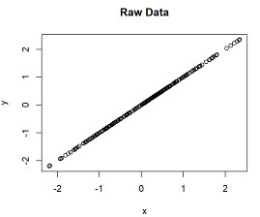 | 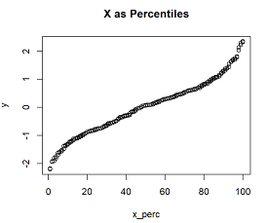
R Script for Analysis and Plots
The datasets analyzed in this study are derived from national Norwegian administrative registries and contain sensitive individual-level information covering the entire population. Due to strict legal and ethical protections under the Norwegian Health Research Act and the General Data Protection Regulation, the data cannot be made publicly available or shared with external parties.
Survival Models
The following sections provide the statistical foundations for the cox models presented in Figure 4. This analysis comprises three distinct bivariate models and a single multivariate model, utilizing Cox proportional hazards regression to evaluate the association between specific predictors and the timing of mental disorder diagnoses. In the bivariate framework, the relationship between the outcome and three independent variables—parental education, parental income, and GPA—is assessed individually. These models provide a baseline measure of the association for each factor without adjustment for potential confounding variables. The R code is the following:
library(survival)
# Bivariate
coxph(Surv(duration,diagnosis)~parental_education,data = dat)
coxph(Surv(duration,diagnosis)~parental_income,data = dat)
coxph(Surv(duration,diagnosis)~gpa,data = dat)
# Multivariate
coxph(Surv(duration,diagnosis)~parental_education+parental_income+gpa,data = dat)

Plots
library(tidyverse)
library(survival)
library(ggsurvfit)
# Survival Model
a <- Surv(time = dat$duration_yrs, event = dat$diag)
survplot <- survfit2(a ~ gpa_raw, data = dat) |>
ggsurvfit(linewidth = 1)
# Survival Plot
a <- ggplot(dat, aes(time, color = color_strata, estimate, group = strata)) +
geom_path() +
scale_x_continuous(breaks = seq(16, 40, 2),
limits = c(16, 40)) +
scale_y_continuous(labels = scales::percent,
limits = c(0, 1)) +
scale_color_manual(values = c("15" = "#009E73",
"25" = "red4",
"35" = "#D55E00",
"45" = "#000000",
"59" = "#0072B2",
"Other" = "grey"),
breaks = c("15", "25", "35", "45", "59")) +
labs(y = "Cumulative Incidence Mental Disorder",
x = "Age",color = "GPA Raw (Nearest Integer)") +
guides(linewidth = "none", alpha = "none", group = "none") +
theme_classic(base_size = 12) +
theme(legend.position = "top")

b <- ggplot(dat_end, aes(strata, estimate, color = color_strata)) +
geom_point() +
scale_y_continuous(limits = c(0, 1),
labels = scales::percent) +
scale_color_manual(values = c("15" = "#009E73",
"25" = "red4",
"35" = "#D55E00",
"45" = "#000000",
"59" = "#0072B2",
"other" = "grey"),
breaks = c("15", "25", "35", "45", "59")) +
guides(size = "none") +
labs(x = "GPA Raw (Nearest Integer)",
y = "Cumulative Incidence at Age 39",
color = "GPA Raw (Nearest Integer)") +
theme_classic(base_size = 12) +
theme(legend.position = "top")
# Combine the plots
a + b
# Save the output
ggsave(here::here("plots", "survival_gpa.pdf"), width = 14, height = 6)

