Supplementary material.
Online Resource 1. Microsatellite marker development for the ocellated lizard (Timon lepidus)
Here we describe 15 new microsatellite markers developed from individual ocellated lizards collected in southern France.
48 microsatellite marker candidates were developed at Microsynth (Balgach, Switzerland), based on DNA extracted from tissues from an individual sampled in a nearby population to the Cadarache study area (Plaine de la Crau, Fig. S1). An Illumina TruSeq nano DNA library was sequenced on an Illumina MiSeq sequencing platform using a nano v2 500 cycles sequencing chip. The resulting paired-end reads which passed Illumina’s chastity filter were subject to demultiplexing and trimming of Illumina adaptor residuals. Subsequently the quality of the surviving reads was checked with the software FastQC v0.11.8. In a next step the paired-end reads were quality filtered and merged with the software USEARCH v11.0.667 to in-silico reform the sequenced molecules. The resulting merged reads were screened with the software Tandem Repeats Finder, v4.09. After this process, 36.914 merged reads contained a microsatellite insert with a tetra- or a trinucleotide of at least six repeat units or a dinucleotide of at least ten repeat units. Primer design was performed with primer 3. A suitable primer design was possible for 25.489 microsatellite candidates.
Individual tests for amplification and polymorphism were assessed for 48 of the microsatellites inserts with suitable primers, using DNA from 6 samples from the Plaine de la Crau (Bouches du Rhône) and 1 from the Var (Fig. S1).
Those 8 samples (1 for library preparation + 1 for polymorphism assessment) were taken from tissues of individuals of the BEV collection (“Biogéographie et Ecologie des Vertébrés” collection” housed at the Centre d’Ecologie Fonctionnelle et Evolutive (CEFE) in Montpellier, France), preserved at 4°C in 96% ethanol. DNA was extracted with the QIAGEN DNeasy® Blood & Tissue kit N° 69506, following the manufacturer's protocol (Qiagen, Hilden, Germany), and eluated and stored in the AE buffer from the kit.
The PCR protocol for the polymorphy test was performed in a total volume of 10 μl using a mix of 3 μl distilled water, 5 μl HOT FOREPol MultiPlex Mix (stock concentration 10 x; Solis BioDyne catalog no. 04-34-00120), 1.5 μl of each the forward and reverse primer (stock concentration 2 μM; the forward primer was FAM-labeled), and 2 - 10 ng of genomic DNA (stock concentration 1-5 ng/μl). The cycling protocol started with an initial denaturation step of 12 min at 95°C, followed by 35 cycles with 20 s at 95 °C, 50 s at 60 °C, and 120 s at 72 °C, and ended with a final extension step of 5 min at 72 °C. Allele calling was based on the pattern detected by an ABI3730, using GeneScanTM 500 LIZ Size Standard.
Based on the profiles of the 48 candidates, 15 loci were multiplexed in three reactions (5 loci each) using four different fluorescent dye. The multiplex PCR amplification was performed in a total volume of 10 μl using a mix of 1.5 μl double distilled water, 5 μl Multiplex Master Mix (stock concentration 2 x; Qiagen catalog no. 206143), 0.3 μl of each the forward and reverse primer (stock concentration 10 μM), and 2 - 10 ng of genomic DNA (stock concentration 1-5 ng/μl). The cycling protocol started with a prolonged denaturation step of 15 min at 95°C, followed by 35 cycles with 30 s at 94 °C, 90 s at 56 °C, and 60 s at 72 °C, and ended with a final extension step of 30 min at 72 °C. Amplifications were performed on a Programmable Thermal Controller (Sensoquest Labcycler), and the PCR products were run on an ABI 3730 DNA Analyzer (Thermo Fisher Scientific).
These 15 loci were then tested on a set of 16 feces samples from Cadarache (Fig.1), using the same multiplexing PCR protocol and material. Those samples were fresh, preserved in 70% ethanol immediately following collection and then frozen at -20C. DNA isolation was performed using a modified Qiagen QIAamp DNA Stool Kit, by Microsynth in Balgach, Switzerland.
The characteristics of the 15 microsatellite loci are provided in Online Resource 2, together with the primer dilution protocols.

Online Resource 1. Localization of the genetic samples used for microsatellite development collected in (left) Plaine de la Crau national reserve (Bouches du Rhône department) and (right) Var department. The location of the Cadarache study area is also shown for information.
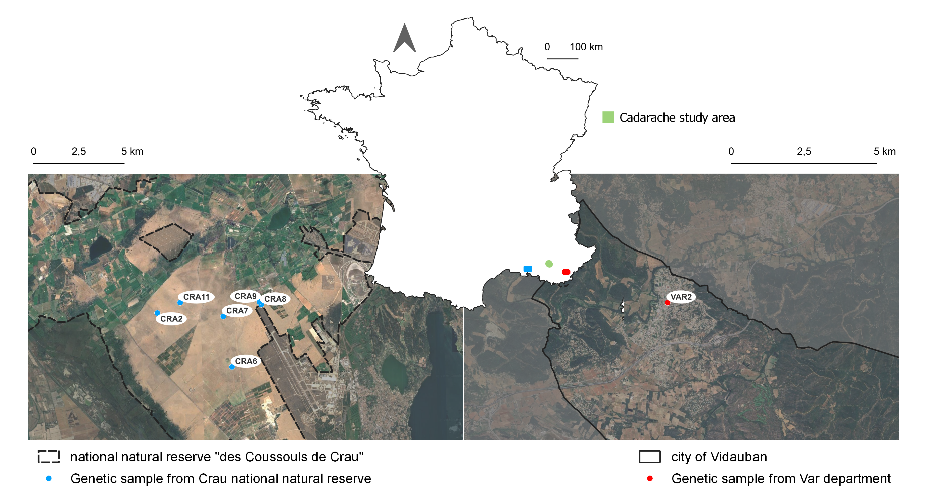
Online Resource 2. Microsatellite loci characterized for the ocellated lizard (Timon lepidus) and distributed across three multiplex assays. The size range (in bp) and number of alleles (A₇) were originally identified in seven genotyped individuals.
Locus | Primer sequences (5' to 3') | Repeat motif | Size range | Multiplex Assay | Fluoresc. Dye | Labelled F-primer (µl) | Unlabelled F-primer (µl) | Unlabelled R-primer (µl) | ddH20 (µl) | Final concentr. | A₇ | Genbank Acc. No
TL_303574 | F: CAT TTC TGT GGG AAA ACG CC  R: GCA TGA CAG GCT ATT GTA ATG TC | (AAGG)11 | 107-122 | 1 | FAM | 0.5 | 4.5 | 5 | 40 | 10 µM total F  10 µM total R | 4 | PZ051614
TL_361715 | F: CTG TTT CAA TGG AAG CCA ACA C  R: TGG AAT CCC AGC CAG TAA CC | (AAG)18 | 138-171 | 1 | ATTO532 | 0.5 | 4.5 | 5 | 40 | 10 µM total F  10 µM total R | 5 | PZ051615
TL_684747 | F: GGG TTG GGG ACT TAA GGC AG  R: GCA AGT CCT AAT TGC GGG TG | (CTTC)7 | 197-229 | 1 | ATTO550 | 0.5 | 4.5 | 5 | 40 | 10 µM total F  10 µM total R | 3 | PZ051616
TL_265456 | F: TCT TGT AGG GAA CAC AGC CC  R: TTT ACT GCC ATT CAG TTC CAC | (CCTT)12  (TC)13 | 101-125 | 1 | ATTO550 | 0.5 | 4.5 | 5 | 40 | 10 µM total F  10 µM total R | 4 | PZ051617
TL_966180 | F: CAG TGG CCA TAA AGC TCA CC  R: ATG TTA GCC ACT CTG AGC CC | (TAA)8 | 128-137 | 1 | ATTO565 | 0.5 | 4.5 | 5 | 40 | 10 µM total F  10 µM total R | 3 | PZ051618
TL_1079095 | F: TCC TGC AAA GTG AAA TAG AAG GC  R: GAA GTA AAT GGC CCT GCA CC | (ATAC)7 | 132-141 | 2 | FAM | 1 | 4 | 5 | 40 | 10 µM total F  10 µM total R | 4 | PZ051619
TL_276028 | F: ACT CCA GCA AAG TGG TAG ATA AAG  R: TCA GTG GGG CGT AAG ACA TC | (CCTT)11 | 148-164 | 2 | ATTO532 | 1 | 4 | 5 | 40 | 10 µM total F  10 µM total R | 3 | PZ051620
TL_619091 | F: TGA TTA CTC GTT CAG GAG CAG  R: GTG GGG AAA CAG CTT CAT GG | (ATA)10 | 177-186 | 2 | ATTO550 | 2.5 | 2.5 | 5 | 40 | 10 µM total F  10 µM total R | 4 | PZ051621
TL_742562 | F: GGG AAC ATC ATC TAA ACT TTG CG  R: GGA CTC CAA TGT GGA AGC AAT C | (GAAA)9 | 116-124 | 2 | ATTO550 | 0.5 | 4.5 | 5 | 40 | 10 µM total F  10 µM total R | 3 | PZ051622
TL_1006729 | F: CAG CTT TAT TCC CAC AGT AAT GG  R: TAG CAA CGT ATT TGC CGC TG | (TTA)10 | 126-141 | 2 | ATTO565 | 0.5 | 4.5 | 5 | 40 | 10 µM total F  10 µM total R | 3 | PZ051623
TL_750235 | F: TTA GGT GAA GCC CAC CCA TC  R: AGC CTC CTT GGA ACA TAA AGG | (ATTT)11 | 128-146 | 3 | FAM | 2.5 | 2.5 | 5 | 50 | 10 µM total F  10 µM total R | 5 | PZ051624
TL_741815 | F: GTC CAA CAG CAT CTG AAG GC  R: GCA AAT GTA CAC GCT TCA CC | (TGA)13 | 156-181 | 3 | ATTO532 | 0.5 | 4.5 | 5 | 40 | 10 µM total F  10 µM total R | 4 | PZ051625
TL_985672 | F: GTC TCG TGC CAA CTG GAT TG  R: GGG AAG TGC AGA TCA CTA TAC G | (TCC)10 | 148-155 | 3 | ATTO550 | 0.5 | 4.5 | 5 | 40 | 10 µM total F  10 µM total R | 3 | PZ051626
TL_748432 | F: AGC TCA TGT AAA TCA TGT GAC TGG  R: TTG TGA AAT CCC CCA AAG CG | (TAA)10 | 85-94 | 3 | ATTO550 | 0.5 | 4.5 | 5 | 40 | 10 µM total F  10 µM total R | 4 | PZ051627
TL_1291540 | F: GTT TCT ATC TGA ATC CCC CAG C  R: GGA AGA CCA CCT TAT TCG GC | (CTT)11 | 130-157 | 3 | ATTO565 | 0.5 | 4.5 | 5 | 40 | 10 µM total F  10 µM total R | 3 | PZ051628

Online Resource 3. Summary of sample collection and microsatellite DNA amplification success by sample type. x is the number of loci that successfully amplified. The maximum number of loci was 14 because 1 of the 15 available loci had to be dismissed because of the presence of null alleles (see Results, 3.1).
Sample Type | Total (n) | x = 14 (%) | x ≥ 10 (%) | 1 ≤ x < 10 (%) | x = 0 (%)
Buccal | 142 | 99.3 | 0.0 | 0.7 | 0.0
Scat | 251 | 6.4 | 13.9 | 70.1 | 9.6
Moult | 18 | 11.1 | 11.1 | 55.6 | 22.2
Tissue | 6 | 100.0 | 0.0 | 0.0 | 0.0

Online Resource 4. Reliability checks of DNA genotyping from feces and moults
We sequentially performed several reliability checks to ensure that fecal and moult -based genotypes were reliable and could be integrated, together with our tissue- and saliva-based genotypes, into our analyses.
First, as a preliminary step preceding sampling campaigns, we used paired samples collected from the same individuals (buccal swabs, feces, and moult) to ensure fecal- or moult-based genotypes were consistent with their buccal-based counterparts from the same individual. Of the 11 initial pairs, only 8 could be compared, as three fecal samples failed to sufficiently amplify for comparison: 5 buccal/fecal pairs and 3 buccal/moult pairs. Among the 5 buccal/fecal pairs, the four fecal samples with >90% locus completion showed no mismatches with their buccal counterparts. The only mismatch occurred in the pair where the fecal sample had a 66% completion rate. For the buccal/moult pairs, we observed 1, 3, and 1 mismatches for moult samples with completion rates of 53.3%, 80%, and 100%, respectively.
Following the sampling campaign, we conducted several analyses to verify that the analyses relying on scat and moult-based genotypes did not differ systematically from those relying on buccal and tissue-based genotypes. Within the central-scale area (CSA), we selected 41 buccal and/or tissue samples and 41 scat and/or moult samples. These were paired geographically so that each sample of one type was matched with a nearby sample of the other type. Using this dataset of 82 samples, we performed a principal component analysis (PCA), a spatial PCA (sPCA), and an MLPE analysis to assess whether sample type influenced inferred genetic patterns. PCA was conducted using the dudi.pca function of the ade4 package, and samples were visualized along the first two principal components. No clustering by sample type was apparent (Online Resource 4a). We then used the spca function of the adegenet package to evaluate whether samples clustered along global or local components depending on sample type. The sPCA revealed a clear isolation-by-distance pattern, with individuals located close to one another being genetically similar, regardless of sample type (Online Resource 4b). Genetic distance was related to Euclidean distance using a GLS model with an MLPE correlation structure (function gls of the nlme package) to account for non-independence among pairwise comparisons, with pair type (buccal–buccal, buccal–fecal, fecal–fecal) used to define correlation groups. The model lacking the pair-type random effect showed the lowest AICc, indicating that incorporating sample type did not improve model fit (∆AICc = -166.834).

Online Resource 4a. PCA based on multilocus genotypes showing overlapping distributions of sample types (B = “buccal and/or tissue”; F = “fecal and/or moult”) along the first two principal components.
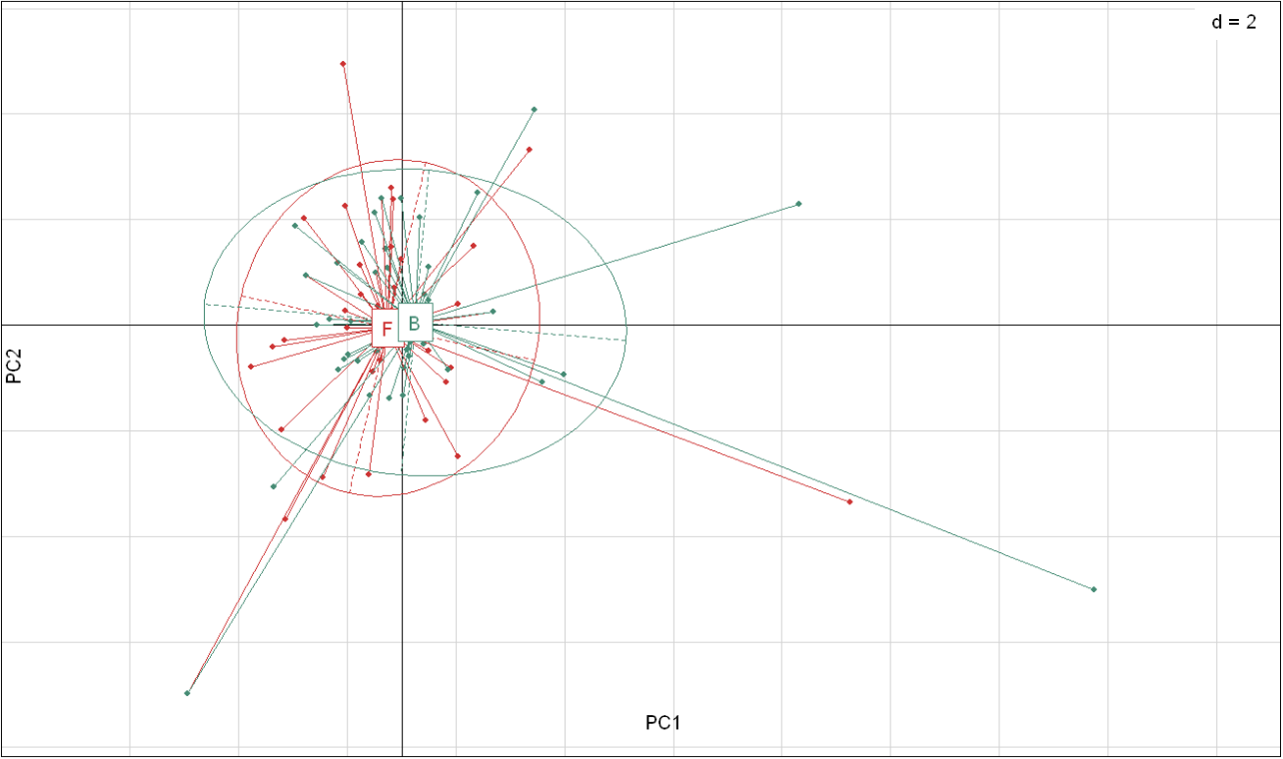
Online Resource 4b. Spatial principal component analysis (sPCA) exhibiting (upper) distribution of samples along the 2 principal components of the global structure, colors indicate the sign and magnitude of the combined sPC1–sPC2 scores (from negative in red to positive in green), and (lower) the distribution of the samples based on their type (B = “buccal and/or tissue”; F = “fecal and/or moult”).
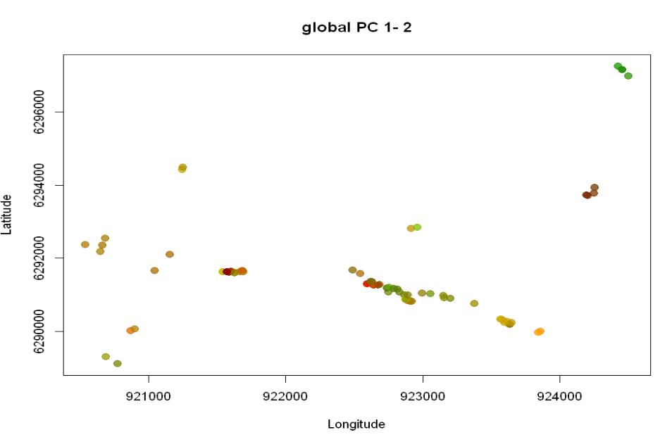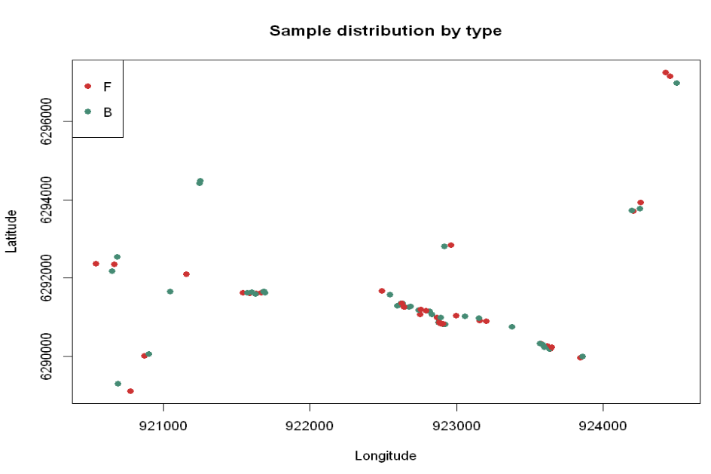

Online Resource 5a. Reclassification of original land-cover classes (CoSIA IGN, 2018-2023) into seven habitat-relevant thematic categories for Timon lepidus.
n | COSIA name | thematic class
1 | building | urban
2 | pervious area | urban
3 | impervious area | urban
4 | pool | urban
5 | bareground | bareground
6 | water surface | water
7 | coniferous | tree
8 | cutting | tree
9 | deciduous | tree
10 | shrub | shrub
11 | vineyard | shrub
12 | grassland | grassland
13 | farmland | agricultural
14 | ploughed land | agricultural
15 | greenhouse | agricultural
Online Resource 5b. Environmental variables (and their units, when relevant) used in analyses and their abbreviations as referenced throughout the manuscript.
variable name | abv.1 | abv.2
natural shelter occurrence probabilities | shelter | nat. shelt. occ. prob.
distance to river (m) | river
slope | slope
urban cover (%) | urban
bareground cover (%) | bareground
tree cover (%) | tree
shrub cover (%) | shrub
grassland cover (%) | grassland
agricultural cover (%) | agricultural
road cover (%) | road

Online Resource 6. Results of pairwise permutation tests for multilocus linkage disequilibrium. The index of association (ia), standardized index of association (r̄D), and corresponding p-value (p.) and FDR-adjusted (.adj) p-values are presented. A to O refer to loci TL_303574, TL_361715, TL_265456, TL_684747, TL_966180, TL_1079095, TL_276028, TL_742562, TL_619091, TL_1006729, TL_750235, TL_748432, TL_741815, TL_985672, TL_1291540 respectively.
loci.pair | Ia | p.Ia | r̄D | p.r̄D | p.r̄D.adj
A:C | -0.04 | 0.860 | -0.04 | 0.860 | 0.996
A:D | 0.03 | 0.190 | 0.04 | 0.180 | 0.696
A:E | 0.07 | 0.034 | 0.07 | 0.034 | 0.419
A:F | 0.00 | 0.550 | 0.00 | 0.550 | 0.975
A:G | 0.02 | 0.260 | 0.02 | 0.260 | 0.736
A:H | -0.02 | 0.750 | -0.02 | 0.750 | 0.996
A:I | 0.00 | 0.700 | 0.00 | 0.700 | 0.996
A:J | -0.05 | 0.900 | -0.05 | 0.900 | 0.996
A:K | 0.06 | 0.120 | 0.06 | 0.120 | 0.565
A:L | -0.02 | 0.610 | -0.02 | 0.610 | 0.996
A:M | 0.03 | 0.210 | 0.03 | 0.210 | 0.727
A:N | 0.11 | 0.020 | 0.12 | 0.026 | 0.419
A:O | -0.02 | 0.630 | -0.02 | 0.630 | 0.996
A:B | -0.02 | 0.750 | -0.02 | 0.760 | 0.996
C:D | -0.02 | 0.890 | -0.04 | 0.900 | 0.996
C:E | 0.06 | 0.064 | 0.06 | 0.064 | 0.498
C:F | -0.04 | 0.960 | -0.04 | 0.960 | 0.996
C:G | -0.03 | 0.850 | -0.03 | 0.850 | 0.996
C:H | 0.03 | 0.730 | 0.03 | 0.730 | 0.996
C:I | 0.15 | 0.002 | 0.15 | 0.002 | 0.105
C:J | 0.04 | 0.480 | 0.04 | 0.480 | 0.958
C:K | -0.02 | 0.760 | -0.02 | 0.760 | 0.996
C:L | -0.03 | 0.790 | -0.03 | 0.790 | 0.996
C:M | 0.04 | 0.560 | 0.04 | 0.560 | 0.975
C:N | 0.07 | 0.028 | 0.08 | 0.036 | 0.419
C:O | 0.01 | 0.370 | 0.01 | 0.370 | 0.899
C:B | 0.10 | 0.058 | 0.10 | 0.054 | 0.498
D:E | 0.00 | 0.510 | 0.00 | 0.510 | 0.958
D:F | -0.02 | 0.820 | -0.03 | 0.820 | 0.996
D:G | 0.01 | 0.360 | 0.01 | 0.350 | 0.899
D:H | 0.00 | 0.590 | -0.01 | 0.590 | 0.996
D:I | -0.02 | 0.900 | -0.03 | 0.930 | 0.996
D:J | -0.02 | 0.930 | -0.04 | 0.930 | 0.996
D:K | 0.00 | 0.370 | 0.00 | 0.370 | 0.899
D:L | -0.01 | 0.600 | -0.03 | 0.640 | 0.996
D:M | 0.03 | 0.120 | 0.06 | 0.110 | 0.553
D:N | 0.06 | 0.210 | 0.08 | 0.084 | 0.518
D:O | -0.02 | 0.930 | -0.04 | 0.950 | 0.996
D:B | -0.04 | 0.940 | -0.09 | 0.940 | 0.996
E:F | 0.01 | 0.330 | 0.01 | 0.330 | 0.899
E:G | 0.00 | 0.520 | 0.00 | 0.520 | 0.963
E:H | 0.07 | 0.018 | 0.07 | 0.018 | 0.419
E:I | 0.01 | 0.390 | 0.01 | 0.390 | 0.899
E:J | -0.02 | 0.950 | -0.02 | 0.950 | 0.996
E:K | 0.00 | 0.480 | 0.00 | 0.480 | 0.958
E:L | -0.09 | 1.000 | -0.09 | 1.000 | 1.000
E:M | 0.02 | 0.490 | 0.02 | 0.490 | 0.958
E:N | -0.05 | 0.920 | -0.05 | 0.910 | 0.996
E:O | 0.01 | 0.400 | 0.01 | 0.400 | 0.901
E:B | 0.06 | 0.790 | 0.06 | 0.790 | 0.996
F:G | -0.02 | 0.740 | -0.02 | 0.740 | 0.996
F:H | 0.03 | 0.092 | 0.03 | 0.092 | 0.536
F:I | 0.01 | 0.250 | 0.01 | 0.250 | 0.736
F:J | -0.03 | 0.890 | -0.03 | 0.890 | 0.996
F:K | 0.04 | 0.076 | 0.04 | 0.076 | 0.498
F:L | 0.00 | 0.510 | 0.00 | 0.510 | 0.958
F:M | 0.00 | 0.500 | 0.00 | 0.500 | 0.958
F:N | -0.04 | 0.920 | -0.05 | 0.910 | 0.996
F:O | 0.07 | 0.002 | 0.07 | 0.002 | 0.105
F:B | -0.01 | 0.630 | -0.01 | 0.630 | 0.996
G:H | 0.01 | 0.340 | 0.01 | 0.340 | 0.899
G:I | -0.01 | 0.590 | -0.01 | 0.590 | 0.996
G:J | -0.04 | 0.890 | -0.04 | 0.890 | 0.996
G:K | 0.00 | 0.440 | 0.00 | 0.440 | 0.954
G:L | 0.03 | 0.160 | 0.03 | 0.160 | 0.637
G:M | -0.03 | 0.790 | -0.03 | 0.790 | 0.996
G:N | 0.05 | 0.062 | 0.06 | 0.068 | 0.498
G:O | 0.03 | 0.150 | 0.03 | 0.150 | 0.637
G:B | -0.05 | 0.920 | -0.05 | 0.920 | 0.996
H:I | 0.04 | 0.200 | 0.04 | 0.200 | 0.727
H:J | -0.04 | 0.990 | -0.04 | 0.990 | 0.996
H:K | -0.03 | 0.810 | -0.03 | 0.810 | 0.996
H:L | -0.01 | 0.640 | -0.01 | 0.640 | 0.996
H:M | 0.06 | 0.140 | 0.06 | 0.140 | 0.603
H:N | 0.03 | 0.230 | 0.03 | 0.230 | 0.736
H:O | -0.03 | 0.860 | -0.03 | 0.860 | 0.996
H:B | 0.07 | 0.120 | 0.07 | 0.120 | 0.553
I:J | -0.03 | 0.830 | -0.03 | 0.830 | 0.996
I:K | -0.01 | 0.730 | -0.01 | 0.730 | 0.996
I:L | 0.00 | 0.490 | 0.00 | 0.490 | 0.958
I:M | 0.01 | 0.550 | 0.01 | 0.560 | 0.975
I:N | 0.06 | 0.030 | 0.07 | 0.034 | 0.419
I:O | 0.00 | 0.450 | 0.00 | 0.450 | 0.954
I:B | 0.00 | 0.730 | 0.00 | 0.730 | 0.996
J:K | 0.01 | 0.380 | 0.01 | 0.380 | 0.899
J:L | 0.00 | 0.690 | 0.00 | 0.690 | 0.996
J:M | 0.07 | 0.022 | 0.07 | 0.024 | 0.419
J:N | 0.03 | 0.210 | 0.03 | 0.230 | 0.736
J:O | -0.04 | 0.930 | -0.04 | 0.940 | 0.996
J:B | 0.07 | 0.230 | 0.07 | 0.220 | 0.736
K:L | -0.03 | 0.810 | -0.03 | 0.810 | 0.996
K:M | 0.06 | 0.048 | 0.06 | 0.048 | 0.498
K:N | 0.01 | 0.390 | 0.01 | 0.400 | 0.901
K:O | -0.04 | 0.940 | -0.04 | 0.940 | 0.996
K:B | 0.04 | 0.260 | 0.04 | 0.250 | 0.736
L:M | -0.06 | 0.980 | -0.06 | 0.980 | 0.996
L:N | 0.03 | 0.180 | 0.04 | 0.190 | 0.696
L:O | 0.02 | 0.260 | 0.02 | 0.260 | 0.736
L:B | -0.06 | 0.980 | -0.07 | 0.980 | 0.996
M:N | 0.06 | 0.068 | 0.06 | 0.074 | 0.498
M:O | 0.04 | 0.100 | 0.04 | 0.100 | 0.545
M:B | 0.09 | 0.056 | 0.09 | 0.058 | 0.498
N:O | 0.05 | 0.096 | 0.05 | 0.100 | 0.545
N:B | 0.08 | 0.010 | 0.10 | 0.014 | 0.419
O:B | 0.02 | 0.350 | 0.02 | 0.350 | 0.899

Online Resource 7. Microsatellite loci characterized for the Ocellated lizard (Timon lepidus), and genetic diversity indices before removal of the locus TL_361715, with the primer sequence (F: forward, R: reverse), repeated motif, size range, (An) total number of alleles, (Ae) effective number of alleles, (Ho) observed heterozygosity, (He) expected heterozygosity, (pHWE) p-value of the Hardy Weinberg equilibrium test, (ANULL) estimated null allele frequency, (CINULL) 2.5th and 97.5th percentile confidence intervals for null allele frequency estimates. Bold text indicates significant values based on α = 0.05.
Online Resource 8. Results of the sPCA in the central study area. First (a) and second (b) global scores of each individual are shown by square size and color. White indicates negative values and black positive values. The urbanized areas and the main linear landscape elements (roads and rivers) are also shown.
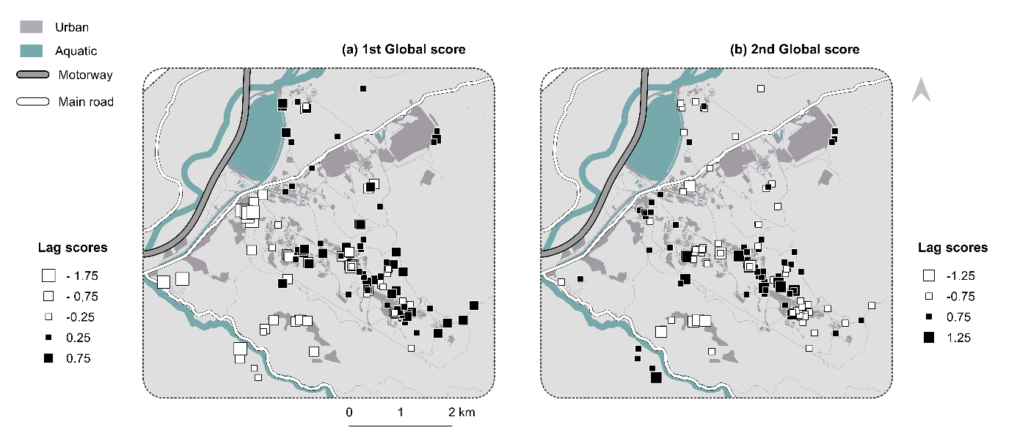
Online Resource 9. Plot of (upper) mean lnP(K) and standard deviation (grey areas) across the different STRUCTURE runs for each value of K and (lower) delta K values based on the Evanno method applied to STRUCTURE results, identifying the optimal number of genetic clusters. Those results are for the extended study area

Online Resource 10. STRUCTURE barplot showing individual cluster (K) membership at (upper) K = 2 and (lower) K = 4 in the extended study area.
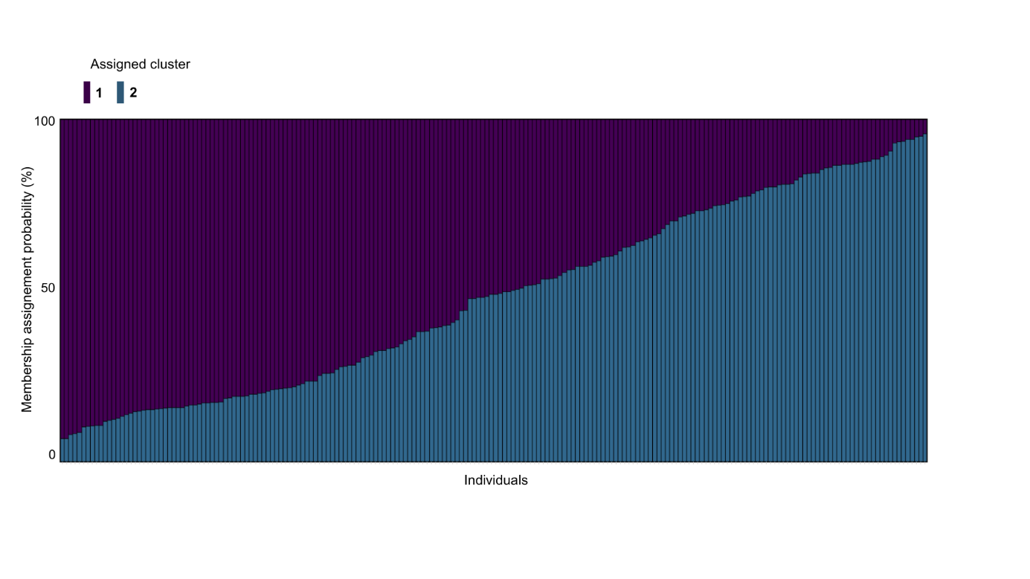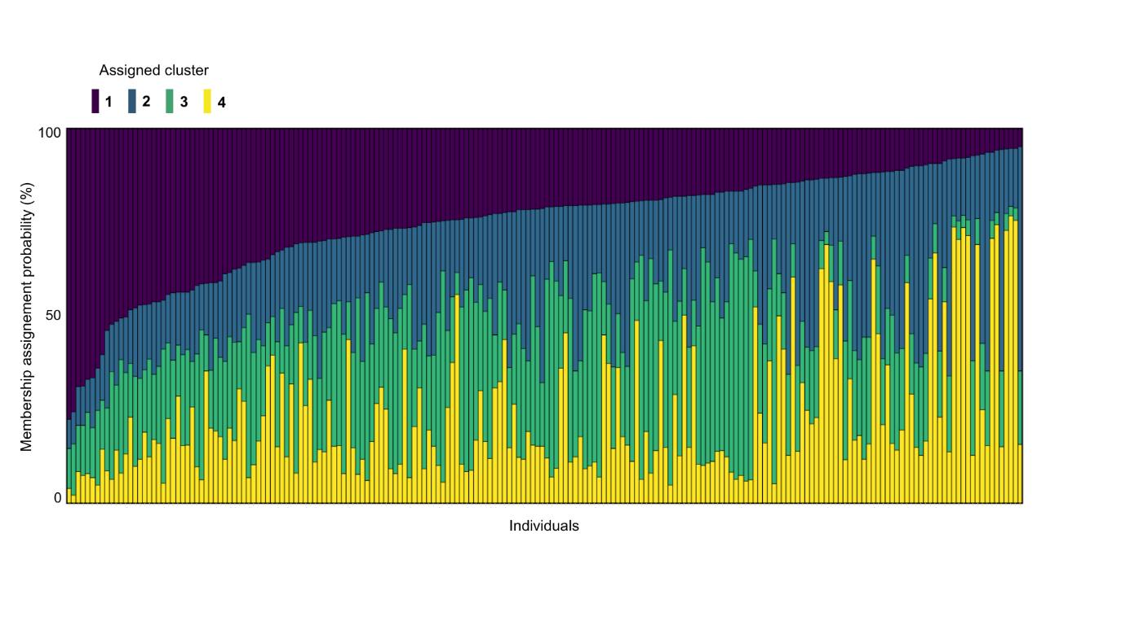

Online Resource 11. Plot of mean lnP(K) and standard deviation (grey areas) across the different STRUCTURE runs for each value of K in the central study area.

Online Resource 12. Characteristics (intercept, slope, log-likelihood, AICc) of the MLPE mixed-effects models evaluating isolation-by-distance patterns using PCA-based genetic distances in the extended and central study areas. Isolation-by-distance was tested by comparing a model including Euclidean distance (dist.pca) to a null model without geographic distance (null.pca).
 |  | intercept | slope coeff. | df | logLik | AICc | Delta
extended study area | dist.pca | 2.313 | 0.033 | 4 | -3378.072 | 6764.1 | 0.00
extended study area | null.pca | 2.568 |  | 3 | -3469.097 | 6944.2 | 180.05

central study area | dist.pca | 2.315 | 0.026 | 4 | -2459.964 | 4927.9 | 0.00
central study area | null.pca | 2.503 |  | 3 | -2498.655 | 5003.3 | 75.38

Online Resource 13. Relationship between PCA-based inter-individual genetic distances and log-transformed inter-individual Euclidean distances from a MLPE mixed-effects model in (blue line, orange and grey point) the extended study area and in (orange line, orange point) the central study area.

surface | k | AIC | AICc | ∆AICc | R2m | R2c | LL
water (%) 0m | 4 | 6721.74 | 6721.94 | 0.00 | 0.03 | 0.38 | -3356.87
water (%) 80m | 4 | 6724.22 | 6724.42 | 2.48 | 0.03 | 0.37 | -3358.11
water (%) 160m | 4 | 6724.82 | 6725.03 | 3.08 | 0.03 | 0.37 | -3358.41
water (%) 320m | 4 | 6725.06 | 6725.27 | 3.33 | 0.03 | 0.37 | -3358.53
distance | 2 | 6726.07 | 6726.13 | 4.19 | 0.02 | 0.37 | -3361.04
bareground (%) 80m | 4 | 6725.64 | 6725.84 | 0.00 | 0.04 | 0.37 | -3358.82
bareground (%) 0m | 4 | 6725.87 | 6726.07 | 0.23 | 0.03 | 0.37 | -3358.94
distance | 2 | 6726.07 | 6726.13 | 0.29 | 0.02 | 0.37 | -3361.04
bareground (%) 320m | 4 | 6727.84 | 6728.04 | 2.20 | 0.03 | 0.37 | -3359.92
bareground (%) 160m | 4 | 6729.97 | 6730.17 | 4.33 | 0.03 | 0.37 | -3360.98
distance | 2 | 6726.07 | 6726.13 | 0.00 | 0.02 | 0.37 | -3361.04
grassland (%) 320m | 4 | 6727.67 | 6727.87 | 1.74 | 0.03 | 0.37 | -3359.83
grassland (%) 160m | 4 | 6729.19 | 6729.40 | 3.26 | 0.03 | 0.37 | -3360.60
grassland (%) 80m | 4 | 6729.46 | 6729.66 | 3.52 | 0.03 | 0.37 | -3360.73
grassland (%) 0m | 4 | 6729.66 | 6729.86 | 3.73 | 0.02 | 0.37 | -3360.83
nat. shelter occ. prob. (%) 320m | 4 | 6687.66 | 6687.86 | 0.00 | 0.10 | 0.42 | -3339.83
nat. shelter occ. prob. (%) 160m | 4 | 6688.11 | 6688.31 | 0.45 | 0.10 | 0.42 | -3340.05
nat. shelter occ. prob. (%) 80m | 4 | 6688.20 | 6688.40 | 0.54 | 0.11 | 0.41 | -3340.10
nat. shelter occ. prob. (%) 0m | 4 | 6691.73 | 6691.94 | 4.08 | 0.10 | 0.41 | -3341.87
distance | 2 | 6726.08 | 6726.14 | 38.28 | 0.02 | 0.37 | -3361.04
distance to river (m) | 4 | 6688.92 | 6689.12 | 0.00 | 0.10 | 0.42 | -3340.46
distance | 2 | 6726.55 | 6726.61 | 37.49 | 0.02 | 0.37 | -3361.27
road (%) 320m | 4 | 6696.04 | 6696.25 | 0.00 | 0.10 | 0.42 | -3344.02
road (%) 160m | 4 | 6699.43 | 6699.63 | 3.39 | 0.08 | 0.40 | -3345.72
road (%) 80m | 4 | 6701.68 | 6701.88 | 5.64 | 0.08 | 0.40 | -3346.84
distance | 2 | 6726.07 | 6726.13 | 29.89 | 0.02 | 0.37 | -3361.04
road (%) 0m | 3 | 6879.56 | 6879.68 | 183.43 | 0.09 | 0.42 | -3436.78
distance | 2 | 6726.07 | 6726.13 | 0.00 | 0.02 | 0.37 | -3361.04
shrub (%) 320m | 4 | 6726.97 | 6727.17 | 1.03 | 0.03 | 0.37 | -3359.48
shrub (%) 160m | 4 | 6727.50 | 6727.71 | 1.57 | 0.03 | 0.37 | -3359.75
shrub (%) 80m | 4 | 6727.56 | 6727.76 | 1.63 | 0.03 | 0.37 | -3359.78
shrub (%) 0m | 4 | 6727.57 | 6727.77 | 1.64 | 0.03 | 0.37 | -3359.78
slope (mean) 320m | 4 | 6692.26 | 6692.46 | 0.00 | 0.09 | 0.39 | -3342.13
slope (mean) 80m | 4 | 6700.60 | 6700.80 | 8.34 | 0.06 | 0.38 | -3346.30
slope (mean) 160m | 4 | 6703.00 | 6703.20 | 10.74 | 0.06 | 0.38 | -3347.50
slope (mean) 0m | 4 | 6712.79 | 6712.99 | 20.53 | 0.04 | 0.37 | -3352.40
distance | 2 | 6726.08 | 6726.14 | 33.67 | 0.02 | 0.37 | -3361.04
tree (%) 160m | 4 | 6717.00 | 6717.20 | 0.00 | 0.07 | 0.38 | -3354.50
tree (%) 320m | 4 | 6717.13 | 6717.33 | 0.13 | 0.07 | 0.38 | -3354.56
tree (%) 80m | 4 | 6718.95 | 6719.15 | 1.95 | 0.06 | 0.38 | -3355.47
tree (%) 0m | 4 | 6722.46 | 6722.66 | 5.46 | 0.06 | 0.38 | -3357.23
distance | 2 | 6726.07 | 6726.13 | 8.93 | 0.02 | 0.37 | -3361.04
distance | 2 | 6726.07 | 6726.13 | 0.00 | 0.02 | 0.37 | -3361.04
urban (%) 0m | 4 | 6729.50 | 6729.71 | 3.57 | 0.02 | 0.37 | -3360.75
urban (%) 80m | 4 | 6729.67 | 6729.87 | 3.73 | 0.02 | 0.37 | -3360.83
urban (%) 160m | 4 | 6729.80 | 6730.00 | 3.87 | 0.02 | 0.37 | -3360.90
urban (%) 320m | 4 | 6729.88 | 6730.09 | 3.95 | 0.02 | 0.37 | -3360.94
agricultural (%) 320m | 4 | 6691.26 | 6691.46 | 0.00 | 0.09 | 0.39 | -3341.63
agricultural (%) 160m | 4 | 6696.53 | 6696.74 | 5.28 | 0.10 | 0.40 | -3344.27
agricultural (%) 80m | 4 | 6700.46 | 6700.66 | 9.20 | 0.08 | 0.39 | -3346.23
agricultural (%) 0m | 4 | 6706.18 | 6706.39 | 14.92 | 0.06 | 0.38 | -3349.09
distance | 2 | 6726.07 | 6726.13 | 34.67 | 0.02 | 0.37 | -3361.04
Online Resource 14. Single-surface optimization results from RESISTANCEGA comparing, for each environmental variable, the results of the MLPE model based on resistance distances calculated on their environmental resistance surfaces optimized at four buffer sizes against an isolation-by-distance model, in the extended study area. Surface: names of the variables involved in the combination, k: number of estimated parameters in the model, AIC: Akaike Information Criterion, AICc: AIC corrected for small sample size, R2m: marginal R², R2c: conditional R², LL: log-likelihood, ∆AICc: difference in AICc between a given model and the best-supported model (lowest AICc). Environmental surfaces providing resistance distances that outperformed Euclidean distance surfaces are in bold.

Online Resource 15. Multi-surface optimization results from RESISTANCEGA comparing all combinations among the retained resistance surfaces from the single-surface optimization step in the extended study area. Here are represented the top ranking (∆AICc<2) combinations across the 5 replicates (r) performed of this multi-surface optimization. N: number of variables involved in the combination, r: replicate number of the multi-surface optimization, surface: names of the variables involved in the combination, k: number of estimated parameters in the model, AIC: Akaike Information Criterion, AICc: AIC corrected for small sample size, R2m: marginal R², R2c: conditional R², LL: log-likelihood, ∆AICc: difference in AICc between a given model and the best-supported model (lowest AICc).
r | N | surface | k | AIC | AICc | R2m | R2c | LL | ∆AICc
1 | 2 | agricultural320m.river | 7 | 6684.49 | 6685.07 | 0.11 | 0.41 | -3335.24 | 0.00
1 | 3 | agricultural320m.river.shelter320m | 10 | 6684.08 | 6685.23 | 0.11 | 0.41 | -3332.04 | 0.16
1 | 2 | river shelter320m | 7 | 6685.05 | 6685.63 | 0.11 | 0.42 | -3335.52 | 0.56
1 | 3 | agricultural320m.river.slope320m | 10 | 6684.53 | 6685.68 | 0.12 | 0.41 | -3332.27 | 0.62
1 | 2 | agricultural320m.shelter320m | 7 | 6685.19 | 6685.76 | 0.12 | 0.41 | -3335.59 | 0.70
1 | 2 | road320m.slope320m | 7 | 6685.48 | 6686.05 | 0.12 | 0.42 | -3335.74 | 0.99
1 | 2 | river slope320m | 7 | 6685.76 | 6686.33 | 0.10 | 0.41 | -3335.88 | 1.27
2 | 2 | agricultural320m.river | 7 | 6683.34 | 6683.92 | 0.11 | 0.41 | -3334.67 | 0.00
2 | 2 | river.shelter320m | 7 | 6683.84 | 6684.42 | 0.10 | 0.41 | -3334.92 | 0.50
2 | 2 | river.slope320m | 7 | 6683.93 | 6684.51 | 0.11 | 0.41 | -3334.96 | 0.59
2 | 2 | agricultural320m.shelter320m | 7 | 6684.31 | 6684.89 | 0.11 | 0.41 | -3335.15 | 0.97
2 | 3 | agricultural320m.river.shelter320m | 10 | 6683.77 | 6684.92 | 0.12 | 0.41 | -3331.88 | 1.00
2 | 2 | road320m.slope320m | 7 | 6685.04 | 6685.62 | 0.12 | 0.42 | -3335.52 | 1.70
3 | 2 | agricultural320m.river | 7 | 6683.34 | 6683.92 | 0.11 | 0.41 | -3334.67 | 0.00
3 | 2 | river.shelter320m | 7 | 6683.79 | 6684.37 | 0.11 | 0.41 | -3334.89 | 0.45
3 | 3 | agricultural320m.river.shelter320m | 10 | 6683.41 | 6684.56 | 0.12 | 0.41 | -3331.70 | 0.64
3 | 2 | river.slope320m | 7 | 6684.22 | 6684.80 | 0.10 | 0.41 | -3335.11 | 0.88
3 | 2 | agricultural320m.shelter320m | 7 | 6684.31 | 6684.89 | 0.11 | 0.41 | -3335.15 | 0.97
3 | 2 | road320m.slope320m | 7 | 6684.66 | 6685.24 | 0.10 | 0.41 | -3335.33 | 1.33
3 | 3 | agricultural320m.river.slope320m | 10 | 6684.57 | 6685.72 | 0.11 | 0.41 | -3332.28 | 1.80
4 | 2 | agricultural320m.river | 7 | 6683.28 | 6683.85 | 0.11 | 0.41 | -3334.64 | 0.00
4 | 2 | river.shelter320m | 7 | 6684.18 | 6684.76 | 0.10 | 0.41 | -3335.09 | 0.90
4 | 2 | river.slope320m | 7 | 6684.19 | 6684.77 | 0.12 | 0.41 | -3335.10 | 0.92
4 | 3 | agricultural320m.river.slope320m | 10 | 6683.63 | 6684.78 | 0.11 | 0.41 | -3331.82 | 0.93
4 | 2 | agricultural320m.shelter320m | 7 | 6684.27 | 6684.85 | 0.11 | 0.41 | -3335.13 | 0.99
4 | 3 | agricultural320m.river.shelter320m | 10 | 6684.16 | 6685.31 | 0.12 | 0.41 | -3332.08 | 1.45
5 | 2 | river.shelter320m | 7 | 6683.38 | 6683.95 | 0.11 | 0.42 | -3334.69 | 0.00
5 | 2 | agricultural320m.river | 7 | 6683.39 | 6683.97 | 0.11 | 0.41 | -3334.70 | 0.01
5 | 3 | agricultural320m.river.shelter320m | 10 | 6683.48 | 6684.64 | 0.13 | 0.42 | -3331.74 | 0.68
5 | 2 | river.slope320m | 7 | 6684.75 | 6685.33 | 0.10 | 0.41 | -3335.38 | 1.38
5 | 2 | agricultural320m.shelter320m | 7 | 6684.76 | 6685.34 | 0.11 | 0.40 | -3335.38 | 1.39
5 | 3 | agricultural320m.river.slope320m | 10 | 6684.37 | 6685.53 | 0.12 | 0.41 | -3332.19 | 1.57

Online Resource 16. Single-surface optimization results from RESISTANCEGA comparing, for each environmental variable (four buffer sizes), the results of the MLPE model based on resistance distances calculated on their environmental resistance surfaces against an isolation-by-distance model in the central study area. Surface: names of the variables involved in the combination, k: number of estimated parameters in the model, AIC: Akaike Information Criterion, AICc: AIC corrected for small sample size, R2m: marginal R², R2c: conditional R², LL: log-likelihood, ∆AICc: difference in AICc between a given model and the best-supported model (lowest AICc). Environmental surfaces providing resistance distances that outperformed Euclidean distance surfaces are in bold.
Surface | k | AIC | AICc | ∆AICc | R2m | R2c | LL
agricultural (%) 320m | 4 | 4894.01 | 4894.26 | 0.00 | 0.09 | 0.38 | -2443.01
agricultural (%) 160m | 4 | 4896.45 | 4896.69 | 2.44 | 0.08 | 0.37 | -2444.23
agricultural (%) 80m | 4 | 4900.16 | 4900.40 | 6.14 | 0.07 | 0.36 | -2446.08
agricultural (%) 0m | 4 | 4908.26 | 4908.51 | 14.25 | 0.01 | 0.33 | -2450.13
distance | 2 | 4915.91 | 4915.98 | 21.72 | 0.01 | 0.34 | -2455.95
bareground (%) 320m | 4 | 4913.94 | 4914.18 | 0.00 | 0.02 | 0.34 | -2452.97
bareground (%) 80m | 4 | 4914.00 | 4914.24 | 0.06 | 0.01 | 0.34 | -2453.00
bareground (%) 160m | 4 | 4914.15 | 4914.39 | 0.21 | 0.02 | 0.34 | -2453.07
distance | 2 | 4915.91 | 4915.98 | 1.80 | 0.01 | 0.34 | -2455.95
bareground (%) 0m | 4 | 4918.90 | 4919.14 | 4.96 | 0.01 | 0.33 | -2455.45
distance to river (m) | 4 | 4895.14 | 4895.38 | 0.00 | 0.09 | 0.39 | -2443.57
distance | 2 | 4915.93 | 4916.00 | 20.61 | 0.01 | 0.34 | -2455.96
grassland (%) 160m | 4 | 4913.83 | 4914.07 | 0.00 | 0.03 | 0.36 | -2452.92
grassland (%) 320m | 4 | 4914.49 | 4914.73 | 0.66 | 0.03 | 0.36 | -2453.25
grassland (%) 80m | 4 | 4914.60 | 4914.85 | 0.77 | 0.03 | 0.36 | -2453.30
distance | 2 | 4915.27 | 4915.34 | 1.27 | 0.01 | 0.34 | -2455.64
grassland (%) 0m | 4 | 4915.69 | 4915.93 | 1.86 | 0.02 | 0.35 | -2453.84
road cover(%) 320m | 4 | 4902.73 | 4902.97 | 0.00 | 0.05 | 0.37 | -2447.36
roadDensity (%) 160m | 4 | 4907.41 | 4907.65 | 4.68 | 0.04 | 0.37 | -2449.70
roadDensity (%) 80m | 4 | 4908.53 | 4908.77 | 5.80 | 0.04 | 0.37 | -2450.27
Distance | 2 | 4915.27 | 4915.34 | 12.37 | 0.01 | 0.34 | -2455.64
roadDensity (%) 0m | 3 | 4988.33 | 4988.47 | 85.50 | 0.05 | 0.37 | -2491.16
nat. shelter occ. prob. (%) 320m | 4 | 4907.09 | 4907.34 | 0.00 | 0.03 | 0.36 | -2449.55
nat. shelter dens. (%) 160m | 4 | 4907.26 | 4907.50 | 0.17 | 0.04 | 0.36 | -2449.63
nat. shelter dens. (%) 80m | 4 | 4907.60 | 4907.84 | 0.51 | 0.04 | 0.36 | -2449.80
nat. shelter dens. (%) 0m | 4 | 4910.04 | 4910.28 | 2.95 | 0.03 | 0.36 | -2451.02
distance | 2 | 4915.29 | 4915.36 | 8.02 | 0.01 | 0.34 | -2455.64
shrub (%) 320m | 4 | 4914.84 | 4915.09 | 0.00 | 0.02 | 0.34 | -2453.42
distance | 2 | 4915.29 | 4915.36 | 0.27 | 0.01 | 0.34 | -2455.64
shrub (%) 160m | 4 | 4915.24 | 4915.49 | 0.40 | 0.02 | 0.34 | -2453.62
shrub (%) 80m | 4 | 4919.27 | 4919.52 | 4.43 | 0.01 | 0.34 | -2455.64
shrub (%) 0m | 4 | 4919.29 | 4919.53 | 4.44 | 0.01 | 0.34 | -2455.64
distance | 2 | 4915.29 | 4915.36 | 0.00 | 0.01 | 0.34 | -2455.64
slope 160m | 4 | 4915.46 | 4915.71 | 0.35 | 0.02 | 0.34 | -2453.73
slope 320m | 4 | 4915.90 | 4916.15 | 0.79 | 0.02 | 0.34 | -2453.95
slope 80m | 4 | 4915.91 | 4916.16 | 0.79 | 0.01 | 0.34 | -2453.96
slope 0m | 4 | 4917.68 | 4917.92 | 2.56 | 0.01 | 0.34 | -2454.84
tile network (%) 160m | 4 | 4910.52 | 4910.76 | 0.00 | 0.03 | 0.36 | -2451.26
tile network (%) 320m | 4 | 4910.96 | 4911.20 | 0.44 | 0.03 | 0.36 | -2451.48
tile network (%) 80m | 4 | 4912.42 | 4912.67 | 1.90 | 0.03 | 0.35 | -2452.21
tile network (%) 0m | 4 | 4913.17 | 4913.41 | 2.65 | 0.03 | 0.35 | -2452.59
distance | 2 | 4915.29 | 4915.36 | 4.60 | 0.01 | 0.34 | -2455.64
distance | 2 | 4915.29 | 4915.36 | 0.00 | 0.01 | 0.34 | -2455.64
tree (%) 320m | 4 | 4918.47 | 4918.71 | 3.35 | 0.01 | 0.33 | -2455.23
tree (%) 160m | 4 | 4919.19 | 4919.44 | 4.08 | 0.01 | 0.34 | -2455.60
tree (%) 80m | 4 | 4919.23 | 4919.48 | 4.12 | 0.01 | 0.33 | -2455.62
tree (%) 0m | 4 | 4919.29 | 4919.53 | 4.17 | 0.01 | 0.34 | -2455.64
distance | 2 | 4915.27 | 4915.34 | 0.00 | 0.01 | 0.34 | -2455.64
urban (%) 0m | 4 | 4917.48 | 4917.72 | 2.37 | 0.01 | 0.34 | -2454.74
urban (%) 80m | 4 | 4917.83 | 4918.07 | 2.73 | 0.01 | 0.34 | -2454.91
urban (%) 160m | 4 | 4917.86 | 4918.11 | 2.76 | 0.01 | 0.34 | -2454.93
urban (%) 320m | 4 | 4919.15 | 4919.40 | 4.05 | 0.01 | 0.34 | -2455.58
water (%) 0m | 4 | 4914.86 | 4915.10 | 0.00 | 0.01 | 0.34 | -2453.43
distance | 2 | 4915.29 | 4915.36 | 0.26 | 0.01 | 0.34 | -2455.64
water (%) 80m | 4 | 4915.67 | 4915.91 | 0.81 | 0.01 | 0.34 | -2453.84
water (%) 160m | 4 | 4916.04 | 4916.28 | 1.18 | 0.01 | 0.34 | -2454.02
water (%) 320m | 4 | 4916.28 | 4916.52 | 1.42 | 0.01 | 0.34 | -2454.14

Online Resource 17. Multi-surface optimization results from RESISTANCEGA comparing all combination among the retained resistance surfaces from the single-surface optimization step in the central study area. Here are represented the top ranking (∆AICc) combination across the 5 replicates (r) performed. N: number of variables involved in the combination, r: replicate number of the multi-surface optimization, surface: names of the of variables involved in the combination, k: number of estimated parameters in the model, AIC: Akaike Information Criterion, AICc: AIC corrected for small sample size, R2m: marginal R², R2c: conditional R², LL: log-likelihood, ∆AICc: difference in AICc between a given model and the best-supported model (lowest AICc).
r | c | surface | k | AIC | AICc | R2m | R2c | LL | ∆AICc
1 | 1 | agricultural 320m | 4 | 4892.68 | 4892.93 | 0.09 | 0.38 | -2442.34 | 0.00
1 | 2 | agricultural320m.river | 7 | 4892.68 | 4893.37 | 0.11 | 0.40 | -2439.34 | 0.45
1 | 1 | river | 4 | 4893.58 | 4893.82 | 0.09 | 0.39 | -2442.79 | 0.90
1 | 2 | agricultural320m.shelter320m | 7 | 4893.23 | 4893.92 | 0.10 | 0.39 | -2439.62 | 1.00
2 | 2 | agricultural320m.river | 7 | 4892.79 | 4893.48 | 0.11 | 0.40 | -2439.39 | 0.00
2 | 1 | river | 4 | 4893.57 | 4893.82 | 0.09 | 0.39 | -2442.79 | 0.34
2 | 2 | agricultural320m.shelter320m | 7 | 4893.26 | 4893.95 | 0.10 | 0.39 | -2439.63 | 0.47
2 | 1 | agricultural320m | 4 | 4892.68 | 4892.92 | 0.09 | 0.38 | -2442.34 | 0.55
3 | 1 | agricultural320m | 4 | 4892.68 | 4892.92 | 0.09 | 0.38 | -2442.34 | 0.00
3 | 2 | agricultural320m.river | 7 | 4892.62 | 4893.31 | 0.10 | 0.39 | -2439.31 | 0.39
3 | 1 | river | 4 | 4893.55 | 4893.80 | 0.09 | 0.39 | -2442.78 | 0.87
3 | 2 | agricultural320m.shelter320m | 7 | 4893.25 | 4893.95 | 0.10 | 0.39 | -2439.63 | 1.02
4 | 1 | agricultural320m | 4 | 4892.68 | 4892.92 | 0.09 | 0.38 | -2442.34 | 0.00
4 | 2 | agricultural320m.river | 7 | 4892.59 | 4893.29 | 0.10 | 0.39 | -2439.30 | 0.36
4 | 2 | agricultural320m.shelter320m | 7 | 4893.23 | 4893.92 | 0.10 | 0.39 | -2439.61 | 1.00
4 | 1 | river | 4 | 4893.69 | 4893.93 | 0.09 | 0.39 | -2442.84 | 1.01
5 | 1 | agricultural320m | 4 | 4892.68 | 4892.92 | 0.09 | 0.38 | -2442.34 | 0.00
5 | 2 | agricultural320m.river | 7 | 4892.53 | 4893.22 | 0.10 | 0.39 | -2439.27 | 0.30
5 | 2 | agricultural320m.shelter320m | 7 | 4893.27 | 4893.96 | 0.10 | 0.39 | -2439.64 | 1.04
5 | 1 | river | 4 | 4893.76 | 4894.00 | 0.08 | 0.38 | -2442.88 | 1.08

Online Resource 18. Summary of the most performant variable combinations (∆AICc <2) during the multi-surface optimization step, and mean contribution of each covariate, across the 5 replicates, in the central study area. N: number of covariates in the combination, x/5: number of replicates that ranked the combination within the most performant among the 5 replicates. Within each replicate, variable contribution was estimated by the genetic algorithm during the multi-surface optimization and reflects the relative influence of each variable on the composite resistance distance.
 |  |  |  | mean contribution across replicates
N | combination |  | presence across replicates | agricultural | river | shelter
2 | agricultural * river | 5/5 |  | 0.37 | 0.63
2 | agricultural * shelter | 5/5 |  | 0.36 |  | 0.64
1 | agricultural | 5/5 |  | 1.00
1 | river | 5/5 |  |  | 1.00

Online Resource 19. The relationship between estimated resistance and environmental covariate is shown for each top ranking combination following the multi-surface optimization in the central study area. Each spatial scale is represented by a different linetype and color, and the mean (line) and standard error (ribbon) of each relationship across replicates is represented.
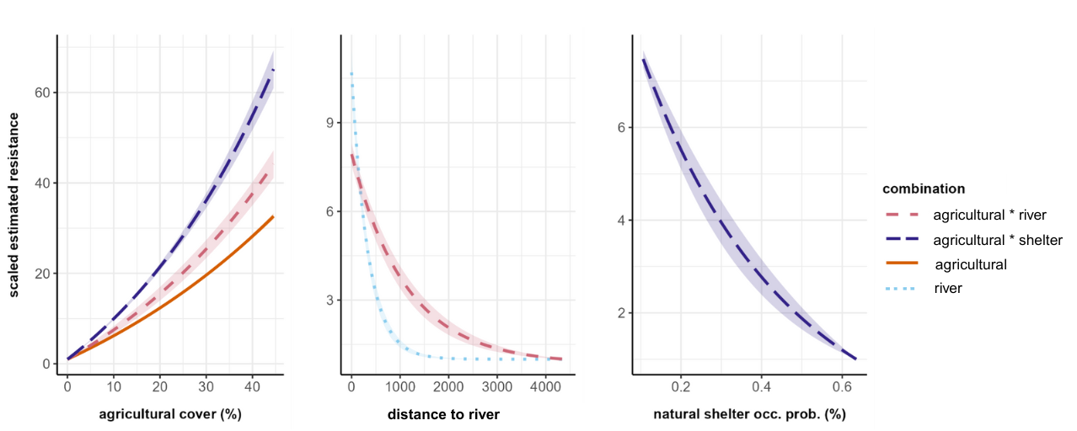

Online Resource 20. Resistance surface of the central study area, and its associated uncertainty. The resistance surface was generated by averaging the resistance surfaces generated by the top-performing variable combinations, across replicates. Grey contours delineate areas where the standard deviation of resistance exceeds 1, indicating areas of higher uncertainty in resistance estimates. White points represent the genetic samples used to parameterize the resistance surface. The environmental gradients of the three covariates that contribute to the best combination are shown to illustrate their spatial distribution.
